**MIT Digital Structures**

digitalstructures.mit.edu



**User Manual Version 1.1**

**Updated September 22, 2017**

Written by Nathan Brown

ncbrown@mit.edu

**1.1 Introduction**

Design Space Exploration (DSE) is a suite of Grasshopper tools developed by Digital Structures at MIT. These tools aim to support visual, performance-based design space exploration and interactive multi-objective optimization (MOO) for conceptual design. Rather than one single component or user interface, these tools can be used flexibly with other Grasshopper components or plug-ins to take a variety of approaches to DSE and MOO, including *a priori*, *a posteriori,* and *interactive* articulation of performance objective priorities.

Section 2 describes the **Catalog** set of tools, which can be used to sample and record a performance-based parametric design space. It also includes a component that approximates the Pareto front of a multi-objective problem. More information about the **Catalog** tools can be found in:

Brown, N.C., de Oliveira, J.I.F., Ochsendorf, J., & Mueller, C. (2016). Early-Stage Integration of Architectural and Structural Performance in a Parametric Multi-Objective Design Tool. Proceedings of the 3rd International Conference on Structures and Architecture, Guimarães, Portugal.

Section 3describes the **Simplify** set of tools, which help designers focus more quickly on areas of the design space that are high-performing. Simplify tools include Cluster, which reduces the number of designs being considered to distinct families; and Effects, which quickly indicates how important variables are for performance. Other components, including Tilde, a tool for building surrogate models to rapidly approximate objective functions, are still in development. More information about Simplify tools can be found in:

Brown N., & Mueller, C. (2017). Automated performance-based design space simplification for parametric structural design. Proceedings of the International Association for Shell and Spatial Structures (IASS) Symposium 2017, Hamburg.

Tseranidis S., Brown N., & Mueller C. (2016). ‘Data-driven approximation algorithms for rapid performance evaluation and optimization of civil structures’. *Automation in Construction*, 72, pp.279-293.

Section 4 describes **Stormcloud**, which is a platform for interactive evolutionary exploration in Grasshopper. Stormcloud is based on the browser tool [structureFIT](http://web.mit.edu/caitlinm/www/structurefit/). More information about Stormcloud can be found in:

Danhaive, R., & Mueller, C. (2015). Combining parametric modeling and interactive optimization for high-performance and creative structural design. Proceedings of the International Association for Shell and Spatial Structures (IASS) Symposium 2015, Amsterdam.

These tools are being developed as part of ongoing research into digital design processes for architects and engineers. The authors welcome any discussion about possible applications, improvements, or new directions.

**2.1 Catalog - Component Descriptions**

 **Sampler**

This component automatically generates a list of parametric design vectors, called a “design map”, based on user-defined design variable properties. It outputs this design map as a nested list and Grasshopper, which can be used directly or plugged into other DSE tools, and saves it as a .csv file for documentation and interfacing with outside software. Sampler works on double-click, which will both output a Design Map and write a new file to your directory.

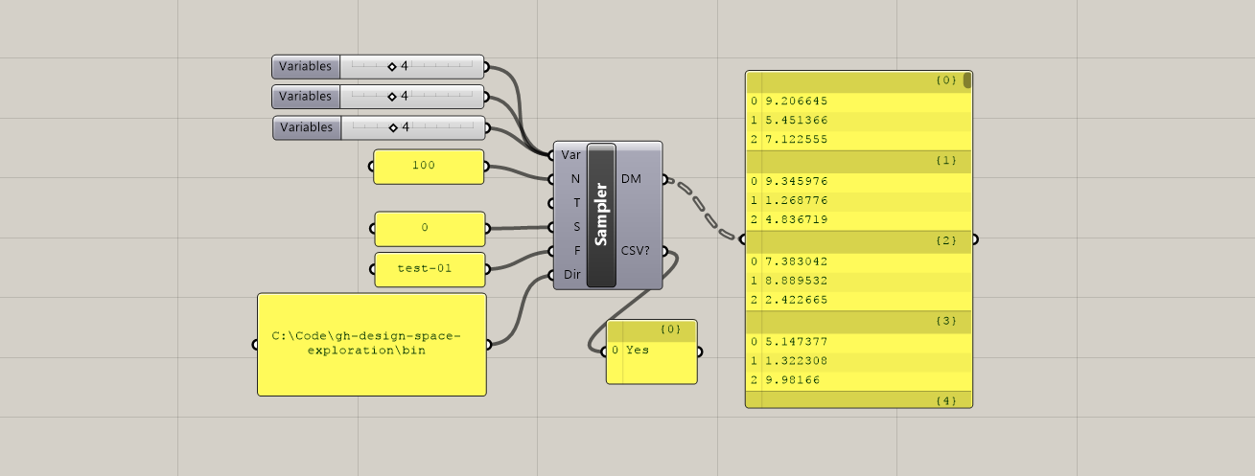

**Inputs:**

**Variables (Var) –** Takes in any number of sliders that are used as design variables for a given project. Sampler automatically reads the bounds of the sliders to set the limits of the design space being explored.

**Number of Samples (N) –** The number of samples to be generated. In the ‘grid’ design mode, rather than automatically truncating the list of samples at the edges or adjusting their spacing, the Design Map contains a list of samples that fully covers the design space in each dimension. This results in a number of samples that is higher than the input N, but is divisible by **Vars**. The user can manually trip this Design Map as needed.

**Type (Type) –** Sets the sampling technique: random, grid, or Latin Hypercube.

**Seed (S)** – Allows the user to refer back to a previously generated Design Map, even if random as involved. If the seed is set to ‘0’, Random or LHC will generate a new Design Map each time it is clicked. Every other integer will reference back to the same Design Map, even if it is randomly generated.

**Filename (F)** – The name of the Design Map file that will be written as a .csv. Does not include extension.

**Directory (Dir) –** The location on your computer where the Design Map will be saved. The directory can end with either a “\” or the folder name.

**Outputs:**

**Design Map (DM) –** A nested list of design vectors that span the design space being explored, based on the selected sampling technique.

**Data (CSV?) –** This output indicates whether or not the component wrote a CSV file to the directory. If Sampler is double-clicked without a directory, this output will be null. If it is attempted with an invalid directory, it will not run. If it is run with a valid directory, this output will read “Yes”.

**Sift**



This component allows the user to select a specific design from the map and access the geometry or other properties generated by the script for this design vector. Although the next component (Capture) allows for cycling through all the designs, Sift changes variable settings based on the given index input, which saves the user from setting these variables manually while considering a single design.

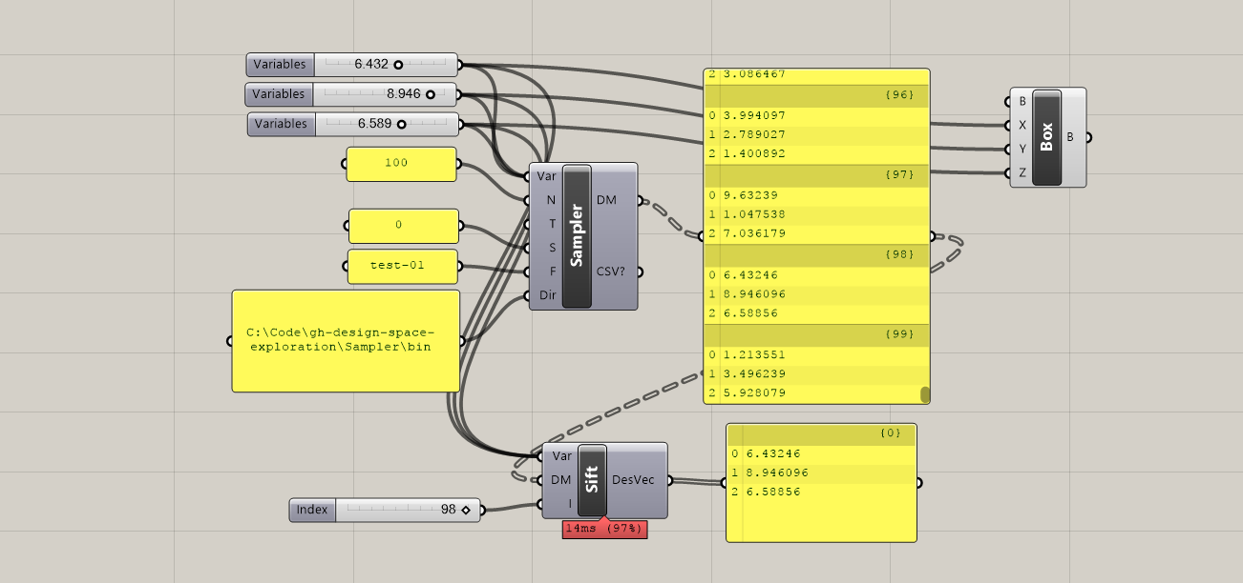

**Inputs:**

**Variables (Var) –** Takes in the sliders that are used as design variables for a given project. Sift is able to reset these sliders based on the index of the design in the Design Map.

**Design Map (DM) –** A nested list of design vectors that span the design space being explored, generated by Sampler or read from another file.

**Index (I) –** The index of the design under consideration from the Design Map.

**Outputs:**

**Design Vector (DesVec) –** The design vector for the design under consideration.

** Capture**

This component is a general iterator, which allows the user to automatically generate many different design options and record an image, the performance, and/or other properties of each design. Capture works on double-click, which will cause the component to cycle through each design option and recording the results.

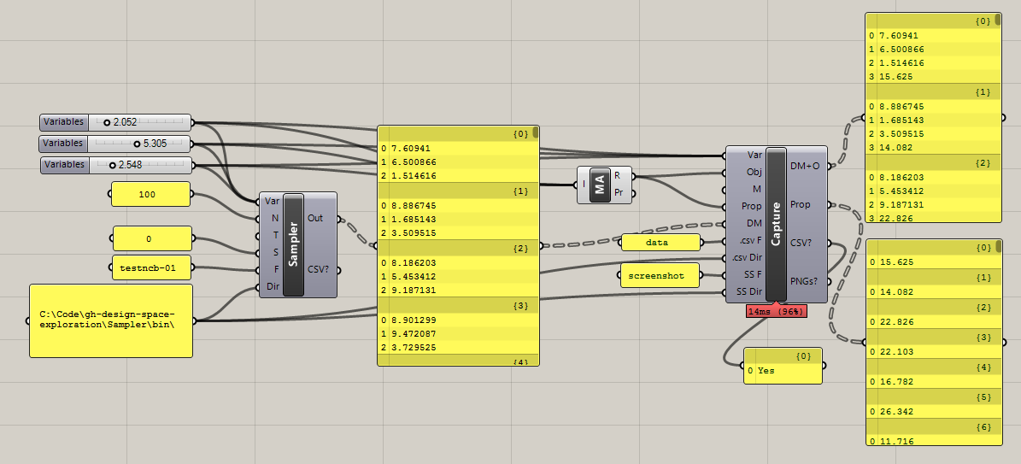

**Inputs:**

**Variables (Var) –** Takes in any number of sliders that are used as design variables for a given project. Sampler automatically reads the bounds of the sliders to set the limits of the design space being explored. The sliders should be identical to those used to generate the Design Map.

**Objectives (Obj) –** Reads in a list of the numerical values from performance evaluations generated by the script. Any performance-based measurement (or objective function), generated from either an outside plug-in or a collection of native Grasshopper components, can be recorded. Depending on Mode, Capture can function with either zero, one, or multiple objective functions in this input.

**Mode (M) –** Sets the operating mode: screenshots, eval, both, or neither. Screenshot mode records the image of the current Rhino view and saves it as a .png in the directory.

**Design Map (DM) –** A nested list of design vectors to be evaluated, coming either directly from Sampler or from another previously generated list of design options.

**Properties (Prop)** – Similar to objectives, reads in a list of numerical secondary design properties to be recorded while Capture is cycling through the different design options. However, these properties are not necessarily objective function evaluations and will be kept separate from the objectives when both are output by Capture.

**.CSV Filename (.csv F)** – The prefix name of the Design Map + Objectives and Properties files that will be written as a .csv to the directory.

**.CSV Directory (.csv Dir) –** The location on your computer where the Design Map + Objectives and Properties files will be saved. The directory MUST end with a “\” – otherwise, the file will be written one level higher than the intended directory.

**Screenshot Filename (SS F)** – The prefix name of the screenshot files that will be saved as a .png in the directory.

**Screenshot Directory (SS Dir) –** The location on your computer where the screenshots will be saved. The directory MUST end with a “\” – otherwise, the file will be written one level higher than the intended directory.

**Outputs:**

**Design Map + Objectives (DM+O) –** A nested list of design vectors and their objective values that span the design space being explored. Standard format for each design is the design vector followed by as many objective values as are recorded.

**Properties (Prop) -** A nested list of the secondary design properties recorded while Capture is cycling.

**Data (CSV?) –** This output indicates whether or not the component wrote a CSV file to the directory. If the component is double-clicked with an invalid directory, it will not run. If it is executed with a valid directory, this output will read “Yes”.

**Images (PNGs?) –** Similar to data, but for provides information about screenshots.



**Reader**

This component reads in a data file with rows and columns and converts it to a Grasshopper nested list.

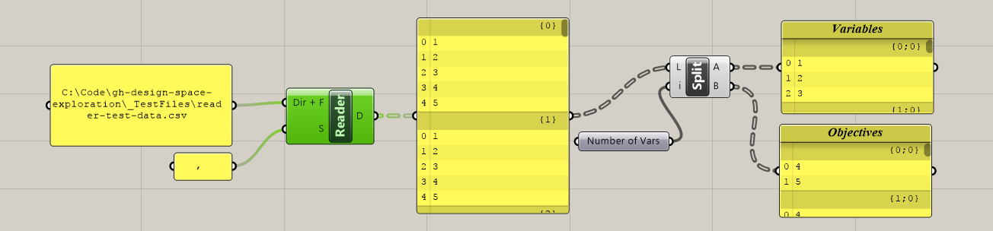

**Inputs:**

**Directory + Filename (Dir + F) -** Takes in the full address on your computer where the desired file is located, including the extension. The format takes in each row and converts it to a nested list, following the standard format for Design Maps. However, this component could read in any file saved in a similar row/column structure, including .txt files.

**Separator (S) –** Sets the character used to separate the data in the .csv. By default it is a space, which is how Design Maps are written, but for other data it could be “,”.

**Outputs:**

**Data (D) -** A nested list of the data contained in the .csv, following the standard format of design variables followed by objective values in the case of DM+O files.

** Writer**

This component automatically writes a Grasshopper nested list to a .csv file in the specified directory. It does not need to be doubleclicked, and will write whenever the inputs are refreshed.

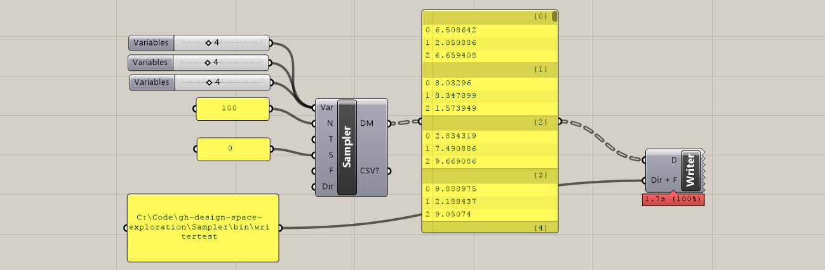

**Inputs:**

**Directory + Filename (Dir + F) -** Takes in the full address on your computer where the file should be written (no extension is necessary).

**Data (D) –** Takes in a nested list of the data that will be converted to a row x column .csv file.

** MOO**

This component implements the NSGA-II multi-objective optimization algorithm (Deb et al. 2002), which is a non-dominated sorting genetic algorithm. NSGA-II approximates the Pareto front in a given design problem by using crossover and mutation to iteratively breed successive, higher-performing generations of designs. MOO works on double-click, which will implement the algorithm. When the last generation has been reached, a dialog box will inform the user that the process is finished, at which point MOO will return the results as nested lists and write them to a .csv file in the directory. MOO uses the jMetal Framework (Durillo & Nebro 2011) to implement NSGA-II.

*\* In order for MOO to work properly, users must also download log4net.dll independently and add it to the Components folder, since it is not distributed with DSE. The .dll file can be found here:* [*https://logging.apache.org/log4net/download_log4net.cgi*](https://logging.apache.org/log4net/download_log4net.cgi)

*Under “Binaries”, click to download* [*log4net-2.0.8-bin-newkey.zip*](http://apache.mirrors.lucidnetworks.net/logging/log4net/binaries/log4net-2.0.8-bin-newkey.zip)*. Once this zip file has been downloaded and unzipped, “log4net.dll” can be found in (…log4net-2.0.8-bin-newkey.zip\log4net-2.0.8\bin\net\2.0\release)*

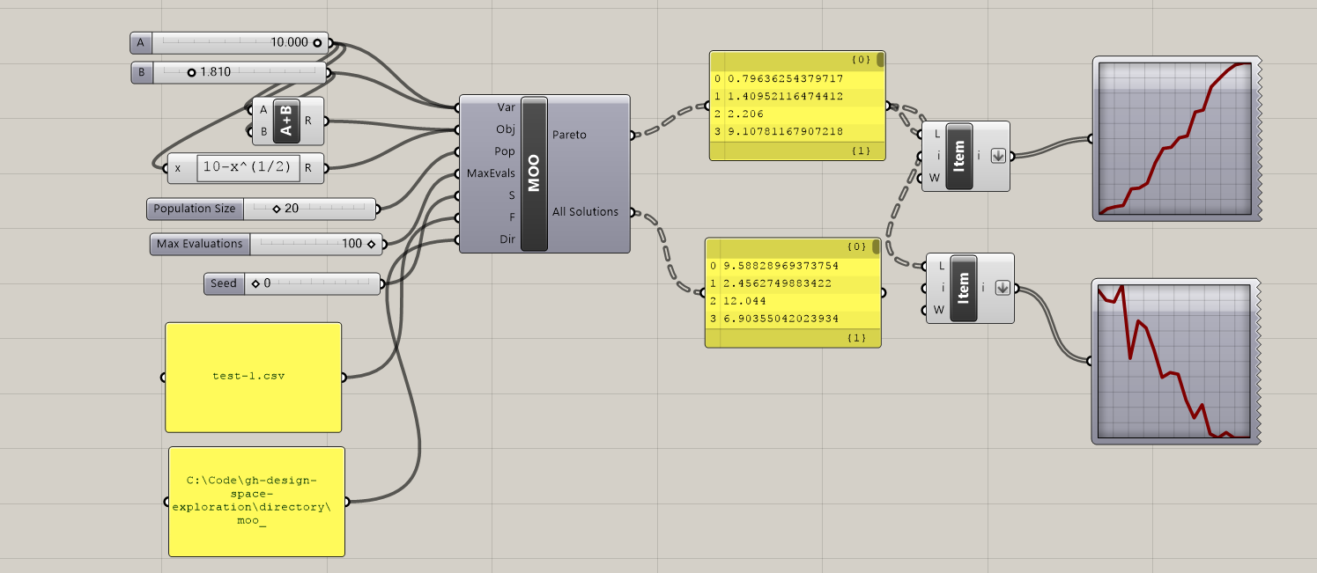

**Inputs:**

**Variables (Var) –** Takes in any number of sliders that are used as design variables for the optimization. MOO automatically reads the bounds of the sliders to set the limits of the design space being explored during the optimization.

**Objectives (Obj) –** Reads in a list of the numerical values from performance evaluations generated by the script. Any performance-based measurement (or objective function), generated from either an outside plug-in or a collection of native Grasshopper components, can be recorded. Although MOO will still run an optimization with only one objective, it is designed to handle at least two. **Note**: the objectives must be flattened in order for MOO to run properly.

**Population (Pop) –** Sets the population size for the for the multi-objective optimization algorithm. The number of generations tested while the algorithm is running will be the maximum evaluations divided by the population. **Note:** due to the way in which the NSGA-II is implemented, the population size *must* be even, and it should be a factor of the Maximum Evaluations. MOO will still run if the population is not a factor of MaxEval, but it will not run if the population is even.

**Maximum Evaluations (MaxEvals)** – Sets the amount of function evaluations to be conducted during the optimization. Since there is no “threshold” mode for this version of MOO, the MaxEvals effectively sets the stopping condition for the optimization—if the results do not satisfactorily represent the Pareto front, more evaluations, and consequently more generations, should be attempted. MaxEvals should be a multiple of the Population size. If your objective function evaluations take a long time, that duration multiplied by the number of evaluations should give a rough indication of the time it takes to run the whole optimization.

**Filename (F)** – The name of files that will be written to the directory. A successful MOO run will write two files: “LogFile-” + F and “allSolutions” + F. The log file will list details about the optimization for each time the component has been run, but the allSolutions file will reset with the evaluations of only the most recent run. **Note:** outputs may be written with different extensions; as such, “.csv” must be included at the end of the Filename if that is the desired file type.

**Directory (Dir) –** The location on your computer where the Design Map will be saved. The directory can end with either “\” or the folder name.

**Outputs:**

**Pareto Front (Pareto) –** A nested list of design vectors and objective function values of the final generation produced by MOO. These solutions are the approximation of the Pareto front for a given problem. The quality of the Pareto front depends on the each of the inputs, as well as the problem itself, so some experimentation might be helpful.

**All Solutions (All Solutions) –** A nested list of design vectors and objective function values for all recorded solutions produced while the algorithm is running. The length of this list will match the MaxEvals input.

**2.2 Catalog - Getting Started Example**

**7 Bar Truss**

This script demonstrates a simple workflow for how the DSE components can all be used together to explore a design space and run multi-objective optimizations. In addition to the Design Space Exploration components, the script contains a 2-variable, parametric, geometric definition of a 7-bar truss, example objective function evaluations, and example properties. Only the geometry of truss is defaulted to be visible.

The truss is a simple example of a potential design in which the structural form can be explored visually, but also numerically evaluated for performance. In this example, the two objectives being considered are the depth of the truss, which roughly correlates with how much load the truss can support, and the area of the envelope of the truss, which could indicate how much space it takes up in a building. A designer might want the deepest truss possible to support the load, but this objective likely trades off with having a small envelope so as not to be a visually and spatially intrusive element. Since MOO is defaulted to minimize objective functions, the depth of the truss has been made negative. In addition, the script records the total length of all members of the truss, which is treated as a secondary property that the designer would like to track, but does not qualify as an objective. Although the geometry and objective functions used in this example rely on native Grasshopper components and are almost trivial, more complex definitions and plug-ins can be used in their place.

When opening the script, the parametric truss geometry can first be explored live by adjusting the variable sliders directly:

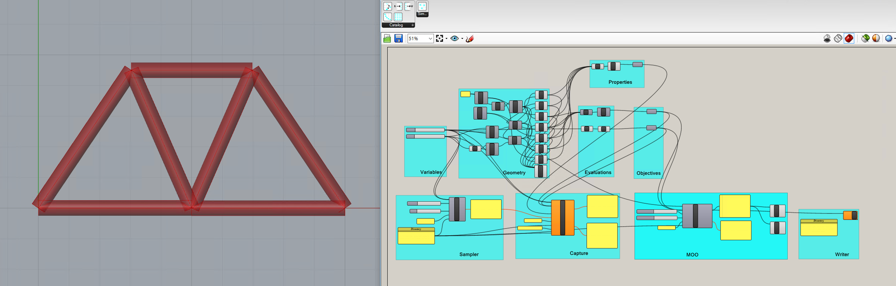

Although free exploration is a powerful parametric method, a designer might want to systematically explore the entire design space, use various optimization tools, and save all results for future decision-making. Each of these tasks can be completed for the provided script using the tools in Design Space Exploration. First, however, the panel containing the “Directory” must be adjusted to the desired location for storing design information. All of the components rely on correct formatting of the directory address in order to work properly:

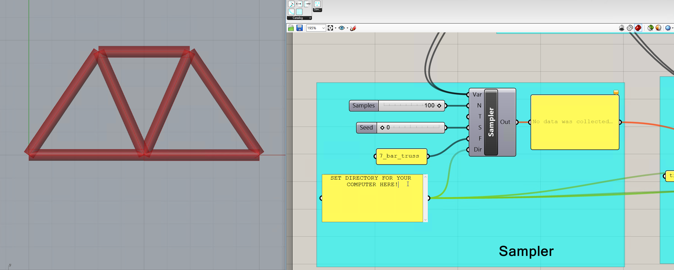

Once the Directory is set, the rest of the components will become functional. To take a representative sample of all potential truss options, doubleclick the **Sampler** component. This creates a Design Map of potential truss variable settings:

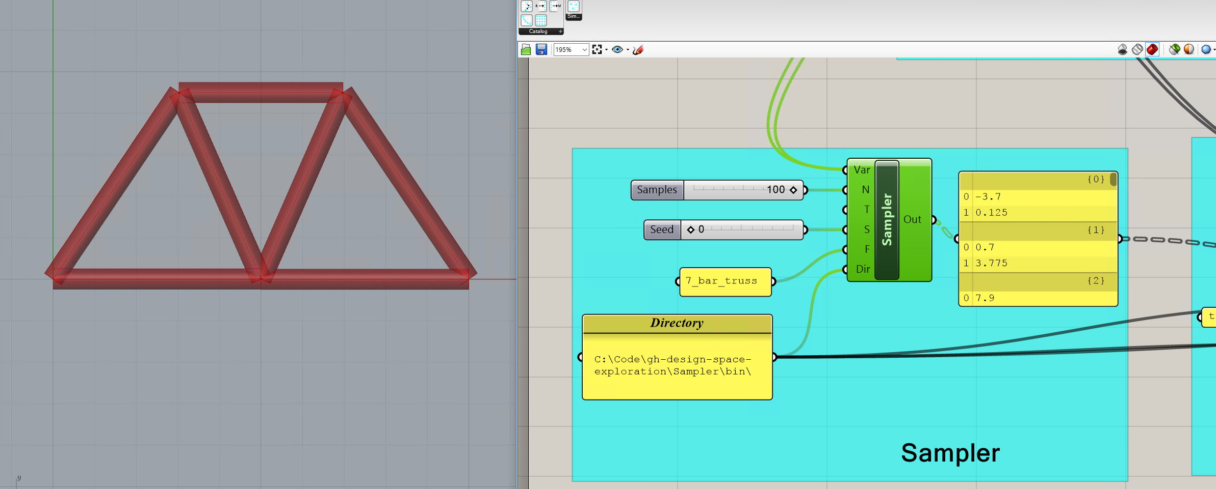

Alternatively, the **Reader** component could be used to read in a Design Map previously saved in a Directory.

After creating a Design Map and feeding it into the **Capture**, it is now possible to cycle through the different design possibilities and record the results. Doubleclicking Capture will start the recording cycle, and when it is finished, the results can be accessed both in the directory and as **Capture** outputs:

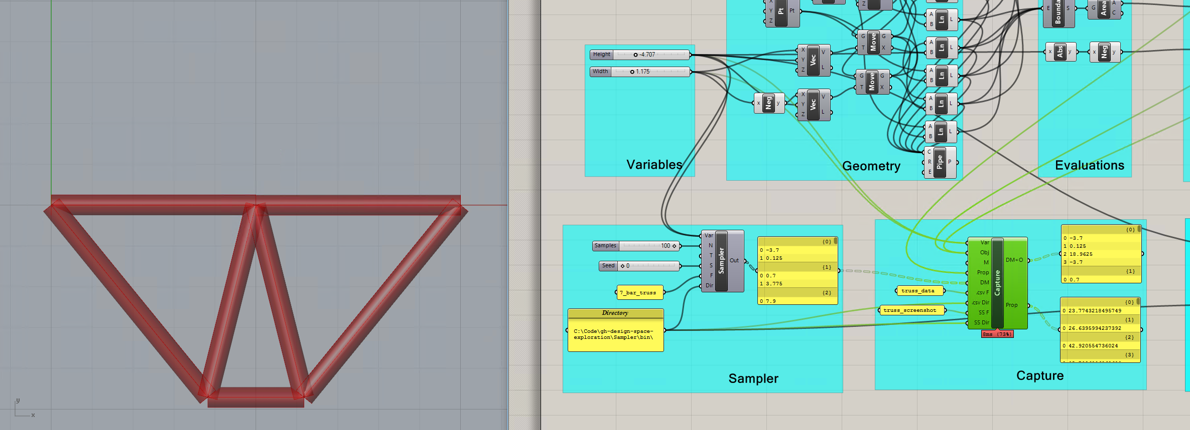

The shot above shows Capture outputting both the new Design Map + Objectives, as well as a corresponding list of design properties.

Instead of taking a representative sample of the entire design space, it may be desirable to automatically find only the best designs, and focus on that area of the design space. Using Galapagos or other plug-ins, it is possible to run single-objective or composite-function optimizations on this 7-bar truss. However, it might also be useful to find the Pareto front between competing objectives, which is done algorithmically by **MOO.** Doubleclicking this component will initiate the algorithm, leading to similar results to those shown below:

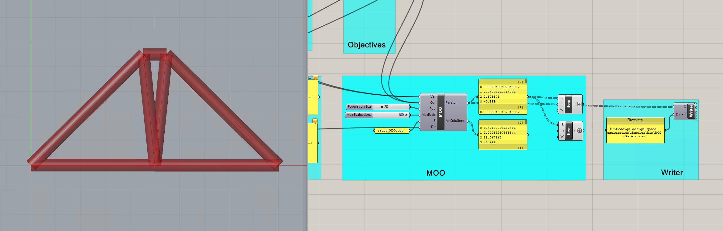

If the designer would like to consider only a single design from the sampled design space, this can be achieved using **Sift**. Although resetting the variable bounds is fairly trivial for this problem, it is more labor-intensive for parametric problems with more variables.

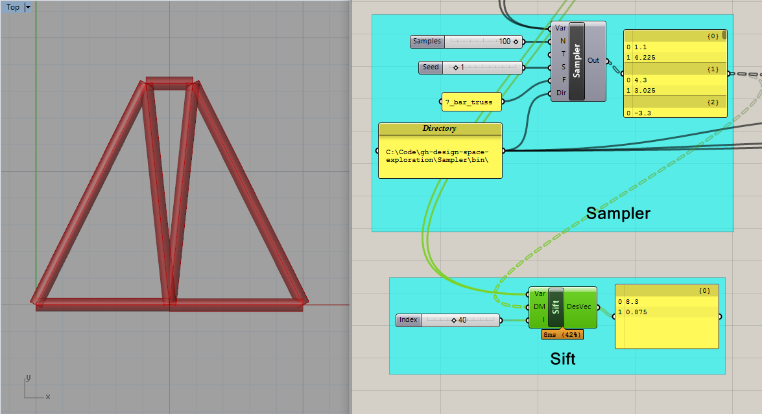

**2.2 Catalog - General Comments and Known Bugs**

Catalog is a work in progress, and although it has been tested for its main functionality, there may be bugs or quirks about using the software. Here are a few comments that may be helpful for smooth usage:

* Status bars and specific errors have not been added yet, so components will only show that they are working once their action is completed. If a component appears to not be working, or does not respond to a doubleclick, check all of the inputs (especially the directory path, and that inputs are flattened when necessary) to make sure they are properly defined.

**3.1 Simplify – Component Descriptions**

** Cluster**

This component executes two separate actions: the first is clustering design samples based on their design variables, and the second is using this information to support cluster-based live exploration. Upon the first double-click, the component reads in a map of designs and runs k-means clustering on the dataset, before returning the cluster indices of each tested design as well as the averages, maxes, and mins of each cluster. On subsequent double-click, the user can select a cluster and reset the bounds of the problem to correspond to that cluster’s properties based on a model flexibility input. As such, a designer can cycle through different clusters organized by performance and explore within the bounds of each cluster, while gaining knowledge about relationship between design decisions and performance. With these two functions, the component can be used for simple data-analysis within Grasshopper or as part of a design space exploration workflow.

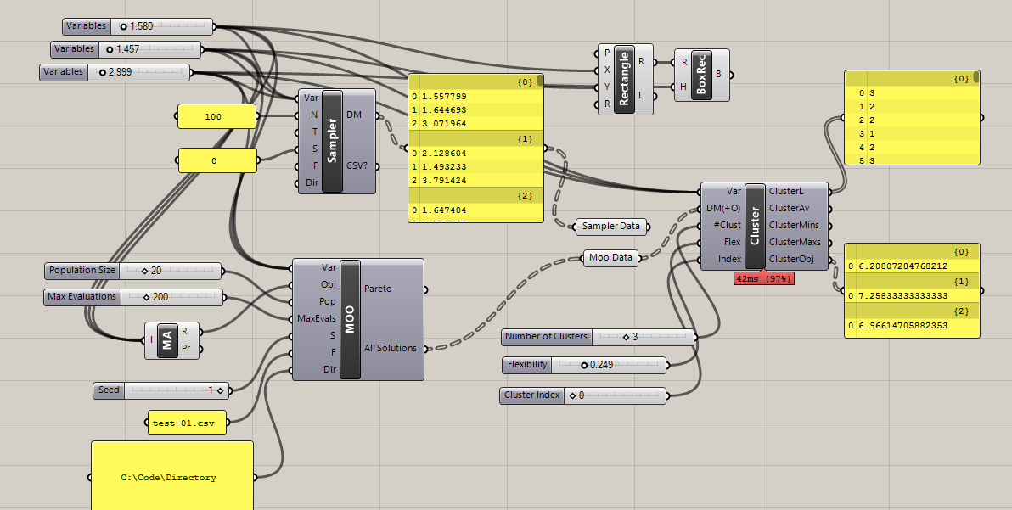

**Inputs:**

**Variables (Var) –** Takes in any number of sliders that are used as design variables for a given project.

**Design Map + Objectives (DM+O) –** A nested list of design vectors and their objective values that span the design space being explored. Standard format for each design is the design vector followed by as many objective values as are recorded. Cluster will automatically detect how many variables exist in the problem. The objective values are not used as part of the clustering, and are thus optional. However, if objectives are included, Cluster tabulates the average objective values of the designs within a cluster (as opposed to the performance of an average design in the cluster, which can be determined by navigating to a specific cluster using the “Index” input).

**Number of Clusters (#Clust) –** Dictates the number of desired clusters.

**Flexibility (Flex) –** A number between zero and one that determines how flexible the bounds are during cluster-based exploration. If set to one, Cluster will reset the slider bounds to the minimum and maximum values found across an entire cluster. As values get closer to 0, the allowable variable ranges will shrink.

**Index (Prop)** – After clustering has been completed, this index controls which cluster is being explored. To navigate to a cluster, switch its index and then double-click the component again. This will reset all slider values to the average for the cluster and adjust the bounds based on the flexibility times the difference between max/min and the average. An index of 0 returns to the original bounds and values of the problem. **NOTE:** It is easy to forget to reset the bounds to index 0—make sure this is done every time using cluster if the starting bounds and values are important. **SECOND NOTE:** Sometimes, the resetting of the bounds gets interrupted while Grasshopper is refreshing the canvas. To be safe, double-click a few times when navigating to a new cluster.

**Outputs:**

**Cluster List (ClusterL) –** Returns the cluster index for each design in the list.

**Cluster Averages (ClusterAv) –** Returns the average variable settings for each cluster.

**Cluster Maximums (ClusterMaxs) –** Returns the maximum variable settings for each cluster.

**Cluster Minimums (ClusterMins) –** Returns the minimum variable settings for each cluster.

**Cluster Objectives (ClusterObj) –** Returns the average objective values for each cluster.

**Effects**



Effects gives a quick measurement of variable importance to overall performance by sampling an orthogonal set of design points and attempting to isolate the contribution of each setting. Upon double-click, it reads in variables, objectives, and experiment settings and evaluates a small number of designs before outputting the average and raw effect of each variable. Each “effect” is a number that signifies the effect on the objective value that results from the “cause” of that variable setting. By testing a few different settings and averaging the magnitudes of the effects for a variable, designers can get a sense of what variables have the most influence on the problem. Users can select a 2- or 3- level experiment and corresponding variable settings to be tested. Although these settings are not guaranteed to represent the entire problem overall, Effects can provide valuable information prior to exploration or optimization with only a few objective evaluations.

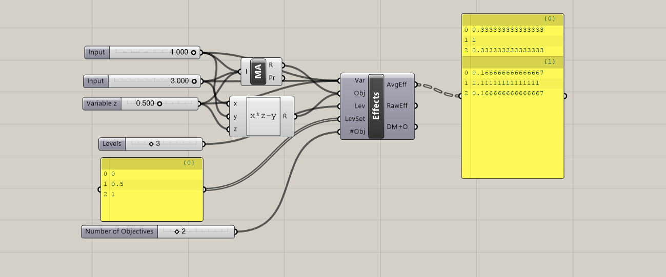

**Inputs:**

**Variables (Var) –** Takes in sliders that are used as design variables for a given project. **NOTE:** Currently limited to 13, because of difficulties in generating orthogonal matrices.

**Objectives (Obj) –** Reads in a list of the numerical values from performance evaluations generated by the script. Any performance-based measurement (or objective function), generated from either an outside plug-in or a collection of native Grasshopper components, can be used.

**Levels (Lev) –** The number of levels being considered as part of the experiment. Either 2 or 3.

**Level Settings (LevSet) –** The (normalized) settings being evaluated during the experiment, in a multi-line list of length either 2 or 3, corresponding to the Levels input. For example, [ 0.33, 0.66] or [0.25, 0.5, 0.75]. The chosen level settings are extremely important and, depending on the behavior of the objective function, can directly affect the calculation of variable importance. For example, a specific variable setting may correspond to a discontinuity in the design space, and thus would not provide a representative calculation of variable importance for the problem. Although these aspects of the design space are often only discovered while experimenting with effects, since it is an early design exercise, level settings require thought and intuition on the part of the user.

**Number of (#Obj)** – Indicates how many objectives should be included in the calculation.

**Outputs:**

**Average Effects (AvgEff) –** Outputs the average magnitude of effects for each variable. A relatively large effect is in indication that the variable has a large influence on the performance outcome for the model.

**Raw Effects (RawEff) –** Outputs the raw effect of each variable setting on each objective. This output shows both the magnitude and direction of each setting, indicating not only which variables are important, but which settings tend to improve performance or make it worse.

**Design Map + Objectives (DM+O) –** A nested list of design vectors and their objective values that were evaluated during the Effects calculation.

C:\Code\gh-design-space-exploration\Effects\Resources\Effects1.png **Tilde**

This component builds a surrogate model to approximate an objective function using only a limited number of evaluations. It takes in variables and a design map + objectives previously generated for a problem, trains the model on double-click, and thereafter outputs an estimated value for the objective function based on the current variable settings. Thus, after spending time to produce the original dataset and train the model, users can gain essentially instant feedback about the performance of any design vector within a parametric model. Although there is a tradeoff between speed and accuracy when using approximation techniques, surrogate models have demonstrated enough accuracy for many early-stage design and optimization applications. Tilde works by reading in the DM+O, attempting to fit different Ensemble Neural Network or Random Forest models to the data, validating each model by calculating its errors, and finally choosing the best model for approximation. The component provides information about this training process for transparency, but since it is implemented automatically, users can access powerful models with a simple double-click.

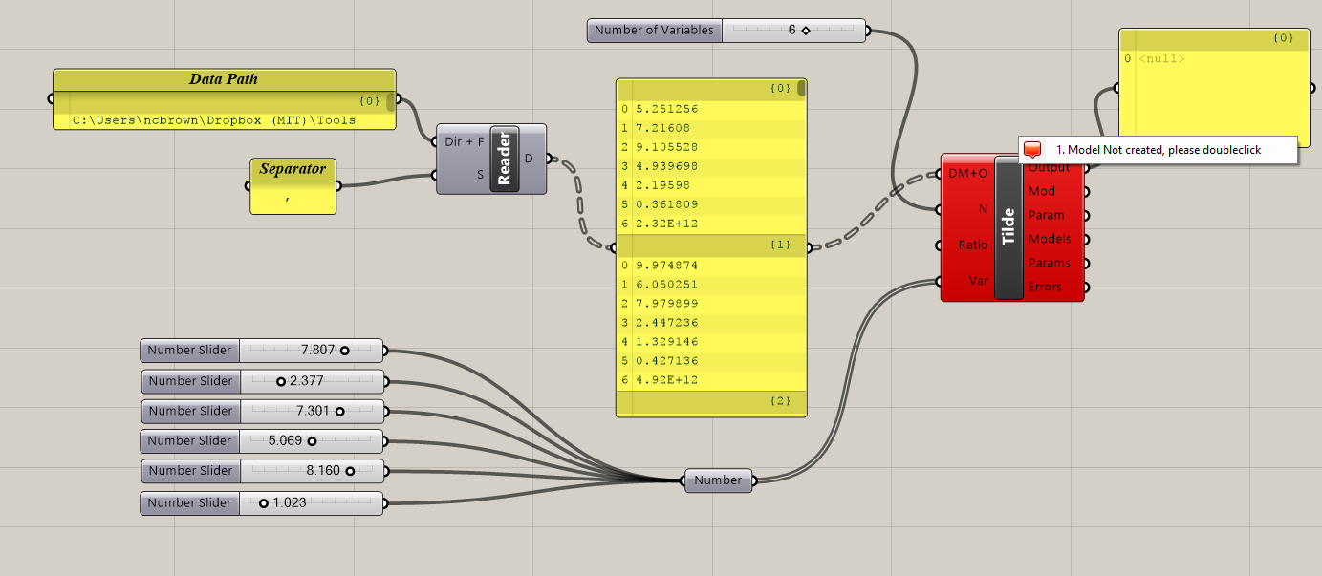

**Inputs:**

**Design Map + Objectives (DM+O) –** A nested list of design vectors and their objective values. This must be pre-generated by the user.

**Number of Variables (N) –** The number of variables in the problem.

**Ratio (Ratio) –** The ratio of training data to validation data for use during the model building process. Tilde needs to split the provided data, and it does so by cutting it into two pieces. By default, the ratio is 0.5, indicating that half is used for each. NOTE: If grid or a related sampling technique is used, it is possible Tilde will train based on one area of the design space and validate based on another, which will not yield good results. For best results, it is important to make sure that the provided data includes points from across the design space in both halves of the DM+O.

**Variables (Var) –** Takes in the sliders that are used as design variables for a given project. These sliders are only relevant after a model has been trained, at which point the prediction is provided for the current variable settings. The number for variables must match the input for “N”.

**Outputs:**

**Prediction (P) –** Outputs the model prediction based on current variable settings. This output is only available after the model has been trained, but it will output live predictions when variables without the need for repeated clicks.

**Model Type (Model) –** The type of surrogate model ultimately chosen by Tilde and used for the problem. Will be either Ensemble Neural Network or Random Forest in the current version.

**Model Parameter (Param) –** The “nuisance” parameter that resulted in the lowest error model, and thus the parameter that is used in making the current prediction. These parameters are different for the two surrogate model types.

**Test Models (TModels) –** a ranked list of models attempted, from best to worst (based on Errors).

**Test Parameters (TParams) –** a ranked list of parameters attempted, corresponding to the models above.

**Errors (Errors) –** an ordered list of RSME for each model attempted, which is how Tilde decides which model to choose.

**4.1 Stormcloud Description**

The tool is implemented as a single component placed on the Grasshopper canvas (see Figure 1) Double clicking on the component opens the user interface of stormcloud. The component takes three different input – geometry (in the form of lines), score, and design variables - and has no output parameter. Data should be flattened when lists are used for the geometry lines. The DVar input should be connected to the sliders that will be changed during the exploration. The score is automatically normalized by the component according to the initial solution score.

**4.2 Stormcloud User Interface**

The user interface is divided in three main parts: the main viewport which visualizes the current Grasshopper solution, the design grid where best performing designs of each generation are visualized and parents for next generation can be selected, and the exploration control panel with miscellaneous buttons and sliders. The main features of the user interface are summarized in below:

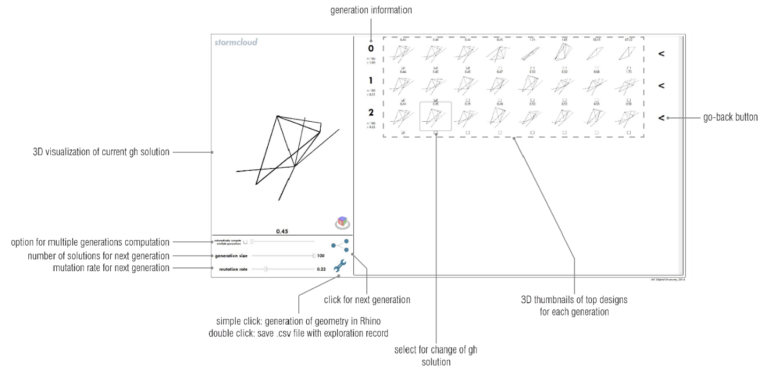

UI features include:

* Navigation in 3D viewports
* Viewports are synchronized for facilitated visualization. The viewports can be navigated using the mouse right-click for rotating, the mouse wheel for zooming, and maj + mouse right-click for panning.
* Selection of design for detailed visualization
* Each candidate solution displayed on the design grid can be selected for detailed visualization on the main viewport by clicking on its corresponding viewport. This also changes the solution state in Grasshopper to correspond with the selected solution.
* Generation of geometry in Rhino viewport
* By clicking on the wrench icon, the user can save the preferred solutions as geometries stored in Rhino. This feature is equivalent to the ‘Bake’ feature existing in Grasshopper but improves it by making it more accessible through a simple button click. Each solution is assigned a different sublayer of a common ‘exploration’ layer.
* By right-clicking on the wrench icon, the designer is offered the possibility to record his exploration by saving the characteristics of each solution explored, i.e. the values of the design variables and the score, as a comma-separated values (.csv) text file on the user’s desktop.

**4.3 Stormcloud Step-by-Step Use**

Place the IEO component on the Grasshopper canvas. The component can be found in the category “DSE”.

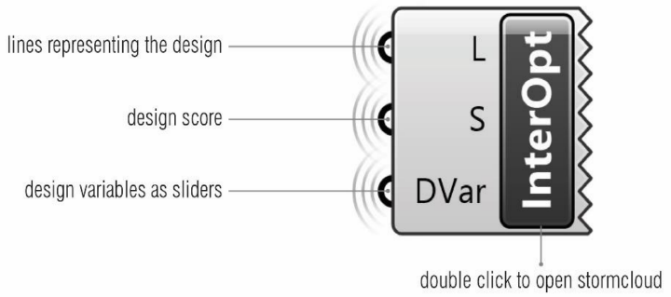

Connect the input parameters of the component to the lines representing the design geometry (data must be flattened), the design performance score (as a number), and the design variables as sliders. The exploration will be performed around the initial value of the sliders. Hence, the user may want to reset the sliders to their middle values.

Double-click the IEO component to open the stormcloud user interface.

Maximize the window. This is currently needed as most of the user interface dimensions are currently hard-coded (=fixed) and starting the exploration when the window is not maximized will result in cropped viewports.

The main viewport might seem empty. However, it may because the camera does not point towards the geometry and needs to be moved around -an automatic move-target-to-objects feature will be added in the near future. Unzooming usually does the trick.

Change the evolutionary parameters to tune the exploration as wished.

Click on the generation button. Depending on the Grasshopper script, the population generation may take more or less time. It is recommended that the user disables the non-vital and slow parts of the script.

When a generation of designs is computed, the 8 top performers will be displayed in 3d viewports on their corresponding row. Hovering over one design will highlight the borders of its viewports with a grey border. Clicking on the viewport will change the Grasshopper solution to the clicked design and will update the main viewport of the user interface. This allows for a detailed visualization of the clicked design.

The user can proceed as before to explore new designs. Parents for next generations can be selected by clicking the checkboxes of the last row of designs.

Recording features can be used to save designs and exploration information.

**4.4 Stormcloud Bugs**

The current version of stormcloud still includes a few bugs and problems. The major ones are listed below:

* Double-clicking on the component can open multiple windows. The user should make sure that only one window is open per Grasshopper solution as stormcloud windows modify the current solution state which has consequences on other existing stormcloud windows
* Deleting the IEO component does not close its corresponding window.
* The IEO component should be deleted and reloaded for each new exploration as closing the stormcloud window does not reconstruct it and the score normalization will remain based on the solution state corresponding the component construction.
* If the exploration is recorded in a .csv file, and if the corresponding file –with the same full path- already exists and is open, Rhino/GH/Excel will crash.

**5.1 Acknowledgements**

The following people contributed to the tools in DSE as developers, researchers, or in other ways:

Caitlin Mueller, Nathan Brown, Renaud Danhaive, Jonathas Felipe, Stavros Tseranidis, Anthony McHugh

**6.1 Licenses**

All components except for Cluster and Tidle are released under the MIT License (<https://opensource.org/licenses/MIT>). Cluster and Tilde are offered under the LGPLv2 License (<https://www.gnu.org/licenses/old-licenses/lgpl-2.1.en.html>).

Various components rely on the following open-source libraries:

Math.NET: <https://numerics.mathdotnet.com/License.html>

log4net: <https://svn.apache.org/repos/asf/logging/log4net/tags/log4net-1_2_9/doc/license.html>

jMetal: <http://jmetal.sourceforge.net/>

Helix Toolkit: <https://helixtoolkit.codeplex.com/license>

Accord.NET: <https://github.com/accord-net/framework/wiki>

ALGLIB.NET: <http://www.alglib.net/download.php>

**7.1 References**

Brown, N.C., de Oliveira, J.I.F., Ochsendorf, J., & Mueller, C. (2016). Early-Stage Integration of Architectural and Structural Performance in a Parametric Multi-Objective Design Tool. Proceedings of the 3rd International Conference on Structures and Architecture, Guimarães, Portugal.

Brown N., & Mueller, C. (2017). Automated performance-based design space simplification for parametric structural design. Proceedings of the International Association for Shell and Spatial Structures (IASS) Symposium 2017, Hamburg.

Danhaive, R., & Mueller, C. (2015). Combining parametric modeling and interactive optimization for high-performance and creative structural design. Proceedings of the International Association for Shell and Spatial Structures (IASS) Symposium 2015.

Deb, K. et al., 2002. A fast and elitist multiobjective genetic algorithm: NSGA-II. *IEEE Transactions on Evolutionary Computation*, 6(2), pp.182–197.

Durillo, J.J. & Nebro, A.J., 2011. jMetal: a Java framework for multi-objective optimization. *Advances in Engineering Software*, 42, pp.760–771.

Tseranidis S., Brown N., & Mueller C. (2016). ‘Data-driven approximation algorithms for rapid performance evaluation and optimization of civil structures’. *Automation in Construction*, 72, pp.279-293.