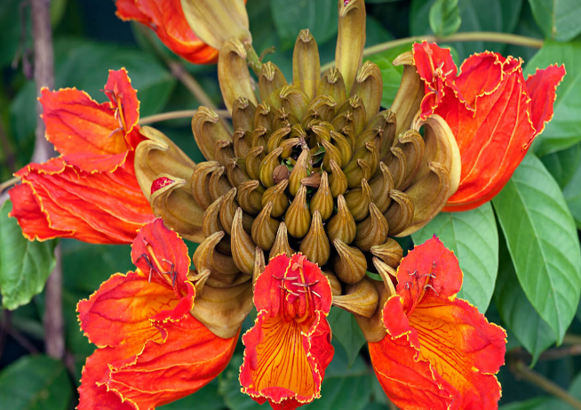 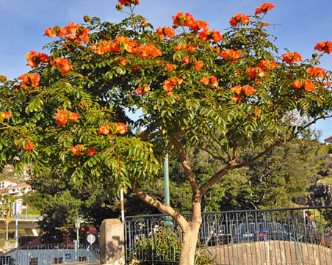

The African Tulip Tree, scientifically known as *Spathodea campanulata*, is a fast-growing, evergreen tree admired for its brilliant orange-red flowers. Native to tropical Africa, it is widely cultivated in India and other tropical regions for its ornamental beauty.

**Classification:** The African Tulip Tree belongs to the kingdom Plantae, the family Bignoniaceae, and the order Lamiales. It can grow up to 25 meters tall and is recognized for its flame-colored blossoms and umbrella-shaped canopy.

**Interesting Facts:**

* 🔥 **Flame of the Forest:** Its bright orange flowers resemble flames, making it a spectacular sight in full bloom.
* 💦 **Natural Water Guns:** The flower buds contain water, which children often use to squirt at each other for fun.
* 🦜 **Wildlife Magnet:** The tree attracts bees, butterflies, and birds, especially sunbirds, which love its nectar.
* 🌿 **Medicinal Uses:** In traditional medicine, extracts from its bark and leaves are used to treat wounds, infections, and inflammations.

**Connection with India:**

The African Tulip Tree is commonly planted along Indian streets, parks, and gardens due to its rapid growth and lush, shade-providing canopy. Though non-native, it has become an integral part of the tropical landscape.

**Health & Environmental Benefits:**

* 🌳 **Soil Improvement:** Its leaves decompose quickly, enriching the soil with nutrients.
* 💨 **Air Purifier:** Helps in absorbing carbon dioxide and releasing oxygen