**Python environment setup for lab computers**

1. Click “Manage Environments” under “Python”

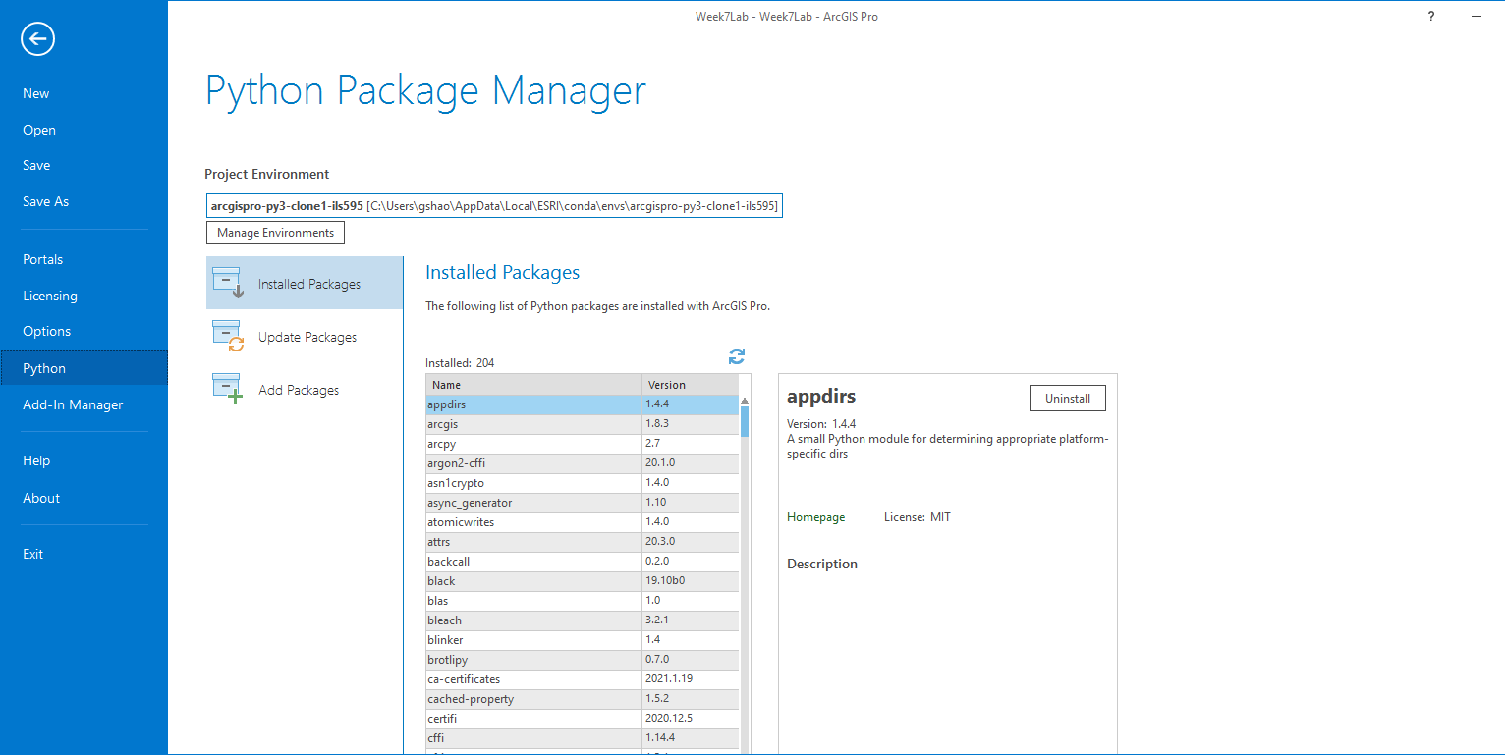

1. Click ”Add” and locate the python environment folder,’arcgispro-py3-clone’, at “C:\Users\Public\Public”

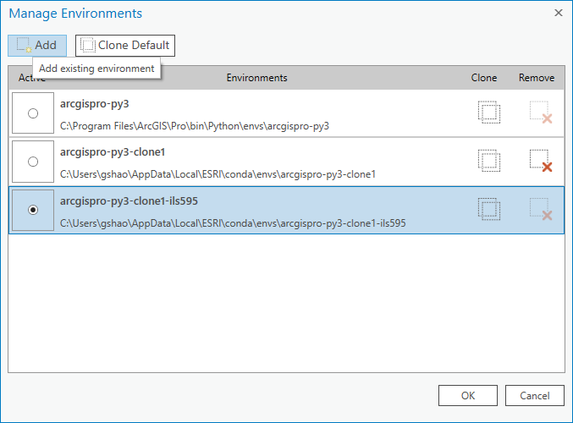

1. Select the cloned environment and restart ArcGIS Pro, then you all set.

**Python environment setup for personal computers**

(Clone a python environment first under “Manage Environment” if you don’t one)

1. Click “Add Packages” under “Python” and search “seaborn”

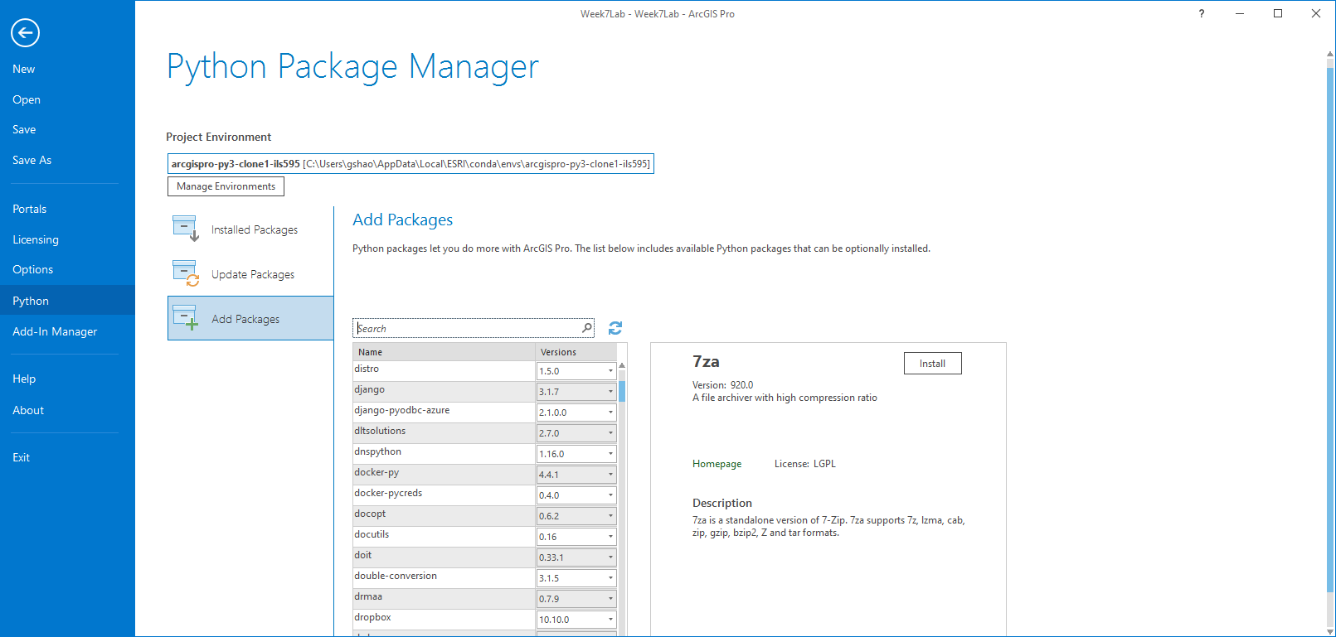

1. Click ‘Install’ to install seaborn version 0.11.1
2. Restart ArcGIS (optional)