*Week 3*

*GPS Module*

*Thursday, February 2nd 5:30 PM – 7:00 PM*

***DUE: Thursday, February 9th***

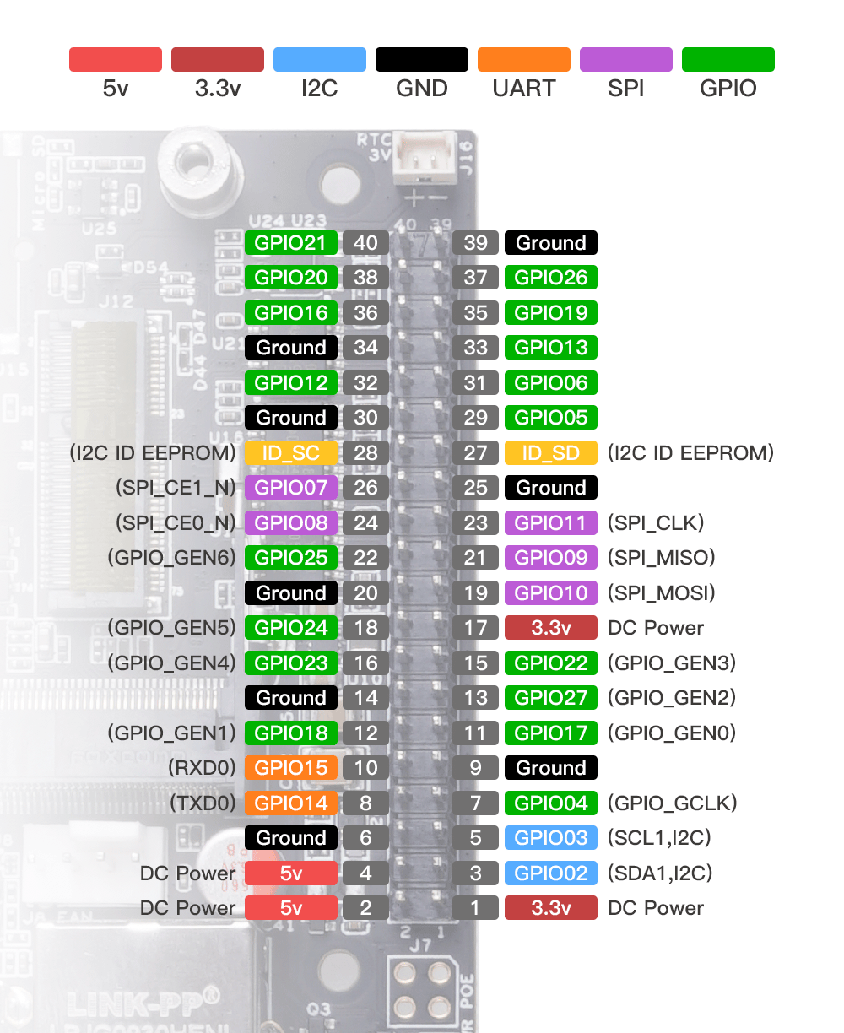

*DESCRIPTION*

Tracking location for various applications is becoming increasingly common, for example, many applications on our smartphones track our location (eg. Maps, Weather, Uber, Social Media, etc.). Therefore, this lab will introduce each student to using GPS sensors for obtaining geolocation information on the edge. Whether edge devices are being used for robotics, precision agricultural applications, etc., an important component is to be able to obtain geolocation information. In this lab, students will:

1. Use the GPS module obtained in Lab 1
2. How to connect the GPS using specific communication protocols
3. Install relevant libraries required to interface the edge device with the GPS module
4. Run different scripts to obtain GPS coordinates
5. Visualize GPS coordinates obtained in real life using Python’s GeoPandas library

*PREREQUISITES*

1. Complete Lab 1
2. Obtain the GPS module

*LEARNING OBJECTIVES*

By the end of this course, students will:

1. Connect the GPS module correctly
2. Install the relevant libraries required to interface with the GPS module
3. Run different scripts to obtain geolocation information
4. Develop a program to acquire geolocation data
5. Creatively visualize the coordinates using Python

*ASSIGMENT*

**Part 1: Setup**

1. Connect the GPS Module to the edge device (use figure above)
   1. Use UART communication protocol which is a serial connection
   2. Connect VCC to PIN 1
   3. Connect Ground to any Ground PIN
   4. Connect RX to TX (PIN 8)
   5. Connect TX to RX (PIN 10)
   6. 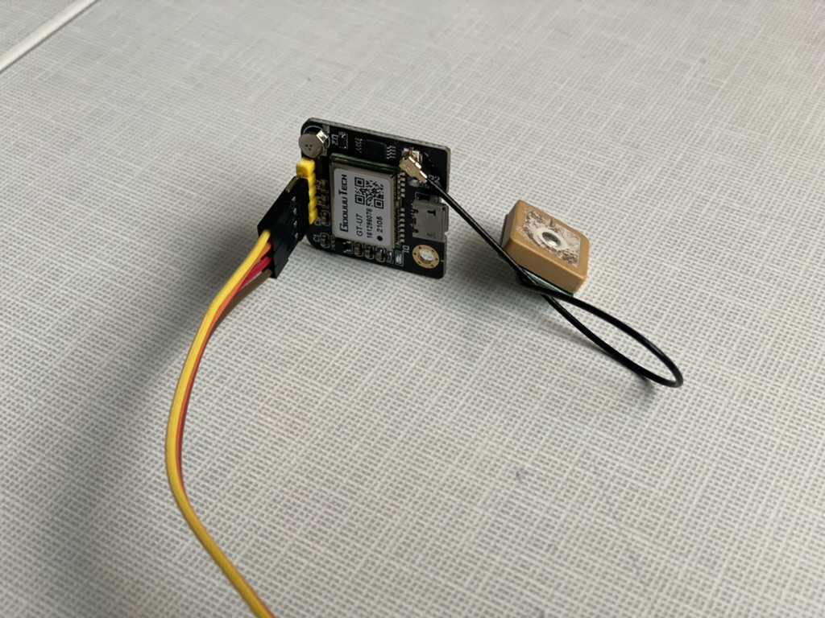
2. Follow Reference Link: <https://python.plainenglish.io/receiving-and-processing-gps-data-using-external-receiver-with-python-24d3592ad2e0>
3. Run “pip install pyserial”
4. On the terminal, run “ls /dev/”
5. This will output all the devices
6. Now connect USB port and run the command again to see which device corresponds to the GPS
7. It will likely be “/dev/ttyACM0”
8. Use this code and tutorial: <https://www.youtube.com/watch?v=bnOeYcfS748>
9. Then run to install GPSD: “sudo apt-get install gpsd gpsd-clients python3-gps”
10. Then run “sudo systemctl stop gpsd.socket”
11. Then run “sudo systemctl disable gpsd.socket”
12. To check data from the GPS moduel:
    1. Run the command: “gpsmon”
    2. Run the command: “cgps”
13. Useful reference: <https://python.plainenglish.io/receiving-and-processing-gps-data-using-external-receiver-with-python-24d3592ad2e0>

**Part 2: Task – Data Collection & Visualization**

1. GPS Unit must be outdoors to obtain a correct signal
2. SSH must be used
3. Go to terminal of the Jetson edge device
4. Type: “ifconfig”
5. The following will be displayed
6. Graphical user interface, text

   Description automatically generated with medium confidence
7. Scroll down till you see “wlan0” as this will provide the ip address on the WiFi connection. Then use the ip address from “inet” shown above.
8. Use the ip address on the terminal of your personal computer and type:
9. ssh usr1@xx.xxx.xx.xx
10. input the password which is “usr”
11. You should now have access to the device via ssh so that you can control it without using a monitor
12. This will be useful as you will need to outside to obtain GPS data from the edge device
13. For this lab:
    1. Go to five different location of your choice around campus
    2. Obtain the GPS coordinates from those locations (a single location should be sufficient) using the Jetson edge device and provided GPS
    3. Save the GPS coordinates
    4. These coordinates will then be used for the second part of the assignment for visualization, distance measurement using GeoPandas in Python.

*REFERENCES / ADDITIONAL RESOURCES*

1. Tutorial: