**AN ADAPTED EVIDENCE-BASED CLINICAL PRACTICE GUIDELINE**

**ON**

**THE DIAGNOSIS AND MANAGEMENT OF ECTOPIC PREGNANCY**

**Overview**

This is an adapted evidence-based clinical practice guideline for the diagnosis and management of ectopic pregnancy.

**Guideline adapter**

**This guideline has been adapted by the Egyptian Universities Obstetrics & Gynecology Guideline Working Group (EUOBGYN-GWG).**

**Release date**

July 2023

**GUIDELINE ADAPTATION METHODOLOGY**

This guideline was produced in accordance with the ADAPTE methodology and procedure for the adaptation of evidence-based clinical practice guidelines published by the ADAPTE Group (Fervers B, et al., Adaptation of clinical guidelines: literature review and proposition for a framework and procedure. Int J Qual Health Care 2006; 18(3): 167-176).

**sources of the guideline**

**This guideline was adapted from:**

1. National Institute for Health and Care Excellence. (2019, updated Nov 2021). Ectopic pregnancy and miscarriage: diagnosis and initial management [NICE Guideline No. NG126].

<https://www.nice.org.uk/guidance/ng126>

1. Po L, Thomas J, Mills K, Zakhari A, Tulandi T, Shuman M, Page A. Guideline No. 414: Management of Pregnancy of Unknown Location and Tubal and Nontubal Ectopic Pregnancies. J Obstet Gynaecol Can. 2021 May;43(5):614-630.e1.
2. American College of Obstetricians and Gynecologists' Committee on Practice Bulletins—Gynecology. ACOG Practice Bulletin No. 193: Tubal Ectopic Pregnancy. Obstet Gynecol. 2018 Mar;131(3):e91-e103
3. Royal College of Physicians of Ireland. The diagnosis and management of ectopic pregnancy (2014, revised 2017). Guideline No.33.

<https://rcpi-live-cdn.s3.amazonaws.com/wp-content/uploads/2016/05/28.-Diagnosis-and-Management-of-Ectopic-Pregnancy.pdf>

# Introduction:

* An ectopic pregnancy (EP) is any pregnancy implanted outside of the endometrial cavity.
* Tubal pregnancy accounts for the majority of ectopic pregnancies.
* The overall incidence of ectopic pregnancy is about 10/1000 pregnancy. The incidence of ectopic pregnancy in women attending early antenatal clinics reaches 2-3%.
* Ectopic pregnancy is still an important cause of maternal mortality. Ectopic pregnancies account for the majority of first trimester maternal deaths.
* Any sexually active woman, in her reproductive age, presenting with marked lower abdominal or pelvic pain, should be suspected as having an ectopic pregnancy.

# Diagnosis:

**Risk Factors:**

* Half of patients diagnosed with an EP have no known risk factors.
* History of one prior EP has a 10% risk of subsequent EP recurrence; while those with a history of two or more prior EPS have a risk greater than 25%.
* Pregnancy that occurs with an IUD in place.
* History of possible damage to fallopian tubes:
  + History of PID.
  + Endometriosis.
  + Prior pelvic surgery.
  + Complications from ascending pelvic infection.
  + Variant reproductive system anatomy.
* Demographic risk factors:
  + Infertility.
  + Smoking.
  + Age greater than 35 years old.
* Risk factors associated with ART include:
  + Increased number of embryos transferred.
  + Fresh instead of cryo-thawed embryo transfers.
  + Cleavage-stage (Day 3) instead of blastocyst (Day 5) embryo transfers.

**Symptoms of ectopic pregnancy:**

* The symptoms of ectopic pregnancy can resemble the common symptoms and signs of other conditions – for example, gastrointestinal conditions or urinary tract infections.
* During any clinical assessment of sexually active women of reproductive age, be aware that they may be pregnant, and think about offering a pregnancy test even when symptoms are non-specific.
* **Common symptoms of ectopic pregnancy include:**
  + Abdominal or pelvic pain.
  + Amenorrhea or missed period.
  + Vaginal bleeding with or without clots.
  + Passage of fleshy “tissue like” pieces from the vagina
* **Other reported symptoms:** 
  + Breast tenderness.
  + Gastrointestinal symptoms.
  + Dizziness, fainting or syncope.
  + Shoulder tip pain.
  + Urinary symptoms.
  + Rectal pressure or pain on defecation.
* Refer women who are hemodynamically unstable, or in whom there is significant concern about the degree of pain or bleeding, directly to a specialized center with capabilities of early pregnancy assessment and surgical intervention.
* Atypical presentations for ectopic pregnancy are common.

**Signs of ectopic pregnancy:**

* **Common signs of ectopic pregnancy include:** 
  + Pelvic tenderness.
  + Adnexal tenderness.
  + Abdominal tenderness.
* **Other reported signs:** 
  + Cervical motion tenderness.
  + Rebound tenderness or peritoneal signs.
  + Pallor.
  + Abdominal distension.
  + Enlarged uterus.
  + Tachycardia (more than 100 beats per minute) or hypotension (less than 100/60 mmHg).
  + Orthostatic hypotension.
  + Shock or collapse.
* Refer immediately to a specialized center with capabilities of early pregnancy assessment and surgical intervention, for further assessment of women with a positive pregnancy test and any of the following on examination:
  + Pain and abdominal tenderness.
  + Pelvic tenderness.
  + Cervical motion tenderness.
  + A pregnancy of 6 weeks' gestation or more.
  + A pregnancy of unknown location.

**Diagnostic criteria for a Pregnancy of unknown location (PUL):**

PUL is a transient state in the diagnostic process leading to a final diagnosis of viable or non-viable intrauterine pregnancy, ectopic pregnancy or persistent PUL.

* The clinical approach to PUL is predictive and not diagnostic, the aim is to stratify cases with PUL as either high or low risk for ectopic pregnancy
  + In a woman with a pregnancy of unknown location, place more importance on clinical symptoms than on serum hCG results, and review the woman's condition if any of her symptoms change, regardless of previous results and assessments.
  + Use the M4-model to stratify pregnancy of unknown location as either high or low risk for ectopic pregnancy.
* Take 2 serum hCG measurements as near as possible to 48 hours apart (but not earlier) to determine subsequent management of a pregnancy of unknown location.
* Advise women to return if there are new symptoms or if existing symptoms worsen.
* Do not use serum progesterone measurements as an adjunct to diagnose either viable intrauterine pregnancy or ectopic pregnancy.

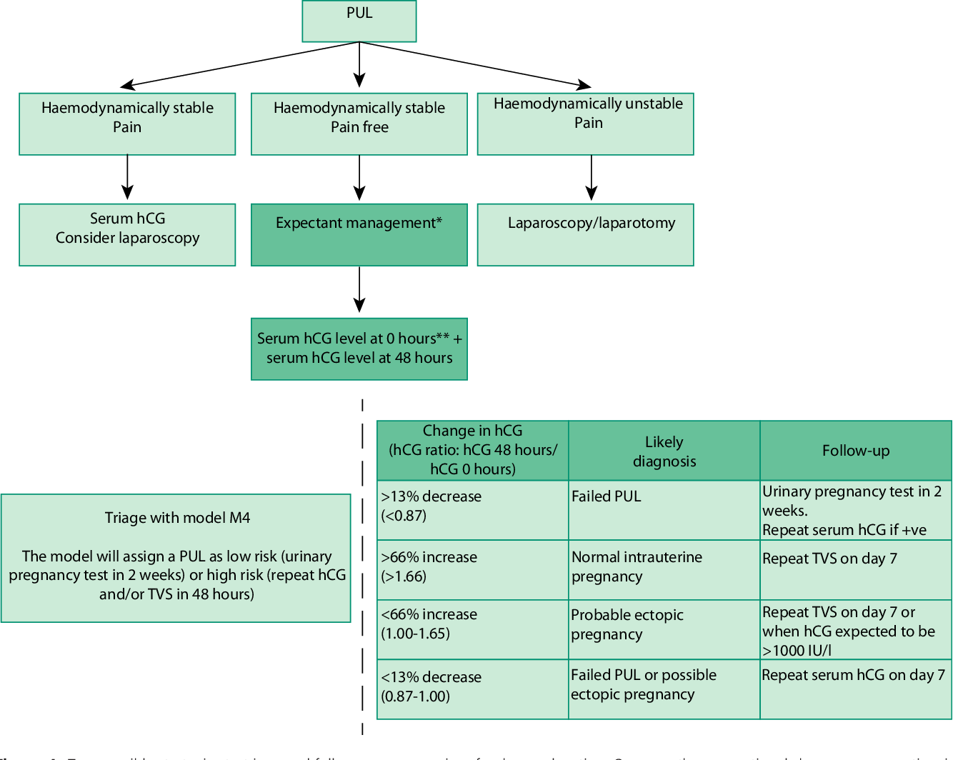

**Diagnostic criteria for tubal ectopic pregnancy:**

**Ultrasound**

* Transvaginal ultrasound to identify the location of the pregnancy and whether there is a fetal pole and heartbeat.
  + If a transvaginal ultrasound scan is unacceptable to the woman, offer a transabdominal ultrasound scan and explain the limitations of this method of scanning.
  + Consider a transabdominal ultrasound scan for women with an enlarged uterus or other pelvic pathology, such as fibroids or an ovarian cyst.
* When carrying out a transvaginal ultrasound scan in early pregnancy, look for these signs indicating there is a tubal ectopic pregnancy:
  + An empty uterus or collection of fluid within the uterine cavity described as a “pseudo-sac”.
  + An adnexal mass, moving separate to the ovary, comprising a gestational sac containing a yolk sac or a gestational sac and fetal pole (with or without fetal heartbeat).
  + An adnexal mass, moving separately to the ovary, with an empty gestational sac, described as a “tubal ring” or “bagel sign”.
  + A complex, non-homogeneous adnexal mass, moving separate to the ovary.
  + Scan the uterus and adnexae to see if there is a heterotopic pregnancy.
  + Moderate to large amount of free fluid in the peritoneal cavity or pouch of Douglas, which might represent hemoperitoneum.

If any of these features are present, take into account other intrauterine and adnexal features on the scan, the woman’s clinical presentation, and serum hCG levels before making a diagnosis.

**Human Chorionic Gonadotrophins (hCG) serial evaluation:**

* Hemodynamically stable woman, with an increase in serum hCG levels greater than 63% after 48 hours, are likely to have a developing intrauterine pregnancy.
  + Perform a transvaginal ultrasound scan to determine the location of the pregnancy between 7 and 14 days later.
  + Consider an earlier scan (within 48-72 hours) for women with a serum hCG levels greater than or equal to 1,500 IU/liter.
  + If a viable intrauterine pregnancy is confirmed, refer for routine antenatal care.
  + If a viable intrauterine pregnancy is not confirmed, refer her for immediate clinical review by a senior gynecologist.
  + For a woman with a decrease in serum hCG levels greater than 50% after 48 hours: inform her that the pregnancy is unlikely to continue but that this is not confirmed and provide her with oral and written information about where she can access support and counselling services. Ask her to take a urine pregnancy test 14 days after the second serum hCG test, and explain that:
    - if the test is negative, no further action is necessary
    - If the test is positive, she should return to the early pregnancy assessment service for clinical review within 24 hours.
    - For a woman with a decrease in serum hCG levels less than 50%, or an increase less than 63%, refer her for clinical review in the early pregnancy assessment service within 24 hours.

**Diagnostic criteria for Cervical pregnancy:**

**Ultrasound**

* Diagnosis of nontubal ectopic pregnancy requires experienced sonographers.
* Providers should have a high index of suspicion for cervical ectopic pregnancy because severe outcomes often occur with delayed diagnosis and management.
  + Implantation is within the cervical canal.
  + The gestational sac is seen distal to a closed internal cervical os.
  + Doppler demonstration of surrounding vasculature helps distinguish a cervical pregnancy from a displaced intrauterine pregnancy.
  + Gentle pressure with the transvaginal probe may elicit the “sliding sign” where a miscarrying sac will slide within the cervical canal, while a cervical pregnancy remains fixed.

**Diagnostic criteria for CS pregnancy:**

**Ultrasound:**

* TVS relies on an empty uterine cavity and a gestation sac in the anterior uterine isthmus with a thin myometrium between sac and bladder.
* There is no contact between the sac and the uterine cavity and the cervical canal is empty.
* Color flow Doppler may show distinct circular peri-trophoblastic perfusion surrounding the gestational sac.

**Diagnostic criteria for interstitial ectopic pregnancy:**

**Ultrasound**

* Diagnosed at first trimester scanning:
  + The presence of an eccentric gestational sac with a thin surrounding myometrial layer, which helps to distinguish this from an angular intrauterine pregnancy.
  + The presence of an echogenic line running from the endometrial cavity to the gestational sac.

**Diagnostic criteria for Cornual ectopic pregnancy:**

Presentation may be delayed and is usually with abdominal pain. About 50% present after rupture and morbidity is high.

**Ultrasound:**

* The sensitivity of ultrasound diagnosis is low.
* The appearance is usually of a gestational sac separate from an empty unicornuate uterus, which is identified by the single interstitial tube.
* The sac is mobile and surrounded by a thick myometrial layer.
* A vascular pedicle may be seen joining the gestational sac and the lateral aspect of the empty unicornuate uterus.

**Diagnostic criteria for Ovarian ectopic pregnancy:**

Laparoscopy is often required for definitive diagnosis of ovarian pregnancy.

# Management

**Management of tubal ectopic pregnancy:**

* **Expectant management**
  + In carefully selected patients, expectant management may be offered, taking in consideration that it can result in serious morbidity and mortality, if not done properly.
  + Advise women that there seems to be no difference following expectant or medical management in:
  + The rate of ectopic pregnancies ending naturally.
  + The risk of tubal rupture.
  + The need for additional treatment.
  + Inform women selected for expectant management that they may need to be admitted urgently if their condition deteriorates.
  + Advise women that the time taken for ectopic pregnancies to resolve and future fertility outcomes are likely to be the same with either expectant or medical management.
  + **Criteria to be fulfilled in order consider expectant management:**
    - **The woman** is clinically stable, is pain-free, and is able to return for follow-up.
    - **Transvaginal Ultrasound** shows a tubal ectopic pregnancy, measuring less than 35 mm., with no visible heartbeat.
    - **Serum hCG** levels are less than 1000 IU/L.
* **Serial hCG levels** on days 2, 4, and 7 after the original test, and:
* If HCG levels drop by more than 15% from the previous value on days 2, 4, and 7, then repeat weekly until a negative result (<less than 15 IU/L) is obtained.
* If HCG levels do not fall by 15%, or if the level stays the same or rises from the previous value, review the woman’s clinical condition and refer immediately to a specialized center with capabilities of early pregnancy assessment and surgical intervention.
* **Methotrexate**:

Methotrexate should only be offered when there is a definitive diagnosis of an ectopic pregnancy, and a viable intrauterine pregnancy has been excluded. The overall treatment success of systemic methotrexate ranges from approximately 70% to 95%. Advise women who choose methotrexate that there is a chance of needing further intervention, and that they may need to be urgently admitted if their condition deteriorates.

* + **Criteria to be fulfilled in order consider medical treatment with Methotrexate:**
    - **The woman** is clinically stable, is pain-free, and is able to return for follow-up.
    - **Transvaginal Ultrasound** shows a tubal ectopic pregnancy, measuring less than 35 mm., with no visible heartbeat.
    - **Serum hCG** levels are less than 1500 IU/L.
* **Serial hCG levels** on days 2, 4, and 7 after the original test, and:
* If HCG levels drop by more than 15% from the previous value on days 2, 4, and 7, then repeat weekly until a negative result (less than 15 IU/L) is obtained.
* If HCG levels do not fall by 15%, or if the level stays the same or rises from the previous value, review the woman’s clinical condition and refer immediately to a specialized center with capabilities of early pregnancy assessment and surgical intervention.
* **Methotrexate regimen:**
* **Single-dose protocol:** appropriate for patients with a relatively low initial HCG level or a plateau in HCG values.
  + - Administer a single dose of methotrexate at a dose of 50 mg/m2 intramuscularly
    - Measure hCG level on posttreatment day 4 and day 7
    - If the decrease is greater than 15%, measure hCG levels weekly until a negative result (less than 15 IU/L) is obtained.
    - If the decrease is less than 15%, readminister methotrexate at a dose of 50 mg/m2 intramuscularly and repeat hCG level as before.
    - If hCG does not decrease after two doses, consider surgical management.
    - If hCG levels plateau or increase during follow-up, consider administering methotrexate for treatment of a persistent ectopic pregnancy.
* **Surgical management:**

Offer surgery as a first-line treatment to women with the following:

* Unable to return for follow-up after methotrexate treatment
* Significant pain
* Adnexal mass of 35 mm or larger
* Fetal heartbeat visible on an ultrasound scan
* Serum hCG level of 3500 IU/liter or more.
* **Laparoscopy**
* When surgical treatment is indicated for women with an ectopic pregnancy, it should be performed laparoscopically whenever possible, taking into account the condition of the woman and the complexity of the surgical procedure.
* Surgeons providing care to women with ectopic pregnancy should be competent to perform laparoscopic surgery.
* Commissioners and managers should ensure that equipment for laparoscopic surgery is available.
* **Salpingectomy and salpingotomy** 
  + Perform a salpingectomy to women undergoing surgery for an ectopic pregnancy unless they have other risk factors for infertility.
  + inform woman who has salpingectomy that removal of one tube will not reduce her chance of having intrauterine pregnancy in the future provided that other tube is healthy.
  + Inform her also that keeping the tube (salpingotomy) after getting the EP out can increase her risk of having another EP, should pregnancy occur in such tube again by about 30%
  + Consider salpingotomy as an alternative to salpingectomy for women with risk factors for infertility such as contralateral tube damage.
  + Inform women having a salpingotomy that up to 1 in 5 women may need further treatment. This treatment may include methotrexate and/or a salpingectomy.
  + For women who have had a salpingotomy, take 1 serum hCG measurement at 7 days after surgery, then 1 serum hCG measurement per week until a negative result is obtained.
  + Advise women who have had a salpingectomy that they should take a urine pregnancy test after 3 weeks. Advise women to return for further assessment if the test is positive.
* **Anti-D immunoglobulin prophylaxis**
  + Offer anti-D immunoglobulin prophylaxis at a dose of 250 IU (50 micrograms) to all rhesus-negative women who have a surgical procedure to manage an ectopic pregnancy or a miscarriage.
  + Do not use a Kleihauer test for quantifying feto-maternal hemorrhage.

**Management of Cervical ectopic pregnancy:(in equipped center)**

* Women should be counselled about the risk of hemorrhage and the possible need for hysterectomy.
* Cervical dilation and curettage may provoke uncontrollable bleeding.
* Suction curettage is the method of choice, combined with the following measures to prevent or decrease bleeding:
  + Infiltration of the cervix with a hemostatic vasoconstricting agent (such as adrenaline 1/200,000),
  + Placement of cervical sutures to temporarily occlude the descending branches of the uterine arteries.
  + Post-suction cervical canal balloon tamponade (such as Foley’s catheter).
* If technically feasible, Uterine artery embolization in combination with methotrexate therapy may be an alternative in selected cases.

**Management of interstitial and cornual pregnancy:(in equipped center)**

Offer conservative medical management with multidose and/or local methotrexate for interstitial or cornual pregnancies in appropriately selected patients.

* If surgery is required; clinicians may perform either laparoscopic cornuotomy or cornual wedge resection because both procedures have comparable results
* Cornual resection is another option that may also be carried out by laparotomy.
* Postoperative monitoring by HCG should be performed.

**Management of Abdominal pregnancy: (in equipped center)**

* Clinicians may choose either laparotomy or laparoscopy to excise an abdominal pregnancy
* Primary abdominal pregnancy which presents in the first trimester can be removed laparoscopically with minimal morbidity.
* Secondary abdominal pregnancies following tubal ectopic rupture are usually advanced at presentation and require an open procedure.
* If the placenta is firmly attached with no significant bleeding it can be left in situ after trimming the cord and membranes.
* Postoperative MTX has been used to assist the involution process.

**Management of Ovarian pregnancy:(in equipped center)**

* Offer conservative medical management of ovarian pregnancies with methotrexate in appropriately selected patients.
* Optimum management is resection of the ovarian pregnancy with preservation of healthy ovarian tissue.
* Follow-up HCG monitoring is recommended.
* Methotrexate is appropriate for persistent trophoblast and has also been used for primary treatment but is limited in this regard due to the need for laparoscopic and histologic confirmation of diagnosis

**Management of Heterotopic pregnancy:(in equipped center)**

* Clinicians should not offer systemic methotrexate in the presence of a desired intrauterine pregnancy.
* Surgical excision of the ectopic pregnancy is the method of choice in cases of heterotopic pregnancy.

**Management of Cesarean scar pregnancy:(in equipped center)**

* Expectant management carries a significant risk of uterine rupture and hysterectomy.
* Blind uterine curettage is to be avoided.
* Clinicians should consider medical management with multidose and/or local methotrexate as a safe and effective treatment in appropriately selected women with a cesarean scar pregnancy
* Clinicians should consider treating type I cesarean scar pregnancies surgically with hysteroscopy
* Clinicians should consider treating type II cesarean scar pregnancies surgically with laparoscopy
* However, combined hysteroscopy/laparoscopy may be required in both type l or II cs
* Surgical treatment by laparotomy and wedge resection should be considered in women who do not respond to these methods and for women who present after rupture or if facilities and expertise for operative endoscopy are not available.

Table (1) ultrasound diagnostics of ectopic pregnancies and clinical mimics:

|  |
| --- |
|  |