**AN ADAPTED EVIDENCE-BASED CLINICAL PRACTICE GUIDELINE**

**ON**

**CONDUCT OF NORMAL LABOR**

**Overview**

This is an adapted evidence-based clinical practice guideline for the conduct of normal labor.

**Guideline adapter**

**This guideline has been adapted by the Egyptian Universities Obstetrics & Gynecology Guideline Working Group (EUOBGYN-GWG).**

**Release date**

November 2023

**GUIDELINE ADAPTATION METHODOLOGY**

This guideline was produced in accordance with the ADAPTE methodology and procedure for the adaptation of evidence-based clinical practice guidelines published by the ADAPTE Group (Fervers B, et al., Adaptation of clinical guidelines: literature review and proposition for a framework and procedure. Int J Qual Health Care 2006; 18(3): 167-176).

**sources of the guideline**

**This guideline was adapted from:**

1. Intrapartum care for healthy women and babies (NICE, 2022) National Institute of Health and Care Excellence guideline [NG235] Published September 2023.

<https://www.nice.org.uk/guidance/ng235/chapter/Recommendations>

1. Queensland Clinical Guidelines (2022). Normal Birth. Published Dec 2022. Approached online at:

<https://www.health.qld.gov.au/__data/assets/pdf_file/0014/142007/g-normalbirth.pdf>

1. ACOG Committee Opinion No. 766 (ACOG, 2019): Approaches to Limit Intervention During Labor and Birth. Obstet Gynecol. 2019 Feb;133(2):e164-e173
2. WHO recommendations: WHO recommendations: intrapartum care for a positive childbirth experience. <https://www.who.int/publications/i/item/9789241550215>

**INTRODUCTION**

This guideline aims to promote and encourage the physiologic spontaneous normal labor in low-risk women at term. It also aims to encourage both practitioners and pregnant women through combined informed decision to promote and grow interest in normal labor through the proper diagnosis and management and use of minimal interventions during labor.

The main reasons for developing this guideline are: decreasing both maternal, fetal and neonatal morbidity and mortality, and decreasing Cesarean section rate on national level.

Complications during labor are suggested to be responsible for one third of maternal deaths, half of stillbirths and a quarter of neonatal deaths with majority of these deaths occurring in low-resource settings.

According to the data by the Central Agency for Public Mobilization and Statistics (CAPMAS) published in Egypt Family Health Survey (EFHS, 2021), Cesarean section births increased to 72% in 2021, up from 52% in 2014.

**DEFINITION**

**Normal labor is labor that:**

* Occurs between 37+0 and 41+0 weeks completed weeks
* Spontaneous onset
* Normal labor progress
* Vertex presentation
* Spontaneous vaginal birth
* No maternal or fetal complications or risk factors

**The following does not preclude the term normal labor:**

* Intermittent fetal auscultation
* Use of oxygen
* Pain relief whether pharmacological or non-pharmacological (e.g., water immersion)
* Third stage management is either physiological or using modified active third stage (cord clamping after 60 seconds).

**CARE AND SUPPORT FOR NORMAL LABOR**

* Providers, senior staff and all healthcare professionals should ensure that in all birth settings there is a culture of respect for each woman as an individual undergoing a significant and emotionally intense life experience, so that the woman is in control, is listened to and is cared for with compassion, and that appropriate informed consent is sought.
* Effective communication between maternity care providers and women in labor, using simple and culturally acceptable methods, is recommended.
* Maintaining the minimum level of birth intervention compatible with safety
* Encouraging desired food and fluid intake
* When women are observed or admitted for pain or fatigue in latent labor, techniques such as education and support, oral hydration, positions of comfort, and nonpharmacologic pain management techniques may be beneficial.
* Admission to labor and delivery may be delayed for women in the latent phase of labor when their status and their fetuses’ status are reassuring.
* The women can be offered frequent contact and support, as well as nonpharmacologic pain management measures.
* Tap water may be used if cleansing is required before vaginal examination.
* Routine hygiene measures taken by staff caring for women in labor, including standard hand hygiene and single-use non-sterile gloves, are appropriate to reduce cross-contamination between women, babies and healthcare professionals
* Increasing clinician knowledge to reduce fear associated with low confidence in supporting women towards a normal birth

**INITIAL ASSESSMENT**

Review history, pregnancy notes and screening results including:

* Gestational age
* Past history (medical, obstetric, gynecological, surgical, social, family)
* Medications and allergies
* Pregnancy complications
* Investigation results (including placental location)

**GENERAL AND ABDOMINAL EXAMINATION**

* Palpate the woman's abdomen to determine the fundal height, the baby's lie, presentation, position, engagement of the presenting part, and frequency and duration of contractions.
* Record time of maternal account of regular, painful contractions
* Assess strength, frequency, duration and resting tone for 10 minutes
* Temperature, pulse, respiratory rate, blood pressure (BP), and urinalysis
* Assess nutrition and hydration status and general appearance
* Assess and record vaginal loss:
  + Discharge: note colour, odor, consistency
  + Blood: note colour, volume
  + Liquor: note colour, volume, odor, consistency
* Ask about fetal movements in the last 24 hours
* Assess FHR with the use of either a Pinard stethoscope or Doppler ultrasound. Auscultate toward the end of a contraction and continue for a minimum of 60 seconds after the contraction has finished
* Palpate the maternal pulse to differentiate between the maternal and fetal heartbeats.
* Routine use of cardiotocograph (CTG) for low-risk women is not recommended

**VAGINAL EXAMINATION (VE)**

**Indications**

* Aim to keep the number of VE to a minimum
* To assist in decision making, offer VE:
  + Within four hours of presentation
  + Offer every four hours in active labor
  + If delay in progress suspected, consider increased frequency
  + If clinical concerns identified

**Contraindications**

* Antepartum hemorrhage
* Ruptured membranes and not in labor
* Placenta praevia
* Placental position unknown
* Suspected preterm labor

**Prior to VE**

* Review history and most recent ultrasound scan result
* Explain procedure and gain consent prior to each examination
* Acknowledge VE can be distressing to some women
* Ensure bladder is empty
* Perform abdominal examination and FHR auscultation

**During VE**

* Maintain privacy, dignity and respect
* Keep the woman informed of findings during the examination
* Consider the woman’s comfort including, but not limited to:
  + The presence of a chaperone
  + Woman’s preference for gender of care giver, where possible
  + Perform VE between contractions
* Assessment:
  + Observe general appearance of perineal and vulval area
  + Position of cervix—posterior, mid, anterior
  + Dilatation
  + Effacement
  + Consistency: soft, medium, firm
  + Application of presenting part
  + Membranes intact/no membranes felt
  + Liquor: note colour, volume, odor
  + Level of presenting part in relation to ischial spines (- 3 to + 3)
  + Presence of caput and moulding
  + Fetal position and attitude

**After VE**

* Sensitively explain findings in the context of clinical picture and history
* Discuss any potential impact on the birth plan
* Auscultate FHR
* Document findings

**TRANSFER TO OBSTETRIC-LED CARE**

Transfer the woman to obstetric-led care, following the section on the general principles for transfer of care, if any of the following are observed on initial assessment:

* **Observations of the woman:** 
  + pulse over 120 beats/minute on 2 occasions 30 minutes apart
  + a single reading of either raised diastolic blood pressure of 110 mmHg or more or raised systolic blood pressure of 160 mmHg or more
  + either raised diastolic blood pressure of 90 mmHg or more or raised systolic blood pressure of 140 mmHg or more on 2 consecutive readings taken 30 minutes apart
  + a reading of 2+ of protein on urinalysis and a single reading of either raised diastolic blood pressure (90 mmHg or more) or raised systolic blood pressure (140 mmHg or more)
  + temperature of 38°C or above on a single reading, or 37.5°C or above on 2 consecutive readings 1 hour apart
  + any vaginal blood loss other than a show
  + rupture of membranes more than 24 hours before the onset of established labor
  + the presence of significant meconium
  + pain reported by the woman that differs from the pain normally associated with contractions
  + any risk factors recorded in the woman's notes that indicate the need for obstetric led care.
* **Observations of the unborn baby:** 
  + any abnormal presentation, including cord presentation
  + transverse or oblique lie
  + high (4/5 to 5/5 palpable) or free-floating head in a nulliparous woman
  + suspected fetal growth restriction or macrosomia
  + suspected anhydramnios or polyhydramnios
  + fetal heart rate below 110 or above 160 beats/minute
  + a deceleration in fetal heart rate heard on intermittent auscultation
  + reduced fetal movements in the last 24 hours reported by the woman.
* **Meconium**
  + As part of ongoing assessment, document the presence or absence of significant meconium. This is defined as dark green or black amniotic fluid that is thick or tenacious, or any meconium-stained amniotic fluid containing lumps of meconium.
  + If significant meconium is present, ensure that healthcare professionals trained in advanced neonatal life support are readily available for the birth.
  + If significant meconium is present, transfer the woman to obstetric-led care provided that it is safe to do so and the birth is unlikely to occur before transfer is completed.

**FIRST STAGE OF LABOR**

**There are two identified phases of the first stage of labor:**

* Latent phase: may also be known as early labor
* Active phase: otherwise known as established labor

Progress during first stage relates to cervical dilatation and head descent and first stage of labor is completed at full dilatation of the cervix.

**Duration of first stage**

* First labors last on average 8 hours and are unlikely to last over 18 hours
* Second and subsequent labors last on average 5 hours and are unlikely to last over 12 hours.

**Latent phase**

**Latent phase definition:**

* A period of time, possibly intermittent periods, associated with irregular painful contractions and some cervical effacement and dilatation less than 4 cm

**Duration of latent phase:**

* The duration of latent phase (Time to progress to established labor) is difficult to measure and can vary between women

**Prolonged latent phase:**

* Limited high-quality evidence to provide a contemporary definition
* Historically, limits of more than 20 hours (nulliparous women) and more than 14 hours (multiparous women) were applied to identify prolonged latent phase
* Limits are not recommended as an indication for intervention when maternal and fetal condition are reassuring
* If slow progress is suspected, assess to identify:
  + Developing complications
  + Reassuring maternal and fetal condition
  + Emotional and physical needs

**Admission to hospital in latent phase:**

* Latent first stage:
  + If not requiring one-to-one care, recommend returning home
  + If one-to-one support needed, recommend hospital admission

NB: Nulliparous women admitted prior to active labor are more likely to experience oxytocin augmentation and caesarean section

**Active phase**

**Definition of active phase:**

* The point at which the rate of cervical change significantly increases associated with regular painful contractions. Active first stage is completed at full cervical dilation

**Defined in this guideline as when there is:**

* Regular painful contractions and
* Progressive cervical dilatation of at least 4 cm
* If cervical dilatation unknown, use maternal account of regular and painful contractions
* Increasing evidence that some women may not be in active labor before 6 cm dilatation

**Progress:**

* In active labor, cervical dilatation of 0.5 cm per hour (2 cm in 4 hours) is considered normal
* A minimum cervical dilatation rate of 1 cm/hour throughout active first stage is unrealistically fast for some women and is therefore not recommended for identification of normal labor progression.
* A slower than 1-cm/hour cervical dilatation rate alone should not be a routine indication for obstetric intervention.
* Labor may not naturally accelerate until a cervical dilatation threshold of 5 cm is reached, therefore the use of medical interventions to accelerate labor and birth (such as oxytocin augmentation or caesarean section) before this threshold is not recommended, provided that fetal and maternal conditions are reassuring.
* At the transitional phase of 8–10 cm cervical dilatation, supportive needs increase. Woman may exhibit shakiness, irritability, nausea and vomiting.
* Consider all aspects of progress including:
  + Maternal behaviour
  + Fetal condition
  + Cervical dilatation and rate of change
  + Descent and rotation of the fetal head
  + Strength, duration and frequency of contractions
  + Parity
  + Previous labor history
  + Slowing of progress in the multiparous woman

**Delay in active phase:**

**Categories:**

1. Protracted labor (slower progress than is usual):

* Nulliparous: cervical dilatation of less than 2 cm in 4 hours
* Multiparous: cervical dilatation of less than 2 cm in 4 hours or a slowing in the progress of labor

1. Arrest in labor (complete cessation of progress):

* Diagnosed at cervical dilatation of 6 cm or more with ruptured membranes and no or limited cervical change for 4 hours of adequate contractions.

**Consultation and referral:**

* Consultation and/or referral with midwifery team leader/obstetrician
* Consider if clinical intervention is required
* Assess:
  + All aspects of progress
  + Maternal and fetal condition
* If delay in the established first stage of labor is suspected, amniotomy should be considered for all women with intact membranes, after explanation of the procedure and advice that it will shorten her labor by about an hour and may increase the strength and pain of her contractions.
* For women with intact membranes in whom delay in the established first stage of labor is confirmed, advise the woman to have an amniotomy, and to have a repeat vaginal examination 2 hours later whether her membranes are ruptured or intact.
* For a multiparous woman with confirmed delay in the established first stage of labor, an obstetrician should perform a full assessment, including abdominal palpation and vaginal examination, before a decision is made about using oxytocin.
* Inform the woman that oxytocin will increase the frequency and strength of her contractions and that its use will mean that her baby should be monitored continuously.
* Offer the woman an epidural before oxytocin is started.
* If oxytocin is used, ensure that the time between increments of the dose is no more frequent than every 30 minutes. Increase oxytocin until there are 4 to 5 contractions in 10 minutes
* Do a vaginal examination 4 hours after starting oxytocin in established labor:
  + If cervical dilatation has increased by less than 2 cm after 4 hours of oxytocin, further obstetric review is required to assess the need for caesarean section.
  + If cervical dilatation has increased by 2 cm or more, advise 4-hourly vaginal examinations.

**ONGOING CARE DURING FIRST STAGE**

**1- Partogram**

* Commence when active labor is confirmed
* Although quality of evidence for clinical benefit is low
  + Provides a pictorial overview of progress
  + Facilitates timely transfer of care
  + May assist in the detection of prolonged labor
* Use a pictorial record of labor (partogram) once labor is established.
* Where the partogram includes an action line, use the WHO recommendation of a 4-hour action line (the WHO partograph in management of labor, published in 1994 as part of the Maternal Health and Safe Motherhood Programme. Lancet 343: 1399 to 404).
* If alert lines are used in facilities a 4 hour action line is recommended for triaging women who may require additional care.

**2- Assessment:**

* Routine use of CTG without clinical indication, is not recommended

**3- Position and mobilization:**

* There is little evidence that any one position is optimal in labor
* Avoid supine position as it is associated with adverse effects including:
  + Supine hypotension
  + Abnormal FHR
* Promote and support adoption of upright (kneeling, squatting or standing) and mobile positions, and support individual choice
* Compared to recumbent, lateral or supine positions during first stage of labor, upright positions are associated with a reduction in duration of first stage
* Birth ball may be an effective tool to reduce labor pain and optimize fetal Position.

**4- Nutrition and hydration:**

* Support woman to eat and drink as desired
* Offer frequent sips of water

**SECOND STAGE OF LABOR**

**Definitions:**

Full cervical dilatation until the birth of the baby. There are two identified phases of the second stage passive and active.

**Passive second stage:**

* Full cervical dilatation before or in the absence of involuntary expulsive contractions
* Delay pushing (in the absence of clinical concern) if there is no urge to push.
* There is no consensus for a defined duration for passive second stage
* Reassess and consult with an obstetrician if in 1 hour (multiparous or nulliparous) there is:
* No urge to push or
* No evidence of progress

**Active second stage:**

* The baby is visible (head on view) or
* Full cervical dilatation and expulsive contractions

**Duration:**

* Duration of second stage varies from woman to woman:
* Nulliparous women birth may occur within 3 hours
* Multiparous women birth may occur within 2 hours
* If progress is inadequate (e.g., lack of rotation and/or descent of the presenting part) suspect delay after:
* 1 hour for nulliparous women
* 30 minutes for multiparous women
* If delay in progress noted and birth not imminent consult and refer with an obstetrician after:
* 2 hours for nulliparous women
* 1 hour for multiparous women
* Diagnose delay in the active second stage when it has lasted 1 hour and refer the woman to an obstetrician trained to undertake an operative vaginal birth if birth is not imminent.
* If full dilatation of the cervix has been confirmed in a woman without regional analgesia, but she does not get an urge to push, carry out further assessment after 1 hour.

**Observation:**

For observation in the first and second stages of labor refer to **Error! Reference source not found.**

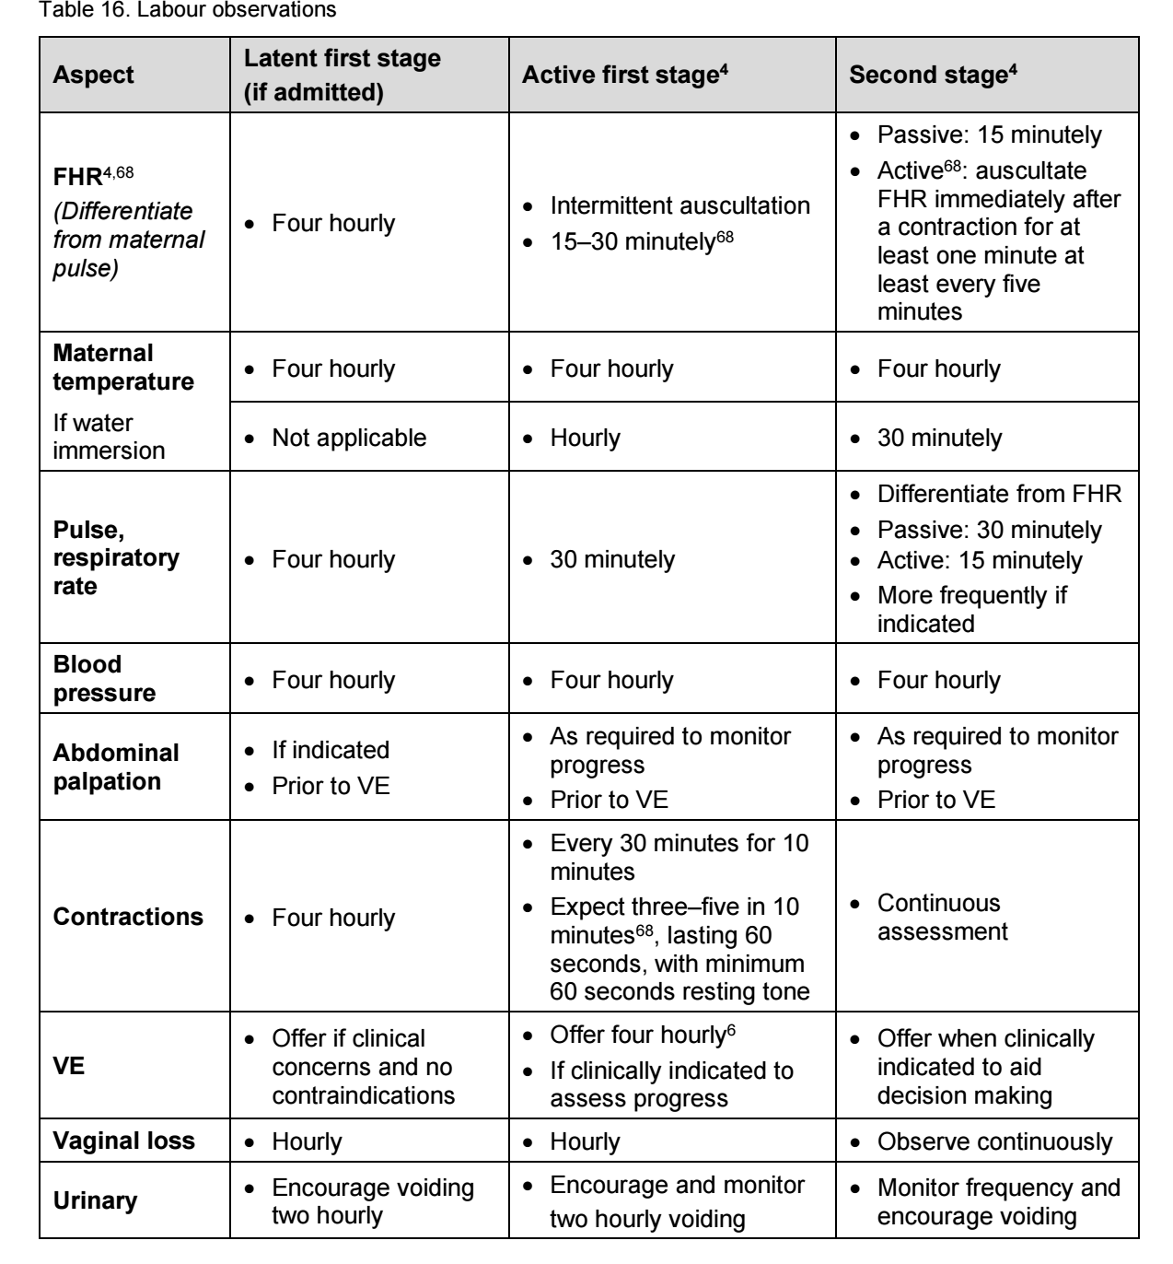

**Figure 1: Labor observation (Adapted from Queensland clinical guidelines; Dec., 2022)**

**Birth of the baby:**

1. **Maternal position:**

* Support women to give birth in whatever position they find comfortable while maintaining good visualization of the perineum.
* Kneeling and all fours position are associated with increased incidence of intact perineum.
* Sitting, squatting and birth stool are associated with increased incidence of perineal trauma
* Upright position in second stage is associated with (quality of evidence generally low):
* A reduction in pushing by around six minutes
* A significant reduction in assisted birth
* A reduced incidence of episiotomy
* An increased incidence of second degree tears
* An increased incidence of blood loss 500 mL or more
* Upright position in second stage may reduce the duration of second stage for nulliparous women through facilitating an extension and flexibility of the pelvic outlet

1. **Pushing:**

* Encourage the woman to push according to own bodily instincts which will usually support pushing with an open glottis.
* Women in the expulsive phase of the second stage of labor should be encouraged and supported to follow their own urge to push.
* For women with epidural analgesia in the second stage of labor, delaying pushing for one to two hours after full dilatation or until the woman regains the sensory urge to bear down is recommended in the context where resources are available for longer stay in second stage and perinatal hypoxia can be adequately assessed and managed.
* Avoid coaching women to push in a prolonged closed glottis effort (Valsalva maneuver)
* Do not check for nuchal cord
* Fundal pressure ***is not*** recommended to expedite second stage.
* If pushing is ineffective or if requested by the woman, offer strategies to assist birth, such as support, change of position, emptying of the bladder and encouragement.

1. **Perineal care:**

* Perineal warm compresses (heat therapy) during second stage may be associated with:
* Decreased incidence of third and fourth degree tears
* Reduced pain scores
* Increased satisfaction and comfort.
* Do not perform perineal massage in the second stage of labor.
* Either the 'hands on' (guarding the perineum and flexing the baby's head) or the 'hands poised' (with hands off the perineum and baby's head but in readiness) technique can be used to facilitate spontaneous birth.
* Do not offer lidocaine spray to reduce pain in the second stage of labor.
* Do not carry out a routine episiotomy during spontaneous vaginal birth.
* Inform any woman with a history of severe perineal trauma that her risk of repeat severe perineal trauma is not increased in a subsequent birth, compared with women having their first baby.
* Do not offer episiotomy routinely at vaginal birth after previous third- or fourth-degree trauma.
* If an episiotomy is performed, the recommended technique is a mediolateral episiotomy originating at the vaginal fourchette and usually directed to the right side. The angle to the vertical axis should be between 45 and 60 degrees at the time of the episiotomy.
* Perform an episiotomy if there is a clinical need, such as instrumental birth or suspected fetal compromise.
* Provide tested effective analgesia before carrying out an episiotomy, except in an emergency because of acute fetal compromise.

**Delay in second stage:**

* After initial obstetric assessment of a woman with delay in the second stage, maintain ongoing obstetric review every 15 to 30 minutes.
* Recognize that, on rare occasions, the woman's need for help in the second stage may be an indication to assist by offering instrumental birth when supportive care has not helped.
* Because instrumental birth is an operative procedure, advise the woman to have tested effective anaesthesia.
* If a woman declines anaesthesia, offer a pudendal block combined with local anaesthetic to the perineum during instrumental birth.
* If there is concern about fetal compromise, offer either tested effective anaesthesia or, if time does not allow this, a pudendal block combined with local anaesthetic to the perineum during instrumental birth.
* Advise the woman to have a caesarean section if vaginal birth is not Possible

**THIRD STAGE OF LABOR**

**Definition:**

Commences with the birth of the baby to the birth of the placenta and membranes.

**Classification:**

1. Physiological management (also referred to as expectant management)
2. Active management is further classified according to the timing of cord clamping:

* Delayed cord clamping—also referred to as modified active management (recommended)
* Early cord clamping—often referred to as ‘active management’ (not recommended)
* Insufficient evidence to recommend for or against cut cord milking, or intact cord milking, when delayed cord clamping unable to be performed.

**Management:**

1. **Modified active management:**

* Recommended for births not requiring immediate emergency care:
* Uterotonic administration immediately after the birth of the baby and before the cord is clamped and cut.
* Waiting at least one minute or more, after birth of baby or for cord pulsation to cease before clamping and cutting the cord
* Use controlled cord traction (CCT) after signs of separation.
* Signs of placental separation include:
* The uterus rises in the abdomen
* The uterus becomes firmer and globular (ballotable)
* Trickle or gush of blood is observed from the vagina
* Lengthening of the umbilical cord is observed
* Cord does not retract with suprapubic pressure
* Woman may feel the urge to bear down
* Placenta may become visible at the vagina
* Sustained uterine massage is not recommended as an intervention to prevent postpartum hemorrhage (PPH) in women who have received prophylactic oxytocin.

1. **Physiological:**

* Suitable for women who:
* Have a healthy pregnancy
* Have had a normal first and second stage of labor
* Have no risk factors for excessive bleeding
* Make an informed decision after discussion of the risks and benefits
* Routinely includes:
* No uterotonic
* No clamping of the cord until pulsation has ceased or following birth of the placenta
* Leave cord unclamped (or if cut, leave clamped)
* Placenta births spontaneously by maternal effort
* Healthcare provider unobtrusively waits and observes for signs of separation and remains ‘hands off’

• Recommend intervention with oxytocin if bleeding needs to be controlled.

1. **Active management:**

* Early cord clamping (within 60 seconds of the birth of the baby) is no longer recommended for routine management of the third stage
* Routinely includes:
* Uterotonic administered with the birth of the anterior shoulder or immediately after birth of baby
* CCT after signs of separation.

**Ongoing care in third stage:**

* When uterotonic required or requested, recommend oxytocin 10 international units (IU) IM injection shortly after birth.
* In settings where oxytocin is unavailable, the use of other injectable uterotonics (if appropriate, ergometrine/methylergometrine, or the fixed drug combination of oxytocin and ergometrine) or oral misoprostol (600 µg) is recommended
* Timing of administration:
* Can be administered before or after the cord is clamped and cut
* Administration before cord clamping is unlikely to impact on placental transfusion to baby
* No significant difference in incidence of PPH when given before or after birth of placenta
* Controlled cord traction:
  + Ensure the uterus is well contracted and the placenta separated before controlled cord traction is applied
  + Perform after cutting the cord
  + Guard the uterus—gently pull downwards on the cord while maintaining counter-traction above the pubic bone
  + Cord traction follows the curve of Carus
* As placenta delivers, hold in both hands and gently turn to twist the membranes
* Slowly tease out membranes to complete birth.
* Immediately following birth of placenta assess uterine tone.

**Placenta and membrane examination**

**Placenta:**

* General shape and appearance
* Calcification or infarctions
* Evidence of abruption
* Missing cotyledons
* Succenturiate lobe/s

**Membranes:**

* One amnion and one chorion
* Complete or ragged
* Presence of vessels

**Cord:**

* Cord insertion site
* Two arteries and one vein
* Velamentous insertion: Vessels noted in membranes

**Perineal examination:**

* Recommend systematic perineal assessment (may include vaginal and/or rectal examination, as clinically indicated)

**Retained placenta:**

* Secure intravenous access if the placenta is retained, and explain to the woman why this is needed.
* Do not use umbilical vein agents if the placenta is retained.
* Do not use intravenous oxytocic agents routinely to deliver a retained placenta.
* Give intravenous oxytocic agents if the placenta is retained and the woman is bleeding excessively.
* If the placenta is retained and there is concern about the woman's condition:
* offer a vaginal examination to assess the need to undertake manual removal of the placenta
* explain that this assessment can be painful and advise her to have analgesia.
* If the woman reports inadequate analgesia during the assessment, stop the examination and address this immediately.
* If uterine exploration is necessary and the woman is not already in an obstetric unit, arrange urgent transfer
* Do not carry out uterine exploration or manual removal of the placenta without an anaesthetic

**FOURTH STAGE OF LABOR**

* This guideline defines fourth stage as the first six hours immediately following the birth.

**Maternal care and assessment (Figure 2):**

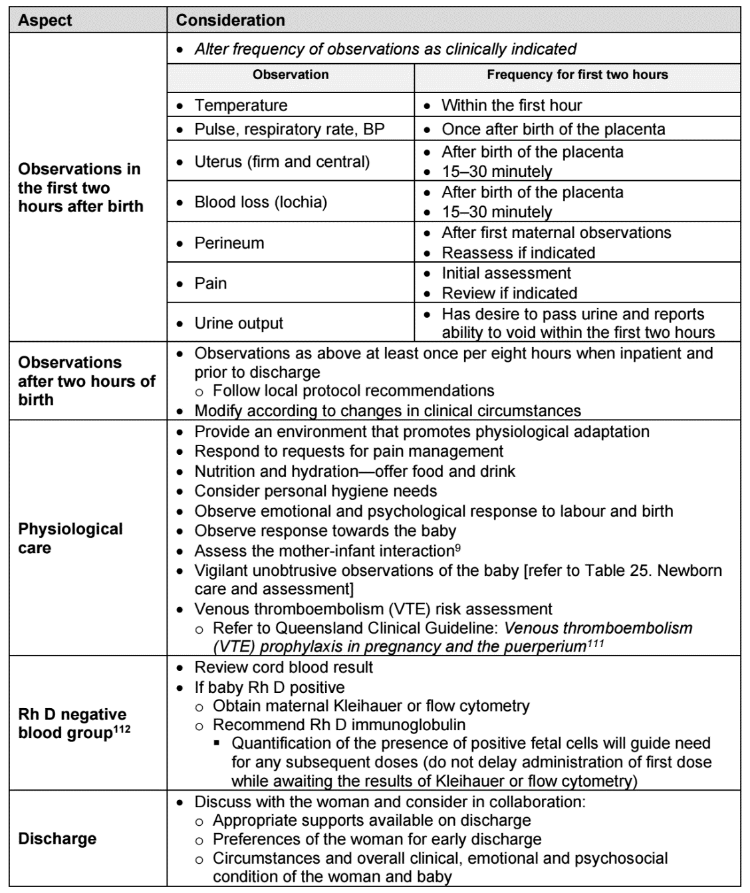

**Figure 2: Maternal care & assessment (Adapted from Queensland clinical guidelines; Dec., 2022)**

* Routine antibiotic prophylaxis is not recommended for women with uncomplicated vaginal birth.
* Routine antibiotic prophylaxis is not recommended for women with episiotomy

**Perineal care:**

* Define perineal or genital trauma caused by either tearing or episiotomy as follows:
* first degree – injury to skin only
* second degree – injury to the perineal muscles but not the anal sphincter
* third degree – injury to the perineum involving the anal sphincter complex:
  + 3a: less than 50% of external anal sphincter thickness torn
  + 3b: more than 50% of external anal sphincter thickness torn
  + 3c: internal anal sphincter torn.
* fourth degree – injury to the perineum involving the anal sphincter complex (external and internal anal sphincter) and anal epithelium.
* If genital trauma is identified after birth, offer further systematic assessment, including a rectal examination; Undertake repair of the perineum as soon as possible to minimize the risk of infection and blood loss.
* When carrying out perineal repair:
* ensure that tested effective analgesia is in place, using infiltration with up to 20 ml of 1% lidocaine or equivalent
* top up the epidural or insert a spinal anaesthetic if necessary.
* Advise the woman that in the case of first-degree trauma, the wound should be sutured in order to improve healing, unless the skin edges are well opposed.
* Advise the woman that in the case of second-degree trauma, the muscle should be sutured in order to improve healing.
* If the skin is opposed after suturing of the muscle in second-degree trauma, there is no need to suture it.
* If the skin does require suturing, use a continuous subcuticular technique
* Undertake perineal repair using a continuous non-locked suturing technique for the vaginal wall and muscle layer
* Use an absorbable synthetic suture material to suture the perineum.
* Offer rectal non-steroidal anti-inflammatory drugs routinely after perineal repair of first- and second -degree trauma provided these drugs are not contraindicated.

**CARE OF THE NEWBORN**

* In neonates born through clear amniotic fluid who start breathing on their own after birth, suctioning of the mouth and nose should not be performed.
* Record the Apgar score routinely at 1 and 5 minutes for all births.
* Newborns without complications should be kept in skin-to-skin contact (SSC) with their mothers during the first hour after birth to prevent hypothermia and promote breastfeeding.
* All newborns, including low-birth-weight (LBW) babies who are able to breastfeed, should be put to the breast as soon as possible after birth when they are clinically stable, and the mother and baby are ready.
* All newborns should be given 1 mg of vitamin K intramuscularly after birth (i.e., after the first hour by which the infant should be in skin-to-skin contact with the mother and breastfeeding should be initiated)
* Bathing should be delayed until 24 hours after birth. If this is not possible due to cultural reasons, bathing should be delayed for at least six hours. Appropriate clothing of the baby for ambient temperature is recommended. This means one to two layers of clothes more than adults, and use of hats/caps. The mother and baby should not be separated and should stay in the same room 24 hours a day.
* If a newborn baby needs basic resuscitation, start with air.

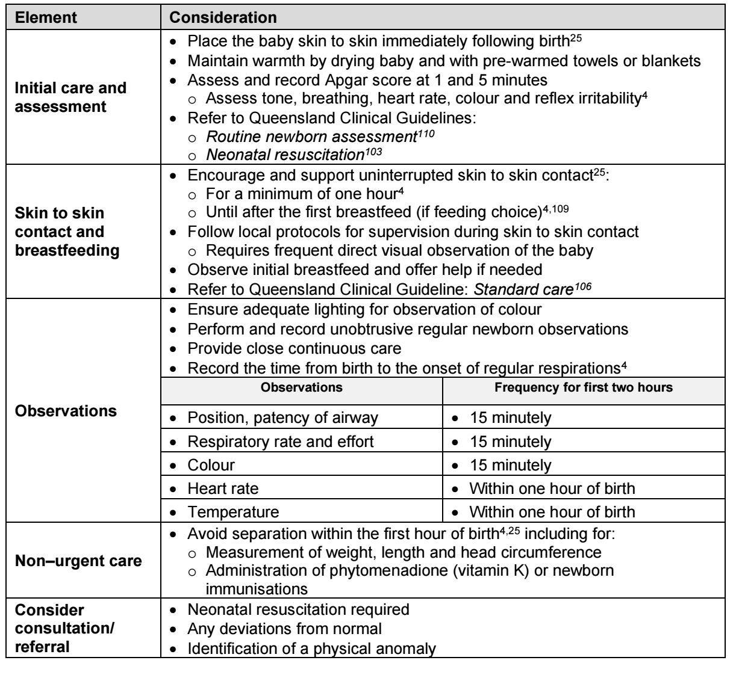

**Figure 3: Newborn care and assessment (Adapted from Queensland clinical guidelines; Dec., 2022)**

**In the presence of any degree of meconium:**

* do not suction the baby's upper airways (nasopharynx and oropharynx) before birth of the shoulders and trunk
* do not suction the baby's upper airways (nasopharynx and oropharynx) if the baby has normal respiration, heart rate and tone
* do not intubate if the baby has normal respiration, heart rate and tone.
* If any of the following are observed after any degree of meconium, ask a neonatologist to assess the baby:
* respiratory rate above 60 per minute
* the presence of grunting
* heart rate below 100 or above 160 beats/minute
* capillary refill time above 3 seconds
* body temperature of 38°C or above, or 37.5°C on 2 occasions 30 minutes apart
* oxygen saturation below 95% (measuring oxygen saturation is optional after non-significant meconium)
* presence of central cyanosis, confirmed by pulse oximetry if available.

**ANALGESIA**

* Do not offer transcutaneous electrical nerve stimulation (TENS) to women in established labor.
* Ensure that Entonox (a 50:50 mixture of oxygen and nitrous oxide) is available in all birth settings as it may reduce pain in labor, but inform the woman that it may make her feel nauseous and light-headed.
* Ensure that pethidine, diamorphine or other opioids are available in all birth settings. Inform the woman that these will provide limited pain relief during labor and may have significant side effects for both her (drowsiness, nausea and vomiting) and her baby (short-term respiratory depression and drowsiness which may last several days).
* Inform the woman that pethidine, diamorphine or other opioids may interfere with breastfeeding.
* If an intravenous or intramuscular opioid is used, also administer an antiemetic.

**Regional analgesia**

* If a woman in labor asks for regional analgesia, comply with her request. This includes women in severe pain in the latent first stage of labor.
* Always secure intravenous access before starting regional analgesia.
* Preloading and maintenance fluid infusion need not be administered routinely before establishing low-dose epidural analgesia and combined spinal–epidural analgesia.
* Undertake the following additional observations for women with regional analgesia:
* During establishment of regional analgesia or after further boluses (10 ml or more of low-dose solutions), measure blood pressure every 5 minutes for 15 minutes.
* Encourage women with regional analgesia to move and adopt whatever upright positions they find comfortable throughout labor.
* Once established, continue regional analgesia until after completion of the third stage of labor and any necessary perineal repair.
* ***Upon confirmation of full cervical dilatation*** in a woman with regional analgesia, unless the woman has an urge to push or the baby's head is visible, ***pushing should be delayed for at least 1 hour and longer if the woman wishes***, after which actively encourage her to push during contractions.
* After diagnosis of full dilatation in a woman with regional analgesia, agree a plan with the woman in order to ensure that birth will have occurred within 4 hours regardless of parity.
* Do not routinely use oxytocin in the second stage of labor for women with regional analgesia.
* Perform continuous cardiotocography for at least 30 minutes during establishment of regional analgesia and after administration of each further bolus of 10 ml or more.
* Use either epidural or combined spinal–epidural analgesia for establishing regional analgesia in labor.
* If rapid analgesia is required, use combined spinal–epidural analgesia.
* Establish combined spinal–epidural analgesia with bupivacaine and fentanyl.
* Establish epidural analgesia with a low-concentration local anaesthetic and opioid solution with, for example, 10 to 15 ml of 0.0625 to 0.1% bupivacaine with 1 to 2 micrograms per ml fentanyl.
* The initial dose of local anaesthetic plus opioid is essentially a test dose, so administer cautiously to ensure that inadvertent intrathecal injection has not occurred.
* Use low-concentration local anaesthetic and opioid solutions (0.0625 to 0.1% bupivacaine or equivalent combined with 2.0 micrograms per ml fentanyl) for maintaining epidural analgesia in labor.
* Do not use high concentrations of local anaesthetic solutions (0.25% or above of bupivacaine or equivalent) routinely for either establishing or maintaining epidural analgesia.
* Either patient-controlled epidural analgesia or intermittent bolus given by healthcare professionals are the preferred modes of administration for maintenance of epidural analgesia.