**DIGITAL DISTANCE MEASUREMENT CONFIGURATION MANAGEMENT PLAN (CMP)**

**V2.0**

**Prepared by:-**

**Ahmed Osama**

**Esraa El Beltagy**

*CM Team*

**DOCUMENT CHANGE CONTROL SHEET**

**Document Title:** Configuration Management Plan (CMP)

|  |  |  |  |  |
| --- | --- | --- | --- | --- |
| **Date** | **Filename/version #** | **Author** | **Status** | **Revision Description** |
| 02/04/2018 | CMP.1.1.DOC | CM Team | Created | Updating CMP |
| 03/04/2018 | CMP.1.2.DOC | CM Team | Update | Updating CMP |
| 05/04/2018 | CMP.1.3.DOC | CM Team | Update | Peer Review Changes |
| 06/04/2018 | CMP.1.4.DOC | CM Team | Final | Final Peer Review changes incorporated |
| 19/04/2018 | CMP2.0.DOC | CM Team | Update | Add Folder Strucutre |

**TABLE OF CONTENTS**

**1.0 INTRODUCTION........................................................................................................................................5**

1.1 PURPOSE ....................................................................................................................................................5

1.2OVERVIEW...................................................................................................................................................5

1.3 SCOPE ........................................... .............................................................................................................5

*1.3.1 Document Organization..........................................................................................................................6*

1.4 CONFIGURATION MANAGEMENT (CM) GUIDANCE ....................................................................................6

*1.4.3 Policy Statements....................................................................................................................................7*

*1.4.4 Assumptions ............................................................................................................................................7*

*1.4.5 Limitation................................................................................................................................................7*

1.5 DEFINITIONS AND ACRONYMS ....................................................................................................................8

**2.0 CONFIGURATION MANAGEMENT ELEMENTS.........................................................................10**

2.1 CONFIGURATION MANAGEMENT ORGANIZATION ....................................................................................10

2.2 CONFIGURATION MANAGEMENT (CM) ROLES AND RESPONSIBILITIES....................................................11

2.3 MANAGEMENT OF THE CM PROCESS .......................................................................................................13

**3.0 CONFIGURATION MANAGEMENT ACTIVITIES .......................................................................14**

3.1 CONFIGURATION IDENTIFICATION.............................................................................................................14

*3.1.1 Identifying Configuration Items............................................................................................................14*

*3.1.2 Naming Configuration Items (CIs) ......................................................................................................17*

3.2 CONFIGURATION CONTROL.......................................................................................................................17

*3.2.1 Configuration Control Process............................................................................................................18*

*3.2.2 Version Control Overview ...................................................................................................................18*

3.3 MAJOR OR MINOR DOCUMENT UPDATES..................................................................................................19

3.4 CONFIGURATION STATUS ACCOUNTING ...................................................................................................19

*3.4.1 Configuration Item (CI) List ................................................................................................................19*

*3.4.2 Change Request (CR) Reporting..........................................................................................................19*

*3.4.3 Audit Reports .......................................................................................................................................19*

*3.4.4 Configuration Management (CM) Metrics Reports.............................................................................21*

3.5 CONFIGURATION AUDITS AND REVIEWS ..................................................................................................21

*3.5.1 Functional Configuration Audit (FCA)................................................................................................21*

*3.5.2 Physical Configuration Audit (PCA) ...................................................................................................21*

*3.5.3 Reviews ................................................................................................................................................22*

3.6 OPDDMTIONS ............................................................................................................................................22

3.7 INTERFACE CONTROL................................................................................................................................22

3.8 SUBCONTRACTOR/VENDOR CONTROL ......................................................................................................22

*3.8.1 Vendor Products ...................................................................................................................................22*

*3.8.2 Release Management and Delivery ......................................................................................................23*

**4.0 CONFIGURATION MANAGEMENT (CM) SCHEDULES.............................................................24**

4.1 GENDDML CONFIGURATION MANAGEMENT (CM) ACTIVITIES SCHEDULE ..............................................24

**5.0 CONFIGURATION MANAGEMENT (CM) RESOURCES ...........................................................26**

5.1 CONFIGURATION MANAGEMENT (CM) TOOLS.........................................................................................26

*5.1.1 Git extenuations ....................................................................................................................................26*

5.2 CONFIGURATION MANAGEMENT (CM) SUPPORT ENVIRONMENT ............................................................27

5.4 CONFIGURATION MANAGEMENT (CM) TRAINING ...................................................................................28

**6.0 CONFIGURATION MANAGEMENT PLAN MAINTENANCE.....................................................29**

**CONFIGURATION MANAGEMENT PLAN (CMP)**

**Section 1.0: Introduction**

This document describes the Configuration Management (CM) activities to be performed in support of Digital Distance Measurement (DDM) Project. Digital Distance Meter is our product that aims to measure distance and velocity of moving object and display it on digital screen. The system is planned as an LCD and Ultrasonic sensor integrated hardware device measuring distance and velocity. “Advanced Solution”, our Company is searching for a simple solution of digital distance-velocity measurement system. So, there are no specific target users. Users can be uneducated and have no technical expertise at all. Product is simple and can suit all user segments. Our product has three major features "milestones", the first one is Measuring distance, and the second one is Measuring velocity, and the last one Display Distance and Velocity on an LCD screen.

**1.1 Purpose**

The purpose of this document is to define the practices and procedures required to accomplish CM throughout the lifecycle of the DDM project. The intended audience for this document is the DDM Project Management, and other management entities that have oversight responsibilities for the DDM Project.

**1.2 Overview**

The digital distance-velocity measurement system has one active actor. The user should be able to measure the distance from a specific object and value will be displayed on a 2*16 LCD screen and should be able to measure the velocity of a specific object on the same LCD screen. Distance and velocity must be measured using an ultrasonic sensor and a microcontroller. System should be portable and can be fixed in a specific place. System should be powered by a non-rechargeable battery. It’s a real time system.

**1.3 Scope**

CM is a system engineering discipline that formalizes the management of the configuration of a system and controls changes to the system throughout its lifecycle. The key principles of CM ensure that all components of the system can be uniquely identified, managed, and that any previous version of the system can be readily reproduced. This Configuration Management Plan (CMP) applies to all software, hardware, Commercial Off The Shelf (COTS) products, documentation, physical media, and physical parts used by DDM and the DDM contractor development team to support various development activities, including engineering, implementation, testing, and configuration management.

**1.3.1 Document Organization**

**Table 1-1, Document Organization**, describes the sections and contents of the CMP.

|  |  |  |
| --- | --- | --- |
| **Section** | **Title** | **Content Summary** |
| 1.0 | Introduction | Describes the CMP purpose, overview, scope, CM Guidance, definitions and acronyms, and references |
| 2.0 | Configuration Management | Introduces and describes the CM organizations, roles and responsibilities, applicable policies, standards and procedures, management of the CM processes |
| 3.0 | Configuration Management Activities | Describes the objectives of configuration identification, configuration control, configuration status accounting, configuration audits and reviews, interface Control, and sub-contractor and vendor control. |
| 4.0 | Configuration Management Schedules | Describes the general CM activities schedule |
| 5.0 | Configuration Management Resources | Describes the CM organizational products, tools, support environment, personnel, and training. |
| 6.0 | Configuration Management Plan Maintenance | The CMP will be updated as per the WBS. |

**Table 1-1, Document Organization**

**1.4 Configuration Management (CM) Guidance**

The purpose of CM is to establish and maintain the integrity and control of the products of the DDM project throughout its lifecycle. CM is an integrated process for identifying, documenting, monitoring, evaluating, controlling, and approving all changes made during the lifecycle of the program to critical information that is shared by more than one (1) individual. CM is one of the best practices identified by the 16 Critical Software Practices published by the Software Program Managers Network and is a key to successful software acquisition. The IEEE Guide to Software Configuration Management (IEEE Std. 1042-1987) provides CM guidelines.

**1.4.1 Policy Statements**

• The CIL specifically identifies the items to be maintained under CM.

• CM will occur concurrently with project management, and will continue throughout the project’s lifecycle.

• The QM function will regularly audit the baselines and the processes according to their procedures and schedules.

• A CCB is established to control the CIs.

• All projects or sub-projects shall provide adequate resources for CM.

• A CM team, headed by the CM Manager, exists and CM processes, library systems, and CM tools are maintained by that team.

• Training for DDM personnel on CM standards, processes, and tools for the DDM Project is provided by the CM team.

• Measurements are defined by the overall *Metrics Plan (MP)* and are used by the program manager to monitor PMO activities. The CM team ensures that CM metrics are collected, and the QM Team verifies that the measurement process is followed as part of their audits.

• Senior and project management reviews CM status and effectiveness. The *Program Management Plan (PMP)* defines the events and intervals for this review.

**1.4.2 Assumptions**

A list of assumptions is provided below, as they may impact the cost, schedule, or ability to perform configuration management activities for the DDM Project.

• Necessary funding and resources required to support CM activities will be available when needed.

• The schedule of CM activities and their task dependencies will be achieved.

• Access to contractor facilities, resources, and work products will be provided as required to allow reliable monitoring of contractor activities and work products.

• Interface with other organizations, e.g. CCB, working groups, etc., will be available as needed to support DDM CM activities.

• Delivery of work products will be provided within a sufficient time frame to allow required CM activities to be performed.

**1.4.3 Limitation**

A limitation that may impact the administration of CM activities for the DDM project is discussed below. DDM will be developed in several increments with multiple system releases to provide increasing functionality to users within reasonable timeframes and to allow shorter periods for the evaluation of contractor progress and product suitability. DDM configuration management must ensure that adequate CM activities are provided to support the incremental release of system components and functionality.

**1.5 Definitions and Acronyms**

The technical terms used in this plan are defined in IEEE Std. 610.12-1990*,* IEEE Standard Glossary of Software Engineering Terminology. **Table 1-3, Acronyms List**, contains a list of acronyms used herein.

|  |  |
| --- | --- |
| **ACRONYM** | **DEFINITION** |
| DDM | Digital Distance Meter |
| ABL | Allocated Baseline |
| CBL | Concept Baseline |
| CCB | Configuration Control Board |
| CDR | Critical Design Review |
| CDRL | Contract Data Requirements List |
| CI | Configuration Item |
| CIL | Configuration Item List |
| CM | Configuration Management |
| CML | Configuration Management Library |
| CMP | Configuration Management Plan |
| ACRONYM | DEFINITION |
| CMN | Common |
| COTS | Commercial Off The Shelf |
| CR | Change Request |
| CSA | Configuration Status Accounting |
| FBL | Functional Baseline |
| FCA | Functional Configuration Audit |
| HWCI | Hardware Configuration Item |
| ICWG | Interface Control Working Group |
| IEEE | Institute of Electrical and Electronics Engineers |
| IRD | Interface Requirements Document |
| ITSS | Information Technology Support Services |
| IV&V | Independent Verification and Validation |
| MCD | Master Configuration Document |
| MP | Metrics Plan |
| OPS CCB | Operations Configuration Control Board |
| PAT | Product Acceptance Test |
| PBL | Product Baseline |
| PCA | Physical Configuration Audit |
| PC | Program Consultant |
| PDR | Preliminary Design Review |
| PM | Project Manager |
| PMP | Program Management Plan |
| QA | Quality Assurance |
| QM | Quality Management |
| QMP | Quality Management Plan |
| RD | Requirements Document |
| RM | Release Manager |
| SCM | Software Configuration Management |
| SDR | System Design Review |
| SOP | Standard Operating Procedure |
| SRR | System Requirements Review |
| Std | Standard |
| SRS | System Requirements Specification |
| TBD | To Be Determined |
| TEP | Technical Review Process |
| TRA | Training Needs Assessment |
| UCM | Unified Change Management |
| WBS | Work Breakdown Structure |

**Table 1-3: Acronyms List**

**Section 2.0: Configuration Management Elements**

This section contains specific organizational information related to the management and organization of CM elements for DDM. The following CM elements will be discussed in the paragraphs below.

• CM Organization

• Roles and Responsibilities

• Organizational entities versus their responsibilities

• Applicable policies and procedures

**2.1 Configuration Management Organization**

The DDM PM CM Organization consists of the following roles.

• Project consultant (PC)

• Configuration Control Board (CCB)

• Configuration Management (CM) Team

• DDM Development Team

• Quality Management (QM) Team

• Testing Team

• Operations Team

The DDM CM Group consists of the CM Manager and CM Team members.

**Configuration Management (CM) Organizational Relationships**

**2.2 Configuration Management (CM) Roles and Responsibilities**

The primary CM responsibilities for each of the DDM PM CM Organizational roles, as identified in **Section 2.1**, are discussed in this section and are provided in **Table 2-1, Configuration Management (CM) Organization Roles and Responsibilities**.

These responsibilities are defined for the entirety of the DDM lifecycle.

|  |  |
| --- | --- |
| **Roles** | **Required Responsibilities** |
| **Program Director (PC)**  **Eng. Mohammed Hassan** | • Provides oversight of CM activities to ensure successful program performance and compliance with program policies and federal regulations.  • Ensures adequate resources are available for CM activities.  • Ensures that support team leads and other persons in management or supervisory roles support the objectives of this CMP.  • Designates the CCB membership and delegates CCB Chair authority to make configuration management decisions on behalf of the PD.  • Resolves open CCB issues by making the final decision. |
| **Program Support Division (PSD) Director**  **Esraa El Beltagy** | • Assists the DDM PC by providing leadership and program support for a wide range of analytical, management, and coordination duties.  • Delegated by the PC to provide leadership and oversight of CM activities, processes, and tasks performed by the division staff and provides similar oversight of contractors.  • Permanent member and Chairperson of the CCB and provides key leadership to the board for the effective review and evaluation of Change Requests (CRs).  • Works closely with the Systems Engineering Division to ensure the successful implementation of CM activities for the DDM.  • Reviews CM reports as necessary. |
| **System Engineering Division (SED) Director**  **Ahmed Osama** | •Assists the DDM PC by providing oversight and leadership for all technical aspects throughout the lifecycle of the DDM program.  • Permanent member that provides leadership to the board.  • Ensures the successful implementation of CM activities for DDM. |
| **Quality Management (QM) Team**  **Mostafa** | • Audits CM program for compliance with documented procedures and standards and reports results to the DDM PC and affected personnel.  • Ensures CM audits are conducted on all baselines.  • Participates in the Functional Configuration Audit (FCA) and Physical Configuration Audit (PCA).  • Verifies approved changes are implemented in accordance with documented plans, standards, and procedures. |
| **Testing Team**  **Omnia Ahmed** | • Responsible for using the appropriate testing and CM tools when performing all test activities.  • Assists in the development and identification of relevant CIs, such as test plans, scripts, data, releases for testing, and test environments.  • Submits Change Requests (CRs) and/or Discrepancy Reports against releases of the system and modifications to CIs that are the results of enhancements and/or defects identified during testing.  • Verify that changes are implemented to CIs. |
| **CM Team**  **Ahmed Osama**  **Esraa El Beltagy** | • Establishes the DDM Configuration Management Library (CML).  • Assists with the administration and management of CM tools and the management of the CM environment.  • Maintains and documents system configuration items and baselines and records and reports configuration history for CM items.  • Ensures that change requests are initiated, recorded, reviewed, approved, and tracked according to the CMP and other relevant documented procedures.  • Provides support to the CCB.  • Assists in conducting CM audits.  • Collects CM metrics and prepares CM metrics reports.  • Collects configuration status accounting data and prepares reports.  • Supports PMO activities with any required CM data.  • Supports the coordination of CM activities.  • Supports various system reviews as required, to include, but not limited to, the System Requirements Review (SRR), System Design Review (SDR), and the Critical Design Review (CDR). |

**Table 2-1 Configuration Management (CM) Organization Roles and Responsibilities**.

**2.3 Management of the CM Process**

CM has an established and documented process to manage necessary changes, ensuring that all impacts to operations and support are addressed. Some of the benefits of CM from an industry view are as follows:

• CIs are defined and documented in the CIL and provide a known basis for making changes.

• CIs are correlated with their associated requirements.

• Proposed changes are identified and evaluated; change activity is managed using a defined process.

• Incorporation of changes to the CIs are verified and recorded throughout the lifecycle of the DDM Program.

• The DDM QM team is responsible for the independent surveillance of the CM activities to ensure compliance with the CM plan.

• Risk management has been incorporated as a critical element of the DDM Program Management process. Risks are identified by the CM team and managed and tracked by DDM Risk Management Team.

Section 3: CM activities

CM activities include all functions and tasks required in managing the CIs of DDM as specified in the scope of this plan. Both technical and managerial CM activities will be identified and controlled through implementation of the following CM processes.

• Configuration Identification

• Configuration Control

• Configuration Status Accounting

• Configuration Audits and Reviews

• Interface Control

• Subcontractor/Vendor Control

• Release Management and Delivery

**3.1 Configuration Identification**

Configuration identification forms the cornerstone upon which all CM activities are based. Configuration identification is an element of CM that is concerned with selecting the CIs for a system or product, assigning unique identifiers and naming conventions, and recording their functional and physical characteristics in technical documentation. A CI is defined as an aggregation of hardware, software, or both that is designated for CM and treated as a single entity in the CM process (IEEE Std 610.12-1990). This section specifies the configuration identification activities to be performed during the DDM Lifecycle, including identifying CIs, naming CIs, and acquiring CIs.

**3.1.1 Identifying Configuration Items**

Configuration identification activities identified for the DDM project include the selection of CIs, baseline management, and the unique identification of CIs (e.g., the numbering or naming CIs). The following paragraphs will specify configuration identification activities for the DDM project.

• DDM Baselines

• System CIs

• Configuration Identification Documents

**3.1.1.1 Identifying DDM Baselines**

A baseline is a logical grouping of CIs that constitute the system. Baselines provide a fixed reference to specify the CIs at a particular milestone event or point in time. A baseline establishes an approved standard upon which subsequent work can be made. After an initial baseline is established, changes to the baseline can only be performed through a formal change request process as identified in **Section 3.2.** The DDM CIs, both internal and external, are listed in the CIL,

The DDM CM establishes four (4) types of baselines as shown in **Figure 3-1: DDM Project Milestones and Baselines**.

• Concept baseline (CBL)

• Functional baseline (FBL)

• Allocated baseline (ABL)

• Product baseline (PBL)

All baselines will be reviewed, established, and approved by the DDM CCB as needed. Changes to baselines are submitted as change requests and are dispositioned by the DDM CCB as indicated.

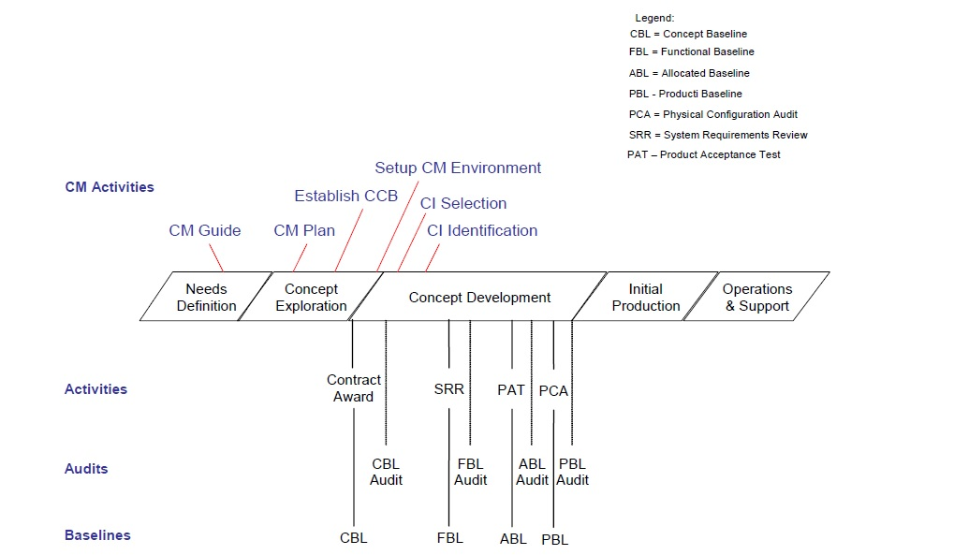

**Figure 3-1: DDM Project Milestones and Baselines**

**3.1.1.2 Identifying System Configuration Items**

System architecture identifies the structure and relationships of system activities, components, and elements within the DDM system. The structure to support the logical identification of system components and their relationships is provided in **Figure 3-2, DDM System Architecture**, and described in the following paragraphs:

**Figure 3-2 DDM System Architecture**

♦ **DDM System** – The DDM system is the highest level of composition and represents the collection of Hardware Configuration Items (HWCIs), COTS CIs and source that are required to accomplish the complete functionality of the DDM system.

The DDM system is decomposed into three (3) functional segments that represent major capabilities of DDM.

* Measure the distance.
* Measure the velocity.
* Display both on LCD screen.

♦ **System Configuration Items (CIs)** – CIs are an aggregation of reasonably mature hardware, software and COTS that combine together to perform a specific function or function. There are four (3) types of CIs that have been identified for the DDM system and they are discussed below.

**Hardware Configuration Item (HWCI)** – An HWCI is an aggregation of hardware components that is designated for CM and is treated as a single entity.

**Source** – A source is an aggregation of **software** components that is designated for CM and treated as a single entity.

**Commercial Off the Shelf (COTS) CI** – A COTS product CI is pre-packaged computer software that performs a specific function or functions. Examples of COTS CIs include operating system software, networking software, database software, etc. Selected COTS CIs that are designated for CM are treated as a single item.

**3.1.1.3 Identifying Configuration Identification Documents**

Configuration identification documents are technical documents that support the configuration and development of a CI throughout the lifecycle of the system. These technical documents are developed through increasing levels of detail as the system evolves. Technical documents are used to establish baselines at specific milestones throughout the lifecycle of the system. Three (3) types of technical documents identified for the DDM project are listed below and discussed in the following paragraphs.

* Specifications
* Technical Manuals
* Management Plans and Procedures

**Specifications** - Specifications state the functions and capabilities that a system must provide and the constraints that are applied to the system. Specifications can be documented in several ways including; textual descriptions, graphical models or drawings, and mathematical models. Approved specifications for the DDM project will be placed under CM control e.g., Requirements Document.

**Technical Manuals** - Technical manuals describe the operation, installation, administration, and maintenance of the system. Technical manuals are generally contract deliverables and will be controlled and maintained under CM control to ensure that they are compatible with the CIs that they describe. Examples of technical manuals include:

• System Administrative Guide,

• System Operational Guide, and

• System Maintenance Manuals.

**Management Plans and Procedures** - Management plans and procedures describe the various activities required for the management of the DDM project. These documents define the organization, policies, procedures, standards, schedules, and resources that are required to provide for the execution of these activities. Examples of management plans include:

• Program Management Plan

• Software Development Plan

• Configuration Management Plan

• Quality Management Plan

• Acceptance Test Plan

**3.1.2 Naming Configuration Items (CIs)**

A naming convention, combined with labels, is used to uniquely identify the CIs and Work Products that are placed under CM control for the DDM project. The naming convention uniquely identifies each item and their different versions.

The naming convention for the CIs is organized into two (2) parts: CI type and the type of file. File names consist of a combination of the file or CI title with an underscore between each word in the title and file type extension, as shown **Table 3-1, Examples of File or CI**.

|  |  |
| --- | --- |
| **Section 3.1.2.1**. **File or CI Title** | **Name Identifiers** |
| Configuration Management Plan | Configuration_Management_Plan.doc |

**Table 3-1: Examples of File or CI**

**3.2 Configuration Control**

Configuration control is a formal process for which a change to a CI is systematically proposed, evaluated, approved or disapproved, and implemented. Configuration control is an important process for regulating the configuration of system baselines and configuration items and ensuring that only approved changes are implemented. Configuration control ensures that system baselines are accurate and known throughout the lifecycle of the system. Currently, configuration control activities are processed and managed through **GIT EXTENSIONS** and the output of configuration control activities are collected and reported in configuration status accounting and metrics reports.

**3.2.1 Configuration Control Process**

Configuration control is the process for evaluating, coordinating, and deciding on the disposition of proposed changes to the CIs, and implementing the approved changes to baselined software and associated documentation and data. The configuration control process ensures that changes that have been proposed are classified and evaluated, approved or disapproved, and those that are approved are implemented, tested, verified, and incorporated into a new baseline. Changes to software and associated documentation are classified according to the impact of the change and the approval authority needed. Depending on the scope, schedule, or cost there will be a hierarchy of people who can approve the changes. This hierarchy is defined in the CCB.

For DDM system there are two (2) types of Configuration Control Processes:

**- Dev Configuration Control Process**

**- Operations Configuration Control Process**

**Changes covered under the Dev Configuration Control Process:**

* Deviations: A deviation is granted for temporary, short-term relief of a requirement whereby future builds/deliveries will be in compliance. Deviation are approved by the CCB.
* Scope Changes: Any changes to the requirements must be approved by the CCB.

**• DDM Operations Configuration Control Board Process**

Any changes to the production system must be reviewed and approved by the CCB.

**3.2.2 Version Control Overview**

**Version control** is the process of managing and maintaining multiple revisions of a CI. **Version numbers** are planned for all types of CIs and document files needed for a program or project.

**Version control** is used to track changes to the CIs. It provides traceability to the documents by allowing:

• Reproducibility of previous versions of CIs, and

• Traceability to document the relationship between CIs.

The **version number** is listed on the cover page of a document. The version number is used to identify a specific set of updates to a CI. Version numbers are planned for all types of CIs and document files needed for a program or project.

**3.3 Major or Minor Document Updates**

A major or minor document update includes updates to documentation CIs. The CI version number is the version number (Version 1.0) on the cover page of a document. It is used to indicate the progressive updates to a document. Changes to CIs can be either major or minor.

A major document update may include documentation of new program activities or extensive rework and is indicated by an increment to the next whole number, for example, 7.0 to 8.0 (these numbers are version numbers listed on the front page of the document). The document owner determines whether the updates are major or minor. A minor document update to documents may include, but is not limited to, spelling, grammar corrections, enhancements, or clarification. A minor release is indicated by an increment of .1; for example, 7.4 to 7.5 (these numbers are version numbers listed on the front page of a document).

**3.4 Configuration Status Accounting**

Configuration Status Accounting (CSA) is the CM activity that provides information about the current status of approved CIs and the progress and status of proposed and approved changes to the CIs. Configuration status accounting activities collect data that can be used to measure various aspects of program effectiveness and to assess product completeness and quality. The four (4) primary types of configuration status accounting reports identified for the DDM project are listed below and discussed in the following sections.

• CI List

• CR Reports

• Audit Reports

• CM Metric Reports

**3.4.1 Configuration Item (CI) List**

The Configuration Item List (CIL) is a list of CIs and it includes attributes of a CI, e.g., Title, Version Number etc. The CIL is a living document. The CM team reviews the CIL on a monthly basis and may add new CIs or modify them as appropriate during the course of the program. The PM determines CI owners. Designated CI owners are responsible for maintaining CIs.

**3.4.2 Change Request (CR) Reporting**

A CR is used to request a change to a CI that has been baselined and placed under CM control. DDM uses GIT EXTENSIONS to document the submission of a request, track its status, and document the evaluation of the potential impact of a change to the affected CIs. CR reports provide useful information about the quality of the product, trends in CR reporting, and the general quality of the configuration control process.

**3.4.3 Audit Reports**

The primary objective of configuration audits is to determine if selected system products meet functional and physical requirements. They are used to assess the products readiness to be baselined or released, and whether the products are complete as delivered. Audits of CM activities are also performed to assess effectiveness and to identify areas for improvement. Configuration audit reports capture audit findings and document discrepancies with corrective actions and estimated completion dates. Configuration audit reports identified for the DDM project include the following.

• FCA Report

• PCA Report

Configuration audit reports for the DDM program are discussed in the following paragraphs.

**3.4.3.1 Functional Configuration Audit (FCA) Reports**

The purpose of the FCA Report is to verify that the contractor development effort has successfully achieved the requirements specified in the configuration documentation, i.e., the design matches the requirements. In other words, an FCA is used to verify that each CI has adequately achieved the performance and the functional characteristics as specified in the system documentation. The FCA will be performed in accordance with the integrated schedule.

|  |  |
| --- | --- |
| **Name:** | **Functional Configuration Audit (FCA) Report** |
| **Methods** | Validation of system functionality can be performed by review of approved test plans, test specifications, and test reports; review of traceability matrix of test cases and test results to system requirements; and verification of test results by test team. |
| **Inputs** | *DDM RD*, SRS, test plans, test specifications, test reports. |
| **Outputs** | FCA findings, traceability verification matrix, discrepancies, proposed corrective actions, estimated completion dates. |
| **Intended Audience** | DDM PC, , CM Manager, QM Manager, Testing Officer, CM Manager |

**Table 3-4: Functional Configuration Audit (FCA) Report**

**3.4.3.2 Physical Configuration Audit (PCA) Reports**

The purpose of the PCA report is to verify the As-Built System matches the design documents, i.e., the hardware/software is fully and accurately documented. The PCA, along with the FCA, will generally be performed in accordance with the integrated schedule.

|  |  |
| --- | --- |
| **Name:** | **Physical Configuration Audit (PCA) Report** |
| **Methods:** | Validation of physical configuration can be performed by an inspection of the system documentation against the items physically listed and present in the product release. |
| **Inputs:** | System deliverables, source code, executables, build reports, release notes, version description documents |
| **Outputs:** | Physical configuration audit findings, discrepancies, proposed corrective actions, estimated completion dates |
| **Intended Audience:** | DDM PC, CM Manager, QM Manager, Testing Officer, CM Manager |

**Table 3-5: Physical Configuration Audit (PCA) Report**

**3.4.4 Configuration Management (CM) Metrics Reports**

The purpose of CM metrics is to measure performance. CM metrics also can be used to review and revise existing CM processes and procedures throughout the project lifecycle. The data derived from metrics is used to understand problems and inefficiencies in products and processes, to address the extent of those problems and inefficiencies, and to provide insight for making necessary corrections and improvements.

**3.5 Configuration Audits and Reviews**

Configuration audits are performed to determine if the configuration item accurately reflects the physical and functional characteristics as defined. Reviews are performed to ensure that CIs have been correctly identified and produced. A discussion of configuration audits and reviews proposed for the DDM project is provided in the following paragraphs.

**3.5.1 Functional Configuration Audit (FCA)**

The purpose of FCA is to verify that each CI has adequately achieved the performance and functional characteristics as specified in the system documentation.

Items to be reviewed include but are not limited to the following test plans, test specifications, and test results to ensure that each CI performs as required:

• Acceptance Test Results;

• Verification Cross Reference Matrix such that requirements from the DDM SRS (which includes the entire requirement set from the *DDM RD*) will be traceable from design documents to test cases; and

• Technical manuals (e.g., system operating manuals, support documents) are verified for accuracy, completeness, and effectiveness of use.

**3.5.2 Physical Configuration Audit (PCA)**

The purpose of PCA is to verify that the product being delivered is identical to the product that had been tested and verified, and to ensure that the configuration identification documentation presented during the audit accurately represents the “as-built” product.

Items to be reviewed include but are not limited to the following:

• COTS Inventory Report;

• Master Configuration Document (MCD);

• Applicable drawings; and

• Final draft versions of technical documents, such as system operating and support documents.

**3.5.3 Reviews**

System design will evolve through a series of stages for the DDM program; from concept exploration, through concept development and initial production. As the design evolves, an evaluation of the completeness and adequacy of the design must be performed at critical milestones throughout the lifecycle of the system to ensure that system design is sufficient for subsequent design and development to proceed.

The following types of design reviews will be used in the DDM program.

• System Requirements Review (SRR)

• Preliminary Design Review (PDR)

• Critical Design Review (CDR)

**3.6 Operations**

The purpose of the Operations Configuration Control Process is to systematically analyze, coordinate, and provide disposition of proposed changes and track the implementation of approved changes to baselined items and associated documentation and data. The process applies to the following areas in the operations environment:

• Software changes in the Production environment (Software components include all operating systems, security patches, application and infrastructure software, and any associated database and/or configuration files that are executed in the Production environment);

• Hardware and operating system environment maintenance (Hardware components include all computers, disk drives, controllers, and any other hardware required for the operation of DDM in the Production environment); and

• System Administration Guide lists, relevant processes and procedures that are needed for day to day activities.

**3.7 Interface Control**

The Interface Control Document (ICD) identifies critical interfaces to the DDM system, the owners of these systems, and specifies the interface requirements for the DDM system. To coordinate changes to configuration items for DDM with changes to interfacing systems, an Interface Control Working Group (ICWG) will be established as required for each interfacing system. Currently, DDM does not interface to any outside systems so there is no need for an ICWG.

**3.8.1 Vendor Products**

Vendor products selected for implementation in the DDM project must show evidence through test results that they meet functional and physical requirements. COTS products are verified for “suitability” to meet functional and physical requirements during system testing and then verified during PAT testing. Preliminary analysis of products should be performed with the System.

**3.8.2 Release Management and Delivery**

The build, release, and delivery of software products for each increment are controlled by the DDM CM Team, and Release Management. The process responsible for planning, scheduling and controlling the movement of Releases to test and Production environments is called Release Management. The primary objective of Release Management is to ensure that the integrity of the Production environment is protected and that the correct components are released.

Section 4.0: Configuration Management (CM) Schedules

This section discusses schedule information for the sequence and coordination of CM and CM-related activities. DDM CM maintains documentation that contains safety or security critical functions in accordance with the policies and procedures outlined in **Section 3.0** of the DDM CM Plan

**4.1 General Configuration Management (CM) Activities Schedule**

A list of planned CM activities and activity frequency for the entire lifecycle of the DDM Program is provided in **Table 4-1, Frequency of CM Activities**. This list will continue to change as details of the DDM Program are expanded.

|  |  |
| --- | --- |
| **CM Activity** | **Frequency** |
| **CM Planning and Management** | |
| Plan CM activities and resources | Ongoing |
| Provide Status Report (Program Review) | Weekly |
| Report CM activities to management | Weekly |
| Update *CMP* | At each Increment |
| Develop CM Procedures | On going |
| Develop CM Checklists | On going |
| Develop CM Forms | On going |
| Develop CM Templates | On going |
| Setup and maintain CM Environment | On going |
| Establish and maintain CM Library | On going |
| Archive CM records | At selected milestones and at close of DDM Program |
| Conduct CM Training | As defined in **Table 5-4: Configuration Management (CM)** Training Needs/As needed |
| **Configuration Identification** | |
| Configuration Item Identification | Ongoing |
| Develop and Maintain Configuration Item List | Ongoing |
| Establish DDM Baselines | At defined milestones (**Section 3.1.1.1**) |
| **Change Control** | |
| Manage Changes, Change Requests, and Change Proposals | Ongoing |
| Conduct DDM CCB Meetings | Monthly (or as needed) |
| **Configuration Status Accounting** | |
| Collect Configuration Status Accounting information | Ongoing |
| Prepare Configuration Status Accounting reports | Ongoing, at specified schedules (see section Configuration Status Accounting) |
| **Configuration Audits and Reviews** | |
| Conduct FCAs | At defined milestones |
| Provide Support to QM of CM Audit of processes and practices | Regularly, as scheduled by QM |

**Table 4-1: Frequency of Configuration Management (CM) Activities**

Additionally, the DDM Schedule provides details for CM activities, schedule, sequence, task dependencies, and planned resources. Details for this schedule will continue to be developed to include the entire DDM lifecycle. A proposed timeline for planned DDM configuration management activities is provided in **Figure 3-1, DDM Program Milestones and Baselines.** The DDM system will be developed and released in multiple increments and releases. Many of the activities identified in **Figure 3-1** will occur iteratively throughout the DDM lifecycle for each system increment.

Section 5.0: Configuration Management (CM) Resources

This section discusses the products, software tools, hardware, personnel, and training required to implement CM activities for the DDM Program.

**5.1 Configuration Management (CM) Tools**

A list of tools identified to support CM activities is provided below.

**5.1.1 GIT EXTENSIONS**

Git Extensions is a graphical user interface for Git that allows you to control Git without using the command line.

**Features**

* Windows Explorer integration for Git
* Visual Studio (2010/2012/2013/2015/2017) plugin.
* Feature rich user interface for Git
* Single installer installs Git for Windows, GitExtensions and the mergetool KDiff3
* 32bit and 64bit support

**Active Community**

The active community of Git Extensions is still growing and is supporting Git Extensions for over nine years now.

**Current Status**

**Version 3.0**

This stream contains the code for the new major version with a number of significant changes - both to the app and the code base.

|  |  |  |
| --- | --- | --- |
|  | **Windows** | **Linux/Mac** |
| Runtime environment | MS Windows 7SP1+  MS .NET Framework 4.6.1+ | No official support |
| Development | MS VS 2017 v15.5+, C#7.2 | No official support |

**5.2 Configuration Management (CM) Support Environment**

Currently, the CM support environment is maintained within the GitHub server as illustrated in **Figure 5-1, DDM Configuration Management (CM) Support**, below. The GitHub server has a partitioned area that is reserved for the DDM project. Currently security, maintenance (including backup and recovery of data), and access control for CM databases is maintained by the DDM staff. Access control is applied to each of the CM databases and managed by the DDM staff. CM is applied to the database to ensure that the configuration of the tool is documented and controlled.

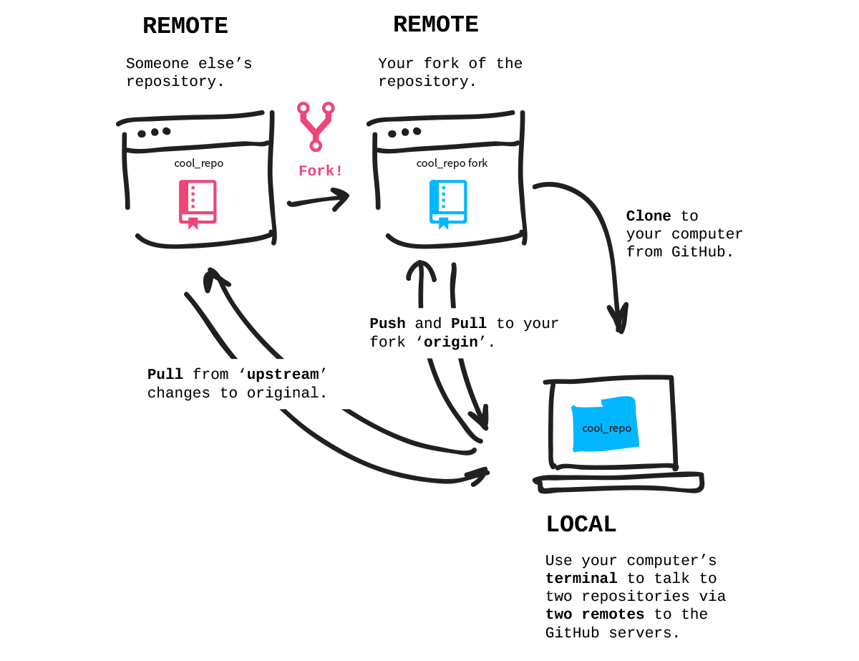

**5.2 Configuration Management (CM) Training**

Proper training is essential for DDM PM to efficiently accomplish their tasks. Training needs are determined by matching skill requirements for a specific task against the skills of the assigned personnel.

|  |  |  |  |
| --- | --- | --- | --- |
| **Training** | **Type of Training** | **Description** | **Level** |
| GIT EXTENSIONS User Training. | Classroom and one on one | Training on the use of GIT EXTENSIONS in a UCM environment. | Basic & Intermediate |
| GitHub User Training | Classroom and one on one | User training on the DDM procedures for CM as implemented in GitHub. | Basic & Intermediate |
| GIT EXTENSIONS for Change Management | Classroom and one on one | User training on DDM procedures for Change Request management as implemented in GIT EXTENSIONS. | Basic & Intermediate |
| Configuration Control Process Training | Classroom and one on one | Informational to introduce CCB members to an overview of the CCB, its intended purpose, and roles and responsibilities. | Basic & Intermediate |
| CM Processes and Procedures Training | Classroom and one on one | User training on CM processes and procedures to PMO | Basic & Intermediate |

**Table 5-2: Configuration Management (CM) Training Needs**

Section 6.0: Configuration Management Plan Maintenance

The DDM CM Manager is responsible for the development and maintenance of this plan. The CMP will continue to be updated as needed throughout the entire DDM lifecycle to ensure the relevance and adequacy of the CMP to plan and manage CM activities. Scheduled updates to the CMP will follow the projected dates listed in WBS. The DDM CMP is under CM control.

**Folder structure**



ReadMe.txt

WorkSpace

Documents

Master

Testing Branch

Development Branch

**Folder structure Second Week**



Documents

WorkSpace

Documents



WorkSpace

ReadMe.txt

Documents

Second Week

ReadMe.txt

Version 1&2

