Project Plan

Client: <Ramadan Mostafa >

Project Name: <Digital Distance Measurement>

Project Manager: <Mohamed Hassan>

Synopsis: <This is initial Plan, and will be updated regularly as per any change>

Version: <PP.0.1 >

Issue Date: <2-4-2018>

Distribution: <All project aspects considered>

Prepared by: <Omnia Yehia>
<Mona Ahmed>
<Mostafa Emam>

Authorized by: <Automation Test Engineer / Ramadan>

<Process Improvement Engineer / Mohamed Hassan>

Amendment History
v
Version Issue Date Changes
<PP.0.1> <2/4/2018> Initial version.
Table of Contents
1 Introduction 1
1.1 Document Purpose 1
1.2 Associated Documents 1
1.3 Project Plan Maintenance 1
2 Project Scope 2
2.1 Outline of Client’s Objectives 2
2.1.1 Objectives 2
2.1.2 Success Criteria 2
2.1.3 Risks 2
2.3 Out of Scope 2
3 Deliverables 3
3.1 To client 3
3.2 From client 3
4 Project Approach 4
4.1 Project Lifecycle Processes 4
4.2 Project Management Processes 4
4.3 Project Support Processes 4
4.4 Organization 4
4.4.1 Project Team 4
4.4.2 Organization Objective 4
5 Communications Plan 5
6 Work Plan 6
6.1 Work Breakdown Structure 6
6.2 Resources 6
7 Milestones 7
8 Performance and Metrics 8
9 Risks, Constraints, Assumptions 9
9.1 Risks 9
9.2 Constraints 9
9.3 Assumptions 9

Introduction

Document Purpose
It is a plan documentation for a multi-phased project, it will be the guide and reference to all stockholders through the project, and it will be updated if any change requested.

Associated Documents
There are five Documents associated to the Project Plan
- Test Plan Document.
- Configuration management plan.
- WBS.
- Configuration management plan.
- RASIC.

Project Plan Maintenance
Every week, we have a meeting with our Client as we are working Agile, so if our client request any change in the project plan, it will be updated from all team members.

Project Scope

The Scope from perspective of "Advanced Solution” is a lead sensors system company that serves many customers in different regions. Company is searching for a simple solution of digital distance-velocity measurement system. So there are no specific target users. Users can be uneducated and have no technical expertise at all. Product is simple and can suit all user segments

Outline of Client’s Objectives

Objectives
The objectives here that client is to be able to measure the distance and velocity (the maximum distance to measure is 4 meter) and projected area of the target object should exceed Effectual Angle of the ultrasonic sensor used.
The output will appear in two different LCDs (one for distance and the other for velocity).

Success Criteria
Customer will accept the product as per following criteria:
- The reading in the LCD screen is updated as long as device on and moving.
- The error rate of the readings to the distance and velocity won't increase by 5.

Risks
Hardware failures and cost issues are the most common risks which our client is make it in consideration, and we make mitigate to these risks defined in risk (section 9).

Out of Scope
- We have specific range to ultrasonic sensor to detect the object within it, so any object not within range considered out of scope.
- Our concern in measuring distance and velocity to a single object, so any more objects are out of scope.
- Security testing isn't our major.
- Performance testing isn't our major.
- Automation Testing isn't our major.

Deliverables

To client
The deliverables:
- Approved SRS.
- Project Planning documents.
- Design documents.
- Code.
- Testing documents.
- Hardware prototype.

From client
- CRS.
- Review of documents.
- Provision of Hardware.
- Budget.

Project Approach

Project Lifecycle Processes
In the project we are working using V-Model Life cycle as the shape below:
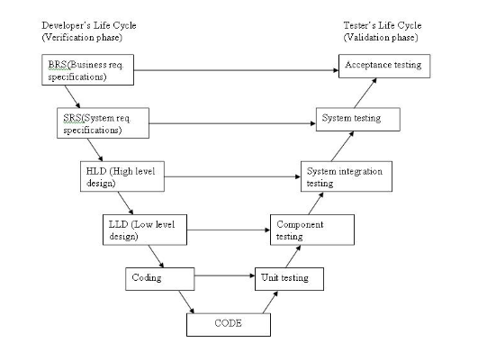

The various phases of the V-model are as follows:
Requirements like BRS and SRS begin the life cycle model just like the waterfall model. But, in this model before development is started, a system test plan is created. The test plan focuses on meeting the functionality specified in the requirements gathering.
The high-level design (HLD) phase focuses on system architecture and design. It provide overview of solution, platform, system, product and service/process. An integration test plan is created in this phase as well in order to test the pieces of the software systems ability to work together.
The low-level design (LLD) phase is where the actual software components are designed. It defines the actual logic for each and every component of the system. Class diagram with all the methods and relation between classes comes under LLD. Component tests are created in this phase as well.
The implementation phase is, again, where all coding takes place. Once coding is complete, the path of execution continues up the right side of the V where the test plans developed earlier are now put to use.
Coding: This is at the bottom of the V-Shape model. Module design is converted into code by developers. Unit Testing is performed by the developers on the code written by them.
Advantages of V-model:
Simple and easy to use.
Testing activities like planning, test designing happens well before coding. This saves a lot of time. Hence higher chance of success over the waterfall model.
Proactive defect tracking – that is defects are found at early stage.
Avoids the downward flow of the defects.
Works well for small projects where requirements are easily understood.

Project Management Processes
During the Planning Phase, information is gathered from many sources with each having varying levels of completeness and confidence. The planning processes identify, define and mature the project scope, project cost, and schedule the project activities. As new project information is discovered, additional dependencies, requirements, risks, opportunities, assumptions and constraints will be identified or resolved. As more project information or characteristics are gathered and understood, follow-on actions may be required. Significant changes occurring throughout the project life cycle trigger a need to revisit one or more of the planning processes and, possibly, some of the initiation processes like (Traceability Matrix, SRS, Project Plan, Test Plan, Configuration management plan) and of course any change updated in configuration management)

During planning all appropriate stakeholders should be involved, depending on their influence on the project and its outcomes.

Project Support Processes
Living Announcement and Meeting Agenda documents will be constantly updated on Configuration management as a means to support project vision and maintain schedule work unit deadlines. Gitextensions will be used for version control for all code.

Organization

Project Team members

Testing Team | Role | Development Team | Role
1-Omnia | Team Leader | 1-Mostafa M.Emam | Team Leader
2-Mona | Member | 2-Yasmeen | Member
3-Mahmoud | Member | 3-Ahmed Ramdan | Member
4-Mina | Member | 4-Feloparteer | Member
5-Israa | Member | 5-Esraa | Member
6-Ahmed Osama | Member | 6-Ahmed Eldakkak | Member

Organization Objectives
- Accountability: Ensuring that weekly work unit deadlines are met.
- Accuracy: Ensuring that work units are traceable to end-phase deliverables requirements.
- Efficiency: Ensuring that no excessive or redundant work is performed.
- Quality Assurance: Ensuring that all work units completed are free of defects.
- Communication: Ensuring low latency communication between and within the team.

Communications Plan
Between the team members:
- Meeting is held every 2 days.
- Use Configuration management to enable working with no conflict and this section is described in CM plan.

Between Leaders and Client:
- Use configuration management as a viewer.
- SIQ to make a direct channel of questions and answers.
- By mail with team leader.
- Weekly meeting.
Table in template
This section may also describe a process by which constant monitoring of the effectiveness of the project communications is undertaken.

Work Plan
In this section we identify the tasks to undertake the project, and how resources are mapped to these tasks, together with other non-people resources that are needed.

Work Breakdown Structure
Referring to WBS (WBS V1.0.0).
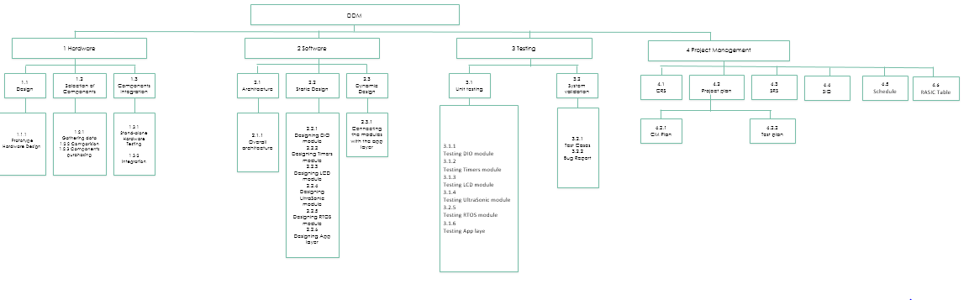

Resources
 | Resource | Role
1 | Moustafa Mohammed Emam | Development Team leader
2 | Ahmed Ramadan | Development team member
3 | Yasmin Alaa-Eldin | Development team member
4 | Esraa El-beltagy | Development team member
5 | Ahmed Samir El Dakak | Development team member
6 | Felopater Nagy | Development team member
7 | Omnia Ahmed Yehia | Test team Leader
8 | Mona Ahmed Mohammed | Test Team Member
9 | Esraa Essam El-deen | Test Team Member
10 | Ahmed Osama | Test Team Member
11 | Mahmoud Ibrahim | Test Team Member
12 | Mina Adly | Test Team Member
13 | Altrasonic Sensor | Equipment
14 | Microcontroller | Equipment
15 | Button | Equipment
16 | LCD | Equipment
17 | Gitextensions | CM tool

Milestones
At first we divided the project to 4 iterations, so there will be 4 milestone to our working and at each milestone there is meeting with our client and the following Table describes our milestone:

Milestone number | Title | Forecast date
First Milestone | <Approve SRS> | 6-April-2018
Second Milestone | <Design and high level test cases> | 13-April-2018
Third Milestone | <Coding and detailed test cases> | 20-April-2018
Fourth Milestone | <Implementation and validation> | 27-April-2018

Performance and Metrics
In this Version we just begin our working, in the next versions there will be performance chart to out progress.
What performance requirements are there on the project, if any, and why. What metrics is the project going to collect, how will they be collected, and what will they be used for.

Risks, Constraints, Assumptions

Risks
Risk ID | Risk Description | Mitigation Plan (what to do to avoid the risk occurring) | Contingency Plan (what to do if the risk occurs) | Impact (what the impact will be to the project if the risk occurs) | Likelihood of occurrence
R1 | Infeasible design | The basic design should be well defined and flexible to take into consideration some future customer adjustments if needed. | Redesign the whole project. | High impact.  Recoding and redesigning the whole project which in return leads submission to be late and not meeting the deadlines. | Low
R2 | Unrealistic schedule estimates or allocation | Put a sufficient schedule plan depends on the team resources and customer outline. | Rescheduling of the estimates and/or reallocation of the resources. | High impact.  Not submitting the project phases on time. | Medium
R3 | Cost or funding issues | Make a detailed financial plan then set an agreement with the customer about it. | Renegotiation with the customer about the product cost. | High impact.  Unprofessional reputation. | Low
R4 | Uncertain requirements | Make a shared SIQ form with the customer to reply to all inquiries. | -Avoided- | -Avoided- | -Avoided-
R5 | Hardware failure | Make sure that the hardware is working fine before usage and Test it before and after development. | Buy a new hardware. | Low Impact.  Pay more money to get a new hardware. | Low
R6 | Insufficient QA time to validate | Make sure that in the project schedule there is a good and clear time for testing. | Ask for extended working hours to the QA team until the main test cases are finished. | High Impact.  If the customer detected a major bug while testing the project the team’s reputation will be damaged. | Low

Constraints
9.2.1 Technical Constraints
- Hardware constraints: LCD screen, Microcontroller, battery, ON/OFF switch and the necessary electronic components to build the system.
- LCD has the size of 2*16.
- A non-rechargeable battery is used to power the system.
9.2.2 Managerial Constraints
1. The Testing team makes validation testing.
2. The development team makes unit testing and integration testing.
3. Personal schedule conflicts between team members.
4. Personal lives of team members.
    - Functional Constraints
- The displayed output Value must be in a specific format given in the SRS.
- It’s a Real time system that the value of distance and velocity changes with changing of the target object related to the final product.

Assumptions

Assumptions from Technical view can be limited to the following:
- The output accuracy of calculated distance and velocity is limited by the selected ultrasonic sensor and microcontroller characteristics.
- The output range of the calculated distance and velocity is limited by the selected ultrasonic sensor, microcontroller characteristics.
Assumptions from Team members view can be limited to the following:
- Team members will be cognizant of project schedule deadlines.
- Team members will stay healthy and remain physically capable of carrying out assigned duties.
- Team members will respond to communications from other team members in a timely fashion.
- Team members remain motivated through the duration of the project.
- Team members will always have access to the necessary tools to complete their assigned work units.
- The group will not lose any team members.

