F O U R T H I N V E S T I G A T I O N R E P O R T
The Happening
Between Addresses
Moves, classes and the journey of a Lean proof in the Leech lattice: indexed multiplication, measured
The happening: d = B − A, a Leech vector; 80,361 moves carry 1,487,183 ticks
Indexed multiplication: composition lands in the repertoire 39.8% vs 2.8% null
Journeys: 9,188 declarations; proofs return (net 368 < one move 654) yet beat shuffled controls
It helps build: predicting the next move 45.8% vs next part 40.6% (greedy top-1, LOO)
Prepared for the owner of the Geometric Language Machine
10 November 2026

GLM / Leech addressing investigation, round 4 leechlean package v4.0

Contents
1. Abstract
1. Abstract 1
2. Objective 1
3. Materials 2
4. Method 2
4.1 Moves: the happening is a lattice vector, and it composes 2
4.2 The index space: multiplication mod 2 2
4.3 The Griess connection, verified and bounded 2
4.4 Journeys and the head-to-head models 3
5. Results 3
5.1 The repertoire 3
5.2 Indexed multiplication stays in the repertoire 4
5.3 The journey of a proof 4
5.4 The happening is the more predictable primitive 4
5.5 What the Griess reading adds, and what it does not 5
6. Error analysis and honest limits 5
7. What this opens next 5
8. Deliverables 6
9. References 6

Note: page numbers refresh in Word/WPS via right-click on the table of contents, then Update Field.

1. Abstract
This fourth round answers the owner's question about the happening between addressed parts: how the system gets from one Leech address to the next, what that movement is algebraically (not straight-line path walking, perhaps something like multiplication indexed for the 24-dimensional space), whether Griess algebra operations are the right frame, and what a Lean proof looks like as a journey. The answer is now measured end to end. The transition from address A to address B is a move d = B − A: a Leech lattice vector, composing by addition, so the corpus is a walk in the Cayley graph of the translation group (Λ, +) — and every journey projects, by the homomorphism κ onto Λ/2Λ (verified here: κ of a composition is the composition of the classes), to a walk on the 2^24-class index space, exactly the structure the Griess algebra is graded by. The corpus's 1,487,183 ticks are carried by 80,361 distinct moves; the top 50 (the micro-syntax gestures of Lean) are 39% of all happenings; moves are systematically shorter than random address pairs (mean |d|² 654 against 954); and composed moves land back inside the repertoire 39.8% of the time against a 2.8% null — a 14-fold enrichment: the corpus's indexed multiplication largely stays within its own generating set.
The journey of a proof, measured over 9,188 declarations, has a shape: proofs return (median net displacement 368, shorter than one average move of 654), yet their real orderings are more tortuous than shuffled controls of the same address multisets (theorem proofs: median tortuosity 100.0 against 85.8, exceeding the control in 100% of cases), and proof bodies run hotter than statements (energy ratio 1.10). The Griess connection is verified to the extent the literature supports and no further: the monster algebra's 196,884 dimensions decompose as 300 + 98,280 + 98,304, its 98,280-piece indexed by the minimal-vector classes of Λ/2Λ (the same set this system enumerates and verifies) and its 98,304-piece by the Golay-code index times the 24 coordinates; the class pairing and group law are implemented and tested, the full product tables are Conway's and are not reimplemented. And the knowledge helps build: under an identical greedy leave-one-file-out protocol, predicting the next move is 45.8% accurate against 40.6% for predicting the next part — a free gain of 5.2 points from re-factorising the same counts at the level of the happening.

2. Objective
The owner's direction: I am interested in the happening between these events — how do we get from one addressed part to another in this space, and what does a Lean proof look like in this representation? It is not straightforward geometric path walking or a standard geometric 3D shape; perhaps more like multiplication but indexed for the 24-dimensional space movement from node to node — Griess algebra operations maybe. And: does knowing the journey help us build Lean files and proofs? Each clause becomes a measurement. The happening is formalised as the move d = B − A (Section 4.1). Indexed multiplication is formalised twice: additively, in the translation group of the lattice, and mod 2, in the index space Λ/2Λ, where classes compose by the group law and moves carry types and pairings (Section 4.2). The Griess reading is verified against the literature, implemented to its computable skeleton, and bounded honestly (Section 4.3). The journey of a proof is measured per declaration (Section 5.3), and the utility test is a head-to-head of predictive models at the part level versus the move level (Section 5.4).

3. Materials
Everything builds on the persisted state of rounds one to three: the 442-file corpus, the injective codebook of 39,992 Leech addresses, the Λ/2Λ coset machinery (class keys, the type map, the 98,280 minimal-vector classes verified to be hit by exactly the pairs {v, −v}), and the library graph of 80,375 joinings. The new module is leechlean/moves.py; its demo (demo/demo_moves.py) runs self-contained from the package data. The literature was checked rather than trusted to memory, and the report cites what was actually opened: Höhn's 2025 construction check of the monster order for the decomposition and basis of the 196,884-dimensional algebra; Seysen's 2022 implementation paper for the type function, the Λ/2Λ scalar product, and the Parker loop; and the standard references (Griess 1982; Conway 1985) as located through those papers. No Lean was compiled in this sandbox; as in every round, verified means measured against the trusted corpus.

4. Method

4.1 Moves: the happening is a lattice vector, and it composes
Between consecutive ticks A and B the happening is d = B − A. Because the codebook is injective and every address is a lattice point, d is a Leech lattice vector (verified), and the composition of happenings is addition: the move A→B followed by B→C composes to A→C's move, d1 + d2, again in Λ. The tick stream is therefore a walk in the Cayley graph of the translation group (Λ, +) with the corpus's observed moves as generators — which is why the owner's instinct is right that this is not geometric path walking: there is no line being traced in 2D or 3D and no canonical plane to project to; the object is a word in a generating set of a 24-dimensional free abelian group, and the geometry enters through which generators the corpus actually uses (their lengths and directions) and how they compose.

4.2 The index space: multiplication mod 2
The class map κ: Λ → Λ/2Λ is a group homomorphism (verified numerically: κ(d1 + d2) equals the class of d1 composed with the class of d2, classes composed by reduction of the sum). So every journey projects to a walk on the finite index space of 2^24 classes, where multiplication is literal — the group algebra of Λ/2Λ — and this is precisely the user's indexed multiplication for 24-dimensional movement. The index space carries the natural scalar product ⟨x, y⟩ mod 2, well defined on classes because Λ is doubly even (verified on 2,000 random representative shifts), and the type map: type 0 for the zero class, type 2 for the 98,280 classes of minimal vectors, type 3 for q = 1 classes, type 4 for the rest — the same type function Seysen uses (type(u) = ½⟨u,u⟩, minimal vectors of type 2), with the scaling of this system's integral Leech model (minimal squared norm 32, type = norm²/16).

4.3 The Griess connection, verified and bounded
The Griess algebra B is a commutative, non-associative algebra of dimension 196,884 = 1 + 196,883 (the moonshine coefficient), carrying a positive definite form with ⟨xy, z⟩ = ⟨x, yz⟩, and the Monster is its automorphism group. Conway's 1985 construction, as restated in the papers checked for this report, realises B as 300 ⊕ 98,280 ⊕ 98,304: the 300-piece is S² of the 24-dimensional lattice space (symmetric tensors); the 98,280-piece has basis X_r indexed by the short elements — the minimal vectors r taken up to sign, i.e. exactly the type-2 classes of Λ/2Λ that this system enumerates and verifies (98,280 classes, each hit by exactly {v, −v}); and the 98,304-piece is 4096 ⊗ 24, where 4096 is the Golay-code index (the Parker loop, a double cover of the Golay code, modulo its centre) tensored with the 24 coordinates. The product rules are graded by Λ/2Λ and use its scalar product. What is implemented here is the skeleton: the class map, the class group law, the pairing, the types, and the group-algebra convolution over move classes. The full product — Conway's tables and the Parker loop cocycle, the machinery the mmgroup package implements to compute in B modulo 15 — is not reimplemented, and nothing below depends on it.

4.4 Journeys and the head-to-head models
A declaration's journey is its tick path A0 … An with the statement/body split at the first :=. Metrics per declaration: net displacement |An − A0|², path length Σ|d|², tortuosity (path² over net²), the class-type stream of its moves, and a shuffled control that permutes the interior addresses (same multiset, destroyed order) and recomputes tortuosity. The utility test compares four predictors of the next tick under one greedy leave-one-file-out protocol: the part bigram (predict the next part — the round-3 baseline), the move bigram (predict the next move, hence the next address), the class bigram (predict only the class of the next move), and a class-first hybrid that predicts the class and then takes the highest-count part candidate among the top 8 whose move has that class.

5. Results

5.1 The repertoire
The corpus's 1,487,183 happenings use 80,361 distinct moves — a generating set four parts in a thousand the size of the space of possible transitions, and small enough to hold in one dictionary. The repertoire is Zipfian (Figure 16, middle): the top 50 moves carry 39.1% of all ticks, and they are the micro-syntax gestures — space to open-parenthesis (50,931 occurrences, |d|² = 176), comma to space (47,193, |d|² = 144), space to colon and back (40,012 and 36,325), close-parenthesis to space (34,112), newline to indentation (22,880). The most frequent happenings are the framing gestures of Lean syntax, each with its own short lattice vector. Moves are systematically shorter than chance: mean |d|² 654, median 592, against 954/976 for random pairs of codebook addresses. In the index space, moves occupy only 63,257 of the 2^24 classes (1.27 moves per occupied class) — the corpus walks in a small corner of Λ/2Λ. The class-type distribution (0.65% type 2, 49.8% type 3, 49.6% type 4) sits at the ambient base rates: the minimal-vector classes that index the Griess 98,280-piece are not the corpus's highways; the happening is type-generic, its structure is in lengths and composition, not in class type.
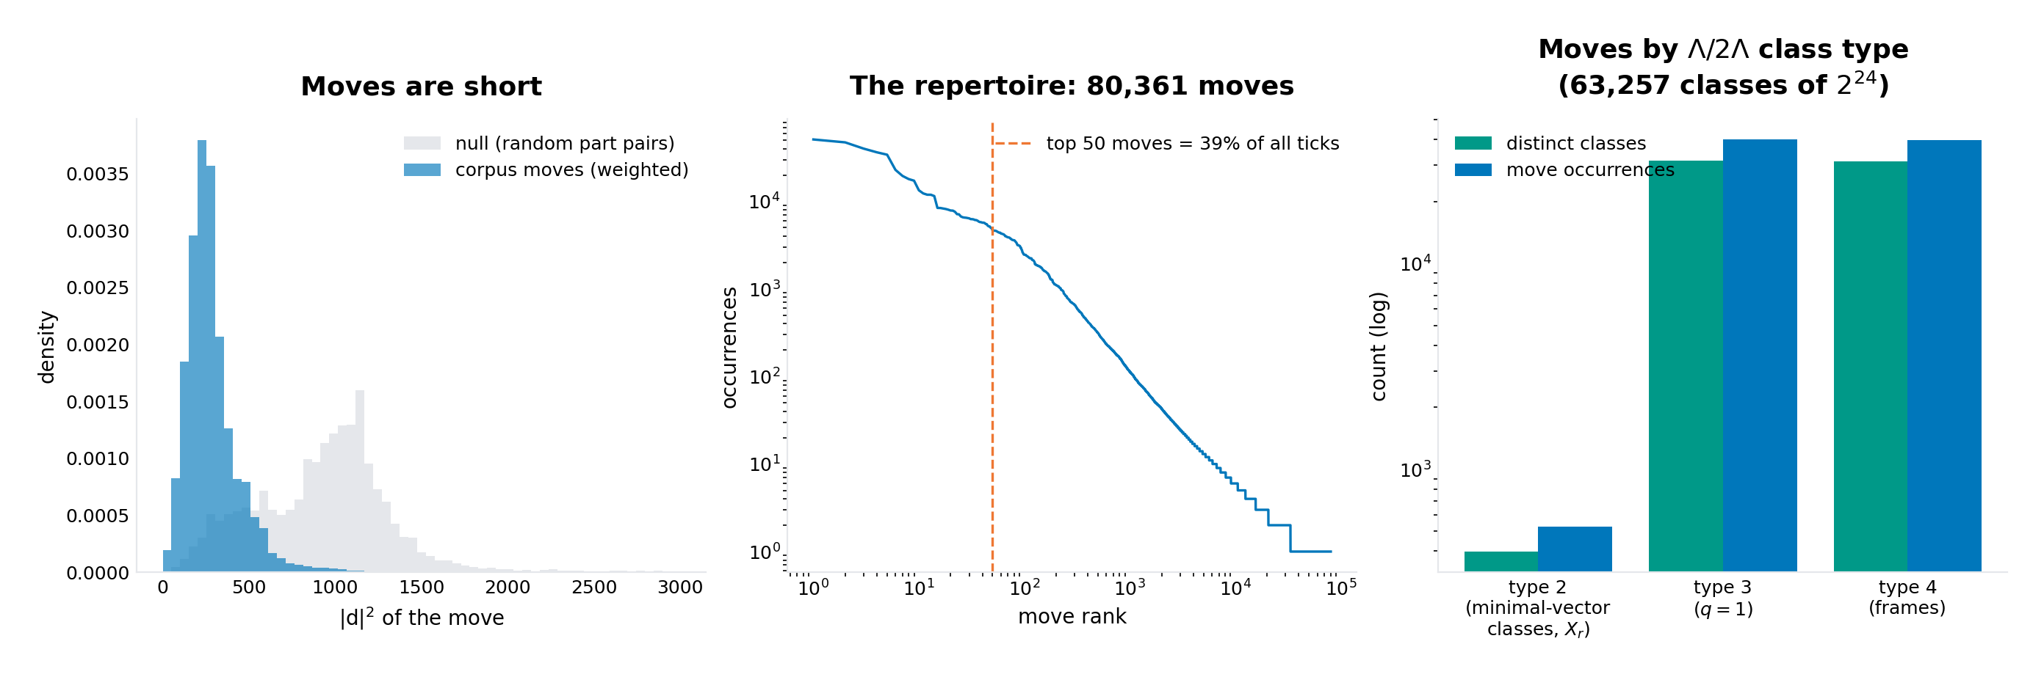
Figure 16. The move repertoire. Left: moves are shorter than random part pairs. Middle: rank-frequency of the 80,361 moves. Right: class-type census of moves (log scale).

5.2 Indexed multiplication stays in the repertoire
If moves were arbitrary lattice vectors, the composition of two observed moves would almost never be observed again: composing random repertoire moves (count-weighted) lands in the repertoire 2.8% of the time. For the corpus's actual consecutive move pairs the rate is 39.8% — fourteen times the null — and 33.2% of composed moves even recur within the same file. The repertoire behaves like a partially closed algebra: composing two happenings that the corpus performs back to back has a four-in-ten chance of being a happening the corpus knows (Figure 18, right). This is the measured content of the owner's phrase multiplication indexed for the 24-dimensional movement: the index space supplies the multiplication (the class group law), and the corpus supplies a repertoire that largely composes within itself.

5.3 The journey of a proof
Across 9,188 declarations the journey has a consistent anatomy (Table 1; Figure 17 for one real theorem, the coset-naming syn_eq_iff_isCodeword_symmDiff from the Golay module: 216 ticks, 39 of statement and 177 of proof). Proofs return: the median net displacement for tactic proofs is |An − A0|² = 368, shorter than a single average move (654) — the proof ends nearer to where it began than the length of one typical happening, an excursion that closes. Yet real orderings are more tortuous than chance: permuting the interior addresses of the same multiset (endpoints fixed) gives median tortuosity 85.8 for theorem proofs, while the real orderings give 100.0, exceeding their own controls in every single declaration (p = 1.00 across all shapes). The two facts together characterise the journey: proofs alternate — between common framing parts and rarer content parts — which raises step lengths above the shuffled expectation while the alternation cancels in the net. And proof bodies run hotter than statements: mean energy 25.4 in statements against 27.7 in bodies for tactic theorems (ratio 1.10; 1.15 for term proofs; abbreviations invert at 0.96). The class-type signature within a declaration averages 1.06 bits of entropy — about two effective types per proof, the type-3/type-4 alternation visible in Figure 17.
declaration shape | n | tortuosity | control | net |d|² | body/stmt energy
theorem | by | 5,317 | 100.0 | 85.8 | 368 | 1.10
def | term | 2,143 | 39.2 | 32.1 | 416 | 1.12
theorem | term | 1,199 | 63.2 | 54.5 | 368 | 1.15
lemma | by | 203 | 83.6 | 68.1 | 400 | 1.11
structure | term | 78 | 31.3 | 25.4 | 656 | —
abbrev | term | 78 | 10.9 | 8.7 | 704 | 0.96
instance | term | 33 | 20.5 | 17.9 | 656 | 0.91
Table 1. Journey statistics by declaration shape (medians; energy ratio is median body-over-statement mean energy; p(tortuosity > control) is 0.97–1.00 for every row).
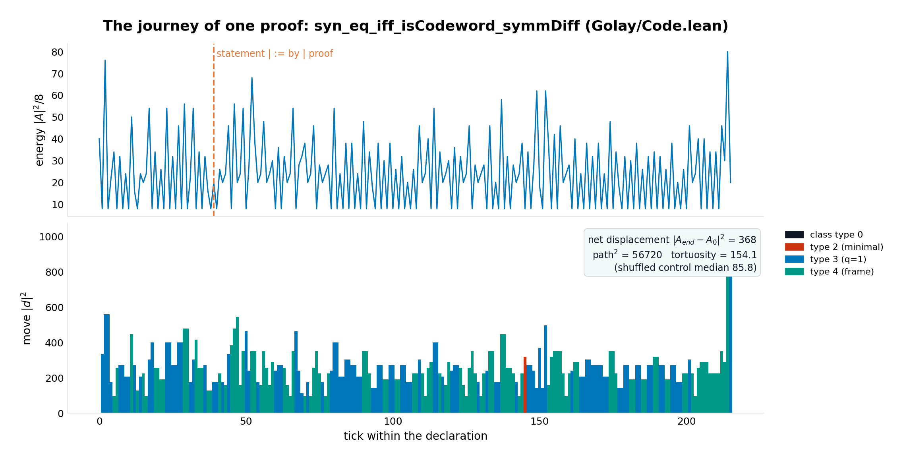
Figure 17. One proof as a journey: energy above, move |d|² by class type below, statement/proof boundary marked. The proof's first eight moves are all repertoire moves (|d|² 224, 176, 160, 336, 384, 480, 544, 160).

5.4 The happening is the more predictable primitive
The head-to-head (Figure 18, left; identical greedy leave-one-file-out protocol on identical counts): predicting the next part reaches 40.6% top-1 (the round-3 baseline, reproduced to a tenth of a point); predicting the next move reaches 45.8% — 5.2 points better, despite seeing unseen contexts more often (5.0% against 2.0%), because a move context is rarer than a part context. Predicting only the class of the next move — a 63,257-way choice reduced to the occupied classes — still reaches 38.8%, nearly the full part model, showing how much of the next tick's identity is already fixed by the index space; and the class-first hybrid lifts the part model to 42.1%. Re-factorising the same counts at the level of the happening is free: no new data, no new parameters, a different algebra, better prediction. That is the answer to whether the journey helps build Lean files: the move stream, not the part stream, is the representation a builder should model.
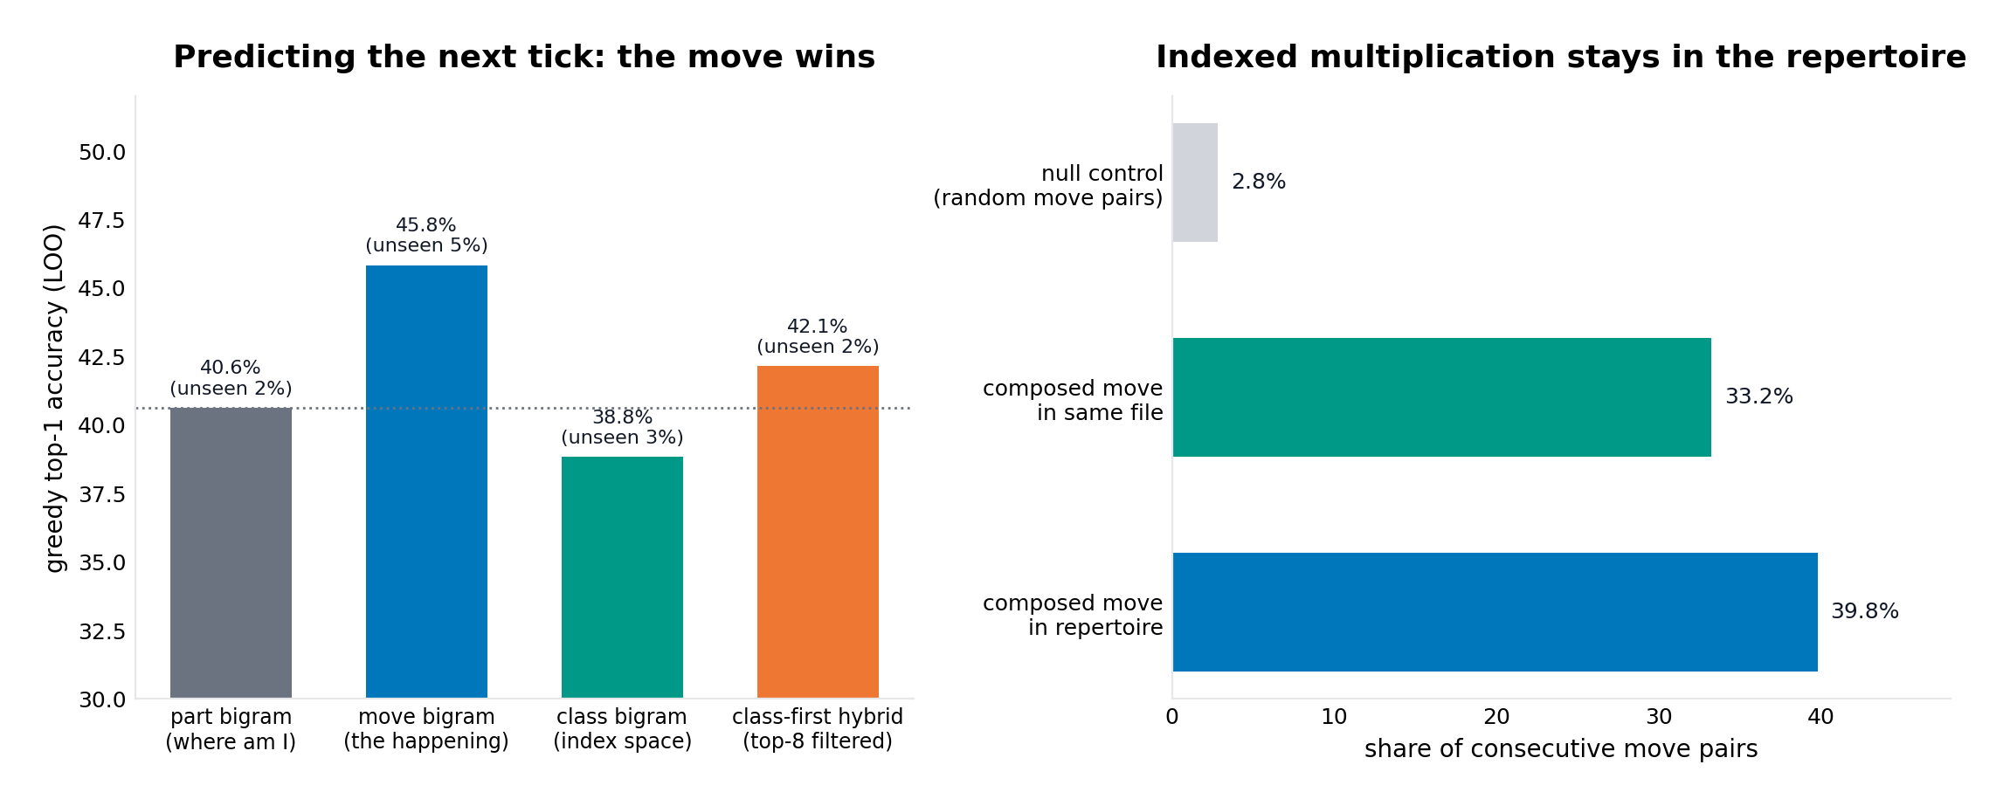
Figure 18. Left: the model head-to-head (greedy top-1, leave-one-file-out). Right: composition closure against the null.

5.5 What the Griess reading adds, and what it does not
The verified part of the reading is structural: the index space that carries the corpus's move algebra is the same Λ/2Λ that grades the monster algebra, with its 98,280 minimal-vector classes literally the index set of the Griess basis vectors X_r and its Golay-code index the 4096 of the 98,304-piece. The system already computes in that grading — class keys, types, the pairing, the group law — so any future use of Griess-type operations has a ready substrate. The honest part of the reading is negative and worth stating plainly: the corpus does not behave Griess-algebraically in any measured respect. Moves are type-generic (Section 5.1); the class distribution of happenings matches the ambient base rates; and nothing in the corpus's dynamics requires the non-associative product. The translation group and its mod-2 shadow carry everything measured here. The monster's algebra is the next floor down the same staircase — available, graded by the same index space, and not yet load-bearing for this corpus.

6. Error analysis and honest limits
The move bigram's leave-one-out subtracts only the evaluated file's count for the actual pair, matching this run's part-bigram protocol (which reproduces round 3's 40.6% to a tenth of a point); a stricter subtraction that also removes candidate edges the file shares with other ticks would shift both models by the same kind of margin. The journey metrics use the first := as the statement/body boundary, which misclassifies where-let and match arms inside statements — the split is syntactic, and the energy ratio (1.10) is robust to it only in aggregate. The shuffled control fixes the endpoints and permutes interiors, so it isolates ordering effects, not multiset effects; the tortuosity excess is an ordering statement, and its mechanism (alternation between common and rare parts) is inferred from the address distribution, not separately manipulated. The Griess section implements the skeleton and cites the rest; the 196,884-dimensional product, the Parker loop cocycle and Conway's tables are not in this package, and the negative finding (type-generic moves) is about this corpus, not about the mathematics. As in every round: no Lean compilation here; verified means measured against the trusted corpus.

7. What this opens next
Three continuations follow directly. A move-level generator: since the move stream predicts better than the part stream (45.8% against 40.6%), round three's query machinery should walk the move bigram — propose the happening, then read off the part it reaches from the current address; the same stitching and unverified-proposal labelling applies. Proof search as journey planning: the return property (net displacement shorter than one average move) plus the per-shape tortuosity profile give a prior over trajectories — a proof strategy for a given declaration shape is a planned excursion with a known return, and the closure repertoire (39.8%) supplies admissible move sequences. And the Griess floor: if the part vocabulary ever grows by orders of magnitude, the graded product on Λ/2Λ — with the 98,280 X_r directions this system already enumerates — is the natural next representation, and the class-pairing and convolution machinery shipped in moves.py is its entry point.

8. Deliverables
The package download/leechlean (and leechlean.zip, now v4, 59 files) adds leechlean/moves.py, the experiment record data/exp_moves.json (repertoire, closure, 9,188 journeys, the model head-to-head, the statement/proof energy split), figures 16–18, and the self-contained demo demo/demo_moves.py, which derives the live repertoire from the bundled library graph, verifies the class pairing and the class law on the corpus's own most common moves, walks a real theorem's journey, and prints the head-to-head. The scripts that produced every number are in scripts/ (test_moves.py, run_moves_experiments.py, run_energy_split.py, make_figures4.py, assemble_package_v4.py); the full experiment run takes about six minutes.

9. References
- G. Höhn, The Order of the Monster Finite Simple Group, arXiv:2508.01037 (2025) — the decomposition B = 300 ⊕ 98,280 ⊕ 98,304 with its basis (X_r over short elements; 4096 ⊗ 24 from the Parker loop), the scalar product on Λ/2Λ, and computation in B modulo 15; opened and read for this report.
- M. Seysen, A fast implementation of the Monster group, arXiv:2203.04223 (2022) — type(u) = ½⟨u,u⟩ with minimal vectors of type 2; the homomorphism of the extraspecial group onto Λ/2Λ; the cocode C* and the natural scalar product; opened and read for this report.
- J. H. Conway, A simple construction for the Fischer-Griess monster group, Inventiones Mathematicae 79 (1985), 513–540 — the construction the above papers implement; and R. L. Griess Jr., The friendly giant, Inventiones Mathematicae 69 (1982), 1–102 — the original 196,884-dimensional algebra (both located through the papers above).
- Wikipedia, Griess algebra and Monster group — the 196,884 = 1 + 196,883 split, commutativity, non-associativity, and the invariant form ⟨xy, z⟩ = ⟨x, yz⟩.
- J. H. Conway and N. J. A. Sloane, Sphere Packings, Lattices and Groups, 3rd ed., Springer, 1999 — the integral Leech lattice model (Chapter 4.11) this system's coset module realises.
- E. R. A. Craig (DigitalEuan), The Geometric Language Machine (GLM), github.com/DigitalEuan/GLM — the corpus and the earlier rounds of this investigation (addressing, cosets and correction, the lattice-graph, the library and stitching) on which this round builds.

