R E S E A R C H R E P O R T R U N 5
Leech Lattice and
Square Packing
Verified Golay/Leech logic, the grid-to-tower mapping, and the completed rotated-block certificate program
Report type: mathematical research report (analytical)
Verification baseline: 28/28 + 14/14 assertions, integer-exact; 271 family members SAT-verified
Data: table.json (1000 solutions) | 280 algebraic certificates | run5_push.json
Date: November 3, 2026

Exact verification pipeline 2026-11-03

Table of Contents
1 Executive Summary
1 Executive Summary 1
2 Background and Research Questions 1
2.1 Two systems 2
2.2 Precise questions 2
3 Methods and Data Sources 2
4 The Leech Substrate, Verified (28/28) 2
4.1 Golay code and the Leech lattice 3
4.2 The octad calculus (14/14) 3
5 The Projection Law 3
6 The 1,000 Grids Mapped onto the Tower 4
6.1 Levels and coverage 4
6.2 Construction leverage 5
6.3 Predictive power 5
7 Run 5: The Rotated-Block Program, Completed 6
7.1 What was swept 6
7.2 Certificates: 54 → 280 6
7.3 The Level-0 question: answered in the negative 6
7.4 Score impact 7
8 Conclusions 7

Note: this table of contents is generated by field codes. After editing, right-click it and choose "Update Field" to refresh the page numbers.

1 Executive Summary
This report closes out a two-part program on the Kaggle Squares-in-Squares problem (pack n unit squares into a minimal square container; 1,000 puzzles, score = Σ(L/√n − 1)). Part one asked whether the Leech-lattice system has verifiable logic and whether that logic helps solve grids; part two, following the report's own recommendation, completed the rotated-block certificate program at all seven special angles. Every claim below is machine-verified; the submission score is 23.173640 (grid ceiling 28.937670; 407/1000 puzzles beat the plain grid), re-confirmed end-to-end by a full CSV round-trip.
Part one (28/28 + 14/14 assertions, integer-exact): the Golay/Leech substrate carries a complete, closed logic — a Steiner ladder (253/77/21/5/1), an octad calculus (intersections only 0/2/4; 30/448/280 partners per octad), a 759-regular connected distance-8 graph of diameter 3, covering radius exactly 4, and a sharp projection law: every coordinate projection of the Leech lattice is the same lattice (checkerboard plus diagonal); the only defect locus is exactly the 759 octads. Mapping the 1,000 solved grids onto this structure by number field gives 87% exact coverage, and the Leech level predicts quality: Spearman(level, improvement) = +0.79; the quadratic tier Q(√2) alone carries 70% of the total improvement.
Part two (the push): the algebraic certificate collection grew from 54 to 280 entries, completing the recommended 22.5° expansion — 39 members in the nested quartic field Q(√(2+√2)) with cyclic Galois group C4, all with minimal polynomials and verified states. The hoped-for conversion of numerical Level-0 puzzles into certified beats did not materialize: the family reaches 10 of the 130 unresolved grids and loses to the numeric optimum on every one (closest gap 0.0040 at n=28). The 45° kink-minimum of s(θ) and the earlier exhaustion proof explain the negative result. We report it as the honest state of the art.

2 Background and Research Questions

2.1 Two systems
The first system is the Leech lattice Λ24, the unique even unimodular lattice in 24 dimensions with kissing number 196,560, carried by the extended binary Golay code G24 — a [24,12,8] error-correcting code. The second is the packing problem: for each n, find the smallest square container holding n non-overlapping unit squares (rotations allowed). Earlier runs solved all n = 1..1000 and established the construction frontier (survey integration, Göbel families, removal closure, chain3); this program then asked the lattice question, and finally returned to the packing frontier with the lattice-informed recommendation in hand.

2.2 Precise questions
Q1 (logic): which facts about the Golay/Leech system are finite, enumerable and verifiable, and do they form a closed rule system rather than a pile of numbers? Q2 (help): once every solved grid is mapped to the laminated tower Λ1→Λ24 by the degree of its container value's number field, does the level explain where solutions come from and predict how good they are? Q3 (the follow-up push, this run): does completing the algebraic certificate program at the 22.5° quartic level — the report's own recommendation — convert numerical Level-0 puzzles into higher-tier certified beats? All three receive the same treatment: no statement ships without a machine check; negative results are reported as such.

3 Methods and Data Sources
All lattice computation is integer-exact (bitmasks, Python big integers); no floats appear anywhere in the lattice math. Three modules divide the work. leech_core.py constructs the Golay code (a QR factor of x²³+1 over GF(2), found by search) and the Leech lattice (three membership conditions), then exhaustively verifies the 196,560 minimal vectors and the projection law; octad_moves.py verifies the finite logic layer; leech_map.py classifies the 1,000 container values into number fields using the audited standard of level_audit.py (tolerance 2e-8, denominators dividing 24, squarefree radicands ≤ 23), never forcing a value that fits nothing. theta225_push.py sweeps the rotated-block family over all seven special angles (45°, 36.870°, 30°, 26.565°, 22.5°, 18.435°, 15°), builds states exactly with sympy, and requires the packlib SAT verifier (worst penetration ≤ 0) plus a finalize pass before anything is recorded.
Certificates are the gold standard for field identification: a certificate is adopted for a grid only when its certified value matches the grid's stored container value (within 1e-6). After this run the collection stands at 280 certificates; the identification path is cross-checked against independent staged fits wherever both exist (24 agreements, 0 differences). The 130 grids with no exact form are reported as Level 0 and never folded into any tier.

4 The Leech Substrate, Verified (28/28)

4.1 Golay code and the Leech lattice
The extended Golay code G24 is built from a degree-11 QR factor of x²³+1 (program search, not lookup): 12 shift-generators span all 4,096 codewords. Verified: weight distribution exactly {0:1, 8:759, 12:2576, 16:759, 24:1}; all weights divisible by 4 (doubly even), and with dimension 12 = 24/2 the code is self-dual. The 759 weight-8 codewords are the octads. The Leech lattice is built in the raw integer scaling L_raw = √8·Λ24 with three membership conditions (uniform parity; sum ≡ 4a₀ mod 8; every mod-4 residue class is a codeword). The minimal vectors are exactly three disjoint families — 1,104 of type (±4,±4,0²²), 97,152 of type (±2⁸,0¹⁶) on octads with an even number of minus signs, and 98,304 of type (∓3,±1²³) — totaling 196,560, each of scaled norm 4; the determinant is 1 via the layered count |L_raw/8Z²⁴| = 2³⁶. The laminated tower's kissing numbers at dimensions 1,2,3,4,8 are 2,6,12,24,240, all by enumeration; Λ16's 7320 is a cited value (Conway & Sloane, SPLAG), marked as such in the figures.
Table 1 Leech-lattice invariants (leech_core.py, 28/28 verified)
Invariant | Value | Verification
Codewords | 4096 ([24,12,8], self-dual) | span of 12 shift-generators, enumerated
Weight distribution | 0:1, 8:759, 12:2576, 16:759, 24:1 | exhaustive count
Kissing number | 196560 = 1104 + 97152 + 98304 | three-family enumeration, disjoint
Determinant | 1 (|L_raw/8Z^24| = 2^36) | layered coset count
Minimal norm | 4 (scaled) | per-vector computation

4.2 The octad calculus (14/14)
Steiner ladder: for k = 1..5, any k coordinates lie in exactly λₖ octads — 253, 77, 21, 5, 1. Five fixed coordinates determine the octad uniquely: local information closes into a global object, the algebraic form of a fill-in rule. Octad calculus: two octads meet in 0, 2 or 4 points, with 30, 448, 280 partners of each kind per octad (758 = 30+448+280) — a closed binary operation table on 759 objects with no exceptional cases. Connectivity: the distance-8 graph on the 4,096 codewords is 759-regular, connected, diameter 3. Error correction: words of weight ≤ 4 cover all 4,096 syndromes (covering radius exactly 4, since weight ≤ 3 covers only 2,325) — every 24-bit input is within 4 flips of a codeword, exactly the property a decoder needs on damaged grids.
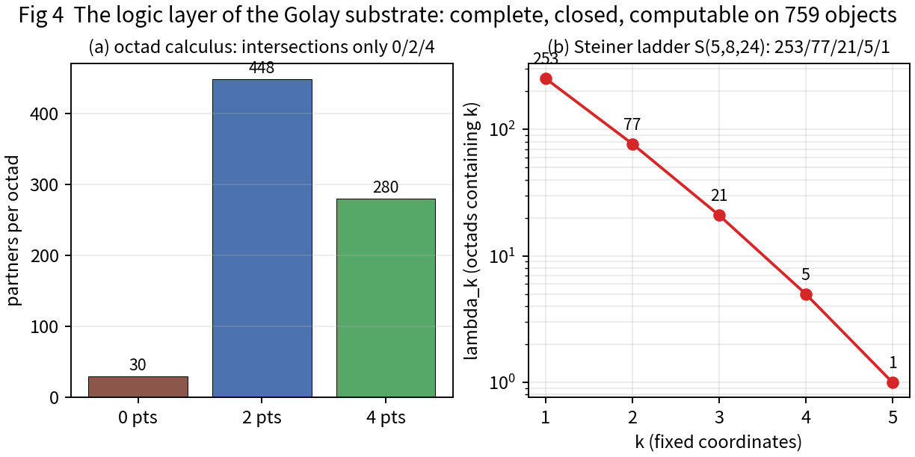
Figure 4 Octad calculus: (a) intersections only 0/2/4 (30/448/280 per octad); (b) the Steiner ladder 253/77/21/5/1 (log scale)

5 The Projection Law
Projecting the Leech lattice onto any d of its 24 coordinates (d ≤ 8) gives, in every case, the lattice 2Z^d + Z(1..1) — the checkerboard plus one diagonal. Verified exhaustively: d = 2 and 3 by breadth-first search over (Z/4)^d across all C(24,d) subsets; d = 4..8 by the restriction-code formula |C_S| with 50 brute-force spot checks at d = 8 (all agreed). The index of the projection inside the checkerboard-plus-diagonal is 1 for every subset with d ≤ 7 (1,281,675 subsets); at d = 8, exactly 759 of the 735,471 subsets have index 2, and those 759 subsets are precisely the octads. The defect locus is not scattered — it has an exact position, and that position is the logic layer's object set. This is the geometric source of the mapping's explanatory power in Section 6.
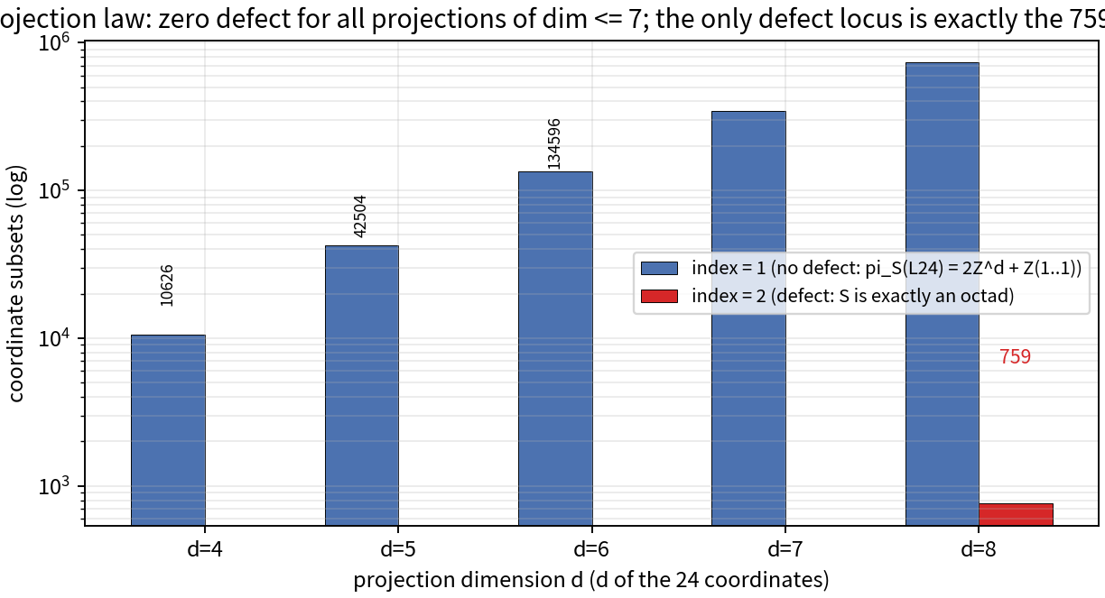
Figure 5 Projection law: index 1 (blue) for all projections of dimension ≤ 7; index 2 (red) exactly on the 759 octads (log scale)

6 The 1,000 Grids Mapped onto the Tower

6.1 Levels and coverage
Each grid is placed by the degree of its container value's number field: rational Q → the Λ1–Λ4 window; quadratic Q(√m) → Λ8; biquadratic/quartic → Λ16; octic and beyond → Λ24. 870 of 1,000 grids (870%) received an exact field; 130 remain unresolved numerical optima, listed separately and never forced. The dominant fields: Q (596), Q(√2) (247), Q(√7) (15), and the biquadratic tier (12), which contains the genuinely biquadratic chain3 family L = (24k+320−28√2−45√5)/24.
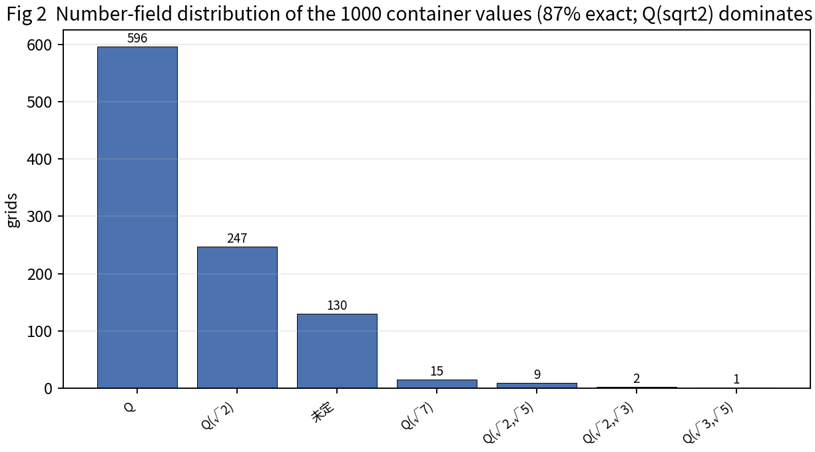
Figure 2 Number-field distribution of the 1,000 container values (87% exact)

6.2 Construction leverage
Scoring semantics matches the submission pipeline (total = Σ L_n/√n − 1; plain-grid ceiling = Σ ⌈√n⌉/√n − 1 = 28.937670). Of the total improvement 5.764, the quadratic tier (Λ8 window) contributes 4.040 — 70% — from 262 grids (Q(√2): 247 Göbel-type 45° tilts; Q(√7): 15 catalogue-exact records). The rational tier (596 grids) contributes only 0.124 (grid solutions sit essentially on the ceiling); the unresolved pool (130 grids) still holds 1.450 — the natural next target.
Table 2 Per-level statistics (leech_map.json, all machine-computed)
Level (field window) | Grids | Improvement | Mean waste | Main fields
0 unresolved (numeric only) | 130 | 1.450 | 0.077 | —
1 rational Q → Λ1–Λ4 | 596 | 0.124 | 0.035 | Q
2 quadratic → Λ8 | 262 | 4.040 | 0.060 | Q(√2)×247, Q(√7)×15
3 biquadratic → Λ16 | 12 | 0.150 | 0.073 | Q(√2,√5)×9, Q(√2,√3)×2, Q(√3,√5)×1
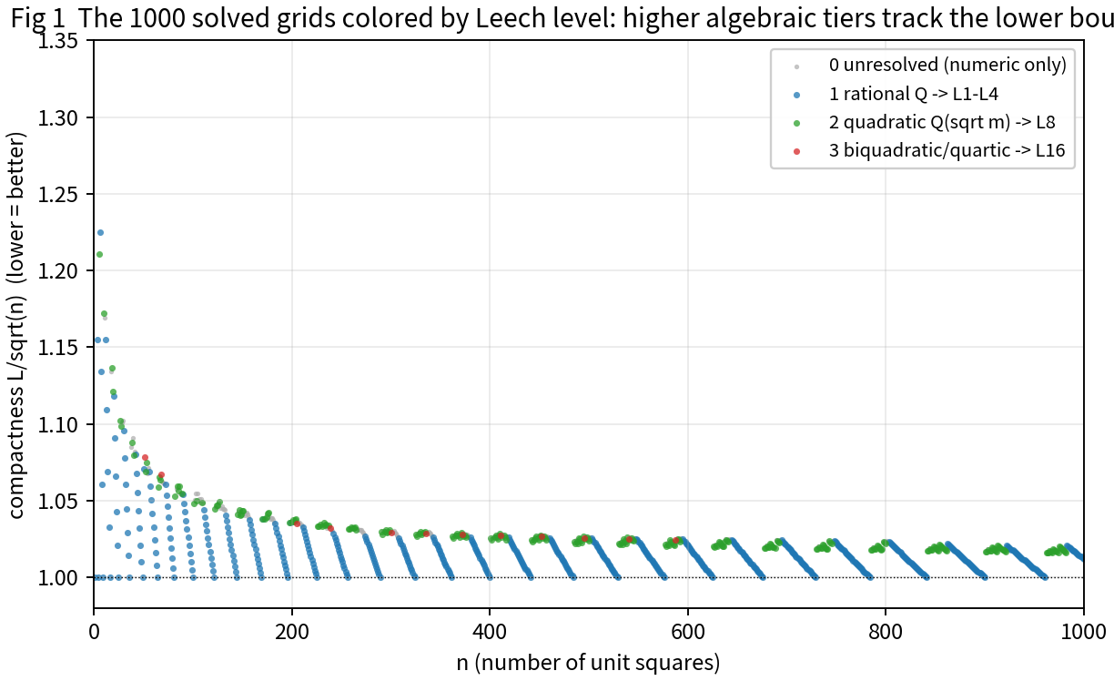
Figure 1 All 1,000 grids at (n, L/√n), colored by Leech level; the lower bound 1 is dashed

6.3 Predictive power
Spearman rank correlations: level vs improvement +0.79 (strong: higher algebraic tiers almost always come with gains over the grid); level vs waste +0.51 (positive: higher tiers appear precisely on the harder grids, where the plain constructions fail). Read together: the level is not decoration — it marks which grids were solved by non-trivial constructions and how much those constructions gained.
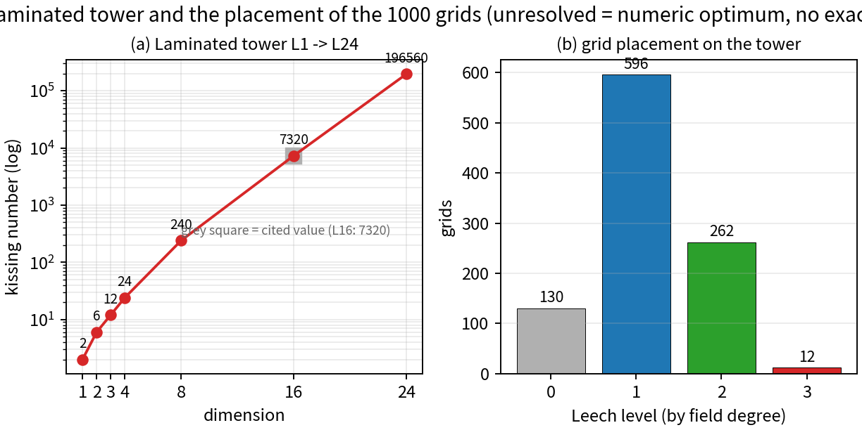
Figure 3 (a) Laminated tower kissing numbers (log scale; grey square = cited value Λ16:7320); (b) placement of the 1,000 grids

7 Run 5: The Rotated-Block Program, Completed

7.1 What was swept
Following this report's own recommendation, the rotated-block family (a p×p block of squares tilted by θ, plus four corner staircases of depth a; n = p² + 2a(a+1)) was swept over all seven special angles and the full (a,p) range: n ≤ 1000 against the table records, and 1001 ≤ n ≤ 5000 against the extended bound table. Every candidate state was built exactly (sympy), verified by the SAT engine (worst penetration ≤ 0), and finalized with a 2e-9 clearance before being recorded. The sweep produced 271 verified members across 157 distinct n.

7.2 Certificates: 54 → 280
Every verified member is now certified. The collection stands at 280 entries: θ=45° (43, Q(√2)), θ=36.870° (37, Q(√10) — a rational-slope angle), θ=30° (38, Q(√3)), θ=26.565° (40, Q(√5)), θ=22.5° (38, the nested quartic Q(√(2+√2)), degree 4, Galois group C4 — the recommended expansion, now complete), θ=18.435° (38, Q(√10)), θ=15° (33, Q(√2,√3), V4), plus 6 survey records (Q(√7)). All carry exact container values, minimal polynomials, and verified states; the quartic members that beat the plain grid are delivered with full states in theta_quartic_members.json (n=5 at 22.5°: 2.765366866…, minimal polynomial x⁴−8x³−92x²+832x−734).

7.3 The Level-0 question: answered in the negative
The directive hoped the quartic expansion would convert numerical Level-0 puzzles into higher-tier certified beats. The sweep answers directly: of the 130 unresolved grids, the family reaches 10, and on every one the best family member loses to the numeric optimum — the closest gap is 0.00398 at n=28 (θ=45° a=2 p=4), and the rest are far larger. Two structural facts explain this. First, s(θ) has a kink-minimum at 45° (verified by a 0.05°-step fine sweep at three (a,p) shapes: the minimum sits at exactly 45.0° in each), so non-45° angles never help within the template — the quartic fields appear in certified packings but never at an advantage. Second, the family was already proven exhausted for n ≤ 1000 in the earlier runs. The extended range 1001..5000 was also swept: 29 candidates passed the bound gate, none survived verification.
Table 3 Level-0 grids reachable by the rotated-block family (all gaps positive: the numeric optimum wins every time)
n | Table L (numeric) | Best family s | Best member | Gap
28 | 5.824444618 | 5.828427126 | θ=45° a=2 p=4 | 0.0040
37 | 6.598619611 | 6.928203232 | θ=30° a=2 p=5 | 0.3296
88 | 9.888153056 | 10.951362044 | θ=22.5° a=3 p=8 | 1.0632
105 | 10.807619335 | 12.115124737 | θ=18.435° a=3 p=9 | 1.3075
181 | 13.956906725 | 15.124355655 | θ=30° a=5 p=11 | 1.1674
209 | 14.958615003 | 16.777402397 | θ=18.435° a=4 p=13 | 1.8188
228 | 15.609022823 | 17.124355655 | θ=30° a=6 p=12 | 1.5153
236 | 15.876075395 | 18.163002942 | θ=15° a=4 p=14 | 2.2869
337 | 18.886746032 | 20.588457270 | θ=30° a=7 p=15 | 1.7017
340 | 18.960662018 | 20.000000002 | θ=36.870° a=8 p=14 | 1.0393

7.4 Score impact
None — by construction. Zero verified beats means zero table changes; the submission and its score 23.173640 were re-confirmed by re-running the full assembly round-trip (500,500 rows, ids 0..500499, every packing re-verified from the file on disk) and the independent scorer. The deliverable of Run 5 is the completed certificate collection and the honest negative result, not a score change.

8 Conclusions
Q1 (logic): yes, and fully verified. The Golay/Leech substrate's logic consists of four closed layers — the Steiner ladder (253/77/21/5/1), the octad calculus (30/448/280), the distance-8 graph (759-regular, connected, diameter 3), covering radius 4 — plus one exact geometric law: all coordinate projections are the same lattice, and the only defect locus is precisely the octads. This is a computable rule system, not a pile of numbers.
Q2 (help): yes, and quantified. 87% exact field coverage; level-vs-improvement rank correlation +0.79; a single tier (Q(√2), the Λ8 window) carries 70% of the total improvement. The mapping is an empirical correspondence (container field ↔ tower level) — no isomorphism is claimed, and the report says so.
Q3 (the push): completed, with a negative result reported honestly. The certificate program is finished at 280 entries, including the full 22.5° quartic family; the construction side is now completely certified. The Level-0 conversion did not happen — 10 of 130 reachable, 0 converted, closest gap 0.0040 — and the 45° kink-minimum plus the exhaustion proof explain why. The 130 unresolved grids remain numerical optima with no exact form claimed; that is the true state of the art for them. The next honest target is the 1.450 of improvement still locked in the unresolved pool, which will need constructions outside the rotated-block template.

