FLEXnet – Licensing-File based licensing

FLEXnet Eco-system

- Vendor (SPADAC)
- End user (Client)
- Licensing Toolkit
- FLEXnet licensing component (FLEXenabled product)

License Model Overview

Un-served License Model Served License Model

Comprises of: Comprises of:

1. FLEXenabled product 1. FLEXenabled product
2. License Certificate 2. License Certificate
3. FLEXnet license server manager
4. Vendor Daemon

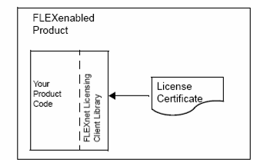

Diagram on the next page

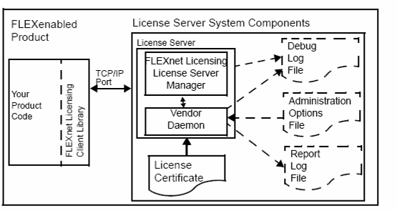

License Models

FLEXnet licensing models are in the license certificate and hence no need to change binaries or source code if models change. Only send new license certificate.

A – Basic License Models
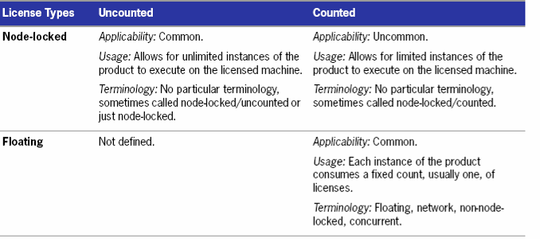
Notes 1: Node-locked/ uncounted can have single feature enabling entire product or scaled functionality (lite, standard and pro versions)
Notes 2: Evaluation License Model can add a) limited product functionality b) Limited number of uses and c) Expiration date
Noted 3: Node-locked/Counted model – fixed number of licenses over network but used by end user defined hosts only
Notes 4: Floating Models – non-node-locked, counted, network or concurrent licensing. Requires a license server system

B – License Model Modifiers

- Required License Model Modifiers:
  - Expiration Date
  - Version
      - Product version
      - License version
      - Date based version

- Optional license model modifiers

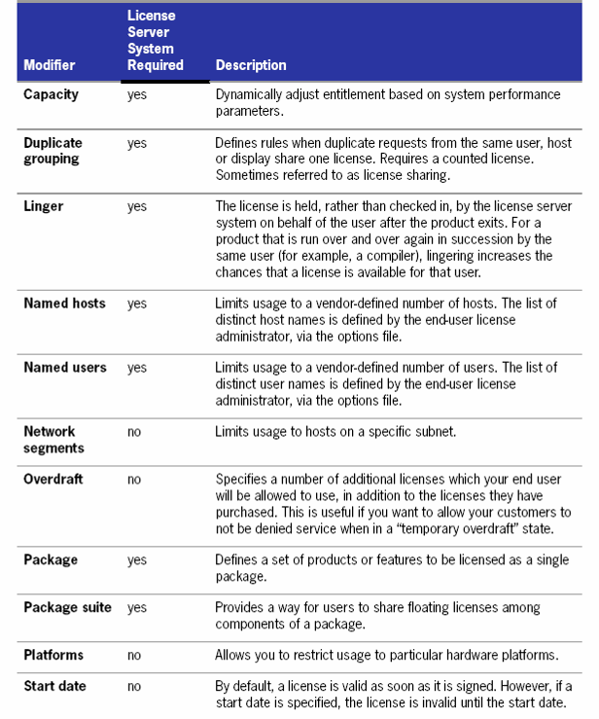
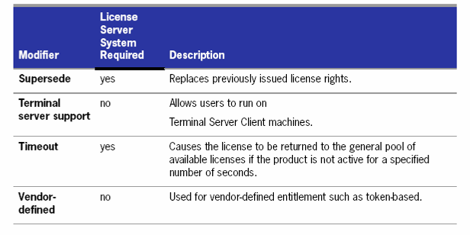

C – Usage Based Licensing

- Modifier to basic licensing model
- FLEXnet Manager and Utility pricing software can analyze data

Examples:
- Overdraft
- Pay-per-use
- High watermark of past use

D – Mobile Licensing

- Working on laptop
- Computer used both at work and home
- Working from different computers not connected to license server

FLEXnet supports various scenarios of mobile licensing
(see on next page)

