## The Ruin: Digital Literary Studies

## The Poem: “The Ruin” (from the tenth century Exeter Book), translated by Sian Echard, silently emended

<http://faculty.arts.ubc.ca/sechard/oeruin.htm>

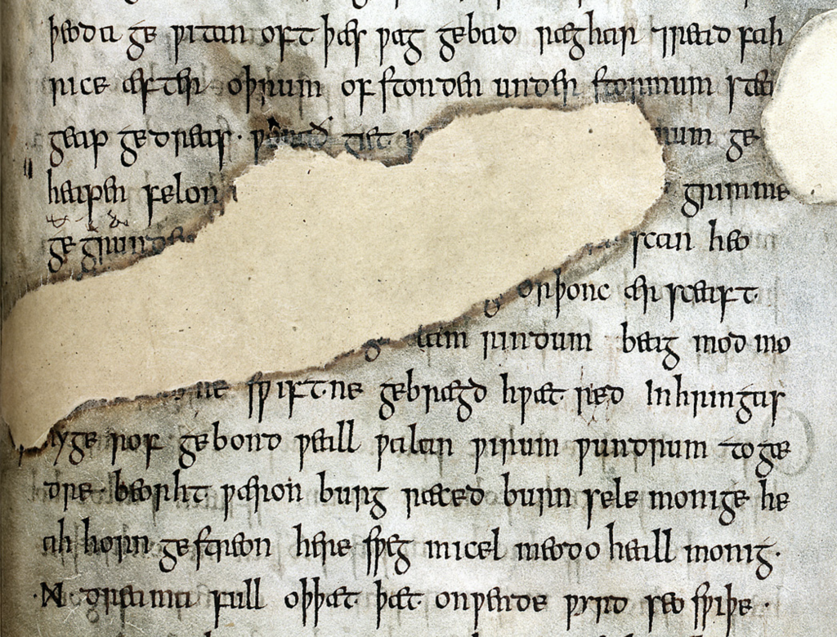

*Exeter Cathedral Library MS 3501, f. 124r, all rights reserved Dean & Chapter Exeter Cathedral*

*(via* [*https://sites.nd.edu/manuscript-studies/tag/old-english-poetry/*](https://sites.nd.edu/manuscript-studies/tag/old-english-poetry/)*)*

1. Wondrous is this wall-stead, wasted by fate.
2. Battlements broken, giant’s work shattered.
3. Roofs are in ruin, towers destroyed,
4. Broken the barred gate, rime on the plaster,
5. walls gape, torn up, destroyed,
6. consumed by age. Earth-grip holds
7. the proud builders, departed, long lost,
8. and the hard grasp of the grave, until a hundred generations
9. of people have passed. Often this wall outlasted,
10. hoary with lichen, red-stained, withstanding the storm,
11. one reign after another; the high arch has now fallen.
12. The wall-stone still stands, hacked by weapons,
13. by grim-ground files.
14. ...
15. …
16. …
17. …
18. Mind quickened … and the artificer,
19. skilled in round-building, bound the wall-base,
20. wondrously with iron.
21. Bright were the halls, many the baths,
22. High the gables, great the joyful noise,
23. many the mead-hall full of pleasures.
24. Until fate the mighty overturned it all.
25. Slaughter spread wide, pestilence arose,
26. and death took all those brave men away.
27. Their bulwarks were broken, their halls laid waste,
28. the cities crumbled, those who would repair it
29. laid in the earth. And so these halls are empty,
30. and the curved arch sheds its tiles,
31. torn from the roof. Decay has brought it down,
32. broken it to rubble. Where once many a warrior,
33. high of heart, gold-bright, gleaming in splendour,
34. proud and wine-flushed, shone in armour,
35. looked on a treasure of silver, on precious gems,
36. on riches of pearl...
37. in that bright city of broad rule.
38. Stone courts once stood there, and hot streams gushed forth,
39. wide floods of water, surrounded by a wall,
40. in its bright bosom, there where the baths were,
41. hot in the middle.
42. Hot streams ran over hoary stone
43. into the ringed water where baths were
44. …
45. …
46. That was a noble thing, the house and the city.

## Deformance

= a portmanteau term coined by Lisa Samuels and Jerome McGann, a combination of “deform” and “performance.”

## Introduction to TEI

TEI is semantic encoding. That is, it involves enclosing pieces of text between tags (<tag> = opening tag; </tag> = ending tag) in order to describe that piece of text.

Example:

And then my lord <person>Yvain</person> arrived in <place>Camelot</place>.

The tags here are “person” and “place.”

TEI is a subset of XML – an agreed-upon set of tags (i.e. <poem> </poem>) for describing literary texts.

## Reading

1. Content: Read your passage. Flag any parts that are unclear or mysterious or confusing. Summarize its content in one sentence.
2. Style: Look for:
   1. verbal patterns (e.g. sentences with the same shape) : what are they? What is their effect?
   2. sensory imagery (e.g. references to what you can see, hear, touch, feel): any patterns? What do they do for the poem?
3. Theme: if you had to summarize the theme of your passage in one word, what would that word be? How does style support or embody theme?

## Encoding

Passages: 1-15; 16-31a; 31b-46.

Encode your passage using the following TEI tags:

**Lines and line numbers**

<poem>Your poem text goes in here!</poem>

<l n=″1″>This masonry is wondrous; fates broke it</l>

**At least one made-up tag of your own, specific to the poem**

<concrete_noun> wall-stone </concrete_noun>

<adjective> wondrous </adjective>

<colour>golden</colour>

<poetic-formula>the work of giants</thew

## Viewing

Navigate to: <https://www.w3schools.com/xml/tryxslt.asp?xmlfile=cdcatalog&xsltfile=cdcatalog>

**Paste your XML poem into the left window of the browser.**

<?xml version="1.0" encoding="UTF-8"?>

<poem>

<l n="1">This <concrete-noun>wall-stone</concrete-noun> is wondrous; fates broke it</l>

<l n="2"><concrete-noun>courtyard pavements</concrete-noun> were smashed; the work of giants is decaying.</l>

<l n="3"><concrete-noun>Roofs</concrete-noun> are fallen, ruinous <concrete-noun>towers</concrete-noun>,</l>

<l n="4"> the frosty gate with frost on cement is ravaged, </l>

</poem>

**Paste your XSLT (your script for turning XML into HTML) into the right window of the browser.**

<?xml version="1.0" encoding="UTF-8"?>

<xsl:stylesheet version="1.0" xmlns:xsl="http://www.w3.org/1999/XSL/Transform">

<xsl:template match="/">

<html>

<body>

<h1>The Ruin</h1>

<xsl:for-each select="poem/l/concrete-noun">

<p> <xsl:value-of select="current()"/> </p>

</xsl:for-each>

</body>

</html>

</xsl:template>

</xsl:stylesheet>

## TEI and XSLT Details

**<xsl:for-each select="poem/l/concrete-noun">**

This line executes a loop—that is, it goes through each concrete noun tag (concrete-noun) of each line (l) of the poem (poem/l/concrete-noun).

How would you change this line to display poem lines rather than concrete nouns?

**<p></p>**

This tag (<p> </p>) is an HTML tag. It tells us to display whatever is inside this tag as a paragraph. What happens if you remove this pair of tags?

**<p> <xsl:value-of select="current()"/> </p>**

This line spits out the value of the current thing (that is, in our case, whatever is inside the current line, and the current concrete-noun tags).

## Encoding Discussion

What is your made-up tag(s)? How is this tag supposed to work, within this poem and more generally? Why is it useful?

After encoding, what additional characteristics of the poem, if any, did you notice in terms of verbal patterns, sensory imagery, or the development of the poem’s themes?

## Appendix: More Complex Example

Here is a slightly more complex example, less-completely annotated, which showcases a few more features.

<?xml version="1.0" encoding="UTF-8"?>

<poem>

<l n="1">This <concrete-noun>wall-stone</concrete-noun> is <adjective>wondrous</adjective>; <hyperbole>fates broke it</hyperbole></l>

<l n="2"><concrete-noun>courtyard pavements</concrete-noun> were smashed; the work of giants is decaying.</l>

<l n="3"><concrete-noun>Roofs</concrete-noun> are fallen, ruinous <concrete-noun>towers</concrete-noun>,</l>

<l n="4"> the frosty gate with frost on cement is ravaged, </l>

</poem>

<?xml version="1.0" encoding="UTF-8"?>

<xsl:stylesheet version="1.0" xmlns:xsl="http://www.w3.org/1999/XSL/Transform">

<xsl:template match="/">

<html>

<body>

<h1>The Ruin</h1>

<table>

<xsl:apply-templates select="node()"/>

</table>

</body>

</html>

</xsl:template>

<xsl:template match="poem">

<table>

<xsl:apply-templates select="node()"/>

</table>

</xsl:template>

<xsl:template match="l">

<tr>

<td style="padding-right:10px; color:gray">

<xsl:value-of select="@n"/>

</td>

<td style="color:white;">

<xsl:apply-templates select="node()"/>

</td>

</tr>

</xsl:template>

<xsl:template match="concrete-noun">

<strong>

<xsl:apply-templates select="node()"/>

</strong>

</xsl:template>

<xsl:template match="adjective">

<span style="color:green">

<xsl:apply-templates select="node()"/>

</span>

</xsl:template>

<xsl:template match="hyperbole">

<span style="background-color: rgba(250,20,20,0.3)">

<xsl:apply-templates select="node()"/>

</span>

</xsl:template>

<xsl:template match="hard-word">

<a href="{concat('https://www-oed-com.myaccess.library.utoronto.ca/search?q=', node())}">

<xsl:apply-templates select="node()"/>

</a>

</xsl:template>

</xsl:stylesheet>