# 

First steps with Holovibes

Estimated time : 10 minutes.

Learning objectives :

* Learn how to start the application for the first time.
* Learn how to calculate holograms from a movie of interferograms in real-time.
* Learn how to adjust the reconstruction parameters.
* Learn how to save your movie of reconstructed holograms.

# Start Holovibes.exe

Holovibes must be started with administrator rights. To do so, right-click on the icon of the application, and select “Run as administrator”.

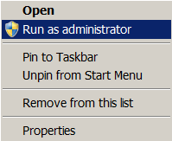

Upon first launch, the configuration file “holovibes.ini” will not be present. Close Holovibes and restart; the file will be created.

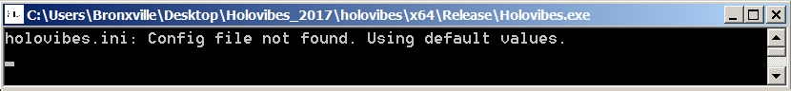

When restarted, the console should not display any message.

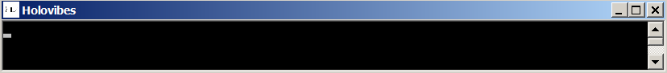

# Select a data file

First, download the interferogram data at this address: [4phaseTargetFresnel](https://ftp.espci.fr/incoming/Atlan/holovibes/data/QuickStart/). Save it on your computer.

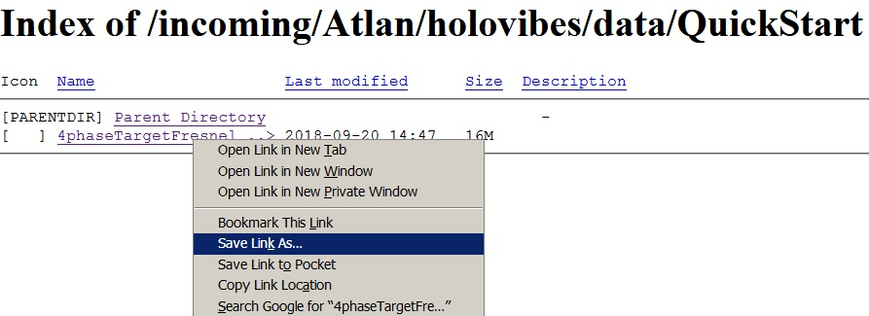

once saved, go back to Holovibes and click on the browse button “(...)” in the import tab:

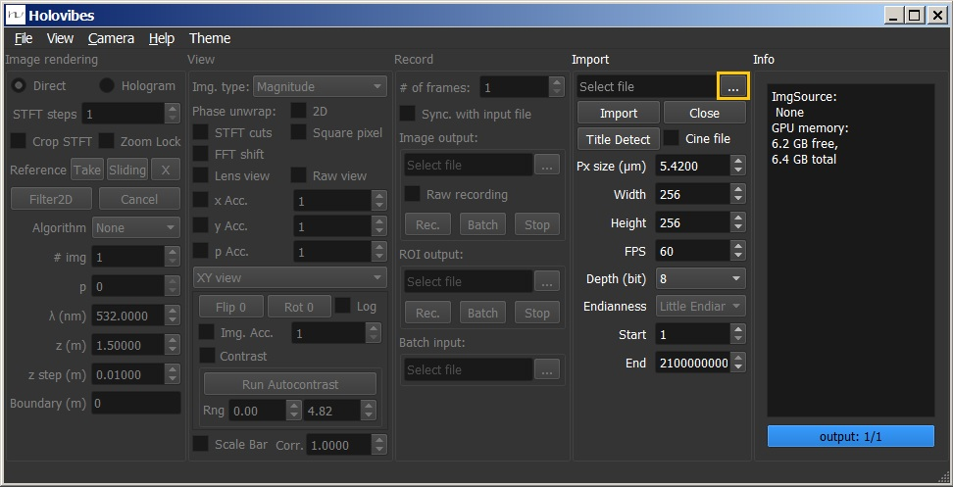

Choose the downloaded file to use, and click “Open” :

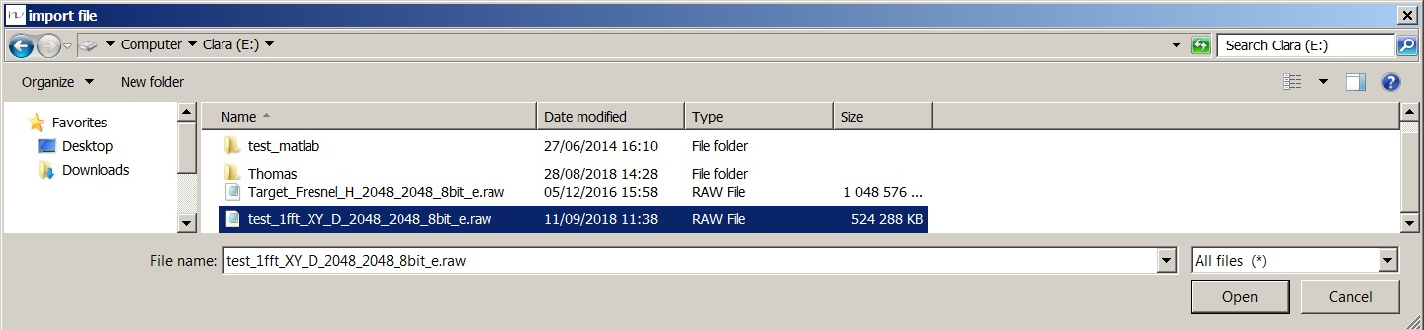

# Initialize image format

Click on “Title Detect”; the frame parameters of the file (width and height in pixels, bit depth, and endianness) will be displayed and used automatically.

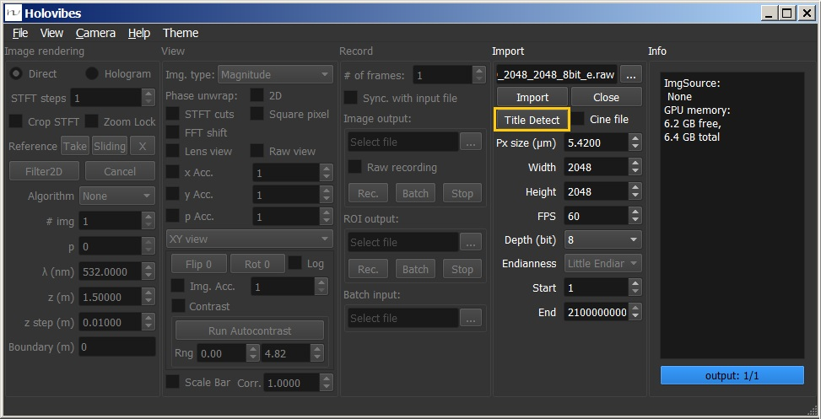

# Read the data file

Click on “Import”; A window will display the interferogram.

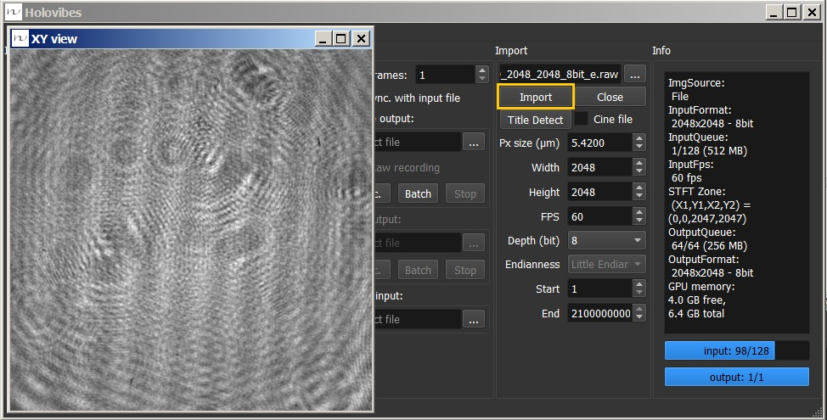

The console should display the following messages.

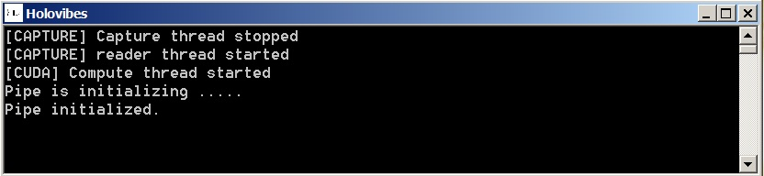

# Adjust hologram rendering settings

Wave propagation and temporal demodulation settings are available in the panel Image rendering (yellow box). In order to reconstruct holograms, switch from “Direct” to “Hologram”. Select the reconstruction algorithm:

* + None: No spatial transform.
  + 1FFT: [Fresnel diffraction equation](https://en.wikipedia.org/wiki/Fresnel_diffraction).
  + 2FFT: [angular spectrum propagation of the wave field](https://en.wikipedia.org/wiki/Angular_spectrum_method).

Set the number of images for temporal demodulation “#img=4”, and “p=1”: to select the second point of a 4-point discrete temporal Fourier transform. Set the radiation wavelength λ to 532 nm (green laser). The wavefield reconstruction distance z (m) should be set around -0.64 m. With those settings, the target image should be reconstructed and displayed. Click on “Run Autocontrast”, then adjust the lower and upper contrast values (red box).

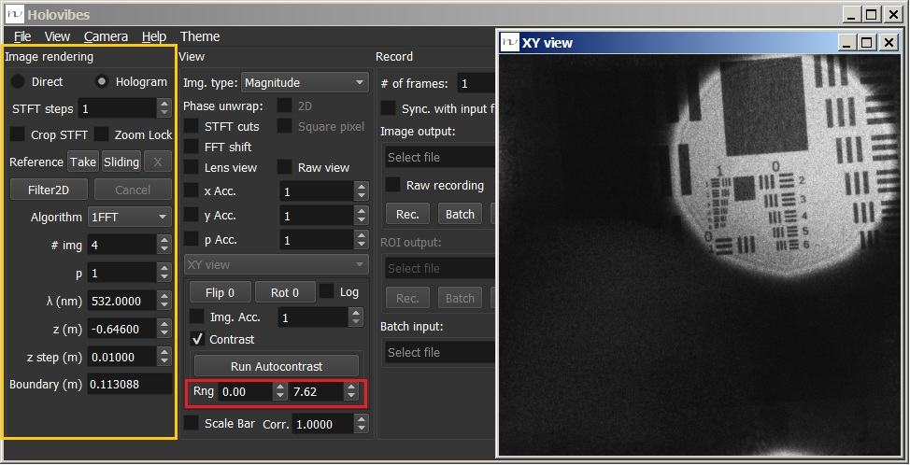

# Save the reconstructed hologram movie

