# 

Holovibes

Quickstart guide

Estimated time : 10 minutes.

Learning objectives :

* start the application for the first time.
* calculate holograms from a movie of interferograms in real-time.
* adjust the reconstruction parameters.
* save your movie of reconstructed holograms.

# Start Holovibes.exe

Holovibes must be started with administrator rights. To do so, right-click on the icon of the application, and select “Run as administrator”.

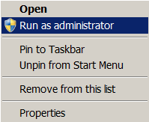

Upon first launch, the configuration file “holovibes.ini” will not be present. Close Holovibes and restart; the file will be created.

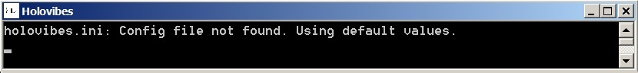

When restarted, the console should not display any message.

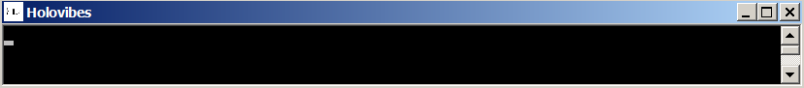

# Select a data file

First, download the interferogram data at this address: [4phaseTargetFresnel](https://ftp.espci.fr/incoming/Atlan/holovibes/data/QuickStart/). Save it on your computer.

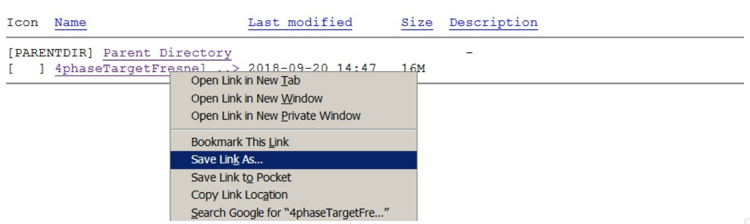

once saved, go back to Holovibes and click on the browse button “(...)” in the import tab:

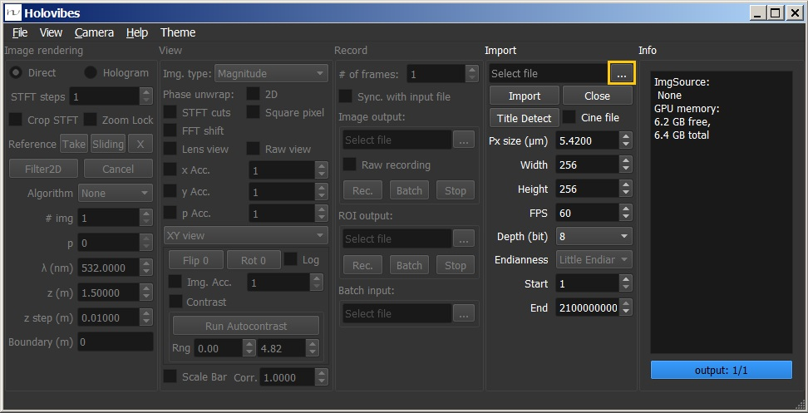

Choose the downloaded file to use, and click “Open” :

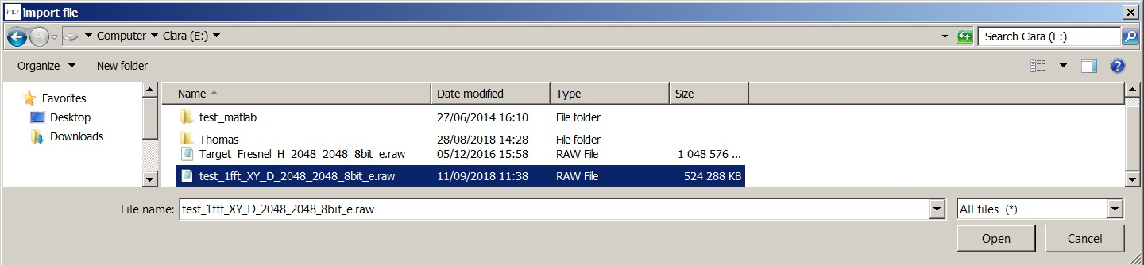

# Initialize image format

Click on “Title Detect”; the frame parameters of the file (width and height in pixels, bit depth, and endianness) will be displayed in the front-end and used automatically.

When saving data, Holovibes includes the frame parameters at the end of the title of the recorded file. This uncommon approach has the advantage of enabling fast visualization of the structure of saved data files.

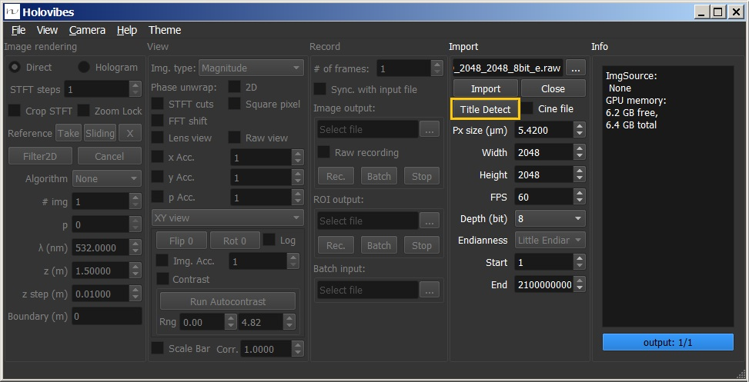

# Read the data file

Click on “Import”; A window will display the interferogram.

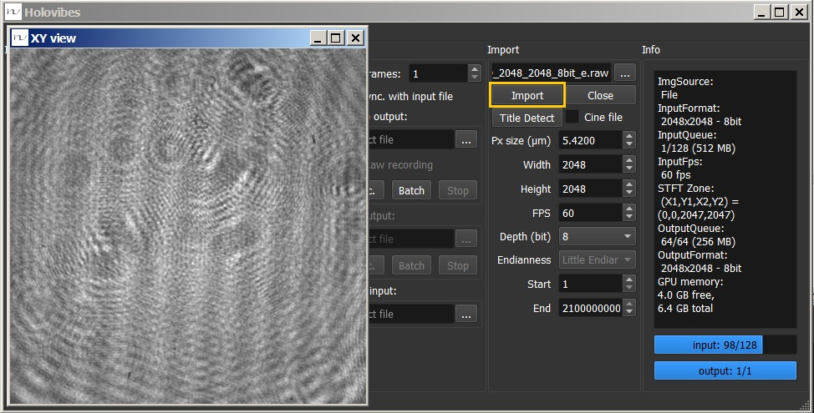

The console should display a few messages, and the last ones should be :

“Pipe is initializing …..”

“Pipe initialized.”

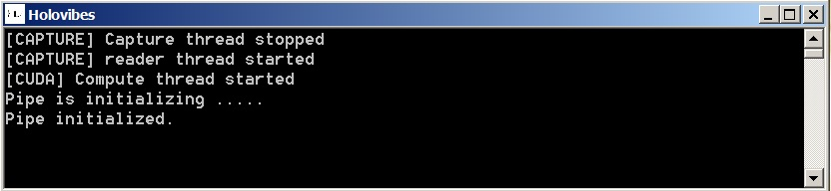

# Adjust hologram rendering settings

Wave propagation and temporal demodulation settings are available in the panel Image rendering. In order to reconstruct holograms, switch from “Direct” to “Hologram”. Set the reconstruction algorithm to 1FFT to use the [Fresnel diffraction equation](https://en.wikipedia.org/wiki/Fresnel_diffraction) for rendering. Set the number of images for temporal demodulation “#img=4”, and “p=1”: to select the second point of a 4-point discrete temporal Fourier transform. Set the radiation wavelength λ to 532 nm (green laser). The wavefield reconstruction distance z (m) should be set around -0.64 m. With those settings, the target image should be reconstructed and displayed. Click on “Run Autocontrast”, then adjust the lower and upper contrast values, in the numeric boxes next to “Rng.”.

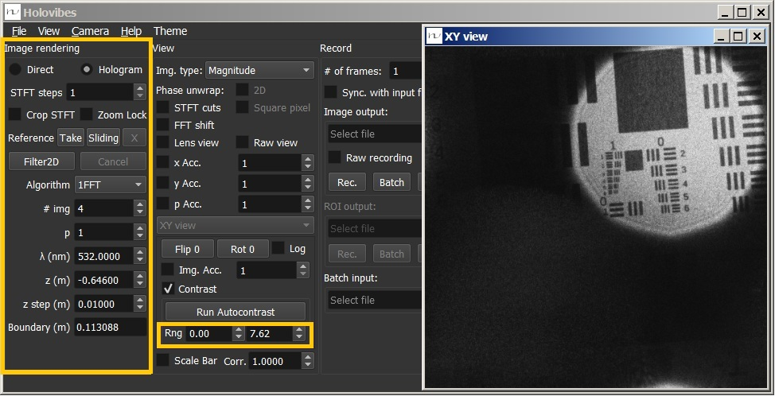

# Save the reconstructed hologram movie

In the “Record” panel, click on the browse button “(...)” to choose the name and destination of the file to save. Set the “# of frames” to record to Click on “Rec.”

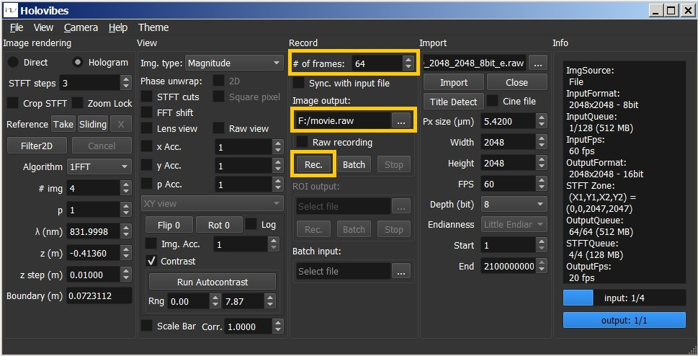

The console should display the following messages:

“movie_XY_H_2048_2048_16bit_e.raw”

“[RECORDER] started recording 64 frames”

“[RECORDER] record done !”

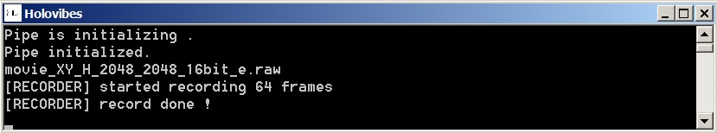

The movie can be now opened with [ImageJ / Fiji](http://imagej.net/Fiji/Downloads) for example. Click on “File>Import>Raw…” and select “movie_XY_H_2048_2048_16bit_e.raw”. In the frame format options, you should set “Image type” to “16-bit Unsigned”, “Width” and “Height” to 2048 pixels, “Number of images” to 64, and select “Little-endian byte order”. Once done, click “OK”. The reconstructed holograms should be displayed in a new window.

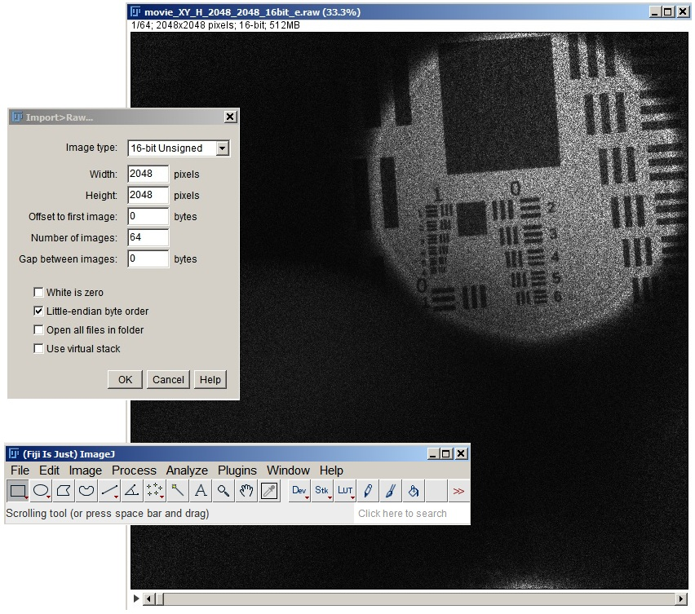

# Congratulations!

If you have been so far, you can now reconstruct your own holographic movies from optically-acquired interferograms. Please share them with us : [contact@holovibes.com](mailto:contact@holovibes.com)