

**EU-GUARDIAN Newsletter**

***Summer Edition 2024***

Advancing Cybersecurity Through Innovation and Collaboration

**Dear EU-GUARDIAN Community,**

We are delighted to share some of the latest developments and achievements of the EU-GUARDIAN project. As Europe's most ambitious initiative to explore Cyberspace Operations within the Mosaic Warfare concept, our mission is to enhance cyber defence capabilities through AI-driven solutions and automation. This newsletter highlights three significant events that have propelled us forward in recent months:

1. **First Dissemination Workshop in Sofia, Bulgaria**
2. **Plenary Meeting in Tallinn, Estonia**
3. **Participation at the ARES 2024 Conference in Vienna, Austria**

We invite you to read on and discover how these events have contributed to our project's success.

1. **First Dissemination Workshop – Building Bridges Across Europe**

**Date:** April 10, 2024  
**Location:** Sofia, Bulgaria

Our journey toward fostering collaborative defence research commenced with the First Dissemination Workshop held on April 10th in the vibrant city of Sofia. This inaugural event marked a pivotal moment for EU-GUARDIAN, providing a platform to introduce our project to a broader audience and establish connections with other related initiatives.

**Key Highlights:**

* **Engaging with Stakeholders:** The workshop attracted over 80 participants, including representatives from mid-sized companies, large industrial partners, SMEs, research organizations, and governmental agencies from six EU Member States.
* **Project Overview:** Our team presented the core objectives of EU-GUARDIAN, emphasizing our focus on developing AI-based solutions that automate incident management and cyber defence processes. We highlighted our commitment to enhancing cyber situational awareness and protecting military infrastructure against advanced threats.
* **Interactive Sessions:** Attendees participated in interactive discussions on the challenges and opportunities in adopting automation and AI in cyber defence. These sessions fostered a collaborative atmosphere, encouraging the exchange of ideas and best practices.
* **Networking Opportunities:** The event facilitated valuable networking, laying the groundwork for future partnerships and cross-border cooperation essential for advancing cybersecurity research and innovation.

**Outcome:**

The workshop successfully raised awareness of the EU-GUARDIAN project and reinforced the importance of collective efforts in strengthening Europe's cyber defence capabilities. The insights gained will inform our ongoing work and contribute to achieving our long-term goals.

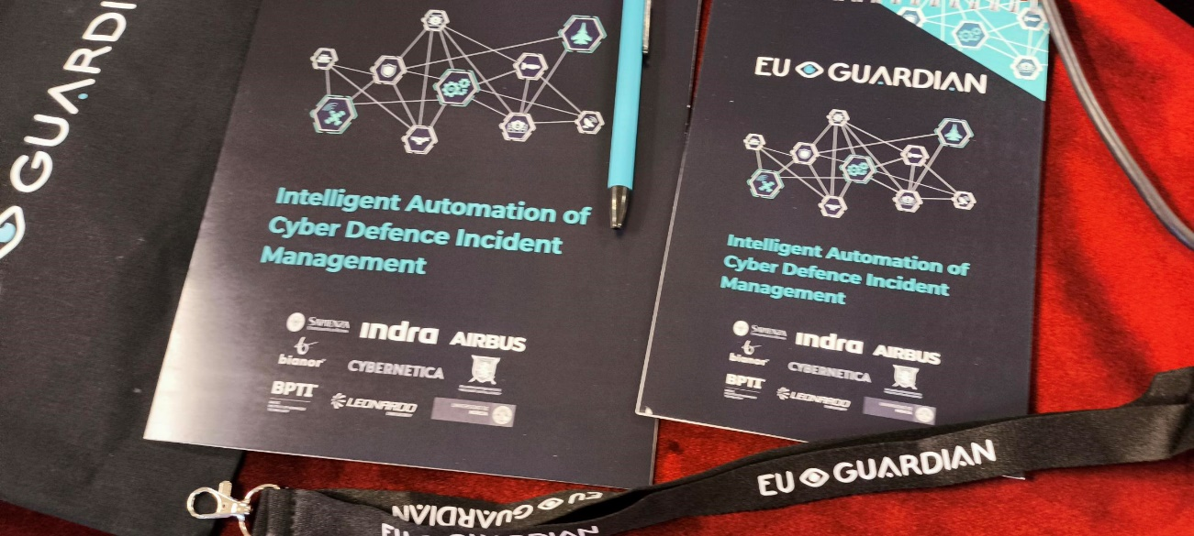

1. **Plenary Meeting in Tallinn – Advancing Innovation and Collaboration**

**Dates:** May 21–23, 2024  
**Location:** Tallinn, Estonia

Building on the momentum from Sofia, the EU-GUARDIAN consortium convened for a Plenary Meeting in the tech-forward city of Tallinn. Over three days, from May 21st to 23rd, we delved deeper into the technical aspects of our project and mapped out the next phases of development.

**Key Highlights:**

* **Orchestration of Artefacts and AI-Based Services:** We focused on integrating various components of the EU-GUARDIAN system, ensuring seamless communication between AI modules and automation tools. This orchestration is crucial for creating a cohesive cyber defence platform capable of rapid response.
* **Automation of Data Layers:** Discussions centered on automating data collection and analysis processes to enhance situational awareness. By leveraging AI, we aim to process vast amounts of data in real-time, enabling faster detection and mitigation of cyber threats.
* **Progress Review:** Teams presented updates on methodologies and proof-of-concept (PoC) developments. Significant advancements were noted in artefact orchestration and the automation of layered defenses, aligning with our objective to achieve semi-automated or fully automated incident response.
* **Strategic Planning:** Collaborative workshops allowed consortium members to refine project strategies, address challenges, and align on deliverables. Emphasis was placed on ensuring that all developments adhere to ethical standards and contribute to regulatory frameworks.

**Outcome:**

The Plenary Meeting solidified our collaborative approach and reinforced our commitment to innovation. By aligning our efforts, we are better positioned to overcome complexities in cyber defence and deliver impactful solutions that enhance Europe's cybersecurity landscape.

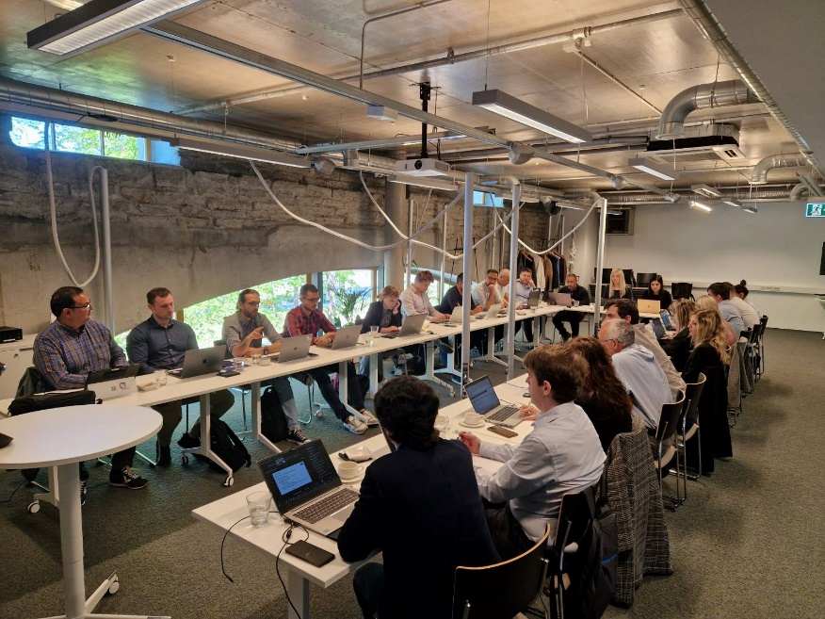

1. **Participation at ARES 2024 Conference – Showcasing Our Impact**

**Dates:** July 30 – August 2, 2024  
**Location:** Vienna, Austria

Our summer activities culminated with the EU-GUARDIAN team's participation in the **19th International Conference on Availability, Reliability, and Security (ARES 2024)** in Vienna. This prestigious conference is renowned for bringing together experts in IT security from around the globe.

**Key Highlights:**

* 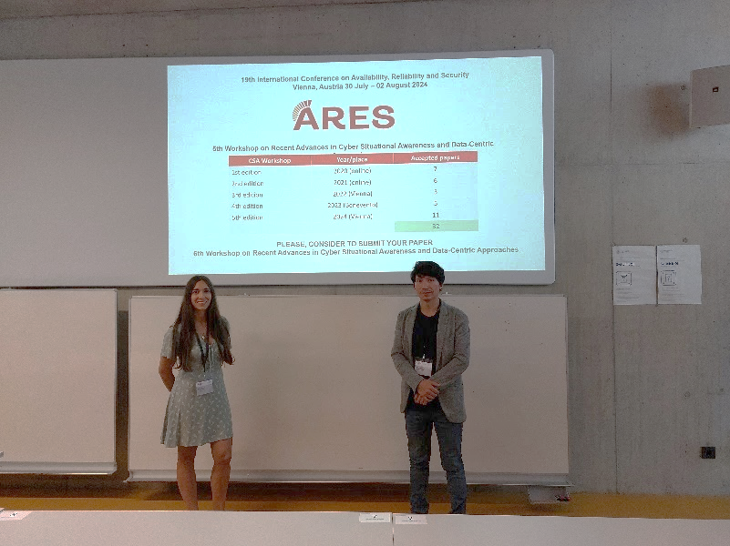**Expert Contributions:** Our colleagues from Indra, a leading partner in the consortium, presented groundbreaking research on enhancing the availability, reliability, and security of IT systems. Their presentations showcased how EU-GUARDIAN's AI-driven solutions are at the forefront of modern cyber defence strategies.
* **Panel Discussions:** Team members participated in panel discussions addressing the future of AI in cybersecurity, the challenges of implementing automation, and strategies for improving operational capabilities in cyber defence.
* **Networking and Collaboration:** The conference provided an excellent opportunity to network with industry leaders, researchers, and practitioners. Engaging with the broader cybersecurity community allowed us to share insights and explore potential collaborations that could amplify the impact of EU-GUARDIAN.
* **Recognition:** Our participation was met with enthusiasm, and we received positive feedback on our project's objectives and progress. The exposure at ARES 2024 significantly enhanced the visibility of EU-GUARDIAN within the international cybersecurity arena.

**Outcome:**

By presenting at ARES 2024, we not only highlighted the advancements of EU-GUARDIAN but also reinforced our commitment to contributing to global cybersecurity efforts. The knowledge exchanged will inform our future developments and help us address emerging challenges in cyberspace operations.

**Looking Ahead**

As we reflect on these milestones, we remain focused on our overarching goals:

* **Enhancing Detection and Response Capabilities:** Continuing to develop AI solutions that improve the speed and accuracy of cyber threat detection and response.
* **Supporting Decision-Makers:** Providing tools and insights to assist human operators and analysts at all levels, ensuring that they can make informed decisions swiftly.
* **Promoting Ethical Standards:** Upholding the highest ethical standards and contributing to the regulation and standardization of cybersecurity practices within the EU framework.
* **Fostering Collaboration:** Encouraging cross-border cooperation and leveraging the industrial potential of innovation and research in Europe.

