Behemoth 0.1
User manual
20/11/09

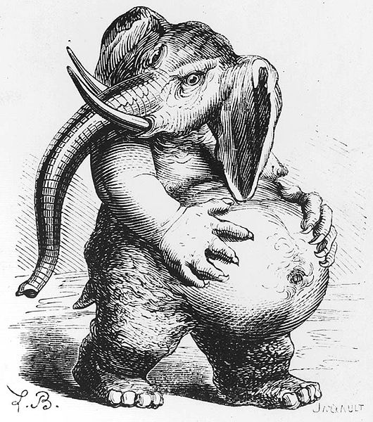

Introduction
Behemoth is a platform for large scale document processing based on Apache Hadoop (http://hadoop.apache.org/).
- common representation format : efficient interaction between different frameworks (UIMA, GATE, etc...) or languages (C++ components based on Hadoop Pipes)
- easy to configure and use
- interaction with other Apache resources : Tika, Mahout
- benefits from Hadoop's advantages : reliability, scalability, large community and support available
This document assumes some knowledge of Hadoop. An introduction can be found on http://hadoop.apache.org/common/.

Prerequisites
Behemoth is based on Hadoop 0.19.x
GATE libs must be available locally for compiling a new job file.
Works only in pseudo or fully distributed mode – relies on the distributes cache to send application resources which currently does not work in local mode.
How to compile Behemoth?

Architecture
Document structure
no corpus as such only a SequenceFile with documents
Drivers and mappers
Map only → create new structure each time
Hadoop Sequence File : key <Text> value <Document>
Resources : GATE zip | UIMA pear
FileSystem > Distributed cache > local deployment in Map

Configuration
Behemoth configuration files : default and site
→ copy them to /conf dir of Hadoop or point to site.xml in the command line
-conf /data/gate-plugins/Behemoth/conf/behemoth-default.xml

Example of use
Corpus creation
./hadoop jar Behemoth-0.1.job com.digitalpebble.behemoth.util.CorpusGenerator /localPath/corpus /data/behe-1 -mime text/plain
The class CorpusGenerator takes a parameter a local directory and stores the corresponding Documents in a Behemoth SequenceFile. When no mime-type is specified, Tika is used to determine which one is the most likely one.
Note : CorpusGenerator fills the fields URL, content and content-type for the Documents

GATE ANNIE in the cloud
configuration
create ANNIE zip → push to HDFS
./hadoop fs -copyFromLocal /a_local_path/ANNIE.zip /apps/ANNIE.zip

run ANNIE
./hadoop jar Behemoth-0.1.job com.digitalpebble.behemoth.gate.GATEDriver /data/behe-1 /data/behe-2 /apps/ANNIE.zip

check the results
./hadoop fs -libjars Behemoth-0.1.job -text /behe-2/part-00000 | more

Nutch adapter : convert segment to Behemoth format

UIMA
./hadoop jar Behemoth-0.1.job com.digitalpebble.behemoth.uima.UIMADriver /naturev2 /naturev2b /apps/WhitespaceTokenizer.pear

