# 03. MAYDAY ROOMS: BUILDING ARCHIVAL RESOURCES FOR CONTEMPORARY MOVEMENTS

### ROSEMARY GRENNAN

MayDay Rooms (MDR) is an archive, resource space and safe haven for social movements, experimental and marginal cultures and their histories. This piece will look closely at a digital archiving project initiated by MDR, called Leftovers. The project is ongoing and seeks to create a shared online archive of radical, liberatory, and working class movements, and the documents they have left behind. This contribution has been treated as an opportunity to lay out some of the thinking behind, and practice around building the online collection, and how it has created new possibilities for creating different forms of archives and archival engagement.

It will look at how MayDay Rooms practices around our paper archive have been reflected and developed in a digital environment, asking questions such as: how can building shared and collaborative digital archives move away from preoccupations around preservation, which dominates much archival practices, towards promoting use and reuse of historical material? How can digital archives be structured and categorized in such a way that they become a resource for contemporary movements rather than a static repository? Finally, it will look at how Leftovers has started to develop networks of sisterly archives who share digitizations and back-up each other's data. These practices ultimately help to break down the authority of the archival object, transforming it into something that can be shared, copied, and reactivated in the present rather than remaining confined to history.

## Archiving from below

MayDay Rooms was established in 2013 in the midst of brutal austerity cuts to public services in Britain, which saw the closure of many public libraries, community centers, and cultural spaces. Austerity policies, in combination with the anti-squatting laws passed in 2011, which criminalized the squatting of residential property, resulting in a real loss of social and communal spaces, which have often acted as containers of cultural memory and histories. Within this context of increasing loss or destruction, MDR was founded as a counter-institution dedicated to safeguarding histories and documents of struggle and resistance with a remit connecting them with, and making them freely available to, contemporary struggle and protest.

The founder members of MDR were able to secure a large building on Fleet Street right in the middle of the City of London. Fleet Street is famous for being the historical center of print culture in Britain since the 16th century, from the Chartists to the seditious printing and distribution of Paine’s Rights of Man. It became later the center of the British newspaper industry until the Wapping Dispute in 1986, when Rupert Murdoch broke the Printers Union.[1]

The building was bought by the Glass House Trust who funds MDR and the location was chosen to be a symbol of urgent resistance in an area where tower blocks of luxury flats blossom out of the old newspaper offices and which now is dominated by bankers, lawyers and speculative real estate.

This urgency was reflected in MayDay Rooms' name, which is drawn firstly from International Workers’ Day, and secondly from the international distress signal. Both references express the emergency facing the radical heritage through austerity cuts and the enclosures of space, but also an anticipation of future festivities in a better world of our own making symbolized by 1st of May. The ‘Rooms’ part of the name emphasizes the importance of having a physical space as a meeting point around radical histories and present struggles. Alongside our archive collection, the building houses communal spaces, meeting rooms and offices, which are used by a wide range of cultural, political, and activist groups.

MDR started with a number of ‘unboxing’ events at the Marx Memorial Library in London, where our three founding depositors – George Caffenzis, Silvia Federici and Peter Linebaugh –, each addressed one of the collections that they deposited: the Marxist-feminist campaign *Wages for Housework NYC* (1972-81), *Midnight Notes Journal* (1971-2001) and *New England Prisoner Association News* (1973-75). Whilst opening up his suitcase to reveal several archive boxes containing his Zerowork’s[2] collection, Linebaugh likened them to Pandora’s box, where different fragments and past dramas fly out. However, he went on to say that MayDay Rooms’ commitment to collectively working on archives took the pressure off these histories being the sole responsibility of the depositors and orients this endeavor toward future organizing.

From these three modest collections, the MDR archive has grown over the last ten years to a paper archive of over 60,000 items, over 2000 films and videos, and a digital archive of over 19,000 digitizations. The collection at MDR focuses on social struggles, radical art, and acts of resistance from the 1960s to the present: it contains everything from recent feminist poetry to 1990s techno paraphernalia, from situationist magazines to histories of riots and industrial transformations, from 1970s educational experiments to prison writing. Central to building these collections has been the cultivation of informal networks and relationships with those involved in social and labor movements past and present, formed in and around the MDR building (particularly whilst having drinks on the roof terrace or cooking together in the kitchen). Some of our depositors bring us a few pamphlets found under the bed or in the corner of a cupboard, others bring us great volumes of material revealing traces of lives lived in struggle. This approach to collecting material is necessarily fragmented and contingent, and speaks to the fact that archives of radical politics have seldom been systematically assembled.

Our work, around the collection, proceeds from the understanding that social change can happen most effectively when marginalized and oppressed groups can get to know – and tell – their own histories ‘from below’: our archival practice and organizational structure reflects this. Marcus Rediker defines ‘history from below’ as a type of social history that describes the experience of working-class people as well as their history-making power, which has long been left out of ‘top-down’ historical narratives. It is a method of approaching the past ‘that concentrates not on the traditional subjects of history, not the kings and the presidents and the philosophers, but on ordinary working people, not simply for what they experienced in the past but for their ability to shape the way history happens’.[3] Peter Linebaugh comments in *Incomplete, True, Authentic, and Wonderful History of May Day* on the kind of documents that this approach to history encompasses and their ability to actualize political programs in the present:

In our day, the traces of our radical movements are being thrown into rubbish pits, as state-sponsored ‘austerity’ demands the commodification of every inch of space, and with sinister intent destroys the evidence of our past, its joys, its victories. Clear out the closets, empty the shelves, toss out the old footage, shred the underground press, pulverize the brittle, yellowing documents! Thus neoliberalism organises the transition from the old to the new; they must silence alternatives. We do not want the voice of George Jackson to be silenced. His words still eloquently describe a desirable program, a necessary program.[4]

Our aim has always been to create a counter archive that resists dominant historical narratives and rethinks the way we learn from the past. We tried to do this through developing new free forms of dissemination, access, research-collaboration, and collective education. This historical work is a collaborative process, often open-ended, sometimes messy, and not always successful. But it continues to build a space of critical opposition to capitalist relations and to inspire future struggles. Some recent examples of the types of activities we have done are: collective scanning and cataloging workshops, bringing archives to picket lines during strike actions, a series of events which profile historical examples of resistance to the ‘cost of living crisis’, social events and fundraisers for no border networks, youth workshops with sisterly archives, writing to people in prison using material from the archive, travelling and online exhibitions.

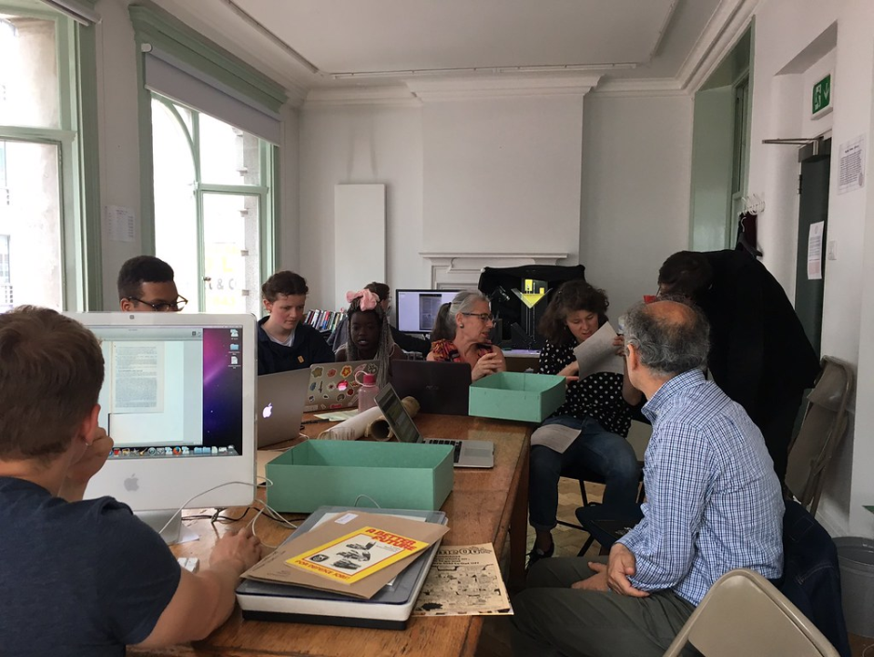

Fig. 3.1. Scanathon for the Lucas Plan collection at MayDay Rooms in 2018

MDR attempts to learn from the politics that are represented in the collection and is organized non-hierarchically around two different collectives and a board of trustees. First, the staff collectively runs the archive that sits at the heart of the building. There have been a number of different iterations of this collective, each bringing with them different political commitments and experiences which in turn has brought new focuses, networks and collections. The second is the Building Collective who use the space for their own activities and in exchange help us run the building and make it accessible to people who want to use the space for meetings and events. The Building Collective currently consists of various groups: the two trade unions Cleaners & Allied Independent Union and Industrial Workers of the World; the radical research groups MayDay Radio and the workerist-inspired groups Pagliacci Rossi and Red Therapy; the June Givanni Pan African Cinema Archive; Statewatch, an organization monitoring state and civil liberties; and the LGBTQAI* support group Living Free and Trans Legal Clinic.

## Leftover ephemera

Despite this important emphasis on cultivating a place for people to meet, learn from history and struggle together, MDR has also been committed to developing models of digitization, online distribution and dissemination. The next section will explore some of the thinking behind and strategies of building Leftovers, our shared online archive. In contemporary archival practices, there is much emphasis on the digitization of collections for reasons of both access and preservation. However, access to material is often still restricted by questions of rights and remains on internal archival systems.In addition to this, digitization of material for preservation purposes takes resources (such as storage and equipment) that smaller independent archives do not have. When we first started thinking about the form of our digital collection, we looked at how features of digital objects (reproducibility, mobility and potential for circulation) could re-imagine an archive that bypasses traditional concerns of preservation in favor of dissemination, collaborative contributions and truly open access.

At MDR we were greatly inspired by the work of friends and comrades from different ‘shadow libraries’, particularly aaaaarg.org, and Memory of the World.[5] Back in 2015, we collaborated with Marcell Mars of Memory of the World to develop a cataloging system which would enable us to contribute to their online collection as librarians. The idea was to host our digitization on memoryoftheworld.org through a hacked version of the ebook management system Calibre in combination with the plugin letssharebooks. However, we soon realized that the historical ephemera (posters, pamphlets, flyers, bulletins, etc) which MDR mainly dealt with was not quite suited to a library which was structured around books. We then started collaborating with Jan Gerber from 0x2620 in Berlin,[6] who had already helped us process and host our video archive.[7] 0x2620 had previously worked on Pad.ma (Public Access Digital Media Archive) an online archive of densely text-annotated video material, primarily footage and not-finished films. Through discussion, we found productive similarities and alignments between print ephemera, unfinished film and video footage; this opened up new ways of thinking about the form of our digital archive.

We came up with the name Leftovers to highlight the centrality of thinking through the qualities of ephemera when creating an archive. The book or academic text is in some ways a relatively self-contained durable object – it has a blurb, a recognizable author – that does not need additional material to become understandable, and its use in some ways is predetermined. Whereas political ephemera has a different temporal scope: it was not meant to endure, and its contemporary use is different from its first production or original purpose. For example: leaflets that mobilize people for a protest, bulletins that communicate actions on a picket line, or newspapers that maintain organizational forms. All of these materials were meant to organize in haste and communicate in the moment, but not to last. Both Jess Baines and Nick Thoburn have written about ‘socialist’ or ‘communist objects’[8] to describe radical print production. Baines proposes that, ‘in contrast to the enslaved, sedated and “finished” possessions of bourgeois commodity culture, the socialist object would be a co-worker, an active and equal comrade that, like its mode of production enriched the bodies of the socialist project’.[9] The material archived on Leftovers was not intended as a static commodity but represents fragments of historical moments woven through different tendencies and movements; so it needs a critical mass of other ‘comradely’ material and different archival strategies to make it understandable. In addition to this Steve Wright’s idea of ‘document work’[10] which sees political ephemera as active objects, rather than simple texts, has been very useful in formulating these ideas. In his long study of the material culture of Italian workerism of the 1970s, Wright looks at material such as ‘La Classe’ or ‘Potere Operaio’. He analyzes how printed matter like pamphlets are written and read, made and consumed, and he argues that these activities create kinds of social relations. These ideas foreground the creation and use of print material rather than just transmitting information, and this has been a guiding focus when building Leftovers.

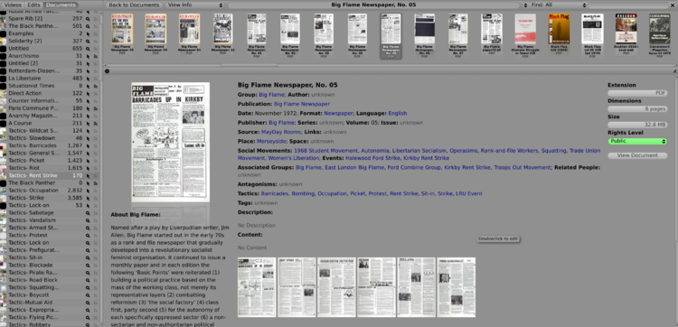

Fig. 3.2. Item records for Big Flame Newspaper from Leftovers.

The structure of the leftovers archive has tried to reflect these ways of thinking about the material culture of social movements. Our collaboration with 0x2620 and working with their software Pan.do/ra, has presented both technical and conceptual possibilities around the way in which digital objects can be pulled apart and accessed in full as opposed to being treated as a single and opaque entity. Much like the distinction Baines makes between a publication that embodies sedate commodity relations and one that is an open and active part of political movements. In the video archives that 0x2620 has been involved in creating, material can be addressed in many different ways; as a clip, a frame or a pixel. This has been key to developing different ways of representing video within the archive, for example as graphical representation of temporal changes of video timelines.

When the software was adapted for an archive of documents such as Leftovers, it resulted in something that might be best thought of as a cut-up inspired, non linear-approach, to historical material. All 19,000 documents are available in full as pdf, but we have added the possibility to directly look at a page, a clipping, and the OCRed text.[11] This has opened up the material for different forms of extraction, recombination and analysis. We have been developing a collaborative tool for working together on the digital collection and creating new ways of interrogating the material remotely. The tool enables users to take clippings from the documents in the archive, then recombine and annotate them to create ‘scrapbooks’ or montages. We have held a series of workshops to test and further develop these tools, and through this, have co-created different scrapbooks around the topics of Health Autonomy, Abolitionist Struggles, Rent Strikes, and Radical Spaces.

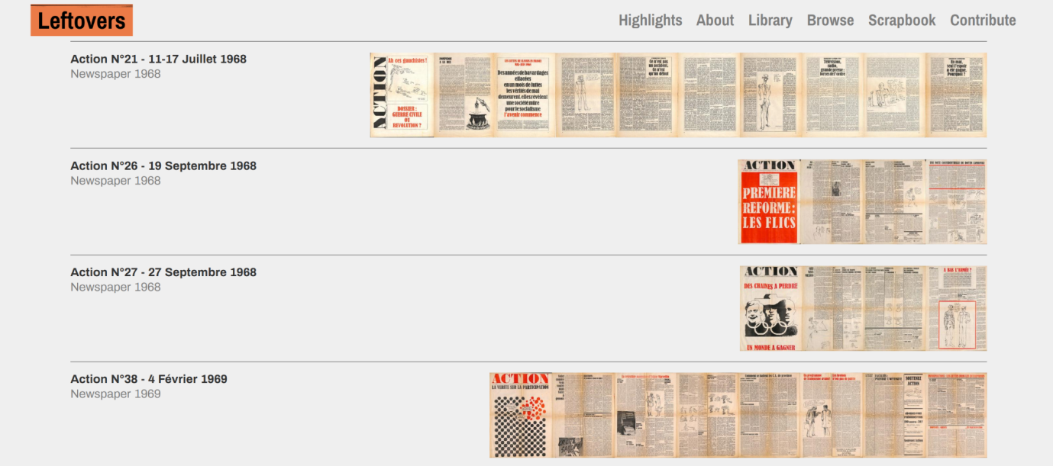

Fig. 3.3. The timeline view from Leftovers.

Our approach has led us to develop our own metadata system for Leftovers, rather than relying on hierarchical systems of classification or inherited metadata conventions. A good example of this is the category of ‘Tactics’. This field was introduced to re-orient the collection as something that can be used as resources for current struggles and developing metadata suited for the collection we hold. The intention behind this field was that if a group wanted to organize a rent strike they could filter or search the collection by ‘Tactics’, choose ‘Rent Strike’ and view every document which mentions the expression. To help further define this category, we used the full-text functionality of the platform which allows you to search *within* the document, not only for data *about* the document. This might sound like a minor technical point, but it has proved highly significant in opening up digital archives and using the actual document’s content as the basis of classification. We made a list of different tactics of left and social movements and searched all documents in Leftovers for them. Some of the results are below with their occurrences in the archive to give an impression of the variety:

Occupation (2858) Rent Strike (164) Riot (1630) Picket (1451) Strike/Grève (3640) Direct Action (2401) Rent Strike (170) Prefigurative (18) Sabotage (2053) Protest (3399) Sit-in (905) Blockade (607) Pirate Radio (76) Collective (4584) Road Block (42) Boss-napping (4 ) Wildcat Strike (124) Squatting/Squat (614) Slowdown (46) Boycott (1367) Forgery (1) Barricades (1310) March (3850) General Strike (245)

Some of these terms, such as ‘Occupation’, occurred too many times or were too broad to be a useful way of filtering an item. But other terms, such as ‘Rent Strike’, are specific enough to be a useful means of clustering documents.

Another interesting metadata category which is worth mentioning is the field of ‘Author’, which in Leftovers is almost completely redundant, as most material in the archive is produced by a group, a collective, or is anonymous. The reasons for collective authoring on the left and in social movements are various; whilst some material is intentionally authored under a group name, others remain anonymous or produced under a collective identity, not as a choice but as a societal position in relation to the state, whereas in some cases other groups are actually a single person masquerading as a group in order to explore imaginary formations. With all of these examples, anonymity is not merely dropping one’s name, but speaks to the complex nature of the production of the documents, where the writing of newsletters, pamphlets, positioning papers, and bulletins becomes a form of internally constituting groups, not individual acclaim, and writing and action combine as a form of collective political organization.

Angela Davis recently spoke in Berlin on the occasion of the ten year anniversary of the occupation of Oranienplatz by the refugee resistance movement in opposition to the *‘Asylverfahrensgesetz’* (Asylum Procedure Act). Whilst highlighting the work and lives of Black Feminists who have been at the forefront of struggles for freedom and rights, Davis added, she is not presumptuous to add her own name to a long list: the ‘reason that people know my name has more to do with what people did to save my life all over the world, including in Germany’.[12] Davis spoke about the ‘1 Million Rosen fürAngela*’* campaign at state-wide solidarity campaign in the GDR, where postcards of roses were sent, including many from school children, to Davis whilst she was in prison between 1971–1972. Davis went on to describe herself as a figure standing in for collective and mass struggle, this was not to lessen the legacy and leading-role many Black feminists have taken but an acknowledgment of the thousands of other people who create mass movements and social change. Here Davis acknowledges the unknown figures that are integral to the political movements that the material in Leftover is part of. The category of author is often bound up with proprietary forms of ownership, but moving away from this as a dominant metadata category, in favor of an emphasis on movements, collective and groups, acknowledges all those who were part of the production of the material. This started to acknowledge that political movements and campaigns are always a work of collective action and remain so.

## Archives of archives

Although MDR initiated the project, Leftovers does not solely consist of our digital collection; it draws in digitizations from many different sources: from torrent files of 1970s newspapers to an autonomously-run online collection of the Ultra-Left in France, to Women’s Liberation movement material from state archives. Sean Dockrey, in ‘HyperReadings’, puts forward the idea of a ‘library of libraries’, which does ‘not to manifest in a single, universal library, but to realize it progressively and partially with different individuals, groups and institutions’.[13] This idea was influential in imagining Leftovers as a shared archive which contains many archives and users uploading and maintaining the material in the collection. We see ourselves as custodians of the material in the collection rather than having some kind of exclusive claim. All material in Leftovers has a ‘Source’ field that takes you back to the original source of the digitization, so aggregating these materials on one platform not only brings them into proximity with one another but also highlights the work of many small independent archives and protects against archival destruction.

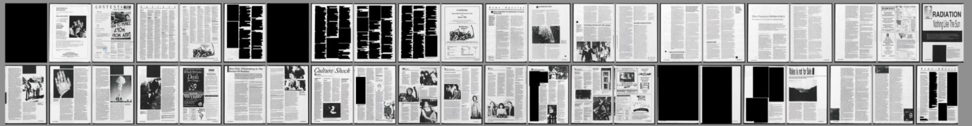

Fig. 3.4. Overview of a section of Spare Rib magazine in Leftovers.

One of the publications in Leftovers is *Spare Rib*, which was published between 1972 to 1993 and represents the biggest Women’s Liberation publication in British history. It was originally digitized by the British Library; however, in their online collection much of the content had been redacted due to copyright claims (see above). After Britain and Northern Ireland left the European Union, the copyright directive that covered the digitization no longer applied and the digital copies were taken down. To my knowledge, Leftovers now holds the only digital copies of this material. We can see here the fragility of digital collections which can disappear at any time and in turn the imperative to freely spread material across many archives and platforms. Dušan Barok advocates the copy, not as something that just ‘mirroring or making backups, but opening up for possibilities to start new libraries, new platforms, new databases’.[14]

Leftovers is also used by many different archival collections, from smaller archives that have only just started embarking on creating digital collections and want to use Leftovers to host their collections to more established archives contributing to Leftovers in addition to hosting their own materials. A good example of this was when we ran a workshop with Glasgow Housing Struggles Archive, a new project from members of a tenants' union called Living Rent. This project was aimed at uncovering Glasgow's hidden history of squatting, rent strikes, and council tenant organization, and at looking at how they can use Leftovers to build a resource and take the archive into everyday organizing. Through this pooling and sharing of digitizations and resources we have built networks with sisterly archives, that is, with other physical and online collections such as Sparrows’ Nest Archive and Library (UK), Archivio Grafton (IT), Rebal.info (IT), and Archives Autonomies (FR).

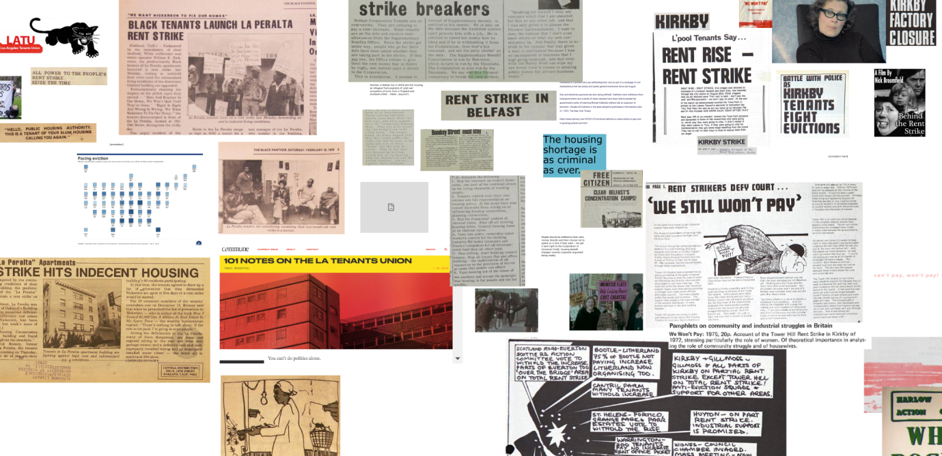

Fig. 3.5. Section of the workshop scrapbook with Living Rent and London Renters Union members in 2020.

Although it has been very important to network with other archives to build the collection, not every contributor to Leftovers does so knowingly. We have searched and scraped pdfs from many different sources on the internet: from national collections to static pages hosting material; from single campaigns or publications to torrents of carefully packaged collections. For example, *The Black Panther,* the newspaper of the Black Panther Party, was scanned at a university in the USA and then did the rounds on the internet as a torrent. We downloaded it and OCRed the scans and uploaded them to the collection. We were not the ones who scanned it, downloaded it from the university, and distributed it online and the scans are not only hosted on Leftovers, but we felt it was important that it become part of the archive and be freely accessible. All of these online searches for material reveal the breadth of radical history resources online and, through bringing them together in one place, we have been able to make connections between documents and collections that would usually be dispersed.

## Dissemination as preservation

Leftovers was founded on the idea that radical archiving should be outward facing and promote distribution, accessibility and use, rather than being a static repository. This is an idea that is mirrored by many radical archives, including Interference Archive in New York, whose members argue that use itself is a form of preservation.[15] Pad.ma (Public Access Digital Media Archive) in their *Ten Theses on the Archive*, further advocate for this vision of the archive:

When Henri Langlois, founder of the Cinémathèque Française, stated that ‘the best way to preserve film is to project it’, he hinted at the very opposite philosophy of archiving: to actually use and consume things, to keep them in, or bring them into, circulation, and to literally throw them forth, into a shared and distributed process that operates based on diffusion, not consolidation, through imagination, not memory, and towards creation, not conservation.[16]

During the *Archive Ausser Sich* conference in HKW in Berlin in 2022, Didi Cheeka, in his talk ‘Reclaiming Nigeria's Audiovisual Archives: Result & Prospects’*,* spoke about the issue of restitution of cultural items made about, or made by, formerly colonized people. He argues that restitution is not just about artifacts but audio-visual material too that needs to be returned to their country, or countries, of origin so that people there can have an idea of their own film heritage. Citing Walter Benjamin, he argues that film and sound recordings are technically reproducible, so the act of returning could also be the act of copying. That the restitution of audio-visual heritage from extractive archives and collections in Europe and North America does not even need to be the ‘original’ but a reproduction that can be seen by people whose history it belongs to.[17] Cheeka’s simple advocacy of the copy as a means of restitution highlights how questions of rights are used as justification by archives to sit passively on their holdings, rather than making them actively accessible and bringing them into circulation.

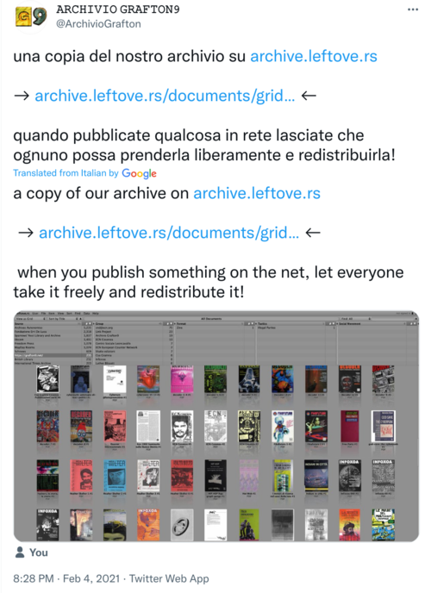

Fig. 3.6. Screenshot of a Tweet from Archivio Grafton. Archivio Grafton [@ArchivioGrafton], Twitter, 04/02/2021, <https://twitter.com/ArchivioGrafton/status/1357425808768385025?s=20>

This tweet from Archivio Grafton, about their material hosted on Leftovers, forms a really fitting conclusion to this piece. It states ‘when you publish something on the net, let everyone take it and freely distribute it’. It points to the fact that the aggregation of all this radical ephemera into Leftovers also brings them into circulation and creates a type of common non-proprietary ownership. Through developing tools, and ways of disseminating, programming, integrating, and re-using the collection rather than it just being a repository where material is merely stored, Leftovers hope to continue to re-imagine what it means to create a digital archive as an active resource shared in common with social movements today.

## References

Baines, Jess. ‘Radical Print Revolution? Objects Under Capitalism’, *Strike Magazine* 8 (2014): 20–21.

Cheeka, Didi. ’Reclaiming Nigeria's Audiovisual Archives: Result & Prospects’, *Haus der Kulturen der Welt (HKW)*, <https://archiv.hkw.de/en/app/mediathek/audio/91369>, 2022.

Davis, Angela. ‘Angela Davis Speaks at Oranienplatz, Berlin 2022’, YouTube, <https://www.youtube.com/watch?v=WGJ5LHZkYSg>, 2022.

Dekker, Annet. ‘Copying as a Way to Start Something New: A Conversation with Dušan Barok about Monoskop’ in Annet Dekker (ed), *Lost and Living (in) Archives. Collectively Shaping New Memories,* Amsterdam: Valiz, 2017, 175–188.

Dockrey, Sean. ‘README.md’, <https://samiz-dat.github.io/hyperreadings/>, 2018.

Hoyer, Jen and MacPhee, Josh. *Interference Archive: Building a Counter-Institution in the United States*, Brooklyn NYC: Interference Archive, 2022.

Linebaugh, Peter. *The Incomplete, True, Authentic, and Wonderful History of May Day*, Oakland: PM Press, 2016.

Martin, Carl Grey and Roy, Modhumita. ‘Narrative Resistance: A Conversation with Historian Marcus Rediker’, *Workplace: A Journal for Academic Labor* 30 (2018): 54–69.

Pad.ma Public Access Digital Media Archive. ‘10 Theses on the Archive’, Pad.ma, <https://pad.ma/documents/OH>, 2010

Thoburn, Nicholas. *Anti-Book: On the Art and Politics of Radical Publishing,* Minneapolis: Minnesota Press, 2016.

Wright, Steve. ‘”I Came Like the Thunder and I Vanish Like the Wind”: Exploring Genre Repertoire and Document Work in the *Assemblea operai e studenti* of 1969’, *Archival Science* 12 (2012): 411–436.

1. See MayDay Rooms online exhibition called ‘Print Subversion in the Wapping Dispute’, <https://exhibitions.maydayrooms.org/wapping/>
2. The Zerowork publishing group was formed in 1974 and could be said to have been informed by an early take up of Italian autonomist theory.
3. Carl Grey Martin and Modhumita Roy, ‘Narrative Resistance: A Conversation with Historian Marcus Rediker’, *Workplace: A Journal for Academic Labor* 30 (2018): 56.
4. Peter Linebaugh, *The Incomplete, True, Authentic, and Wonderful History of May Day*, Oakland: PM Press, 2016, 106.
5. Shadow Libraries is a term that refers to mass online libraries which operate outside formal institutions as well as outside copy-right law. The largest examples of these are Sci-Hub and Libgen although smaller collections such as Aaaaarg.org and memoryoftheworld.org are also referred to by this term. Aaaaarg.org is an online repository with over 50,000 books and texts. It was created by Sean Dockray and serves as a library for the Public School – an online platform that supports offline autodidactic activities. [Memory of the World](https://www.memoryoftheworld.org/) is a collaborative online library. It advocates completely bypassing the existing distribution system by creating a peer-to-peer library system, in which users become librarians of their own digital book collections and share them.
6. 0x2620 are based in Berlin and have initiated and collaborated on different software and archiving projects, most notably Pad.ma with CAMP in Bombay, bak.ma, an archive of video from the protest movements that started around Gezi Park in 2013 (see Çelikaslan in this volume) and 858.ma with Mosireen Collective a collection of material from the 2011 uprisings in Egypt.
7. See Activist Media Project, <https://amp.0x2620.org/about>
8. Nicholas Thoburn, *Anti-Book: On the Art and Politics of Radical Publishing,* Minneapolis: Minnesota Press, 2016.
9. Jess Baines, ‘Radical Print Revolution? Objects Under Capitalism’, *Strike Magazine* 8 (2014): 20.
10. Steve Wright, ‘”I Came Like the Thunder and I Vanish Like the Wind”: Exploring Genre Repertoire and Document Work in the *Assemblea operai e studenti* of 1969’, *Archival Science* 12 (2012): 411–436.
11. Optical Character Recognition (OCR) is the process by which you can convert an image of text into a machine-readable text format. For example, a digitization of a page from a journal becomes an image that also contains text data.
12. Angela Davis, ‘Angela Davis Speaks at Oranienplatz, Berlin 2022’, YouTube, <https://www.youtube.com/watch?v=WGJ5LHZkYSg>, 2022.
13. Sean Dockrey, ‘README.md’, <https://samiz-dat.github.io/hyperreadings/>, 2018.
14. Annet Dekker, ‘Copying as a Way to Start Something New: A Conversation with Dušan Barok about Monoskop’ in Annet Dekker (ed), *Lost and Living (in) Archives. Collectively Shaping New Memories,* Amsterdam: Valiz, 2017, 188.
15. Jen Hoyer and Josh MacPhee, *Interference Archive: Building a Counter-Institution in the United States*, Brooklyn NYC: Interference Archive, 2022.
16. Pad.ma Public Access Digital Media Archive. ‘10 Theses on the Archive’, <https://pad.ma/documents/OH>, 2010
17. Didi Cheeka, ’Reclaiming Nigeria's Audiovisual Archives: Result & Prospects’, *Haus der Kulturen der Welt (HKW)*, <https://archiv.hkw.de/en/app/mediathek/audio/91369>, 2022.