# Memes in Kuwait as Coping Mechanism for a Lack of Infrastructure Yasmeen Khaja

When the pandemic arrived in Kuwait, things happened fast. Makeshift COVID-19 testing centers were quickly organized, tracking technologies for contact tracing were put into use, grassroots organizations worked to provide suddenly-inaccessible everyday needs to residents, and long lockdowns were implemented. Kuwaiti TV channels and public media buzzed with enthusiasm for the state’s initial response to COVID-19.

Then, about a year into the pandemic—7 February 2021—gyms and salons were forced to close once again. Cases had gone up dramatically, nearly doubling in number. Restaurant-goers. however, could still dine in with unregulated conditions save for an 8 p.m. curfew for all commercial activities. After 8, you couldn’t eat at a restaurant, but you could do virtually everything else. Unsurprisingly, these decisions were met with an increasing spread of the coronavirus. On March 4th, the country witnessed its highest number of new cases with 1,700 reported in a single day. That same night, the Cabinet met to impose a nationwide curfew and reshuffled some rules: salons and gyms that had been forced to close a month earlier could reopen, while dining in at restaurants was replaced by a delivery and pick up only rule. Parks and other outdoor public spaces were set to close, and a 5pm to 5am curfew would be implemented.

These new restrictions were set to begin on the night of March 7th, but much was unclear: were restaurants allowed to deliver after hours? What happens to those unable to obtain permits? Why are outdoor parks—places where it’s easiest to practice social distancing—shutting down? The day before these restrictions took place, the Ministry announced that parks will actually remain open for exercise, but not picnics. On the first day of the curfew, traffic jams lasted for hours as workers rushed home. Videos of people leaving their cars to walk and city workers stranded without transportation circulated online, mainly on Twitter. On March 8th, the Cabinet met again, and the private media organization Kuwait News reported that both extending the curfew and allowing restaurants to deliver while it was active were on the meeting agenda. The head of the Restaurants Union, Fahad al-Arbash, was also quoted anticipating good news, but after the meeting neither issue was resolved.

One of the most keenly felt critiques of the political system and government of Kuwait that came out of this pandemic was delivered in the form of a meme: an animated WhatsApp sticker of a 100 fils coin flipping between sides labelled *lockdown* and *no lockdown.* The message this sticker carries is simple: state decisions feel like nothing but a coin toss. But the medium— the sticker itself—is uncanny. For those who remain protected by fluctuating policies, law is mediated with no real consequences. In effect, so is their dealing with it. The sticker comes from the same place that yields uneasiness—the screen—except it lets us reconcile it.

Curfew, no curfew. Digital animated sticker. Received on WhatsApp. February 21, 2021. 

Fig. 1 Curfew, no curfew.

Fig. 1 Curfew, no curfew. Digital animated sticker. Received on WhatsApp. February 21, 2021.

A lack of planning and foresight—it seemed—left the government with an ad hoc strategy that appeared to rely on trial and error. Whether this was really true was beside the point; it probably (hopefully) isn’t. The point is the virtual experience of it all: the doomscrolling, the fragmented information, the discombobulating pulls of social and traditional media, the lack of a cohesive narrative. There’s already little motivation to participate in any politics that aren’t directly changing one’s life, especially not at the expense of one’s own security. But during the pandemic, politics became even more virtual, with the state becoming a live theater in which the unaffected audience witnesses major actors improvising. If laughter is indeed the best medicine, there’s nothing quite as satisfying as a punchline that you can download. Memes become a coping mechanism for infrastructural failure—a balm especially soothing for when it seems like there’s nothing else you can do.

## Memes from the Pandemic

The rise of internet memes in Kuwait is concurrent with the adoption of social media for communication in the country. Though humor can be traced to Kuwait’s cultural production since the 40s, the speed of conversation on Twitter and Whatsapp has amplified a cultural tendency to simply make fun of things. There is a kind of meme in Kuwait that isn’t a prescriptive template requiring a certain level of internet fluency, but a free-for-all mocking made up of cartoonish images with text about an event is happening, or event-specific images with satirical text. They’re easy to make on any social media app—just upload an image and add some text to it. These memes work like primal language, or like a joke: communication that doesn’t change anything, or *do* anything, except carry its message to the receiver.

With the onset of the pandemic in late February 2020, when the first few cases were traced to people having just returned from Iran, a few quarantine facilities were set up for people at hospitals, camps, and—for the definitively non-severe cases—the Khiran Resorts. This was a large beachfront resort with villas, chalets, and apartment studios: a tried and tested spot for local family vacations. It was around this time that pandemic memes began to be forwarded, attached, uploaded, and made into stickers. Some didn’t need much cultural context, like a stock image of five white doctors with a caption reading, ‘وضع قروبات الواتساب’ (‘What Whatsapp groups are like now’). Other memes required a knowledge of what was happening on the ground, like figure 2’s collage of the Khiran Resort and Nabeel Shuail—one of the first Kuwaiti singers and a symbolic figure dearly nicknamed the hummingbird of the Gulf—with a photoshopped mask asking ‘ملكي ولا استيديو؟’ (‘King suite or studio?’).

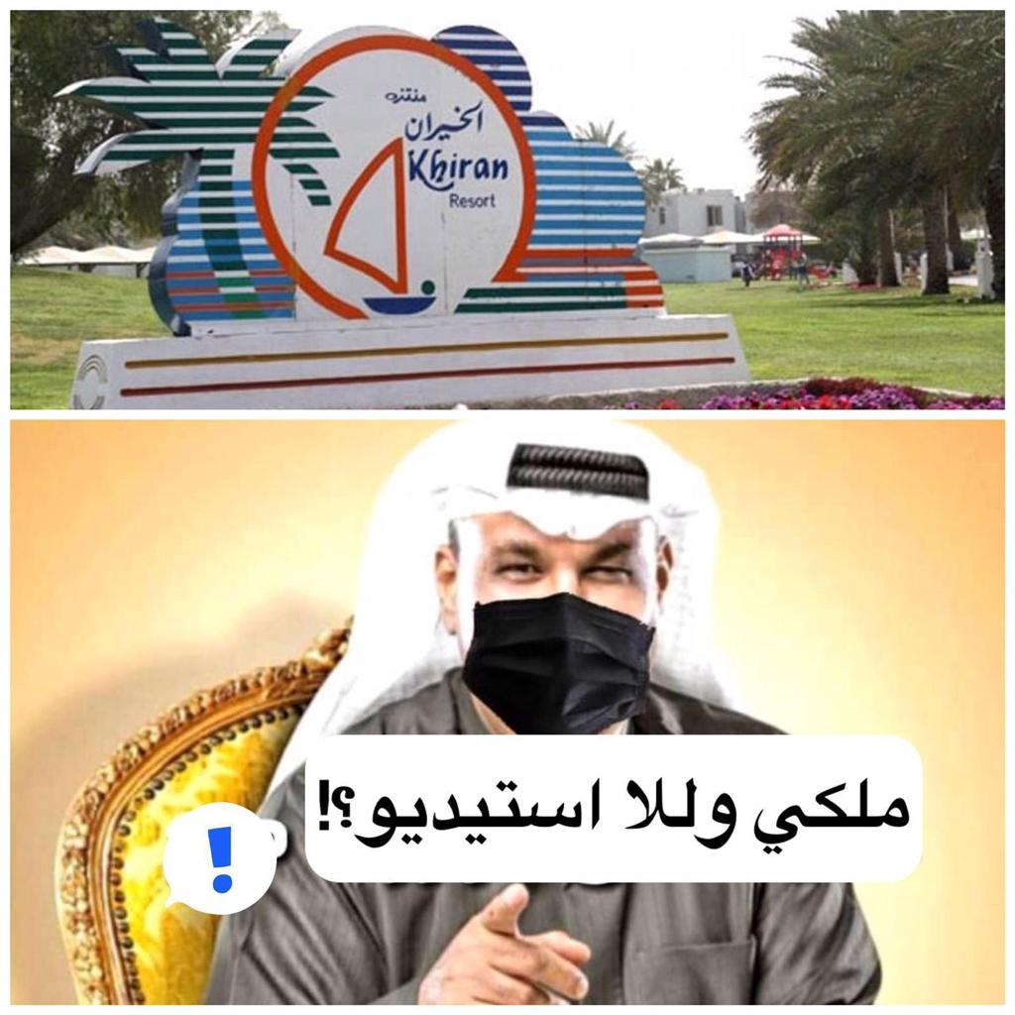

Fig. 2 King suite or studio? Digital image. Received on WhatsApp. February 25, 2020.

Another meme from this period: a video of a woman declaring the free food provided at the resort to be bland, inedible, oily, and the salad without sauce. The actual video is a 57–second long unrevelatory Snapchat, where the person behind the camera complains about the containers of untouched food and says that she wishes she hadn’t come back to Kuwait. But the comment that the salad doesn’t even have *sauce* prompted a flurry of online responses united by the hashtag and nickname for the woman #أمالصوص(‘umm al-sauce,’ or the one with sauce) as well as an article in *Watan*—an Arab-American newsletter—describing the video as ‘an irritating clip that shook Kuwait’[1] and eventually turned into a Whatsapp sticker (fig. 3). Even *Al-Majlis*—an online newspaper run by Kuwait’s Ministry of Information—tweeted a video of Dr. Mona Abdulredha (a well-known doctor and daughter of the late iconic Kuwaiti actor Abdulhussain Abdulredha) wherein she directly addresses ‘umm al-sauce,’ asking her to show just how she’d manage to survive the pandemic outside of Kuwait. Dr. Mona goes on to reiterate what hundreds of comments already expressed: Kuwait is a ‘mothering, giving country’, and that its citizens ought to see it that way. Beyond the nationalist rhetoric, Dr. Mona isn’t wrong: if your quarantine facility is a resort, *something* must be working in your favor.

The salad doesn't have dressing. Digital sticker. Received on WhatsApp. March 5, 2021.

Fig 3. The salad doesn't have dresing.

Fig 3. The salad doesn't have dressing. Digital sticker. Received on WhatsApp. March 5, 2021.

A lot happens around a joke like this, and the activity alone means there is attention and thereby potential for something to be done, or for something to be learned. Of course, a video of a person in a resort complaining about a dry salad is pathetic and ripe with memetic possibility. But at the beginning of the video, the woman addresses the Minister of Finance—she calls out to him, to see the waste in what is happening. Her point, I believe, is not to have a well-dressed salad, but to draw attention to the fact that there is a ton of money being spent and things still do not work.[2] The problem is that this meaning is lost when the video becomes a meme. It is easy to laugh at the forwarded video, the sticker, the joke of someone complaining about a dry salad in the middle of a pandemic—I still do—but nothing is learned regarding the structures or policies that led to these events. What we get instead is a salve to use when the next symptom of systemic failure comes around. This is the nature of the meme in online discourse: it perpetuates hell, then helps you survive it.

## The Absence of Feeling

In *Laughter: An Essay on the Meaning of the Comic[3]* Henri Bergson writes that ‘*the absence of feeling* which usually accompanies laughter,’ is crucial to the ability to laugh at everything. He reckons that if you were to ‘look upon life as a disinterested spectator: many a drama will turn into a comedy.’[4] If apathy is the mechanism of humor that lets us laugh at hard things, then the kinds of memes that can be found in the Kuwaiti digital public—trivializing issues by turning them into caricatures of themselves—signals a kind of apathy towards how things are handled, namely with regard to the ability of the citizen to change it.

A meme isn’t a site to critically examine a problem. For Kuwaiti memes, this means that the humor is only apparent to those who share the same apathy towards things—they’re ideologically comfortable and don’t require much interpretative work. Perhaps the only critical moment that a meme can offer is when it fails to deliver a punchline. Take a bad joke, for example: if a joke is not funny, it has failed as a joke, and what’s left are the words that should’ve done something. At that moment, the lack of humor suddenly reveals something that maybe, had the joke landed, would’ve been invisible. Humor conceals the fact that nothing has actually changed.

The more Kuwaiti memes are shared, looked at, and laughed at, the more questions of governance and its failures are obscured. The sticker of the coin flipping replaces an understanding of why decisions have been revised so often in the pandemic. Nabeel Shuail memed into a kind of sweetheart asking if you have a king suite or studio at the resorts has a coddling effect. When it doesn’t, a given meme simply falls flat. When memes are circulating, moving across social platforms and among groups of people, they don’t make space for changing the way we think about whatever disaster the memes are addressing—they simply reproduce the disaster in mimetic form, and then deliver the memes that help cope with it. So, if a meme is not capable of transforming the way we think about something, what does a meme do when it moves among some groups of people but not others?

## Those Who Laugh Together, Stay Together

Humor is a deeply cultural language that relies on factors like social context for a joke to work. This makes laughter a strong binding agent—when groups of people can laugh at the same thing together, they obviously find the same thing to be funny. However, their laughter alone is a signal that they share something far more important: the *ability* to find something funny. To Bergson’s point, if apathy is required to render something laughable, then that means that those who laugh at the same thing share their position of disinterested spectatorship. They are witnessing, but unbothered.

This sense of togetherness becomes even more apparent in internet meme-exchange. On an average day online, we might pass by thousands of images and strings of text. The algorithmic reasons we may be seeing certain items of content and not others is hidden by the user interface. What we see are decontextualized articles, opinions, memes, essays, forwards, videos, links, and status updates—as if there is nothing else to be learned about where they had come from. Did someone send this to me directly, or am I seeing it on my feed? Who published this? What are the motives this thing’s being shared? On the internet, and especially on mobile — where scrolling is the main form of movement—there is little to no room to understand the background of what we’re seeing. What we see is what we get.

When it comes to humorous things like gifs, stickers, and memes we experience them in an even quicker flash. They are funny, or they are or not. For those who get the joke, something like a bond is created. Sharing the sticker of umm al-sauce creates a space to laugh again, *together*, at something that is now far removed from the actual event or its real-life implications.

In *How to Do Things With Memes,* Eric Thurm converses with Wittgenstein’s language-games. ‘The closer words are shared and the deeper they are held, the harder it becomes for their users to back away from the things they are doing when they speak.’[5] Sharing memes starts to crystallize a myopic view of reality. With the collapse of meaning, memes meme for meme purposes only: the meme is the end.

As coronavirus cases first started to escalate in Kuwait towards the end of February 2020, memes were not harbingers of racism, but rather trafficked in jokes that could have only been formed from a racist worldview. There is a fine distinction between the two. A photo of the Turkish celebrity chef and meme figure ‘Salt Bae’ was sent around with the chef labeled ‘Iran’, the salt as ‘corona virus’, and the out of frame salted object as ‘Kuwait’. Another sticker used an image of former Parliament Member Waleed al-Tabatabaie—known for his conservative Islamist politics—saying ‘هالمرة صج كله من إيران’ (‘This time it really is Iran’s fault’). Reading this sticker as a joke reveals many things, mainly that for those with racist worldviews, Iran is an easy culprit. The jokes aren’t funny, but to address them as unfunny would be to address a message that is far from the message that this meme carries. When it comes to memes, the joke is the point.

Saltbae meme with Iran, Coronavirus, and Kuwait. Digital image. Received on WhatsApp. Feb 27, 2020.

Fig. 4 Iran, Kuwait, Coronavirus

Fig. 4 Saltbae meme with Iran, Coronavirus, and Kuwait. Digital image. Received on WhatsApp. Feb 27, 2020

This time it really is Iran's fault. Digital sticker. Received on WhatsApp. March 5, 2021.

Fig. 5 This time it really is Iran's fault.

Fig. 5 This time it really is Iran's fault. Digital sticker. Received on WhatsApp. March 5, 2021

There have been multiple critiques of the failure of the Kuwaiti government to address the root of problems. Policies have long protected Kuwaiti citizens in ways that render the environment and 70% of the entire country’s population, made up of migrant workers, , vulnerable. But from Sharifa AlShalfan’s examination of the effects of COVID-19 on existing urban infrastructure, it appears decisions in the pandemic were especially designed to leave non-Kuwaiti residents facing consequences.[6] As Kuwaiti officials encourage xenophobic hatred by announcing plans mid-pandemic to reduce the expat population down to 30%, the practice of neglecting real issues for ones materialized out of insecurity is perpetuated. Problems only worsen as the byproducts of a faulty system reveal its shortcomings under massive pressure to perform, and to perform quickly—the pandemic being the catalyst. These social critiques are quick to draw on law, policy, and regulation that affect the course of society, but seldom do they address the theatrics of the Kuwaiti government. On the internet, there is no government. What we are given instead is a charade that acts and talks like a state.

## The Final Meme

Bergson exemplifies the comic as a disinterested spectator. But it helps to think more specifically about the unaffected spectator, for whom the stakes of an event are low. To bear witness to a disaster is not unlike watching it unfold onstage: the event is acutely real, yet out of reach. Consequently, the audience is quite literally out of touch. As Mordechai Gordon writes, ‘humor allows us to view the world from a perspective that is amusing and comical rather than serious or sad.’[7] It is all too easy to become disillusioned online, where meaning is compounded and then collapsed into something alienating—hence the persistence of the joke.

Of course, the memes I have discussed here are—for a lack of a better word—mainstream. They are populist even by the standards of the internet, in that they transcend the need for prior literacy in meme culture. This is what makes them powerful tools to speak with. But as regards their potential to become a site for useful critique, these memes fall short. They are circulated to diffuse tension and offer a cheap laugh. All of this continues to mystify the conditions that sustain xenophobia, climate deterioration,[8] and an unimaginable labor crisis in Kuwait.[9]

## References

Alshalfan, Sharifa, “COVID-19 in Kuwait: How Poor Urban Planning and Divisive Policies Helped the Virus Spread.” *LSE Blog*, 16 September 2020.

Bergson, Henri. *Laughter: An Essay on the Meaning of the Comic.* Translated by Claudesly Brereton, and Fred Rothwell. Mineola: Dover Publications, Inc., 2005.

Gordon, Mordechai. *Humor*, *Laughter and Human Flourishing: A Philosophical Exploration of the Laughing Animal.* Springer, 2014.

Hamadah, Faisal. “COVID and Kafala.” *Monthly Review Online*, August 17, 2020. <https://mronline.org/2020/08/17/covid-and-kafala/>.

Thurm, Eric. “How to Do Things With Memes.” *Real Life Magazine*, January 16, 2018. <https://reallifemag.com/how-to-do-things-with-memes/>.

Watan. “فيديو-مستفز-لمواطنة-كويتية-من-داخل-الح.”March 26, 2020. https://www.watanserb.com/2020/03/26/%D9%81%D9%8A%D8%AF%D9%8A%D9%88-%D9%85%D8%B3%D8%AA%D9%81%D8%B2-%D9%84%D9%85%D9%88%D8%A7%D8%B7%D9%86%D8%A9-%D9%83%D9%88%D9%8A%D8%AA%D9%8A%D8%A9-%D9%85%D9%86-%D8%AF%D8%A7%D8%AE%D9%84-%D8%A7%D9%84%D8%AD/

1. “فيديو-مستفز-لمواطنة-كويتية-من-داخل-الح,” *Watan,* March 26, 2020, https://www.watanserb.com/2020/03/26/%D9%81%D9%8A%D8%AF%D9%8A%D9%88-%D9%85%D8%B3%D8%AA%D9%81%D8%B2-%D9%84%D9%85%D9%88%D8%A7%D8%B7%D9%86%D8%A9-%D9%83%D9%88%D9%8A%D8%AA%D9%8A%D8%A9-%D9%85%D9%86-%D8%AF%D8%A7%D8%AE%D9%84-%D8%A7%D9%84%D8%AD/
2.
3. Later in 2020, most of major public discourse in Kuwait addressed massive corruption and cases of money laundering. Henri Bergson, *Laughter: An Essay on the Meaning of the Comic.* trans. Claudesly Brereton, and Fred Rothwell (Mineola, New York: Dover Publications, Inc., 2005), 10.
4. Bergson, *Laughter,* 10.
5. Eric Thurm, “How to Do Things With Memes,” *Real Life Magazine*, January 16, 2018, <https://reallifemag.com/how-to-do-things-with-memes/>.
6. Sharifa Alshalfan, “COVID-19 in Kuwait: How Poor Urban Planning and Divisive Policies Helped the Virus Spread,” *LSE Blog*, September 16, 2020,

   https://blogs.lse.ac.uk/covid19/2020/09/16/covid-19-in-kuwait-how-poor-urban-planning-and-divisive-policies-helped-the-virus-spread/
7. Mordechai Gordon, *Humor*, *Laughter and Human Flourishing: A Philosophical Exploration of the Laughing Animal* (Springer, 2014), 3.
8. In 2018, flash floods in Kuwait revealed extreme unpreparedness. Memes permeated social media, and I traced their use in perpetuating national identity online. <https://vimeo.com/341394524>.
9. Faisal Hamadah writes about the Kafala system and migrant labor a few months into the coronavirus pandemic. See Faisal Hamadah, “COVID and Kafala,” *Monthly Review Online*, 17 August 2020, <https://mronline.org/2020/08/17/covid-and-kafala/>.