# Masks, Monsters, and Memes: In Conversation with Scoobert Doobert By Max Horwich

Forgive the ‘Webster’s Dictionary defines…’ introduction, but I recently learned (from Wikipedia, obviously) that the word meme comes from the Greek word for ‘imitation/impersonation.’ When I excitedly relayed my discovery to Scoobert Doobert, he already knows: ‘I actually studied Ancient Greek for a minute,’ he tells me. ‘When I retire, I want to translate the early Socratic dialogues into Japanese. Everyone has to have goals.’

Over the past six months, I’ve spoken to Scoobert Doobert more often than my own parents, although I still don’t know his real name and have never seen his face. He’s a San Diego-based musician, and I’ve been working with him on a variety of techy creative projects—building his website, animating his album covers to make Spotify canvases, designing an AR Instagram filter for the release of his upcoming EP, that sort of thing.

Late last summer, a friend sent me a link to his album-length music video *Masks and Monsters*, a sprawling reflection on life in the early months of quarantine set to a pastiche of woozy, psychedelic guitar pop. I watched the 50-minute video in its entirety four times that night. We were introduced over the phone two days later and have been working together ever since.

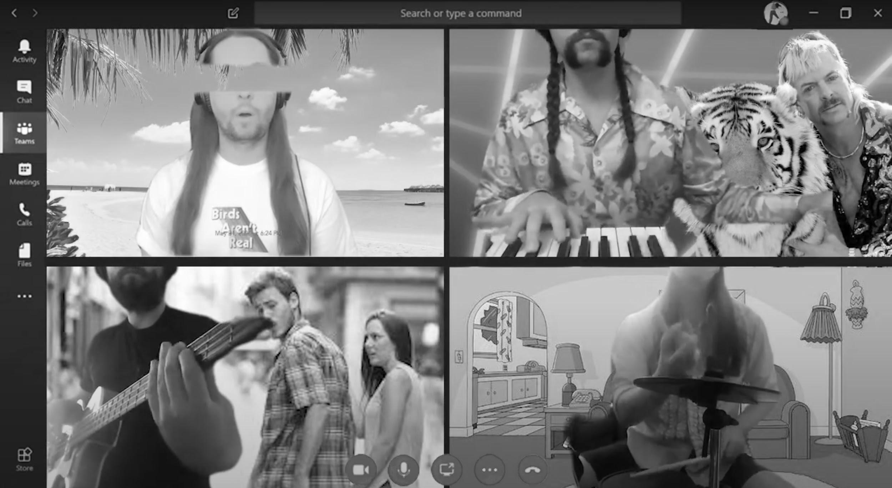

Figure 1: Still from Scoobert Doobert’s video for ‘A Good Life’

While his stage name and many of his song titles (‘Shaggy’s Anthem,’ ‘Mystery Machine,’ ‘What a Velma What a Night,’ etc.) might give the impression of some sort of Scooby Doo-themed novelty act, he rather uses this source material as a conceptual and ideological framework through which he examines and navigates the contemporary world. It turns out to be a disarmingly potent metaphor: accidental heroes with no superpowers or special abilities—they’re not even brave, they’re just stoned—forced to confront one monster after another which, in the end, always turn out to be just another rich asshole.

However, Scoob is quick to clarify: ‘My namesake is actually the Scoobert Doobert memes. So let the record show, it wasn’t from Scooby Doo. In fact, there is no character named Scoobert Doobert. Just Scoobert Doo.’

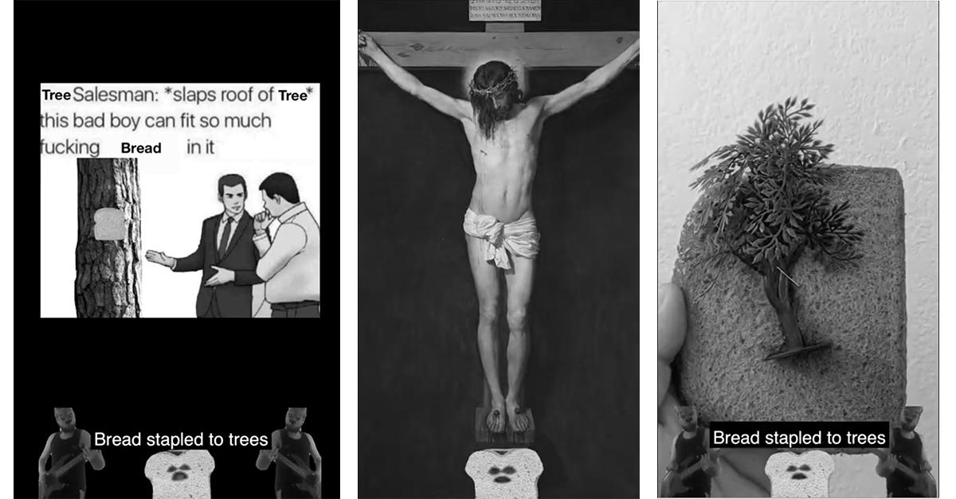

Figure 2: A tryptic of stills from the music video for ‘Bread Stapled to Trees’

Much of his work engages heavily with memes—from his ongoing series of one-minute songs dedicated to various Subreddits, to the year-in-review supercut for his recent single ‘2020 Is Over,’ to the aforementioned *Masks and Monsters*, which feels like a 50-minute scroll through knowyourmeme.com set to music. And while his work is at times laugh-out-loud funny (the shot of Christ on the cross at the end of his video for ‘Bread Stapled to Trees’ is one of the best visual puns I’ve ever seen), the humor is often a Trojan Horse for genuinely affecting moments of open-hearted poignancy and philosophical inquiry.

In many ways, Scoobert Doobert is himself a living meme, a meta-modern spin on Gilbert and George’s ‘living sculpture’ personas of the previous century. Unfettered by the shackles of his Christian name and real-world identity, he is free to ascend to a higher plane of existence, becoming one with the internet and the zeitgeist that it has spawned.

Scoobert explains it more humbly: ‘For me, being liberated of identity allows me to create things that I might normally be embarrassed by. David Bowie said in an interview that his goal of art is akin to being in a pool, deep enough to barely touch the bottom. That resonates with me, but I don’t know if I can do that without some freedom of judgement. Then again, David Bowie wasn’t his real name.’

I recently called Scoob to talk about memes, what they mean to him, and what they mean to all of us.

———

*I had your song ‘Don’t Worry’ stuck in my head recently and realized the hook is a paraphrase of a joke I’ve seen on Twitter. It got me thinking about how music engages with meme culture, and how much it’s changed over, say, the past decade. Ten years out from the coinage of the term trollgaze and we’ve had Beyonce and Lizzo unassumingly interpolating tweets into lyrics for chart-topping songs. It feels like pop music is figuring out what to do with memes.*

Popular music has always been meme-based. A ‘hit’ is unpredictable, it catches some invisible thread of shared reality.

Now it's like an internet allegory, where you're using this cultural repository like in the way that we used to use Shakespeare or the Odyssey. Then it's taking that same thing, but then being recursive with it—it's a really cool thing about where we're essentially headed. Allegory used to be such a highbrow art, and now it's becoming as lowbrow as a bastardization of a bastardization of a tweet. It's taking something that used to be part of an institution, tearing it down, and then rebuilding it back up while laughing at it.

People talk about how Donald Trump was this very postmodern president, like revealing how every institution is fake and flawed; but then there's kind of a necessary question of ‘and then what? What do you do after that?’ And there’s no real postmodern answer.

I think that when it wraps back around on itself and you get to the absurdity of meta-modernism, then you’re able to look at things more honestly. I think there's a lot of power there because you may actually get an answer out of it, not like an answer that's handed down to you from God, but an answer that we recognize as entirely flawed and entirely artificial, but still useful.

And I think that it's the role of the artist to try and influence that conversation, to try and nudge us along... to look at the world that we've created, look at the amazing scientific advancements, but also look at the things that we completely don't understand—probably never will understand, and have the hubris to think that we will—and digest it, help people digest it. Be part of the conversation that is the dialectic of culture.

I really believe that through absurdism, by taking things that are precious and making them unprecious, but then analyzing them and seeing what we still want even if it’s artificial—what we still think has value in an entirely artificial world—there's a very optimistic path that we could take, that recognizes that everything is meaningless, but then does the next thing beyond just tearing it down.

*Absolutely. When I think about the absurdity of this time period, and the way art reflects that and tries to deal with it—which is something that I see you engaging with a lot in your work—it reminds me of how modernism largely emerged as a response to World War I, and this previously unimaginable sense of, like, ‘Oh, shit, people can be awful.’*

We have the means to be awful on a grander scale. We were always awful. We just... industrialization turned to war, and then from there we realized that we were able to create hell on earth, and we did. We chose that option.

*Right. And since then there’s been this cultural churn over the past century, where movements will emerge to combat or subvert the dominant problem of the day, and the Powers That Be figure out ways to adopt the tools of our resistance and judo flip us back into subservience. Like, the things that saved us from misery a hundred years ago ended up making us bored, and the things that saved us from boredom fifty years ago ended up making us anxious. And now we’re so entrenched and overwhelmed by that anxiety that, like, it seems easier to imagine the end of the world than the end of capitalism. It’s hard to address a problem when you’re so deep in it that you don’t even have the language to identify and describe it, and it seems to me like one of the roles of memes as an artform (or whatever you want to call them) has been to help us develop the language.*

I think that's barking up the wrong tree though. I think that postmodernism, to me at least, was all about trying to find the right language to deconstruct language. And, like... it's so hard to read Derrida. It's just a nightmare. He's a genius, and you can get great stuff out of it. But it almost feels like talking to a lawyer about law rather than talking about, like, ‘why do we even need a law?’

The longer that we're kept out of the roots of the problem, the harder it will be to really talk about or tackle the problem. And sometimes I feel like we spend so much time trying to develop the proper language to discuss something that we end up getting thrown off course through that same verbal judo.

Like, I really like Socrates, a lot more than Plato. I like him because he's this ultimate ironic figure. You don't really know his true identity. You don't know what he looks like. You don't know any of his own words. You just know that he could go into town and talk to the smartest guy and make them feel like an idiot; because we're all idiots, and his central wisdom is we're all idiots. And, it's like, that's a really hard thing for people that are academic and people that have aspirations to cope with. That's why I like absurdism so much — I think it drills back down to the essential truth that, like, we're not that smart. We're not that good. There's not a lot for us to grasp onto. We can't trust our eyes. We can't trust our experiences. We can't trust the systems that we’ve built. All of it is artificial.

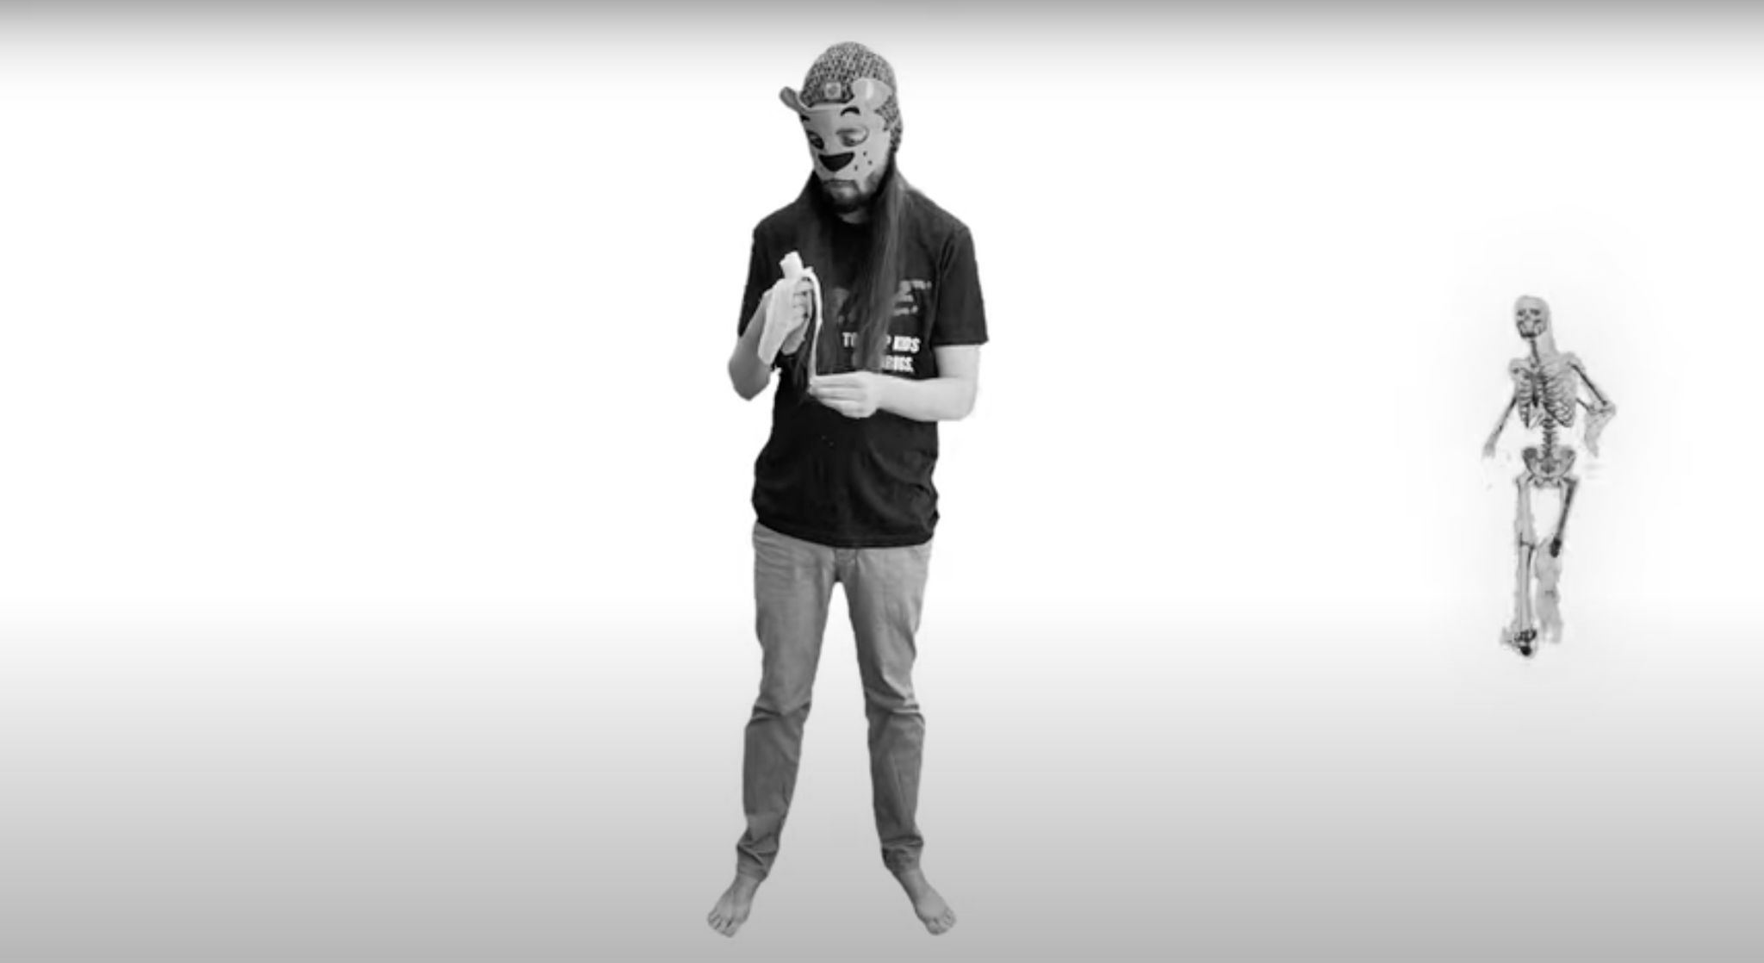

Figure 3: Still from ‘Scoobert Doobert Eats a Banana in the Void’

And then what do you do with that knowledge, according to Socrates? You laugh! And you just say, like, ‘I don't really know what good *is*, but that doesn't mean I shouldn't try to be good.’ And it's like, there are these contradictions that you can't get to with language. Like you can't dissect and find an answer with language, but it doesn't necessarily mean like you have to say, ’Oh, there's a Platonic Ideal.’ That's a stupid leap, in my opinion, from ‘we can't understand anything, we're all idiots, deal with it, accept it’ to ‘no, no, no, there's this *thing*, we just can't get to it. It's like looking at the sun... but it exists.’

And so in terms of memes and stuff, I think that it's getting hijacked by the thing that it makes fun of. And that pisses me off a bit. When you're waving a meme flag while you're storming the Capitol, it's awful, but it's also so absurd; and if you can’t see the absurdity in it, then I don't think you can be broken from the chains that it's ensnaring you in.

For me, hope lies in acceptance and then moving forward. Because if you accept that we're all in this fatalist experience with artificial trappings that make us *feel* comfortable and safe, but that safety and comfort don't really exist, you feel anxious. But you could also feel community, because, like, we're all in the same boat and nobody's better than each other. Nobody has any secret wisdom, and that's freeing to me. That's the state of play that I think Derrida was getting at, but had a hard time communicating because he was trying to deconstruct language with language, rather than just laughing.

*Since we’re having an academic discussion about memes, I feel like we should probably talk about Richard Dawkins. I haven’t actually read* The Selfish Gene*—I was supposed to read it in grad school but I think I was busy that week—but I’m interested in him as a figure, because before I knew he was ‘the memes guy,’ I just thought of him as ‘that stuffy old British dude who’s shitty about Muslims,’ and I’m fascinated by a guy who’s so on-point about one thing and so wrong about everything else.*

Definitely. Richard Dawkins is funny because, like, my first introduction to him was some of my religious friends showing me, like, ‘watch this guy get schooled about creationism.’ Going back to the conversation we were just having, I feel firmly agnostic about almost everything now. I think that in atheism, there's the same hubris that there is in religion. It's like you think you know, but nobody knows anything. Richard Dawkins is funny because he's such an authority figure for this thing that spiraled completely out of control; so then he, by nature, doesn't have authority over it.

It's just funny, like how Bukowski says ‘you'll never meet an old radical.’ There's just a certain erosion that I think happens over time. I think it entrenches people deeper and deeper into their observed reality and stops them from imagining others. And then it's funny to see somebody that was so imaginative, like Richard Dawkins, flipped in a tweet right now. He's the butt of the joke.

*Right. I mean, in some ways, we do kind of get dumber as we get older — when we’re young we spend all this time forming synapses and making connections; and then at some point in adulthood we figure out which ones are useful, and then the other ones just sort of slowly start to die off. And I think it happens literally on a neurological level, but I think it also happens on a more ideological—or I guess the word would be memetic—level. You get to a certain age and you're an expert in your chosen field. You know everything there is to know about one thing, and you know just enough about everything else to make it work. You have an understanding about how the world works, but it's sort of the ‘Columbus sailed to America to prove the world was round’ kind of understanding. It's wrong, but it works as a placeholder until you can learn how it really is. But the longer you sit with that incorrect understanding as the objective truth, the more ossified it becomes and the harder it is to break out of it.*

Yeah, exactly. There is a hidden danger in the economic theory of specialization, where you look at people as little machines—even if you're good at more than one thing, you should only do the thing that brings the most economic utility and let the other people do the other things. And I think that industrialization has helped us program ourselves in that direction, but people aren't meant to be that.

And I think that we've seen younger generations kind of fight back against that a little bit—with the rise of DIY culture and stuff like that—where it's like, what happened to the Renaissance Man? What happened to the... you know, you dabble and you study and you grow and you question and then, ‘hey man, like, I figured out a new field of botany!’ What happened to *that*?

And it's not that everything's been found out already. I think that there's a certain danger to the culture of PhDs and very narrow fields of research and study, now that we have so many more things that are multidisciplinary. And as we get more robots, I think the skills that we really need in a post-AI world are the ones that connect dots that a robot couldn't.

And that's the human stuff. That's where art comes in. And I hope that art can help lead people to, you know, interact with it more. I don't like that people are such passive music listeners. I like that there are more tools to actively make music, because that'll allow me, as a performer and instrumentalist, to do more things, because now the listeners will be capable of listening to more things at once because they've trained their ears. I feel like even if you don't get great at something, just like the act of doing other stuff, it'll make people and society as a whole more open, more generous, more well-rounded.

*I think this is a great place to segue back into talking about your practice. I know you primarily identify as a musician, but to me your video work feels indispensable to the project. All of your videos look and feel, unmistakably, like Scoobert Doobert videos, in this idiosyncratic, almost auteurish way. Did you have experience working with video before this project started? Or was it just, like, ‘I got Adobe Creative Suite from work, I guess I'll start fucking around with it’?*

A little bit of both. Um, funny enough, the day I was born I was on TV, because my dad was on TV. They filmed me as I came out of the womb with a big cone head, ‘cause they had to like vacuum suck me out of my mom. So I had a very misshapen skull for the first few months of life. So yeah, like, I don't know, video has been a big part of my whole life growing up; my dad was a cameraman and did stuff on screen too. And so yeah, I was learning like shots and framing and stuff and like watching things a little more critically, I guess.

But at the same time, I'm not a film student. I don't really know what I'm doing. I'm kind of trying to bring, like... you know like Meg White from the White Stripes?

*She’s my favorite drummer.*

Dude, right?!? Like, there's an appeal to a childlike approach to a medium. And I'm trying to bring that too. I'm trying to push myself in a way with it so that, you know, like I find myself I'm getting pretty decent at it just because I'm trying to keep myself scared with what I'm doing and intimidated by the vision. But I also try to bring improv to everything I do. Pretty much every record has got at least one song on it that’s entirely improvised, at *least* one. And I want to do that forever. I'm trying to bring the same kind of spirit to the video editing where it’s just, like, split second, *what if I did this?* Do it. And then like a day later look back and be like, ‘that's funny.’ Like stuff that you wouldn't be able to logically think out, you just have to find subconsciously.

I also feel like that's kind of a big thing with memes, right? Like, sometimes I see memes that are too logical and it doesn’t sit right. I really like the way gen Z is memeing, because it's so chaotic and it's so reductive. I love the chaos, but I’m also kind of sad because I worry about them sometimes. Because sometimes it’s pushed so far that it doesn't seem like it’s absurdist anymore. Sometimes it just feels really depressed and dark and sad through an absurdist lens.

But I dunno, as somebody who makes art, my goal would be to pull the people that are too literal away from the literal, and the people who are too sad toward the happy, because I think that absurdism and like retrospection should have a laugh to it, even the darkest things. Like even some of the worst things in human history, I think that the human impulse to laugh is one of our greatest strengths just to cope with existence. And it’s not like I want to just make happy glossy music, but I hope to bring that sensibility to the videos and to the music and stuff, so that even when I'm talking about a dark subject, it'd be a little bit tongue-in-cheek so that, you know, there's a place to land.

*Yeah, absolutely. One of the things that I think is so interesting and powerful about humor is the reaction is so immediate and visceral. Someone tells a joke and either you laugh or you don’t, there’s no faking it. And a joke is often an observation about the world, so when someone laughs at your joke, it's because they share some of your underlying assumptions about the way the world works.*

*I mean like so much of the stuff that you're doing is genuinely funny, but it's always in service of the other stuff that you're grappling with, like deconstructing the absurdity of modern life and, you know, Derrida or whatever. Humor can be in service of these like larger things that don't go down so smoothly without it, you know?*

Definitely, definitely. I think it's interesting how there are certain things that translate really well across cultures—like character acting, everybody loves Mr. Bean all over the world. But, like, I go to Japan and nobody knows who Will Farrell is. A lot of American media gets consumed in Japan but a lot of American comedy doesn’t land. I want to try and bring a healthy dose of that to what I'm doing, and hopefully make stuff that’s cross-cultural. I don't want to get too swept up in the U.S. and thinking that our problems are the universals.

*Will Farrell is a funny example because, did you see that* EuroVision *movie that came out like last year? I mean, it wasn’t great; but the thing that I thought was interesting about that movie was 1) it was clearly intended for an international audience (i.e. people who watch EuroVision), and 2) all of the humor is visual. There aren’t really any funny lines of dialogue, all of the jokes are in the camera tricks or the staging or all of these other things that are unique to the language of film; which is great, because it’s kinda rare for American comedies to meaningfully engage with the medium of film in their humor* — *it’s mostly just a camera pointed at people while they tell jokes. It begs the question of what’s even the point of making something as complicated and expensive as a movie when the content could just as easily be delivered through a much simpler medium?*

That's a good way of looking at it. And I think that that's a good way to kind of flip the narrative, because I know a lot of people are really bummed, especially directors. I just listened to a podcast where the director who did the new Billie Holiday movie was lamenting how everybody should just do superhero movies now.

It’s the same way that I get frustrated with how music can sound very commoditized, how record labels are just signing competitive acts that sound similar to another already-successful act, and it ends up squishing music into a very narrow spectrum.

And I feel like the same thing is happening to film, and film just doesn't know what it's like yet. They're complaining about having to be direct-to-streaming, and losing out on the revenue streams. And like music has had to deal with this since forever. ‘Oh, boo hoo! Netflix bought your movie!’Like, I get that you’re gonna make less money, but you're still gonna make money.

*And people are going to be watching it on a smaller screen, but at least they’re watching it.*

They’re lamenting the change of experience. There's a certain experience of going and seeing a movie for the first time in a theater with other people that are validating your emotions. And I miss that a lot since the pandemic, so I don’t think that’s going away. But I think it's funny because music lost that experience, and it’s not coming back. But you know, we're just going to have to continuously evolve and hopefully find a bright path. And this pandemic I think has reinforced that in my head. It's like, there will be black swans… What do we do today? We can’t control very much.

*And I think on the flip side, another trend I’m noticing in film discourse, that music was dealing with like 10 years ago (and it was insufferable, so good luck guys), I feel like film is experiencing poptimism for the first time now. Which, on its most basic level, like, that’s valid. Your love of [whatever popular thing] is no less valid than my love of [whatever unpopular thing]. Sure. But it also has people doing some like pretty weird mental gymnastics trying to politicize every consumer decision they make. It just seems a little unnecessary, and frustrating for everyone involved. It just becomes another thing to get angry at strangers on Twitter about.*

Yeah, but I feel like that goes back to control. For a long time we had this illusion of control that felt safe but boring. Now there are cracks in that illusion—and the Covid crisis was the biggest, most obvious one, just like a war would be—and the boredom turns into anxiety. But then that anxiety either turns to outright fear, which turns to anger, or it turns into a moment of revelation of growth and community.

And we’ve seen both throughout the course of the pandemic, the highest high of ‘we're all in this together’—finding out that things like student loans and rent can just go away; that if we want to, everybody can get vaccinated, like, for free. There were paradigm-shifting responses, not just from the policy angle, but like from businesses, from people, from neighbors. And then it all eroded it into storming the Capitol.

*Totally. What strikes me most about your album* Masks and Monsters *is how it feels almost nostalgic now*—*there was that period in 2020 from around March to May when it really felt like everyone on planet earth was dealing with the same problem for the first time ever. It’s like we were all right on the verge of this incredible epiphany and then just ran screaming in the other direction.*

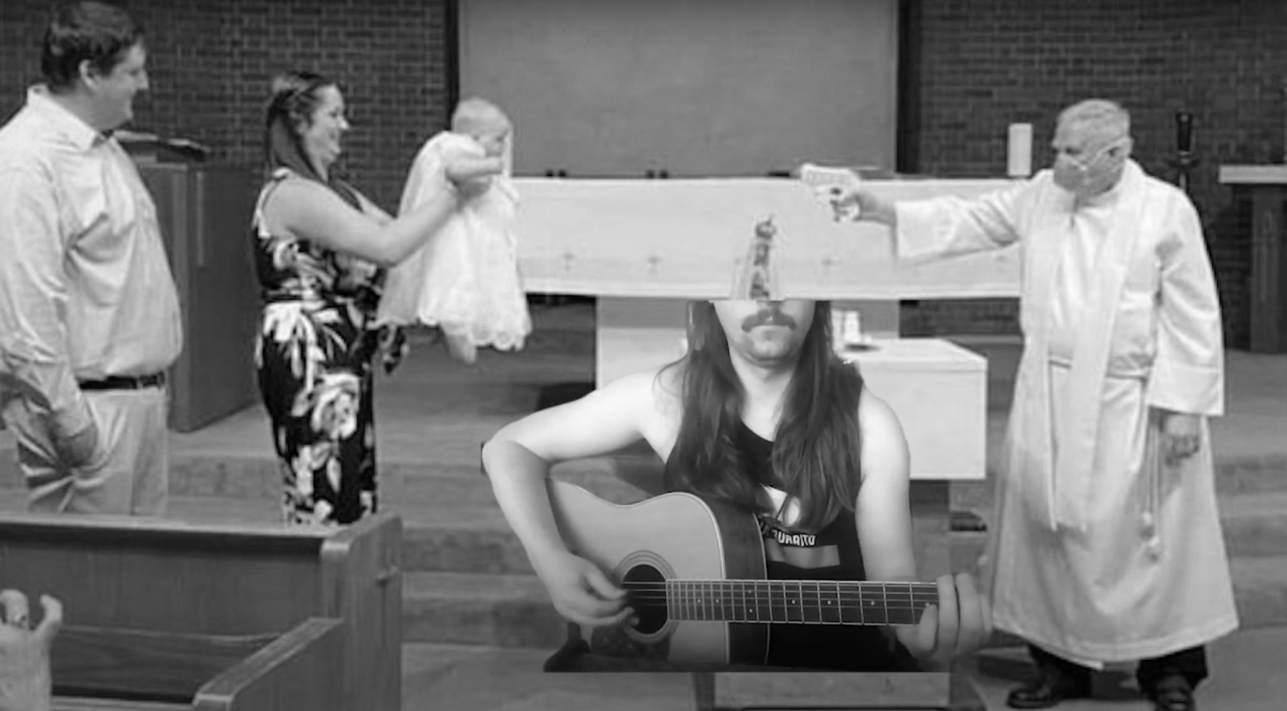

Figure 4: Still from the music video for ‘Why, How, Yeah, Yeah’

COVID connected all of us, and I think a lot of people were extremely uncomfortable with that. Just consider all of the rich people fleeing to New Zealand. I’ve gotten pretty into learning about billionaire bunkers. Did they forget they're human?

I guess, hyper-connective moments are terrifying to those that aren’t used to connecting. Some very literally spend their lives trying to disassociate from the masses. Why?

Imagine what it would actually be like if aliens landed. I think we just got a taste of it. For a brief moment, it really felt like we were All In This Together™. There was something heartwarming while that brief moment lasted. And it was sad how quickly it evaporated. But it gives me hope, because we had a glimpse of what a united globe could look like. We really could solve every problem on this planet if everyone actually cared. If we stepped out of the damn billionaire bunkers. Figuratively.

So we saw what I think is both the revelation and that acceptance of these things as artificial. And because they're artificial, we can look at them rationally rather than just saying ‘this is the way it always has been and this is the way it always will be.’ We can have a discussion about our artificial thing rather than a holy thing.

And instead of weaponizing memes to protect what we think is holy, we can use memes as a tool to poke fun and to show absurdity and to flip things on their head and unite, even in small communities. And so I think that there are two logical responses and I'm just trying to put my weight on the one that is less combative and is more revolutionary, because I think you can do both. I don't think it has to be a revolution of killing people. It can be a revolution of thought. If we’re able to accept the absurd and accept that it’s artificial, then anything is possible.

*On the subject of revolutions of thought, I want to bring the conversation back to humor one more time. Humor is a powerful tool for creating in-groups and out-groups, and some of the worst people in America have used this to great effect. Do you think there’s a way that we could use humor to fight back?*

Especially in the West, we tend to think linearly and in binaries. There’s left and right, with cause-and-effect. One and zero. So, our natural Western response would be to say, we need to fight the Pepe’s with an equal-and-opposite force. Some sort of Newtonian retribution.

Dig down deep enough though, and everything *can't* be reduced to 1's and 0's. It can just appear to be. Like how a movie is just images moving quickly enough to give the impression of reality. Or a pixel can give the illusion of a curved line with nothing but blocks to work with.

I'd like to pitch an alt-alt path, for us to be less adversarial and more absurdist. I mean, we have people flying meme flags storming the capitol. That’s horrifying, but is the appropriate action to fuel it—or to laugh at it?

Of course, seeing things that I love weaponized yields a certain disquieting vibe. But the goal shouldn’t be to take up arms against it. Instead, what if we neutralized it. What if we left the Nazis punching air instead of fighting back. What if there was no equal-and-opposite force. What if?

That’s the ethos, I guess. Take a step back. Laugh at it. Neuter hate.

And remember what we can be together. All of us have a defined and absolute destiny—death. What do we do with that knowledge? I think we either turn our fear into anger and anger into hate—or—we can laugh at it. In that, we can assert control over the uncontrollable.

Like, Socrates laughed on his deathbed. That’s memeable AF.