# ‘The Disturbingly Humanoid Face of the Lamb of God Has Shocked Many’: Visual Strategies in Internet Memes on the Restoration of the *Ghent Altarpiece*. By Martin Hanßen

What do the Lamb of God painted by Hubert and Jan van Eyck in 1432 and Kylie Jenner have in common? Well, a variation of the *Ghent Altarpiece Lamb Restoration Meme* might just have the answer. The meme juxtaposes Kylie’s face with the head of the Mystic Lamb after its recent restoration. The comparison is captioned ‘So apparently they restored the Ghent altarpiece and:’ (Fig. 1). You can kind of get the resemblance between the two faces: the lamb’s head to the left with its bug-eyed stare, jutting Shrek ears, lantern jaw, and daring pout *is* faintly reminiscent of Kylie’s strong bone structure, saucer eyes and (in)famous full lips. But while the two images do share similarities in their own respect, it is the caption that draws them into equivalence and, in essence, makes the joke.

Indeed, it is the same text that captions the initial form of the meme (Fig. 2), and the difference is remarkable: on the left, we see the center of the altarpiece prior to restoration. It is characterized by its naturalistic, almost mimetic depiction of a sheep featuring slightly askew eyes on the side of the head (just where the eyes of a flight animal are naturally positioned), a broad nasal bridge ending in tenderly pink y-shaped nostrils and philtrum, and ears obliquely sticking out on top of its head. Looking straight at the viewer with a subtle smile, the image gives the impression of a passively observing animal that does compellingly resemble the natural look of a sheep—bar, perhaps, the odd structure that weirdly sticks out of the left side of the head which turned out to be the animal’s original right ear. To the right, separated by a vertical black line, the now-revealed true face of the lamb looks strikingly unlike a sheep, almost grotesque.

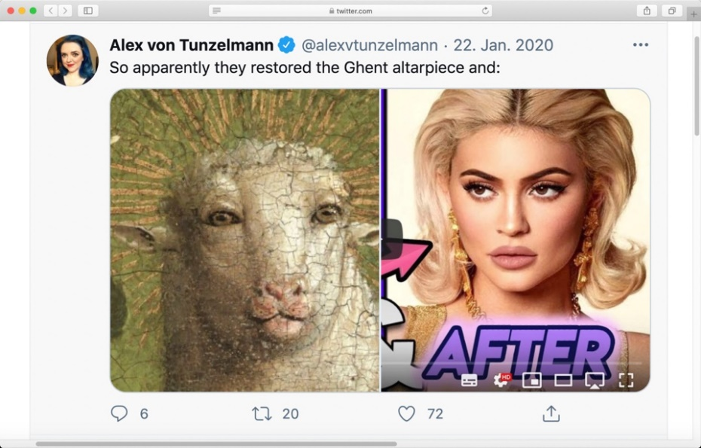

Fig. 2 Screenshot of a variation of the Ghent Altarpiece Lamb Restoration Meme juxtaposing the restored head of the Eyckian Lamb to Kylie Jenner’s face. A comment connects the two images. Posted by @alexvtunzelmann to twitter.com on 22 January 2020.

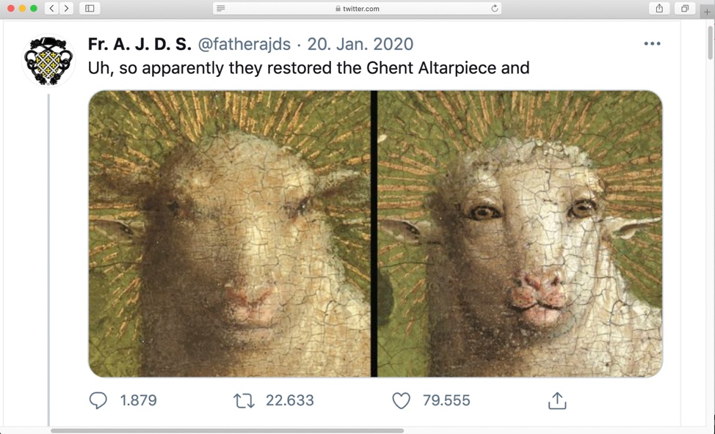

Fig. 3 Screenshot of the initial variation of the Ghent Altarpiece Lamb Restoration Meme juxtaposing the head of the Mystic Lamb before and after restoration. A comment connects the two images. Posted by @fatherajds to twitter.com on 20 January 2020.

As a way of making the restored lamb’s head tangible for the internet community, both variations choose comparative vision: a traditional yet effective method of image criticism. In doing so, the memes elucidate formal parallels between the heads in question and so mockingly comment on the restoration of the *Ghent Altarpiece*. Just as with comparative vision, they place two images from different contexts in contrast and assess them primarily based on their formal characteristics, which already suggests their analogy (or their shortcomings, respectively).

[1] Thus, the image pairings are implemented as a purely visual argument that claims similarity or difference of the images, and is supposed to give proof of formal analogies tied together by a brief, provocative comment.

Nevertheless, let’s not forget that the head of the Mystic Lamb in van Eyck’s painting is only about the size of a walnut, mingling as it does with the myriad other pictorial elements of the 24 panels of the altarpiece. It is in cropping down the artwork to its very center, where the lamb’s head is depicted as the iconographic climax that the formal likeness to Kylie’s face is finally achieved. But even if the comparison of the lamb and her face is bewildering at first glance, it does not—after all—highlight a factual equivalence. Especially in the pop-cultural context of social networks, comparative vision is likely to be narrowed in its capabilities. This happens as polarizing images like these are paired—original/copy, before/after or right/wrong—in order to provide visual evidence or illustrate causalities.[2] Most internet memes make use of such incongruous couplings and anomalous juxtapositions, which are deliberately provocative and as bizarre as possible.[3] In pairing the Lamb of God with a sensational example of internet culture like the #KylieJennerLipChallenge, or by highlighting the drastic changes of the head during the restoration process, the memes seem to look for juxtapositions which specifically cater to the shock humor and the rapture for spectacle of the net community and, at the same time, illustrate their point of criticism.[4] But what is so shocking about the restoration of thealtarpiece anyway, particularly regarding the restoration of the Mystic Lamb? Keeping in mind that the *Ghent Altarpiece* has, ever since its creation, been appreciated as *the* most significant testimony of late medieval European art by art historians and art lovers alike, the conspicuous transformation of this important detail *is* quite shocking from an amateur perspective.[5]

Already prior to the unveiling of the restored panel with the *Adoration of the Mystic Lamb* (Fig. 4) in Ghent on December 24th, 2019, online press had picked up on the incongruous depiction of the lamb’s head. Most articles were illustrated with a comparison of the lamb prior to and after restoration in a manner pretty much identical to the juxtaposition later seen in the meme.[6] Additionally, the media quickly adopted a certain sneering rhetoric regarding the restoration campaign: calling the face ‘disturbingly humanoid’ or ‘alarmingly anthropomorphic’, immediately evoking a comparison of the Lamb of God to human physiognomy⎯anticipating the comparison to Kylie that followed about a month later.

By picking up this rhetoric of a ‘disturbingly humanoid’ sheep, yet another variation of the *Ghent Altarpiece Lamb Restoration Meme* introduces a different strategy to criticize van Eyck’s Lamb of God. Instead of utilizing the image of the Mystic Lamb, this meme opts for an image of the anthropomorphized face of children’s show character Shaun the Sheep floating before a greenish-blue backdrop. It is captioned: ‘The disturbingly humanoid face of the lamb of God has shocked many …’ (Fig. 3). Here, it is apparent that the user expects their peers to get the joke based on their awareness of the memetic discourse and media coverage of the restoration. While in the other examples it is the image or image pairing that specifies the context of the discussion about the restoration, in this variation of the meme the joke lies in the caption as there is no visual reference to the artwork in question. Captions, however, always influence the way images will be read by the viewer and the meaning of the image is altered by the sequence of all its preceding captions.[7] Following this quality of captions, the variation ties in with its memetic relatives not by implementing the same imagery, or by making use of comparative vision as its visual strategy, but simply by including the framing rhetoric of online press in its caption. The text enables a reading of the image of Shaun’s face as an example of van Eyck’s humanoid lamb as the ekphrasis generates visual correspondence.[8] At the same time, the image itself does share formal characteristics with the square portrait of the Lamb of God that is used by all the other memetic variations. It appears to offer enough visual equivalence to the other images that cluster around the ‘failed’ restoration to support the caption’s ironic claim—even if the work of art itself is not depicted and the lack of comparative vision undermines the processual character of the before-and-after-idea.

Fig. 4 Screenshot of a variation of the Ghent Altarpiece Lamb Restoration Meme. The user substitutes the image of the Mystic Lamb with the face of Shaun the Sheep. The comment labels the head ‘disturbingly humanoid’, picking up online media rhetoric. Posted by @CheeseWorrier to twitter.com on 22 January 2020.

In combining images with witty captions internet users apparently had a great time joking about the restoration of the *Ghent Altarpiece*. However, all of the variations make use of similar—if not the identical—visual strategies to frame the recovered head of the Lamb of God. This is to say that they all rely on a network of images that are in some way related to each other to create the joke and criticize the post-restoration Lamb of God primarily by highlighting formal similarities or differences. Based on the concept of comparative vision, these images, together with their textual add-ons, function as profound, taunting judgements. They deliberately juxtapose the head of the Mystic Lamb to historic and expressive moments of online communication—moments which are etched into the memory of its users—to hint at the broader history of *lulz* within the online community. As artifacts of a collective memory of internet culture, these images offer references by which the phenomenon of a ‘disturbingly humanoid’ face ties back to and is explained within the visual culture of the internet.[9]

## (Re-)Formatting the Altarpiece

When the extensive overpainting was removed, the Lamb of God was only one of many details that changed drastically throughout the restoration of thealtarpiece. But it was this specific transformation that caused quite the stir on social media. Why might the head have had such a memetic career? Apart from the facts that it sits at the very center of the retable and is also the eponym of the alternative name of the artwork, it may be that the head functions as a focal point of ironic criticism, catering to the visual habits of meme creators and consumers alike. Not only is the comparison of the before and after visually effective, but the image of the ‘alarmingly humanoid’ face immediately reminds internet users of the many other images of the same format and pictorial object. Case in point, the selfie: a squared-up close-up of a face taken at arm’s length, in which snoots, grimaces and many other facial expressions are encoded in complex nuances which can nevertheless be unambiguously deciphered by its users within seconds. Selfies and similar mugshots usually pop up in very distinct moments of online communication, evoking and fulfilling certain reactions and expectations of net users.[10] Keeping in mind the very specific role of portraits of comical faces in digital communication, the headshot of the Mystic Lamb also proves convenient in countless other memetic circumstances beyond commentaries on the restoration campaign.

While the term *format* is nowadays heterogenous in meaning, within the discipline of art history it is traditionally used to describe the dimensions and aspect ratio of a work of art. Furthermore, it identifies different format types with their very own material, dimensional and symbolic peculiarities. Within this definition, the format itself is regarded as the product of a formatting process through which the borders of an image are defined, and its visual dimensions and properties are specified.[11] Accordingly, it restricts the pictorial object, as it determines what is to be seen in an image. In the case of the portrait, for example, viewers will always expect face-like features in what they see, although they will not necessarily encounter a human sitter. This shows that whatever is depicted acts within the terms of its format, no matter what the pictorial object is.[12] Consequently, formats—like captions—fulfil an important role in how images are seen by encoding the object. In the case of the *Ghent Altarpiece Lamb Restoration Meme,* this means that by simply cropping the lamb’s head to a square portrait, the format alone suggests similarities to the human face.

However, the case of the ‘alarmingly humanoid’ lamb cannot be entirely put down to a formatting process. The image of the restored head itself is a detail of a digital photograph that has been cropped into a close-up portrait. Accordingly, cropping the photograph of the original painting needs to be regarded as a process of strategic reformatting. This means that the previous dimensions of the original digital image have been changed in order to align it to the already-established square portrait format with its very own formal aspirations, meanings, and expectations in digital communication, as well as to the image repertoire of net culture. In doing so, the very complex reference system of the original painting is lost: the identification of the Lamb of God with Jesus Christ, for example, as it is sacrificed on the altar and the *Precious Blood* spills into the golden chalice in presence of the Holy Spirit representing the transubstantiation*.* Also lost is the Lamb’s exposure to the *Arma Christi* or the *Fountain of Life* which again emphasizes the lamb as a metaphor of Jesus himself. (Fig. 4).

Fig. 5 Hubert & Jan van Eyck, Adoration of the Mystic Lamb, 1432, 350 x 461 cm, oil on wood, St. Bavo’s Cathedral, Ghent. Macrophotography after the restoration. © closertovaneyck.kikirpa.be

In contrast to the original iconographic interplay, the lamb’s now-trademark facial features are the focus of attention, additionally emphasized by the green background with the radial golden lines that draw the gaze to the center of the image. Without its context, the lamb’s head looks daffy and silly as well as ‘poorly executed’ if considered simply as an attempt at a mimetic depiction of a sheep. Accordingly, cropping it down to a square means that the image has been reformatted to such an extent that its visual impact was completely modified. The intention behind this strategy is obvious: in cropping the image to a square portrait, the narrative of an alarming resemblance of the restored animal to a human face appears visually confirmed. Moreover, reformatting fosters comparisons to other portraits of meme icons and thereby manifests the ‘failure’-narrative through comparative vision alone.[13] Van Eyck’s sheep is now available in the large pool of other square portraits to which it can be compared, may it be Kylie Jenner’s face, or the everyday Insta-girl’s duckface selfie. Through reformatting, the lamb’s formal properties within its original context are circumvented and matched to similar images—which have also been reformatted in their own respect. Just look at the image of Kylie (Fig. 1) and you’ll immediately notice that it actually is a still of a popular video on YouTube that has been aligned to the Eyckian lamb in order to enhance the effect of the juxtaposition.[14] Through reformatting, van Eyck’s outstanding work has been standardized to such an extent that it can be swapped with pretty much any other image of this visual cluster. The user can trade the head of the Mystic Lamb for a close-up of Shaun the Sheep.[15]

When looking at the format of the images implemented in the lamb memes, it is obvious that a certain iconic formula—an archetypal formal pattern or visual scheme—connects them all. Within it lies the memetic power of the reformatted image of the Mystic Lamb: every variation of the *Ghent Altarpiece Lamb Restoration Meme* implements square centered close-up portraits that recall the omnipresent selfie and its ilk, which are part of daily communication online. These headshots with their encoded facial expressions are an essential part of everyday visual literacies of net culture. As they reappear over and over again, in their familiarity users are encouraged to remix the components themselves.[16] For most of them remixing takes just a minute and they can become part of the discussion. Reformatting as a visual strategy, therefore, has a bifold character. On the one hand, it demonstrates the interaction of users with images as a way of communicating with their online peers. On the other hand, it highlights the independent existence of the image in its new form within the visual cluster into which it has been inserted based on this format.

## Visual Clusters in Network Cultures

Through reformatting, the image of the Mystic Lamb has become part of a cluster of images gathering around the keywords ‘disturbingly humanoid’ or ‘restoration gone wrong’. The concept of visual clusters is a loose association of images based on formal characteristics. It describes their relation to and among each other on a level of content, emotion, or personal meaning. The idea traces back to the methodology of early 20th century art historian and cultural scientist Aby M. Warburg who brought together images on large mood boards. These were supposed to ‘illuminate new connections at the level of content, new insights, and the shifting and transfer of figurative traditions’[17] and could be regarded as an early predecessor of Pinterest. Transferring Warburg’s understanding of how images behave in a cluster structure to the realm of the internet, Kerstin Schankweiler observes that clustering similar images which recur on related topics or share a certain set of formal properties is a widespread way of dealing with images in net communication. Rather than promoting a specific single image, these clusters are likely to spawn certain image types so that pretty much any image of the cluster can be regarded as a representation of all the others and act in their place.[18] Within this dynamic, the square portrait of the restored lamb is absorbed by an image type that recurs principally on the same subject—the portrait of an ‘alarmingly humanoid’, ‘poorly restored’ or ‘botched’ face (#KylieJennerLipChallenge).

The ways visual clusters form and operate in net cultures greatly depend on the expectations of community members and the way they are met by references to a collective cultural memory. Expectations themselves bear a historicity as they are ‘built through recognition, which requires some regulated process of repetition’.[19] They are produced and manifested over time by a community as they are repeated in everyday practices of net culture through style, rhetoric, or their modus operandi. As they are reproduced over and over again, confronting community members on a daily basis, expectations are not only generated by the practices themselves, but also by the referentiality to historic predecessors that resonate within them.[20] Both the iconic formula of the square portrait image, and the act of comparative vision seem to cater to the expectations of the community. Tapping into their shared memory of pop culture, members playfully remix the lamb’s head. In relation to the cluster of ‘botched’ or ‘alarmingly humanoid’ headshots, the comparisons of the Mystic Lamb to icons of meme culture illuminate new connections beyond the boundaries of the restoration of the *Ghent Altarpiece*.These comparisons work at the level of content on the one hand, formal similarities on the other, enabling shifts of historic traditions, visual expectations, meaning, and—as always—ironic reading between images.[21] It is exactly this visual referentiality and formal relation that makes the ‘disturbingly humanoid’ lamb comprehensible for the net community. In fact, it is the fair reminiscence of other online phenomena as well as users’ expectations that allow new readings of the restoration campaign and the work of art itself.

But what does entering this cluster mean for our mugshot of van Eyck’s Lamb of God? Let’s finally come back to one of our previous examples: the initial variation of the *Ghent Altarpiece Lamb Restoration Meme*. The juxtaposition of the two heads before and after restoration works as a historical mise-en-scène of two distinctive temporal stages of the same picture.[22] The comparison of works of art before and after their often-astonishing restorations has a long-standing tradition in visual history and internet culture respectively. Like the infamous *Potato Jesus* aka *Ecce Mono* (Fig. 5), an internet meme based on the botched restoration of a 20th century Ecce Homo-fresco by an amateur conservator in Borja, Spain, that took social media by storm in 2012 and the many more memes of failed restoration attempts following the same genre of ‘restoration gone wrong’.

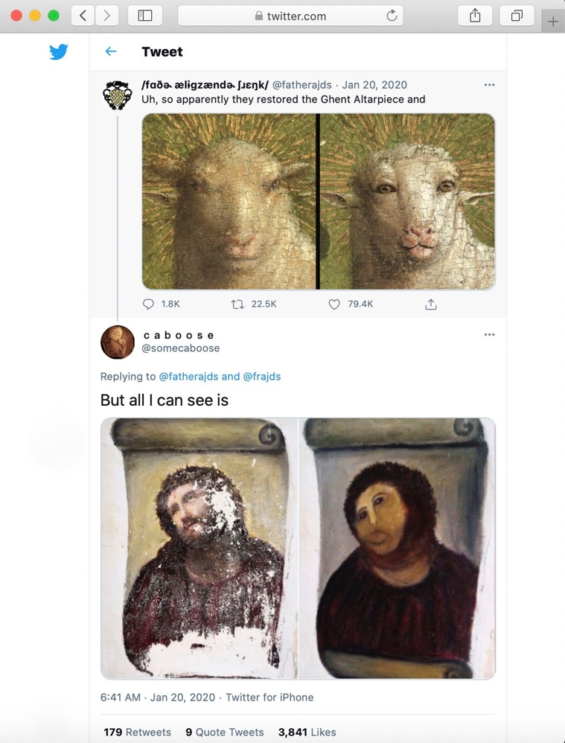

Fig. 6 Screenshot of a Twitter-thread on the initial variation of the Ghent Altarpiece Lamb Restoration Meme by @fatherajds. The user @somecaboose replied with a before and after juxtaposition of the Potato Jesus on 20 January 2020.

Fig. 7 Screenshot of a variation of the ‘The Immaculate Conception of Los Venerables’ Restoration Fail Meme on knowyourmeme.com, originally posted by @thetomzone to twitter.com. The meme compares the before to the two restoration attempts focusing on the face of the Virgin. A comment relates it to the Potato Jesus.

In its original state, the devotional fresco by Elías García Martínez showed Christ in a half-length portrait in three-quarter profile placed on an unrolled scroll, his suffering and lifelike face the center of attention. After the amateur ‘restoration’ of the artwork the face in particular looks shockingly beastly. Within a day, countless internet memes were spawned photoshopping *Potato Jesus’s* revolting face onto Leonardo’s *Mona Lisa* or the apostles in his *Last Supper*, giving it teddy bear ears, or simply comparing it to its pre-restoration counterpart. *Potato Jesus* can be regarded the first and most influential predecessor of the ‘restoration gone wrong’ genre and is certainly an icon of meme culture. It was followed by a vast amount of other internet memes on the topic of ‘failed’ art restorations that all are somewhat visually related to the restoration fiasco from 2012. Just search for ‘Potato Jesus’ on *knowyourmeme.com* and you’ll encounter a large variety of more or less famous cases of ‘failed’ restorations—among them, of course, van Eyck’s Lamb of God. Many of them, just as is the case with the *Ecce Mono* himself, and in the initial variation of the *Ghent Altarpiece Lamb Restoration Meme*, feature before-and-after-comparisons of the artworks in question. What is remarkable, however, is that they all have one thing in common: They all focus on (oftentimes square) portraits that are joyfully photoshopped, remixed, and mockingly labelled (Fig. 6). From the very beginning, always referencing *Potato Jesus* in one way or another, the portrait format has been of central interest to memetic jokes on ‘restoration gone wrong’. As *Potato Jesus* is an icon of meme culture, it is thus not surprising that users immediately drew the connection between the *Ghent Altarpiece Lamb Restoration* and the *Ecce Mono* (Fig. 5).

By looking more closely into the visual cluster of ‘restoration gone wrong’, the memetic power lying within the reformatted image of van Eyck’s Lamb of God becomes obvious. It shows that the dynamics evolving from the practice of clustering images in meme culture enable exactly what Warburg tried to follow when creating his mood boards. That is, based on formal similarities, images like the mugshot of the lamb are open to transfers in meaning through which they diversify (or completely change) their visual arguments and may then be referenced to yet other images. As part of a visual cluster they are able to leave behind their original contexts, enter into new ones and represent completely different concepts of net culture. The Mystic Lamb, for example, even if it has never been the center of interest to scholars of art history and admirers of van Eyck’s art, is in its new format not only more appreciated by net users, but also is no longer read as a metaphor of Christ. Instead, it is assessed and appreciated primarily based on its distinctive looks: in net culture, therefore, the restoration has to be regarded a huge success.

## References

Bader, Lena. *Bild-Prozesse im 19. Jahrhundert. Der Holbein-Streit und die Ursprünge der Kunstgeschichte*. Munich: Wilhelm Fink Verlag, 2013.

——— “Bricolage mit Bildern. Motive und Motivationen vergleichenden Sehens.” In *Vergleichendes Sehen*, edited by id., Martin Gaier, Falk Wolf, 19-44. Munich: Wilhelm Fink Verlag, 2010.

Benjamin, Walter. “The Work of Art in the Age of Mechanical Reproduction.” In *Illuminations*, edited by Hannah Arendt, translated by Harry Zohm, 1-26. New York: Schocken Books, 1969.

Beyer, Andreas. “Die sichtbaren Städte: Architekturgeschichte als Bildwissenschaft.” In *Art History on Demand? Dienstleistung Kunstgeschichte?*, no. 2, edited by Oskar Bätschmann, Julia Gelshorn, Norberto Gramaccini, 99-105. Emsdetten/Berlin: Ed. Imorde, 2008.

Dubois, Hélène. “When, By Whom and Why? Decisive Material and Optical Alterations of the Ghent Altarpiece.” In *Van Eyck. An Optical Revolution*, edited by Maximiliaan Maartens, Till-Holger Borchert, 236-259. Veurne: Hannibal Publishing, 2020.

Geimer, Peter. “Vergleichendes Sehen oder Gleichheit aus Versehen? Analogie und Differenz in kunsthistorischen Bildvergleichen.” In *Vergleichendes Sehen*, edited by Lena Bader, Martin Gaier, Falk Wolf, 45-70. Munich: Wilhelm Fink Verlag, 2010.

Knobel, Michele, Colin Lankshear. “Online Memes, Affinities and Cultural Production.” In *A New Literacies Sampler*, edited by id., 199-228. New York: Peter Lang Publishing, 2007.

Lüders, Marika, Lin Prøitz, Terje Rasmussen. “Emerging Personal Media Genres.” *New Media & Society* 12, no. 6 (May 2010): 947-63. https://doi.org/10.1177%2F1461444809352203.

Meyer, Roland. “Gesichtsbildformate 1860/1960. Disdéri, Warhol und der Primat der Zirkulation.” In *Format. Politiken der Normierung in den Künsten ab 1960*, edited by Magdalena Nieslony, Yvonne Schweizer, 170-183. Munich: Edition Metzel, 2020.

Pichler, Wolfram, Ralph Ubl. *Bildtheorie zur Einführung*. Hamburg: Junius Verlag, 2014.

Schankweiler, Kerstin. *Bildproteste. Widerstand im Netz*. Berlin: Wagenbach, 2020.

Siegal, Nina. “Up Close, There’s More to the Ghent Altarpiece Than the Lamb,” *New York Times*, 27 January, 2020. https://www.nytimes.com/2020/01/27/arts/design/mystic-lamb-ghent-altarpiece-van-eyck.html.

Ullrich, Wolfgang. “Selfies as a Universal Language.” In *Self Expression in the Age of Instant Communication*, edited by Roger Scruton, 42-47. Berlin: Self-Published 2016.

Völlnagel, Jörg. “The Total Museum: On the Utopia of a Limitless Collection.” In *Between Cosmos and Pathos. Berlin Works from Aby Warburg’s Mnemosyne Atlas*, edited by id., Neville Rowley, 16-41. Berlin: Deutscher Kunstverlag 2020.

1. Peter Geimer, “Vergleichendes Sehen oder Gleichheit aus Versehen,” in *Vergleichendes Sehen*, ed. Lena Bader, Martin Geier, Falk Wolf (Munich: Wilhelm Fink Verlag, 2010), 49.
2. Lena Bader, “Bricolage mit Bildern. Motive und Motivationen vergleichenden Sehens,” in *Vergleichendes Sehen*, ed. id. Martin Geier, Falk Wolf (Munich: Wilhelm Fink Verlag, 2010), 21.
3. Michele Knobel et. al., “Online Memes, Affinities and Cultural Production,” in *A New Literacies Sampler*, ed. id. (New York: Peter Lang Publishing, 2007), 215.
4. Knobel et. al., “Online Memes,” 216.
5. Hélène Dubois, “When, By Whom and Why? Decisive Material and Optical Alterations of the Ghent Altarpiece,” in *Van Eyck. An Optical Revolution*, ed. Maximiliaan Maartens, Till-Holger Borchert (Veurne: Hannibal Publishing, 2020), 236.
6. Nina Siegal, “Up Close, There’s More to the Ghent Altarpiece Than the Lamb,” *New York Times*, 27 January 2020, 5.
7. Walter Benjamin briefly discusses captions and their impact on the image they accompany as they are reproduced in media. Transferring Benjamin’s observations on image captions in connection with photography and film onto internet memes proves fitting due to the net structure of the digital sphere in which threads and other means of referencing like hashtags play a superior role in communication and clustering thought patterns. Cf. Walter Benjamin, “The Work of Art in the Age of Mechanical Reproduction,” in *Illuminations*, ed. Hannah Arendt, trans. Harry Zohm (New York: Schocken Books, 1969), 8.
8. Andreas Beyer, “Die sichtbaren Städte: Architekturgeschichte als Bildwissenschaft,” in *Art History on Demand? Dienstleistung Kunstgeschichte?*, vol. 2, ed. Oskar Bätschmann, Julia Gelshorn, Norberto Gramaccini (Emsdetten/Berlin: E. Imorde, 2008), 99.
9. Kerstin Schankweiler, *Bildproteste*. *Widerstand im Netz* (Berlin: Wagenbach, 2020), 20.
10. Wolfgang Ullrich, “Selfies as a Universal Language,” in *Self Expression in the Age of Instant Communication*, ed. Roger Scruton (Berlin: Self-Published, 2016), 43.
11. Roland Meyer, “Gesichtsbildformate 1860/1960. Disdéri, Warhol und der Primat der Zirkulation,” in *Format. Politiken der Normierung in den Künsten ab 1960*, ed. Magdalena Nieslony, Yvonne Schweizer (Munich: Edition Metzel, 2020), 170.
12. Wolfram Pichler, Ralph Ubl, *Bildtheorie zur Einführung* (Hamburg: Junius Verlag, 2014), 144.
13. Meyer, “Gesichtsbildformate,” 171.
14. @FamousEntertainment, “Kylie Jenner | Before & After Transformations | Plastic Surgery UPDATED,” YouTube video, 2 October 2019, https://www.youtube.com/watch?v=VloNr-ek1Jo&list=PL4suFCmDzZ0_AucuxQfp0NWvuFoy70kWK&index=11.
15. Schankweiler, *Bildproteste*, 28.
16. Schankweiler, *Bildproteste*, 27.
17. Jörg Völlnagel, “The Total Museum: On the Utopia of a Limitless Collection,” in *Between Cosmos and Pathos. Berlin Works from Aby Warburg’s Mnemosyne Atlas*, ed. id., Neville Rowley (Berlin: Deutscher Kunstverlag, 2020), 22.
18. Schankweiler, *Bildprosteste*, 28.
19. Marika Lüders et. al., “Emerging Personal Media Genres,” *New Media & Society* 12, no. 6 (May 2010): 949, https://doi.org/10.1177%2F1461444809352203.
20. Lüders et. al., “Media Genres,” 954.
21. Völlnagel, “Total Museum,” 22.
22. Lena Bader, *Bild-Prozesse im 19. Jahrhundert* (Munich: Wilhelm Fink Verlag, 2013), 184.