# On the Prospect of Overcoming Meme-Culture or, The Last Meme in History Åke Gafvelin

Meme culture, at its present stage, consists in an oscillation between two opposed tendencies. On one hand, it attempts to *rigidify* various cultural phenomena, through the creation of certain paradigms of schematic representation: like the dichotomies of virgin/chad, boomer/zoomer, tradwife/thot, based/cringe, and woke/problematic – to name but a few. On the other hand, it aims to *dissolve* these same schemas as soon as they have been widely adopted. This can be inferred from the fact that the taxonomy of the alt-right and 4chan-associated ‘incel’ is now commonplace in zoomer meme-culture, without there being any ideological commonality between the two groups. The taxonomy is quite obviously employed ironically, with the purpose of dissolving a world-view rather than endorsing it.

In approaching this issue, we might first ask whythis rigidifying/dissolving structure is constructed. The need to categorize is no new phenomenon – it is plausibly at the core of human cognition – but I doubt that it has previously been so intimately paired with a corresponding need to also *dissolve* the very schemes it puts in place. I take this, however, to have a straightforward explanation in what has been called the cultural logic of late capitalism. Because capitalism ultimately – as Marx put it – melts all that is solid into air, rigidifying memes satisfy our need to get a grip of accelerating social, technological and economic change. But since memes have themselves become a commodity, placed right next to advertisers and influencers in our social-media feeds, they are themselves subject to the same brutal forces that push the acceleration. Like products competing on a free market, memes either undergo cycles of radical self-transformation, to the point of unrecognizability, or otherwise they lose the attention of their consumers. That is, memes gain their value because they *rigidify*, but are *dissolved* by the very logic that makes that feature valuable. Hence, their duality.

A second question, perhaps of more philosophical importance, regards why this structure is not *de*constructed. It seems reasonable that the dissolving tendencies of meme-culture might, at some point, come to dissolve meme-culture itself, just as Marx thought that the logic inherent to capitalism would lead to its self-destruction. With the fall of the Soviet Union, however, the *End of History* was proclaimed, and it became easier *to imagine the end of the world than to imagine the end of capitalism* (as quipped by Fisher or Zizek or Jameson or your stoner dorm-mate). Can we imagine the end of meme-culture? This requires a dialectical analysis, showing how memetic paradigms go through three stages of upward development until they are finally transgressed and new paradigms emerge as the result of sideway movements. In the end, the dialectics of meme-culture finds its ambivalent conclusion in the equally ambivalent conclusion of this essay.

## Moving Up

Consider the *Distracted Boyfriend Meme*, featuring (unsurprisingly) a distracted boyfriend (see Figure 0). Figure 0 can be called **Level 0** meme in this paradigm—a memetic paradigm being simply a set of memes that share a family resemblance. Although Figure 0 forms a stable building-ground for the paradigm, it is clearly not a meme in the colloquial sense. To create an actual meme, we need to map the relations between the objects we find in level 0 to the relations of some other phenomena, thus moving up to **Level 1.** An example of this is Figure 1, which gains its meaning from the fact that the distracted boyfriend stands in relation to his girlfriend and the other girl as the youth stands to capitalism and socialism. Both wish to replace the former with the latter. We might, then, think ofLevel 1memes as analogous to what logicians call an *object-language*. In such a language, we are capable of representing relations between various objects in reality. Figure 1 is simply representing the relation between the youth, socialism, and capitalism by means of the relations between the people in Figure 0.

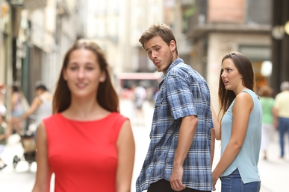

Figure 0 - Source: https://en.wikipedia.org/wiki/Distracted_boyfriend_meme

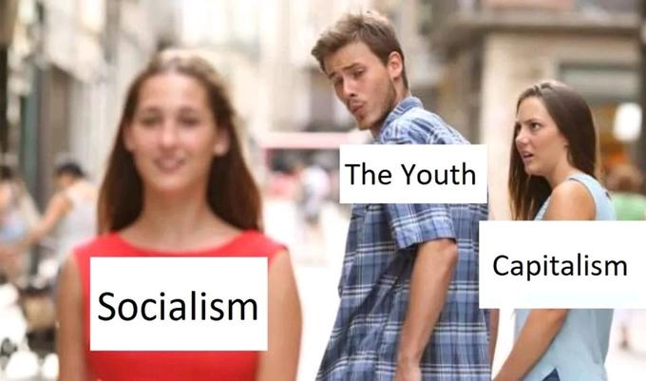

Figure 1 - Source: https://en.meming.world/wiki/Distracted_Boyfrien

One can find an infinite number of possible memes within Level 1, all with different levels of *dankness* (*dankness* roughly standing for the quality of a given meme). The thrust of this meme resides partly in the fact that someone has managed to compare a man feeling the urge to cheat with the comparative public support for capitalism and socialism. However, divisions of *dankness* within this level are so culturally contingent and dependent on personal taste that they do not lend themselves to rigorous philosophical analysis.

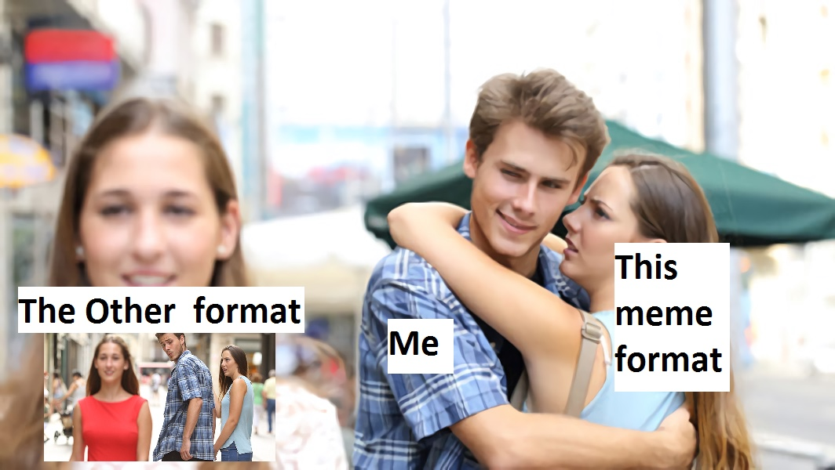

Figure 2 - Source: https://knowyourmeme.com/photos/1287554-distracted-boyfriend

Moving up to **Level 2**, we find memes making reference to other memes. Consider Figure 2, for example, which refers to memes discovered on Level 1. We can think of Level 2 as roughly equivalent to what logicians call a *meta-language*: a language used to talk about languages.

[1]

We can further imagine that Level 2 has an infinite number of possible layers: Figure 2 is a *meta*-meme, a meme about memes, but we might imagine meta-meta memes: memes like the meme in Figure 2 (see Figure 2.1); meta-meta-meta memes and so on… It should be noted, however, that memes do not always become *danker* as they become more ‘meta’: the fundamental joke is already in place by Figure 2. One might speculate whether this has something to do with the fact that these memes are not genuinely self-referential. Any attempt at *representing* a meme M *within* itself would instantaneously move M up one order in the hierarchy. But then, the meme we are representing is obviously no longer M.

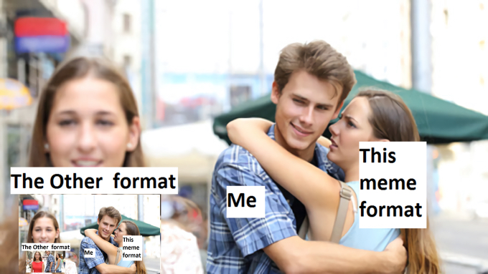

Figure 2.1 - Source: https://knowyourmeme.com/photos/1287554-distracted-boyfriend

This fits neatly with our (albeit imperfect) analogy of a hierarchy of languages, which was developed by Tarski precisely because any notion of a language representing itself runs into paradox (see Figure 2.2). However, we might still ask if it would be possible, in the search for ultimate dankness, to move beyond the linguistic limitations that Tarski put in place. But that requires moving up a level.

To fully comprehenda **Level 3** meme, we need to make a short detour through Russell and Wittgenstein’s dispute on the distinction between *saying* and *showing* outlined in the *Tractatus-Logico Philosophicus.* In his treatise, Wittgenstein sought to unveil the necessary structures of language. In doing so, he argued that all logical truths, like *it* *rains or it does not rain,* are vacuous; absolutely true precisely because they say absolutely nothing. Such tautologies instead gain their significance by *showing* something about the structure of the language in which they are formulated; in the case of *it rains or it does not rain*, that the language abides by the *law of the excluded middle*. A consequence of this view, however, is that Wittgenstein’s own philosophy is unsayable, since it successfully formulates the necessary structure of language from within that very structure. Hence his treatise concludes: *Whereof one cannot speak, thereof one must be silent*.

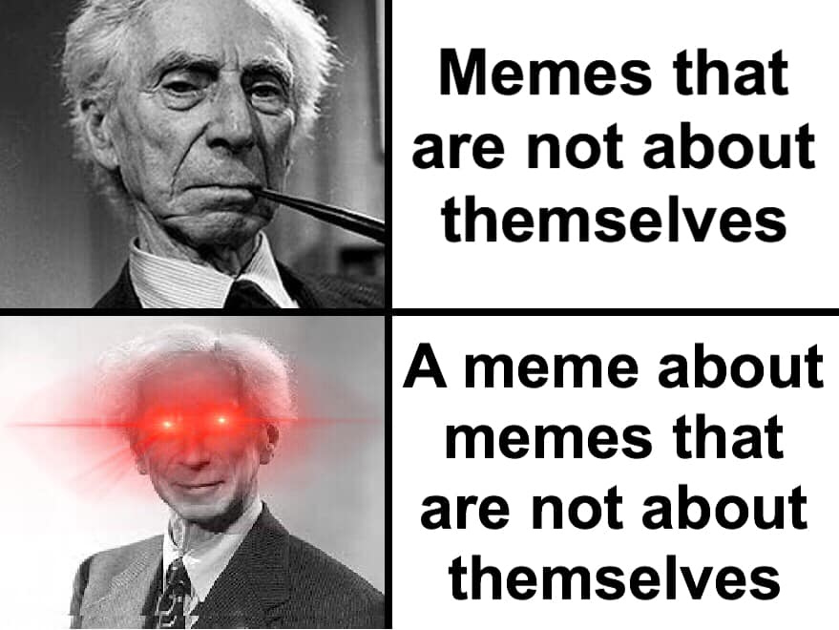

Figure 2.2 - Source: Set Theory Memes for Logically Equivalent Teens

Russell thought this to be a superfluous piece of mysticism. He suggested in the preface that any quietism could be avoided by postulating a Tarskian infinite hierarchy of languages, in which the truth of the *Tractatus* is formulable in a language commenting on the syntactic properties of the language below it (just like our memes comment on memes in Level 2). Wittgenstein, however, despised Russell’s preface, because he didn’t think it did justice to the width of his philosophical achievement. On Russell’s model, Wittgenstein was trying to *say* something about a particular language. But that was not his aim. He was trying to *show* it; and thus utter a truth transcending the representational scope of any possible language.

With this distinction in place, we can now begin to comprehend a **Level 3** meme. On Level 2, we attempted to *say* something about other memes by means of *representation* (like the picture under “the other format” in Figure 2). But Level 3 memes (see Figure 3)[2] *show* the structure of all possible memes within its paradigm by simply instantiating its barren structure, breaching the limits of any representational scope found within the hierarchy at Level 2. Figure 3 can thus be seen as the *Tractatus* of the *Distracted Boyfriend-*paradigm of memes, elucidating the ultimate structure of its memeological language by embodying it, saying *nothing.* Russell rejected the *Tractatus* because it would, as Wittgenstein proclaimed, mean the end of philosophy. Similarly, any Level 3 meme must finalize the upward movement in its paradigm: when one has reached it, one must – paraphrasing proposition 6.54 of the *Tractatus – throw away the ladder one used to climb it*.

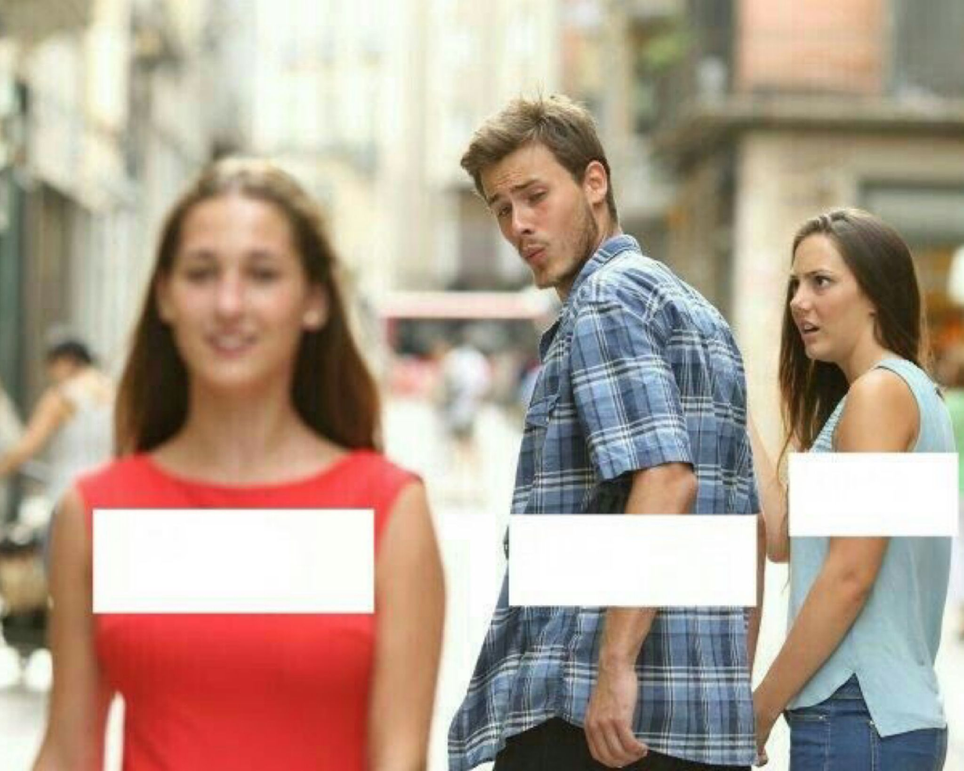

Figure 3 - Source: https://emaaneastwood.blogspot.com/2019/11/meme-template-distracted-boyfriend.html

## Moving Sideways

So where does the meme go if it no longer can move upwards? Here, I wish to introduce the notion of the *sideways* movementinto a newparadigm. Let’s consider the dialectics in the movement from what might be called the *woke/problematic* paradigm to the *based/cringe* paradigm. These paradigms obviously do not consist of image-based memes like the *Distracted Boyfriend*, but they are memes in the sense that they encapsulate cultural ideas and phenomena in an easily transmittable form on the internet. Hence, we can try to see if our previous analysis applies to them.

As the term is understood in popular culture, woke means being “aware of and actively attentive to important facts and issues (especially issues of racial and social justice),"[3] and problematic means rejecting or being unaware of such issues. Let **Level 0** simply be the values of ‘woke’ and ‘problematic', with **Level 1** memes in this paradigm assigning the labels *woke* or *problematic* to objects in reality. Let us now commence our upward journey by using the example of racial color blindness. On the most naive stage, color blindness is considered woke, as it makes race irrelevant in describing or assessing a person. But this is obviously also problematic, for roughly the very same reason – it leads one to ignore racial injustices. So, the **Level 2** woke person will rightly reject color blindness, achieving the state of being *meta-woke –* woke about the problematic nature of Level 1 wokeness. We can then imagine a further dialectics in which “thinking that ‘color blindness is woke’ is problematic” becomes problematic (achieving meta-meta-wokeness), and “thinking that “thinking that ‘color blindness is woke’ is problematic” is problematic” becomes problematic, and so on.

To climb up to **Level 3**, however,we need to become sowoke as to realize that the woke/problematic paradigm *itself* is not woke enough. An embodiment of this stage can be found in Dasha Nekrasova and Anna Khachiyan – the hosts of the American podcast *Red Scare* – who reject the paradigm as a “liberal-feminist piety” used by people who are “disgusted and horrified by working-class people.”[4] NoreenMalone describes their critiques (perhaps *hot takes* is a more fitting term) as “putting so much of the language of contemporary feminism and femininity through a feedback loop [that] it becomes meaningless; even their mocking of it indistinguishable from their organic use of it.”[5] Red Scare’s fundamental proposition, that *wokeness* is *problematic,* builds on the very schemes of representation inherent in the woke-problematic paradigm itself. It is therefore nonsensical in the same way that the *Tractatus* is: whatever they are trying to *say* can only be *shown* to an outside observer. When they reached Level 3, they threw away the ladder they used to climb it.

Now, when no higher move in the woke/problematic paradigm was possible, they arguably moved *sideways* into a new rigidifying scheme of representation: the *based/cringe* paradigm*.* According to Urban Dictionary, being *based* means “having an opinion without regard for what other people think, often a controversial opinion but not always”, implying that one is *cringe* when one shares too many opinions with the mainstream. The based/cringe paradigm must be understood in reference to the woke/problematic, as it succeeds it dialectically. However, it also has its own internal logic. In one way, we might say that based/cringe inverts woke/problematic: the *bonum* of former – the based – is the *malum* of latter – the problematic (and vice versa). This logic provides a simple explanation of how *Red Scare* manages to assign a positive value to mocking ‘woke feminism’: the very purpose of based/cringe is to turn woke/problematic on its head.

Similar to what was the case before, the objects of **Level 0** are the values of ‘based’ and ‘cringe'. And equally alike is the movement upwards. Geist wakes up on a 4chan board, and “based” is applied to someone like Ben Shapiro or Jordan Peterson. But that **Level 1** usage is obviously cringe. So we move up to **Level 2**, achieving *meta-basedness.* I take it that this is where Geist is located presently: ‘return to monké,’ is Urban Dictionary’s most up-voted example of something based, and this clearly mocks the alt-right and /pol/-associated wish to reject modernity and embrace tradition. We can only speculate what is to come, but plausibly the paradigm will continue to accelerate its upward movement in the hierarchy of meta-memes until it realizes that the based-cringe dichotomy itself is cringe, thus reaching a **Level 3** basedness (see Figure 4 and Figure 5). But this will, as before, result in quietism, requiring us to throw away the ladder and move sideways into a new paradigm. And so memeological history will continue.

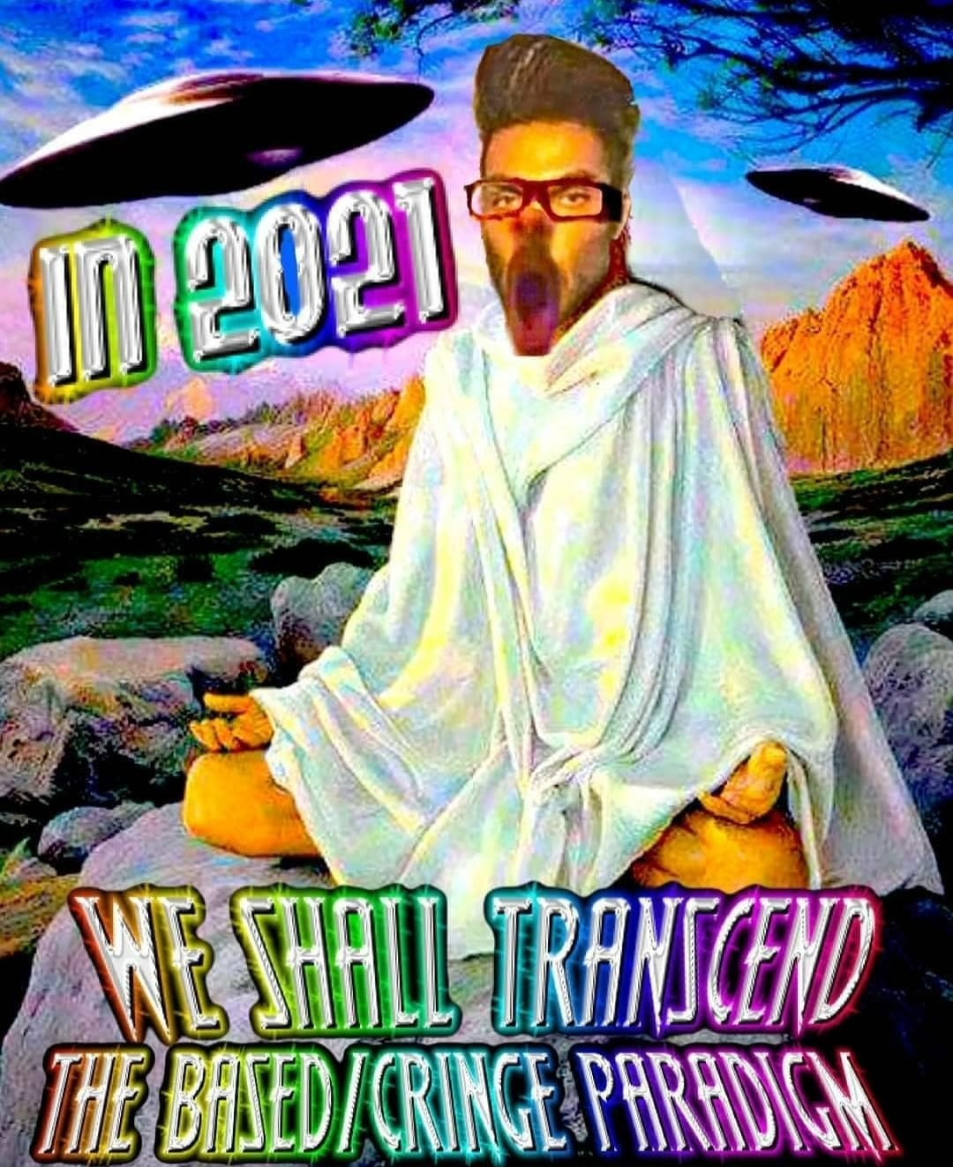

Figure 4 – Source: eSCATological posting (a Facebook group that has now been *zucced*)

## Moving Beyond?

The preceding parts of this essay have sought to describe the workings of memeological history – the point, however, is to change it. Is meme culture something we ought to leave on the historical scrap-heap? Don’t get me wrong; I like a good meme just as much as the next person, and tropes like ‘based’ or ‘woke’ carry important information about where we are as a culture. But meme-culture is—dare I say—*toxic*. As soon as we go beyond Level 1, we merely find a muddle of signs valued far higher than whatever they signify. We turn into *ironists*, putting quotation-marks over anything asserted, deconstructing whatever has been constructed, *dissolving* whatever anyone *rigidifies*. In his *Postmodernity and Its Discontents*, the late sociologist Zygmunt Bauman likens this (non-)identity to that of a perpetual tourist, always on the move, safe from any kind of vulnerable interaction with the fellow human:

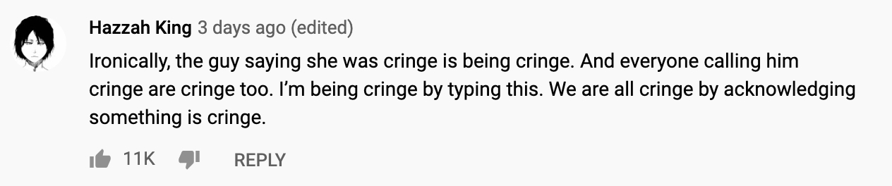

Figure 5 - Source: https://youtu.be/VSkPkSYFQ3U

Indeed, tourists worth their salt are the masters supreme of the art of melting the solids and unfixing the fixed. First and foremost, they perform the feat of not belonging to the place they might be visiting; theirs is the miracle of being in and out of place at the same time. The tourists keep their distance, and bar the distance from shrinking into proximity. It is as if each of them was enclosed in a bubble with tightly controlled osmosis; only such things as the occupant of the bubble admits may leak in, only such things as he or she allows to go, may seep out. Inside the bubble the tourist may feel safe; whatever the pulling power of the outside, however sticky or voracious the world outside may be, the tourist is protected.[6]

We might enjoy visiting new places at times, maybe even as much as we like memes, but no one wants to travel *all the time*. The memeological nomad embodies the very worst of postmodern culture: always ironising, never endorsing anything. I think we can all agree that this is both cringeand problematic. What is based and woke is keeping a distance to the memes, rather than the human beings they are intended to mock. Doing so might not only give us a glimpse of the end of meme-culture, but perhaps the end of irony itself. That, I take to be a good thing.

So we might reject meme-culture on the basis of this critique. But at this point the reader is invited to worry. The dankest possible meme is probably a meme that distances itself from the very idea of a meme – a *dab* on all possible memetic structures. The reader should now wonder: *is this essay itself a meme?* It does not look implausible. There is a whole genre of this sort of *theory-posting,* pretentiousmemes applying high-brow philosophical theory on low-level phenomena, and this might just be an essayistic variant. Note also that before this paragraph, it sought to *rigidify* the dialectics of meme-culture, making it comprehensible; presently, it is seeking to *dissolve* this very exposition by suggesting it was all irony. So might it be the case that this meme (if it is a meme) is embodying the structures of the dialectics of meme-culture in itself in order to *show* how utterly *meaningless* it is? For no other reason than *trolololololol…*

Were this essay a **Level 3** meme of all possible memes, it would be the greatest feat of irony in the history of memes: it should rightly be dubbed the *last meme of history*. Neither moving *upwards* or to the *side* of any particular paradigm/hierarchy in our postulated memetic space, it would move *beyond* the space completely, its very structure exposing the dialectics of meme-history to be as cynical, nihilistic, *cringe, problematic* as this essay. The impossibility of this move, however, is apparent—the essay is obviously unable to properly transgress the ironic structures it seeks to move beyond if genuinely a meme. We can only conclude that, whatever this meme (if it is a meme) is attempting to *say*, it could only *show*. And *whereof one cannot speak, thereof one must be silent.*

Where does this leave the prospect of overcoming meme-culture? Plausibly, if we do not put an end to it, the inevitable heat-death of the universe will do so. But the mere destruction of a thing does not overcome it; Marx didn’t overcome Hegel when Hegel died: Marx overcame Hegel (if he ever did) by putting him on his head. Can we put meme-culture on its head? I do not know. Perhaps any attempt to do so is itself memetic, an attempt at radical ironizing beyond all dimensions. With these considerations in mind, I conclude that it is much easier to imagine the end of the world than the end of meme-culture.[7]

## References

Bauman, Zygmunt. *Postmodernity and Its Discontents*. New York, New York University Press, 1997.

Malone, Noreen. “Red Scare Leans Into Nothing. A podcast that offers a critique of feminism, and capitalism, from deep inside the culture they’ve spawned.” *The Cut*. October 25, 2018. https://www.thecut.com/2018/10/profile-red-scare-podcast.html.

Merriam Webster Online. “Woke.” Accessed May, 2021, https://www.merriam-webster.com/dictionary/woke.

Myers, Fraser. “Meet the anti-woke left.” *Spiked Online*. July 4, 2019. https://www.spiked-online.com/2019/07/04/meet-the-anti-woke-left/

Wittgenstein, Ludwig. 1922. *Tractatus Logico-Philosophicus*. 1st edition. Kegan Paul, Trench, Trubner & Co.

1. This analogy, however, is not perfect. Many memes reference both memes and actual things in reality, but it is not allowed to reference both languages and objects in the ordinary sense of a meta-language.
2. The *Top Text Bottom Text* meme is a useful example of memes at this level
3. “Woke,” Merriam Webster Online, Accessed May, 2021, https://www.merriam-webster.com/dictionary/woke
4. Fraser Myers, “Meet the Anti-Woke Left,” *Spiked Online,* July 4, 2019, https://www.spiked-online.com/2019/07/04/meet-the-anti-woke-left/
5. Noreen Malone, “Red Scare Leans Into Nothing. A Podcast that Offers a Critique of Feminism, and Capitalism, from Deep Inside the Culture They’ve Spawned,” *The Cut,* October 25, 2018, https://www.thecut.com/2018/10/profile-red-scare-podcast.html
6. Zygmunt Bauman, *Postmodernity and Its Discontents* (New York: New York University Press, 1997), 89-90
7. The use of this quote suggests that this essay could in fact be a meme.