# Weapons of Mass Distraction: Far-Right Culture-Jamming Tactics in Memetic Warfare Andy King

## Memefluencers

When it comes to the creation and dissemination of weaponized memes, the alt-right remains one step ahead. The ‘Great Meme Wars of 2016’ might be old news to the veterans that waged them, but have only recently been scrutinized by journalists and politicians, tripping over the already outdated lingo. Progressives have sheepishly acknowledged the political power of memes but still fail to accommodate their production mechanismsand develop countermeasures. Leftist memes are still primarily created *by* leftists *for* leftists, without a methodical branching out to adversaries. The alt-right excels at conquering new territories by invading not only politically neutral online spaces, but also those belonging to their opponents.

As a far-right political movement, they were able to manufacture what appeared to be a newidentity—complete with its own jargon and visual culture—while retaining archaic beliefs. Apart from its surface rebranding, the only ‘alternative’ aspect of the alt-right is the average age of its members and technological prowess. In its heart, it never stopped pandering to mainstream racist, homophobic, and sexist sentiments. Despite this, the alt-right managed to capture the attention of younger generations with dank memes, controversy and networked adventure, filling the void left by multiple financial crises and social disintegration. The left, on the other hand, was placed in the position of an out-of-touch academic defender—rather than influencer—fighting to protect remaining online territories, instead of seizing and subverting new grounds.

**Fig. 1.** Right-wing meme stereotyping leftists as digitally illiterate

and therefore irrelevant SJWs. https://imgflip.com/i/1zwubx

This is not to say that tech-savvy leftists haven’t been trying to discredit the internet maxim ‘*The left can’t meme’* [Fig. 1.]. There has been a recent surge of artists including Joshua Citarella, Brad Troemel, and clusterduck collective, as well as YouTubers such as ContraPoints, hbomberguy, PhilosophyTube—who have managed to capture the imaginations of young, left-leaning netizens. They co-opted the ironic and populist style used by the alt-right to appeal to disenfranchised millennials, using it to raise class consciousness, spread awareness of the climate crisis, and support trans rights while retaining a rebellious, anti-establishment tone. Fans of controversial leftist podcasters such as Chapo Trap House, Cum Town, and Red Scare happily appropriate Pepe and Wojak memes to suit their political needs. Using a frank and vulgar sense of humor, they aim to prove the left can be as subversive and rebellious as the alt-right. This is important because the left currently finds itself in the contradictory position of being referred to as ‘the establishment’ while not having the powers that come with actually being one.

Conversely the alt-right, with their cash-pumped think tanks and political connections, have nevertheless molded their image into that of an underdog: a convenient ploy to justify aggressive tactics such as spamming pro-choice Facebook groups with images of aborted fetuses, raiding subreddits, and shitposting cringe compilations of angry feminists and liberals appearing to ‘cancel free speech’. Their outreach has been far and wide—no corner of the internet was spared. Leftists’ understandably angry reactions to racist memes and hateful speech were documented and fed back into the online propaganda machine portraying them as humorless snowflakes.

## Open Book for Those Who Dare Look

Alt-right instructional guides and manifestos for online warfare have remained accessible and easy to share. Once uploaded to a pastebin, they are continuously updated, copied and pasted. This is why they are referred to as ‘copypastas’: anyone can modify and repost them. As is the case with memes, maximum efficiency trumps attribution rights: the original author is rendered insignificant. They are written in an engagingly hyperbolic manner, containing clear instructions for immediate action which are continuously updated. [Fig. 2.] A call-to-action copypasta is typically written in a buoyant military tone, beginning with a gallant battle speech followed by a ‘best of’ selection of far-right articles, a curated collection of meme templates and YouTube compilations of ‘liberals being rekt’. Copypastas run by krautpol

[1] even come with their own FashWave playlist to energize recruits during their missions. Despite the horrific content, the tone remains overwhelmingly positive and incentivizing. It ends with a to-do list consisting of specific tasks divided into ‘strategic echelons’. The reader can join a relevant battalion, depending on their level of bravery and skill set. These range from ‘top tier’ battalions for activists willing to publicly expose their faces in real-life Identitarian rallies to ‘lower tier’ (but more popular) battalions consisting of anonymous activists ready to spam, dox, and harass.

**Fig. 2.** Example of a krautpol copypasta. Note the upbeat military tone and the reminder for members to be proactive without in-fighting. Copypastas such as this one help far-right factions overlook their ideological differences and work together to complete specific tasks. https://pastebin.com/zRU2HecC

Another reason the alt-right is able to amass large troll armies is due to its ability to embrace ideological differences within its own factions. Infighting is seen as unproductive and is strongly discouraged. Therefore, it is not unusual to witness atheists, hardcore Christians, gay white supremacists, and homophobes fighting side-by-side during an online crusade. In a faux display of goodwill, far-right members can even jump in to protect their political opponents if they find themselves scrutinized for a politically incorrect tweet or a comment taken out of context. Combined with widely circulated stories of leftist cancel culture, this open-arm embrace is very compelling to potential recruits who are desperate to belong. Yet is a false image. The alt-right does not offer economic alternatives or psychological support even to its most ardent members. Their ‘act first, think later’ campaigns are adept at fueling proactive urgency, but are built on nothing more than negative emotion. Economic policy always boils down to the naive belief that once all immigrants are expelled and women are stripped of their rights, the economic and psychological ills of capitalism will simply evaporate. Their willingness to embrace is opportunistic, lacking a heartfelt concern for the well-being of their recruits.

## All Your Base are Belong to Us

It’s sometimes hard to believe that only a decade ago, disruptive online interventions, hacktivist raids, and the marriage of truth to irony were tools that once belonged to left-leaning anarchists working under the name *Anonymous.* After key members were imprisoned by government intelligence agencies, the alt-right were quick to take over 4chan threads and co-opt youthful hunger for online anti-establishment politics. They also cultivated their hacktivist tools, namely Anonymous’ ability to recruit massive online armies in a decentralized manner. One of the assimilated weapons was culture jamming, which included disruptive campaigns such as trespassing into enemy grounds and converting mainstream culture into a Trojan horse for radical thought. Prominent neo-Nazi Andrew Anglin outlined the importance of culture jamming in the *Daily Stormer Style Guide*:

Always hijack existing cultural memes in any way possible. Don’t worry if the meme was originally Jewish. It doesn’t matter. [...] Packing our message inside of existing cultural memes and humor can be viewed as a delivery method. Something like adding cherry flavor to children’s medicine. [...] We want to take over the culture, to consume it.[2]

Politically neutral memes were appropriated and subverted. SS armbands were photoshopped onto the arms of dainty Anime girls. Speech bubbles in popular internet comics were blanked out and rewritten. Scientific infographics were edited to authenticate racist and sexist stereotypes. Fake avatars, accounts, and profiles were created to impersonate and caricature their adversaries. Under this guise, far-right users raided neighboring forums and threads. Like countless others, Fredrick Brennan—who later went on to create 8chan—was first exposed to 4chan trolls on an imageboard for *Sonic the Hedgehog* fans during a raid. Fascinated, he followed the trolls back to their mothership, where he stayed for over a decade. After 8chan was linked to multiple domestic terror attacks—and was overtaken by shadowy billionaires—Fredrick is now working hard to remove the imageboard site from the internet.[3]

Far-right trolls capture the attention of potential recruits by hijacking their visual culture and posting inflammatory content on their platforms—a kind of digital graffiti. Because they hide behind avatars typical for the targeted community while baiting members into throwing tantrums, it’s difficult to differentiate between an actual member acting out in response to a troll and a troll acting out as a member. As mods struggle to control a raid, they initiate platform-wide account purges in which innocent members get thrown out together with the guilty. This, in turn, breeds further anger and mistrust in the community and its leaders. Meanwhile, curious members are lured out of their platforms and given the opportunity to join future raids. After Gamergate—the largest cross-platform assimilation—far-right trolls began to run out of internet subcultures to infiltrate. They felt ready to take on ‘The Media’.

## Accidental Victory

Once upon a time, Pepe was a generic reaction meme used across the political spectrum, not dissimilar to how Facebook stickers are used to display a variety of emotions. Its adoption by the alt-right was circumstantial. The real danger to Pepe’s demise was always the potential appropriation by the ‘lamestream media’. When celebrities and boomers share a certain meme, they effectively write its eulogy. Much to the chagrin of professional netizens, this was beginning to happen to Pepe. Far-right users restored Pepe’s fading edginess by creating increasingly controversial renditions to separate themselves from the much-hated normies. When Pepe was flagged by the Anti-Defamation League as a hate-symbol, the move was met with celebration and hilarity across the far-right: Pepe’s cancellation was his resurrection [Fig. 3.]. The alt-right had won a culture war they weren’t even waging by gaining a mascot they didn’t even invent. Best of all, political opponents who weren’t aware of Pepe’s new status as a hate symbol, or refused to give him up, were suddenly attacked for being closeted fascists.

**Fig. 3.** Matt Furie—Pepe’s creator—officially killed off his creation in 2017. Far-right users

responded by resurrecting him. (i) <https://me.me/i/00-pepe-has-been-resurrected-praise-kek-shadilay-13576027>

(ii) https://archive.4plebs.org/pol/thread/257302630/#q257304889

A movement born on the internet needs real life legitimacy if it aspires to influence the world at large. Since trust is difficult to manufacture, it can be scavenged from those who have more of it. For the alt-right to succeed, the public had to lose trust in the movement’s critics: the mainstream media. Even though many fascists were indeed using Pepe, many were not. The far-right caricatured journalists as being out of touch with youth culture and blamed the mainstream media for being paranoid and spreading fake news. Journalists retaliated by defending their rationale while Twitter mobs argued over whether the continued use of Pepe memes in politically neutral contexts was morally condemnable. It was the dawn of fake new allegations.

## Operation O-KKK

In 2017, alt-right activists decided to exploit the media’s lack of internet know-how by laying out traps. If Pepe—a goofy everyman created by a hippie cartoonist could be branded as a fascist symbol—what about something even more innocuous and arbitrary?

Before long, Operation O-KKK was launched [Fig. 4.]. Its mission was to trick the media into believing that the OK hand gesture was a dog whistle for fascism. The rationale was invented on the spot: three outstretched fingers designated the letter ‘w’ while the index finger forming a loop with the thumb represented ‘p’. Together, they spelled out **w**hite **p**ower. Activists were instructed to create fake feminist, POC and leftist twitter accounts, and then tweet their disgust at this new symbol for white power. At the same time, openly fascist alt-accounts were used to spam twitter with offensive content accompanied by the OK Hand emoji👌 in order to validate accusations.

**Fig. 4**. One of many OPERATION O-KKK threads on 4chan.

Image: https://archive.4plebs.org/pol/thread/209521954/#q209527911

Far-right users masquerading as feminists began to wage a pretend war with far-right users masquerading as caricatured versions of themselves [Fig. 5.]. Soon enough, actual feminists caught wind and joined in to defend the faux feminists. The media picked up the story and was immediately ridiculed. Meanwhile, the alt-right celebrated their newfound power to control the media narrative.

When right-wing trolls LARP as ‘literal nazis’, the borders between irony and sincerity quickly dissolve. It was a matter of time before ‘literal nazis’ began to *unironically* use the OK Hand sign. When called out, they pretended to be conservative trolls. Brenton Tarrant—a domestic terrorist who murdered 51 people—spent 14 years frequenting 4chan and 8chan boards, the source of PsyOps such as Operation O-KKK. During his livestream of the Christchurch mosque shootings, he demonstrated a masterful knowledge of ironic, far-right memetic lore. In his manifesto, he wrote that he isn’t against foreigners living abroad and wished ‘different peoples of their world all the best regardless of their ethnicity, race, culture or faith’.[4] Justin Trudeau and Candace Owens—a black conservative—were sardonically credited as influences. After his arrest, Tarrant flashed the OK hand sign in court.[5]

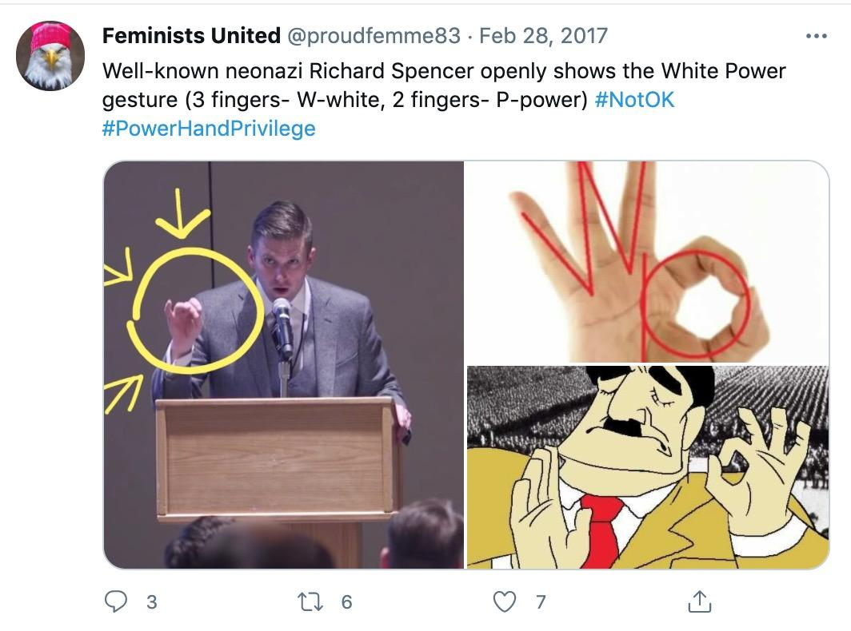

**Fig. 5.** Feminists United is a Twitter account led by a 4chan troll.

Tweet: https://twitter.com/proudfemme83/status/836366339514241024

Ironic far-right charades benefit everyone whose ideologies lie beyond the centre-right. It’s advantageous for Conservatives if the Overton window shifts to the right because their opposition to refugees pales in comparison to calls for a white ethnostate. At the same time, neo-Nazis can hide behind the curtain of irony. Robert Evans, a journalist for bellingcat, was publicly listed as a target for assassination after he reported on Brenton Tarrant and 8chan. One 8chan poster promised to pay 15 bitcoins (worth $60,000 at the time) for his death. When Evans posted a screenshot of the bounty on his Twitter account, 8channers alleged the bounty was fake and mocked him for not getting ‘the joke’.[6]

## Operation Honk

Around the same time, a Pepe variant had begun gaining traction. Donning a rainbow colored wig and red nose, he symbolized a world gone mad. This new clownified offshoot was called Honkler [Fig. 6.]. According to the disseminators of Honkler memes, liberals had taken over the media, and anyone caught disagreeing with the ‘liberal agenda’ ran the risk of being cancelled. In this mad world, everything had been turned upside down; degeneration was dressed up as progressivism. The only way to combat progressive elites was to dress up as a clown in order to avoid scrutiny, for only the fool can laugh at kings.

Honkler came with its own pill-philosophy: the Honkpill. According to a 4chan post, it is best described as the Blackpill on nitrous oxide. Advertised as a coping strategy for feelings of anomie, the Honkpill evangelized laughing at the absurdity of the world instead of living in a state of depressed apathy. A Honkpill copypasta explains: ‘Taking the Honkpill is a declaration of freedom and an act of philosophical transcendence; it is the simultaneous acknowledgment of the Blackpill with the decision to avoid its attendant nihilism – by consciously choosing to seek joy, to seek adventure, to seek light-hearted and self-amused mastery in the midst of all the chaos.’

However, much like everything else on 4chan, its purported nihilism was tongue-in-cheek. There was a method behind Honkler’s madness, and it culminated in a series of PsyOps – some of which still continue today. One such PsyOp was called ‘Operation Honk’. Since posting Pepe memes on social media resulted in bans, a stand-in had to be used. The emojis 🤡🌏 became a cross-platform dog whistle for Honkler and, more generally, a ‘degenerate’ clown world ruined by liberals. The supposedly ‘nihilistic’ message behind Honkpill was boastful rather than pessimistic: if the media is a circus, then 4chan is the ringmaster. A 4chan user explains Operation Honk:‘we created the clown meme to give the fake media a face. the [sic] media reports lunacy and not the objective fact. the fact that they will report on this clown meme proves this point and will redpill the masses as the fact that they are reading about a cartoon frog clown sinks in.’

**Fig. 6.** *Honkler* holding Brenton Tarrant’s inscribed gun. In one of his manifestos, Brentan Tarrant wrote ‘Clown memes are step one of riding the tiger where we have to go a little coocoo and rebuild ourselves.’[7] He also advocated supporters to: ‘Create memes, post memes, and spread memes. Memes have done more for the ethno-nationalist movement than any manifesto.[8] Image: https://boards.4chan.org/pol/

Once again, the media took the bait. Articles such as ‘White Nationalists Adopt Clowns as Their Next Racist Symbol’[9] and ‘No Joke: White Nationalists are now Using Clowns to Spread Hatred’[10] brought more attention to the movement. After ‘tricking’ the media into believing that a frog, the OK hand gesture, and clowns were symbols of white supremacy, channers decided to see how deep the rabbit hole could go. Hijacking the LGBT flag—the ultimate symbol of progressive politics—was going to be their crown jewel.

## Taking Back the Rainbow: A Place for Every Race

Operation #takingbacktherainbow went like this: If the rainbow flag emoji 🏳️‍🌈 is used concurrently with hate speech, it will be flagged as the latest fascist symbol. The PsyOp was advertised as a win-win: If the rainbow flag gets cancelled for being a dog whistle for fascism, LGBTQIA+ communities will be silenced on social media. If the rainbow flag doesn’t get cancelled, then the far-right will have co-opted their opponent’s symbol and defaced it [Fig. 7.]. Channers were hoping that algorithms designed to automatically remove hate-speech would pick up on this artificially manufactured connection. Fortunately, despite their best efforts, this has not happened yet.

**Fig. 7.** 4chan thread laying out Operation #takingbacktherainbow.

Image: <https://boards.4chan.org/pol/>

#takingbacktherainbow memes were (poorly) disguised as being pro-LGBT+, advocating ‘preserving diversity’ through racial segregation. Some far-right memes were accidentally shared by progressives too distracted by the rainbow optics to notice the supremacist tagline: ‘a place for every race’ [Fig. 8.]. Far-right users who were hungry for real-life mayhem developed a piggyback strategy: bringing physical rainbow flags to rallies. The goal was two-fold. First, the LGBT Pride flag could be used to deflect accusations of bigotry. Under its ‘protection’, far-right protesters could provoke foes such as Antifa into a fight in order to label them as ‘homophobic’. The second goal was more insidious: showing up to demonstrations with rainbow swastikas photoshopped onto Confederate flags would give the impression that the far-right was in allegiance with the LGBT+ community. This would allow the alt-right to feign open-mindedness to potential converts, while simultaneously tricking opponents into unfairly condemning LGBT+ communities for inciting hate.

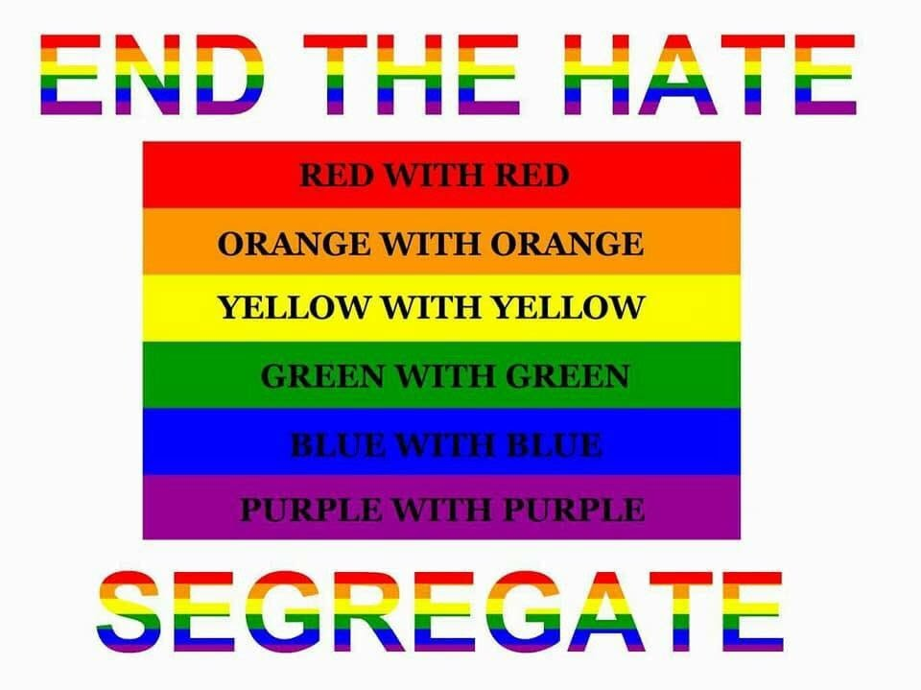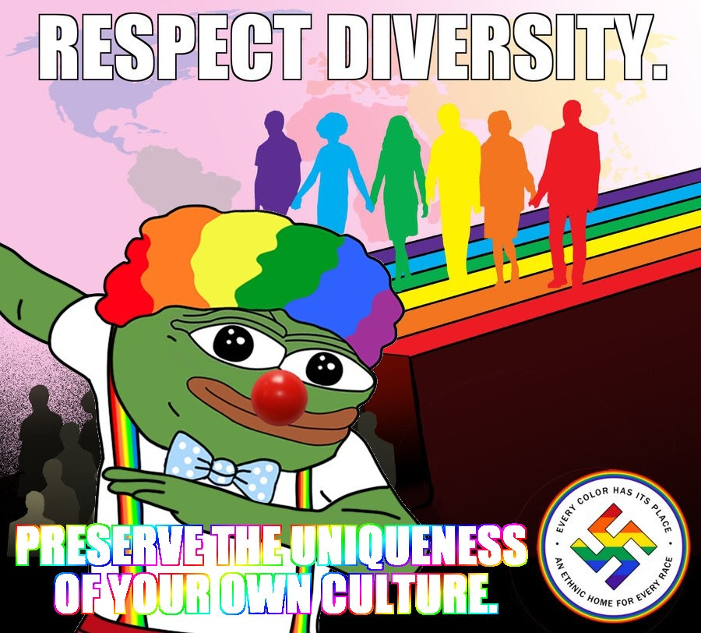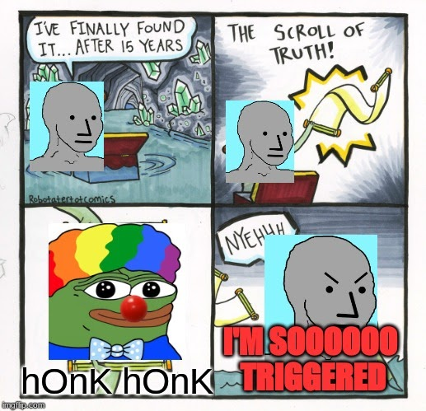

**Fig. 8.** Collection of Honkler and #takingbacktherainbow memes.

Images: <https://boards.4chan.org/pol/> & https://knowyourmeme.com/memes/clown-pepe-honk-honk-clown-world/photos/

## How to Kill a Clown

Clown world memes reached their peak popularity in anticipation of the 2019 *Joker* film release. This was not circumstantial: Joker meme formats were in use before the alt-right decided to hijack clowns, and there were parallels between the Honkpill and the Joker’s philosophy of manic contempt. The 2019 *Joker* film offered a relatable origin story in which the protagonist—who ends up becoming the Joker—is unemployed, single, and still lives with his mother. After underfunded social services forcibly cut off his medication supply, he spirals into madness and unintentionally triggers an uprising against the wealthy elites.

Incels were excited to see a film depicting a lonely man going on a killing spree. They memed extensively about their identification with Joker, calling for a ‘beta uprising’. Far-right trolls hoped the media would notice the parallels between clowns, incels, and fascism, and the film would get cancelled or become restricted. The more people believed the 2019 *Joker* film posed a domestic terrorist threat, the more precautionary measures would be taken to secure cinemas. Their ultimate goal was to engineer a self-fulfilling prophecy by provoking audiences enough to launch an emotional avalanche culminating in a terror attack. For a period of time, the plan seemed to be working: the media began to criticize the film before it was even released.

The director, Todd Phillips, was berated for creating a protagonist sympathetic to incels. Movie critics continuously pointed out the problematic and irresponsible aspects of the film. *Salon* described *Joker* as a ‘dangerous manifesto that could inspire incels to commit acts of violence’.[11] *Indiewire* agreed, labelling it as ‘a toxic rallying cry for self-pitying incels’.[12] Social media was split into two camps: those agreeing the film was a threat to democracy, and those belittling ‘woke culture’, and denouncing journalists and critics as being disingenuous and cowardly. The US Army issued a warning to service members about a ‘credible potential mass shooting’, explaining why incels idolise Joker, and listing instructions for a mass shooter scenario.[13] Twitter users promised to boycott the film. The actor playing the lead role —Joaquin Phoenix—stormed out of an interview in response to a question asking if his character might inspire mass shooters. The NYPD promised to supply uniformed officers during screenings. Cinemas banned toy guns, costumes and masks.[14] The film still hadn’t been released yet.

The alt-right felt victorious, sprinkling mayhem on social media platforms by sardonically suggesting cancelling all white men and advocating ‘penis inspections’ before movie screenings. The antics of one 4chan troll, self-identified as Payne, went viral. He hung signs in cinemas proclaiming that single men were banned from attending Joker screenings. The signs were photographed and posted online, adding fuel to the fire. Because so many people believed the signs were real, AMC had to step in and assert that no such policies had actually been implemented. Moral outrage and anger was in full swing, and far-right trolls couldn’t wait to see what would happen when the film was publicly released.

Then, disaster struck: normies loved the film. Slavoj Žižek—a Marxist philosopher—congratulated Hollywood for producing an anti-capitalist blockbuster.[15] Instead of inciting incels to commit violence, *Joker* captured a zeitgeist. The film’s immediate acclaim exposed the commonality of anti-establishment sentiment across the political spectrum, irrespective of gender, race, or class. The film’s bleak portrayal of late-stage capitalism and crumbling social security nets resonated with many of its viewers. Clown memes became mainstream. The clown emoji began to be used extensively to convey the feeling of being shortchanged, drowning its secondary meaning. The far-right couldn’t get their last laugh in a world overrun with clowns.

**Fig. 9.** *Putting on Clown Makeup* meme template was popularized in 2019. It depicts an individual suffering cognitive dissonance from contradicting observations of the world. He reconciles the contradiction in a nonsensical way, thereby making a fool of himself*.*[16]Image: https://knowyourmeme.com/photos/1563390-putting-on-clown-makeup

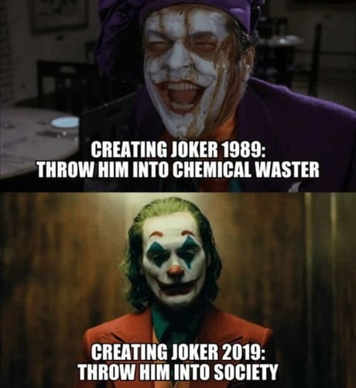

**Fig. 10.** Joker memes created and spread outside far-right circles.

*Left:* ‘We Live in a Society’ became one of the most popular Joker memes, yielding endless variants. <https://me.me/i/creating-joker-1989-throw-him-into-chemical-waster-creating-joker-866cd2582a7042679e82fd818478d36e>

*Right:* Left-wing meme depicting Karl Marx as Joker.

When right-wing extremists began to exit the screen in 2016, their threat to democracy became apparent IRL. People who previously brushed off incels as petty virgins and the alt-right as a niche collection of misfits were suddenly unscrambling boogaloo memes and learning the differences between Chads and Stacies. However, their efforts stopped there. No major online counter-strategies were undertaken and, all the while, class inequality continues to grow. Then, in January 2021, far-right mobs stormed the US Capitol. Since there was no time left to develop deradicalisation think tanks, drastic solutions had to be implemented. Twitter accounts, Facebook groups and subreddits were banned en masse. Parler, a ‘free speech’ social network used by right-wing radicals and conspiracy theorists, was shut down by Google, Apple, and Amazon.

There is no doubt that deplatforming is an efficient strategy; when executed on a wide scale it can throw an entire movement into disarray. Nationalist rhetoric has lulled as right-wingers mourn election losses. But this is only temporary. The practice of deplatforming opposes the inherent structure of the internet. The long-standing failure to undermine online piracy is proof of this. Banning The Pirate Bay yielded thousands of mirrors with VPNs mushrooming overnight. It’s only a matter of time before alt-tech social media platforms grow in scope, this time out of plain sight. Fascist shibboleths will become subtler so as to evade auto-bans; the conversion tactics will become more nuanced.

## Countering the Counterstrategies

The alt-right have persistently proven their ability to adapt to situations geared against them. By masterfully manipulating the narrative to appear in control, they transformed the act of getting banned from an inconvenience into a goal: *we didn’t get banned, we got ourselves banned on purpose to prove how arbitrary free speech policies are*. When Blizzard forbade the use of OK hand emojis in a multiplayer game,[17] it inadvertently confirmed the alt-right’s power to decide what is a fascist symbol and what is not. When far-right trolls spam enemy communities with far-right symbols and memes, those communities get flagged and removed. Proving the original members weren’t fascist is difficult if the community is small. Stricter regulation is leading to the emergence of a parallel internet composed of alternative social media platforms—such as Gab and Bitchute—toxic echo chambers and melting pots for far-right ideologies and conspiracy theories. While this feels like a breath of fresh air for Twitter users and Redditors who are sick of being harassed by malicious edge-lords, research shows that publicly engaging with far-right extremists on a Twitter comment thread deradicalizes that thread.[18] In recent years, there has been an uptick of studies proposing direct intervention as a viable countermeasure to hate speech, referred to as ‘building a counter-narrative’. Unfortunately, many progressives often end up debating trolls or bot accounts, overlooking legitimate posters who might be more open to changing their minds. Misplaced debates can be avoided by checking a user’s post history to see if the account is genuine. A quick analysis of a user’s profile and post history should be done even when a user is presenting as left-wing: as mentioned previously, far-right trolls pose as feminists and POC in order to misdirect and flame in-fighting. It’s also important to engage with the goal to de-escalate the conversation, even when it’s tempting to do otherwise. According to the Anti-Defamation League, this can be done through fact-checking, humour and satire.[19]

PsyOps such as Operation O-KKK, Operation Honk and #reclaimtheflag taught the alt-right a valuable lesson: their enemies were an untapped source of unpaid labour who could be recruited as faux gatekeepers, unknowing transmitters of confusion and demoralization. The left’s slow adoption of digital canvassing methods and failure to acknowledge far-right populism as a legitimate threat has also played a role. Instead of subverting the rules of the game—which once belonged to them—leftists continue to walk into traps. They end up targeting the ever-shifting fascist symbols designed to be obsolete instead of analysing and learning from the root of the problem – the alt-right’s success at assimilating and organizing supporters online. Short-sighted by anxious goodwill, progressives have inadvertently placed themselves into the position of online janitors. They remain stuck in the pre-digital past, adhering to outdated rules of symbol creation, dissemination and control.

In the digital era, anyone with access to a computer is a graphic designer, and anyone with access to the internet is a propagandist. It takes less time to manufacture an endless stream of far-right symbols than it does to identify, analyse, detect, and remove them. Figuring out the latest far-right dog whistles, exploits and in-jokes is a full-time job. Automating the process by building bots to flag online hate speech cannot be a long-term solution. First, removing content does not deradicalize the posters, it simply makes them less visible to the general public. This inadvertently masks the severity of the situation we currently find ourselves in: far-right parties are gaining power all over Europe. Election results seem shocking in part because so much online content is tidied up. Second, bots cannot read between the lines. Anti-racist technologies have increased far-right reliance on coded language based on acronyms, innocuous words and emojis, which morph on a daily basis and escape detection. *Operation Google* involved the use of ‘unbannable’ company names such as ‘google’, ‘skype’ and ‘yahoo’ as stand-ins for Jews, African Americans, and Latinos respectively.[20] As with Operation #reclaimtheflag, their goal was to trick google algorithms into displaying racist images to innocent viewers, while at the same time deceiving Google algorithms into censoring Google itself. Third, far-right trolls often control multiple puppet accounts, and generate new ones as soon as old ones are banned.

Controlling online platforms costs time, energy and nerves—resources that might be better spent on assimilating left-wing armies to build a counter-narrative to the far-right. Left-wing copypastas can help unite leftists by outlining specific tasks, such as the formation of digital flash mobs and targeted canvassing of social media groups. Flooding fascist platforms with satirical content would catch the attention of recent alt-right recruits—many of whom are just teenagers—and expose them to alternate views. Raiding former left-wing forums would allow expelled members to reclaim lost territory. For example, many anarchist and leftist eco-groups have been overtaken by eco-fascists. The original members were either thrown out or converted. These territories still exist and can potentially be reclaimed. After all,the good newsis that any *progressive* with access to a computer is a graphic designer, and any progressive with access to the internet is a propagandist. Memes should be viewed for what they are—propaganda posters—and meme dissemination adheres to the same principles guiding advertising firms: repetition breeds familiarity, which leads to preference.

When it comes to coded language, the best strategy is to hijack it. The far-right fears losing control over symbol creation. This was evident when 4channers were brainstorming culture jamming strategies in Honkpill threads. Some users worried that conjoining Pepe with the LGBT flag was too risky because normies would assume that Pepe was *un*cancelled. Which could lead to Pepe being reappropriated by the left, stripping the far-right of their favorite mascot. One hesitant 4channer outlined his concern in an Operation Honk thread: ‘All your [sic] doing is taking the greatest meme /pol/ ever had and making it gay. You are letting the fags claim Pepe, not the other way around. Because anybody outside of the chans sees rainbow Pepe and thinks LGBT /.../ your doing their dirty work for them.’ Other users echoed similar concerns:s the real danger to Pepe is appropriation, *not* cancellation.

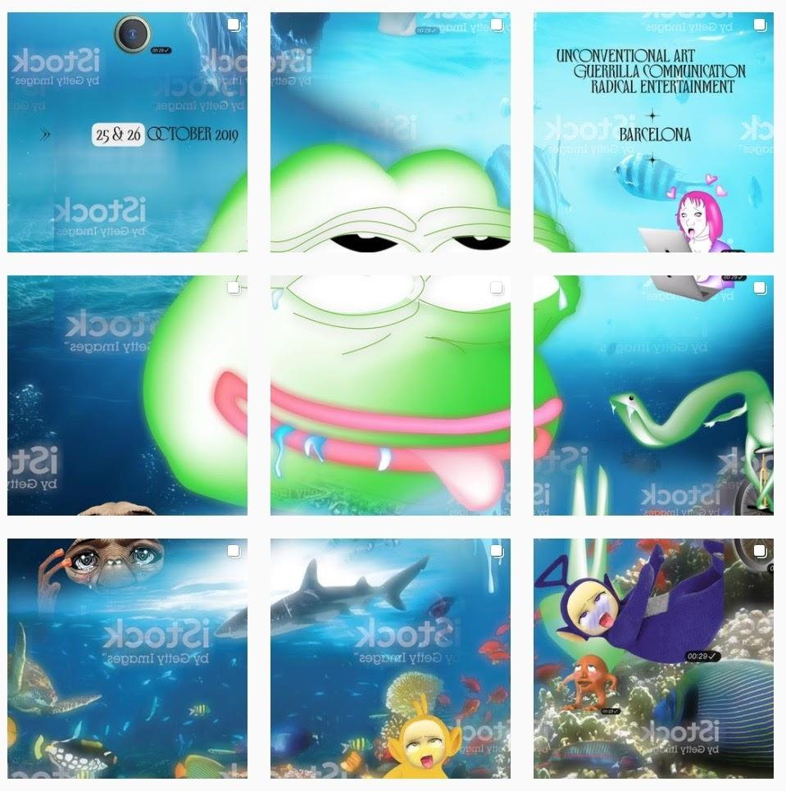

**Fig. 11.** Pepe Instagram collage created by clusterduck, a left-wing artist collective that uses memes to protest the climate crisis. They have reappropriated Pepe to promote a positive message of inclusivity. https://www.instagram.com/realclusterfuck

What the alt-right fears most is losing media attention and its reputation for being an edgy counterculture that defends ‘free-speech’ for the underdogs. Punk was killed by popular culture, not law enforcers. Anti-fascists can fight culture-jamming tactics using signal flooding. When clown emojis and Joker memes inadvertently became mainstream, far-right trolls were furious because they could no longer distinguish between their own ironic shitposts and normie sincerity. They were forced to revert to Honkler, a less subtle symbol, due to Pepe’s controversial status. If leftists were to casually reclaim Pepe, the alt-right would be forced to invent a new mascot, or resort to using explicitly fascist symbols which cannot be reappropriated – such as swastikas and Odal runes. Forcing them to revert to old-fashioned symbols would repulse their center-leaning members as well as future recruits who have not yet become desensitized.

Of course, continuously co-opting freshly-minted right-wing symbols doesn’t eliminate the alt-right—culture-jamming is just one tool in their digital toolbox. But it would damage their reputation as dissident purveyors of online culture, and prevent the unnecessary surrender of arbitrary symbols. Repossessing additional hacktivist tools and using them against the alt-right would signal the beginning of an online anti-fascist retaliation. Memetic warfare is more immediate and accessible than real-life demonstrations. It is not susceptible to police disruptions and pandemics. If anti-fascists build an active online presence, they can assimilate enough supporters to demote the alt-right from *provoker* into an inept *reactor*.

## References

Anti-Defamation League. “Best Practices For Responding To Cyberhate.” 2021. <https://www.adl.org/best-practices-for-responding-to-cyberhate>.

BBC News. “OK Hand Sign Added To List Of Hate Symbols.” September 27, 2019. <https://www.bbc.com/news/newsbeat-49837898>.

Beran, Dale. “Why Does 8chan Exist at All?”. *Medium*, September 27, 2019. <https://medium.com/@DaleBeran/why-does-8chan-exist-at-all-33a8942dbeb2>.

Ehrlich, David. “‘Joker’ Review: For Better or Worse, Superhero Movies Will Never Be the Same.” *Indiewire,* August 31, 2019. https://www.indiewire.com/2019/08/joker-review-joaquin-phoenix-1202170236/.

Evans, Robert. “Ignore The Poway Synagogue Shooter’s Manifesto: Pay Attention To 8Chan’s /Pol/ Board.” *Bellingcat,* March 15, 2019. <https://www.bellingcat.com/news/americas/2019/04/28/ignore-the-poway-synagogue-shooters-manifesto-pay-attention-to-8chans-pol-board/>.Feinberg, Ashley. “This Is The Daily Stormer's Playbook.” *Huffpost UK,* December 13, 2017. <https://www.huffpost.com/entry/daily-stormer-nazi-style-guide_n_5a2ece19e4b0ce3b344492f2>.

Garland, Joshua, Keyan Ghazi-Zahedi, Jean-Gabriel Young, Laurent Hébert-Dufresne, and Mirta Galesic. “Countering Hate on Social Media: Large Scale Classification of Hate and Counter Speech.” *Proceedings of the Fourth Workshop on Online Abuse and Harms*, June 2, 2020. <https://doi.org/10.18653/v1/2020.alw-1.13>.

Holt, Jared. “White Nationalists Adopt Clowns As Their Next Racist Symbol (Yes, Seriously).” *Right Wing Watch,* April 4, 2019. <https://www.rightwingwatch.org/post/white-nationalists-adopt-clowns-as-their-next-racist-symbol-yes-seriously/>.

Lee, Chris. “How Joker Became the Most Hated, Loved, Obsessed-Over Movie of 2019.” *Vulture,* October 9, 2019. <https://www.vulture.com/2019/10/all-the-joker-controversy-and-threats-explained.html>.

Pink, Aiden. “No Joke: White Nationalists Are Now Using Clowns To Spread Hatred.” *Forward,* May 6, 2019. <https://forward.com/fast-forward/423812/white-nationalist-clowns-honk-honkler/>.

KnowYourMeme. “Putting on Clown Makeup.” Accessed March 4, 2021. https://knowyourmeme.com/memes/putting-on-clown-makeup.

Rozsa, Matthew. “‘Joker’ is a Wildly Uneven Mess – and a Dangerous one in the Wrong Hands.” *Salon,* October 4, 2019. <https://www.salon.com/2019/10/04/joker-review-todd-phillips-incels-alt-right-warner-bros/>.

Rozsa, Matthew. ”U.S. Military Issues Warning to Troops About Incel Violence at Joker Screenings.” *Gizmodo,* August 24, 2019. <https://io9.gizmodo.com/u-s-military-issues-warning-to-troops-about-incel-viol-1838412331>.

Tarrant, Brendon. *The Great Replacement.* 2017. <https://img-prod.ilfoglio.it/userUpload/The_Great_Replacementconvertito.pdf>

Tarrant, Brendon. *The Great Replacement: A Final Manifesto*. 2017. <https://www.docdroid.net/Q4nIbBM/the-great-replacement-original-brenton-tarrant-pdf#page=21>.

Trent, John, “Report: Blizzard Forbids ‘Okay’ Symbol in Overwatch League Arena – Claims It’s a ‘White Power Symbol’.” *Bounding into Comics,* April 5, 2019. https://boundingintocomics.com/2019/04/05/report-blizzard-forbids-okay-symbol-in-overwatch-league-arena-claims-its-a-white-power-symbol/.

Weimann, Gabriel and Ari Ben Am. "Digital Dog Whistles: The New Online Language of Extremism." *International Journal of Security Studies* 2, no. 1(2020).Available at: https://digitalcommons.northgeorgia.edu/ijoss/vol2/iss1/4

Žižek, Slavoj. “More on Joker: from Apolitical Nihilism to a New Left, or Why Trump is no Joker.” *The Philosophical Salon,* November 11, 2019. <https://thephilosophicalsalon.com/more-on-joker-from-apolitical-nihilism-to-a-new-left-or-why-trump-is-no-joker/>.

1. *Krautpol* refers to German-speaking far-right factions active on 4chan and 8chan. After helping Trump win the 2016 presidential elections by supporting their US members, krautpol is now focusing on Identitarian movements in Europe by organizing raids and raising money for rallies.
2. Ashley Feinberg, “This Is The Daily Stormer's Playbook,” *Huffpost UK,* December 13, 2017, https://www.huffpost.com/entry/daily-stormer-nazi-style-guide_n_5a2ece19e4b0ce3b344492f2.
3. Dale Beran, “Why Does 8chan Exist at All?,” *Medium*, September 27, 2019, https://medium.com/@DaleBeran/why-does-8chan-exist-at-all-33a8942dbeb2.
4. Brenton Tarrant, *The Great Replacement* (2017), 13, https://img-prod.ilfoglio.it/userUpload/The_Great_Replacementconvertito.pdf
5. “OK Hand Sign Added to List Of Hate Symbols,” *BBC News,* September 27, 2019, https://www.bbc.com/news/newsbeat-49837898.
6. Robert Evans, “Ignore the Poway Synagogue Shooter’s Manifesto: Pay Attention To 8Chan’s /Pol/ Board,” *Bellingcat*, March 15, 2019, https://www.bellingcat.com/news/americas/2019/04/28/ignore-the-poway-synagogue-shooters-manifesto-pay-attention-to-8chans-pol-board/.
7. Brendon Tarrant, “*The Great Replacement: A Final Manifesto*” (2017), 21, https://www.docdroid.net/Q4nIbBM/the-great-replacement-original-brenton-tarrant-pdf#page=21.
8. Tarrant, *Great Replacement,* 147.
9. Jared Holt, “White Nationalists Adopt Clowns As Their Next Racist Symbol (Yes, Seriously),” *Right Wing Watch*, April 4, 2019, https://www.rightwingwatch.org/post/white-nationalists-adopt-clowns-as-their-next-racist-symbol-yes-seriously/.
10. Aiden Pink, “No Joke: White Nationalists Are Now Using Clowns To Spread Hatred,” *Forward,* 6 May 2019, https://forward.com/fast-forward/423812/white-nationalist-clowns-honk-honkler/.
11. Matthew Rozsa, “‘Joker’ is a Wildly Uneven Mess – and a Dangerous one in the Wrong Hands,” *Salon,* October 4, 2019, https://www.salon.com/2019/10/04/joker-review-todd-phillips-incels-alt-right-warner-bros/.
12. David Ehrlich, “‘Joker’ Review: For Better or Worse, Superhero Movies Will Never Be the Same,” *Indiewire,* August 31, 2019, https://www.indiewire.com/2019/08/joker-review-joaquin-phoenix-1202170236/.
13. Matthew Rozsa, “U.S. Military Issues Warning to Troops About Incel Violence at Joker Screenings,” *Gizmodo,* August 24, 2019, https://io9.gizmodo.com/u-s-military-issues-warning-to-troops-about-incel-viol-1838412331.
14. Chris Lee, “How Joker Became the Most Hated, Loved, Obsessed-Over Movie of 2019,” *Vulture,* October 9, 2019, https://www.vulture.com/2019/10/all-the-joker-controversy-and-threats-explained.html.
15. Slavoj Žižek, “More on Joker: from Apolitical Nihilism to a New Left, or Why Trump is no Joker,” *The Philosophica*l *Salon,* November 11, 2019, https://thephilosophicalsalon.com/more-on-joker-from-apolitical-nihilism-to-a-new-left-or-why-trump-is-no-joker/.
16. “Putting on Clown Makeup,” *Knowyourmeme*, 2019, Last accessed: March 4, 2021, https://knowyourmeme.com/memes/putting-on-clown-makeup.
17. John Trent, “Report: Blizzard Forbids ‘Okay’ Symbol in Overwatch League Arena – Claims It’s a ‘White Power Symbol’,” *Bounding into Comics,* April 5, 2019, https://boundingintocomics.com/2019/04/05/report-blizzard-forbids-okay-symbol-in-overwatch-league-arena-claims-its-a-white-power-symbol/.
18. Joshua Garland et al., “Countering Hate on Social Media: Large Scale Classification of Hate and Counter Speech,” *Proceedings of the Fourth Workshop on Online Abuse and Harms,* June 2, 2020, https://doi.org/10.18653/v1/2020.alw-1.13.
19. “Best Practices For Responding To Cyberhate,” *Anti-Defamation League,* https://www.adl.org/best-practices-for-responding-to-cyberhate.
20. Gabriel Weimann and Ari Ben Am, “Digital Dog Whistles: The New Online Language of Extremism,” *International Journal of Security Studies,* 2, no. 1 (2020). https://digitalcommons.northgeorgia.edu/ijoss/vol2/iss1/4