# Acknowledgments: From Amsterdam to Zagreb, Back, Forth and In-Between

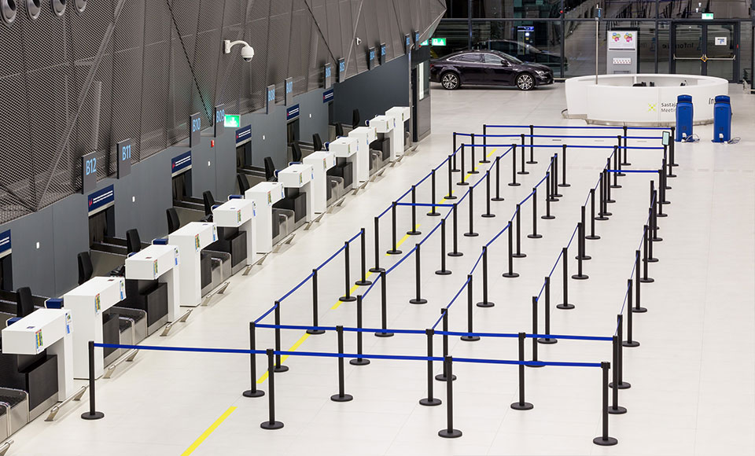

Franjo Tudjman Airport, Zagreb.

I first wrote the text of this book as a thesis for the rMA-program Art Studies at the University of Amsterdam. My supervisor, Prof. Dr. Christa-Maria Lerm Hayes, had recognized my interest in critical studies and practices in the arts years before my graduation and since encouraged me to look beyond the confinements of the art historical canon and the (former) West. Amongst the interests I thus developed was one in the Yugoslav (neo-)avant-gardes like Gorgona, the Group of Six Artists, and New Tendencies. In the summer of 2017, during a holiday on the Croatian coast, I decided to spend some days in Zagreb, going to the various museums and talking to cultural workers about my topics of interest. Who knows what unopened archival file or oeuvre of a long-dead artist I would find… It was idle hope, not least because I did not speak any Croatian. But the visit taught me something much more interesting and important. It taught me about a discursive notion with a ground-breaking impact on my theoretical frame of reference, a theoretical stealth bomb casually dropped by my conversation partner Mika Buljević: ‘independent culture’. I remember myself, sitting on the terrace of Program in the heat of the Zagreb summer, rambling: ‘I’m sorry? Independent culture? I don’t think I understand you. Culture always depends on money and labor. No one really believes that a thing like independent culture could ever exist, right?’ I was, of course, wrong. My notion of ‘independence’ was too narrow to understand what the term ‘independent culture’ in Croatia meant. It was necessary to somehow unlearn my understanding of independence so as to be able to formulate a new one. I was hooked and decided to write my thesis about this one question: What is independent culture?

In order to find answers to that question, I had to come back to Zagreb. So, on the first of March 2018, I departed for a three-month stay in the Croatian capital once more. During that time, I did a research internship at the Academy of Fine Arts in Zagreb, under the supervision of Leonida Kovač. This was wonderful for a number of reasons. I remember the first time we had an appointment, one week into my three months. I expected to get fifteen minutes of Leonida’s time, some theoretical remarks, and a tip or two about whom to speak to. Instead, five minutes into our two-hour meeting, Leonida picked up the phone and started calling people and handing me the phone to make appointments for interviews. I didn’t even have time to realize what was going on or to become shy. Thanks to this head start, I was able to almost twenty people in and around the scene, including Jens Brandt, Boris Buden, Mika Buljević, Maja Flajsig, Darko Fritz, Ivana Hanaček, Jasna Jakišić, Antonija Letinić, Olga Majcen Linn, Tomislav Medak, Petar Milat, Leonida Kovač, Dejan Kršić, Ana Kutleša, Sunčica Ostoić, Lana Pukanić, Tomislav Tomašević, Goran Sergej Pristaš, Darko Šimičić, Klaudio Štefančić, Lea Vene, Dea Vidović, and Janka Vukmir. Needless but necessary to say, I am very thankful everyone I talked to on tape in Zagreb for sharing their time and thoughts with me.

Fortunately, my life in Zagreb existed of more than only interviews. I went to exhibitions, (private) movie screenings, informal and formal performances, parties, conferences, gallery openings, and dinners. I have been lucky to meet a bunch of wonderful people at and through the Academy – especially the new media department – and make some dear friends: Ana, Gregor, Hrvoje, Ivana, Jasen, Karen, Klaudio, Laura, Leonida, Maja, Mak, Marko, Nika, Sonja, Tara, Tina, and the crews at MAMA and Booksa. As a result, even after the brief period of three months, I felt like I really got some understanding of Zagreb’s independent cultures. Since, I have returned to Zagreb several times. During one such trip back, in September 2018, Galerija Miroslav Kraljević hosted me for the lecture *Dimensions of Independence / How Are Independent Cultures Born?* This event allowed me to present the product of my work within the context of the independent cultural scene, and to revise my initial analysis and recognize theoretical dimensions of independence that transcended the local urgency.

Back in Amsterdam and after my graduation, I joined the Institute of Network Cultures as Senior Intern. I continued to work with my friends from the scene in Zagreb and was provided with the opportunity to rewrite and expand my thesis – to make it into a book. I thank Geert Lovink for his pragmatic interventions in the argument and Miriam Rasch for her thorough editorial work. Without Miriam, this book would be ten times as boringly academic as it is now, and without Geert, I certainly would not have been able to write the exploded essay which is the third part of this book. My dear friends Koen Bartijn and Mari van Stokkum, as well as my mother Lysbet Haverkamp gave me valuable editorial comments. Two friends from Zagreb also kept contributing to my writing substantially: Klaudio Štefančić with his unrelenting thoughts, comments, and suggested readings, and Marko Gutić Mižimakov by giving me the chance to publish an excerpt from this book in his magazine, *The* *Hub Between the Iliac Crest and the Public Bone.* Rosie Underwood, my predecessor as INC-intern, was the best proofreader I could have hoped for. I’ve also been extremely lucky to be with Laura Mrkša, who not only happens to be a supportive partner, but also great designer. She created the beautiful bubbly cover of this book. It’s an homage to Zagreb, Little Rome, city of fountains.

A last, big thanks goes out to all the artists and heirs who allowed me to reproduce their work, not as ornaments, but as visual arguments: Ilona Szwarc, Marko Gutić Mižimakov, Sarah Gotovac and the Tomislav Gotovac Institute, Braco and Nena Dimitrijević, Minna Henriksson, Darko Fritz, Nicole Hewitt, This Town Needs Posters, Jagoda Kaloper and Ana Tajder, Ana Kuzmanić, Constant Nieuwenhuys, Mladen Stilinović and Branka Stipančić, and David Maljković.