Skylines I’ve Never Seen: Net-Real China as Hopeium

Aleksy Domke

Originally published on May 1st, 2025
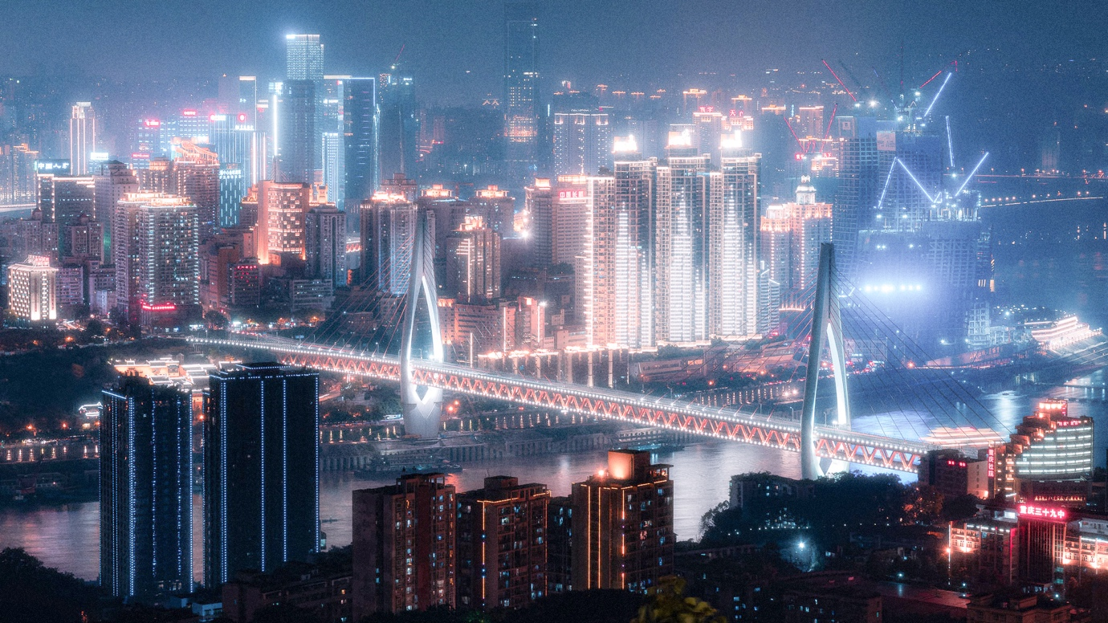
My old roommate is crashing at my place. As a thank you, he gives me an incredibly well-designed box of Sina Ginger Candy. Sized like a cigarette box, a beautiful illustration of a ginger root [inside joke about rhizome] occupies the center, with red Chinese writing placed vertically on either side. On top, “Sina Ginger Candy” is written in an Evangelion-like, vertically stretched serif font. The rest of the label is sprinkled with various symbols and certificates like “real ginger.” I place it next to my 7-eleven Gundam, a limited edition 2005 Hello Kitty keychain and a centimeter thick plate of 5052 aluminum I brought from Asia.
We spend the next morning talking about Weibo thirst traps, Xiaohongshu shopping streams, Chinese aunties in Balenciaga sweats and the sublime Chinese manufacturing industry. If this was 2022 we would probably be talking about some random meme or a niche Bandcamp release [we are edgy like that]. In 2025 we’re discussing the wonders of economic development in a country we’ve both never been to, but somehow share a strong connection with.
China’s Soft Power Grind
With the release of Trump 2, the American machine of computational propaganda steps into overclock. Multipliers on the CPU — China propaganda unit — just got cranked up for real. Last edition’s fan favorite “China Virus” could not stand up to the new and improved AI-assisted attacks. While the U.S. is running on NVIDIA’s Blackwell Architecture, it’s struggling to keep in the lead against China’s highly efficient, centrally-managed cores.
The New Red Scare is America’s last-ditch effort to cling onto its radiant plaque on the global scoreboard. The new admin has triggered America’s Great Crashout, spamming its economic weapons on Canada, Mexico, EU, and most importantly — China. Since Twitter’s 280-word limit proves to be limiting, U.S. officials turn to have their post-game meltdowns on whitehouse.gov.
“Somehow it’s a crime when Russia does it to us, but good 'information ops' when we want to discredit Beijing’s Belt & Road initiatives worldwide” — Marcus Stanley in a dek for Responsible Statecraft.
Just five years ago, China was predominantly seen as an Orwellian surveillance state. Fueled by headlines of Western terror bait, an image of a scary totalitarian regime was ingrained as a reflexive response. Echoing the breakneck speed of China’s exponential economic development, the country’s soft power climbed the ranks from an ostracized walled garden to the frontier of innovation. Driven by subsidized cultural exports and technological advancements — accelerated by the decline of American hegemony.
In 2023, influence of Mandarin-speaking digital culture rooted itself in the West as surrealist selfies, Douyin makeup and TCM, reaching even surface scrollers. Last year, Chinese viral content has swept over Western feeds, announcing its presence with dances like Ke Mu San (一笑江湖), transnational TikTok e-commerce stars like LC Sign or Etong space capsule house and Chinese-flavored brainrot. Chinese-owned games have dominated the market with titles like Final Fantasy or Genshin Impact. Snowballing off of both organic trends, and subsidized enterprise entertainment, travel influencers stormed Zhangjiajie’s towering mountains, misty rice fields of Guangxi and the meandering Great Wall. Yoga girls on Instagram photoshoots in Yunnan and fratboys soyfacing in Chongqing, prompted the government to ease travel restrictions for foreign tourists. American tech nerds drool at the sight of Huawei’s triple fold Mate XT smartphone and Deepseek’s ChatGPT equivalent, shifting their attention away from home-grown AI Pin scams.
Increasingly hostile relations between world’s competing superpowers have brought China into the media’s spotlight. Although my perception might be skewed by an attentional bias, I found China's presence elevated to a familiar refrain. Whether drinking beer at a bar with people I’ve met at a youtuber’s meetup, having Xiao Long Bao with roommates or chatting with colleagues. The American propaganda machine seems to have lost its momentum, exhausting its grip on media, allowing a shift in Western reporting and public opinion. One demographic has swallowed a disproportionate amount of China-pills — the chronically online Western youth. What happened here? And what’s the role of social media and meme culture in all of this?
Algorithmic Politics & Aesthetic Logics
The worldview-forming process for digital natives is usually based around whatever slop they get served on their algorithmic plates. The infinite canteen of Instagram’s for you page seems to have introduced their brand-new Sinic menu. Today’s content is often entirely removed from the 2021 wave of ‘social credit score’ memes. In contrast, contemporary China-posting is characterized by a surge of quasi-inspirational videos, depicting the unmatched aura of the economic giant.
In the platform-driven, algorithmic era of politics, the doomscrolling-induced paralysis draws a lot of parallels with Fisher’s framework in Capitalist Realism, predating current social media landscapes. Analogous to capitalism itself, algorithms are opaque, but omnipresent and unchallengeable. They structure desire, attention and worldview. The algorithm replaced ideology as the dominant structuring force of reality. The database of ideas has fallen victim to a deterministic algorithm — people don’t analyze politics, they scroll into them. Knowledge collapses into aesthetics. Your carefully-researched argument and a swiss knife of references will never be content. Joe Rogan is though. [liberal destroyed]
The left’s search for a reciprocal Joe Rogan is a Web 2.0 equivalent of Fisher’s reflexive impotence. The Democrats recognize their Kamala HQ cringefest cannot compete against the Republican swarm of online grifters. Yet instead of challenging the post-truth affect regimes, they set out on a vibe-seeking venture, blindly chasing after their opponents' successes. In spectacle politics, you either win the aesthetic arms race or you get offloaded from collective memory.

> recommendation_watchnext.serve()
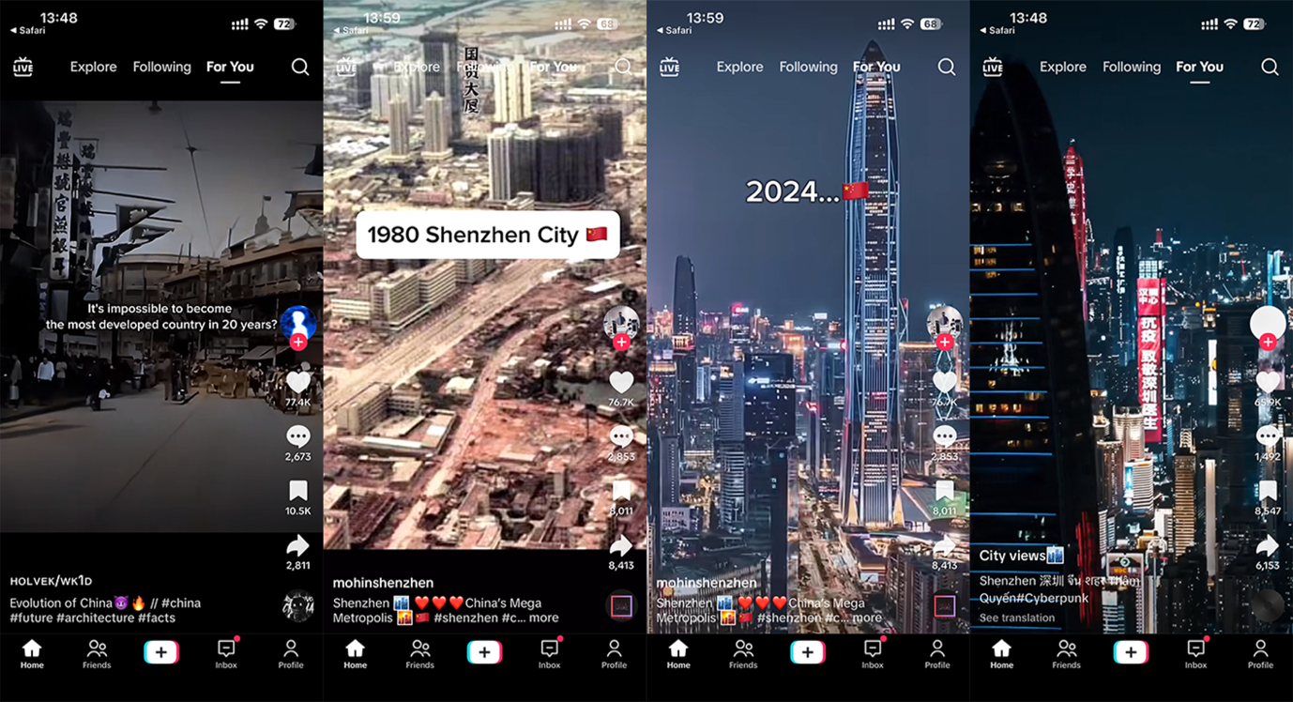
A sigma-esque montage of first-tier skylines like Shenzhen or Shanghai; high-rises glistering with hypercoordinated addressable RGB LEDs. Bullet trains and shiny pick-and-place machine timelapses interpose the aerial drone views, cut to the rhythm of SKAI’s 因果 (yīn guǒ) evil jerk remix. Surfacing in countless short-form videos, aforementioned trend epitomizes a new genre of posts, reframing China as a technological power, challenging Western preconceptions.
Stylistically branching out from ‘sigma male' edits, the videos share the same tone conveying <power> <dominance> <stoicism>. The choice of music and editing pace are instrumentalized in calculated ways. As a phonk subgenre, ‘evil jerk’ is closely associated with the manosphere, often paired with a plethora of Patrick Bateman or Jordan Peterson TikToks. TikToks, edited in an eerily similar fast-paced and beat-matched style to those celebrating China’s prosperity era. The East rises not through ideology but via streamable symbolism.
Projecting this pattern forward, “mogging" a term widely used in the Andrew Tate cesspool to describe dominating another person, was applied to China’s economical and technological presence on the international scene. Memes portraying the country’s leader as a ‘chad’ have carpet bombed the algorithm in a confusing composite of alt-right aesthetic trends and anti-Western sentiment. Most recently, the image was captioned with “Do nothing. Win.” and spread as a response to America’s failures in the economic arms race. Extrapolating this analogy further, a hustle-culture-adjacent phrase “making moves in silence” can describe China’s Peaceful Development Policy — Xi is making moves in silence while Western powers implode before our very eyes.
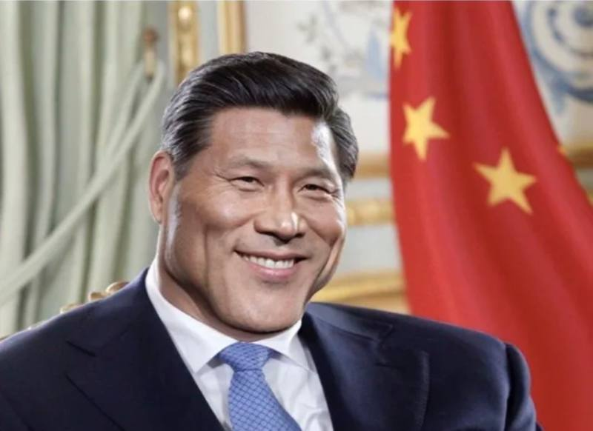
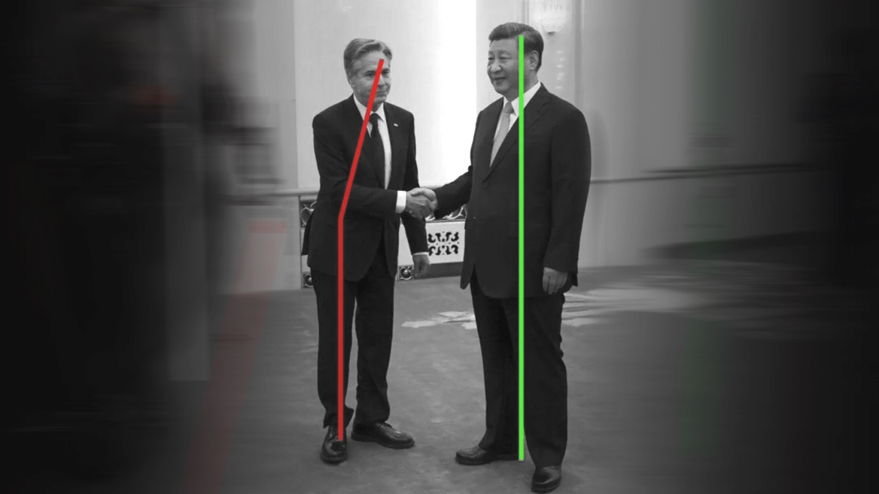
This seduction of image, as described by Baudrillard, instrumentalizes affective labels like <prestige> <authority> in warfare of pre-cognitive capture. All those post-internet artists who slap candles in front of a screen wrapped in lasercut cybersigilist motifs actually have a point. The algorithm is not just infrastructure, it’s a semiotic spirit, seducing users into pre-coded reactions. The scroll is no longer informational but ritualistic, ceremonial. While Western tech might have you visualize Christian signifiers, they soon might be replaced with Buddhist or Taoist ones. [feel free to use this idea in your next installation for that unpaid show you have in East London.] Akin to online alt-right’s tactics, the symbolic authority collapses into a circulating set of signs.
The algorithm doesn’t lie, it arranges political configurations. In Pasquinelli’s terms, it becomes a real abstraction, embedding geopolitical narratives not through discourse, but through optimized aesthetic logics. In this way, China is not understood, but algorithmically performed, again and again, until the performance becomes perception. Connecting visual stimuli to cognitive control is not something you decide on. You scroll until it sediments into belief. Deceived by the illusion of participation, the algorithm choreographs our feelings, managing attention through symbolic saturation.
With the internet's shift from a library to a conveyor belt of content, we carelessly let the algorithm reprogram our brains when we’re most vulnerable. We don’t scroll to think about what we see, it’s a passive process we engage in to avoid thinking. This subconscious reprogramming of our brains through visual stimuli makes us prone to build emotionally-charged associations based on the way a given post is edited. Rather than persuasive, new media is habitual. Although Fox News still glazes Trump through their North-Korean-state-TV tenue, traditional propaganda is no longer as effective. This disjuncture of new media into an embodied process is excellently described by Wendy Hui Kyong Chun in Updating to Remain the Same. New media doesn’t simply inform, it habituates. It doesn’t cultivate knowledge so much as condition a reflex: aesthetic awe as political truth, aesthetics as foreign policy. The emotional resonance happens before critical reflection.
After you get served thirty over-edited Peaky Blinders reels with phonk music some teen made with CapCut, the style nests itself in the depths of your brain, labeled <dominance> <power>. Next time you see a post with matching stylistic characteristics, those subliminal labels shape how you perceive its contents. Memetic templates reproduce ideology. When I first saw one of those sigma-like China edits, the wirings of my frontal lobe triggered a short circuit. The pre-programmed visual associations in my brain placed a stamp of approval on my hyperobsession. As shivers extend down my spine, I think to myself—based—as I proceed to put on Ke Mu San (hardstyle remix) on SoundCloud. I realize I no longer care about the factual, I am here for the vibe.
IShowSpeed — Hyperrealist China & Statecraft Through Livestream
Awaiting the mythical fall of the west, you’re stuck in the limbo of enshittified remnants of European welfare-states. Your outlook for the future was ravaged by some loser who posts 150 times a day. The hyperrealist demon of x.com has taken over. The tsunami of blue checkmarks flooded your content village and wiped out your niche twitter poetry community. Someone responded to you liking a video of a baby monkey getting mopped on the ground by an adult monkey. You open YouTube in a new tab, IShowSpeed is live right now.
IShowSpeed, a 20 year-old American streamer has announced his Asia Tour. Asia in question: China and Mongolia. Not the Western associative reflex of Korea or Japan. China. “[IShowSpeed] embarked on a marathon livestreaming tour across China, broadcasting for six uninterrupted hours on the first day alone, he vaporized the meticulously constructed ‘China threat theory’ peddled by some in the West. His lens revealed a nation so starkly divergent from typical Western caricatures that it made many viewers confront the uncomfortable truth that their perception of China had been systematically distorted.” — China Daily.
Partially engulfed in sweaty dreams by virtue of misclicking snooze two hours ago, I reach for my phone. The moment I expose my optic nerve to the environment, my finger wanders over to the Instagram icon. I get hit with the screen time limit popup courtesy of scrolling for too long after midnight. As I choose “Remind me in 15 minutes,” I am immediately greeted by Speed lip-syncing Super Idol (热爱105°C的你) with a backdrop of Chongqing’s stunning skyline. In what feels like a fever dream, Tian Yiming, the creator behind the famous song cover, enters the frame two seconds later. The epic crossover of internet celebrities from opposite sides of the globe goes viral in China and mildly confuses his Western viewers.
I get absorbed by the aftermath of clips from Speed’s stream. A never ending forest of massive, hypermodern skyscrapers, dotted with spotless architectural landmarks. Superhighways converge with elevated rail overpasses designed for an operating speed of 350 km/h. BYD’s Yangwang U9, a $250k electric supercar packed with lavish features like individual wheel drive or a capability to perform brief vertical jumps. The night sky is broken up with DJI drones sparkling with colorful LEDs. Speed yells in excitement, “Zoom out, show the whole city! Chat, this is cyber city, this is China!” as his producers switch the stream to one of the orbiting drone cameras.
In platform-driven exquisite poverty mindset, these lavish, luxury commodities and cyberpunk aesthetics are extremely appealing to Speed’s younger audience. Resembling an open world of the popular game Cyberpunk 2077, Chinese cities are superlative impressions of their ‘futuristic city’ mental image. Deeply rooted within Western culture, Techno-Orientalist connotations certainly enhance this perversion.
Speed is not a propagandist, his team just purely optimizes for engagement affect and virality. A curated vibe-package of innovation and information technology through cultural iteration. How Speed presents Chinese cultures is a simulacrum. How exactly is trying out a human-carrier drone in Shenzhen Chinese culture, or rather “real China”? This image of China as represented by technological fetish objects, bears questionable resemblance to culture in a typical sense — arts, social behavior or collective achievement. Speed’s itinerary mimics one of a diplomat, invited to marvel over carefully selected, cutting-edge markers of innovation. First-tier cities epitomize hypermodernity, the BYD flagship EV sportscar is a fetish object of luxury, the bullet trains are fetish objects of precision.
The hyperrealist lens of Speed’s content appeals to the viewer’s sensory system, following algorithmically-defined desires. By virtue of their affect-optimized format and the overarching backdrop of U.S. political scenery, his streams effectively arise as digital diplomacy. The format of IRL streaming captures audiences with authenticity other forms of content lack. His tour is centered around activities which align with the semiotic language of earlier discussed signifiers, shaping a sort of semiocapitalist foreign policy. The Chinese century is a century of semiocapitalism, the country’s image is being commodified in real time. China’s network image reduces “5000 years of culture” into a set of over-iterated representations. China is LED skyscrapers, China is fast electric cars and human-sized drones, China is dancing robots. Where did the real China go? These semiotic labels distill the most recent and engagement-optimized elements of modern China, abandoning pre-internet culture in the quest for maximum affect.
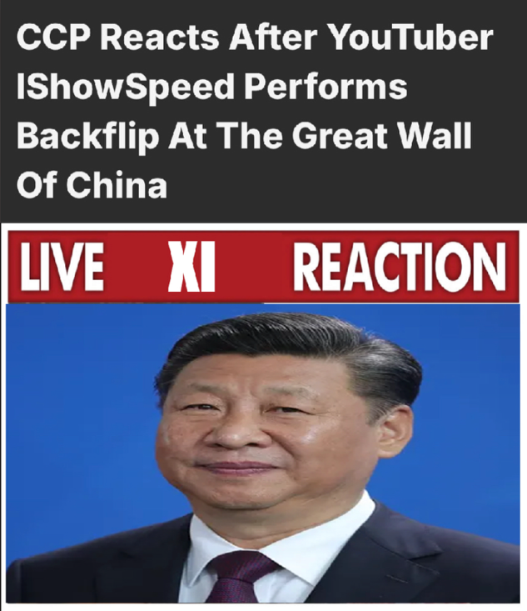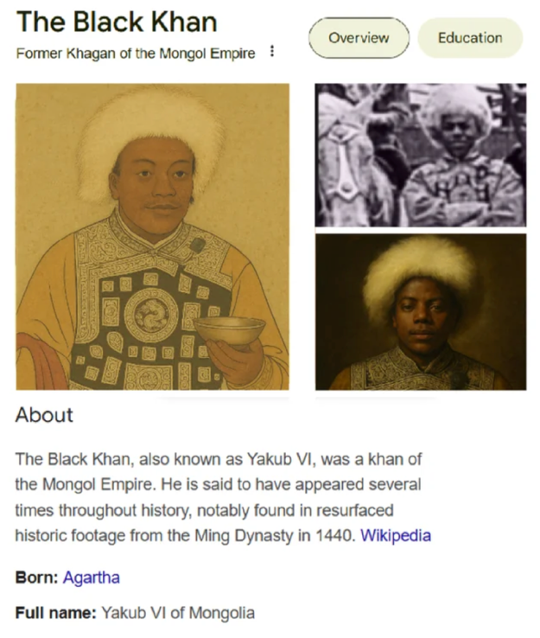
on the right: meme portraying IShowSpeed as a khan of the Mongol Empire

An official account of the Chinese embassy in the U.S. tweeted “The 20-year-old popular American YouTuber IShowSpeed has kicked off a journey in China that has already garnered massive global attention, which indicates a broader trend of digital influencers bridging cultural gaps and creating alternative channels for foreign audiences to understand a vibrant China.”
Through soft weaponization of parasociality, Speed's presence works as an ideological counterbalance to anti-China narratives. Abandoning rhetoric in favor of affective presence, the content becomes "depoliticized" and seamlessly absorbed into platform capitalism. Unintentionally, Speed might just have pioneered statecraft through livestream. A total of eight streams, although not funded by any state actors, might go down in history as one of the greatest, most unexpected new media psyops. A random streamer born in 2005 went on luxury vacation and crumbled a multi-million dollar American propaganda operation in the process. The State Department’s fear mongering simply did not pass the vibe check.
The parasociality of Speed’s streams becomes a state-compatible aesthetic. He doesn’t need to lie, because his curated, experience-driven perspective is already doing the work. Content creators used to visit China to perpetuate fear-mongering rhetoric or be racist for views, capitalizing on American propaganda campaigns. Speed was by no means the first one to break this pattern, but most certainly the most influential. Not only is his audience mostly composed of young impressionable teens, but he’s one of the biggest streamers in the world. His support and position on Palestine without a doubt played a role in countering Zionist narratives from alt-right groypers like Asmongold. Expectedly, his visit to China has the potential to cement the already rapid sinicization of Gen Alpha and beyond.
China Runs Without an RTX4090
Cyberpunk aesthetics avoid the utopian tendencies of earlier fiction. A sense of nihilism and hopelessness encompass neon city landscapes, urban jungles full of depressed laborers. Corrupt governments and abusive megacorporations loom over the masses trying to navigate their strict, highly-automated systems of control. In contrast, Silicon Valley entrepreneurs massage their raytraced images of solarpunk utopias packed with symbiotic urban architecture where trees grow on buildings. A spotless self-driving pod takes you to work while your AI assistant plans a post-work dinner with your smiling, diverse group of colleagues. The Chinese Century does a 180 and drops you off at Night City.
Millennials submit to those tech bro fantasies, Zoomers already gave up and Gen Alpha never cared in the first place. Exhausted and disillusioned by decades of neoliberal ideology promising personal freedom, choice, and empowerment, Western youth lives through the system’s failure to deliver meaningful agency. Described by Byung-Chul Han as freedom fatigue, the mythical “freedom” has become an obligation to self-optimize. A burden to choose between endless options, while constrained by the invisible infrastructures of debt, platforms and biases. Neoliberal “freedom” has made the vision of a more coherent and stable, but more authoritarian future appealing. In conjunction with instrumentalized aesthetics of China, youth has earned a tendency to gravitate toward authoritarianism.
This attractive force of Chinese hyperreality shares countless similarities with young men’s turn to the alt-right. Fueled by a sense of displacement and alienation, young men struggle to find meaning, community and identity. Similarly, disillusioned youth, living in the increasingly fascist West often fails to find meaning and prospects for the future. Both groups are craving a sense of being a part of some bigger, more powerful entity. Reactionary circles satisfy this need by means of redpilled guilds and grievance-driven culture wars. The Sinopill constructs a pseudo-parasocial connection to a hypermodern society, a technological civilization state. In Kill All Normies, Angela Nagle describes how the alt-right emerged not from traditional conservative spaces, but from weird, chaotic corners of the internet. Fueled by LARP and edgy memes, the Sinopill surfaced from scattered online content — and just like the alt-right — got accelerated by a chain of global events. Related not only anthropologically and aesthetically, but also aspirationally, both phenomena position themselves against an antagonistic hegemony. One side claiming to resist “woke capital,” feminism and globalism, and the other, American hegemonic power.
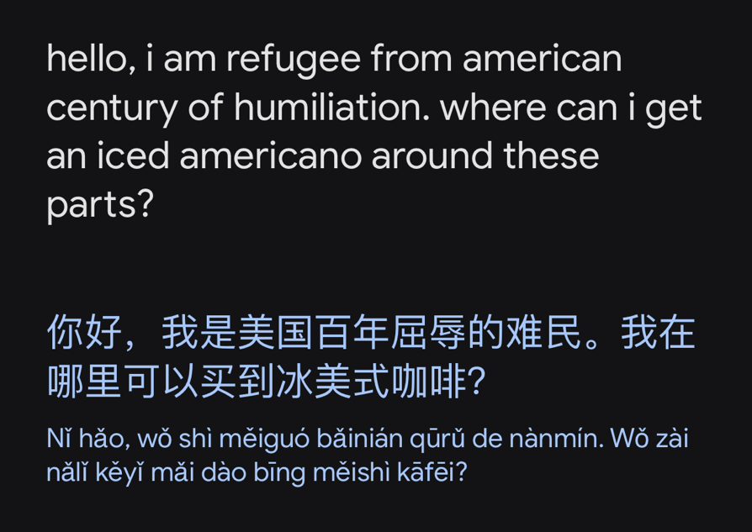
Borrowed Futures — Red Hauntology
Having defined a relevant political framework, linking algorithmic reprogramming of aesthetics into worldview, digital sinicization has gained a psychoanalytical backbone. Aesthetic parallels with the manosphere hint towards a subconscious shift resulting from aesopian cultural iteration. Optimized visual logics, habitual consumption, algorithmic affect regimes. The case study of Speed’s tour emphasises the semiotic nature of XXI-century Chinese capitalism. Broadcasting the aura of China as a hypermodern civilization state excites the culturally-programmed desires for technological acceleration. Cyberpunk nightscapes and high-tech optimizations of daily life appeal to the warped mental image of futurism, unfazed by traits of authoritarian surveillance-states.
Perpetuated promises of Western capitalist freedoms eroded dreams of prosperous futures. Red Capitalism breaks away from the religious trust in the invisible hand of the free market. Instead of blindly relying on made-up mechanics of supply and demand, China involves the very-much-visible hand of the party. It’s still capitalism, the CCP just sets the research agenda. The end goal of capitalism is always profit, but Red Capitalism breaks that officially sanctioned fact. Building on the remnants of Maoism, contemporary China is defined by principles from times of economic reform in ‘79. Xi Jinping Thought driving modern policy is purely a reiteration of earlier socialism with Chinese characteristics. These last remnants of socialism redefine the ultimate goal of ‘their’ capitalism as common prosperity, building a "prosperous, democratic, civilized, harmonious, and beautiful socialist modern country."
Western capitalism suffers from a lack of collective objectives, replacing them with tech bro utopias or reactionary fantasies. The lack of shared futures suffers from endless recycled creations, proven to generate profit. What Jameson applies to culture in Postmodernism, or, The Cultural Logic of Late Capitalism, can be applied to collective objectives in general. Contrast that with Chinese-style planned economy focused on 'pushing humanity forward,' and the dichotomy becomes clear.
Lacking futures of their own, Western youth clings to China not just as a country, but a borrowed future. On the sinking ship of neoliberalism, young Westerners yearn for something that looks like progress, order — and most importantly — future. China, through its portrayal on social media, offers a simulation of that futurity. ‘Simulation’ is a key word here. I seriously doubt most Sinopilled zoomers would actually consider living there. China’s image as a country, gets overridden by Net-Real China, its idealized network image. Their image of China is purely an idealized fantasy, a fantasy which they’re scared of shattering with reality. In Ghosts of My Life, Fisher describes exactly that through hauntology — we’re consuming a fantasy of futurity, not reality. Western futures we’ve been longing for are suspended in time, slowly cancelled by realities of neoliberalism. Haunted by lost futures, we become mesmerised by foreign futures.
In a crisis of viable futures, the psyche will cling to anything that looks like one. When the West represents the collapse of futures, Net-Real China appears as the Other. In Lacanian terms, China becomes the ‘subject-supposed-to-know,' the fantasy of a coherent Big Other who has not yet lost the plot. Net-Real China doesn’t resolve the subject’s lack, but it simulates its resolution through image delivery. Each piece of China-posting content offers a temporary fantasy. This aesthetic imaginary functions as the object-cause of desire in a new, post-liberal libidinal economy.
The hyperreal spirit of Sinofuturism excites our idea of human progress in a play of transnational digital edging. Some elements are more real than others. Silicon Valley’s empty promises of pseudo-emancipatory technologies get picked up by the yes-men of Shenzhen. I like to bring up an example of Shanghai metro cars, a humble epitome of China’s dedication to technological empowerment:
When taking some metro lines in Shanghai, you can choose between a warmer or colder compartment from the platform, even before entering the train. This hyperoptimization of comfort is completely unnecessary. Nobody asked for it, nobody would notice if it wasn’t there, nobody would seriously miss it if it went away. Shanghai’s metro is already one of the best in the world. Shiny, surgically-clean stations the size of airports, providing eye-candy at every step in form of flowing architectural forms and interactive illuminations. The visionaries behind the city’s transit infrastructure have truly made it to the top. The stations are clean, efficient and equipped with (controversial) facial recognition gates for even more automated convenience. In line with Beijing's rush of technological innovation, somebody sat down and thought: is there anything which could possibly improve this state-of-the-art experience? After pitching their idea, a board of engineers and policy makers worked hard to fund and implement this convenience-feature. Anywhere else in the world, this idea would have died in the boardroom at the first “but how will this make us turn a higher profit?”
China is not afraid of change. Sculpted by the slogans of the economic reform period, people have been conditioned to accept change. Coming with an unfortunate side effect of bulldozing ancient landmarks standing in the way of economic plans, China changes, and changes rapidly. The neoliberal rollercoaster on the other hand is not rational change, it’s chaos. What Western youth is yearning for is economic competence and hyper-coordination, seeking emotional relief and stability.
We no longer believe to be living in “the most prosperous part of the world.” Wronged by state narratives, we feel resentment and grief. Unable to escape the paralysis of capitalist realism, we fight back in symbolic ways. Briefly mentioned while describing the Xiaohongshu saga in my previous article, young Americans have weaponized their usage of social media. The cyberspace uprising after the proposed TikTok ban was not only a protest directed at the performative ruling, but a way of showing frustration with state propaganda. Pretending to mail their data to the CCP, hopecore edits, ‘sharing [data] is caring,’ or advocating to download as many Chinese apps as possible.
America’s theatrical attempts at defending its network sovereignty fostered a memetic insurgency. Youth on TikTok and Xiaohongshu broke up the cultural hegemony of American tech and the Department of Homeland Security lost the fight for their cognitive territory. The balkanization of the internet created sovereign content spheres. Instead of being tied to a nation state’s demographic, their size and influence are network representations of a state’s cultural influence. The American sphere encompasses the entire Western world, while the Chinese one barely broke through territorial boundaries. What happened is a platform betrayal against the Western internet sphere, signaling towards a newly gained consciousness.
Everyone should use a VPN, and everyone in the West also needs a cultural VPN. A semiotic proxy to escape your immediate ideological (media) environment and re-route your worldview through a foreign server. A cultural VPN masks your geopolitical IP, bypassing contextual firewalls and liberating cognitive traffic. Chinese netizens constantly climb the steep side of the Great Firewall, we never even entertain taking the stairs on the other side. TikTok’s migration over to Xiaohongshu breaks this pattern in a unique example of weaponized content in a fight for a future beyond the LAN. Aligning with a foreign adversary to puncture the domestic content bubble in protest of homogenous local traffic.
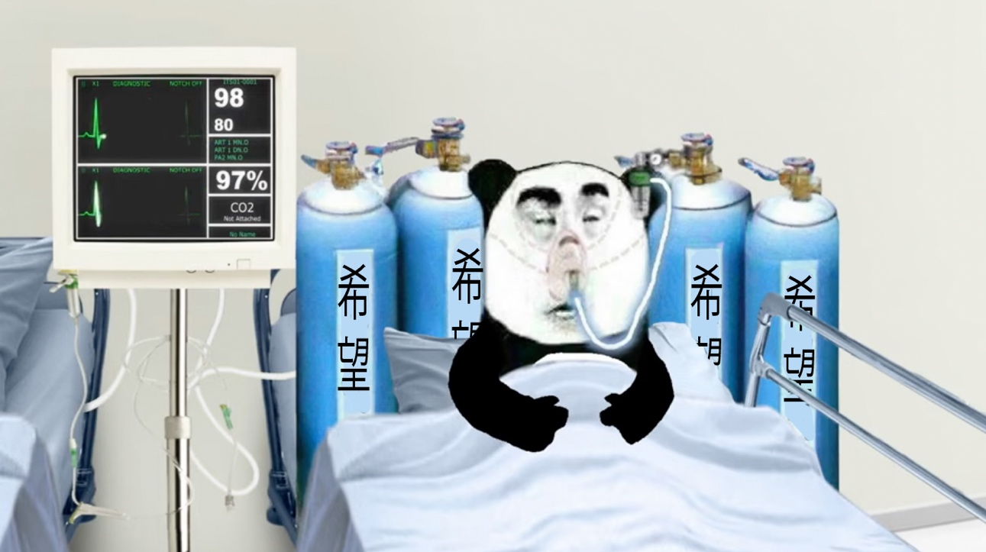

Hope with Chinese Characteristics
As the West descends deeper into corpofascism, China lives the life promised to you by the neoliberal dream. China is living through the transition from industrial to post-industrial, frequently romanticized in e.g. Japan's history. Flourishing economy uplifting the working class, scientific and technological innovation, and most importantly, endless access to cheap treats. Omnipresent low-cost goods, palettes of brands and superficial commodities acted as a distraction from deteriorating material conditions. As affordable consumerism withers away, neoliberal reality sets in. We shipped our future to the treat supplier. China is effectively sitting in the server room of global capitalism with kernel access. The dream of the East becomes a mirror of everything the West promised but couldn’t fully deliver.
Absorbed in the chaos of neoliberal collapse, we ache for any semblance of a prosperous future. Venture capital kidnapped utopia. Lost futures scarred us with generational wounds, incapable of being healed with conventional medicine. Net-Real China acts as an alternative treatment for the neoliberal tumor. Falling under traditional Chinese medicine, moxibustion entails the burning of mugwort leaves on a patient’s skin, redirecting the body’s attention through signaling. Analogously, hyperreal visions of China redirect one’s longing for domestic futures via aesthetic signaling.
Stranded by the deserted ideological landscape of algorithmic governance, we desperately cling onto outdated visions or set for compromises. Exhausted by positive psychologies of capitalist “freedoms,” we accept the unconcealed governance of one party rule. “If you ask ordinary people do you want to be free?, their answer usually would have been yes. But if you look at it closely, you will see that the majority of people, me included, wouldn’t really like to make radical choices all the time. What they want is to maintain the appearance of freedom, but discreetly they want to be told what choice to make.” What Žižek spits out here aligns with Han’s view on Western freedom. Instead of posing as a compromise, the lack of democratic process has the potential to subconsciously further accelerate this transnational nostalgia for Net-Real China.
Transgressive affection of Western youth towards China functions as dark catharsis. Akin to the ecstatic romanticization of Luigi Mangione following his alleged assault on United Healthcare CEO’s life, a celebration of a foreign adversary reveals itself as a perverse libration in the eye of the neoliberal status quo. China is the West’s Luigi, admittedly, just as prone to idealization. While Americans celebrate a small win against oligarchy, China kidnaps its overly greedy business owners. Inversely, in America, the state trembles in fear of the capital.
Where everything else degrades, China progresses. In the liminal shell of Western exceptionalism, the Chinese Dream shimmers through the dark with individually-addressable LEDs. Exercising its healing properties over fiberoptic veins, Net-Real China is an opium for the neoliberal crisis of futures. Now I’ll be booking my flights to Shanghai to address the extraterritorial placebo.
Postscript: A Note on Freedom
Chinese society’s submission to the state is not unique, but rather a larger trend in much of Asia. With a soft exception of American-influenced Korea, Confucian principles in the Sinosphere foster a trust relationship between the populace and government. Paraphrasing Žižek, Western democracies give an illusion of freedom, with little to no policy being influenced by public opinion. Lost in the rhetorical sandbox of free speech (increasingly challenged by technocapital), the West is convinced of its governance model’s superiority. China, as an undoubtedly authoritarian state, when analyzed through the lens of everyday needs, community emancipation or interest of the people, wins over Western democracies. When freedom of speech is undermined by quiet deals with platform giants, the open censorship of Beijing becomes a controversial alternative in the sad spectacle of Western kleptocracy. In America, the party changes, the policy stays static — in China, the party stays in power, the policy undergoes radical transformations. While an overarching set of vague values looms in the background, the intricate data-driven decision process evolves rapidly in close pursuit of material needs.
Aleksy Domke is an interdisciplinary artist and researcher whose work engages with the internet, technology, philosophy and Chinese cultural influence. Their writing revolves around the internet – its phenomenology, cultural and political significance, and virtual milieux. Alongside critical internet research, their practice reflects on and amplifies the spectacles of hyperaccelerated internet-era life. Often working with computer-aided and digital techniques, Aleksy makes installations, objects, moving image, and other media.

Weibo and Xiaohongshu are Chinese platforms, similar to YouTube and Instagram/Pinterest.
“China Virus” or “Kung Flu” are racially charged terms coined by Trump during his first presidency, referring to COVID-19. The phrases significantly contributed to Sinophobic sentiment in the West, particularly spreading through hashtags on the platform. See: Paul Cooper and Sofia Lampropoulou, “China Virus, Kung Flu, and MAGA: Countervalues and Sociological Fractionation on Twitter as Evidenced by Pro- and Anti-Trump Discourses in Relation to Covid-19,” Discourse, Context & Media 57 (February 1, 2024): 100758–58, https://doi.org/10.1016/j.dcm.2024.100758.
Ying Fu, “The Construction of China’s National Image under the COVID-19 Epidemic by the American News Media,” International Journal of Education and Humanities 15, no. 2 (July 27, 2024): 6–9, https://doi.org/10.54097/6fggxv24.
The White House, “Yes, Biden Spent Millions on Transgender Animal Experiments,” The White House, March 5, 2025, https://www.whitehouse.gov/articles/2025/03/yes-biden-spent-millions-on-transgender-animal-experiments/.
William Hartung, “Can Bernie Stop Billions in New US Weapons Going to Israel?,” Responsible Statecraft, April 2025, https://responsiblestatecraft.org/signal-yemen/.
MØRNING, “China, the Internet’s Favourite Trendsetter?,” Substack.com (Burn After Reading, February 8, 2024), https://morningfyi.substack.com/p/china-the-internets-favourite-trendsetter.
Mark Fisher, Capitalist Realism: Is There No Alternative? (Winchester: Zero Books, 2009).
Jodi Dean, Democracy and Other Neoliberal Fantasies: Communicative Capitalism & Left Politics (Durham: Duke University Press, 2009).
Jean Baudrillard, The Evil Demon of Images (Sydney: Power Institute of Fine Arts, University of Sydney, 1987).
Matteo Pasquinelli, The Eye of the Master: A Social History of Artificial Intelligence (Verso Books, 2023).
Wendy Hui, Updating to Remain the Same: Habitual New Media (Cambridge: MIT Press, 2016).
Elon Musk.
Zhang Zhouxiang, “IShowSpeed Livestreams Show World an Unfiltered China,” Chinadaily.com.cn, 2025, http://www.chinadaily.com.cn/a/202503/31/WS67e9e447a3101d4e4dc2bb85.html.
Jean Baudrillard, Simulacra and Simulation (Ann Arbor: The University of Michigan Press, 1994).
Franco "Bifo Berardi, Precarious Rhapsody: Semiocapitalism and the Pathologies of Post-Alpha Generation (London: Minor Compositions, 2009).
Chinese Embassy in US on x.com, March 26, 2025.
Byung-Chul Han, Psychopolitics: Neoliberalism and New Technologies of Power (London/Brooklyn: Verso, 2017).
Luke Munn, “Alt-Right Pipeline: Individual Journeys to Extremism Online,” First Monday 24, no. 6 (June 1, 2019), https://doi.org/10.5210/fm.v24i6.10108.
Angela Nagle, Kill All Normies: The Online Culture Wars from Tumblr and 4chan to the Alt-Right and Trump (Winchester: Zero Books, 2017).
Fredric Jameson, Postmodernism, Or, the Cultural Logic of Late Capitalism (Durham: Duke University Press, 1991).
Mark Fisher, Ghosts of My Life: Writings on Depression, Hauntology and Lost Futures (Zero Books, 2014).
Fisher, Ghosts of My Life.
Jacques Lacan, The Seminar of Jacques Lacan. Book 11, Four Fundamental Concepts of Psychoanalysis (New York: Norton, 1998).
Jacques Lacan, Transference (Cambridge/Malden: Polity Press, 2017).
Lawrence Lek. Sinofuturism, https://sinofuturism.com/.
Aleksy Domke, “Weaponized Data Sharing and Gen Xi – Notes on China II,” Networkcultures.org, March 16, 2025, https://networkcultures.org/blog/2025/03/16/weaponized-data-sharing-and-gen-xi-notes-on-china-ii/.
Internet balkanization, cyber-balkanization or splinternet is the breaking of one global internet into several smaller and fragmented pieces due to content filtering and censorship. Internet balkanization creates separate content spheres, e.g. Chinese internet or Russian internet.
Slavoj Žižek, How to become free, n.d.
Han, Psychopolitics.
Jack Ma, a former chairman of Alibaba, was briefly disappeared after criticizing China’s regulators during a speech at the annual People's Bank of China financial markets forum.

