Youmaxxing: Masculinity, the RedPill, and the Online Self-Improvement Culture. Journey into the Italian Manosphere.

Francesco Barchiesi

Originally published November 25th, 2024

PlayLover Academy (PLA) is the foremost Italian seduction school. They offer a “social and emotional improvement” program to transform you into “the man women want”. It is not merely a standard pick-up artist school, as there were many twenty years ago; it is a wider offer, aimed at “activating your maximum potential,” as stated on their website: they promise to work on you comprehensively. The seductive training is sold as a gateway to personal development. They entrepreneurially take care of you. PLA’s extensive range of services includes “improvisational theatre” to improve performance anxiety, “stylistic consulting” for a more appealing look; classic live seduction coaching, “winning back an ex,” or “reconciling a marital rift,” as well as training on finding a partner through dating sites and apps.
Of course, all these services come at a steep price. Online courses for becoming a playlover start from 499 euros up to a thousand, for 12 and 30 hours of video training respectively, on “how to structure opening lines”; “how to make contact”; “how to have a steel mentality,” or perform “a total mindset reset”. In-person courses, which involve three days with a trainer at one stop of the PlayLover Summer Tour — afternoon trials of picking up girls on the beach, then ice cream with the bros: it’s always white boy summer after all — start from the special price of 1499 euros, just for the privilege of enjoying each other’s company. What about PlayLover New Year’s Eve, which includes “three intensive days of emotional improvement, vacation, and fun”? Another thousand euros.
They make it clear: choosing PLA is just the beginning of a whole journey; “the most difficult decision to make” for those who dare to “take the dark road” and are “willing to do the opposite of what the masses do”. For those who are tired of mediocrity and want to really start living. PLA heavily relies on psychology — but street psychology, “without a grade”: be wary of the kind of professionals who don't get you anywhere... — with “the very same principles adopted by Elon Musk, Bill Gates, Mark Zuckerberg and virtually every other celebrity and influential structure in the world”.
In addition to online courses and in-person training, PLA offers specialized private counselling services. PlayLover Always Training: you can have a personal trainer available for a certain number of hours per month (depending on the subscription level), through a mix of calls and WhatsApp messaging (how is the time spent chatting on WhatsApp measured exactly?). In order to assert authority, no satisfaction or money-back guarantee. Having a trainer at your personal disposal for 5 hours per month is the ‘bronze’ level of subscription, the lowest tier. It costs 599€.
This kind of consulting is even available as a one-off service (‘On Demand’), you can pay 149 euros for just an answer to an email, or 199€ for an hour-long phone call. And then there’s the Fashion Lover Day: eight hours with a trainer acting as a personal shopper, to review your wardrobe and redo your look. They take you shopping, to the hairdresser, to the cosmetician. They buy you clothes, fix them on you, comb your hair, tell you what to wear for the day, and force you to smile to make an impression. The mother’s caring gaze, worrying about how you are seen — except now you are paying for it, and this attention is provided as a service.
PLA is embodied by the two founders, Christian and Steve. On their website, there is a brand identity page dedicated to the story of these characters — building their reputation as gurus is a key factor for the business. The first one describes himself as ‘predestined,’ with an innate “propensity for conquering the fairer sex”; but, at the same time, his plot has a redemption arc: he was able to forge his mindset following a troubled adolescence, precisely as a student of ‘PUATraining’ (which is another seduction school, spread all over the world), where he learned the rules of the game. As sometimes the student surpasses the teacher, Christian has now moved to the other side of the desk, distinguishing himself through his “know-how” and his “skills at teaching”. His motto is: “Practice is better than grammar” (at least it rhymes in the original Italian language).
The second character, Steve Meister, instead has always been successful: he claims to “have closed 85% of his friends’ female friends he has met”. Some kind of Casanova Superhero, whose standout quality is a “strong inner game”. From him, we also know that he has travelled a lot (“many times in Ibiza”, he says); features a “Machiavellian disposition”; his girls “must strictly have nice butts”. Both the PLA’s founders can be “cocky and funny”, but each one specializes in different techniques and situations to teach students.
They said they were quartered in Dubai, and that “the company pays 100k€ a month in salaries for employees and collaborators”. The work beyond their online presence is indeed managed at least to some extent by their subordinates. PLA has been relentless on social media, fueled by an aggressive marketing strategy that turned them into a viral sensation — even landing them on national TV (a feat they never tire of flaunting on their website). The two founders can be almost daily seen on YouTube videos where they share nuggets of wisdom: “7 bad boy approaches that make women go crazy” — ‘The method to get her butt photo sent to you’ — ‘Screw her head in with messages!’. But also, videos dedicated to maximizing your physical appearance, tips on investments, and how to improve other people's perception of you. Looks, Money and Status — sounds familiar? It’s not just seduction: it is “personal growth”.
From history, we know that the RedPill Theory is supposed to be at odds with pick-up artists’ notion of the game, as something that can be learned (and sold) — the RedPill discourse has partially stratified out of this disillusionment, as we can deduce from the forum PUAHate (crucial for the genealogy of the RedPill and incel culture). Yet, a fundamental continuity echoes between these two discourses: there is one male narrative of permanent self-improvement, oriented towards the attainment of the same object of valor (to put it in semiotic terms).



The pick-up artist (PUA) movement emerged with the appearance of the first ‘seduction manuals’ as a popular sub-genre on the bedrock of self-help culture in the late 1980s, but it became mainstream just around the turn of the millennium. It is closely tied to the evolution of the Internet and the culture of online forums, where some men began sharing advice and techniques on how to attract their targets, on how to snag them in the growing nightlife scene of clubs.
The PUA community-building process is characterized by a distinctive group vernacular. This recurring element, rooted in the digital forums of the late 1990s, reflects a fusion of nerd and geek culture with the terminology of the financial sector. Expressions like ‘f-close’ or ‘k-close’ explicitly derive from sales jargon and indicate, respectively, the success of ‘fucking’ or ‘kissing’ a girl, as if it were the closing of a deal. These terminologies persist in the international community’s vocabulary, and we find these same words on the (Italian) PLA website.
The real surge in popularity occurred at the beginning of the aughts, in conjunction with the rise of the so-called post-feminist, neoliberal sensitivity. These were the years of Bridget Jones and Sex and the City, when the service-class single woman in her thirties was portrayed as empowered by the possibility of enjoying her newfound freedom — one increasingly recast as spending power and casual, detached sex “like a man”. The complementary objective-correlative of this chick-lit temperature is the seduction master, the pick-up artist (PUA). Men Are From Mars, Women Are From Venus, after all: At the turn of the millennium, heteronormative culture was defined by the idea that biology and psychology could provide the codes to master relationships with the opposite sex.
The pinnacle of the PUA movement coincided with the publication of the bestseller The Game, in which author Neil Strauss recounts his journey from nerd to star performer, after receiving the initiatory knowledge passed on to him by his guru, Mystery.
The Game advances a whole metaphysical program, staging a deterministic world based on the laws of evolutionary biology, a mesclun of behavioural psychology, and cognitive sciences. You can learn and draw conclusions about the objectification of interactions and relationships between the sexes, hence achieving the desired results: if women are predictable, the art of seduction can be mastered. The guru bears the light of knowledge, and then it is up to you to try hard enough. Almost needless to say, in this intrinsically sexist cosmos, there is no role for female subjectivity other than being the object of men’s predatory desires.
Mystery had his reality show on British television called The Pickup Artist (2007-2008), after which the decline of the movement began. This was also due to increasing criticisms and controversies — partly from the collective acknowledgement of a feminist sensitivity, and partly from the PUA community itself. Discontent was the sign of the inevitable fraudulent turn taken by the expansion of a whole seduction business.
Sociologist Rachel O’Neill spent eight years conducting an ethnographic investigation with a feminist theoretical framework in London’s seduction community, participating in courses and workshops held by various PUAs in the area. The result is her book Seduction. She describes seduction communities as places of ‘mediated intimacy’:
I am concerned to examine how neoliberal rationalities, centered on management and entrepreneurialism, shape the intimate subjectivities of heterosexual men. In doing so, I am interested less in arguing that neoliberal capitalism is fashioning a new hegemonic variant of masculinity than in examining how the logics of neoliberalism get under men’s skin.
O’Neill argues that the PUA community must be interpreted as a reaction of men navigating the terrain of post-feminism, in neoliberal terms: embracing intimate entrepreneurialism. At its core, PUA’s discourse seeks to rationalize the transformation of the self, converting personal development into a targeted strategy for sexual acquisition. Your inner game as a locus of labour: this is mediated intimacy. It is not limited to your sexual persona; it affects your social skills, your aesthetic appearances, and your narrative of yourself. You, as a subject of enterprise. As feminist literature has reviewed, this is what women have traditionally been compelled to do, and now men seem to have arrived at this stage as well, though ‘following very different routes’ — as Susan Faludi puts it.
O’Neill also pinpoints that, around seduction, it has established ‘a community-industry hybrid’. Pick-up artists are primarily salesmen. The guru-manager projects the image of a grandiose self, on which their authority and competence are based, mainly through the heroic metric of the body count — which stands for how many deals with girls they succeeded in closing. The commodified good that the guru is thus selling is intangible, but it is translated into a method that can be learned and promises success if followed correctly: a life hack. In short, if it’s not working, it’s only your fault, and you’d better invest more: more of yourself and more money in training.
The system is fuelled by former students who become trainers themselves at the service of the guru, earning dividends. In this frame, the PUA business is not so distant from other Ponzi schemes, aligning itself with sectarian movements like those new age cult-enterprises that were popular just a few decades earlier, but explicitly marketed on a new, tight, and culturally distant consumer target.
The communities populating seduction academies are strictly sexual-connoted and homogeneous collective identities — heterosexual males wanting to become “skilled” with women — persuaded to share a rigid worldview and a secret knowledge infused with technical jargon. The group thus often becomes insular, pushed to develop some kind of “us against the world” mentality. In addition, for this reason, it is unusual for participants to publicly share their affiliation with the movement, opting instead to engage with each other in online echo chambers through anonymous proxies.
It is also worth noting that the internal logic of association within PUA communities is, in part, a legacy of the pro-feminist consciousness-raising groups that emerged in the United States during the late Sixties and the Seventies. The spectacle of men confronting one another and seeking mutual support for their perceived failures with women is, indeed, a departure from traditional hegemonic masculinity. In the case of PUAs, however, one finds no critical deconstruction of the link between these personal struggles and patriarchal structures — a stark contrast to the ‘men's liberation’ experiments of the past. Instead, the PUA’s masculinist stance finds a more direct precursor in the mythopoetic movements of the 1990s, specifically the 'deep masculine' research groups inspired by Robert Bly’s Iron John.

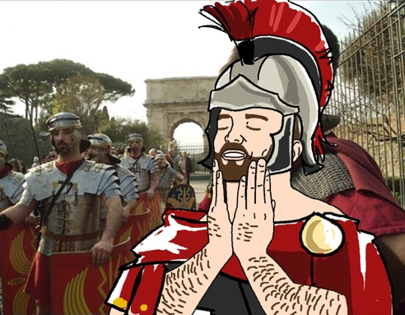

Quite a tangible representation of the neoliberal turn: what starts as a political experience capsizes into the self-help business-culture within twenty years. In the post-1977 Italian political scenario, scarred by the “reflux into private”, the former male activists found out that they were more like their fathers than they expected, or perhaps they had wished to be. The masculine experience of self-consciousness groups, framed as feminist therapy, dissolves into psychological and existential mutual support without the overarching revolutionary hope pushing at their back, and goes on without progressive social politics guardrails, longing for self-realization goals.
In the alleged post-ideological world, where the therapeutic discourse takes hold, males start crying out for their traumas and psychic wounds, “blaming women” for being responsible for this pain. Social and political powerlessness turns into gender resentment on the tidal wave of the consumeristic sexual revolution and rampant individualism. This is perhaps the bending point of the misogynistic tendency that characterizes homosocial masculine communities especially today, from PUAs to The Red Pill Theory, and the digital enclaves of involuntary celibates. Here comes the Manosphere.
In the meantime, the very same sexual revolution helped push the psy discourse among the aspirational middle class, and therapeutical culture went hand in hand with the withdrawal of sociability, giving birth to the convergence of self-help and self-improvement commercial culture. The very American idea of the perfectability of the self has espoused the therapy setting, requesting the (costly) reliance on someone else’s guidance. The locus of intervention is the Self, but the work is directed from above, which is the expert’s authority. “Psychologists increasingly addressed the public both as patients and consumers”. But the therapist’s role soon emerged from the fence of psychoanalysis, invested by broader, more generalist streams. Our familiar figures of the guru, as in the case of the PUAs, took their place there.
While this therapeutic sensitivity draws heavily from the post-1968 experience at first, and the liberal new age-wave finds a nod to the cultures of the self in the Eastern tradition, there is a second strand that is ignited by the foundation of cognitive-behavioural psychology. A therapeutic approach that is powerfully pragmatic and oriented toward the realization of the individual project and its success, which, not surprisingly, takes hold equally well among Silicon Valley geeks, soon to become global masculine role models.
The inspiration in this case, however, takes root in the Western culture of the self, specifically Stoicism — obviously the “popular” one, a watered and commercialized version of its ethos, capable of delivering the simple (and twisted) message of becoming masters of our own emotional world for well-being and prosperity. A strand far more reconcilable with the reassuring reinforcement of a traditional hetero-masculine hegemonic identity, now openly challenged in certain milieus of the globalized West, and with the whole so-called TradWest imaginary, which is constituted precisely by opposition to the development of feminist culture and its post-revolutionary mainstreaming. “Men are not into therapy culture”, because they are less geared towards healing and more towards success; so “[this kind of] Stoicism is therapy with gladiators”.
This brief conceptual thread might shed light on some of the oddities of our contemporary digital culture. For example, why have we seen AI-generated images of the Giga-Chad in the guise of Roman emperors on YouTube video thumbnails about digital entrepreneurialism; the memes of men thinking about the Roman Empire many times per day; the very existence of the expression “broicism” itself; why someone like Andrew Tate refers to stoic Marcus Aurelius. Tate's dark flower blooms from all this wide sowing.

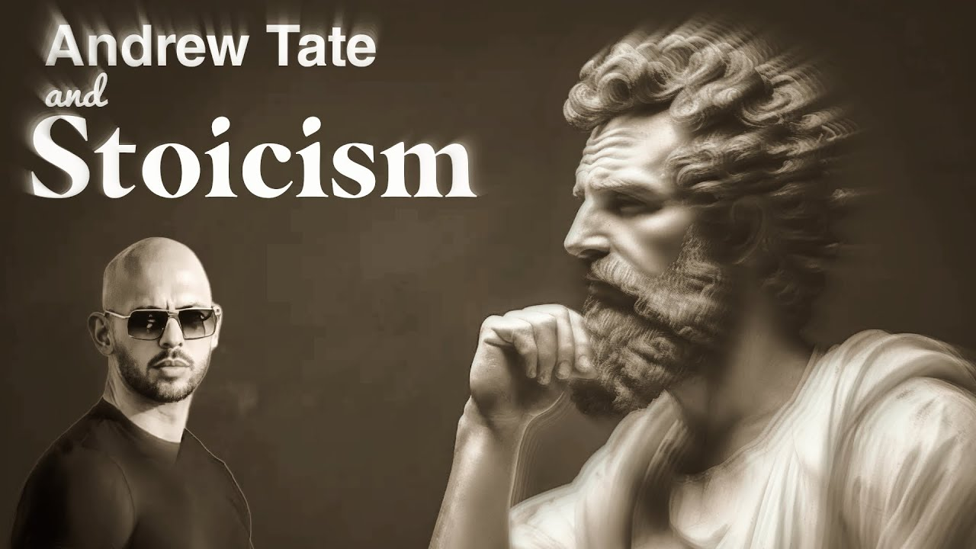

It was December 2022 when former kickboxing champion Andrew Tate and his brother Tristan were arrested by Romanian authorities. They have been charged with rape, exploitation of prostitution, and human trafficking after having lured and groomed women to sexually perform on cam-sites. In the months prior, Andrew Tate had reached the peak of his popularity as an influencer: during the summer, he had been googled more than Donald Trump and Kim Kardashian.
Mainstream social media platforms banned all his official accounts for violating community guidelines after receiving repeated allegations of promoting violence against women. In the UK, polls reported that 8 out of 10 teenagers had watched Tate’s content on YouTube, Instagram, or TikTok. This is when the world realized how worrisome his allure had become. Today, after the second election of Donald Trump as President of the United States, we confront Tate’s influence once more.
Thanks to his ‘Hustlers University’ he became a multi-millionaire, attracting more than 250k subscribers (who paid handsome fees) to learn the basics of self-entrepreneurship, and investment plans related to crypto, AI, and digital marketing. His business strategy involved dividends for members who were able to bring new subscribers to the community and share his videos, as is generally the approach of the seduction industry. “In essence, Tate created a Ponzi scheme by making his followers believe that they were pursuing their own financial freedom while, at the same time, they were contributing to his viralization throughout social media”.
He was the best at weaponizing the algorithmic feedback loops of the early 2020s, turning the rapid-fire scrolling morphology of TikTok into a billion-share engine for his content. In his videos, Tate excels at persuasively saying the same old things, with cuts and edits specifically tailored for the format. His tale is the classic hero’s journey: overcoming difficulties to become stronger. “Life is a battle: for power, for attention, for dominance”; “Name an attribute of masculinity that does not come from pain”.
He aims to be an inspirational source for males without contemporary role models. Fast cars, cigars, and gunfire: the traditional, reassuring alpha male, telling them how he struggled to earn his Bugatti. To become like him, a “high-value man” (and a successful entrepreneur), you need to control your emotions, overcome your fears, accept suffering, take risks, believe and take care of yourself; abandon the cheap hedonism promoted by the godless, feminized, and debauched West, quitting the mainstream and possibly embracing Islam (but Tristan Tate is a proud Christian: the Tate Brothers Inc. is a brand with differentiated placements, to attract the broadest audience possible). Most of all, you must give him money and help him create more proselytes. Numbers growing, his edginess ended up consuming the entire alt-right menu, without missing out on Nazi apology and conspiracy innuendos — recorded during his arrest, winking to QAnon’s acolytes, he just said: “The Matrix has attacked me”.
However, his reception on incel’s community forums is double-edged. Users are often divided between those who defend him tooth and nail, and those who see him as a bluepilled scammer, on par with the PUAs — truecels (blackpilled incels) are desensitized to the lure of success, so they do not trust those who sell this kind of way out. However, Tate at one point explicitly started pointing out the RedPill Theory: he talks about LMS and power imbalances in relationships between men and women. Women who shouldn’t vote; who shouldn’t be free to choose on matters regarding their own body; whose place must be just in the kitchen and the bedroom.
To summarize his trajectory with the formula of an Italian forumcel, Andrew Tate is ultimately “some crook who redpilled half of GenZ following him on TikTok”. A deadly cocktail of self-improvement digital marketing, hustler culture, and traditionalism, embedded in misogyny and developed as a pyramid scheme. In two words: “Populist RedPill”, commercialized as the latest variant on the tropes of neoliberal exploitation within the manosphere.
Yet I think Tate did not popularize the Red Pill; he cannibalized the Red Pill to popularize himself. He recognized the RedPill as a potent mask for the contemporary Capitalist Discourse, now recalibrated for its newest target: the young male, caught in a vice of unprecedented aesthetic pressure, forced to translate his own image into a marketable visual identity, amidst the fog of existential and economic precarity. The Man is thus torn: he’s haunted by the desire for the Jeune-Fille while being forced to embody her logic, trapped in the tragic cycle of becoming the very commodity he seeks to possess.
Another piece of evidence in support of this argument is the looksmaxxing trend, the ‘maximization’ of one’s appearance: from gua sha to seasalt water hairspray, from skincare lotions and moisturizing — for the delight of the beauty industry — to diet and workout apps. Influencers are happy to offer counselling and sponsor products.
The #looksmaxx trend is supposed to be ‘a space to discuss changes in your physical appearance to help yourself in society,’ as TikTok describes the hashtag. The ‘glow-up’ video format showcases the before and after of the transformation. It seems that many of the million people who subscribe to this trend are unaware of where it all originates, that is, the incel forums’ original looksmaxxing section — there’s even a ‘female looksmaxxing’ sub-trend, which, for true redpilled believers, would be a blatant contradiction.
The most widespread tenet of looksmaxxing is ‘mewing’, which involves pressing the tongue against the palate to train the jawline, hoping to achieve hyperbolic Chad’s jaw. The name comes from the controversial orthodontist John Mew, who has found scarce agreement within the medical-scientific community. The jawline serves as the primary aesthetic signifier of an attractive masculinity, that can only be aggressive. In looksmaxxing forums, the obsession with facial geometry extends to the canthal tilt, the slant of the eyes on the face. The difference between a positive canthal tilt and a negative one divides those with ‘hunter’s eyes’ from the prey, which is the ‘lamb’. Sticking to this parameter, not even Jacob Elordi is safe (he is actually poorly rated in the forums).

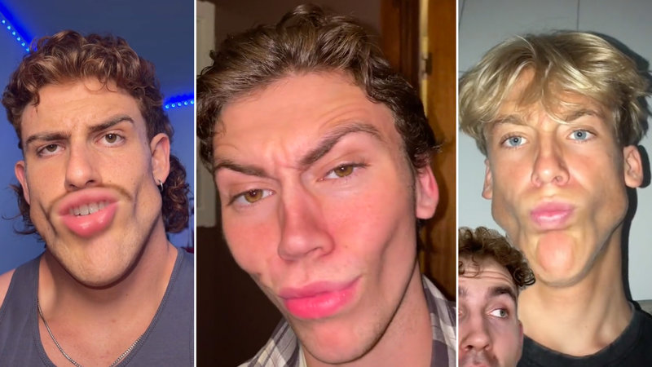

But this is just softmaxxing. On the other hand, hardmaxxing involves much more invasive practices, from official plastic surgery — which has sharply increased in recent years, and notably among men — to far more questionable DIY solutions, like bonesmashing: hammering your face to remodel those facial structures that are supposed to doom those who lost the ‘genetic lottery’. As the RedPill Theory claims, “Only the pretty face matters”. Looksmaxxing as a (pseudo)scientific theory discussed in forums mainly focuses on the visage, the factor with the most weight in determining one’s ‘L score’.
Thankfully, bonesmashing is mostly a meme. More serious, however, are the speculations about hormone therapies and the experimental use of drugs sourced on the black market to increase one's height, or for muscular development. It is not hard to imagine the harmful side effects that can arise from this kind of deregulated work on oneself. The bodybuilding YouTuber Sergeyevich Shavershian (known as ‘Zyzz’ in his community, ‘The Aesthetic Crew’) passed away on his DIY work of muscular enlargement, because of an undiagnosed heart condition.
On ‘looksmaxx.org’, discussions about “successful genetics” are heavily tainted by racism. Caucasian ethnicity is considered to be the “most valuable”, and users suggest that non-white people should embrace “whitemaxxing” through makeup and skin treatments. Asian males, widely considered the least attractive to Western heterosexual women within this community, are called ‘currycels’ after their ethnicity, and they represent a significant portion of the user base in incels forums, especially in the UK (the legal country of the largest online community, ‘incel.is’), where there is a major diasporic community.
RedPill’s racism is of course an alarming issue — considering its proximity to fascist and neo-Nazi ideologies swarming in the alt-right, with their eugenics fantasies. I also noticed that, besides neurodivergence and other mental disorders, physical disabilities are widely discussed on incel forums — and I am not referring to those who advance the incel condition as a disability itself. There is a lack of research in this regard, and this should be investigated further too.
Men with the least competitive genetic kernels are ‘mogged’ by Chads. 'To mog' means to be aesthetically dominating, more attractive, with respect to another person — the expression was predictably coined by pick-up artists some years ago. Everyone wants to be the mogger. Why not think of a service that can harness this desire? Some ‘mogging’ academy perhaps?
Mogwarts — a pun making an obvious reference to Harry Potter— is the “school of looksmaxxing & profound self-improvement,” as the website states. It was somewhat the phenomenon of 2024 summer in the manosphere, thanks to the visibility achieved by its founder Kareem Shami, after a glow-up before/after video of him went viral on TikTok. “Looks, Money, and Status matter” a lot concerning how we are perceived and treated, in every aspect of our lives: “It's a tragedy the society we're in, now from social media to dating apps our overall image is constantly evaluated,” the 20-year-old beauty influencer recites in the trailer.
So here is ‘Mogwarts Academy’, in order to achieve “the transformation” into “the best version of yourself” (remember PlayLover Academy?). You can subscribe for the super-discounted price of $20 a month to access exclusive content that will help you manage your skincare, your diet, your workout, and your approach to girls. Just click on the “Ascend Now” button — ‘to ascend’ is the expression incels use when they talk about the possibility of coming out of their involuntary celibate status. Yet in none of his videos or interviews, nor on the website, is the reference to the RedPill Theory and the inceldom ever made explicit. Shami has about half a million followers on Instagram by now, and his community has more than three thousand (paying) members.

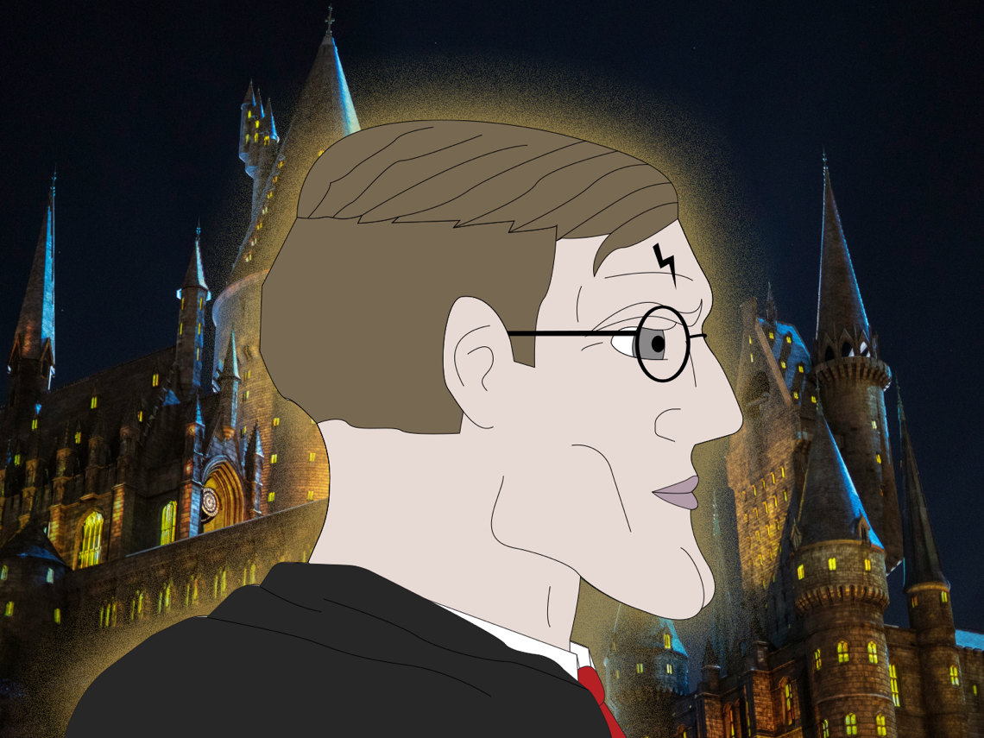

Studies on post-feminism have since long focused on the concept of “aesthetic labor”, the industrious and ceaseless work of looking beautiful on the outside and the inside, faced specifically by young girls as a gendered issue, since “patriarchy has been reterritorialized in the fashion-beauty complex”. But “today we are all living in the image factory”, and this subjectivation process is getting increasingly gender blinded. Indeed, it almost seems redundant to highlight the continuity between the cases observed by feminist critique and the trends currently involving these male subjects. The mere existence of the “male beauty influencer” figure is here to testify to it, although the two phenomena are yet to be comparable in extension.
The common thread is the aesthetic pressure disguised as self-care; the establishment of a heavily normative relationship with one’s body, an endless site of anxiety and labor involving forms of nano-surveillance. But the elephant in the room in this conversation — which plays out across digital media — is the visual dimension of this ‘body’ being worked on, more and more seen as portrayed in pictures. Photo-editing for emphasizing the results in ‘Before-After’ or ‘glow-up’ trends is an open secret. This kind of ‘care labor’, today, always involves taking care of a profile.
The new regime of visuality brought about by the social media revolution has mobilized a whole technology of impression, that we delegate to proxemic and photogenic proficiency, and to digital post-production where the physical body does not stretch out. Framing, lighting, gaze, posture. Attention to skin tone involves its quality as a reflector. We are not only responsible for the product but especially for the packaging, as the marketing revolution taught us. Contemporary beauty and aesthetic labour are strongly related to the digital reputation economy; with the simulacra of our own preceding us in the digital-social arena; with the ‘profile’, intended as the most efficient identity technology today. Incels are not properly mindful about it, but I read their visual paranoia as a reaction to this new kind of incitement.
On the other side of the coin from looksmaxxing, we find ‘bed rotting’. This has somehow been another popular trend on TikTok among Gen Zs, consisting of lying in bed and engaging in passive activities for a couple of days at most — before it becomes ‘unhealthy’. It oddly fits into the category of self-help and mindfulness content: it turns out people need to relieve social pressures and just vibe on their own sometimes. Our society tends to glorify being busy or productive all the time, and “this can lead to feeling burnt out and not allow us time to rest or recharge without labelling this as being lazy,” experts say. Is bed rotting the youth’s rebellion against neoliberal subjectivity and its imperative of performance? Maybe, for the better. Or maybe it’s just another way to glamorize depressive states while capitalizing on it: bed rotting befits the Sad Girl.
But if we follow the stream of bed rotting, we eventually arrive at the spring of the BlackPill forums. LDAR is the acronym blackpilled users have for ‘Lay Down And Rot’. “Lying down and rotting describes the mindset many incels adopt once they have attached themselves to the idea that there is no hope of them ascending. It goes beyond sexual in-opportunity, they do not believe they can improve their life in any capacity”. The picture worsens when we realize that many incels populating these forums are NEETcels.
NEET is another acronym for ‘Not in Employment, Education, or Training,’ which has replaced the term ‘status zero’. The NEET figure, which triangulates with that of the incel and the hikikomori, also sheds light on the socio-economic roots of this discomfort. In 2022, the Organisation for Economic Co-Development (OECD) reported that almost 22% of Italian males aged 15 to 29 are NEETs. Under the bombardment of hustler culture, these supposedly failed individuals are finding identity in failure itself. Bed rotting and seeking sympathy in online ‘brocels’ are all that is left. This nothingness can actually be interpreted as the blackpilled’s silent uprising, which is way less boisterous than what the Beta Uprising of incels used to be (see Elliot Rodger, Alek Minassian, and the other massacres), but no less alarming in the bigger picture.

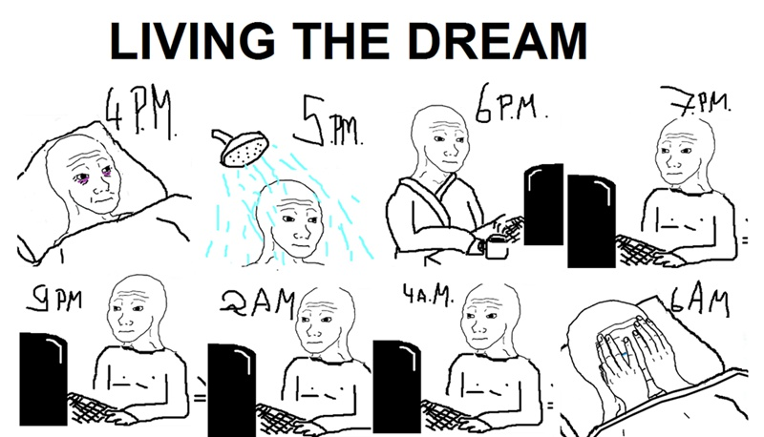

If Andrew Tate’s story illustrated the mainstreaming of an ideology, in the case of Mogwarts and these trends on TikTok we are also clearly dealing with the mainstreaming of a malaise — that seems to give a reason for this same ideology, without providing a justification for it. TikTok’s alleged triviality conceals the source code, it is invisible by design. Incel forums are fibers away from mainstream social media discourse, yet their toxicity is peeping out. Whether it takes the red hue of looksmaxxing or the black of bed rotting matters little. There is the pill jargon underneath: it becomes translucent when you shine light through the prism of the internet’s dark corners.
The RedPill seems then to have become the Trojan horse of neoliberal subjectivation; the adaptation of a ‘technology of the self’ capable of gripping masculine identity in its development, under the conditions that are shaping it in contemporary Western societies — after the sexual revolution and the visual one of social media, after the Great Recession and the re-proletarianization of the service class, and after the pandemic as well. The RedPill with its tendrils is now common sense for late-zoomers and Gen Alpha on TikTok. Functioning as a proper ideology, it manages to hold together the contradiction between hegemonic masculinity and the impulse towards its feminization; between the harsh and straight Tate and the obsessive care, the visual hypersensitivity of looksmaxxing.
The narrative structures of this therapeutic-entrepreneurial culture, that are exploiting today's media infrastructures to target young boys as new customers, are the recurring element of this story. Underneath lies an ideal of professional and sexual success framed in terms of absolute productivity. A subject’s capacity to be productive — and thus successful — depends on how diligently they 'take care' of themselves. This 'care' manifests in many forms: mastering a stoic unflappability in the face of the 'tyranny of passions,' learning how to get a girl into bed on the first date, adopting the mindset required for crypto-trading, or sculpting a jawline sharp enough to prevent girls from skipping you on Omegle. The 'self-improvement' etiquette is merely the sheep's clothing worn by the redpilled wolf.
Here then is the care of the self, where this 'Self' is little more than a business project in need of permanent aesthetic-emotional (and ‘profilic’) management, the object of relentless attention and work — so overwhelming that it must be delegated to private forms of counselling, such as gurus, subscriptions and apps of sorts. The cruel optimism of investing in yourself, improving yourself, and activating your maximum potential, is only the poor but obliged answer to fathomless conditions of social, economic, and epistemic discomfort in which so many isolated young males find themselves today.
As it is possible to witness, many elements of the Red Pill Theory — intended as a toxic-masculine and conservative ideology — have previously originated but now almost detached themselves from the condition of involuntary celibacy. The pharmakon has evolved, like a living entity, to become more appealing, viral, and visible. In the darkness, incels are excruciated from this performative imperative. It loops with their sense of failure. After all, their despair is too raw to be marketable and sold as a product; it has been swept under the rug. They are the loudest in the room screaming, yet the most overlooked account of the manosphere — our blinders being on one side the reduction of the incel as a ridiculed memetic stereotype, and counter-terroristic rhetoric on the other that could be missing the target as well.
The crisis is latent, but endemic.


Francesco Barchiesi is a full-time PhD student at the University of Birmingham, currently digging into the world of incel culture. Having spent most of his life in Bologna (Italy) navigating the clouds of Philosophy and Semiotics, his research is essentially an excuse to obsess over digital cultures of the self, the pitfalls of networked intimacy, and the messy transformations of modern love.

All the following quotes are free translations from the Italian PLA’s website: https://playloveracademy.it/.
The price list is eighteen months old; it might have been adjusted for inflation in the meantime.
KnowYourMeme. “White Boy Summer.” Updated May 21, 2024. https://knowyourmeme.com/memes/white-boy-summer
For a wider discussion about ‘happy faces’ and entrepreneurialism see Ehrenreich, Barbara. Smile or Die. 2010.
Information available at: https://mowmag.com/lifestyle/ho-partecipato-a-una-lezione-di-seduzione-di-playlover-academy-e-ora-non-voglio-piu-provarci-con-nessuna.
A well-known blackpill forum, which had origins in PUA criticism. See https://incels.wiki/w/Puahate_Sluthate_Lookism_(PSL).
The pioneer of seduction manuals is hypnotist Ross Jeffries, How to Get the Women You Desire into Bed (1992), combining neurolinguistic programming with hooking up.
For more on this, see Angela, McRobbie. The Aftermath of Feminism. 2009.
Men Are From Mars, Women Are From Venus (1992) by John Gray is a self-help manual that redefined the relational language during the Nineties, selling around 50 million copies all over the world.
Neill Strauss. The Game (2005).
Rachel O'Neill. Seduction (2016).
Susan Faludi, Stiffed (1999).
Rachel O'Neill. Seduction (2016) cfr. § Introduction.
Reading Houellebecq’s The Elementary Particles (1998) it is perhaps possible to better grasp this continuity.
For a historical insight of Men’s movement, from the Seventies to the present day, see C. Hodapp, Men’s right, gender and social media (2017). Regarding the Italian specificity, see S. Bellassai, L’invenzione della virilità (2011).
Sandro Bellassai. L’invenzione della virilità (2011). Free translation.
Illouz Eva. Saving the Modern Soul: Therapy, Emotions, and the Culture of Self-Help. Berkeley: University of California Press, 2008. In this book, Illouz exposes the affinity between the psy culture and the American Dream (which I believe to be still crucial in The RedPill discourse).
See Aperture, How Stoicism Became The World’s Greatest Scam (2024). https://youtu.be/h8REOHfdVZQ?si=sPRwvykiK-Ah1sU4.
Ibid.
YouTube. “How to Be Unstoppable: 5 Stoic Lessons for a Happier You.” YouTube Shorts. https://www.youtube.com/shorts/J4HR4NMuuDM
For a detailed and focused account of the intersection between stoicism and the Manosphere, see M. Maloney, C. Jones, and S. Roberts, “‘I Can Choose to Be a Good Man Even if I Got a Raw Deal’: Neoliberal Heteromasculinity as Manosphere Counter Narrative in r/Stoicism,” Social Media + Society 10, no. 3 (2024).
Jamie Tahsin and Matt Shea. “Andrew Tate: Chats in ‘War Room’ Suggest Dozens of Women Groomed.” BBC News, June 19, 2023. https://www.bbc.com/news/world-europe-66604827.
Shanti Das. “Inside Andrew Tate’s Violent, Misogynistic World of TikTok Fame.” The Guardian, August 6, 2022. https://www.theguardian.com/technology/2022/aug/06/andrew-tate-violent-misogynistic-world-of-tiktok-new-star
Maya Oppenheim. “Andrew Tate’s Influence on Young Men in the UK Is Shocking, Poll Finds.” The Independent, February 16, 2023. https://www.independent.co.uk/news/uk/home-news/andrew-tate-influence-young-men-misogyny-b2283595.html
Vlad Budei-Tebeica. “Neoliberalism and the Red Pill: How Andrew Tate Used Populist Discourse to Spread Online Misogyny” Civil Szemle 20 (2023), p.9.
Shanti Das. “Inside Andrew Tate’s Violent, Misogynistic World of TikTok Fame.” The Guardian, August 6, 2022. https://www.theguardian.com/technology/2022/aug/06/andrew-tate-violent-misogynistic-world-of-tiktok-new-star.
These quotes are taken as an example from one of the countless channels that re-share Tate's motivational videos. 'Personal Growth Pills' and ‘Imprenditor Tips' are two Italian cases in point.
YouTube. “The Matrix Has Attacked Me! | Andrew Tate Is Detained and Has House Raided in Romania.” Posted March 30 of December 2022. https://www.youtube.com/watch?v=fU0e0xOlxso
The pillars of the RedPill Theory — the ideological glue of the manosphere — are precisely Looks, Money and Status: the parameters according to which women would be Darwinistically hardwired to choose their male partners. Now women are free, so they only go for the Alpha males. In the evaluation forms offered on incel forums, Looks is measured in decimals; Money and Status influence Look. Under the score of ‘7’ they say “it’s over”.
This is how users in incel forums often refer to each other.
Il Forum dei Brutti. “Che opinione avete di Andrew Tate?.” Username: normie_timidone (11/12/2023). Free translation. https://ilforumdeibrutti.is/threads/che-opinione-avete-di-andrew-tate.513/.
Vlad Budei-Tebeica. “Neoliberalism and the Red Pill: How Andrew Tate Used Populist Discourse to Spread Online Misogyny” Civil Szemle 20 (2023), p.9.
From the “Milan Discourse” (1972), J. Lacan.
I am referring to Tiqqun, Preliminary Materials for a Theory of the Jeune Fille (1999).
Kidology, LOOKISM… and how LOOKSMAXXING is destroying everyone (2023). https://www.youtube.com/watch?v=DKnfVHgaTf0&t=631s.
Farrell Riley. “Inside Looksmaxxing, the Extreme Cosmetic Social Media Trend.” BBC Culture, March 26, 2024. https://www.bbc.com/culture/article/20240326-inside-looksmaxxing-the-extreme-cosmetic-social-media-trend
See this app: https://www.mewing.app/blog/hunter-eyes-vs-prey-eyes.
See the report from the British Association of Aesthetic Plastic Surgeons (BAAPS). https://baaps.org.uk/about/news/1872/cosmetic_surgery_boom/
Simon Usborne. “From Bone Smashing to Chin Extensions: How ‘Looksmaxxing’ Is Reshaping Young Men’s Faces.” The Guardian, February 15, 2024. https://www.theguardian.com/lifeandstyle/2024/feb/15/from-bone-smashing-to-chin-extensions-how-looksmaxxing-is-reshaping-young-mens-faces.
Farrell Riley. “Inside Looksmaxxing, the Extreme Cosmetic Social Media Trend.” BBC Culture, March 26, 2024. https://www.bbc.com/culture/article/20240326-inside-looksmaxxing-the-extreme-cosmetic-social-media-trend
To deepen the South-Asian case of incel, see Kaur, Gurpreet. Incel Extremism in India: A View from the Global South (2022). https://gnet-research.org/2022/08/23/incel-extremism-in-india-a-view-from-the-global-south/.
See Moskalenko, S., González, J. F.-G., Kates, N., & Morton, J. (2022). Incel Ideology, Radicalization and Mental Health: A Survey Study. The Journal of Intelligence, Conflict, and Warfare, 4(3), 1–29.
Kieran Press-Reynolds. “Meet the Young Men Paying to Attend Mogwarts, an Online School for Becoming Hot.” GQ, July 11, 2024. https://www.gq.com/story/mogwarts-looksmaxing.
https://www.mogwarts.net/#section-3.
Incel Wiki. “Deincelization.” Last modified February 1, 2024. https://incels.wiki/w/Deincelization
Ana Sofia Elias, Rosalind Gill, and Christina Scharff, Aesthetic Labour: Rethinking Beauty Politics in Neoliberalism. London: Palgrave Macmillan, 2017.
Angela McRobbie, (2009) in Elias, Gill & Scharff (2017): p.39.
Ibid.
Hans-Georg Moeller & Paul J D’Ambrosio, You and Your Profile. Profilicity after Authenticity. 2022.
Alyssa Hui-Anderson. "What Is 'Bed Rotting'? Gen Z's Newest Self-Care Trend, Explained.” 2024. https://www.health.com/what-is-bed-rotting-trend-7561395.
Jade Poolen. “Revisiting Sad Girl Sentiments.” 2024. https://networkcultures.org/longform/2024/01/16/revisiting-sad-girl-sentiments/. and Sara Marzullo. Sad Girl. La ragazza come teoria (2023).
Kate Babin. “Condemned to Rot Alone: The Incel Paradox of Collective Loneliness.” 2023. https://networkcultures.org/longform/2023/09/05/condemned-to-rot-alone-the-incel-paradox-of-collective-loneliness/.
This statistic is alarming about Italian economy, for example compared to the 4% of The Netherlands. It is double the OECD average figure. https://www.oecd.org/en/data/indicators/youth-not-in-employment-education-or-training-neet.html?oecdcontrol-dec63071aa-var6=15_19_WOMEN&oecdcontrol-00b22b2429-var3=2022.
The “incel” figure has tragically become popular because of several mass murders claimed by scattered members of this broad online community, occurred between 2014 and 2021. https://incels.wiki/w/Beta_uprising.
Francesco Gerardi, “Incel, palestrati e troll: chi sono gli idoli dei giovani maschi su internet.” 2024. https://www.rivistastudio.com/giovani-maschi-social-incel/.
The notion of ideology is understood here as the discourse that narcotizes and silences its own partiality. See Umberto Eco. Trattato di Semiotica Generale. 1975. p.340.
YouTube. “I FOUND MY GIRLFRIEND ON OMEGLE !.” YouTube video, 0:00. Uploaded by torynoah, March 8, 2024. https://www.youtube.com/watch?v=Q0TvHMxopFE
Of course I am bothering Foucault’s History of Sexuality here. See The Care of the Self (1984).
Lauren Berlant. Cruel Optimism. 2011.
The TV show Adolescence (2025) showcases this dynamic: the term 'incel' appears only once, as an instance of bullying against the protagonist — almost as if it were the motive for the murder he is going to commit.
In August 2021, 22-year-old Jake Davidson killed five people (including his mother and a 3-year-old girl) in Plymouth. He had a YouTube channel where he discussed his commitment to bodybuilding and the Black Pill. Following the incident, the UK’s Commission for Countering Extremism (CCE) commissioned the Swansea University Research on the Incel Community (SURIC) to produce a report. The result highlighted was that ‘Incels need mental health support rather than a counter-terrorism intervention’ https://www.gov.uk/government/publications/predicting-harm-among-incels-involuntary-celibates/press-release-incels-need-mental-health-support-rather-than-a-counter-terrorism-intervention-the-worlds-largest-study-of-incels-finds-accessible#fn:1.

