Condemned to Rot Alone: The Incel Paradox of Collective Loneliness

Kate Babin

Originally published on September 5th, 2023

“Whether we learn how to love ourselves and others will depend on the presence of a loving environment. Self-love cannot flourish in isolation.”
Bell Hooks

In 2022 I spent the better part of five months of my life lurking on an incel forum. Truthfully, I don’t remember how I ended up here. One moment I’m researching the commodification of authenticity on Instagram for a BA paper and the next thing I know I’m neck deep in incel vernacular, acronyms like KHHV (Kissless, hugless, handholdless virgin) swirling in my head. I now find myself writing a piece that requires a trigger warning for mentions of suicidal ideation, extreme misogyny, racism and self-harm. After stumbling upon Men Who Hate Women and being nosy enough to search out one of the forums Laura Bates frequented in order to write the book, I was curious to find out how a space that claims to be a community for lonely men to connect with one another ends up further alienating members, not just from the outside world, but even from each other. How can over 20K men who join an 'involuntary celibate' forum that announces on its home page: “Are you lonely and wish you had someone in your life? You're not alone!” simultaneously experience debilitating loneliness? They are attempting to bond over a specific sense of mutual longing, yet it is clear that their attempts at connection over a shared loneliness plunges the members of this incel forum deeper into isolation, attaching their identity to a sense of failure they can’t escape from.
They are alone and always will be.
But how can they be lonely together?
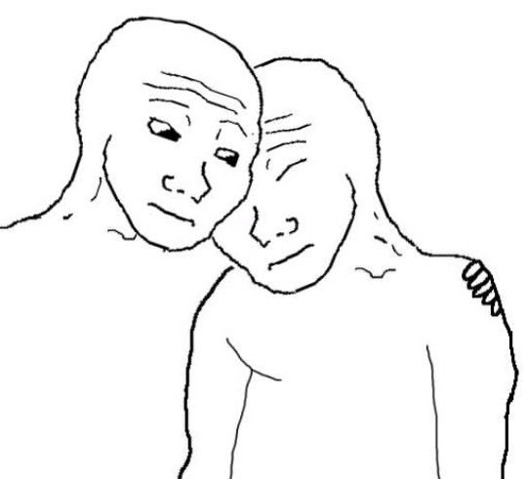
It's not a new or radical statement to say that many online spaces populated by incels are volatile. With extreme misogyny on full display, infused with hostility towards those both within and outside of the community. Or that those who self identify as incels have much higher rates of loneliness and mental health struggles than other men. Suicide and self-harm are very popular topics within incel spaces and there have even been studies done on the countless suicide posts that can be found memorialized by the reddit user u/incelgraveyard. What is it about this particular community (and the forum itself) that makes it impossible for its members to connect with one another in a meaningful way? In a way that would help them feel less alone. I decided to explore this paradox of collective loneliness by looking at a popular incel forum, how the affordances of the site and intricacies of the ideology influence members’ behavior toward each other.
In a VICE News video titled “This Is What The Life Of An Incel Looks Like”, a reporter spends a day with a young guy named Joey, who identifies as an incel. We see him laughingly interacting with fellow incels online. He video chats with his friends while they are yelling gross and aggressive things for shock factor. Shouting things like “I’m going to firebomb multiple government buildings” followed by one fellow incel actually purposefully shitting his pants on camera. This perfectly animates what reading posts on the forum out loud sounds and feels like. Chaotic, disgusting and a bit scary. They look like they’re having fun, but we are left with this closing statement by the reporter: “In this subculture people bond over self-loathing. Joey says it’s therapeutic, but four of his friends have killed themselves”. One former incel that shared the experience he had on these forums, during an anonymous podcast interview, equated the community to a black hole. He said that joining the subculture is a downward spiral that sucks you in, perpetuating ideologies born from trauma, depression and abuse. Men whose loneliness pushes them to seek solace online are robbed of the comfort that collectivity is meant to provide.
In a group of over 20K users who presumably share each other's desperate need to connect with others, what is it about the space that plunges its members deeper into isolation? An isolation that has been linked to multiple mass murderers and suicides within the community. What aspects of the forum perpetuate the negative affect that ultimately leads members of the community to act out in these ways?
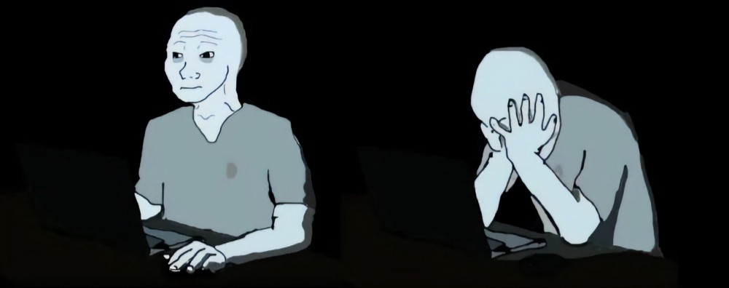

The Incel
Before answering these questions, let me first set the stage.
The incel community does not exist in a vacuum. It is part of a larger online network of men-centered groups aptly named ‘the manosphere’ that consists of varying degrees of anti-feminist collectives. The belief system that pervades many of these groups is the idea of being ‘redpilled’, a term that originated from the 1999 film The Matrix. In the film, the main character Neo needs to choose between taking the redpill and seeing the world’s true nature or choosing oblivion by taking the bluepill, which is to live in ignorance of reality. In the case of prominent manosphere ideologies, the redpilled reality asserts that the world is a gynocentric sexual marketplace wherein women have the upper hand. The belief is that men’s romantic and sexual success with women is determined by their social status or ‘sexual market value’ (SMV). This means that low-status men, those without wealth or who are not deemed conventionally attractive, are unable to form romantic or sexual relationships with women. Bluepilled men are ignorant, delusional normies that are continuously manipulated by promiscuous women for their money and resources.
In 2016 journalist Stephen Marche spent time on the now quarantined subreddit r/TheRedPill (TRP) and summed up the essence of the manosphere in a surprisingly poetic way for his article Swallowing the Red Pill: a journey to the heart of modern misogyny:
"In the hours upon hours I spent wandering this online neighborhood, I saw mostly feral boys wandering the digital ruins of exploded masculinity, howling their misery, concocting vast nonsense about women, and craving the tiniest crumb of self-confidence and fellow-feeling"

Here Marche was describing a community within the manosphere that focuses on sexual strategy. However, it is a very fitting description of what I witnessed during my time on the incel forum. Unlike many manosphere communities such as TRP that discuss dating and sex like it is a game they have every intention of winning, incels are (as the name implies) much more focused on their perceived permanent sexual lacking. The word incel is a portmanteau of ‘involuntary’ and ‘celibate.’ The origins of the term date back to 1997 on a website and listserv called Alana’s Involuntary Celibacy Project, a space created by a queer feminist in her 20s that aimed to confront the shame around virginity and provide a supportive space for single people to speak to each other about their struggles with finding a romantic partner. The focus of these groups was really on loneliness and support, whereas modern digital spaces that label themselves as ‘for involuntary celibates’ have warped the label into an identity which is exclusive to cis-hetero men that engage with pill jargon, projecting their blame onto what they consider ‘the feminist delusion’. In short, the beliefs perpetuated on the forum push the anti-feminist narrative that women empowerment and the subsequent financial independence that many women have gained has ruined the romantic prospects for men who do not fit a very specific idea of physical attractiveness and masculinity.
The Blackpill
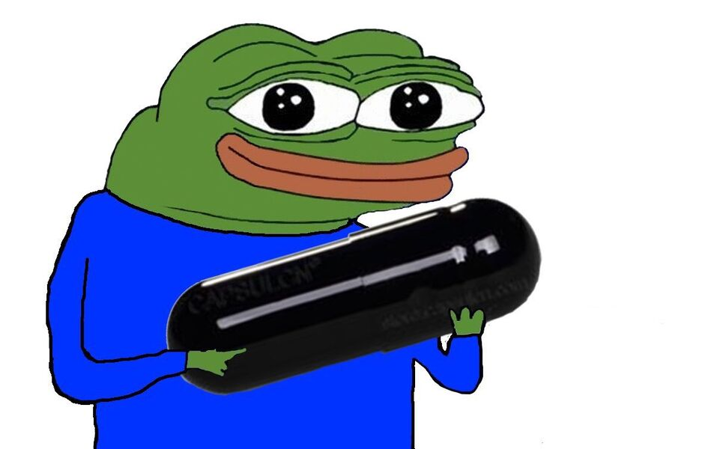
In a world of normies who are either redpilled or bluepilled, the incel (within the aforementioned forum) is blackpilled. Being blackpilled requires internalizing the belief that men who do not fit into societal definitions of attractiveness or masculinity are systematically marginalized, othered by society and completely without hope of having sexual or romantic partners. Although redpilled men believe that feminist society is inherently lookist; they engage in looksmaxxing forums that focus on fitness, plastic surgery as well as improving their financial situations in order to improve their sexual prospects. Unlike other manosphere groups like Pick Up Artists and Men Going Their Own Way, those who have subscribed to the blackpill ideology do not believe that there is a solution to their problems. No matter what they do, incels will always be genetically inferior to alpha men or chads and for this reason they are doomed to be alone forever, together. Blackpillers, according to the Incel Wiki Blackpill page, believe that “ugly, 'genetically inferior' men have no chance of getting laid in an unconstrained mating context, as women are assumed to choose based on looks rather than personality or effort.” Basically, young men embracing the blackpill leads to a biological determinist influenced nihilism that is rampant on the forum.
The Wiki
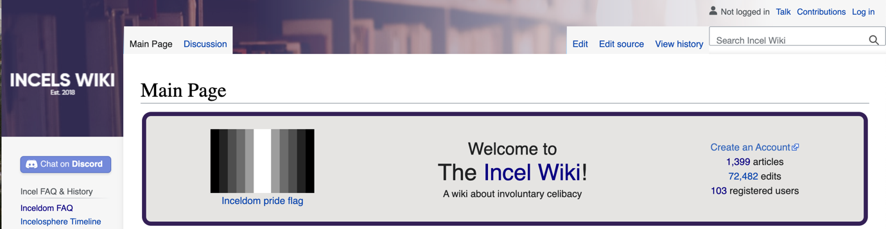
To understand more about the various acronyms and the history of inceldom I perused the Incel Wiki, which is a rich source of incel related definitions, theories and lore that was created independently from any one specific incel community. Among 1,399 other pages, there are in-depth explanations of the blackpill along with the ‘science’ they use to back up this belief system, pages addressing balding, speculating Hitler’s inceldom and even an incelosphere timeline dating back to the 1700s. While I find it pretty interesting to read about these things from their own (albeit often hateful) perspective, I did have the misfortune of stumbling across an article claiming women’s argumentation style is emotion-based, manipulative blackmail titled Arguing with holes. As well as the one about ‘Femoids’ or ‘foids’ that refers to women as toilets and includes charming memes like the one below. Despite this, it has been incredibly helpful for understanding incel related slang and history, as well as providing memes and interesting visuals related to inceldom.
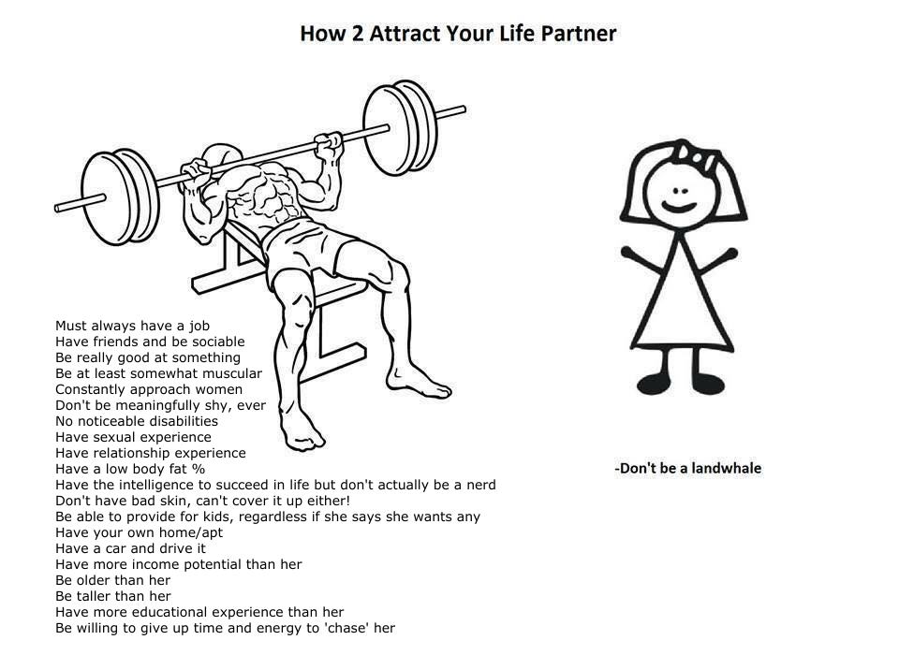
Image from Incels.wiki - Femoid
Lonely Together
In November 2017, the community based network Reddit implemented a new policy that prohibited incitement of violence on the platform. The 40K member subreddit /r/incels was banned and users moved to more heavily moderated subreddits or created their own forums. In the case of the incel forum I have been lurking on, it was created as a result of this ban by modmins SergeantIncel and Master. It is considered the third iteration of the /r9k/ board on 4chan, the anonymous image-based bulletin board known for the ephemerality and absurdity of its content. This is where some believe the essence of /r/incels or men "howling their misery" within "the digital ruins of exploded masculinity" originated from. /r9k/ was and still is used for sharing original personal anecdotes that are often bleak and involuntary celibate adjacent.
This website that was created in response to Reddit's mass banning of violent subreddits is reminiscent of early internet forums. The default style is Dark Mode and the color scheme is dark blue with white text. There are three main subforums, Must-Read Content, Inceldom Discussion and for off-topic content: The Lounge. As of September 1st Inceldom Discussion has 5.6 million posts and The Lounge has 2.6 million. Users can post their own threads within the subforums or reply to the threads which are ranked by number of responses. There is a Rules and FAQ page where the admins have outlined who can and cannot join the forum, what sort of behaviour will not be tolerated and what kind of content is allowed to be posted. Some fun cherry picked examples are:
Women and LGBT Individuals (Not allowed): Banned on sight, no exceptions. This is a heterosexual male-only forum.
Do not humble-brag, such as by subtly praising your own features ("I'm incel even though I'm muscular and 6'2").
Do not discuss or request personal romantic or sexual experiences, even if they happened long ago. Discussion of paid sex is allowed as an exception, as the community has voted to allow it.
Do not troll, bait, proselytize, post platitudes, mass tag users, or necropost (i.e., do not post in inactive threads older than ~1 month unless you have something to contribute - plain agreement, mere quoting, and meaningless one-liners don't qualify as contributing).
Another rule worth noting:
Do not persecute, harass, or attack others.

This rule is clearly not followed or enforced by moderators. One of the first things that stood out to me about the way members interact with each other; how much they seemed to hate each other. For a forum that defines itself as Not just a forum, but a community, there largely lacked any sense of camaraderie, or as Marche put it, fellow-feeling. Incels are just plain mean to each other. Not only did I see these interactions play out on the forum but I also saw a lot of posts made by incels themselves complaining about this open hostility towards their own ‘brocels’.
Incels are no strangers to self-loathing, this is clear just by considering an initial description of the community and the concept of involuntary celibacy itself. However, it was interesting to see the way this translated into an outward hatred towards those they consider similar, if not the same, as them. For incels self loathing doesn’t just morph into an extreme hatred of women and a sense of utter hopelessness. This hatred is also projected heavily onto other incels within their community; creating such a hostile digital environment that engaging with these forums can be considered a form of digital self-harm.
During my time as a lurker on the forum, I identified four main factors that prevent supportive connection between members on the forum, perpetuating their low self esteem and deep feelings of isolation: Othering the in-group, clogging up the forum, asserting masculinity through shitposting and fatalism.
Othering the In Group

A.K.A. “everyone is fakecel except me theory”
Incels are no exception to the in-group/out-group dynamic and linguistic work that subcultures within the deep vernacular web are known for (shout out Marc Tuters and Daniel de Zeeuw). Elina Vaahensalo developed the theory of Othering Online Discourse (OOD) that helped me to understand how this collective identity is established and where in this case community building goes wrong. OOD relates to how incel identity and community is built through “shared experience of otherness and opposing the cultural master-narrative.” Identity formation within incel communities is complicated because in a way they establish themselves as the out group and ‘other’ by positioning themselves as oppressed and marginalized by society. Identity and self-image are often created through the concept of juxtaposing oneself against the ‘other’ and constructing the self through sameness within the community. At the same time the ‘other’ is constructed through conceptions of difference.
Incels, however, have constructed their identity around the ‘other’ possessing similarities that incels lack. A common hypocritical theme within the community is the idea that all women think and act a certain way, while individual incels are vastly different from one another, emphasizing how they are misunderstood by society. Their entire identity revolves around being an outcast, a loser, an outsider and their vernacular reflects that. The ‘us’ versus ‘them’ mentality manifests in destructive ways. While they ‘other’ themselves they manage to fracture their collectivity with very strict definitions of who can be considered a truecel those who are meant to be a part of the in-group and find community instead become excluded with increasing hostility.
Some fakecels (seriously check out the Incel Wiki Glossary for definitions if you’re lost, there is only so much I can do) are considered fake because they are either knowingly or unknowingly volcels. The truest of truecels have much bleaker prospects than the average (in)voluntary celibate. Members of the forum believe that volcels or fakecels are participating in the community inauthentically. Volcels are men who are considered celibate of their own volition, sometimes due to their standards being too high for sexual or romantic partners, claiming a true incel would ‘get with’ any woman if only they could. Other reasons may be that they believe a volcel could ‘ascend’ if they relocated to a larger city or worked on their physical appearance.
Truecels are those who have no hope of ascension. There is no amount of exercise, plastic surgery or money that will ever make them attractive to women, this is often attributed to facial structure, height or a disability. This belief that the other self-defined incels in the community are not actually experiencing the same degree of social rejection and loneliness as those who consider themselves truecels perpetuates negative affectivity around the interactions members have with each other on the forum.
While the forum states its purpose as being to “talk to people just like you”, many incels are convinced that their fellow forum members are nothing like them and instead are there due to their own self-inflicted failures or lack of self-awareness.
Failed Normies
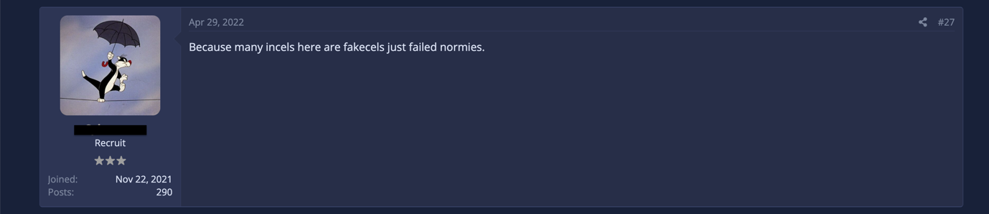
The legitimacy of one’s inceldom is impossible to prove in this pseudonymous environment. The cognitive affordances of the forum have a much looser definition of what constitutes an incel. Describing an incel under the Membership section of the FAQ as “A man (18+) who desires a romantic relationship but is unable to enter one.”
Though this becomes rather subjective when actually signing up to the forum, the registration page requires the aspiring member to explain their situation, asking “Why do you want to join? Are you incel? Tell us about yourself. If you are lazy here you will be rejected.” What is considered truly incel is then in the hands of the admins that are approving members. However, the authority of this decision is not a guarantee that the new member will be accepted by the other members as an actual true incel once a member of the forum.
OK GrAYcel
The forum allows users to pick their own username, tagline and avatar. Few rules exist for avatars and usernames, the main one being that usernames should be masculine sounding, specifically they must “create the kind of username that when you yourself look at it or other’s view it, that it gives off the vibe that a masculine heterosexual male created the name, otherwise your new account will be rejected effectively banning you from the website.”
Beyond being associated with a username, an avatar and a tagline, forum members have ranks which are determined by the number of times they have posted on the site. According to the Rules and FAQ page the ranking and starring of members functions as stated:

The concept of a graycel derives from this ranking system. If a member has any number of posts below 500, their username and stars are displayed as gray and their title below their username is listed as Recruit.
According to the Incel Wiki page on greycels, they face a lot of stigma on the forum for being ‘noobs’ and potential fakecels. This was incredibly clear during my time lurking on the site. GrAYcel was a very popular insult and there are posts by members that point out how unsupportive that environment can be for new members or members who choose not to post excessively. One of the comments I came across during my time on the forum addressed the way members respond to newer or naive members by belittling them, writing:
“Calling naive members GrAYcels/cucks instead of correcting them, so that some of us had finally something to feel good about (number of shitposts and time spent on a forum for people who cannot succeed in life, not the greatest honor really).”
Many members responded to this statement by calling the original poster a ‘soycuck’, a ‘GrAYcel’ or the classic non-answer: ‘Sounds GAY’. Another user responded stating that almost none of the newer members were actual incels and that figures into the animosity towards them: “Do you realize how many infiltrators we get here? 90% of greycels turn out to be infiltrators, bluepillers, (homophobic slur, transphobic slur or all together).” There is a common belief that “GrAYcels are more likely to he [sic] larpers + criticism is a good way to build character, unless you're a (homophobic slur) that can't handle insults GrAYcel.” The ranking system on the site sets these relationships up for failure. Members ranked as Recruits are not taken seriously and often mocked or disregarded which continuously fractures any possible connections they could be making. Graycels are often assumed to be LARPers25 or fakecels, there to destroy the forum. I noticed that the members providing the most constructive and least fatalistic social support were graycels who have since been banned. This contributes to how the site cannot function as the support forum it claims to be and why members seeking company on these forums continue to deal with debilitating loneliness despite each other’s company. There is no room for compassion beyond distrust.
"Yeah, something's definitely not right with practically ALL incel spaces."
Despite the cognitive affordance that demands that registered members be single cisgendered, straight men who are having trouble finding a partner, it is apparent that many members believe that the majority of their fellow incels are frauds. This has the opposite effect of traditional discursive gatekeeping that typically utilizes identity speech to foster a sense of community and sameness. The fakecel rhetoric, instead of fostering a strong collective identity, cultivates hostility and distrust between members. It further complicates the ‘us’ versus ‘them’ dynamic that often shapes and empowers online subcultures. There is no clear ‘in-group’ that members can latch onto which causes unstable identities as well as low quality relationships within the forum.
Sex Havers and LARPers
One concern of those within the community are LARPers. LARP or Live Action Roleplay often refers to acting out role playing games with real costumes, props and physical action. In the incelosphere LARPers are registered members of an incel forum that are actually ‘sex havers’ impersonating incels. Members of the forum are similarly concerned with false flagging and astroturfing, which is when fakecels join the forum and create posts intended to make the community look bad. Incel Wiki claims that:
“Users of r/IncelTears and other incelphobic terrorist groups have a tendency to take part in astroturfing by posting false flags [in] communities in the incelosphere to make incels look bad.”
LARPing comes up a lot during members’ discussions about the community, some specifically blaming LARPers for destroying the forum. One member argued that due to the freedom to express controversial ideas that the forum affords, it attracts non-incels who as a bid for attention try to be “funny or dark” by saying inflammatory things that do not add anything constructive to the thread. He claims these LARPers aim to destroy threads that otherwise would be good topics of debate or conversation between members. This forum member then attempted to appeal to the LARPers in his post, stating: “You should look elsewhere, here you only get in the way of people who want to find solutions to a problem that is destroying them physically and mentally every day.” The majority of replies on that specific thread were agreeing with this sentiment.
Incels who are seeking to quell their social loneliness by co-ruminating with peers are instead bombarded with ridicule and irrelevant inflammatory statements riddled with slurs. Members believe that those that behave this way on the forum are “just bored edgy normies.” Alone Together author Sherry Turkle writes about how digital loneliness points to this issue when addressing being vulnerable with strangers online. She states that these digital environments do not "connect us with people who want to know us; rather, it exposes us to those who […] may use our troubles to relieve them from looking at their own.” This sentiment is shared by forum members, one claiming that many of the active members of the forum are fakecels with ulterior motives. He wrote: “I bet a lot of the guys are here to feed on our suffering like parasites.” The idea that these types of forums are populated by users with bad intentions is something Laura Bates addresses in Men Who Hate Women:
“You really feel the contradictions of the community: vulnerable, unhappy men mingling closely with men determined to wreak as much destruction as possible. You watch as people in urgent need of mental health support, who have somehow found themselves sucked into this whirlpool of misogyny, are met with vitriol, ridicule and incitement to self-harm by other men getting their kicks from online hate.”
The fact that many members believe there are LARPers in their midst may account for the general hostility forum members exhibit towards each other on the majority of threads. This inability to trust one another feeds into the already hostile environment regardless of if those who are posting are LARPing or not. The forum is rife with distrust and paranoia which impedes collectivity and community formation in a serious way.
Clogging Up the Forum
A.K.A. “they just make the sewers more miserable”
The ranking system the forum has in place is a clear example of the negative affect affordances have on user relationships. The ranking system encourages users to over utilize the posting feature in order to move up in rank. Instead of engaging with other incels as themselves with a sense of camaraderie and compassion, members instead have a more gamified approach to their pseudonymous identities. Although the Rules and FAQ page attempts to account for this by not allowing “low effort posting” in the main subforums (The Lounge subforum is a free for all), this rule is rarely upheld. Low effort posting is defined by the forum as:
"Content that is unrelated to a thread, posted for memetic value, or spam-like in nature. Examples: an emote reply, quoting someone and adding nothing else, one-word replies, and many other variations. The content might as well not have been posted."
This rule as well as the behavioral rule of “Do not persecute, harass, or attack others” are rarely followed and infrequently enforced by moderators, which points to an issue with the governance of the platform. The forum is committed to freedom of speech within the law, which may account for the lenient moderation for these types of posts. The majority of the comments I came across could be considered low effort posting according to the forum’s own stated definition. On her podcast Incel, while interviewing the forum’s founder and past co-administrator Sergeant Incel - Diego Joaquín Galante conducted under his pseudonym “Alexander Ash” (doxxed by the NYT in 2021 for running a pro-suicide forum), Naama Kates described this behavior as ‘statusmaxxing’ and Galante called it ‘postmaxxing’. Members who want to move up in rank post excessively on the forum in order to increase their post count. Low effort posts, emojis (often morbid variations of pepe the frog), one-word replies (often slurs) make up a large portion of replies on all threads. On several threads I came across forum members argue about the negative affect that postmaxxers create on the forum. One user claimed that “this forum is one big popularity contest just like society is.” This shows how the forum may not function as the refuge from the outside world that it claims to be. On the same thread members attributed the forum’s problems to fakecels, graycels and larpers, one comment placed the blame on postmaxxers. It read: “I will never understad [sic] why they feel good for having a high post count. They just make the sewers more miserable.”
In the same 2019 Incel podcast interview, Galante claimed that although the site is heavily moderated to prevent it, there are inevitably going to be posts that flood the site and as he puts in, clog up the forum. He attributes this to users seeking instant gratification, users trying to get the most validation with the least amount of effort. He claimed that sites such as Reddit encourage this behaviour and it is a part of wider internet culture, this type of controversial as well as short and non-complex posting is not unique to incel forums. Galante points to the fact that the shortest posts such as one-line shitposts and picture memes get the most upvotes and therefore visibility on Reddit. For this reason, the ‘like’ feature is disabled on the forum in order to promote long, good quality posts that attract equally high-effort replies, fostering conversation. Which is not what is being accomplished. It’s clear that the no low effort posting rule is only enforced on the posts themselves and not the replies within the thread. What differentiates this incel forum from Reddit is that the posts that get moved to the top of the page are those with the most replies. This is another affordance of the site that encourages excessively posting low effort replies or creating posts with controversial topics that will attract a lot of vitriol. Admins disabling the ‘like’ feature in order to discourage low effort posting was not successful.
The user ranking system by number of posts, lack of moderation within threads and the fact that posts with the most replies are the most visible on the site enables the postmaxxing that disrupts any real conversations. The potential social support provided by this forum that may help incels with their loneliness is impeded by members who use the commenting feature as a tool in order to move up in rank as well as obtain validation and attention. This behavior within the threads overpowers much of the potential social support and as a result perpetuates the negative affect between members.

Shitposting
A.K.A. “(racial slur) who told you that this hellhole of a website is a self help group?”
Another way the commenting feature is used by members in destructive ways is through shitposting. While postmaxxing and shitposting can have similar negative affectivity on the forum, the intentions behind each type of post are very different. The 4chan FAQ page describes shitposting as being ill-intentioned, off-topic or low quality. They are often irony infused inflammatory comments that function to derail discourse. While the off-topic posts can be attributed to postmaxxing, there are many posts and replies that would fall under that come across as ill-intentioned and as Adrienne Massanari defines shitposting, low effort and pandering. These are the genre of posts that are an integral part of the online culture wars. Shitposters aim to be reactionary, often using extremely offensive language or ideas in order to elicit a response, all under the guise of humor and irony. One member expressed his disappointment in the forum’s lack of sociality due to this use of irony stating:
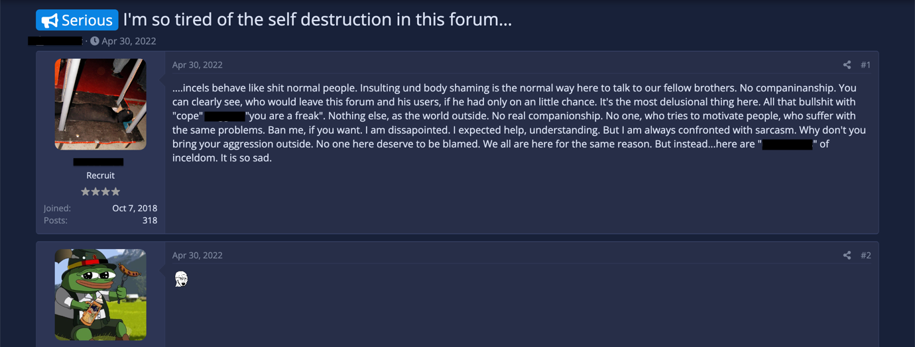
This post was immediately followed by a comment proving the original poster's point. A simple angry wojak which is an emote titled by the forum as 'Soy'.
During my time on the forum I saw how rampant inflammatory posts and replies are within threads. As the user above expressed, many cries for help and understanding are met with insulting sarcastic replies. Researchers Sarah Daly and Shon M Reed interviewed ten incels for a study that examined the themes of their lived experiences and identities. They connected their excessive use of racism, misogyny and violence within their conversations to an attempt to assert their masculinity online. Members of the forum are aware that the content they post is visible to non-members. The most shocking content on the site is often screenshotted by non-members and shared on other sites such as Reddit (r/IncelTear) in order to expose the hateful ideology and use humour as a form of critique, often being extremely hateful themselves. As a response, members post threatening messages on their own forum or intensify the violence and ‘ironic' offensiveness of their posts in order to get screenshotted again. This contention distracts from forming connection with each other on the site, many members express that posts about and directed at r/IncelTear specifically were ruining the forum. Another aspect of othering online discourse is the disruptive nature of discourses that are used to “troll the imagined audience of the conversation” which in this case is outside the community. The shitposting that is done in order to establish this masculinity tends to manifest as attention seeking behavior and extremely shocking rhetoric around marginalized communities such as women and POC. Researcher Debbie Ging wrote that male beta affective publics claim victimhood while pushing for male hegemony through racist and misogynistic discourse. She wrote about how the affordances of these forums encourage shitposting and therefore amplifies “new articulations of aggrieved manhood.” This aggrieved manhood is an aspect of the community that is not conducive to emotional support, compassion and connection.
Forum admin Galante actually participated in the interviews conducted by Daly and Reed under his Alexander Ash pseudonym. His perspective shines a light on the value of forum governance and the considerable impact of the decisions he made when making the platform. One of those decisions being the way threads appear on the site. While in the Incel podcast interview Galante described the placement of threads based on replies as creating more thoughtful conversation than the ‘upvoting’ affordance on Reddit, in the 2021 interview with Daly and Reed this perspective had drastically shifted. He stated that “We score threads on number of replies. Those with the most replies go to the top. Again, you have a few people that are the most extreme...while the rational ones go into oblivion.” Although he acknowledges that this type of scoring of threads has led to the most vitriolic posts getting the highest visibility and therefore engagement on the forum, this affordance has not been modified since the forum’s creation in 2017, pointing to the fact that rational discourse and community building might not be the true intention of those running the site.
Real Men Shitpost
A.K.A. “Leave that kumbaya shit for someone that care”
Because incels feels marginalized and infantilized offline, their behavior on the forum is extreme in a way that Daly and Reed suggests is an attempt to prove “their manhood within the incel collective.” Incels make it a point to amplify a deep hatred for women in order to reclaim their masculinity which they feel women have stolen from them by not desiring them. This hostility, created through this extreme performance of masculinity leaves little room for emotional connection or support within the community. While lurking I observed many instances of negative emotionality or toxic masculinity towards other members which adds significantly to the negative affect. Many members displaying vulnerability and expressing loneliness were met with homophobic slurs or dismissive replies. One member expressed that this behavior impacted their ability to socialize with others, commenting “I joined this forum this forum [sic] to socialize with other social outcasts, and I was immediately met with toxicity.” While Daly and Reed suggest that a dominant masculinity within the forum creates a shared social support, I disagree. This intense attachment to toxic masculinity inhibits social support and fractures collectivity within the community by default. Bates connected this issue to the wider manosphere when she wrote:
“while pretending what threatens these boys is women or immigrants or non-white men, the real threat comes from the very forms of rigid ‘manhood’ their so-called saviours are desperate to preserve and promote.”
To address this lack of community one member suggested improving the relationships between incels in order to address Maslow’s hierarchy of needs.
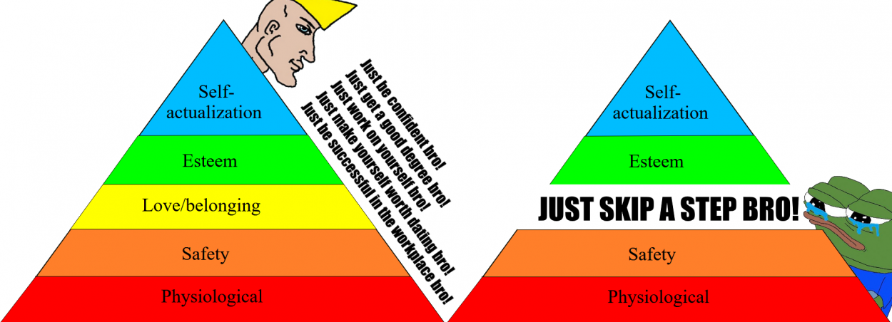
Incels.wiki user Bibipi
He wrote “That might be taken care of in some way by strengthening bonds between incels, since we cannot connect with the rest of society due to them being fucking dicks to people they think are uglier. Some incel exclusive podcasts, online video gaming sessions or other projects are possible considering the distance between many of us.” This, along with some other collective improving suggestions were met with multiple insults meant to be emasculating, such as “Sounds GAY”, “soyfuck” and “Leave that kumbaya shit for someone that care [sic].”
Many members are not engaging with emotions outside of anger despite the fact that managing loneliness requires emotional connection. Online social support is often lacking in the necessary compassion and care that would lead to meeting the needs of those seeking love and belonging. This coupled with the fact that the incel ideology pushes members away from accessing emotions that do not fit into traditional notions of masculinity leads to a lack of intimacy and therefore fractured collectivity between members. The construction and perpetuation of masculinities within incel spaces is intrinsic to negative affect which makes it difficult to find solace within the community. Making it the perfect counter-intuitive space for lonely people to gather.
Fatalism
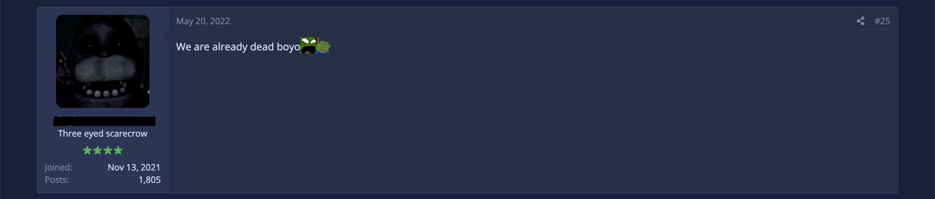
A.K.A. “We are already dead boyo”
The forum defines itself through blackpill fatalism.
Hopelessness seeps into every thread, often through shitposts and sometimes even through very genuine and thoughtful posts and replies. While a lot of the negative affect on the forum and between members can be attributed to postmaxxing and shitposting, there are members who are far less inflammatory or disingenuous in their approach while still fracturing any potential community building on the forum. One member’s response to a post exemplifies this perfectly: “Expecting help to solve a problem that cannot be solved, as inceldom, is far beyond delusional.”
Because of how hopeless this outlook is, it is likely that blackpilled members have already fully accepted their loneliness and many are not using the community to remedy it. This means that the other half of the members who have not reached that level of desolation are met with despondency instead of encouragement when seeking help on the forum. Blackpilled incels are convinced that their shared life circumstance is permanent, there is nothing left to do except cope with it. Any positivity from members, whether it be reassurance, a compliment or encouragement is met with hostility or dismissed by labeling it a ‘cope’ or ‘copium.’
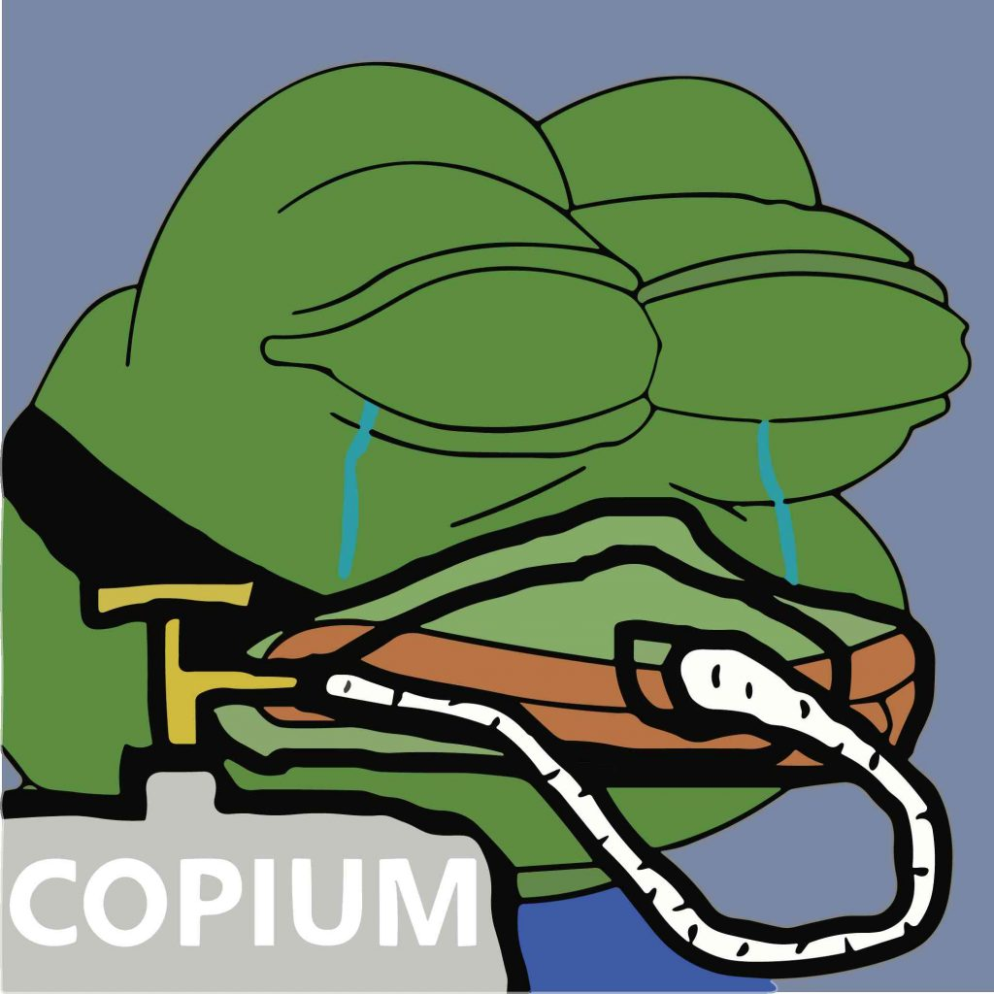
Incels have a special attachment to the concept of coping mechanisms, this is illustrated through their use of the word ‘cope’ within their shared vernacular. On the Incel Wiki they explain that the term cope is often used to insinuate someone is delusional or out of touch with reality. When a member has a more optimistic outlook on their situation other incels digitally shout cope at them, declaring that their perspective is just a denial of facts. The blackpill ideology coupled with the notion of positivity being a coping mechanism results in any advice or potential positive affect between members being regularly and easily invalidated with the use of a one-word, low effort reply: cope. Another way this word is utilized on the forum is to refer to individual incels’ various hobbies, interests or even addictions. Labeling everything a coping mechanism negates any possible positive affect sharing common interests or problems could have on collectivity.
Researcher Grace Sharkey labeled this fatalistic behavior as an “aggressive performance of collective failure” which from what I observed was clearly manifesting through blackpill discourse. One subgroup of the incel subculture that illustrates this attachment to failure are NEETs. NEET stands for Not in Education, Employment or Training. Not all incels are NEET or vice versa, however, members claim that a lack of romantic prospects could be the cause of ‘NEETdom’ or be caused by their NEETdom. Many who identify as NEET have attached themselves to this identity and are resigned to this lifestyle despite it causing further social isolation. A popular term within incel/NEET vernacular that pairs nicely with the fatalism of the blackpill is LDAR, which is an acronym for Lay Down And Rot.
Laying down and rotting describes the mindset many incels adopt once they have attached themselves to the idea that there is no hope of them ascending. It goes beyond sexual in-opportunity, they do not believe they can improve their life in any capacity. The forum perpetuates this sense of defeat. One member posted on the forum self-requesting a ban due to feeling like the forum was holding him back from his desire to grow in real life. He claimed to need a break from incels and the NEETcels and rotters specifically. This shows how the fatalistic mindset negatively influences other members who have yet to fully give up on themselves. Many incels project their hopelessness onto their peers which makes any kind of attempted camaraderie especially toxic.
Incels display an overidentification with failure that feeds into the already harsh environment on the forum and contributes to the feedback loop of social isolation and negative affect. As a post within the r/Braincels thread that was analyzed as part of the study A Short Story of a Lonely Guy put it, “it’s really a breeding ground for defeat.” While the negative affect drag members further into their despair they reject positivity and simultaneously personal responsibility. To these incels their failure is inevitable, inceldom is inescapable and above all else it is not their fault (it is of course, the fault of all womankind). Their collective failure sustains and validates their identities as incels which justifies their attachment to it. In his book The Queer Art of Failure Jack Halberstam explains how failure can be so enticing. He wrote:
“What kinds of reward can failure offer us? Perhaps most obviously, failure allows us to escape the punishing norms that discipline behavior and manage human development with the goal of delivering us from unruly childhoods to orderly and predictable adulthoods. Failure preserves some of the wondrous anarchy of childhood and disturbs the supposedly clean boundaries between adults and children, winners and losers.”
Ironically, the incel blackpill ideology seeks to escape the societal norms around masculinity by pushing further into their failure to fit into them. Sharkey connects failure to the incel’s perceived exclusion from manhood due to its inextricable link with sexual maturity. Someone who is involuntarily celibate would feel excluded from this concept of “orderly and predictable adulthoods” and instead feel as if trapped in boyhood. The hostile behaviour of the incel to outsiders and each other could be viewed as the actions of immature boys who feel as though they do not have a future and are performing their attachment to failure. Incels have utilized the negative affect of failure in a violent manner that harms themselves and each other over and over again. This feedback loop of maladjustment and isolation is the result of a cruelly optimistic attachment to companionship. The way incels position themselves against “the good life” along with attaching to their inability to obtain it fixes their identity and impedes any hope of ascension. While the collectivity of their attachment to failure has become appealing to incels in their search for companionship, the resulting negative affects fracture the collective.
Many members approach the forum with the understanding that it is meant to provide connection, solidarity and support evidenced by the many posts by users disappointed that this wasn’t the case. However, others who have fully committed to the biological determinism of the scientific blackpill only see the forum as a source of informational support. One incel criticized how self destructive the forum is due to there being “No one, who tries to motivate people, who suffer with the same problems.” The responses to this post provided insight into the lack of cohesion between members and how it relates to blackpill ideology. Many of the more vocal members of the forum do not believe that the community is meant to function as a space to offer and receive support. One user replied: “sounds like you're blackpill bitter and taking it out on us forumcels. We're mostly here to discuss things, delusional if you thought that somehow we can help. the blackpill is ultimate, there's no moral support for your face/height/etc”
Due to the biological determinism of blackpill theory many incels feel that not only is their life hopeless and meaningless, so are the lives of their fellow ‘brocels’. This interferes with their ability to connect with one another since they are consistently perpetuating negative affect during their co-ruminations on the forum. The OP of the thread summarized the outcome of this behavior perfectly, posting “No need for foids, normies, Simps or cucks to destroy us...we do their job very well.”
While posts seeking support on the forum do receive a variety of replies, some even providing advice or emotional support, many members perpetuate the type of hopelessness that encourages suicidal ideation both implicitly and explicitly. I witnessed one member who was desperately seeking advice on killing himself, titling the post you are my only friends with the tag It’s Over. Many members did offer help, empathized with him, recommended therapy and even offered for him to direct message them for support. One reply indicated that there is support to be had on the forum despite the shitposters, he wrote “Don't end it yet. Keep breathing even though it seems pointless man, you have your forum friends for support. At least the ones who aren't trolls.” Conversely, other members mocked him, responded with one or two word replies like “Over” and “Ok” and gave advice encouraging suicide like the following, “Save money to move out, or save money for a gun to rope.” Comments on other threads echoed this positive attachment yet extreme negative affect around incels and death, one user posting “why live when you can die” and another posting “I wish we were never born.”
Fatalism is one of the three subcultural values Simon Cottee extracted from his analysis of the community. He wrote that:
“The whole incel subculture can be understood as a veritable counsel of despair that facilitates the self-damnation of those who participate in it. However, and paradoxically, this damnation is experienced as an existential state of true (“blackpilled”) consciousness and authentic existence. By rejecting both the goal of sexual intimacy and the means of male self-improvement, incels transform their shame and inferiority into a form of resistance against the “normie” status quo.”
This ties into the notion that the behavior created by their attachment to failure is an act of rebellion as well as self-preservation which is being weaponized against members of their own community.
Forum members are very aware that the environment is not conducive to sociality and companionship, this is apparent through the concerns about behavior that are expressed within threads on the forum. This perspective, the incel perspective, is very important when considering the actual benefits lonely men gain when engaging with the community online. Many acknowledge the overt racism and disturbingly violent misogyny present on the forums as problematic, however some claim that the majority of men using the forums are solely there to vent about their anger and sadness with men who can relate. As former admin Galante expressed along with many members who have participated in interviews, incels join the forum believing that the main focus is relatability and comfort, not the encouragement of violence or self-harm. However, while actually visiting the forum it is clear to me that any companionship they seek is drowned out by extreme rhetoric, shitposting and fatalism. Many of these men have experienced trauma and abuse and struggle with mental health issues or developmental disabilities that make it harder for them to connect with others. The defeatist nature of the blackpill ideology ensures that those who joined the community with any sense of hope will soon not be able to imagine themselves as anything other than “condemned to rot alone and be excluded from any meaningful connection or meaning.”
They end up believing that their lives are pointless, and they have nothing to live for. One member's take on the community sums up the toxic aspects of the space quite sharply: “The entire purpose of it is to piss you off, isolate you, then send you down a rabbit hole that leads to your suicide.”
If we know there are incels who are genuinely seeking emotional support and connection on these forums then the question becomes: why are they unable to find solace within their own community? The danger incel ideology poses to the outside world has been the dominating narrative around the identity. There is no denying this threat, self-identifying incels have been linked to multiple devastating acts of mass murder or attempted assaults since the 2014 Isla Vista Killings. Criminologists and experts on extremism have delved deep into the ideology to assess this threat while incels themselves claim that the perpetrators of these events were not even active members of the community. Those that are active within incel community spaces seem to pose more of a danger to themselves and each other, breaking down any hope they still held for finding companionship leading young vulnerable men to the conclusion that they are subhuman and their lives are not worth living.
The role the forum plays in this breakdown of hope for these men is significant. It is an environment that encourages members to flood conversations with low effort, vitriolic garbage posting in order for them to move up in rank and for their participation to be considered valid by fellow incels. The most inflammatory posts have the most visibility and members are not even convinced that those they are interacting with are not infiltrators. It is not a place for vulnerable and lonely young men to find community, it is where their hearts go to rot.
Incels are set up to fail every step of the way. A subculture already embedded with hate gather together on a platform that cultivates it. It further isolates them, makes them hate not only themselves but also each other. Personally, I found this pattern extremely sad to witness. While a lot of the hateful things said on the forum made me incredibly uncomfortable and at times scared, it was hard to overlook the fact that those posts didn't feel authentic. Instead, the genuine moments on the forum were the ones where bitterly lonely men desperately reached out for connection and were met time and time again with indifference and outright verbal abuse.
Some men who are sucked into these spaces have actually found their way out with help from online communities. Subreddits like r/exredpill and r/IncelExit have provided a space for men to come together, question those ideologies and talk about their problems in an environment that disallows suicide encouragement, misogyny, trolling and bullying while actually enforcing those rules. Those who are in the deepest trouble, however, don't want to water down their pain or hate in order to find support.
But how does this pain and hate breed to begin with? What do these men lack that they are getting from these spaces, since it is so clearly not companionship and connection? Through this exploration I discovered the way governance of the platform impedes support between members and the ideology itself alienates them from each other, but I also saw how non-members antagonize the community and exacerbate the vitriol. Subreddits like r/exredpill and r/IncelExit are the compassionate middle ground between scorning the incel and accepting their hateful rhetoric. But these men will not find the community they so desperately crave on a pseudonymous subreddit.
While the ideology of inceldom is veiled in the idea that men need to find value and fulfillment in the sexual market place, the real problems stem from isolation, scorn and lack of mental health resources. All problems that are harder to fix than simply banning a subreddit or forum. We need to look beyond the vitriol, see the lonely individual wailing for someone to care and find a way to help them hold on to their last shred of hope.
Kate A. Babin (she/her) is a Postgraduate Researcher within the Centre for Postdigital Cultures at Coventry University. Her research adopts a methodological approach of critical empathy, using feminist affect theory to examine the technological and affective formations of communities online. Her ongoing PhD project examines the affective constructions of race, neurodiversity and the body within a 'blackpilled' misogynistic incel forum. She has collaborated with the Institute of Network Cultures as a research intern, copy editor and proofreader since 2023.

Bell Hooks, All About Love: New Visions, (Avon A, 2016).
Involuntary Celibate.
Laura Batea, Men Who Hate Women, (Simon & Schuster Ltd, 2021).
It is important to note that there are men who identify as involuntarily celibate who do not engage with the kind of extreme rhetoric they have become known for in popular media. There are men who may refer to themselves as involuntary celibate but consider it a (temporary) state of being and not an identity. Being incel versus being AN incel. When writing about ‘an incel forum’ I am referring to the most active forum with the highest concentration of self-identified incels, it is an extreme example of the community and an accurate illustration of how easily identity and ideology can be radicalized.
A normie is someone like you or me, someone (I hope) that is grounded in reality. Also referred to NPCs.
Stephen Marche, “Swallowing the Red Pill: a journey to the heart of modern misogyny”, The Guardian, April 14, 2016, https://www.theguardian.com/technology/2016/apr/14/the-red-pill-reddit-modern-misogyny-manosphere-men.
Some are red, and some are blue. Some are old and some are new. Some are sad, and some are glad, And some are very, very bad.
Supposedly this is determined by women.
Your worth is determined by your level of attractiveness.
PUA's believe the solution is manipulating women and MGTOW believe it is separating themselves entirely from women.
The stereotypically 'high status' man. Tall, wealthy, incredibly fit with magnificent cheek bones.
As opposed to the famously male logic-based mode of communication.
Female humanoids.
Moderator/Admins.
The originality here is key to how the board became a popular space for incels to share their stories. The /r9k/ board was originally an experiment done by artist Randall Munroe to encourage original and unpredictable content, creating a community focused subculture on a site that is best known for its repetitive memes and noisy chaos. A bot was created to filter out reposts and non-original content. Although this never explicitly became an incel forum, the content that was produced as the community formed was often original stories of social isolation and awkwardness leading to a lot of incel related discussions.
Pinned by the mods.
Elina Vaahensalo, “Creating the Other in Online Interaction: Othering Online Discourse Theory Open Access” in The Emerald International Handbook of Technology-Facilitated Violence and Abuse, (Emerald Publishing Limited, 2021).
A true incel. Someone who has never had any sort of sexual or romantic experience and never will.
Fake incels.
Voluntarily celibate.
Have sex. No longer be celibate.
Locationcel.
Looksmaxxing.
Previously there was a rule which prohibited images of ‘foids’ in avatars but this has since been revoked in January of this year since many members like using anime girls as their avi.
An extremely hostile relationship exists between members of incels.is and members of the subreddit r/IncelTear. r/IncelTear has 95.3k members and is dedicated to “posting screenshots of hateful, misogynist, racist, violent, and often bizarre content created by hateful “incels" (involuntary celibates).” The majority of the content posted in the subreddit are screenshots of forum posts and subsequent mocking.
Sherry Turkle, Alone together: Why we expect more from technology and less from each other, (Basic Books/Hachette Book Group, 2011).
Adrienne L. Massanari, Participatory Culture, Community, and Play: Learning from Reddit, (Peter Lang Inc., 2015).
Soyboy is a term used to indicate a lack of masculinity.
Sarah Daly & Shon M Reed, ““I Think Most of Society Hates Us”: A Qualitative Thematic Analysis of Interviews with Incels”, Sex Roles 86, 14–33 (October 2021). https://doi.org/10.1007/s11199-021-01250-5.
Debbie Ging, “Alphas, Betas, and Incels: Theorizing the Masculinities of the Manosphere”, Men and Masculinities, Volume 22 Issue 4, (May 2017), https://doi.org/10.1177/1097184X17706401.
Daly & Reed, ““I Think Most of Society Hates Us”: A Qualitative Thematic Analysis of Interviews with Incels”.
Grace Sharkey, “Failure to thrive: incels, boys and feminism”, Journal of Media & Cultural Studies Volume 36, 2022 - Issue 1, August 6, 2021, https://doi.org/10.1080/10304312.2021.1958160.
A now defunct (banned in 2019) subreddit, considered the most popular incel subreddit after r/incels was banned.
December Maxwell et al., ““A Short Story of a Lonely Guy”: A Qualitative Thematic Analysis of Involuntary Celibacy Using Reddit”, Sexuality & Culture, Volume 24, 1852–1874, March 25, 2020, https://doi.org.10.1007/s12119-020-09724-6.
Jack Halberstam, The Queer Art of Failure, (Duke University Press, 2011).
Simon Cottee, “Incel (E)motives: Resentment, Shame and Revenge”, Studies in Conflict & Terrorism Volume 44, Issue 2, June 18, 2020, https://doi.org/10.1080/1057610X.2020.1822589.

