I, too, was Mouchette at 13 years old

Anielek Niemyjski

Originally Published July 18th, 2025
I'm 13 and my best friend from primary school asks me if I have an account on Tumblr. I do, but I'm not sure if I want her to know. She broke the unspoken rule—you never share your blog with IRL friends, it's taboo to talk about it. I hesitantly agree, and we exchange blogs. I take a look at her page. In her bio, there's a quote from Forrest Gump: 'Life was like a box of chocolates, you never know what you're gonna get.' Her reblogs consist of summer destinations, clean girls in bikinis, LA highways lined with palms, New York architecture, and Brandy Melville models. I scroll lower and lower and am becoming engulfed in shame. What is she gonna think of me when she sees my blog? Is she gonna think I'm crazy or unstable? I need to check my recently reblogged posts to determine how bad it is. I open my blog page. The difference between our visual aesthetics and personalities is imminent. I go through black and white analogue photos with depressing captions, graphic self-harm content, gifs from AHS Asylum, posts glorifying eating disorders, grunge fashion, soft animals lying on the grass, and nihilistic quotes from coming-of-age movies. I frantically scroll through my own blog as if seeing it for the first time, suddenly aware of how performative my pain looks when viewed through someone else's eyes.

In the next couple of years, I will forget all about Tumblr, and I will slowly stop reblogging. I will migrate to different platforms with my peers, but fortunately never delete my account. My blog will patiently wait for me to return, but… so will the same feelings of shame and cringe, preserved with embarrassing clarity, waiting to reveal itself as an archive of my becoming.
The decision to slowly stop using Tumblr would, unexpectedly, come as a direct result of a certain motion. In 2018, the last year of Verizon’s and Yahoo!’s ownership of the platform, NSFW visual content was to be completely banned from the platform. After losing about 30% of the user traffic on the platform in response to a stricter content policy, the American media giant got rid of the site and sold it to Automattic for less than 0.3% of the purchase price. For a little while, it seemed like the platform had come full circle: being bought back by a company that is responsible for the blog service WordPress.com, seemed to promise the return to the simpler times: easily made, accessible blogs!! reunited communities!! unchanged, not-algorithm dictated dashboard!! chronological feed!! ….but, wait…not so fast….. slow down.. In February 2024, Automattic announced it would start selling its users’ data to OpenAI and Midjourney…… So much for the simpler times….
At 22 years old, I discovered mouchette.org while researching net art works for my thesis. The site, created by French artist Martine Neddam in 1996, mimics a teenage girl's diary with deliberate naivety and whimsy: pink text, buzzing flies, stuffed animals, and a navigation menu that mimics early GeoCities pages. Yet, the content quickly subverts this childish innocence, with hyperlinks leading to the deepest curiosities of a seemingly pre-adolescent mind. From asking site visitors to physically connect through the cold surface of the screen, and asking strangers on the internet how to commit suicide, to suicide notes, and a forum where visitors share their struggles, jokes, experiences, and offers of help.
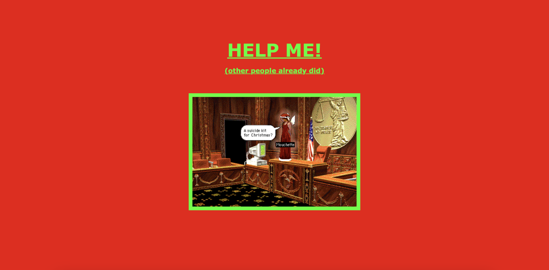
While exploring the domain of mouchette.org, I noticed myself getting lost in the same familiar feelings that, up until now, were intrinsic to scrolling through my Tumblr dashboard. The dark thoughts and desires displayed by the character of an almost 13-year-old being out in the open brought me back to the same feelings I had at 13.
What struck me was how precisely Neddam had anticipated the aesthetic and behavioral patterns that would later define Tumblr’s confessional culture. The site’s juxtaposition of girlish visuals with existential dread mirrored my own Tumblr experience. Whereas, of course, the difference was Mouchette’s website being a carefully constructed artwork, and our Tumblr blogs were most often unconscious, messy autofictions.
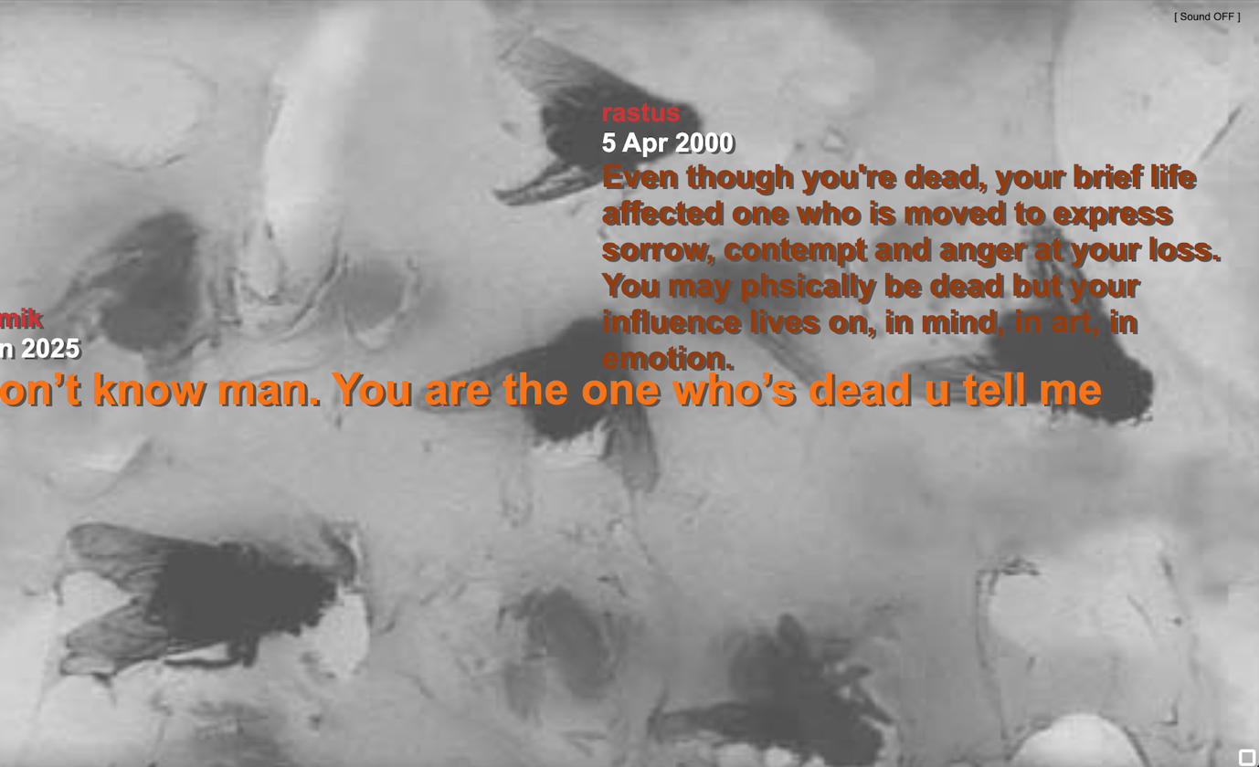
Lauren Berlant’s concept of intimate publics helps explain Tumblr’s ecosystem of shared vulnerability. In The Female Complaint, Berlant argues that:
an intimate public is an achievement. Whether linked to women or other nondominant people, it flourishes as a porous, affective scene of identification among strangers that promises a certain experience of belonging and provides a complex of consolation, confirmation, discipline, and discussion about how to live as an x.
Tumblr operationalized this: the platform’s reblog function turned intimate, personal suffering into viral, communal texts. Every disturbing post wasn’t only a cry for help, but a template others could adapt. Notes under graphic self-harm posts functioned as a perverse metric of care, where visibility equaled validation. You learned to package your despair in aesthetically pleasing ways, to juxtapose frat party gifs with confessions about your eating disorder, to make your suffering palatable enough to be consumed by strangers. We weren’t expressing sadness; in reality, we were competing in what could only be called the Trauma Olympics, where visibility passed for validation, and the most graphic posts received the most notes.
This tension between real pain and performed pain is where Mouchette becomes most illuminating. In an interview with Annet Dekker, Neddam describes the suicide forum of mouchette’s website as "a social space where people could communicate and help other people". It’s striking how precisely this project anticipated the ecosystems of care we’d later build and use on Tumblr. Mouchette’s greatest insight wasn’t that people would perform care online, but that they’d do so more earnestly for a fictional character than platforms would ever let them do for each other. We built real support systems in Tumblr’s margins, but instead of making our troubles solvable, the platform turned them scrollable.
I feel like it is crucial when talking about Tumblr to include the Sad Girl Theory, since its roots are deeply interlinked with the platform. In 2014, artist and writer Audrey Wollen proposed a theory that female sadness should be looked at as an act of resistance against the hypermasculine system of domination, rather than a performative, self-involved, passive action. In retrospect, I have trouble agreeing with Wollen’s theory. As opposed to stigmatized notions of sharing your private business, especially on topics surrounding mental health, all the trauma posting I encountered in my years on Tumblr in some way felt liberating. This liberation and, as called by Wollen, resistance swiftly turned into another online aesthetic, which itself was tailored to capitalise on white, skinny, western middle-class girls and their pain, leaving no space for anyone who didn’t fit into those very confined categories.
Maybe what Wollen’s Sad Girl Theory misses is that our Tumblr years weren’t just about resistance or aesthetics—they were the messy work of digital adolescence. This was the evolution of drawing eyes and roses in middle school notebooks, translated for the platform age. Where we once filled margins with angsty song lyrics, we would reblog My Chemical Romance lyrics over grainy photos. The physical diary became an infinitely scrollable dashboard, but the impulse remained the same: to externalize the unbearable weight of teenage angst.
To conclude my reflection on my Tumblr archive, maybe what emerges isn’t just shame or nostalgia, but something more useful. A critical lens on how platforms mediate emotional development in the platform era. These archives matter not because they’re embarrassing or profound, but because they document what it means to come of age in systems that turn identity formation into engagement data.
I want to end this essay with a #hopecore message I found while perusing the suicide forum of mouchette.org. I am leaving you with a message from Loraen O. D. from the 10th of May 2010.
Live to love deary if nothing else. Pleasing to all and as addictive as a smile, love is all you need. All other emotion crumbles before it; they are neutralized in its wake. Love heals all wounds as they say. You suffer merely from the lack of this emotion. A simple prescription of love once a day will remedy this childish desire for an end of yours. Open up to your anyone, hang out with that someone, share a smile with a stranger. Love is not a commodity in short supply, rather it is in low demand. It comes to those who look for it. My dear, find love and you will never forget it. Likewise it will never forget you. Find it in any form with anyone and when you have found it, cherish it. Go on; start now! Don't wait. Get on the phone and talk to Julia, or got to Alex's house. Head over to the local park and smile at people, talk about the weather or the world. Walk to your father, tell him you love him. Run to your mother, give her a hug. Theres no time to lose, only time to gain assuming the state you're in. To start you off and to end my note I'd like to say: Good luck, have fun, and I Love You!
Anielek Niemyjski is an independent researcher based in Amsterdam. They are an Artistic Research graduate of the Academy of Fine Arts in Warsaw. Drawing on digital nostalgia and online archives, their research practice explores collective memory, identity, and resistance in networked cultures, with a focus on early web practices and alternative forms of online presence.

Berlant Lauren. The Female Complaint: The Unfinished Business of Sentimentality in American Culture. Duke University Press, 2008.
Lucy Watson. “How Girls Are Finding Empowerment through Being Sad Online.” Dazed, November 23, 2015. https://www.dazeddigital.com/photography/article/28463/1/girls-are-finding-empowerment-through-internet-sadness
Stigma imposed by previous generations, that inculcated the same conception in our (millenial, gen-z) generation.

