(W)orld Currency

Paolo Cirio

(W)orld Currency is an artwork that illustrates a global currency through the creative formulation of an equation and a trading algorithm for the currency exchange market. The visionary creation of algorithmic trading combines art with the material that governs contemporary society and in doing so, it aims to introduce new art practices.   
  
The artwork seeks to inspire social transformation through envisioning a positive and innovative economic tool. It addresses the inherent instability of various currencies, as well as the need for a new independent global reserve currency that could potentially empower and unite the world population. As a sustainable financial instrument, the World Currency Equation will act as a cushion that will protect people against the increased volatility of individual currencies due to speculative manipulations and economic swings, while preserving market access across different geo-political and social domains.   
  
The proposed algebraic equation provides valuation and liquidity for a new currency (W) based upon the average of an index of individual currencies. The formula combines and secures dominant national currencies with new digital and local complementary currencies, preserving autonomy and diversification within universal acceptance.   
  
The artwork is illustrated through the artistic expression of a mathematical equation and a diagram of an algorithm. These two elements indicate how the value of the currency is calculated and how its liquidity is created and maintained.   
  
How it works  
World Currency is a global reserve currency backed by popular currencies. It's based on a value-weighted index, in which each currency in a basket influences the index in proportion to its exchange rate and spread for every combination of pairs of currencies traded. The overall average of the rate exchanges determines (W). In the system, the value of (W) is kept steady by the daily trading of each currency in the basket in an interconnected network of deposits. For every node of the network each currency is stored only for the average amount of the whole network. The gains and losses are also leveled equally in every deposit. The equal distribution of multiple reserve currencies always maintains (W) with liquidity and stable value.   
  
The equation and the algorithm make use of Forex market conventions and can only include currencies that are tradable electronically.   
  
The Equation  
The following equation illustrates how (W) is calculated upon an aggregate of exchange rate values of a basket of leading currencies within the gains and losses that the fluctuations among them generate over time. The mathematical average of the values of currencies (A) in the basket keeps the value of (W) steady. The gains compensate the losses in the total average (G).   
  
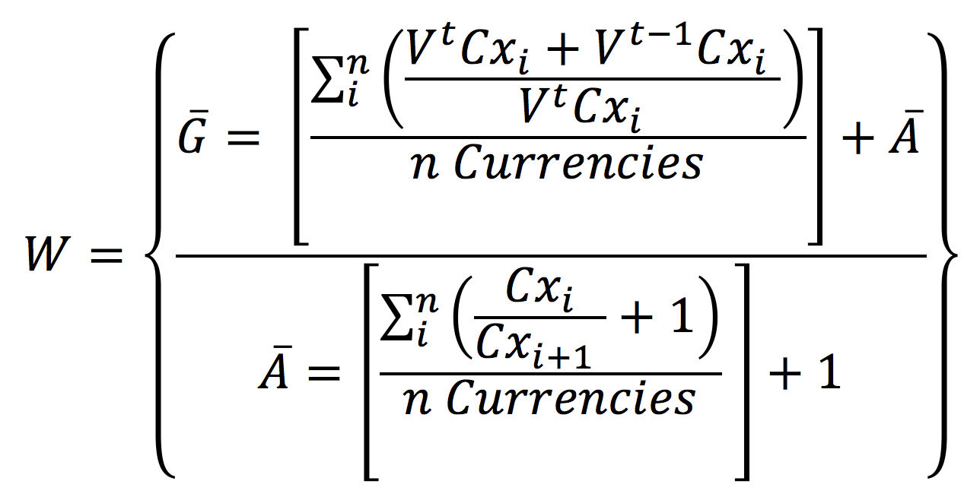  
The Algorithm  
The following diagram illustrates how an algorithm can automatically aggregate (W) by wiring currencies over the multiple reserve deposits based on the recursive calculation of the (W) equation.   
  
**Glossary**  
W: Value of World Currency. Symbol (W).  
**¤**: Any currency symbol in the basket.  
A: Average of exchange rates between each pair of currencies in the basket.  
G: Average of spreads between each pair of currencies in the basket over time.  
N: Number of currencies in the basket.  
Cx: Current exchange rate of the currency of the index.   
V: Current value of the currency of the index.  
T: At past and future time period.

**Credits**

Images and picture courtesy by the artist Paolo Cirio

**Commission**

Artistic Bokeh and Quartier21, Museum Quarter, Vienna - Austria

**Selected shows**London Design Festival, exhibition at Victoria and Albert Museum, 2014, London - UKSynthetisch Vernünftig, exhibition at LEAP, 2014, Berlin - Germany In Search of Symmetry, exhibition at HDLU, 2014, Zagreb, Croatia