

PUBLISHINGLAB

MANUAL

September 2015

COLOPHON

# 

ABOUT 4

WHO WE ARE 5

APPLIED RESEARCH 5

AMSTERDAM CREATIVE INDUSTRIES NETWORK 5

CREATE-IT 5

WHO OUR STUDENTS ARE 5

WHO OUR PARTNERS ARE 6

WHAT WE DO 6

PROGRAMME 8

DESIGN PROCESS 9

RESEARCH, TRANSLATE AND CREATE 9

SCRUM 9

SPRINTS 10

RITUALS 10

INTERESTING READS /  
RESOURCES 13

PREPARATION 14

HYBRID PUBLISHING WORKFLOW 14

UX PRINCIPLES 15

CODE 15

STUDIO 17

MULTIDISCIPLINARY AND MULTICULTURAL TEAMWORK 18

LANGUAGE 18

COMMUNICATION STYLES 18

HIERARCHY 18

CONFLICT 19

PRESENTING YOUR WORK 19

BLOG 19

SHARING, WORKING AND DOCUMENTATION 19

RULES OF THUMB 20

# ABOUT

## WHO WE ARE

The world of digital publishing has been growing steadily for several years. The arrival of tablets and smartphones has accelerated the developments, and today it is impossible to imagine a media landscape without e-books, newspaper apps, and digital magazines. Digitalization is turning the field upside down! The PublishingLab is a ‘hybrid publisher’ working at the intersection of publishing and digital technology, both in print and digitally.

### APPLIED RESEARCH

PublishingLab conducts applied research by doing innovative experiments in de field of (digital) publishing. This can be research on the impact of developments on the branch as a whole, conducting small experiment in the field of EPUB3 such as research/work on user interfaces for collaborative online editing environments, research/work on conveying hybrid publishing concepts and workflows to a non-expert audience or just looking into interesting design problems to tackle.

### AMSTERDAM CREATIVE INDUSTRIES NETWORK

The PublishingLab is part of the Amsterdam Creative Industries Network. The Amsterdam Creative Industries Network (ACIN) is the Dutch national talent, knowledge and business network for creative industry and digital technology. ACIN was founded by the Amsterdam University of Applied Sciences, the Amsterdam School of the Arts and Inholland University of Applied Sciences.

### CREATE-IT

Publishing is based in Create-IT, the knowledge center of the School of Design & Communication from the Amsterdam University of Applied Sciences. Students, teachers and researchers work together on applied research with the creative industries and the ICT sector. The results will be used in curriculum development and for consulting the industry. Together with the Institute of Network Cultures, PublishingLab is located in the center of the Amstel Campus Amsterdam.

## WHO OUR STUDENTS ARE

PublishingLab works with mainly final year students from different backgrounds, and offers a multitude of opportunities to its students. We’re looking for people who are ready to respond to opportunities and challenges intelligently, creatively and enthusiastically; people who are motivated, have ambitions in life, love to explore what’s happening around them, and have specific skills and talents. We like to work with students who don’t give up easily, and who love experimenting with text, typography, code, (moving) images and the opportunities that digital media provide.

PublishingLab students most of all work in multidisciplinary teams guided by experts from the industry and the Amsterdam University of Applied Sciences. Where possible the team consists of a mix of a (graphic) designer, interaction designer, programmer, researcher and a publisher. In a period from 3 till 6 months you conduct research and deliver a paper or develop a working prototype in close collaboration with the stakeholder and the PublishingLab. Preferably you work four days at the PublishingLab (other variants are also possible). Team members work five days a week either at Studio HvA, the client’s office or in the field (the latter terms are negotiable).

## WHO OUR PARTNERS ARE

PublishingLab is interested in working with new partners, because great relationships with committed project partners are crucial to the depth of our students’ learning and to the development of new knowledge and design in the hybrid publishing process.

PublishingLab works with various assigners from government, Dutch SMEs, and large international corporations in the field digital media and publishing, as well as various other domains.

Our projects are always shaped in co-creation with our partners. During the projects the PublishingLab brings in a network of Amsterdam’s creative industries. Recent partners have included Persgroep Nederland, UNStudio, Canon, Hogeschool Bibliotheek Amsterdam, Het Vlaams-Nederlands platform Laboratorium Actuele Kunstkritiek, Domein voor Kunstkritiek, Rekto: Verso, Archined, PIet Zwart Institute and many others.

## WHAT WE DO

The world of digital publishing has been growing steadily for several years. The arrival of tablets and smartphones has accelerated the developments, and today it is impossible to imagine a media landscape without e-books, newspaper apps, and digital magazines. Digitalization is turning the field upside down! The PublishingLab is a ‘hybrid publisher’ working at the intersection of publishing and digital technology, both in print and digitally.

The entire publishing chain is influenced by these developments: technology is changing the creation, production, distribution, marketing and end use of publications. The PublishingLab researches into the impact this will have on the branch as a whole.

PublishingLab activities are directed towards the following three groups:

1          makers (authors, designers);

2          intermediaries (publishers);

3          end users (readers / students).

The PublishingLab conducts applied research by doing innovative experiments in the field of (digital) publishing. This can be research on the impact of developments on the branch as a whole, conducting small experiments in the field of EPUB3 such as research/work on user interfaces for collaborative online editing environments, research/work on conveying hybrid publishing concepts and workflows to a non-expert audience or just looking into interesting design problems to tackle.

# PROGRAMME

### DESIGN PROCESS

One of the methods we use, is the the MediaLAB Amsterdam design process[1], which is a problem-solving method that helps create and evaluate solutions in response to challenges. In this process one tries to evoke real curiosity in order to make teams feel highly motivated to find answers and solutions. This involves lots of iterations, making, prototyping, going out on field studies and testing each idea, concept or prototype with actual users.

### RESEARCH, TRANSLATE AND CREATE

At the start of every design challenge, and afterwards, at the start of each new stage in the design process, research has a central role. Research provides plenty of insights; how people act/think/feel and who the intended users are, within the context of the challenge.

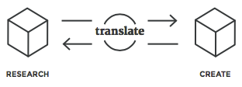Figure 1. MediaLAB Amsterdam Design Process, Research, Translate and Create phase (source Manual MediaLAB Design Process 2014).

These insights are the key to a solution, but they have to be translated into actual design requirements: which are key for the optimal solution? This is something that can be decided on the basis of research, and implemented and tested by creating a prototype. A next step might be to research again into what you created by setting up a test with users. During the project there is a constant two-way flow: from research, translation to creation, and from creation, translation to research.

### SCRUM

Scrum is an iterative and incremental process for the design and development of products and services, and it has a very specific way of organizing a team. Tasks are achieved faster and with higher quality when using the Scrum Framework. This is possible because of the high self-motivation of the team, which chooses itself how tasks will be executed. The project partner’s demands are iteratively prioritized and quickly actualized. The flow of the design process is embedded in a sprint-based schedule, ideally supported by Scrum roles, rituals, sessions and artifacts that support the process.

### SPRINTS

A ‘sprint’ (or iteration) is the basic unit of develop-ment. The sprint is a ’timeboxed’ effort; that is, it is restricted to a specific duration. The sprints in the PublishingLab have an average duration of three weeks. However, teams are free to fit and perform more sprints within those scheduled three weeks.

### RITUALS

Specific ‘rituals’ during each sprint are being used. Each sprint starts with an ideation and planning session, has a mid-sprint translation / transfer session, and ends with a sprint review meeting and retrospective. During a sprint, the team has daily stand-up meetings.

Figure 2. 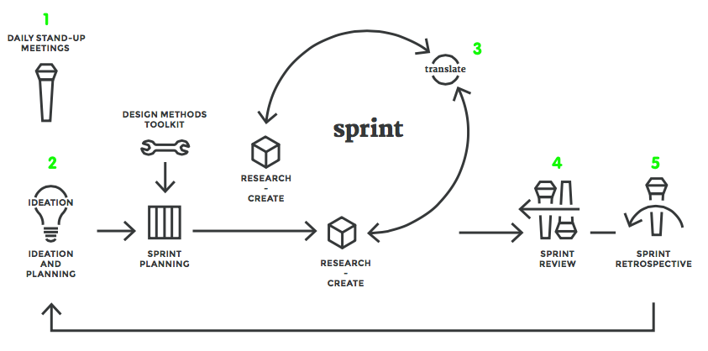MediaLAB Amsterdam Design Process (source Manual MediaLAB Design Process 2014).

1 — DAILY STAND-UP MEETINGS

The daily stand-up meeting takes place at the same time and place of every working day. The daily scrum meeting is held in the morning, as it helps set the context for the coming day’s work. These scrum meetings are strictly time-boxed to 15 minutes. This keeps the discussion brisk but relevant.

The daily stand-up meeting is not used as a problem-solving or issue resolution meeting. Issues raised are taken offline and usually dealt with immediately after the meeting. During the daily scrum, each team member answers the following three questions:

a) - What did you do yesterday?  
b) - What will you do today?  
c) - Are there any impediments in your way?

2 — IDEATION AND PLANNING

Every sprint has a ‘ideation and planning’ session. In this session the creative process is triggered by the facilitation of a brainstorm and ideation session in which ideas are identified and quickly sketched.

The most promising ideas are placed in a hierarchy and it is decided which have potential to be taken along in the sprint. After this, tasks are identified, but more importantly the exact sprint goal (and duration) is defined.

It is important to have a very clear goal, so that the team can break the effort down into smaller-sized pieces that contribute to achieving that goal more smoothly,

3 — TRANSLATE AND TRANSFER

In the middle of the 3-week sprint there is a scheduled ‘translate and transfer’ session in which your team and the project-related researchers come together to translate research insights and decide which things to act on in this sprint or the next (transfer).

4 — SPRINT REVIEW

After the team has completed the planned deliverables for this sprint it is time for the ‘sprint review’. In this meeting, which is organized with all stakeholders present, decisions on progress and how to proceed are made, including next steps and possible needs and wishes. Specifically, the team will present the work they did during the sprint and will run through the sprint backlog together with stakeholders.

5 — SPRINT RETROSPECTIVE

A ‘sprint retrospective’ is held at the very end of each sprint. This is a meeting to reflect on both the results and the processes with the team. It is meant to change, improve, or stick to the way they work and function as a team.

# INTERESTING READS / RESOURCES

### PREPARATION

In order to prepare yourself and get you up to speed in the digital publishing area we have some recommendations for reading and coding.

### HYBRID PUBLISHING WORKFLOW

Everything has a user experience. The goal of a UX designer is to make users effective. UX design involves a process that is very similar to doing science. Firstly doing research to understand the user, develop ideas to solve the users’ needs, and thereafter build and measure the solutions created in the real world.

— REQUIRED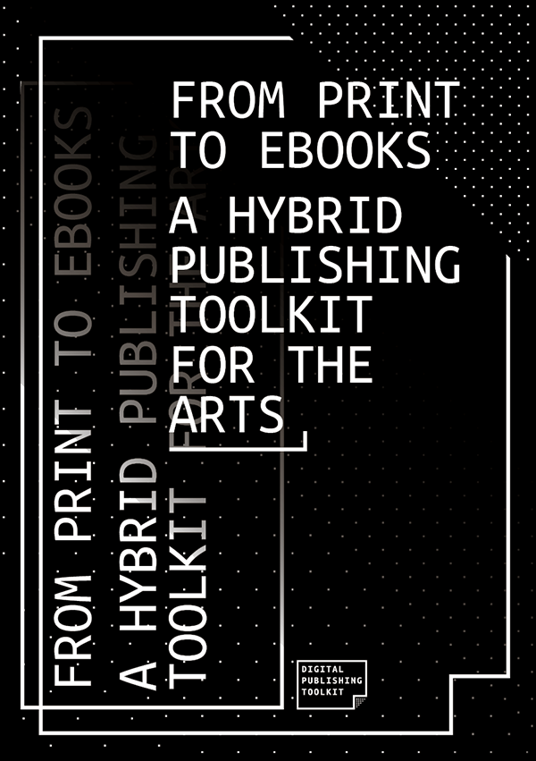

*From Print to Ebooks: a Hybrid Publishing Toolkit for the Arts*

**About this publication:**This Toolkit is meant for everyone working in art and design publishing. No specific expertise of digital technology, or indeed traditional publishing technology, is required. The Toolkit provides hands-on practical advice and tools, focusing on working solutions for low-budget, small-edition publishing. Everything in the Hybrid Publishing Toolkit is based on real-world projects with art and design publishers. Editorial scenarios include art and design catalogues and periodicals, research publications, and artists’/designer’s books.   
**About the authors:**Digital Publishing Toolkit Collective, consists of: Marc de Bruijn, Liz Castro, Florian Cramer, Joost Kircz, Silvio Lorusso, Michael Murtaugh, Pia Pol, Miriam Rasch and Margreet Riphagen   
<http://www.publishinglab.nl/blog/publication/from-print-to-ebooks-a-hybrid-publishing-toolkit-for-the-arts/>

PublishingLab blogroll (the last 6 blogposts) - <http://www.publishinglab.nl/blog/>

— OPTIONAL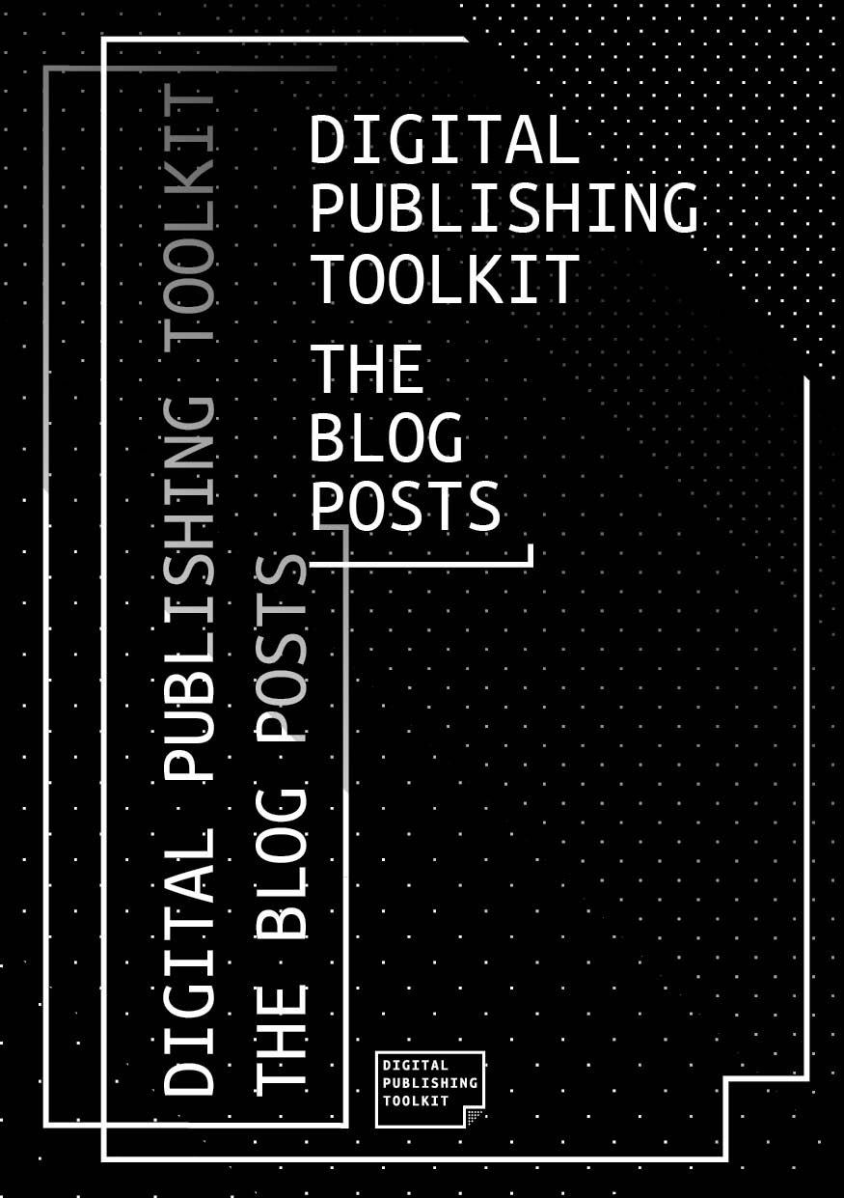

*Digital Publishing Toolkit: The Blog Posts*

**About this publication:** This publication contains the findings obtained in a two years research and have been documented on the blog [http://networkcultures.org/digitalpublishing](http://networkcultures.org/digitalpublishing.). Digital Publishing Toolkit: the Blog Posts collects all these blog posts. This EPUB consists of texts, images and links to video files. The videos themselves have been omitted, to prevent the EPUB file from being too memory intensive to load on some reading devices. It includes reflections, reports and tools. The blog posts are arranged in reverse chronological order, with the exception of the earliest post, as we thought it would be most appropriate to begin the collection with the original first post.

**About the authors:** Digital Publishing Toolkit Collective, consists of: Marc de Bruijn, Liz Castro, Florian Cramer, Joost Kircz, Silvio Lorusso, Michael Murtaugh, Pia Pol, Miriam Rasch and Margreet Riphagen and guest bloggers.   
<http://www.publishinglab.nl/blog/publication/digital-publishing-toolkit-the-blog-posts/>

### UX PRINCIPLES

Everything has a user experience. The goal of a UX designer is to make users effective. UX design involves a process that is very similar to doing science. Firstly doing research to understand the user, develop ideas to solve the users’ needs, and thereafter build and measure the solutions created in the real world.

— REQUIRED

iOS Human Interface Guidelines [- https://developer.apple.com/library/ios/documentation/UserExperience/Conceptual/MobileHIG/LayoutandAppearance.html](https://developer.apple.com/library/ios/documentation/UserExperience/Conceptual/MobileHIG/LayoutandAppearance.html)

Why you're overthinking your UI/UX - <https://youtu.be/Is2O666qDPs>

— OPTIONAL

How to become a UX designer - <https://youtu.be/CexVeagtk2Y>

Paper prototyping - <http://www.userfocus.co.uk/articles/paperprototyping.html>

Adaptive (ebook) layout - <http://sorotokin.com/adaptive-layout/>

— REFERENCE  
UX design reference - <http://www.nngroup.com>

### CODE

Coding is something you learn by doing. We don’t expect you to become a coder if you are a designer, but some basics understanding of HTML and CSS is nice to have.

— REQUIRED

codeacademy HTML & CSS - <http://www.codecademy.com/tracks/web>

Grids for the web - <http://www.slideshare.net/huer1278ft/grids-are-good-right>

CSS glossary - <http://www.codecademy.com/glossary/css>

— OPTIONAL

Positioning - <https://css-tricks.com/all-about-floats/>

Positioning - <https://css-tricks.com/absolute-positioning-inside-relative-positioning/>

Positioning - <http://www.barelyfitz.com/screencast/html-training/css/positioning/>

Transitions & Animations - <http://css3.bradshawenterprises.com/transitions/>

Transitions & Animations -   
<http://www.kirupa.com/html5/css3_animations_vs_transitions.htm>

— REFERENCE  
CSS reference - <https://developer.mozilla.org/en-US/docs/Web/CSS/Reference>

# STUDIO

## MULTIDISCIPLINARY AND MULTICULTURAL TEAMWORK

At PublishingLab you work in a team comprising people with different skill sets and from different educational and cultural backgrounds. Even local cultural differences between people from the same country can have a big impact on the way they work with each other. Working in a team with a varied composition therefore requires a special attitude, both professionally and socially. Here are some things you should take into account.

### LANGUAGE

Multidisciplinary and intercultural teams are great for creative processes. However, when people who work together have different languages, this can be an obstacle to success. Speaking in your mother tongue is very different from speaking in a second or third language. So please consider your words carefully; there are issues of interpretation, but also of cultural differences, especially when the spoken language is not the first language for either of you. Use visuals, write down your ideas, sketch. Make sure you under- standing each other.

### COMMUNICATION STYLES

Methods of communication that are normal for one group of people may appear ineffective or inappropriate to another group. A person from a culture in which loud voices and interruptions are not seen as aggressive may intimidate someone from a culture that teaches more reserved modes of expression. Learning in advance about the cultures of your team members before you work on a team with them can help you understand their methods of communication.

### HIERARCHY

The importance of authority varies greatly between cultures. Some groups give great respect to people in positions of authority, while people from other cultures are perfectly willing to question an authority figure if they see them doing something wrong. Authority is based on different criteria in different cultures. The nature of a team should be made clear to all participants at its inception. At the beginning of the semester you will therefore write a team ‘plan’ in which ways of working together, but also values and roles are written down and agreed on.

### CONFLICT

When conflict does occur within a team, members from different backgrounds may react to it in dramatically different ways. Some people will repress their reactions to an insult or slight, while others will fight back. These reactions are based on individual personality to some extent but are also conditioned by a person’s background.

Resolving conflict between team members effectively requires an understanding of everyone’s view of what caused the conflict. Being open, but respectful to each other’s background, is the best remedy for conflict resolution.

## PRESENTING YOUR WORK

At the end of the design process you will have the opportunity to share with the world what you have created. We use the website as a communication portal for all our projects, but you will also have the opportunity to present your results to the creative industry during a final event. This will be the showcase of your final design and prototype. You will present yourselves as experts to an audience consisting of friends, family, and partners from the creative industries, but also creative agencies looking for the latest trends and scouting for talent.

### BLOG

One of MediaLAB Amsterdam’s most important communication channels is its blog. Here, project teams keep followers and friends updated on the latest developments and insights in their projects or in related fields. As a team we trust you are just as proud as we are of our work, and just as keen to share its news on a regular basis. In the first week you will learn how our blog works and how you can best communicate and promote your team’s work there.

### SHARING, WORKING AND DOCUMENTATION

To work together efficiently you’ll need tools to collaborate on projects, share documents and calendars, and communicate. There are huge numbers of digital tools to help you with this: use them! The right tools will put the most relevant information within easy reach.

### RULES OF THUMB

No ambitious programme would be achievable without some good old rules of thumb about things you can do, or should do (act); things to remember; and things to respect. We expect you to take note of these and commit them to memory. We are open to initiatives, so if you have anything to add or suggest (a change), please do not hesitate to talk to someone from the PublishingLab team and your team members. We’ll find a way to make everybody happy.

— ACT

1 — Every team works and studies for five days a week from 9:00 until 17:30 (if otherwise agreed with the coach).

2 — Schedule when you will spend time on individual research, your own graduation project, or your personal development plan

3 — Appreciate the value of the structured morning-scrum setup; it is there to help you and your team aim for the highest level of quality

4 — Finish things on time, as agreed upon with your team in your meetings

— REMEMBER

1 — Involve or CC your Publishing expert coach in communications with the project partner. In case of a meeting, inform them in time about the details. The expert will always want to be present at partner meetings

2 — You can request a day off with your PM. Of course you will have to inform your team too. One-day requests: a week in advance. More than one day? At least 3 weeks in advance. Be aware that your requests may or may not be granted, depending on project needs.

3 — The PublishingLab team is not responsible for your personal grades (except for international students).

— RESPECT

1 — Keep to the team agreement document that you filled in at the start of the process

2 — In the event of illness, please contact your expert coach before 9:30

3 — Keep the PublishingLab Studio tidy, shiny and awesome!

4 — Scheduled workshops are obligatory. There are no exceptions, as these are a vital part of the programme. If you arrive late, the doors will stay closed

5 — Some distraction is good, but don’t over-do social media, appointments with others during working hours, etc. Keep the work/fun ratio balanced

6 — You are not alone, and your team members will need to feel the same dedication coming from you as they are putting in themselves. Keep the same energy level and the motor will run beautifully!

1. MediaLAB Design Method toolkit, http://medialabamsterdam.com/toolkit/