# 3. Climate Debate Actors in Science and on the Web

On 12 December 2015, a consequential agreement in the history of global climate negotiations was reached when 195 countries adopted the so-called *Paris Climate Agreement* during the 21st annual Conference of the Parties, better known as COP21. Two weeks of ‘fierce negotiations’ ended with the words ‘I hear no objection in the room, I declare the Paris Climate Agreement adopted’, spoken by the president Laurent Fabius.[1] Loud cheers followed, and festive pictures were published along with a dedicated hashtag #ParisAgreement (Figure 2).

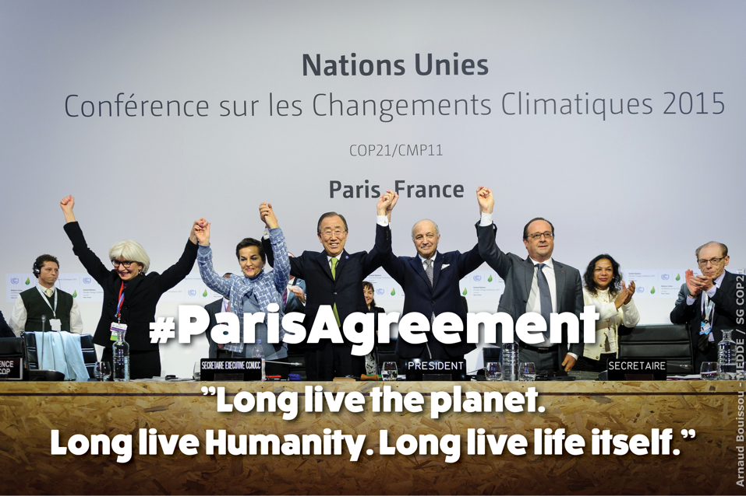

Figure 2: #ParisAgreement. Cheers after the declaration of the adoption of the Paris Climate Agreement on December 12th of 2015. United Nations Framework Convention on Climate Change, 'Adoption of the Paris Agreement', United Nations, 12 December 2015, https://unfccc.int/resource/docs/2015/cop21/eng/l09.pdf.

The global agreement that was adopted is a substantiation of the widespread consensus on climate change as a most urgent issue of our times, or as it is phrased in the agreement itself, of:

[R]ecognizing that climate change represents an urgent and potentially irreversible threat to human societies and the planet and thus requires the widest possible cooperation by all countries, and their participation in an effective and appropriate international response, with a view to accelerating the reduction of global greenhouse gas emissions.[2]

As such, the agreement marks an important milestone in the climate debate, which has spread from a scientific debate to a public debate. Arguably, the agreement may also signal a new chapter, indicating that, in fact, skepticism is losing ground. In the case studies that follow, I begin tracing ‘new' or unfolding elements of this debate from 2008, the date of the first international skeptics' conference, as discussed in the Introduction, moving all the way to 2015. However, engaging the technicity of web content (i.e., that of Wikipedia) sometimes requires the researcher to go back in time to allow for a historical reconstruction of present issues or to assess earlier milestones in a current controversy, such as important IPCC reports and COP events before 2008. As this book is not a historiography of the debate but rather a study of the controversy through networked content, I will furthermore not always discuss the events in chronological order. In my research, tracing the climate change controversy involves encountering certain objects, images, publications, or events that resonate strongly or even cause a heating up of the debate.

The most famous climate controversy object, in my view, is the so-called ‘hockey stick graph,' a chart in which a thick black line powerfully depicts a sharp and unprecedented rise in global temperatures since the late 20th century (). The hockey stick graph has been widely published, for instance, in the IPCC report of 2001. But a wider audience may know it from the performative account of climate change given in the documentary *An Inconvenient Truth* (2006), in which Al Gore projects the graph and uses a lift to follow the unprecedented rises in temperature and CO2 levels all the way toward the top of the screen. In 2009, the hockey stick graph found itself at the center of the climate debate again, with the so-called Climategate scandal. Following a hack of East Anglia University’s climatic research unit, a selection of emails was leaked in which climate scientists described the making of the hockey stick graph for publication in the journal *Nature* as the fraudulent-sounding ‘Mike’s Nature Trick’, in which research visualizations ‘leave out the anomalies’.[3][4]

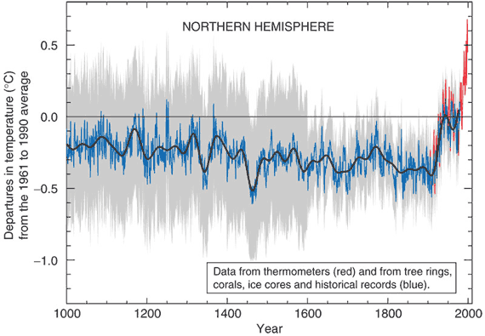

Figure 3: The Hockey Stick Graph. Graph showing unprecedented rises in temperature since the late 20th century. M.E. Mann, R.S. Bradley, and M.K. Hughes, 'Northern Hemisphere Temperatures During the Past Millennium: Inferences, Uncertainties, and Limitations', *Geophysical Research Letters* 26.6 (1999): 759–762.

Here rather than contributing to a critical discussion of climate science, which is by no means my area of expertise, I ask how content analysis may be amended to include networked content’s technicities, and, in doing so, learn from controversy analysis and digital methods. This book thus aims to contribute to those respective fields, as well as to previous scholarly work on the climate debate, especially its mediation through networks. Academic research on the climate debate has taken as its point of departure the histories of events, objects, and scandals, and studies their coverage, framing and impact across a broad spectrum of mediation, from mass media to scientific literature. Scholars have, for instance, focused on public awareness and the general public's engagement with the issue. With central questions such as ‘Do people believe in climate change? And is the percentage of people who believe climate change is taking place increasing or decreasing?’ surveys and polls are undertaken by organizations such as Pew Research Center.[5] The outcomes of these reports are referenced in scholarly works that look at public opinion and the public understanding of climate change.[6] Other scholars have created timelines and so-called trend chronologies, which ‘summarize public opinion across key dimensions including […]public awareness of the issue of global warming’ to analyze the development of public opinion over time.[7] Another strong tradition of climate debate research in the tradition of media monitoring to measure the coverage of the issue in the news, for instance, by comparing its coverage across a set of newspapers.[8]

A different strand of climate debate coverage research longitudinally monitors the coverage of the climate debate in mass media.[9] Here, the focus can be on television shows or printed news, or on specific features of the coverage, such as the use of imagery in environmental news.[10] Longitudinal analysis of news coverage can reveal the so-called ‘issue attention cycles' in a specific country or in a comparison across countries.[11] The related concept of *news spirals* refers to the phenomenon that once the climate is in the news, this creates a general upsurge of other environmental news.[12] Studies specifically centered on events and scandals zoom in on controversy objects such as Climategate or debates around (alleged mistakes in) the IPCC reports.[13][14][15] Rather than looking at controversy objects as a starting point, in the following case study, I will enter the climate debate through the scope of its actors, who I will approach using scientometric analysis and networked content analysis, for which I will conduct both hyperlink analysis and search engine-based resonance analysis.

As the climate debate is not limited to a single communication channel but takes place across online platforms, I will first consider Google Web Search — a dominant entry-point to the web for many — as a beginning platform through which to operationalize some endeavors of capturing, reading and analyzing this controversy's content. Whereas Google Web Search has grown dramatically since 2008 (as have Twitter and Wikipedia, the other platforms discussed in the next case studies of Chapters 4 and 5), its role in controversies has not been systematically examined. In this first case study, I will discuss Google Web Search in a Networked Content Analysis of the climate controversy in the period of 2008 - 2011. The case study asks how the technicities of networking (through hyperlinked websites) and search (e.g., its output of ranked lists) might be used to measure the prominence of specific actors in specific issues, in this case, looking at the networks and resonance of climate change actors. By ‘climate change actors', I mean to indicate both non-skeptical climate scientists (for lack of a better term) and climate change skeptics. ‘Climate change skeptics' here refers to those skeptical of climate change and its sub-issues such as human-made global warming, unprecedented global warming (temperature rises), and a variety of the methods employed to study climate change. All scientists are ‘skeptical' to a certain extent, so when I use the term ‘non-skeptical climate scientists', it refers to scientists who do not publish skeptical articles on the anthropogenic causes or unprecedented effects of climate change. I choose the term skeptic over ‘denialist' (a stronger term often used by those who stand in opposition to these skeptical actors) while bearing in mind that the term ‘alarmist' as used by climate change skeptics to describe their opposition is also rhetorically overloaded. Importantly, ‘deniers' and ‘alarmists' are labels used by others to define and already delegitimize these specific actors, not by the actors to describe themselves.

To assess what the techniques of networked content analysis may add to the study of the climate controversy, I pair its approach with that of scientometrics (or the quantitative study of science), a traditional means to study the prominence of scientific actors within a specific scientific field.[16] In all, this chapter assembles a profile of these actors' (aspired to) positions inside and outside academia and offers a finer-grained picture of the status, group formations and issue commitments of climate change skeptics. The chapter in this way assumes that the *question* of whether these actors are scientists or lobbyists holding open or reopening the climate debate into controversy is an extremely current question, and that finding answers towards such questions as I do here, is integral to a better understanding of the climate change debate’s entanglement with stakeholders.

In the Introduction, I have outlined that the group formation of these skeptics has been key to climate change becoming a major controversy. As I detailed in that chapter, the first international conference for climate change skeptics was organized in March 2008. The Heartland Institute, a Chicago-based libertarian public policy think-tank, organized this event with the inaugural title, *Can You Hear Us Now? Global Warming Is Not a Crisis!* The format was that of a traditional scientific conference with three days of parallel sessions and keynote speakers as well as online proceedings.[17] In his opening remarks, Heartland’s president Joseph L. Bast stressed that the conference featured talks by ‘over 200 scientists and other experts from leading universities and organizations from all over the world’. Bast furthermore stated that:

These scientists and economists have been published thousands of times in the world’s leading scientific journals and have written hundreds of books. If you call this the fringe, where’s the center?[18]

Bast gave credence here to climate skeptics as core actors in climate science, while most descriptions of climate change skeptics, whether by watchdogs (e.g., watchdogs of corporate PR campaigns such as SourceWatch.org), journalists or scientific analysts, paint a less flattering picture. Scholars have emphasized how skeptics effectively keep the climate conversation alive *as a controversy* in the face of increasing statements of consensus from the global scientific climatology community.[19][20] Skeptics are often criticized for having strong ties to specific industries invested in the status quo reproduction of our climate-changing economy, as described in books such as *Merchants of Doubt* and *Doubt is their Product*, as well as the report *Smoke, Mirrors and Hot Air: How ExxonMobil Uses Big Tobacco’s Tactics to Manufacture Uncertainty on Climate Change* and various academic papers.[21][22][23]These publications describe how industry-funded skeptics insist on the lack of consensus on anthropogenic (i.e., human-induced) global warming, using strategies from prior decades' tobacco industry-funded research that downplayed truth claims on the health risks of smoking. In October of 2015, this topic flared up in the news, as the New York attorney general announced an investigation of Exxon Mobile ‘to determine whether the company lied to the public about the risks of climate change’.[24]

The industrial and financial ties of climate change actors have been visualized for public awareness and comprehension in projects such as Exxonsecrets. This watchdog project by Greenpeace shows key scientists, spokespersons, and organizations that have received Exxon-Mobil funding since 1998. Figure 4 shows a map of the affiliations of the prominent climate change skeptics Willie Soon and Sally Baliunas and depicts which of those organizations have received funding from ExxonMobil. On the left, Soon is depicted as having six institutional affiliations (for instance, with the George C. Marshall Institute and the Fraser Institute), four of which have received funding from ExxonMobil and one of which is the American Petroleum Institute. On the right-hand side, Baliunas is shown to hold eleven institutional relations, ten of which have received ExxonMobil money and one of which is also the American Petroleum Institute. Economic visualizations like this, of supposedly ‘disinterested' scientific debate and controversies, are designed to activate public comprehension of bias and (sometimes artificial) controversy in the networked, public mediation of so-called ‘scientific research’ on climate change.

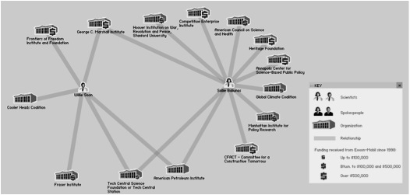

Figure 4: Exxonsecrets. Map showing the institutional relationships of Willie Soon (left) and Sallie Baliunas (right) and their funding by Exxon-Mobil since 1998. ‘Greenpeace’, http://www.exxonsecrets.org/maps.php?mapid=1804.

Rather than zooming in on the industrial ties of specific climate change researchers, in this chapter, I want to zoom out to laterally consider the place and status of climate change *skepticism*, that is, the resonance of skeptics, within the networked content of climate change science and its online debate. I will start with a brief discussion of scientometric analyses of these prominent climate skeptics.[25] In these analyses, I take to the opening statement of the first international climate change skeptics’ conference abovementioned, to turn its claims of authority into a question. Putting aside the epistemological claims of the conference content, I trace its main actors to assess whether these climate change skeptics are indeed at the ‘center’ of climate change debates. Here, I drew on a data set of over 15,000 scientific articles on climate change that had been cited at least three times, to find whether these skeptics—speakers of the first Heartland conference—were indeed located at an authoritative ‘center’ of climate science.[26]

Related to this understanding of citation networks, the utility of hyperlinks for online content analysis has been asserted by many scholars. Here, I would like to point specifically to the work by those media scholars who describe links as being both an indicator of reputation and the performance of politics of association.[27][28] For example, not all organizations link to all other organizations that work in the same field; they rather link only to the organizations that they prefer to be associated with. New media scholar Axel Bruns describes the IssueCrawler, the hyperlink analysis tool used in this chapter to conduct hyperlink analysis and visualize the hyperlink networks, as ‘predominantly designed for identifying “issue networks”, that is, networks of websites which form around the interlinking and exchange of information pertaining to specific issues or topics’.[29] This technique of hyperlink analysis has been applied to the climate debate before. In the paper *Landscaping Climate Change* (2000), Rogers and Marres describe the study of hyperlinking as a means to map the debate around an issue. They regard linking as a way to recognize other participants in the debate and ‘[s]imilarly, non-linking is a sign of non-recognition, or, more radically, is an act of silencing through inaction. (Greenpeace does not link to Shell, but Shell links to Greenpeace)’.[30] When thinking of a hyperlink in terms of recognition or as politics of association, the link can also be deemed and repurposed as an instance of group formation, as described in the Introduction in reference to the work of philosopher and anthropologist Bruno Latour, who has argued cogently for the fact that there are no groups ‘without a rather large retinue of group makers, group talkers, and group holders’.[31][32]

Important to mention here is that this use of hyperlink analysis has been recognized as an important technique by content analysis too. In the third edition of *Content Analysis: An Introduction to its Methodology* (2013), Klaus Krippendorff describes hyperlink analysis as a means to study issue networks and answer issue-related research questions regarding the composition of actors, influence and authority within the network, and the life of an issue over time (when conducting longitudinal analysis).[33][34][35] The mentioning of hyperlink analysis and its qualities for *issue research* in this handbook not only demonstrates again the willingness of content analysis in its original form to open up to such digital research methods and objects. The inclusion of this research technique also stresses the importance of the further development of networked content analysis and makes a case for the inclusion of hyperlink analysis therein. As hyperlinks are the basic ‘webby' way to network online content, they are an essential means to trace and capture affiliations, aspirations, and alignment between actors.

The third way in which I will measure the reputation of climate actors and their viewpoints within larger contestations of climate change knowledge online is through what I call ‘resonance analysis’. Here, a demarcated set of sources, in this case, the top results for the query of [climate change], is assessed for the presence (and absence) of climate change skeptics, as well as other scientists in the top search findings. This is of interest on two levels. Firstly, we may ask which sources make it into the top of the results in Google Web Search. Often critically referred to as a ‘black box’, due to its undisclosed algorithm, it is known that Google grants status to sources that are both established (as in receiving many in-links from other websites) and relevant as in often clicked, a logic that has been discussed in relating PageRank to citation analysis.[36][37][38][39] Secondly, such analysis makes visible which sources grant a voice to the skeptics prior-identified from the Heartland Conference program. Which of the top 100 results are proven to be the most ‘skeptic-friendly' websites? And who of the prior identified skeptics appear most frequently? This harkens back to traditional means of content analysis, where in media monitoring the airplay of specific actors (for instance, a ‘Democratic presidential candidate' versus a ‘Democratic presidential candidate in a televised pre-election debate') would be counted and analyzed. Lastly, it enables an assessment of who makes it into the top results (a technique referred to as ‘source distance analysis’).[40]

This actor-centric approach to the comprehension of the work and networks of skeptics leads me to raise further important questions about climate change skeptics’ *issue commitment,* once it becomes possible – and useful – to map skeptics’ (non-) scientific publications on topics other than climate change. In other words, their claims towards scientific rationality can be further researched by asking whether such claims are actually (*scientifically)* concerned with climate change at all, or with the political questions that acceptance of the science might raise. This is less of a radical move than it may seem at first glance. Consider, for example that one of the most prominent Dutch climate skeptics is the president of Stichting Skepsis, a foundation that deals with not just one controversy but many (making climate change a target of purposeful scrutiny to the point of delegitimization, alongside topics like homeopathy and so on). To understand how such controversies are networked online into *issue relations,* through issue actors is to understand the network of a controversy’s content and actors, and to study the complex ecologies of debates through the distances and connections between them (as I will bring into practice again in chapters 4 and 5 on Wikipedia and Twitter). Such analyses give space to the *drama* in the network, to paraphrase Noortje Marres.[41]

Before applying these three methods of analysis to the actions and impacts of skeptics (through hyperlink analysis, actor-oriented actor resonance analysis, and actor-issue commitment analysis), a brief discussion of my mapping of the issue *within* science is necessary. Here I make use of the ISI Web of Science to chart the position of these skeptical scientists within climate science; from this, I can test how *fringe* or *central* to climate science these actors are.

## Climate Change Skeptics: Mainstream or Fringe?

This scientometric analysis of the identified skeptics’ position tests the claim that they are in the scientific center (of climate science). A question that might be raised is whether climate change skepticism should be considered to be its own field in the sense of a particular distribution of disciplines, and following this, whether the composition of climate skepticism mirrors that of climate science. In other words, whether they are doing the same science and generating different results that would technically add up to a ‘controversy’ or whether something more complex than this is operative in the politics of online climate change knowledge. Thus, to consider whether skeptics are at the ‘center’ of climate science, I will first compare the academic disciplines of skeptical authors and assess whether they mirror the composition of climate science authors. I then look at publications in climate science and compare these to a subset of academic publications from climate skeptics. The aim of this analysis is to first to get a better understanding of the place and status of skeptics within climate science, and then to complement this with networked content analysis techniques capable of shedding light on the role of such actors within a controversy that plays out inside and outside of advanced, scientifically adjudicated academic research settings.

The basic data for my starting point is a list I have compiled of prominent skeptics to which I will apply the scientometric analysis. The prominence of the actors has been determined through reference to prior-developed listings of climate change skeptics mentioned by Wikipedia entries, previously mentioned watchdogs and other scholars' academic analyses of climate skepticism.[42] Cross-referencing these existing listings with the line-up of keynote speakers at the Heartland conference of 2008, resulted in a shortlist of fifteen prominent climate change skeptics: Sallie Baliunas, Joseph Bast, Paul Driessen, William Gray, Sherwood Idso, Václáv Klaus, Richard Lindzen, Patrick Michaels, Steven Milloy, Frederick Seitz, S. Fred Singer, Willie Soon, Roy Spencer, John Stossel, and James M. Taylor. Concurrent to this assembling of prominent skeptics, I queried the ISI Web of Science for all articles on ‘climate change'. On 9 July 2008, there were approximately 27,000 articles, 15,877 of which received at least three citations; these form the list of articles retained for the analysis.

Using this data set of nearly 16,000 articles with the list of skeptics, I compare the disciplines of the journals in which significant climate change articles appear to the disciplinary backgrounds of the climate skeptics and their co-authors. This first analysis demonstrates that seven out of the top 10 disciplines in the climate sciences are present in the skeptics' top 10: ecology, meteorology, and atmospheric sciences, multidisciplinary sciences, environmental sciences, interdisciplinary geosciences, plant sciences, and agronomy. The climate change skeptics’ disciplinary composition partially matches that of climate science, besides having some signature disciplines of its own (within the top 10 most occurring disciplines), namely astronomy and astrophysics, biochemistry and molecular biology, and medicinal chemistry. Disciplines unique to the rest of climate science are multidisciplinary sciences, forestry, and environmental engineering. These large overlap in the disciplinary background of the climate scientists publishing (cited papers) on climate science and the subset of climate skeptics seems to confirm Bast’s statement that skeptical climate science is, in fact, part of climate science and not positioned outside the field. Or, at least, it resembles climate science in terms of the composition of scientific disciplines involved. Knowing the place of climate change skeptics within the climate science disciplines, I now want to test whether the skeptics publish in prominent climate science journals or whether they have their own dedicated skeptics' journals.

Using the ISI result files and ReseauLu (the network analysis software), I compare which journals *do not* publish skeptics at all, which publish *only*skeptics, and which journals publish *both*skeptics as well as non-skeptical views. Here it is found that the shortlisted climate skeptics and their co-authors publish in the top four climate journals (which are in the shared nodes in the center of the network). This may be counterintuitive, especially when thinking about the aforementioned readings of the climate change skeptics’ ‘lobby’ in which these actors are described as a relatively small but powerful group of scientists of which ‘the most vocal skeptics were *not* qualified, were *not* working in the field’.[43]

Figure 5 shows the visualization of the results. In the center are the shared nodes. These are the 30 publications that publish articles (cited at least three times) by skeptics as well as others. The shared journals include prominent academic publications, including *Nature*, *Science*, *Journal of Climate*, *Geophysical Research Letters*, *Journal of Geophysical Research*, and *Climatic Change*. This is where climate change skepticism overlaps or resides within the rest of climate science. On the left are the journals that do not publish work by our short-listed skeptics and their co-authors. On the right are the nodes that represent the journals that publish only the works of climate change skeptics.

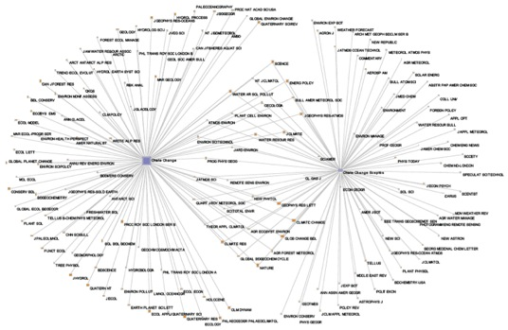

Figure 5: Climate science publication graph. ReseauLu Map showing journal publications for climate science and skeptics.

This comparative (of articles cited at least three times) shows that the climate change skeptics are indeed part of the scientific mainstream of climate change research, in the sense that they publish in top climate science journals. It also reveals that they also have their own specific outlets that publish only skeptics’ research.[44] However, climate change skeptics cannot be characterized as merely a fringe based on this research. It is relevant to mention here that two separate qualitative analyses of global warming-related article abstracts through ISI have found no ‘disagree[ment] with the consensus position’[45] and that ‘an overwhelming percentage (97.2% based on self-ratings, 97.1% based on abstract ratings) endorses the scientific consensus on A[nthropogenic] G[lobal] W[arming]’.[46] So while the climate skeptics are part of the scientific center, this does not mean that their prominent scientific publications are by definition those in which they voice their skepticism.

As we have seen in the scientometric analysis of the place and status of actors within climate science (through querying ISI), selecting only cited academic papers (at least three citations) filters out the less relevant sources (i.e., those of uncited papers). The web and its search engines know a related logic that enables a means of analysis similar to citation analysis. As described by Sergey Brin and Lawrence Page in 1998, when they presented their search engine prototype, the algorithm treats hyperlinks almost like a web of science would treat a citation. ‘Intuitively, pages that are well cited from many places around the web are worth looking at’.[47][48] But not all citations are equal; those from well-cited pages have more weight. It is noteworthy that Page and Brin explicitly use the term ‘citing’ when they refer to linking.[49] As citations network content, scientometrics could be considered a means of networked content analysis. As scientometrics can help evaluate the weight and relevance of scientific actors and outlets, for the study of the climate controversy, it is relevant to also assess the place and status of specific actors within the broader climate change debate as it plays out on the web. This is possible with web-specific techniques of networked content analysis, as I will discuss in the following sections.

## The Case of the Dutch Skeptics

On the web (broadly conceived) a national set of sources may be demarcated by taking the local domain of Google Web Search (e.g., Google.nl for the Dutch web) and querying it in the specific local (in this case Dutch) language(s). In this next section, I will zoom in on the networks and resonance of climate actors in the Dutch climate debates, to consider how networked content analysis may help to capture instances of group formation and actor resonance. I will consider moments of group formation through hyperlink networks, as I have described in the introduction; thus, rather than labeling scientists according to pre-formed categories, I understand them as part of a group when they perform as such. This approach, informed by Latour, can perhaps be best explained by example. In October 2011, the Royal Dutch Academy of Sciences (KNAW) published a report titled *Climate Change: Science and Debate*.[50] With the brochure written by a small committee of scientists from inside and outside the Academy, the KNAW set out to map the state-of-the-art of climate science, more specifically discussing what has reached scientific consensus and what still causes controversy and why. The report ends with a summary in which the topics of consensus are listed as seven statements. Statement A reads:

Humankind changes the composition of the atmosphere quickly and drastically. The increased concentration of carbon dioxide and other greenhouse gases cannot be marginalized.[51]

This first statement already is likely to turn the brochure into a controversial object, for it directly and without qualification stresses the role of humankind in global warming and the effects of CO2 (and other emissions) on climate change. Unsurprisingly, soon after its publication, Dutch skeptical blogs started posting about this report by the KNAW, characterizing it as ‘alarmist’.[52] One of the more prominent skeptical blogs of the Netherlands, climategate.nl, featured a blog posting in English stating that the brochure contained a ‘tsunami of scientific errors’:

The brochure claims that these seven statements are hard science on which all scientists agree. Nothing is further from the truth: they are a rendering of the claims of the IPCC, in denial of all serious criticism that has been brought against it by the scientific community.[53]

Besides blogging about the report in various Dutch climate blogs, the skeptics chose two other formats for their criticism: a letter signed by 22 scientists demanding the retraction of the report and a *climate seminar* organized at Nieuwspoort, the international press center in The Hague.

In the letter, the scientists refute the seven statements and demand a retraction of the publication.[54] They state they represent various academic disciplines including (bio-) chemistry, physics, geology, engineering, and climatology. The only non-academic who signed the letter is Ralf Dekker, blogger and chairperson of the aforementioned Groenerekenkamer.nl. One of the scientists on the list is Pieter Ziegler, Swiss Geology Professor Emeritus at University of Basel and Emeritus Member of the Royal Academy (KNAW). For the purposes of the analysis, it is useful to consider the signatures of the letter as a ready provision or short-listing of 22 climate change skeptics. Not surprisingly, the program of the climate seminar organized by Groenerekenkamer.nl and its list of speakers was filled mostly with people on this shortlist.

The next step in the analysis of the skeptics’ group formations is to study their networks, to better understand the scope and aspirations of these actors through hyperlinking, and the composition of the issue network. To generate such analyses, a list of the skeptics’ websites is first entered into the IssueCrawler tool for hyperlink analysis. The IssueCrawler then performs co-link analysis, crawling the inputted (seed) ‘URLs for links and retain[ing] the pages that receive at least two links from the seeds’, and outputting a network graph.[55] Figure 6, the IssueCrawler map of Dutch skeptics, shows that the group's hyperlink network is dominated by Anglo-American sources. This is perhaps surprising given the appearance of a strong national network of Dutch skeptics with an active collective blogging culture in the Dutch language. The IssueCrawler map reveals, however, that these sites link not so much to each other or to other Dutch sources, but mainly to sources outside the Netherlands (see Figure 6, top).

The Dutch scientists that authored the KNAW publication (the ‘non-skeptical’ actors in this comparative study) show a more heterogeneous network (see Figure 6, bottom), with many Dutch sources. There is a science and government cluster in which the website of the Dutch Ministry of Foreign Affairs links to an international cluster that includes the homepages of the UN and the World Bank. There are also mainstream media clusters, involving the large Dutch daily newspapers and broadcasting companies who link to their international colleagues such as *The New York Times*, the *Financial Times*, and *La Reppublica* (Italy).

The networks immediately show two distinct actor groups. The skeptics show international aspirations in linking to their Anglo-American counterparts, and the non-skeptics reveal their rooting in science and government and their contributions to the mainstream media. To further understand their resonance within dominant sources on the topic of climate change, I proceed to use Google Web Search to select top sources and query them for the resonance of these sets of actors.

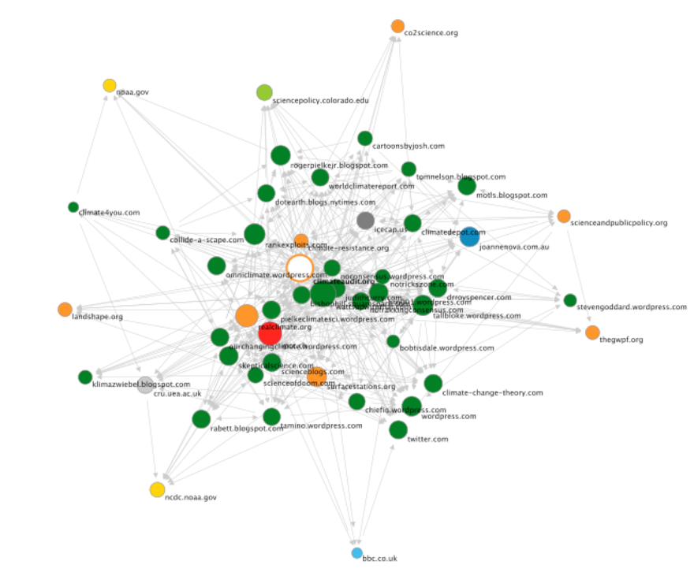

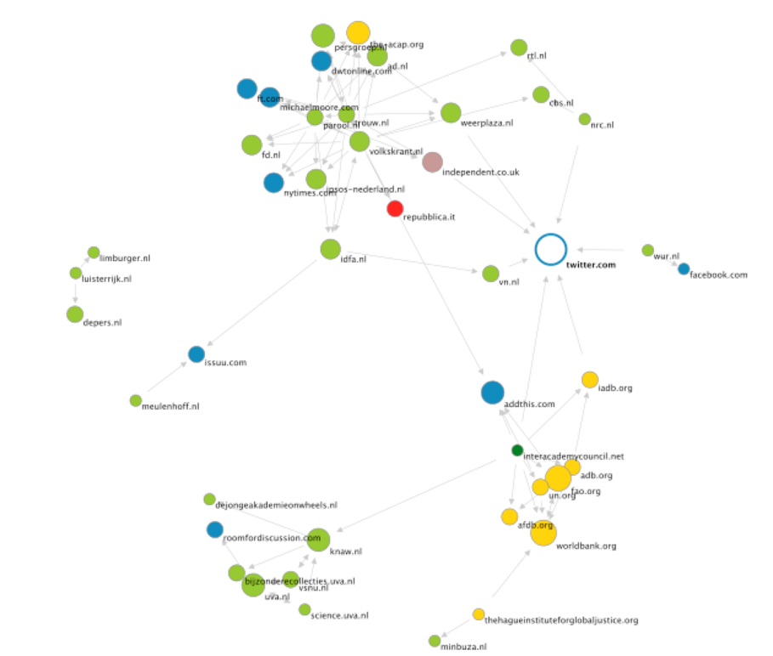

Figure 6: Dutch climate actor networks. IssueCrawler maps for the Dutch climate actors (top: ‘skeptical,’ bottom: ‘non-skeptical’).

## Dutch Climate Change Actor Resonance Analysis

As discussed in the previous chapter on traditions in content analysis, the demarcation of networked content is a key part of networked content analysis research, and much attention needs to be paid to the design and fine-tuning of search strings when using search engines. In this case, the demarcation of Dutch climate change sources can be operationalized by querying the Dutch Google.nl for the search term *klimaatverandering* (Dutch for ‘climate change'). The top 100 results contain only 25 unique hosts consisting mainly of news sources, governmental sources, and some environmental organizations and blogs. Here, I subsequently query each of these 25 URLs for all of the 24 skeptics on the shortlist. This can be done manually, with queries such as *‘Hans Labohm’ site:knmi.nl* and *‘Hans Labohm’ site:www.wnf.nl*, and so on. At this point, I use the so-called Lippmannian device, a tool inspired by Walter Lippmann to discover partisanship, which takes as input a list of URLs and a list of queries, and then the tool does the sequencing automatically.[56] Re-sizing the URLs according to their mentioning of prior identified or short-listed skeptics then shows the sources that most involve these actors, or are most ‘skeptic-friendly.' Showing a source cloud per actor and leaving the search results in their original order (i.e., of the result list in Google Web Search) renders visible that some skeptics enter into the top results, and others resonate only in the bottom results. The tool also offers a so-called ‘issue cloud' in which the keywords (in this case actors' names) are clouded according to their resonance within the top sources; this shows who the most prominent actors on the shortlist are.

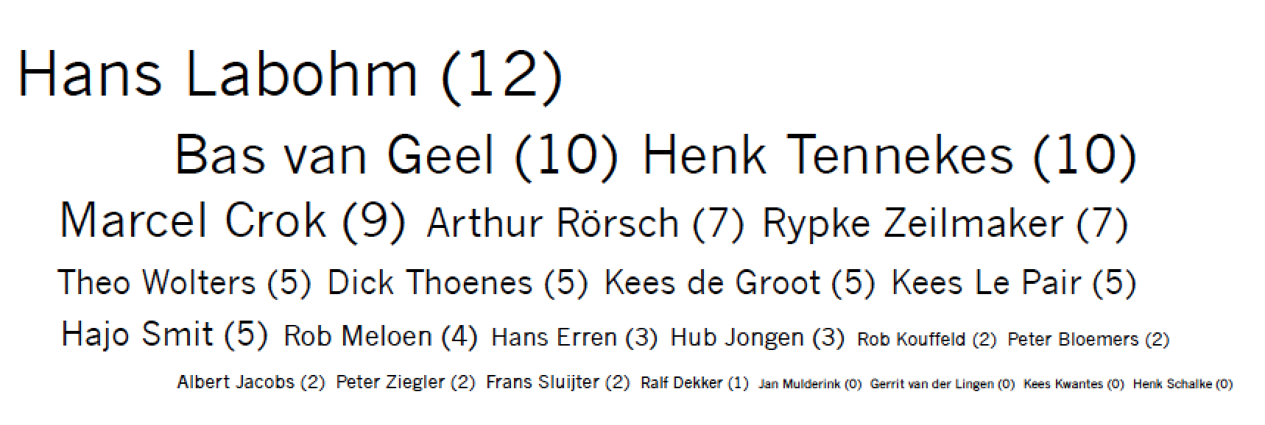

Figure 7: Dutch climate change skeptics resonance cloud. Issue cloud visualizing the resonance of Dutch climate skeptics in Google search results for the query ‘klimaatverandering.’

Figure 7 presents such an issue cloud (in this case, an actor cloud) for the Dutch skeptics, visualizing the resonance of the actors in the top results for the query of ‘klimaatverandering’. The more the actors resonate in the results, the larger their name is depicted. The three most prominent Dutch skeptics are economist Hans Labohm, Henk Tennekes, former Director of Research at the Royal Netherlands Meteorological Institute (KNMI), and Bas van Geel, Associate Professor of Paleo-Ecology at the University of Amsterdam. Hans Labohm is an economist formerly employed by the Dutch Institute of International Relations Clingendael and, notably, a former expert reviewer at IPCC. He has also been a speaker at one of the Heartland Institute’s climate skeptics conferences.[57] In 2004, Labohm published the book *Man-Made Global Warming: Unravelling a Dogma*, which he co-authored with Dick Thoenes (who is less resonant in the online debate) and Simon Rozendaal (not on the shortlist).[58]

Zooming in on Hans Labohm we can create a ‘source cloud’ to see which sources mention him most (see Figure 8). Labohm generally resonates well in the media (also in *Volkskrant* and *Trouw*) and makes it into the top results. He resonates most in klimaatverandering.wordpress.com, a blog authored by atmospheric scientist Bart Verheggen, where Labohm has his own tag and category and in the Dutch daily newspaper NRC. A closer look at the NRC archives then reveals that most of this attention stemmed from 2004 when Labohm’s book was published and 2007 when NRC published a portrait of him as a ‘liberal’ climate skeptic.[59]

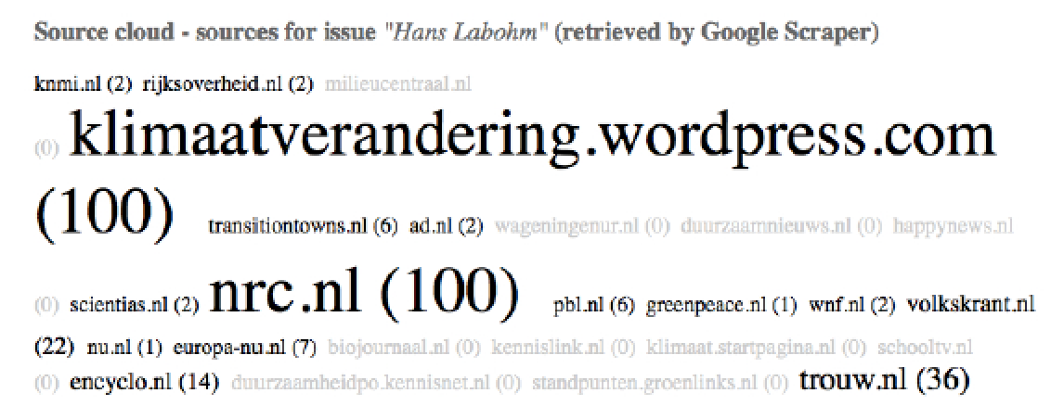

Figure 8: Hans Labohm’s source cloud. This cloud shows the resonance of Hans Labohm, the most prominent Dutch climate change skeptic, in the top results for climate change.

The sources in which skeptics resonate most are KNMI, Klimaatverandering, and NRC. There are only five sources in the results that do not mention any of the short-listed skeptics, the highest-ranked one of which is milieucentraal.nl. Milieucentraal is a foundation dedicated to providing consumers ‘unbiased information on energy and environment’ (Milieucentraal.nl), and its website offers hands-on tips and tricks for a sustainable or *green* lifestyle (such as reducing waste, being more energy-efficient, etc.).

Of the analyzed KNAW scientists, the author and editor of the KNAW brochure, Louise Fresco, a renowned scholar in the field of Tropical Plant Breeding and Production, Food and Agriculture, President of Wageningen University and KNAW member, is the most prominent actor (see Figure 9). Fresco resonates in sixteen of the top climate change sources (which is only one more than Hans Labohm). In half of these sources, she is mentioned at least 100 times.[60] The second most prominent scientist is Rudy Rabbinge, Professor of Sustainable Development and Food Security at Wageningen University. The third most resonating scientist is Robbert Dijkgraaf, Director of the Institute for Advanced Study in Princeton (United States), who at the time of the publication of the report was president of the KNAW.

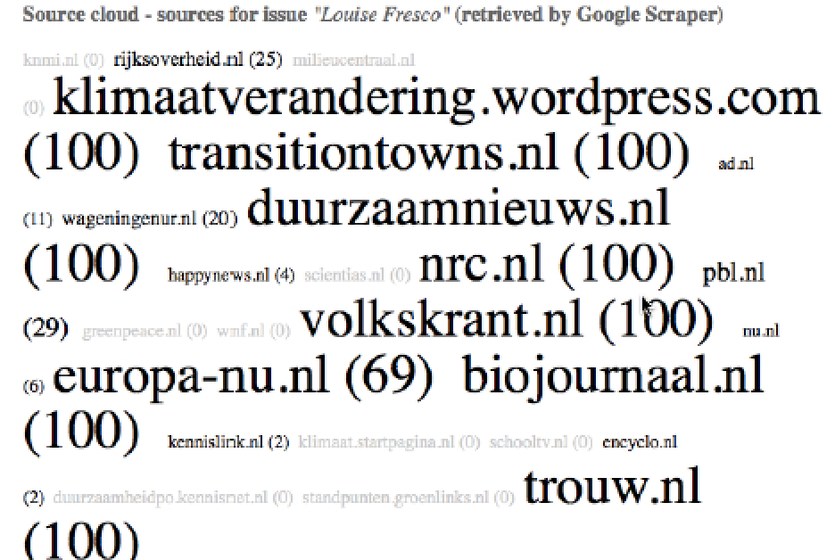

Figure 9: Louise Fresco’s source cloud. This cloud shows the resonance of Louise Fresco in the top results for climate change.

Collectively, the scientists resonate in all but seven of the sources. They are not present in two sources that do list skeptics, namely scientias.nl and greenpeace.nl.

In this resonance analysis, we find that there are no sources that mention only our small sample of ‘non-skeptical’ scientists without the short-listed skeptics. All scientists, be they climate change skeptics or not, resonate broadly in the results, both at the top and bottom of the list. So from these profiles, just as from the scientometric analysis, it is not easy to detect stark differences between the place and status of climate skeptics from that of non-skeptical scientists. But as the climate change debate takes place internationally, using networked content analysis to compare such a national *actor profile* with sets of other national actor profiles within a debate can perhaps reveal different (scientific) cultures and national frames on a global issue.

In a comparative analysis of these Dutch climate actors with French climate actors, I indeed noted major differences with the Dutch case and was able to demonstrate how such comparative analyses can give insight into the composition and position of these groups.[61] This French climate skepticism analysis, which I conducted together with climate journalist Denis Delbecq was already briefly discussed in the Introduction. Delbecq is an expert on the French climate debate and its prominent actors, which he appraised extensively in a ‘dossier’ for the French environmental journal TerraEco.[62] For this case study, Delbecq provided short lists of prominent French skeptical and non-skeptical scientists and scientific organizations. With this list, I also started by conducting hyperlink analysis, just as I did for the Dutch actors aforementioned. By linking frequently to the objects of their own criticism, the French skeptics granted high authority to these same objects, thus positioning controversy objects right in the center of their network. The IPCC was the main node in the skeptics’ network. The non-skeptical scientists showed a different and much more traditional approach. These scientists granted network authority to established French scientific figures and organizations. The Dutch non-skeptical scientists also granted authority to Dutch government and media. From the resonance analysis, the most important finding was that the French skeptics, in contrast with the Dutch ones, resonated throughout the ranked results and appeared in the same outlets as their non-skeptical counterparts.

On a methodological plane, we may ask how this national perspective would be scalable to other platforms, and this is something I will assess in the next chapter (4) on Wikipedia. In ending this chapter, I want to propose the development of another actor-centric technique of networked content analysis that looks at actors within a specific issue in order to map their other issue involvements, which I show sheds further light on the actors’ role and operationality in the climate change debate *as such*. As said in the introduction to this chapter, a prominent Dutch skeptic is the director of Skepsis, the skeptical organization that also addresses many other issues regarding health and religious practices. If climate change skeptics are skeptical of a range of other issues, then this arguably sheds significant extra light on my current study's consideration of these actors' operationality, opinions, and degrees of skeptical activity *within* climate change as an issue. They would be professional skeptics instead of professional climate change experts.

## Do Skeptics Have Related Issues?

It is a commonplace that all issues have their skeptics, thus that the presence (and problematics) of skeptics' involvement is not at all specific to climate change. Nevertheless, as I argue that we must take the involvement (and impact) of skeptics in such a consequential debate seriously, then it is also worth asking what happens if we take the matter of climate skeptics' involvement in other issues seriously. Indeed, what would it mean to know if (climate) skeptics have *other* issues to be skeptical about? And further, how might it matter to know *which* other issues they are skeptical about?

In a previous small-scale study, I took the shortlisted climate skeptics (of the scientometric analysis) and conducted a close reading of the personal homepages. Here, I found that these prominent climate actors also publish articles and blog postings in which they present skeptical viewpoints on neighboring issues such as organic agriculture and biofuels. More unexpected—in an illuminating sense—is their skepticism on health-related issues such as the dangers of smoking and second-hand smoke, the human variety of mad cow disease (Creutzfeld-Jacob disease), and evolutionary theory.[63] In my opinion, the analysis of controversies would benefit strongly from the development of robust methods for retrieving such ‘related issues,’ which could be developed as part of networked content analysis. As ‘climate change skeptics’ are skeptical of a range of other issues, then this arguably defines them as professional skeptics. This sheds significant extra light on my current study’s consideration of these actors’ role *within the* climate change debate.

As we have seen in this chapter, the climate change debate, when studied only as a scientific debate (accessed through ISI), presents a scholarly space in which both non-skeptical and skeptical actors are active, publish in the same top journals (as well as separate journals for each of the groups) and have a similar distribution of scholarly disciplines. However, when addressing the same debate from a broader base, looking at the prominence and resonance of skeptical actors within climate change content on the web (accessed through Google Web Search), we are presented with distinct groups of actors and a stark profile of skeptics as professional skeptics. When the Dutch climate change publication came out in 2011, skeptics organized themselves in an event to counter the claims of consensus presented in the booklet. A closer look at the hyperlink networks of these Dutch skeptics showed their (aspired) affiliations with their Anglo-American counterparts. One of the prominent Dutch skeptics is the director of the Skepsis foundation, addressing skeptical viewpoints on a myriad of issues. This raises the question of whether these prominent skeptics are dedicated to skepticism *as such*, or to climate change as a field of knowledge production and research. Google Web Search and a close reading of the skeptics' websites gave insights into their commitments along these (divided) lines and put the scientometric analysis into a new light. It found that prominent skeptics are indeed ideologically bound, dedicated to skepticism rather than to the climate debate alone.

## Conclusions

Where the Paris Agreement of 2015 marked a new phase in the climate debate, with a historic agreement but also a historically broadly perceived consensus on climate change, in this chapter I have traced back actors across science and the web, and in doing so went back in time to the first Heartland Conference of 2008. Where controversy analysis often centers on an issue (or a set of issues), the actor-centric approaches proposed in this chapter can follow actors *across* (and relevantly ‘beyond') single issues as objects. This kind of analysis further complicates the characterization of climate skeptics as presented in critical literature (that, for instance, focus on industrial ties), given the revelation that these skeptics are not only focusing on climate change in their skeptical endeavors. These findings have a number of implications. First of all, on a methodological level, it provides a shift from the idea that all issues have skeptics (or that a skeptical stance is part of science) to consider the ramifications of skeptics having multiple issues. Second, as the scientometric analysis has revealed, the fact that these skeptical scientists are part of the scientific mainstream raises questions about the employment of their expertise. Why do they write about these other issues while being climate scientists? Are their publications on related issues also part of the scientific mainstream in their respective fields? Finally, we may conclude that an actor-centric approach of networked content analysis provides a means to trace a controversy and its actors outside of the boundaries of a single issue, and thus is a valuable addition to the study of actors within science (through scientometrics).

This chapter makes use of web content to research the place and status of skepticism within climate science and the climate debate. The study started with a scientometric analysis looking at the distribution of disciplines and shared places of publication of skeptical and non-skeptical actors. The scientometric data shows that climate change skeptics are part of climate science, sharing both a distribution of disciplines and a mainstream of prominent scientific outlets. Besides being sometimes at the ‘center' of climate science, skeptics also work in parallel to non-skeptical climate scientists and have their respective unique journals and disciplines, their respective ‘fringes' if you will.

To extend this comparison beyond academia, hyperlink analysis — in this case, in a comparison between skeptics and non-skeptics in the Netherlands — has shown the associations and aspirations of these actors. For the Dutch skeptics, this aspirational linking plays out in the prominence of skeptical Anglo-American sources appearing in their hyperlink networks. The Dutch (non-skeptical) scientists have a heterogeneous network, including science and government, as well as news media. The Dutch skeptics form an international network by linking to both (international) skeptic blogs and the subjects of their criticism. These findings here cannot be generated through citation indices and other scientometric data, but are rendered possible only through the networked content analysis techniques I have outlined.

Web resonance analysis scoring the prominence of one or more actors in a demarcated issue source sets allowed for further comparison between skeptical scientists and others. Furthermore, the output of a source cloud-enabled an analysis of actor-friendly sources. The comparative analysis reveals different ‘profiles' per type of actor. The most prominent Dutch skeptics resonate well in the news and on one dedicated climate blog but as a whole resonate in fewer sources than the non-skeptical short-listed climate scientists.

Shifting focus from the issue space to an actor-centric perspective, skeptics appear to work on multiple issues, some of which are well outside of the climate science, let alone outside of climate change debates. Tools and methods like those worked through in this chapter can help to assess the commitments of individual actors to and beyond specific issues, and therefore reveal larger stakes in a much richer and more complex ecology of related issues. Future analysis along these lines and using these methods could also benefit from a longitudinal approach, which would render visible not only the resonance of actors over time but also the top sources for the issue of climate change and their (analytical) treatment of these actors.

Where with scientometrics alone I was not able to identify the skeptics as entirely distinct from climate science, with networked content analysis I found distinct networking behavior as well as *related* issues that were objects of their skepticism (ranging from the dangers of second-hand smoke to Creutzfeld-Jacob), which qualified them as *professional skeptics* rather than professional climate experts.

Asking then what the web *does to* the climate debate, I would like to conclude that the technicity of the web, with its hyperlinked websites and search engine result rankings, reveals actor-networks of affinity, association, critique (as the skeptics linking to their main object of criticism: IPCC) and aspiration, which may result in *drama* (in the case of the Dutch skeptics linking to their Anglo-American colleagues without them linking back). Search engines that rank results can be used for resonance analysis, presenting on one level the sources that make it into the top results of a query, while also offering up specific keywords or (as presented in this case) actors. A close reading of these actors' websites in the presented case study of this chapter establishes a clear image of their professional skepticism, rather than a commitment to climate change as a scientific issue.

This first study sets the ground for a networked content analysis of the climate debate that is able to make use of, and also go beyond, the following of online actors and their group formation. The case studies that follow will apply similar novel techniques of networked content analysis to the study of the climate debate on two online platforms. As web content itself is increasingly formatted towards inclusion in such platforms, my treatment of the technicity of Wikipedia, the collaboratively authored encyclopedia project, and Twitter, the micro-blogging platform, to study the climate change debate I argue is key to comprehending the debate itself.[64] In both chapters, I will discuss the dependency of each of the respective platforms as well as their various user groups and content on the (underlying) technicity. In the case of Wikipedia, this means assessing the climate debate in this socio-technical platform for encyclopedic knowledge production, understanding the interplay between users and technical agents. In Twitter, I will address how content is networked and will further the utility of resonance analysis, which I deployed here in the study of climate skeptics, to see how the various stages of the climate change debate resonate. Furthermore, I will closely read clusters of hashtags in assessing the state of the climate change debate. Overall, these studies are geared towards the understanding and inclusion of technicity in the analysis of networked content.

1. United Nations Conference on Climate Change, ‘COP21’, 2015, http://www.cop21.gouv.fr/en/.
2. United Nations Framework Convention on Climate Change, ‘Adoption of the Paris Agreement’, 1.
3. F. Pearce, 'The Five Key Leaked Emails From UEA’s Climatic Research Unit', *The Guardian*, 7 July 2010, http://www.theguardian.com/environment/2010/jul/07/hacked-climate-emails-analysis.
4. However, research based on Google Trends data has shown that the Climategate scandal, in retrospect, has had an only short-lived effect on the public debate around climate change. W.R. Anderegg and G.R. Goldsmith, 'Public Interest in Climate Change Over the Past Decade and the Effects of the “Climategate” Media Event', *Environmental Research Letters*, 9.5 (2014): 054005.
5. A. Kohut, D.C. Doherty, M. Dimock, M., and S. Keeter, 'Fewer Americans See Solid Evidence of Global Warming', *Washington, DC: Pew Research Center,* 2009.
6. S.C. Moser, 'Costly Knowledge – Unaffordable Denial: The Politics of Public Understanding and Engagement on Climate Change', in *The Politics of Climate Change: A Survey*, 2010, 155–181.
7. Nisbet, M.C. and T. Myers, T. 'The Polls-Trends: Twenty Years of Public Opinion About Global Warming', *Public Opinion Quarterly* 71.3 (2007): 444.
8. Djerf-Pierre, ‘When Attention Drives Attention’.
9. A. Nacu-Schmidt, K. Andrews, M. Boykoff, M. Daly, L. Gifford, G. Luedecke, and L. McAllister, 'World Newspaper Coverage of Climate Change or Global Warming, 2004-2016', 2016, http://sciencepolicy.colorado.edu/media_coverage.
10. S.J. O’Neill, M. Boykoff, S. Niemeyer, and S.A. Day, 'On the Use of Imagery for Climate Change Engagement', *Global Environmental Change* 23.2 (2013): 413–421.
11. D. Brossard, J. Shanahan, and K. McComas. 'Are Issue-cycles Culturally Constructed? A Comparison of French and American Coverage of Global Climate Change', *Mass Communication & Society*, 7.3 (2004): 359–377.
12. Djerf-Pierre, ‘When Attention Drives Attention’.
13. Anderegg and Goldsmith, 'Public Interest in Climate Change Over the Past Decade and the Effects of the “Climategate” Media Event.’
14. A.J. Hoffman, 'Talking Past Each Other? Cultural Framing of Skeptical and Convinced Logics in the Climate Change debate', *Organization Environment* 24.1 (2011): 3–33.
15. B. Nerlich, '“Climategate”: Paradoxical Metaphors and Political Paralysis', *Environmental Values* 19.4 (2010): 419–442.
16. This study was published in the European Journal of Media Studies, *NECSUS*. S. Niederer, 'Global Warming Is Not a Crisis! Studying Climate Change Skepticism on the Web', *Necsus* 3 (Spring 2013): http://www.necsus-ejms.org/global-warming-is-not-a-crisis-studying-climate-change-skepticism-on-the-web/.
17. The Heartland Institute, ‘First International Conference on Climate Change’.
18. The Heartland Institute, ‘First International Conference on Climate Change’.
19. N. Oreskes, 'Beyond the Ivory Tower: The Scientific Consensus on Climate Change', *Science* 206.5702 (2007): 1686.
20. N. Oreskes, 'The Scientific Consensus on Climate Change: How Do We Know We’re Not Wrong?' in J.F.C. DiMento and P. Doughman (eds) *Climate Change: What It Means for Us, Our Children, and Our Grandchildren*, Cambridge: MIT Press, 2007, pp. 65-99.
21. Michaels, *Doubts Is Their Product.*
22. Union of Concerned Scientists, 'Smoke, Mirrors and Hot Air.'
23. C.W. Schmidt, 'A Closer Look at Climate Change Skepticism', *Environmental Health Perspectives* 118.12 (2010): A536–A540.
24. J. Gillis and C. Krauss, 'Exxon Mobil Investigated for Possible Climate Change Lies by New York Attorney General', *The New York Times*, 5 November 2015, http://www.nytimes.com/2015/11/06/science/exxon-mobil-under-investigation-in-new-york-over-climate-statements.html.
25. Some of the specific research methods that I am employing may be unfamiliar to existing content analysis or other media studies approaches. Scientometrics uses data sets of scientific publications and assesses these through citation analysis. More specifically, scientometric analyses can extend from tracking citational behavior and referencing, to understanding these processes as constructing norms and rules of scientific writing, to considering how specific or groups of texts play out in an inter-referential network of influence and authority. Citational behavior as indexed by ISI Web of Science, thus provides the researcher with a searchable data set of scientific publications that are networked by interlinking. Wouters, *The Citation Culture.*
26. For this study that tested claims made in 2008, the sample is limited to those publications cited at least three times by July of 2008.
27. A. Dekker, *The Politics of Association on Display: Interview with Richard Rogers,* Amsterdam: Netherlands Media Art Institute, January 2008, http://nimk.nl/eng/the-politics-of-association-on-display.
28. Gerlitz and Helmond, ‘The Like Economy’.
29. A. Bruns, 'Methodologies for Mapping the Political Blogosphere: Explorations Using the IssueCrawler Research Tool', *First Monday*,12.5 (2007): http://firstmonday.org/ojs/index.php/fm/article/view/1834/.
30. Rogers and Marres, ‘Landscaping Climate Change’.
31. Rogers, *Information Politics on the Web,* vii.
32. Latour, *Reassembling the Social,* 32.
33. Krippendorff, *Content Analysis,* 2013, 234-235.
34. Here Krippendorff refers to the definition by Heclo, who ‘introduced the term in 1978 to describe connections between people who regard each other as knowledgeable and interested in particular public policy issues and who work these issues out essentially among themselves’ Krippendorff, *Content Analysis,* 2013, 233.
35. Krippendorff also cites Rogers, who uses the term in reference to the output of the IssueCrawler. Krippendorff, *Content Analysis,* 2013, 234.
36. Lawrence Page, Sergey Brin, Rajeev Motwani, and Terry Winograd. ‘The PageRank Citation Ranking: Bringing Order to the Web,’ Technical Report, Stanford InfoLab, 1999, http://ilpubs.stanford.edu:8090/422/.
37. Rieder, ‘What Is in PageRank?’ In this paper, Rieder conducts a historical analysis of PageRank through two paper publications (S. Brin and L. Page, 'The Anatomy of a Large-Scale Hypertextual Web Search Engine', *Computer Networks*, 56.18 (2010): 3825–3833.; Page et al. 1999) and two US patents for PageRank, and explores their references to citation analysis (and similarly to sociometric literature), where the patents interestingly prove a richer resource for such references.
38. See also: E. Weltevrede, *Repurposing Digital Methods: The Research Affordances of Platforms and Engines*, University of Amsterdam, Amsterdam, 2016, 105, for her historical discussion of the changes in its algorithm over time which she bases on ‘Page and Brin’s whitepaper (1998), key patents and empirical projects’ and in which she underlines that ‘Google Web Search’s current algorithm is not only PageRank but consists of over 200 signals and metrics’. Relevant to note here is that, as in my own work, Weltevrede strives not to *know the algorithm* but to *research with algorithms*.
39. See also Clay Shirky’s speculation on ‘algorithmic authority’, or the discussion of the trust people place in the algorithms of Google, Twitter and Wikipedia alike in Rogers’s *Digital Methods*. C. Shirky, 'A Speculative Post on the Idea of Algorithmic Authority', 2009, http://www.shirky.com/weblog/2009/11/a-speculative-post-on-the-idea-of-algorithmic-authority/. Rogers, *Digital Methods,* 96.
40. Rogers, *Digital Methods,* 112.
41. Marres, ‘There is Drama in Networks’.
42. For the compilation of the list, I have triangulated lists of skeptics from: A.M. McCright and R.E. Dunlap, 'Defeating Kyoto: The Conservative Movement’s Impact on US Climate Change Policy', *Social Problems* 50.3 (2003): 348–373; Mother Jones, 'Put a Tiger in Your Think Tank,' *Mother Jones,* 2005, http://www.motherjones.com/politics/2005/05/put-tiger-your-think-tank; Sourcewatch, n.d.; Wikimedia contributors, 'Bot Activity Matrix', http://stats.wikimedia.org/EN/BotActivityMatrix.htm. Frederick Seitz passed away prior to the conference yet has been kept on the list.
43. J. Hoggan and R. Littlemore, *Climate Cover-up: The Crusade to Deny Global Warming*, Vancouver: Greystone Books, 2009, 4.
44. For instance, in this sample, journals such as *Environmental Conservation*, the *Journal of GeoPhysical Research: Oceans,* and *Environmental and Experimental Botany* had only published skeptics' papers (cited at least three times and published before July of 2008).
45. N. Oreskes, 'The Scientific Consensus on Climate Change', *Science* 306.5702 (2004): 1686–1686.
46. J. Cook, D. Nuccitelli, S.A. Green, M. Richardson, B. Winkler, R. Painting, and A. Skuce, 'Quantifying the Consensus on Anthropogenic Global Warming in the Scientific Literature', *Environmental Research Letters*, 8.2 (2013): 024024.
47. Brin and Page, ‘The Anatomy of a Large-scale Hyptertextual Web Search Engine’.
48. See also Krippendorff, *Content Analysis,* 2013, 33.
49. See also Rieder, ‘What Is in a PageRank?’ for a discussion of how PageRank relates to citation analysis.
50. KNAW, *Klimaatverandering, Wetenschap en Debat.*
51. KNAW, *Klimaatverandering, Wetenschap en Debat,* 34.
52. T. Wolters, 'Alarmistische KNAW in Grote Problemen', 2011, http://climategate.nl/2011/10/25/alarmistische-knaw-in-grote-problemen/.
53. T. Wolters, 'Bad Science in Alarmist Report from Royal Dutch Academic Council', 2011, http://climategate.nl/2011/10/19/bad-science-in-alarmist-report-from-royal-dutch-academic-council/.
54. H. Labohm, 'Klimaatsceptici Verzoeken KNAW Klimaatrapport in te Trekken', October 2011, http://www.dagelijksestandaard.nl/2011/10/klimaatsceptici-verzoeken-knaw-klimaatrapport-in-te-trekken.
55. Govcom.org Foundation, 'IssueCrawler: Instructions of Use', http://www.govcom.org/Issuecrawler_instructions.html.
56. See also the Digital Methods Initiative’s Lippmannian Device tool page: Digital Methods Initiative, 'Lippmannian Device', https://wiki.digitalmethods.net/Dmi/ToolLippmannianDevice.
57. ICCC4 in May of 2010.
58. H. Labohm, S. Rozendaal, and D. Thoenes, *Man-Made Global Warming: Unravelling a Dogma*, Essex: Multi-Science Publishing Co. Ltd, 2004.
59. M. aan de Brugh, 'Liberaal in de Strijd Tegen Klimaatgekte', *NRC Handelsblad*, 19 February 2007, http://vorige.nrc.nl/article1771418.ece.
60. The ceiling for this scrape was set at 100, and she hits that ceiling in eight of the sources.
61. Delbecq and Niederer, 'Climatosceptiques et Climatologues'.
62. Delbecq, ‘Dossier Climato-sceptiques’.
63. Niederer, 'Global Warming Is Not a Crisis!'.
64. Helmond, *The Web as Platform.*