# 4. Walking in Circles in the Search Engine, or Collecting the Possible

We will wander, improvise, fall short and move in circles

— J. Halberstam, The Queer Art of Failure

## Introduction

Thirty years ago, some hoped that the internet would weaken information monopolies by offering inclusive access to information on the web. Things turned out differently. Elizabeth Kolbert observes: ‘Thirty years ago, almost no one used the internet for anything. Today, just about everybody [in the West] uses it for everything.’[1] Managing the complex information infrastructures of the internet has come with user reliance on search engines. Search engines form a key part of the infrastructure of online information. Or rather and more to the point, ‘surfing the web’ in the West has come with reliance on Google’s search engine. In popular perception, and absent strong competition, Google is perceived as *the* archive of the web, and even as *the web* — and ‘googling’ has become close to synonymous with a web search. Its engine is assumed to comprise all existing information available on the internet and offers many other related information products through services such as: YouTube, Google Library, Google Scholar, Google Earth, Google Drive, Google Calendar, Google Phone, Google Maps, Google Video, Google Image, Google Analytics, Google Docs, Google Chat, Waze, DropCam, Nightcorn, AppBridge, Senosis, Polar, Cronologics, and Google Home, to name but a few. All you need to do is type in your query and Google's engine will find it for you and deliver it in a neatly ranked list on your screen. The company is also one of the largest computer manufacturers in the world. To service its users, it makes use of massive storage and computing power it manufactures itself. Google's competitive advantage is further reflected in the Oxford English Dictionary. ‘To google’ was added as a verb to the OED in 2006, meaning to ‘search for information about (someone or something) on the internet using the search engine Google’.[2] The verb's common currency reflects Google's stable market share of over 90%.[3] It also reflects its commercially and technically centralized position. How is this reliance on Google’s information infrastructure perceived and what anxieties are braided around Google’s centralized position?

I begin this chapter with a more general discussion of the nexus of concerns revolving around Google’s search engine and web search. Google’s monopoly position is a cause of anxiety for both artists and academics. Considering the work done in academia and the arts, a number of issues emerge. Much academic work is dedicated to showing how web search mediated by Google is imbricated in a system that thinks merely in terms of profits and what the implications are thereof. Here, issues arise that have to do with the use of personal data, the for-profit logic behind search algorithms, and the power imbalance therein, whilst artistic strategies tend to focus on specific algorithmic features that are part of the infrastructure of a web search. The use of Google's search engines and algorithms in art comes in many guises. From iconic fictional browser narratives (Olia Lialina), a live stream of an artist’s personal browser in real-time (Jonas Lund), a play with bots used to identify pornography on the internet (Jake Elwes), epistolary art about the influence of the internet on people's lives (Jeroen van Loon), subversive play in the form of Google browser extensions (RedNoise), tinkering with Google's ad algorithms (Alessandro Ludovico), with its image search algorithms (Rebecca Lieberman), or with Google Chrome plug-ins (Rafaël Roozendaal), to a physical theatrical performance piece in which a group of people enact a search engine (Christophe Bruno). In addition, a variety of artists engage with ‘digging down’ practices and aim to expose the hidden materiality and centralisation of search engine infrastructure by focusing on internet cables, data centers, servers, and stacks of hard drives (Timo Arnall, Jeroen van Loon, Ingrid Burrington).[4]

This chapter focuses on a concept only a few artists have engaged with, but that nonetheless helps in understanding the anxieties around web search: collecting. Take, for instance, the conceptual documentary photography of Philippe Braquenier. With *Palimpsest* (2012-present), he presents a series of photographs of major libraries, archives, and data centers in Western Europe and the East Coast of the United States. In Braquenier's own words, his project ‘bears witness to the infrastructures of information repositories’.[5] These repositories include images of databases, amongst which Google's Data Center in Belgium, which is hidden from view by artificial dunes. His work points to different times and scales of collection: the time of library and archival collections and the time and scale of data centers. In a different vein, Richard Vijgen created *Deleted Cities* (2011), a work that could be described as a digital excavation site. It plays with the notion of GeoCities as an excavated conglomerate of cities in relation to which *Deleted Cities* could be seen as a collection of relics taken from the excavation site. GeoCities was a free web-hosting service that ran from 1995-2009. It was used by many early internet users to build their homepages, which were modelled after a user’s city of choice, including neighborhoods, streets and squares. At its peak, in 1999, GeoCities hosted over 1 million websites. After the arrival of Web 2.0. and with the growing popularity of Facebook and Twitter, the announcement came in 2009 that GeoCities would be taken offline and deleted. Archive Team, a collective of digital archivists, then decided to make a back-up of ‘approximately 650 gigabytes worth of digital, cultural heritage created by the Web's earliest citizens, or “netizens”’.[6] The cities, neighborhoods, and their inhabitants (called homesteaders) of GeoCities are no longer on the web, but there are numerous fan-fiction websites dedicated to GeoCities as well as web archive projects that give access to a part of the GeoCities webpages that have been recovered and archived. Vijgen’s *Deleted Cities* is an interactive visualization of parts of the back-up made by the Archive Team in 2009 *and* an attempt to collect and preserve a part of the web’s cultural heritage.

The most intriguing artwork on search anxiety, I think, has been conducted by Camille Henrot. In her work she reflects on the ‘searching condition’ of humans, the different modalities in which the quest for answers takes place and what underpins the quest for knowledge. Further, it reflects on what happens when this seemingly eternal search for answers is delegated to proprietary algorithms run by companies whose operations are based on the quest for profit. In Henrot’s experimental video *Grosse Fatigue* (2013), the emphasis goes to searching as an act of collecting and it addresses the question of what constitutes a web search and why this is a causes anxiety.[7] In an attempt to answer this question, the artist explores a long tradition of philosophical reflections on the will to know, zooming in on collecting as an activity that gives form to this desire. The second half of this chapter focuses on how *Grosse Fatigue* imagines search anxiety and how searching as collecting and the searcher as collector open out onto the dimension of the possible in relation to the will to know. What anxieties underlie web search? What is the connection between collecting and search anxiety? I will argue that *Grosse Fatigue* tacitly links Kierkegaard’s conception of objective uncertainty to Walter Benjamin’s notion of the collector. Doing so, the film hints to the *possible* as part of the act of collecting and links the act of collecting to a web search. By connecting the work of Kierkegaard and Henrot to that of Benjamin, the latter's conception of the collector offers a way of living with and through search anxiety. I will demonstrate how Henrot’s notions of searching as collecting and the searcher as collector open out onto possible alternative spaces on and off the World Wide Web. I start this chapter by introducing the subject of search anxiety as it is discussed in the academic literature from media studies, sociology, Science and Technology Studies, and communication and computing studies, before moving on to explain how search anxiety is imagined in contemporary art.

## Search Anxiety: Google Slaves, Bias, For Profit Indexes, and the Politics of Web Search

Various scholars from a variety of disciplines have expressed concern in particular about the monopolization of Google search and on the capitalist rationality behind Google's search engine.[8] Astrid Mager, for example, has written about how the algorithms behind search engines are shaped by their for-profit target-advertising business-models and advance a capitalist logic and ideology.[9] Wendy Chun argues that software and hardware are ‘ideology machines’.[10] Further, issues pertaining to globalization and localization of web browser used in different fields and geolocations have flourished too, as well as reflections on past and present search technologies and their implementations.[11] [12] Significant work has been done on the political and cultural bias reflected in search results.[13] Safiya Umoja Noble shows in *Algorithms of Oppression*: *How Search Engines Reinforce Racism* (2018) how Google’s search engine ‘reflects the political, social, and cultural values of the society that search engines operate within’, including the racist and sexist beliefs of the society.[14] Research on the legal implications of search engines has grown too.[15]

Google’s search engine provides vital access points to the world wide web, as one of its core functions is the algorithmic channeling of information by inclusion, exclusion, localization, personalization, and hierarchization. Importantly, the algorithms operating Google’s search engine are part of its business model. The majority of Google’s profits comes from targeted ads. Which is to say, some companies benefit financially from other people’s search queries in Google’s search bar. Features like localization and personalization — also known as averaging — have effects on the list of search results and so do matching and ranking algorithms.[16] Your search keys are linked to and across all the devices on which you use Google search and its other applications. Google stores that information to target you with personalized ads, one of its main sources of income. Together they are used to analyze patterns in people's queries and churn out lists of results based on, amongst other things, popularity. Up to this day, Google tracks the geolocations of millions of phones worldwide, and all Android devices come with ad viewing behavior trackers such as scripts and cookies. As a consequence of Google’s high search volume and market share, an industry of marketeers continually tries to manipulate Google’s algorithms to improve their ranking in Google’s search engine. These factors amount to the self-referential, recursive, for-profit, financialized, proprietary monopolization of web access. Google is self-referential, as it brings you what it has already found and indexed. Moreover, its search results are ranked according to popularity as measured by its own algorithms, and it has incentives to direct searchers to its content. Google’s search engine is also recursive. It takes input from its users and continually reuses that data to refine search results for its users and for the delivery of ads. Google's for-profit and proprietary search engine is integrated into browser extensions, GPS systems and numerous web applications on tablets such as smartphones and iPads.

Google's self-referential, recursive, financialized, and proprietary monopolization of web access shapes what information we come across online. Search algorithms, Taina Bucher states, ‘hint at the fundamental question of who or what has the power to set the conditions for what can be seen and known with whatever possible effects’.[17] This power derives in part from its index. When one uses Google's web browser, one does not search the world wide web. When we search, Google's algorithms select, sort and rank documents that it has saved in its search engine index, a local copy of web documents that it has indexed. In *Why We Need an Independent Index of the Web* (2014), Dirk Lewandowski explains how Google’s web search functions. On the one hand, there is the worldwide web, which contains billions of documents. On the other, there are for-profit web indexers, such as Google, whose web crawlers attain a small portion of the available data on the web that is then held on a local unit of storage. Finally, this local copy of the web is indexed by Google so as to make it searchable. This indexed part of the web is called the surface web and contains web documents that can be found through Google’s search engine.

According to Lewandowski, the search engine index is therefore the foundation of the search engine.[18] Users type a query into Google’s search bar and get a list of ranked pages in return. Meanwhile, the broader web comprises billions of documents that change all the time: new pages are added, others deleted, and changes are made on existing pages. This requires the constant updating of the local copy of the surface web and its index. Yet, as Lewandowski explains: ‘It is impossible to maintain a perfectly complete and current index.’[19] He goes on: ‘The pool of data changes thousands of times each second. No search engine can keep up with this rapid pace of change. The local copy of the web can thus be viewed as the Holy Grail of web indexing at best.’[20]

This Grail, the copy of a website in the index, can lag behind for days. Not to mention, search engines do not merely capture and store documents they find on the web; instead, Lewandowski explains that they generate replicas of documents.[21] These replicas contain information extracted from the document (source, title, length, date of creation, keywords and the like), information on the popularity of the document (measured by the number of times it was accessed and how many links to the document exist on the web, among other measures), and an alternative, text-based version of the document comprising the anchor texts from other documents.[22] Different types of algorithms decide what parts of the web one sees — this can be a single page on a blog that has not been indexed, content on Facebook, information behind paywalls, or any other content that is not indexed or cannot be found through a standard search engine. Considering the market share of Google’s search engine in Europe — a solid 90% — users rely on Google’s method of indexing and ordering results. They are ‘confined by the limitations of Google’s collection of data. If Google has not seen it — and indexed it — or kept it up-to-date, it can't be found with a search query.’[23] Seen this way, Google’s search results form a collection within a collection.

In light of this, to search the web is political ‘in the sense that it is ordered, governed, shaped’.[24] Indeed, search anxiety stretches beyond Google's search engine. In her popular and widely circulated polemic piece *Google as a Fortune Teller: The Secrets of Surveillance Capitalism*, Shoshanna Zuboff even warns of a possible assault by Google.[25] With the data we feed it, Google is selling ‘access to the real-time flow of your daily life — your reality — in order to directly influence and modify your behavior for profit,’ she argues.[26] This, she explains, threatens ‘the existential and political canon of the modern liberal order’.[27] Zuboff fears a future in which we all become ‘information slaves’ of Google. ‘We are the native people now,’ she writes.[28]

The consequences of the web’s centralization and monetization are a concern for artists, who provide us with means of grappling with these processes by taking position in relation to the centralization and monetization of web search. A number of artists express concern about the use of aggregated and interconnected search data. One canonical work is *I LOVE ALASKA* (2009), a 50-minute documentary video by Lernert Engelberts and Sander Plug. On August 4, 2006, the personal — and, it can be assumed, private — search queries of close to 650.000 America Online (AOL) users, the then-largest internet provider in the U.S., were accidentally published as a text file on AOL’s public website. The file consisted of three months’ worth of users’ search keywords. AOL pulled the data from public access on August 7, 2006. However, by then it had been copied and disseminated on the internet — the file can still be found on mirror sites accessible through the internet archive Wayback Machine. *I LOVE ALASKA* consists of a selection of the search queries of AOL user #711391. The queries are read aloud as a voiceover by a female with a southern drawl and in chronological order, as indicated by the insert of a timestamp in the left corner of the screen preceding each query. The narration of the search queries is accompanied by static shots of different, barren, presumably Alaskan, landscapes, such as a snow-capped mountain range, a sunset, a log cabin, windy dunes and a highway.

The selection from the search queries read:

cannot sleep with snoring husband;

Jackie zeman nude;

reverend harry meyers;

How to kill mockingbirds;

how to kill annoying birds in your yards;

God will fulfil your hearts desires;

online friendships can be very special;

People are not always how they seem over the internet;

can liver problems cause you to lose your hair;

gay churches in Houston tx;

are growths on the face always cancer;

cooking channel;

how can I tell if spouses spy on me while I’m online;

married but in love with an other;

back pain;

Is George Clooney gay;

how to make good impression first time meeting an online friend;

Ticketservice;

How can I be a good example to an unsaved friend;

I love Alaska;

treating computer addiction

A sense of voyeurism and secrecy arises in the interplay between the voiceover, the time stamps and the images, which I LOVE ALASKA presents from the search queries of user #711391. The queries invite the viewer to make up a story, to fill in the gaps. Nate Anderson describes I LOVE ALASKA as:

[…] real pain, stripped of a human face […] Puzzling out the person presented eventually gives way to thinking about our own search and browser histories, the trail of cybercrumbs leading through the forests of the internet on paths that our own friends and even spouses may not know we tread.[29]

User #711391 seems to be a woman of faith from Houston, Texas, in a relationship with a snoring husband, apparently has met someone online, has anxiety about diseases, shows an interest in Alaska and in same-sex.

Anxiety about the possible future use of individual and aggregated search data is a recurring topic of concern both in art and in academia. Anja Groten developed the *Machina Recordatio* (2013)*,* an alternative search engine where you can browse for specific topics and keywords relating to existential issues and romantic problems you may not want to share with Google. The search ‘results’ have the form of voice recordings of elderly people giving life advice to searchers who want to keep their private lives somewhat private. Relatedly, Harlo Holmes and Camille Henrot created an offline *I Ching*-like search application named *Desktopmance* (2015), which algorithmically answers a user's personal questions about life decisions and the future with a poetic response based on a selection of poems liked by Holmes and Henrot, combined with images randomly selected from the files stored on the user’s desktop.

As a form of artistic resistance to Google’s monopoly position, the financialization of its search results, and the anxieties about the possible use of aggregated search data, artists such as Anja Groten, Taryn Simon and Aaron Swartz, Phil Jones, and Aharon Amir have created alternative search engines. With their alternative search engines, they each tackle different aspects of search anxiety. *Image Atlas* (2012), made by Taryn Simon in collaboration with Aaron Swartz, responds to anxiety about filter bubbles. The two developed a search engine that compares the top image results for search terms across localized engine settings of 57 countries around the world. Users of the *Image Atlas* can play with these settings and refine or expand location settings to compare the given image results. *Image Atlas*, in the artists’ own words, ‘questions the supposed innocence and neutrality of the algorithms upon which search engines rely’.[30]

Relatedly, Renée Ridgway’s *Re:Search* (2016) also offers a view of the powerful forces at play in the back-end of the web search. Her works focus on the centralization of power in the political economy of search engines. Through data visualizations and an interactive touch screen, *Re:Search* shows the value of key words as measured through the lens of ‘personalized’ and ‘anonymized’ search results. The work consists of two tablets that show two interactive data visualizations of the search queries and results. One shows the results of Google Search in a Firefox browser on a personalized Apple (signed in to Gmail account, no ad-blocking plug-ins). The other shows the results of a ‘hacker-approved’ clean Lenovo PC with a Tor browser. In the exhibition view, the two tablets were complemented with a paper print out with long lists of the different URLs of the search results of both engines. *Re:Search* is an investigation into the ‘personalization’ feature of the Google search and alternative methods of querying the web, such as with the onion browser on Tor. To counter the self-referentiality of Google's search results, Phil Jones and Aharon Amir created the *Narcissus Search Engine for N.E.W.S.* (2009). Like Google’s engine, *Narcissus* searches a database of documents for matching keywords, keeping tabs on when searchers click through to see the results. Contrary to Google’s engine, however, it favors the less popular or unpopular over the popular. It does so by downplaying popular sites by pushing a popular result site down in its ranking. If a popular site continues to be clicked on despite these efforts, it will no longer appear in the list of results.

Other artists have engaged with the recursive aspects of Google’s engine and the use and financialization of user data. Erica Scourti’s *Life in AdWords* (2012–2013) stages a personal interaction with Google’s AdWords algorithm. At least until 2017, AdWords algorithms would sift through user’s Gmail accounts and chat history, analyze topics of possible interest and use this data to target its users with personalized ads that would appear in their inbox and on the result pages of Google search. Google claims that since 2017, it scans Gmail data only with the consent of its user. Starting in 2012, for nearly a year, Scourti logged into her Google email account and emailed her diary to herself. In *Life in AdWords* she performs, to a webcam, the list of keywords that turned up in her inbox as a result.

Of course, the revenue model and data exploitation of Google’s search engine is not the only issues with web search — though they seem the more pronounced causes of anxiety both in academia and in the arts. While artistic and academic projects pick up on different issues, a shared focus is to expound on the conditions of centralization, localization, and financialization of Google’s search engine in order to critically rethink the ‘results’ of the search engine. That is, most academics and artists tend to ‘stand back’ and focus on Google’s search algorithms and results, reflecting upon its revenue model and the power dynamic between searchers and the profit-driven corporate mediators that administer Google’s engine and aggregate its data. Web search, however, is not a matter of political economy alone. It is also a matter of collecting. It is this act of collecting and the relation between the collector and the collected, which forms the central concern of Camille Henrot’s experiential video work *Grosse Fatigue* to which I turn in the following section.

## The Searching Condition in *Grosse Fatigue*

Henrot’s *Grosse Fatigue* can be described as a Kierkegaardian reflection on a web search. The film could, to an extent, be read as performing a synthesis between faith and knowledge as it loosely links religion and science and world-building to Google's search engine. Moreover, the artistic enactment of the act of collecting presented in *Grosse Fatigue* shows a way to work with and through the self-referentiality and recursiveness of Google’s search engine. *Grosse Fatigue* carries its viewers through the realms of epistemology, taxonomy, theology, and technology, offering reflections on the act of collecting on the one hand and an artistic imaginary of the underlying moods and shapes of the quest for knowledge on the other.

Set entirely on a desktop computer, *Grosse Fatigue* begins with a window popping up on a desktop with the query ‘the history of the universe’ being typed into the Google search bar. From there, the film takes its viewers on an audiovisual *tour de force* along with numerous creation stories, down the rabbit hole of Google's web browser, and through the collections of the Smithsonian Institute in Washington, D.C. In 13 minutes, the film covers millions of years in the history of the universe, crossing numerous disciplines, methods of research, and fields of expertise. *Grosse Fatigue* was made during Henrot’s stint as a research fellow at the Smithsonian Institute in Washington D.C. — the world’s largest conglomerate of museums and research centers, which is administered by the US government and holds over 137 million artworks, objects, and specimens in its collection. Her book, *Elephant Child* (2016), expands on some of the formative ideas for *Grosse Fatigue. Elephant Child* is in part a collection of the research material and thinking that informed *Grosse Fatigue* and offers images of the artworks and quotes of thinkers that have shaped Henrot's ideas.

Furthermore, Henrotconnects the quotidian practice of web browsing to the eternal question of life on earth and the moods and shapes underlying the mystery of life on planet earth. Spirals and rectangles, hands, turtles, and globes reappear throughout the film as it draws in on the concepts of recursion and self-similarity. To trace the connection between these concepts is to discern Henrot’s understanding of what it is we do when we search.

*Grosse Fatigue* invites viewers to rethink the idea of a web search as broadly situated in the history of how knowledge is conceived, narrativized, preserved, distributed, and, importantly, *collected*. The footage of *Grosse Fatigue* consists of film images taken at the Smithsonian Institution combined with images and clips taken from Google Image and Google search results. The Smithsonian Institution is not modest about its ambitions. Its mission is to ‘unlock the mysteries of the universe’ and to continue to take the ‘lead in the quest to understand the fundamental nature of the cosmos, using next-generation technologies to explore our own solar system, meteorites, the Earth’s geological past and present, and the paleontological record of our planet’.[31]

Google has parallel ambitions in the digital realm by, as one example, allowing its users to navigate the earth. Through Google Earth, one can traverse oceans and mountains or zoom in and zoom out of cities. With Google Books, one can leaf through any of the books it has digitized, while Google Scholar provides access to the digital archives of museums and institutions, amongst other things. With its combined services and products, the company aims to ‘organize the world’s information and make it universally accessible and useful’.[32] In this sense, the Smithsonian Institute and the Google search engine would seem to be good places for starting a query on the history of the universe. That said, queries into Google's vast database or the Smithsonian collection are mediated and governed queries. What Google's search algorithms and the Smithsonian have in common are their attempts to organize disorder.

The opening scene of *Grosse Fatigue* starts with an image of a laptop screen with a desktop image of the milky way. A *Final Cut Pro* file is opened, and two windows pop onto the desktop. Each show what appears to be the same art catalogue against a yellow background. In one window, the book opens on a page with a centerfold portrait picture of native tribespeople. In the other window, the art catalogue is leafed through by a woman's carefully manicured hands. The two windows cut to superimposed clips of a young woman opening a locker in the sterile grey corridor of what seems to be an archive. These images are then paired with another window in the top right of the screen showing a Google search bar. The words ‘the history of the universe’ are being typed in the bar. What follows is a torrent of quickly-paced edited shots of Google's search images mixed with short video clips of quotidian moments as well as images and clips of artefacts, taxidermic flora and fauna, and a plethora of objects that form part of the vast collection of the Smithsonian Institution.

*Grosse Fatigue* enacts the phenomenon of the web search by way of overtaxing its viewers with sound and images taken from different internet sources, archival research and personal files of the artist. Different file systems and internet interfaces fill the screen — the desktop, the screensaver, folders, windows opening and closing. These are visually linked with images of files, cabinets, boxes, and drawers in which the Smithsonian Institution preserves its collections. The rhythm and movement of the film’s montage is synched to the punches of a kick-drum. A deep and warm voiceover begins to read a poem:

In the beginning there was no earth, no water – nothing.

There was a single hill called Nunne Chaha.

In the beginning everything was dead.

In the beginning there was nothing, nothing at all.

No light, no life, no movement, no breath.

In the beginning there was an immense unit of energy.

In the beginning there was nothing but shadow and only

darkness and water and the great god of Bumba.

In the beginning there were quantum fluctuations.

In the beginning, the universe was a black egg where

heaven and earth were mixed together.

In the beginning there was an explosion.

In the beginning, a dark ocean waged on the shores

of nothingness and licked the edges of Night.

In the beginning was the eternal night Han.

In the beginning, before all things, there was

Amma, and he rested upon nothing.

In the beginning, Ptah the demiurge born from the essential ocean.

In the beginning, the fabric of space-time unfurled, it inflated.

In the beginning, atoms were formed.

In the beginning a giant cobra floated on the waters.

In the beginning everything was still, there was no beginning.

In the beginning, and in the Void, the Oldest of Old

Gods was formed, the world had no time, no shape,

and no life, except in the mind of the Creator.

In the beginning the Word already was.[33]

The editing and the drum rhythm are seamlessly synched with the flow of the spoken word poem that forms the backbone of *Grosse Fatigue*.

Henrot mentions in her book *Elephant Child* that the poem lines mix creation stories from various religious traditions (Hindu, Buddhist, Jewish, Christian, Islamic), hermetic traditions (kabbalah, freemasonry) and oral traditions (Dogon, Sioux, Shinto, Inuit, Navajo). In poetic recital, we hear:

Then the Gods split humans in two, making them each search for their lost half

Then some degree of sperm competition took place

Then Eve of the rib was adorned in jewellery

Then a brother and sister were locked in a yellow wooden drum

Then the milky way took form

Then there was no need for light on Dzambu Ling,

For the god emitted a pure light from their own bodies,

Then the creator was in the form of a man without bones,

Then the gravity of galaxies slowed the expansion of the universe,

Then there were units of matter,

Then Ogo introduced disorder into the world by

committing incest with his Mother Earth,

There was no world then, only the white, yellow, blue,

black, silver and red mist floating in the air.

In the beginning was only the sky above,

And water and marshland below.

In the beginning was nucleosynthesis.[34]

Henrot has a knack for image matching and juxtaposition, sound-image choreography and color composition. Using these techniques, she forms a mesmerizing dance of spoken word, drums, images, colors and movements. With this dance she attempts to tell the story of the universe’s history.

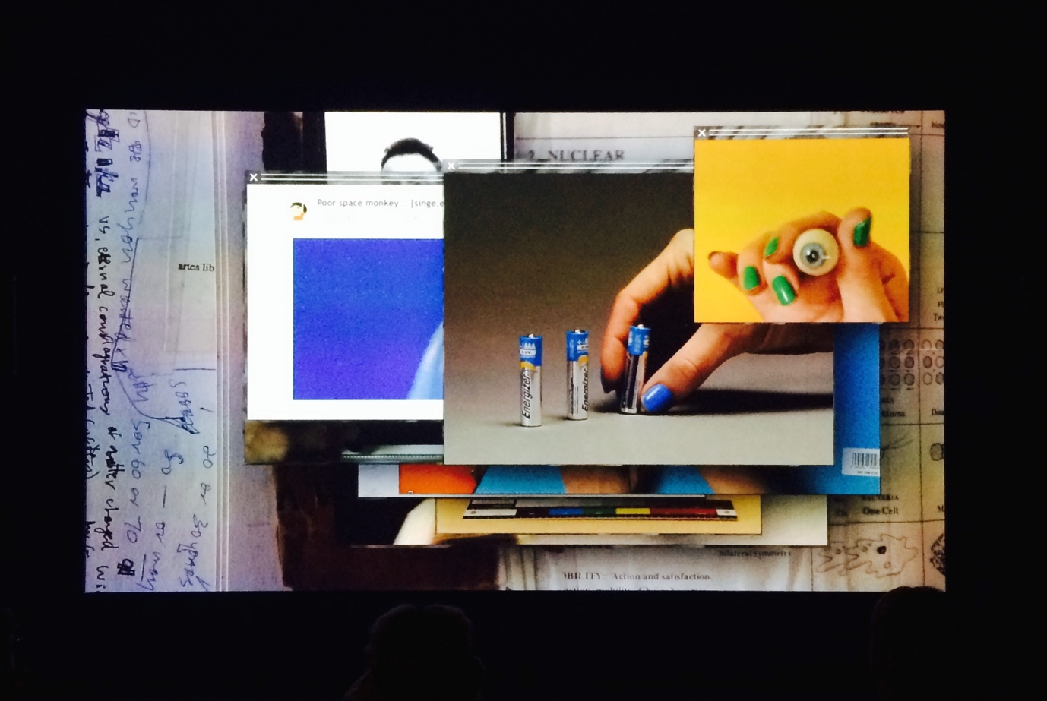

Figure 9: Exhibition view Grosse Fatigue by artist Camille Henrot.

Kierkegaard would have argued that *Grosse Fatigue*’s searcher knowingly sets itself up for failure. He would have dismissed the suggestion that reconstructing the history of the universe helps to understand the meaning of existence. As existence is not a mere object or question of knowledge, it cannot be answered by scientific pursuit. Kierkegaard further explains this by way of dancing:

If someone who wanted to learn to dance were to say: For centuries, one generation after the other has learned the positions, and it is high time that I take advantage of this and promptly begin with the quadrille — people would presumably laugh a little at him.[35]

Just like a dancer has to learn, retrace and rehearse the basic positions, again and again and again, the meaning of existence lies in existing, as a verb. It requires commitment and constant and often thankless effort. Which does not mean that nothing is edifying about reading about dance or watching others dance; it is to say, rather, that questions regarding the meaning of existence cannot be answered by science alone.[36]

However, the searcher of *Grosse Fatigue* does not search for answers within the walls of the Smithsonian Institution alone.Superimposed pop-up windows open to short video clips, web texts, and web images taken from a variety of digital platforms and sources. The viewer encounters: drawers full of dead tropical birds; YouTube videos; a clip of a woman masturbating; Wikipedia lemmas; home videos; marbles; a *SkyMall* magazine; a toned male torso showering; a world map visualizing occurrences of bipolar disorder; an orange rolling; a soaped naked female torso; turtles eating; a turtle hedging eggs; a frog sitting on a smartphone; flora and fauna from across cultures; as well as numerous other objects that first fill, and then flood, the screen. Henrot weaves together objects and aesthetics of oral and digital culture, natural science and theology, mixing the seemingly trivial and personal with the monumental collections of the Smithsonian Institute. Meanwhile, the spoken word poem recited in the voiceover jumbles various creation myths, moving chronologically from the beginning of creation to the end.The voiceover’s tone tightens, he sounds anxious, and his breathing becomes more and more pronounced while he’s heard saying:

The Creating Power then took many animals and birds from

His great pipe bag and spread them across the earth.

First came self-promoting chemicals and then fat formed membranes

And then came the green algae colonies in the sea,

And then the oxygen, oxygen.

Eight faced air, air to make winds and breezes,

Air filled with sounds, air carrying oceans

And then came the vertebrates, the jawless fish

And then came the nautiloids in the Devonian ages of fishes,

And then came amphibians from the coelacanth,

And then came the birds from the coelacanth,

And after the flowering plants came the bees,

And after the bees came the snakes,

And after the snakes came the ants,

And after the creodonts came the primates,

And after the primates came the song birds,

The parrots, the loons, the swifts

And then came the butterflies and moths,

And came the grasses

And came the marsupials

And came the pigs and cats from the coelacanth,

and came the deer,

After the deer came the zebras, elephants and then the dogs

And came the hyenas, the bears, the giraffes,

And came the three sloths, the hippopotami,

the zebras, the elephants, the lions, the dogs,

And then came the mammoths from which came nothing at all.[37]

At the end, the narrator gasps for air.

*Grosse Fatigue* hurries through aeon and aeon. In 13 minutes, art and culture, science, extinction, Jackson Pollock, Charles Darwin, Pantone colors are all there, as are drawings, notes, and numerous browser windows. Henrot draws no boundaries between one category and another, mashing up science, myth and the creation stories of the world; making associative leaps of imagination between objects and images of eggs, planets, marbles, a fox, and flexing biceps, spume and turtles. In doing so, she synthesizes disciplines and values: science and religion, words and images, epistemology and ontology. *Grosse Fatigue* seems to refuse to dualisms. Who says *this* is spirituality and *that* philosophy? Who says this is *subjective* and that is *objective*? Henrot explains in an interview: ‘It was my aim for the film to reflect the anxiety generated by the open nature of the world and its excessive dimension’.[38] Referring to anxiety like that which underwrites the search for knowledge — be that through quests within an archive or queries on the web — Henrot echoes Kierkegaard. In *Elephant Child,* one can read another Kierkegaardian echo. Henrot writes: ‘when you try to grasp universal questions, or questions that are too big, you need to draw into yourself, to use intimacy and subjectivity as a means of accessing something beyond the self’.[39] In Kierkegaardian fashion, Henrot synthesizes faith and knowledge.

## Frames, windows, boxes & other rectangular encounters

As noted earlier, what Google’s search engine, the Smithsonian collections, and creation stories have in common are their attempts to organize disorder. They attempt to organize the Great Chain of Being and the World Wide Web. Every part gets its allotted position in the whole of the natural/digital world. *Grosse Fatigue* could be seen as an enactment of the operations and mechanisms of search algorithms.

In the voiceover we hear:

And language was used to praise Heart-of-Sky rightly

And mankind discovered the knowledge of history and nature

Of minerals and vegetables, animals and elements

The knowledge of logic and the art of thinking

The sciences of gratification and those of utility,

The art of remembering and pure mathematics,

The science of physics, the science of medicine,

The science of botany, the science of chemistry,

The knowledge of politics, the knowledge of alphabets,

The knowledge of magic and the science of God,

The knowledge of virtue and the mechanics of poetry,

The science of laws and the science of commerce,

The metaphysics of bodies and the transcendental geometry,

The dynamics, the hydraulics, the optics, the dioptrics,

The acoustics and grammar, music, cosmology, geography,

Orthography, chronology, zoology, physiology,

arthology, astrology, aerology, and more.

Then there was promiscuity, monogamy and polygamy.[40]

When the narrator says, ‘first there was nothing, and then, an explosion’, we see footage of marbles spreading out and rolling on a tabletop. When he says, ‘primates’, a YouTube clip of the meme ‘poor space monkey’ pops up. When he says, ‘[t]hen the Gods split humans in two, making them each search for their lost half’, we see hands placing two small and identical figurines on a blue surface. When we hear, ‘[w]ho can understand the loneliness of Gods?’, we see a tidy row of taxidermy birds in a Smithsonian file drawer. With the pronunciation of each *logos,* a window pops up that is superimposed by the next window popping open, forming a sequence of ever-smaller rectangles within rectangles. When the narrator says ‘music’, we are shown an image of a cassette-deck player. When he says ‘cosmology’, we see a turtle crawling through sand. We hear ‘geography’ and see images of a typewriter’s text. ‘Orthography’ is linked to a nest of turtle eggs in the sand. ‘Chronology’ is linked to a picture of an analogue calculator. ‘Zoology’ is connected to a blue bucket full of tiny turtles; ‘physiology’ to a laptop keyboard; ‘pathology’ to a short clip of a large number of turtles crawling over sand; ‘astrology’ to a clip of text displayed on a light-box and turtles running on sand. ‘Polygamy’ is linked to a clip of a chameleon being stroked by a female hand with brightly colored polished nails. The rhythmic popping open of windows presents a succession of images shot at the Smithsonian: corridors with file cabinets and drawers full of neatly ordered macaws, toucans, penguins, and insects are visually linked to a collection of ancient fertility statues, to X-rays of fish and seahorses. These are combined with video clips of turtles burrowing into sand, ostrich eggs being peeled, a man looking at the inside of what appears to be a nuclear bomb, a photograph of the universe, a glass eye, eyedrops falling onto a blinking eyeball, seashells, dried tree leaves, an iguana, the back of a bald head, a zebra, a boulder, pictures of bees, paintings of fish, a collection of insects, a drawer filled with taxidermized penguins, a clip of a mosquito hovering over a glass plate, an inflatable globe, a woman sitting on the subway, and framed insects. The viewer is never informed about what kind or sort of animals, objects or rituals they are looking at, where the snippets of the footage come from or what the structure of image forms and associative ideas is supposed to convey.

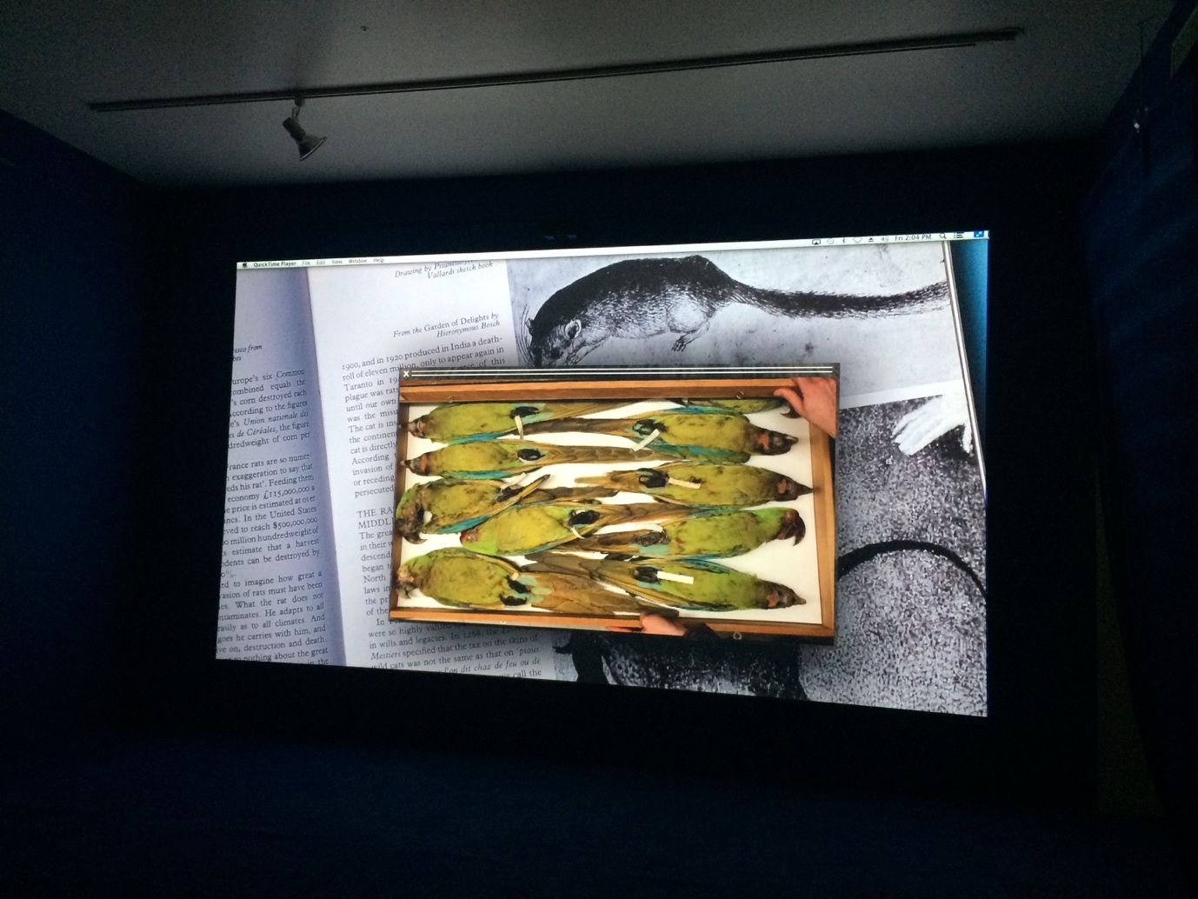

Figure 10: Exhibition view *Grosse Fatigue* by artist Camille Henrot.

Each image or clip is framed by a file window. Taken together, the different fields of study and concepts listed by the narrator are visually represented as part of a larger whole made up of other disciplines that are similar to it. In *Grosse Fatigue,* all the different parts are represented by rectangles. Henrot calls these ‘reciprocal inclusions’, and they are formally represented on screen as a stack of superimposed windows diminishing in size.[41] Like envelops like envelopes like envelopes like. This visual play with patterns of rectangles is repeated throughout the film, like a Fibonacci sequence. In doing so, *Grosse Fatigue* stages a mesmerizing audio and visual *mise en abyme* of the ‘different systems of belief — the different strategies used by humankind — used to synthesise human history which is also kind of a history of the universe’.[42] That is, Henrotimagines the styles and forms of what humans consider forms of knowledge and ideas as an endless recursion of squares within squares. The search engine is yet another square within a square within another square — in an infinitely recurring sequence of squares within squares.

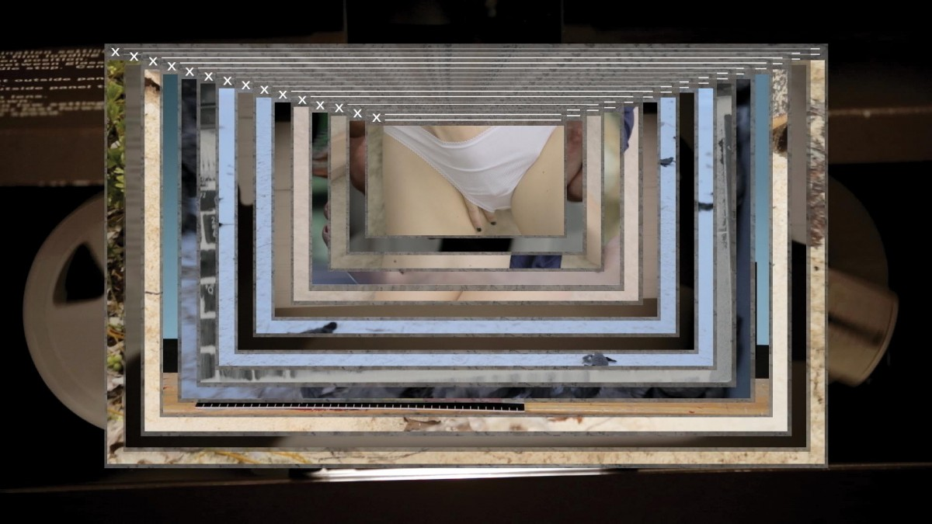

Figure 11: Video still *Grosse Fatigue* by artist Camille Henrot.

‘Knowledge is made for cutting’, Foucault once famously asserted.[43] In other words, in an attempt to understand the whole, parts are formed. In *Grosse Fatigue,* this cutting of knowledge is represented by file systems: storages boxes, file drawers, the folders of computer files, and Google’s search bar. These are all composed in rectangular shapes that crop, frame, set limits. Pop-up window upon pop-up window is interspersed with footage of the neatly-ordered archival facilities of the Smithsonian, suggesting a link between the different ways in which knowledge is cut out, shaped. The rectangle signifies order that results from human intervention.

In *How to Live Together: Novelistic Simulations of Some Everyday Spaces,* Roland Barthes points to the 90- and 180-degree angles of the majority of the livings spaces we create: houses, apartment buildings, doors, windows, roofs. ‘It’s all rectangular ≠ nature: no rectangles […] Rectangle: as the basic shape of power.’[44] The rectangle it is ‘the mark of the division between man and nature’, Henrot claims.[45] Rectangles shape the interfaces through which we navigate spaces of human dominion: databases, archives, maps, contractual papers, field guides, screens, books, and documents. Rectangles separate order from chaos. Rectangles mark off territory and separate inside from outside, what belongs, and what cannot belong, what fits and what does not fit within the four straight lines of its shape. ‘Conquest begins with mapmaking.’[46] Henrot visually emphasizes the imposition of the rectangle by browser windows, folders, and files, the square vignettes and storage rooms and cabinets, boxes — the shape of order — and by juxtaposing them to spiraling objects such as shells — the shape of limitless infinitude.

The final scene of *Grosse Fatigue* shows windows opened to Wikipedia’s lemma of a world map of bipolar disorder and schizophrenia and images of caged animals. Here, the maddening quest for understanding life on earth is linked to contained wilderness and psychiatric disorders with symptoms of disorganized thinking and delusion.The experience of psychiatric disorder is presented in the form of a lemma; the ‘wildness’ of the world is mediated through the rectangular form and straight lines of a cage. *Grosse Fatigue* associates the process of ‘rectangling’ with the caging of animals. A pen is a closed space. Caging an animal is a safety measure. A cage reigns in the unpredictable, and tames it, domesticates it. In imposing clear boundaries, a pen makes the unpredictable, to a degree, predictable. By entering a rectangle, by putting things within a rectangle — also achieved through the preservation of objects within the rectangular spaces of an institution — a closed space is created, a space of finitude, to preserve and hold on to for eternity. Like a wild animal in a cage, the archive and the search engine contain disorder by enclosing it in a rectangle and by rendering it into an ordered list of ‘results’ and a neat line of taxidermal animals.

The rectangle is also a key characteristic of another Google feature, the so-called Knowledge Graph. When users query a well-known person, event, place or thing, they encounter a square panel atop the search results, on mobile phone devices, or to the right of the top results, on most other devices. Google's knowledge graph feature was added to its search engine in 2012. Say you type in ‘Mae C. Jemison’, the graph shows her full name, five portraits and headshot pictures — some older and some more recent — that are captioned ‘American Engineer’. A short text below states: ‘Mae Carol Jemison is an American engineer, physician and NASA astronaut. She became the first African American woman to travel in space when she went into orbit aboard the Space Shuttle Endeavor on September 12, 1992.’[47]

Also included is an additional link to her Wikipedia lemma. In addition, it mentions her date of birth, the space mission she was on, where she went to school, awards received, and the names of her siblings. Reportedly, the information is taken from a variety of sources; however, the information provided is frequently unattributed. In October 2016, Google's CEO, Sundar Pichai, claimed that Google's Knowledge Graph ‘encompasses 70 billion facts’.[48] That is, 70 billion search queries spawned answer boxes atop search results. Knowledge graphs also appear on contentious topics like ‘capital of Israel’, to which Google's Knowledge Graph answers: ‘Jerusalem’.[49] Query ‘best book of 2018’ and it gives you a list of 53 books. Apart Chennapragada, Google’s director of product management states: ‘So the knowledge graph is Google’s understanding of the world and all the things in it.’[50] This comment suggests the world is a container of things. Its reconstruction of the world is one in which every question yields neatly ordered and boxed results. Of course, not everything can find its place in the limited coordinates of a rectangle.

The imposition of rectangles can have deadly consequences. *Grosse Fatigue* refers to ideas in Jacques Derrida’s *Archive Fever: A Freudian Impression*. Derrida explores the subject of the archive from a Freudian perspective and examines the archival desire to collect and preserve in relation to what Freud called the death drive. Derrida draws attention to what remains outside of the archive, to its ‘forgetfulness, amnesia, the annihilation of memory’ and asserts that there is ‘no archive without [an] outside’ of that which is not preserved, or, by virtue of the archive, destroyed.[51] Henrot reflects on this paradox: ‘This is how the collection of endangered species ends up precipitating the complete extinction of certain species, and how some inter-categorical species cannot be named, such as certain invertebrates that are not invertebrate.’[52]

No archival drive exists without a destruction drive, claims Derrida. Death haunts the Smithsonian in a literal sense. The Smithsonian's Department of Anthropology, to which Henrot had full access, was created and expanded rapidly in the context of the end of the American Indian War. As Henrot comments: ‘The first collection contributed in an exponential way to the Smithsonian’s collections was the collection of American Indian artefacts.’[53] The Department of Anthropology has the largest collection in the world of American Indian artefacts. The collection illustrates the historical nexus of power and knowledge. Henrot suggests that the genocide that gave impetus to the collection of the Smithsonian is now dressed up in scientific form masking the violence that fueled the foundation of the Institution. Indeed, Walter Benjamin claims that ‘[t]here is no document of culture which is not at the same time a document of barbarism’.[54] To collect is to cage. To cage is to create a closed space. A closed space is to divide. To divide is to set limits. To set limits is to separate; like a zoo, it provides a way to engage with what is by virtue of the separation considered the wild, the unknown, the other.

The rules of a collection involve classification (be it emblematic, didactic, encyclopedic, or otherwise). Classification has difficulty with what defies classification, with the extra-orderly: cross-links, diversions, hybrids, in-between bodies, monstrosities, the nebulous, imponderables, and other unstable categories. Jack Halberstam observes that in societies focused on classification, counter-archives exist ‘of bodies and modes of being that fall out of the definitional systems produced to describe them’.[55] Any system of order needs an exception and exclusions to be validated. As noted in the previous chapter, when an object, animal or person does not fit the rules of classification, it becomes dangerous, with the potential to bring down curses on those who have disturbed the order of things. To maintain an ordered system always involves violence, partiality and politics. Like politics, you need to know the rules of the game to play the game. And like a game, systems of classification contain, bound, and are rule-based. To create an ordered system always involves violence. To create an ordered system is an interruptive act, which still, necessarily and inevitably, involves prejudice, predilection, and preference. No method of ordering exists without dissymmetry, without exclusions, without some quality of violence, skewing in certain directions and not others.[56] The work of sorting, classifying, ordering, and ranking is outsourced by Google to its algorithms. This is how Google’s index is formed. To be part of its index rules are established. Rules not only point to what is allowed and what not — to what is indexed and what not — but also to who sets the rules and who owns the index. An index, as is well known, is a tool of arrangement. Google’s index is a means to create a system of order in what would otherwise be perceived as a chaotic multitude. To index is to practice exclusions. Exclusions generate a list of results with top and a bottom. Without cutting, discarding, and excluding, there can be no index and no ranked results. An index makes available and unavailable, connects and disconnects, and interconnects, recognises, misrecognizes, and unrecognizes. What is considered part of its index is therefore subjective, contingent, and self-referential.

The moving in circles within rectangles of self-similarity give the narrator of *Grosse Fatigue* much anxiety. While we hear heavy breathing, the voiceover continues in a mournful tone:

And Bumba vomited up the sun, and the sun dried

up some water, leaving land,

and when the earth was to be made, it fell down from the sky.

Earth, hills and stones, all fell down from the sky,

and the Earth rose up like a mountain

And the King above the Sky said, “Punch holes in the Earth,

The water will drain away”

Woman Who Fell From the Sky rested on turtle’s back

God blessed the seventh day and sanctioned it,

Because that in it He had rested from all his work.

The arrow of time points to the heath death of the universe.

And Pan Gu felt lonely

And Heart-of-Sky felt lonely with the loneliness that ends

the worlds.

Who can understand the loneliness of Gods?

Yaweh was lonely

And Ogo was lonely

Lonely like Wak and lonely like Allah.

The whole earth was heavy and then Yahweh rested.

…resting, Pan Gu laid down

and resting, he died.[57]

The inherent subjectivity and self-referentiality of human knowledge or, differently put, the inaccessibility of earthlings to a view from nowhere — to objective knowledge — is expressed in *Grosse Fatigue* by way of emphasizing the loneliness of the Gods in creation stories. Further, the unknown is rendered as both an ontological and epistemological problem. Not knowing the full story, not being able ‘to make sense’ out of a vast and chaotic multitude, is associated with losing one’s mind — in the form of images of a Wikipedia lemma about schizophrenia and bipolar disorder — and with death. The point *Grosse Fatigue* seems to make is that some things cannot be detached from subjectivity. Queries into Google’s vast database or into the Smithsonian’s collection are mediated and governed queries that happen within the bounded space of the web and the archive, which are limited spaces and bounded by time. By overestimating what Google, the Smithsonian and creation stories can provide, Grosse Fatigue's searcher is seized by anxiety. Questions regarding existence cannot be answered by data or documents alone. Further, many things in human existence cannot be documented, transfixed, factually accounted for, indexed or datafied, or reduced to facts.[58]

## Between Fact and Faith: Searching as Collecting

Collections depend on systems of ordering. Ordering systems represent, to use Tara McPherson’s words, ‘a logic of the fragment or the chunk, a way of seeing the world as discrete modules or nodes, a mode that suppresses relation and context’.[59] In his work, Kierkegaard suggests that the anxiety the limits of knowledge leads to can be taken up ‘by a passionate mentality devoted, paradoxically, to overcoming the ultimate limitation of her own understanding’.[60] Or in Kierkegaard's own words, one must ‘infinitely passionately relate himself to the indefiniteness of the definiteness’.[61] How this must be done remains unclear in Kierkegaard writings, but Walter Benjamin's conception of the collector demonstrates one way to leap into objective uncertainty passionately. His notion of collecting as a redemptive activity, ‘a box in the theatre of the world’ as he describes it, offers a way to live with subjective truth and within the limits of knowledge.

In the essay *Unpacking my Library*, Walter Benjamin writes: ‘There is in the life of a collector a dialectical tension between the poles of disorder and order.’[62] Another dialectical tension he points to in *The Arcades Project* is between the collector and the allegorist, when he writes: ‘In every collector hides an allegorist, and in every allegorist a collector.’[63] In *Grosse Fatigue,* the dialectical play between order and disorder and between the collector and allegorist resembles a Google search engine on high-speed. The loose associations between words and images are immediately followed by additional image associations or juxtapositions that, in turn, are supported by other quick associative links made between images and between image and spoken word and within images.

Further, the editing of *Grosse Fatigue* resembles a synthesis between the finite and the infinite and between order and disorder. Images of spiraling objects reoccur in *Grosse Fatigue*. The spiral, as is well known, is the structure of the infinite, the unlimited and the endless — it represents chaos. Kristina Scepanski, one of the editors of *Elephant Child*, describes it as follows:

Camille Henrot deliberately sets out to overwhelm the viewer. The sheer number of objects, the concentration of the stories behind them, the splicing of different disciplines from diverse fields of knowledge, competing principles of classification and, not least, the sensory experience within endlessly looped soundtrack coalesce en masse to demonstrate the excesses of an unbridled urge to collect and hoard, an excessive almost pathological compulsive desire for order, which ultimately is condemned to spill over once more to create its own disorder.[64]

Henrotrepresents order by way of desktop folders, browser windows, archival storage facilities and other ordering systems. These are interspersed with clips and images taken at the Smithsonian of lockers being opened or closed and panned images of its endless corridors filled with file cabinets and boxes. These rectangles and practices of order find their spiral counterparts in the next scene. A small file window hovers over others at the center of the desktop screen. In this window, we see a video of a laptop playing a film. The film shows a man stumbling down a tungsten-lit institutional hallway. He falls against one wall, then against the other, trying to maintain some balance to then quickly topple and fall to the ground. The film is a clip from Rainer Werner Fassbinder’s *World on a Wire* (1973), a German science fiction TV series that plays on the possibility that the world exists entirely inside another world. Fred Stiller, the series’ protagonist, struggles to keep his sanity in this web of worlds within worlds in which the lines between simulation, representation and the real are blurred. *Grosse Fatigue* seems to suggest that when searching for answers about the history of the cosmos, we are all Fred Stiller, thereby linking search engine anxiety to the limits of knowledge. The whole escapes our grasp, ‘[w]e will wander, improvise, fall short and move in circles’.[65]



Figure 12: Video still *Grosse Fatigue* by artist Camille Henrot.

Images of globes reappear in *Grosse Fatigue*: an inflatable globe, a picture of the earth from space, the cover of the Whole Earth Catalogue, a desk globe and a button with the text: ‘Why haven't we seen a photograph of the whole earth yet?’ Globes, and by extension images of globes, imitate the perspective of *Panoptes*, the all-seeing. A globe offers a ‘model of totalizing vision’.[66] Globes also provide an image of the world as an object. Importantly, globes place the one looking at the globe outside of it. It suggests the gaze of an all-seeing outsider. In looking at a globe, one takes the gaze and the position of someone who no longer inhabits the world, but holds it before their eyes, from a distance — like a lonely God. Henrot writes:

The [Smithsonian Natural History Museum] is like a neurosis… Everything must enter the museum: everything living, dying, or deceiving; all the fish in the sea, all the birds in the sky, all the animals of the forest. The aim of the Smithsonian’s Natural History Museum—to be a museum of everything—is an irrational project that is driven by the wish, the ambition, to reconstitute a world.[67]

This reconstituted world, in the form of a collection, becomes an object under one's power and control. Benjamin repeatedly speaks of properties *in the hands* of the collector and to ‘the *tactical sphere*’ of collecting.[68] In *Grosse Fatigue,* feminine hands regularly appear: rolling an orange, throwing marbles, grasping eggs and a sea sponge. Emphasis is also given to the manual act of scrolling, leafing, touching, clicking, and grasping. Another pattern of the manual labor conducted: browser windows being minimized, maximized, overlapped, moved and dragged. Subjective and bodily presence is here presented as forming an essential part of collecting, selecting, and rejecting. Henrot writes that ‘as individuals, we understand an object by holding it in our hand […] The word comprehend derives from the Latin *comprehendre*: *“*com” meaning together, and “prehendere” to grasp’.[69]

What connects the Smithsonian Institution and Google is their shared desire to gather all within a demarcated space. In *Elephant Child,* Henrot associates this desire to own everything, to have the complete set without anything missing, and to hold on to it for eternity with the narcissism of a child, ‘[t]he hungry hoarding child who wants everything’.[70] In a similar vein, Benjamin writes about the collector in *The Arcades Project*:

What is decisive in collecting is that the object is detached from all its original functions in order to enter into the closest conceivable relation to things of the same kind… It is the deepest enchantment of the collector to enclose the particular item within a magic circle, where, as a last shudder runs through it (the shudder of being acquired), it turns to stone. Everything remembered, everything thought, everything conscious becomes socle, frame, pedestal, seal of his possession.[71]

Possession, Benjamin adds, is the most intimate relation a collector can have to their objects.[72] What is the power of the circle of possession? What you can collect you can hold, and what you can hold you can control and protect. In *The Arcades Project,* a book that is also a collection of quotations, Benjamin associates the collector’s accumulation of possessions with a struggle against time — against linear and progressive time and, ultimately, the end of time. The possessive relation between the collector and its objects is characterized by their fate, Benjamin states. ‘[T]he need to accumulate is one of the signs of approaching death.’[73] However, when entering a collection, that fate changes: *it turns to stone*.[74] To collect is to synthesize the eternal and the temporal.[75] Or phrased in Benjamin’s terms, the collection, a circle of possession that encircles the collected, forms a dialectical image at standstill. In a collection, past, present, and future converge into a single materialization of what Benjamin called now-time. Benjamin’s conception of the collection also offers an opening to Kierkegaard’s notion of the possible.

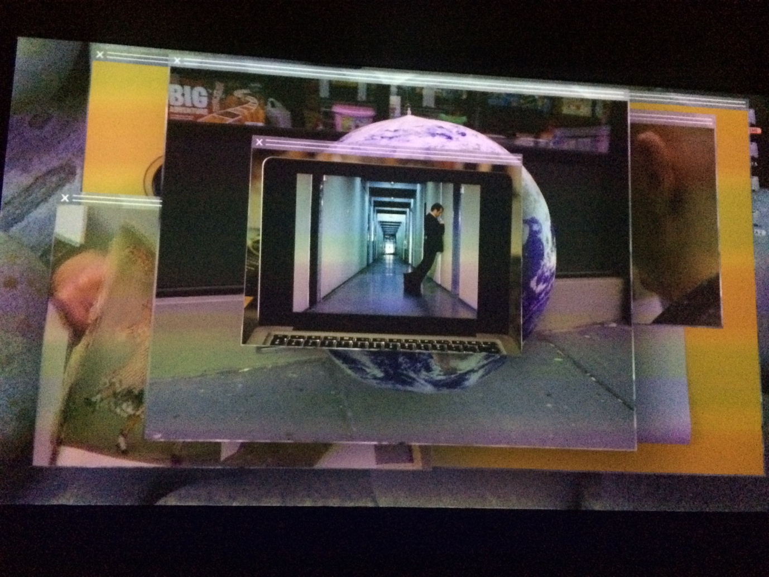

Figure 13: Video still *Grosse Fatigue* by artist Camille Henrot.

In her reminiscence *Walter Benjamin: 1892-1940*, Hannah Arendt writes about the primacy of collecting in Benjamin’s philosophy. She identifies a redemptive quality central to his understanding of collecting. It is this redemptive quality that further connects the work of Benjamin and Kierkegaard. Arendt comments:

And inasmuch as collecting can fasten on any category of objects (not just art objects, which are in any case removed from the everyday world of use objects because they are ‘good’ for nothing) and thus, as it were, redeem the object as a thing since it now is no longer a means to an end but has intrinsic worth, Benjamin could understand the collector’s passion as an attitude akin to the revolutionary, the collector “dreams his way not only into a remote or bygone world, but at the same time into a better one…” Collecting is the redemption of things which is to complement the redemption of man.[76]

When mapped onto Kierkegaard’s notion of the possible, the ‘redemptive’ in Benjamin’s understanding of the collection provides an opening to Kierkegaard’s concept of the possible within the rectangular spaces of knowledge that have made the narrator of *Grosse Fatigue* gasp for air.

Ownership, Benjamin writes about the collector’s object, is ‘the asylum’ where objects ‘take refuge’.[77] He explains this in a way reminiscent of Kierkegaard’s relational synthesis of the self: ‘The collector delights in evoking a world that is not just distant and long gone but also better.’[78] It is the interior home of the collector, the dwelling space, that forms the asylum, not just of the collector’s collected objects, but also of:

The private individual, who in the office has to deal with realities, needs the domestic interior to sustain him in his illusions. [The interior] represents the universe. In the interior, he brings together remote locales and memories of the past. His living room is a box in the theatre of the world.[79]

The collector gathers fragments from a world outside of their control to rebuild a world within their confines and control. The collector restores a fragmented world within the world — a box within a box. Benjamin relates this redemptive act of collecting to the attempt to reconstitute God, on a human scale.[80] A collection gives collectors the possibility to surround themselves with their belongings, to dwell in them, live in and with them, and to *redeem* them for the present.[81] A collection saves an object from the ‘drudgery of being useful’ by making it a material manifestation of an eternal value frozen in time that, hence, cannot die.[82]

*Grosse Fatigue* is the result of Henrot’s collection of a collection curated by people at the Smithsonian’s Institution and by Google’s algorithms. What is the function of the collection for Henrot? In *Elephant Child,* Henrot argues that collecting is a defense mechanism: ‘The desire to gather everything together always arises in response to a stress: it is a defense mechanism.’[83] The collection re-fabricates an encompassing whole, oneness. It re-creates completeness, she argues.[84] Here, Henrot echoes Benjamin who writes: ‘For the collector, the world is present, and indeed ordered, in each of his objects. Ordered, however, according to a surprising and, for the profane understanding, incomprehensible connection.’[85]

According to Benjamin, ‘the collector lives in a piece of dream life’.[86] The collector arranges a miniature of the universe — a globe within a globe.[87] The collector’s ‘deepest desire’ is to ‘renew the old world’, Benjamin writes.[88] As Henrot elaborates, this desire involves a restorative impulse: ‘The aim of exhaustiveness, the desire of the complete collection, or the total history of the universe: each desire to collect is a desire to collect fragments that aims to effect a kind of symbolic restoration.’[89] Restoration implies origins and loss, the restoring to a former condition, the replacement of what is considered lost, dispersed. *Grosse Fatigue* represents the collections of the Smithsonian archives and Google’s index as fueled by the age-old desire to repair and make whole again, to reconstitute the exterior within a demarcated space of the interiors of the archive and the database — imagined completeness as a defense mechanism against linear and progressive time. To collect is to re-create a world cleansed of frustration, like a miniature world — a box in the theatre of the world. In a box, things have their designated place, things considered to belong together are kept together and shielded from the outside. A collection is a box in a world. Henrot: ‘When the facts of life are painful, building a world of knowledge and ideas offers a shelter.’[90] ‘The accumulation of objects is a way to build walls around a space, to create a world within a world […] The return to the womb, an autarkic space protected from what it fears.’[91] To collect is to synthesize the temporal and the eternal. How does a collection relate to the infinite?

## Searchers as Collectors of Possibility in Structures of Faith and Knowledge

Collections make connections to forces, intensities, and capacities that roam inside and outside the dwelling spaces of the collector. The reappearance of hands that click, double-click, reject and select in *Grosse Fatigue* emphasize the ability to ‘edit’ a story, as well as the ability to become a creator of those stories. Considered this way, *Grosse Fatigue* is a collection within a collection within a collection. The Smithsonian collection, it could be argued, is a creation story in reverse order. It attempts to make a whole out of fragments. By contrast, the list of URL results Google’s search engine offers moves from link to link and makes connections that could be seen as selecting fragments from the whole. Collections make connections; they have a fictional quality; they tell a story. What does narrativization offer? A narrative provides linear structure, a before and an after, and causation within a limited space. Creation stories are linear stories of classification. They are often represented as following a linear, progressive structure, that clusters and organizes events around a continuum — *and then came the vertebrates, the jawless fish. And then came the nautiloids in the Devonian ages of fishes*. Stories also offer a sense of location and direction. This is how it began, we are *here*now, and *this* is how it ends — *and on the Seventh Day…* Like a narrative, science organizes its forms and contents into a series of events and gives them meaning. Every collection creates a story, re-tells a creation story, and collects stories within stories. By arranging objects, a collector produces a narrative. By making different selections or using the same objects but order them differently, different stories can be told. A collection forms part of an infinite spiral of possible stories in a finite and bounded space. A synthesis between the finite and the infinite emerges. Collecting has infinite components, yet it involves plain and straightforward work: seeking, assembling, scavenging, perusing, gathering, purchasing — making all the necessary rounds, doing often thankless tasks, and having patience. Searching-as-collecting and the searcher-as-collector offers a relational play with components and connections between faith and knowledge, fact and fiction, and the finite and the infinite.

To search is to collect, and to collect is to create a dwelling space. Dwelling is an embodied activity that takes place in the thresholds between finitude and infinitude, the temporal and eternal. Camille Henrot’s *Grosse Fatigue* represents a web search as an activity filled with contradictions. It enacts web search as the result of a continuous exchange between two opposites that influence each other: the analogue and the digital, the historical and the contemporary, the factual and the fictional, faith and reason. Quests for knowledge are about thinking *and* being. Kierkegaard writes in *CUP*: ‘thinking and being signify one and the same’.[92] Kierkegaard would insist that these dwelling spaces of collectors are not autarchic spaces; they are never cleansed of frustration nor rinsed clear of uncertainties. Likewise, search queries are always haunted by the limits of knowledge, by dispersion, by disorder, which stains the neat list of result offered to the searcher. Paradoxically, the very ordering and sorting operations of search algorithms invoke uncertainty and anxiety. Acknowledging this and reckoning with these limits is as close as one can get to faith and as close as one can get to the possible. Seen this way, collecting is a reminder of the synthesis between faith and knowledge and the collector’s relation to the infinite, as well as a way to move in and out of a world without permanent certainties.

In the previous chapters, I sketched out the concept of algorithmic anxiety through a close reading of a range of prominent contemporary artworks that address concerns about facial recognition algorithms (Chapter 2), trading algorithms (Chapter 3), and, in this chapter, search algorithms (Chapter 4). In the next and concluding chapter, I synthesize the main ideas of the previous chapters that together affirm the importance of an aesthetics of possibility in relation to algorithmic anxiety.

1. E. Kolbert, ‘Who Owns the Internet?’ *The New Yorker*, 21 August 2017, https://www.newyorker.com/magazine/2017/08/28/who-owns-the-internet.
2. Google Search, ‘How Search Works: Our Mission’, *Google,* 2019, https://www.google.com/search/howsearchworks/mission/.
3. In Europe, the market of search engine technology and database infrastructures is dominated by Google. See, for example, StatCounter: http://gs.statcounter.com/search-engine-market-share.
4. In various ways artists such as Femke Herrengraven, Jeroen van Loon, Timo Arnall, Emma Charles, James Bridle, Jan Robert Leegte, Barrett Lyon, Adam Harvey, Ingrid Burrington, Clement Valla, Jonas Lund, Paolo Cirio, and Evan Roth, visualize the seeming ‘immateriality’ of aspects of the web search and search infrastructures in their work. With *Internet Landscapes* (2016) Evan Roth presents a series of landscape photography. For this series he travelled to parts of the world where submarine internet cables arrive on land. The work *Internet Machine* (2014) by Timo Arnall, aims to reveal the hidden materiality of the data that makes up the internet. Using a wide-angle lens and slow-motion his multi-screen film installation depicts the inside and outside of one of the largest data centres in the world. And in her multi-screen film installation *White Mountain*, Emma Charles draws in on the Pionen Data Center, buried under granite in Stockholm. The data centre is embedded in a former Cold War-era nuclear defence bunker, buried 30 meters underground beneath a rocky granite mountain of the Vita Bergen Park in Stockholm. By focusing on the spatial-architectural features of search engines, Charles develops conceptual associations between a web search and the vast and remote data centre, as well as, its server stacks.
5. P. Braquenier, ‘Palimpsest‘, *Philippe Braquenier*, 2012, https://philippebraquenier.com/palimpsest.
6. Counter Map Collection, ‘The Deleted City’, *Counter Map Collection*, May 2019, http://countermapcollection.org/collection/deleted-city/.
7. For *Grosse Fatigue*, Henrot was awarded the Silver Lion at the 55th Venice Biennale. Her work has been shown at numerous museums, art institutions and biennale, including at Chisenhale Gallery, London; Kunsthal Charlottenburg, Copenhagen; Bétonsalon, Paris; Westfällischer Kunstverein, Munster; Palais de Tokyo, Paris; Hammer Museum, Los Angeles; Fondazione Memmo, Rome; the New Museum, New York; Schinkel Pavilion, Berlin; New Orleans Museum of Art, New Orleans; Musée du Jeu de Paume, Paris; MoMA, New York; Centre Pompidou, Paris; Astrup Fearnley Museet, Oslo; Stedelijk Museum, Amsterdam; SculptureCenter, New York; as well as the 2015 Lyon Biennial and the 2016 Berlin Biennial.
8. E.g. T. Jordan, *Information Politics: Liberation and Exploitation in the Digital Society,* London: Pluto Press, 2015; N. Couldry, *Media, Society, World: Social Theory and Digital Media Practice*, Cambridge: Polity Press, 2012; C. Fuchs, ‘Google Capitalism’, *TripleC - Cognition, Communication, Co-operation*, 10.1 (2012): 42-48; R.W. Gehl, *Reverse Engineering Social Media: Software, Culture, and Political Economy in New Media Capitalism*, Philadelphia: Temple University Press, 2014; R. Epstein, ‘To Break Google’s Monopoly on Search, Make its Index Public’, *Bloomberg Businessweek*, 15 July 2019, https://www.bloomberg.com/news/articles/2019-07-15/to-break-google-s-monopoly-on-search-make-its-index-public; A. Mager, ‘Algorithmic Ideology: How Capitalist Society Shapes Search Engines’, *Information, Communication & Society*, 15.5 (2012): 769-787; D. Lewandowski, ‘Why We Need an Independent Index of the Web’, in *Society of the Query Reader: Reflections on Web Search*, edited by R. König and M. Rasch, Amsterdam: Institute of Network Cultures, 2014; V. Campanelli, ‘Frictionless Sharing: The Rise of Automatic Criticism’, in *Society of the Query Reader: Reflections on Web Search*, edited by R. König and M. Rasch, Amsterdam: Institute of Network Cultures, 2014; K. Jarrett, ‘A Database of Intention’, in *Society of the Query Reader: Reflections on Web Search*, edited by R. König and M. Rasch, Amsterdam: Institute of Network Cultures, 2014.
9. Mager, ‘Algorithmic Ideology’.
10. Chun, *Control and Freedom,* 19.
11. Min Jiang conducted a comparative study of Baidu’s and Google’s search results in China. Based on the search results of 316 popular Chinese news events Min Jiang found in the top 10 search results of Baidu and Google an overlap of less than 7%. M. Jiang, ‘The Business and Politics of Search Engines: A Comparative Study of Baidu’s and Google’s Search Results of Internet Events in China’, *New Media & Society*, 2013, https://doi.org/10.1177/1461444813481196.
12. E.g. A. Jobin and O. Glassey, ‘“I Am not a Web Search Result! I Am a Free Word”: The Categorization and Commodification of “Switzerland” by Google’, on *Society of the Query Reader: Reflections on Web Search*, edited by R. König and M. Rasch, Amsterdam: Institute of Network Cultures, 2014; S. Vaidhyanathan, *The Googlization of Everything: (And Why We Should Worry)*, Oakland, CA: University of California Press, 2011; Petzold, ‘The Merkel Algorithm’; E. Pariser, *The Filter Bubble: How the New Personalized Web is Changing What We Think and How We Read,* London: Penguin Books, 2011; S. Knight and N. Mercer, ‘The Role of Exploratory Talk in Classroom Search Engine Tasks’, *Technology, Pedagogy and Education*, 24.3 (2015): 309-319; Ørmen, ‘Googling the News’.
13. E.g. W.H. Dutton, B. Reisdorf, E. Dubois, and G. Blank, ‘Search and Politics: The Uses and Impacts of Search in Britain, France, Germany, Italy, Poland, Spain, and the United States’, *SSRN* (2017): http://dx.doi.org/10.2139/ssrn.2960697; R. Epstein and R.E. Robertson, ‘The Search Engine Manipulation Effect (SEME) and its Possible Impact on the Outcomes of Elections’, *PNAS*, 112.33 (2015): https://doi.org/10.1073/pnas.1419828112; A.L. Hoffmann, ‘Where Fairness Fails: Data, Algorithms, and the Limits of Antidiscrimination Discourse’, *Information, Communication & Society*, 22.7 (2019): 900-915.
14. S. Noble, *Algorithms of Oppression*, New York, NY: New York University Press, 2018, 148.
15. K. Becker and F. Stadler, *Deep Search: The Politics of Search beyond Google,* Vienna: Studien Verlag, 2010.
16. E.g. Pariser, *The Filter Bubble*; Borra and König, ‘The Filter Bubble Show’.
17. Bucher, *If... Then,* 3-4.
18. Lewandowski, ‘Why We Need an Independent Index of the Web’, 49.
19. Lewandowski, ‘Why We Need an Independent Index of the Web’, 50.
20. Lewandowski, ‘Why We Need an Independent Index of the Web’, 50.
21. Lewandowski, ‘Why We Need an Independent Index of the Web’, 50-51.
22. Lewandowski, ‘Why We Need an Independent Index of the Web’, 50-51.
23. Lewandowski, ‘Why We Need an Independent Index of the Web’, 51.
24. Bucher, *If... Then*, 8.
25. Zuboff, ‘Google as a Fortune Teller’.
26. Zuboff, ‘Google as a Fortune Teller’.
27. Zuboff, ‘Google as a Fortune Teller’.
28. Zuboff, ‘Google as a Fortune Teller’.
29. N. Anderson, ‘2006 AOL Search Data Snafu Spawns “I Love Alaska” short films’, *ArsTechnica*, 1 January 2009, https://arstechnica.com/information-technology/2009/01/aol-search-data-spawns-i-love-alaska-short-films/.
30. Simon, ‘Image Atlas’.
31. Smithsonian Institution, ‘Smithsonian Purpose and Vision’, https://www.si.edu/about/mission.
32. Google Search, ‘How Search Works: Our Mission’, *Google,* 2019, https://www.google.com/search/howsearchworks/mission/.
33. C. Henrot, ‘Grosse Fatigue’, video, 13 min., 2013, exhibited at *GLOBALE: Exo-Evolution*, ZKM, Karlsruhe, 2015.
34. Henrot, ‘Grosse Fatigue’.
35. Kierkegaard, *Fear and Trembling*, 46.
36. In *Fear and Trembling*, Kierkegaard uses the example of love. All of us have to learn what it means, experientially, to love. Sure, poetry, films, novels, and songs, as well as stories from experienced people, can help us form a conception of what love is. However, each one of us needs to struggle with it ourselves and to proceed to understand it experientially. There are no short-cuts or substitutes for that. We cannot learn what love is by merely listening to love songs nor reading all the books that have been written about it.
37. Henrot, ‘Grosse Fatigue’.
38. C. Henrot as cited in A. Picard, ‘Camille Henrot: A Hunter-Gatherer During a Time of Collective “Grosse Fatigue”’, *Cinema Scope*, 56 (2013): http://cinema-scope.com/columns/tiff-2013-preview-grosse-fatigue-camille-henrot-franceusa/.
39. Henrot, *Elephant Child*, 184.
40. Henrot, ‘Grosse Fatigue’.
41. Henrot, *Elephant Child*, 28.
42. Henrot, *Elephant Child*, 182.
43. M. Foucault, ‘Nietzsche, Genealogy, History’ in *The Foucault Reader*, edited by P. Rabinov, New York: Pantheon, 1984, 88.
44. R. Barthes as cited in Henrot, *Elephant Child*, 54. A classic example is the powerful effect of the shiny black rectangular monolith in Stanley Kubrick’s *2001: A Space Odyssey*.
45. Henrot, *Elephant Child*, 54.
46. Henrot, *Elephant Child*, 141.
47. This is the result of the search query ‘Mae C Jemison’ of November 19, 2018. The content of the Knowledge Graph is subject to change.
48. S. Pichai as cited in J. Vincent, ‘Apple Boasts About Sales: Google Boasts About How Good Its AI Is’, *The Verge*, 4 October 2016, https://www.theverge.com/2016/10/4/13122406/google-phone-event-stats.
49. This is the result of the search query ‘Jerusalem’ of November 19, 2018. The content of the Knowledge Graph is subject to change.
50. A. Chennapragada as cited in J. Slegg, ‘Google Has Over 1 Billion Knowledge Graph Entities in Search Results’, *The Sem Post*, 29 May 2015, http://www.thesempost.com/google-1-billion-knowledge-graph-search-results/.
51. J. Derrida, ‘Archive Fever’, in *The Archive: Documents of Contemporary Art*, edited by C. Merewether, London: Whitechapel, 2006, 78.
52. Henrot, *Elephant Child*, 99.
53. C. Henrot, ‘Table Ronde: Le Musee des Choses: Autour de “Grosse Fatigue”’, *l'Amphithéâtre d’Honneur de l’École Nationale Supérieure des Beaux-Arts*, Paris, France, 12 February 2014, https://vimeo.com/88138929.
54. W. Benjamin, ‘On the Concept of History’, in W. Benjamin, *Selected Writings: Volume 4*, Cambridge: The Belknap Press of Harvard University Press, 2003(1938-1940), 392.
55. J. Halberstam as cited in D.R. Young, ‘Public Thinker: Jack Halberstam on Wildness, Anarchy and Growing up Punk’, *Public Books*, March 26 2019, https://www.publicbooks.org/public-thinker-jack-halberstam-on-wildness-anarchy-and-growing-up-punk/.
56. J. Derrida, ‘Force of Law: The Mystical Foundation of Authority’ in *Deconstruction and the Possibility of Justice*, edited by D. Cornell, M. Rosenfeld, and D.G. Carlson, New York, NY: Routledge, 1992.
57. Henrot, ‘Grosse Fatigue’.
58. Take the story of Hans Christian Andersen’s *Thumbalina* (1835). The facts are straightforward: a tiny girl is kidnapped by a toad who wants to marry her off to her son. The girl is held captive by the toad on a lily pad deep in the woods. Some wood creatures – fish, butterflies, and birds — come to her rescue. A swallow drops her off at a meadow where she meets a fairy prince, and they fall in love. These facts tell us nothing about the charm, warmth and wit of the characters, the poetics of the story, the allegorical style, nor of the contradictory and diverging meanings attributed to the tale. In other words, life refuses to be entirely factual. In *Concluding Unscientific Postscript,* Kierkegaard puts it thus: ‘Even if a man his whole life through occupies himself exclusively with logic, he still does not become logic; he himself therefore exists in other categories.’ Kierkegaard*, Concluding Unscientific Postscript*, 185.
59. McPherson, ‘Why Are the Digital Humanities So White?’, 144.
60. Cake, ‘Thinking the Unknown’.
61. Kierkegaard*, Concluding Unscientific Postscript*, 372.
62. W. Benjamin, ‘Unpacking My Library’, in *Illuminations,* edited by Arendt, London: Pimlico, 1999, 60.
63. W. Benjamin, *The Arcades Project,* translated by E. Howard and K. McLaughlin, Cambridge: Harvard University Press, 2002, 211.
64. K. Scepanski, ‘Introduction’, in *Elephant Child*, edited by C. Meister, M. Connor, J. Bromberg, and K. Scepanski, New York: Inventory Press & London: Koenig Books, 2016, 8.
65. J. Halberstam, *The Queer Art of Failure*, Durham and London: Duke University Press, 2011, 25.
66. Henrot, *Elephant Child*, 138.
67. Henrot, *Elephant Child*, 80.
68. Benjamin, ‘Unpacking My Library’, 63, italics mine.
69. Henrot, *Elephant Child*, 150.
70. Henrot, *Elephant Child*, 59.
71. Benjamin, *The Arcades Project*, 204-205, italics mine.
72. Benjamin, ‘Unpacking My Library’, 67.
73. Benjamin, *The Arcades Project*, 208.
74. Benjamin, *The Arcades Project*, 205.
75. *The Arcades Project* contains a number of quotations from the work of Kierkegaard, specifically from *Either/Or* in which Kierkegaard discusses the synthesis between history and memory, past and present, and exterior and interior history. Benjamin’s concept of history does away with history as a *narrative* and transforms the concept of history into an *image*. His account of the dialectical image offers a starting point for a materialist history as an encounter between the past and the present that is articulated as a rapidly emergent image — a flash. This transduction of images for narratives constitutes his immanent critique of the concept of progress. As he explains in *The Arcades Project*: ‘Not that what is past casts its light on what is present, or what is present its light on what is past; rather, *image* is that wherein what has been comes together in a flash with the now to form a constellation. In other words, image is dialectics at a *standstill.* Benjamin, *The Arcades Project*, 462. There are more links to be made between Benjamin and Kierkegaard. Both emphasise interruptions and transformative events. Rupture permits an opening through which the eternal and infinite can be allowed a place in the present. Benjamin's emphasis on ‘flashes’, ‘moments’, ‘suddenness’, as well as Kierkegaard’s stress on the ‘sudden’, ‘the possible’, ‘singular’, and ‘seizing’ counters with conventional modernist philosophies of continuity and progress. When Benjamin looks back at history, he sees not laws or systems of development but contradictory forces and a dialectical process in which impacts of the past play an important, yet often suppressed, part in the present. When Kierkegaard looks at human existence, he sees calculation, laws, and rules, but also contradiction, paradox, and absurdity. For Kierkegaard, heterogeneity and syntheses signify the non-opposition of opposites. For Benjamin, dialectical images signify the non-opposition of the what-has-been and the now. And for both, change must come from within. Alas, a more substantive comparative analysis of the central concepts and ideas of these two thinkers falls beyond the scope of this book.
76. H. Arendt, ‘Walter Benjamin: 1892-1940’, in *Illuminations,* edited by H. Arendt, London: Pimlico, 1999, 46.
77. Benjamin, *The Arcades Project*, 19.
78. Benjamin, *The Arcades Project*, 19.
79. Benjamin, *The Arcades Project*, 19, italics mine.
80. As Daston and Park have documented in *Wonders and the Order of Nature*, in medieval Western Europe writers of encyclopaedias were often monastic Christians that studied God’s creation in order to come closer to Him. Encyclopaedias often followed the structure of the days of creation by God. Likewise, John Prest argues in *The Garden of Eden* (1981) that sixteenth-century botanical gardens were not merely a collection of plants, they were considered re-creations of the garden of Eden. J. Prest as cited in C. Kwa, *De ontdekking van het weten: De andere geschiedenis van de wetenschap*, Amsterdam: Boom Uitgevers Amsterdam, 2009, 277.
81. Benjamin, ‘Unpacking My Library’, 67.
82. Benjamin, *The Arcades Project*, 209.
83. Henrot, *Elephant Child*, 84.
84. Henrot, *Elephant Child*, 48.
85. Benjamin, *The Arcades Project,* 207.
86. Benjamin, *The Arcades Project,* 205.
87. Benjamin, *The Arcades Project,* 208.
88. Benjamin, ‘Unpacking My Library’, 61.
89. Henrot, *Elephant Child*, 59.
90. Henrot, *Elephant Child*, 102.
91. Henrot, *Elephant Child*, 48.
92. Kierkegaard, *Concluding Unscientific Postscript*, 407.