# The Green-and-Yellow Black Box: Mobilization on Platforms for the Attempted Coup on January 8, 2023

### Aline Roes Dalmolin[1]and Maria Eduarda Mathias[2]

## Introduction

This chapter aims to analyze how the mobilization for the anti-democratic act of January 8, 2023 took place through extreme-right Bolsonarist groups on social media platforms. The purpose is to illustrate how the groups were organized and their gradual radicalization. To understand the radicalization of Brazilian extreme-right groups on social media, which led some of their members to pose a threat to Brazilian democracy, it is necessary to link the invasion of the Planalto in Brasilia with a history of escalating hatred, disinformation, and lack of accountability during Jair Bolsonaro’s government (2019-2022) – and even before that.

Radicalization has been a recurring theme for Bolsonaro and his followers long before his election as President of Brazil in 2018. During the presidential elections of 2018, Bolsonaro’s speeches consistently incorporated elements of military authoritarianism and nationalism using phrases such as 'let's eliminate the petralhada'[3] and 'our flag will never be red'[4], which garnered significant resonance and was widely adopted among his followers. Throughout his government, there were constant attacks on various sectors of society and state institutions, such as the Supreme Federal Court (STF), which repeatedly acted to hold the government accountable for its mistakes with grave consequences for the population. For example, the Bolsonaro government's handling of the COVID-19 pandemic was marked by widely disseminated disinformation, often by the former president himself, his family members, and members of his government. In addition, delays in vaccine procurement, advocacy for unproven medications, and the absence of large-scale vaccination campaigns and few public education efforts by the national government.

During Bolsonaro’s four-year mandate, disinformation networks were strengthened and intensified during the 2022 electoral campaign that led to the terrorist acts on January 8, 2023. While polls indicated Luiz Inácio Lula da Silva as the favorite candidate in the race, then-President Bolsonaro made several statements on social media casting doubt on the reliability of electronic voting machines. However, this claim was made public by Bolsonaro during an official meeting with foreign ambassadors on July 18, 2022, in which he criticized the Brazilian electoral system without presenting evidence for his allegations. This meeting played a pivotal role as the Superior Electoral Court of the country would later condemn Bolsonaro for abuse of political power and the misuse of the media for electoral purposes while still in office. As a result, he has lost his political powers and was declared ineligible until 2030, preventing him from running for the next presidential election in 2026.[5]

Attempts to undermine democracy, however, are not exclusive to Brazil. A similar movement occurred two years earlier in the United States, led by then-President Donald Trump. During the tumultuous 2020 US presidential elections, characterized by the emergence of the COVID-19 pandemic and the rise of the Black Lives Matter movement, Trump fueled public debate byquestioning the integrity of the American electoral system, amplified through disinformation campaigns and conspiracy theories across various social media platforms. On January 6, 2021, Trump supporters stormed the United States Capitol in Washington D.C. alleging election fraud, an episode marked by vandalism, aggression, and homicide.[6] The attack was an attempted coup which was promoted and organized online, with acts of violence and various offline repercussions.[7]

Similarly, the attempted coup in Brazil was not a spontaneous protest but an organized act of terrorism. It was orchestrated over the past few years through speeches, videos, and organized mobilizations disseminated within Bolsonaro-supporting groups that culminated on the events of January 8, 2023, with over one thousand individuals detained in Brasília. Masked by patriotism, the purpose of these groups has authoritarian tendencies and aims to destabilize democracy, demonstrating, above all, how social media and messaging app platforms have become a disinformation machine for the far-right in Brazil.

## Platformization and Far- Right Media Ecology

The interdisciplinary nature of the platformization of society makes it difficult to conceptualize concretely, mainly because it refers to an unfinished process. Technologies and everything surrounding them are part of a multidimensional system. Since the present times are multidimensional, Van Dijck, Poell and De Wall emphasize the importance of contexts and how our research and observation are subject to many structural and historical interpretations and intersections.[8] Platforms permeate society in all its dimensions, from geopolitics to global infrastructures, and everything is interdependent on them. For instance, technological elements in the anatomy of a platform help guide user interactions and actions, and thus provide an overview of how society is shaped by them.

According to Van Dijck, Poell and De Wall, a platform is a digital architecture that seeks to organize interactions among its users through systematic data collection, algorithmic processing, and data monetization.[9] The collective network of platforms constitutes a *platform ecosystem* defined by various mechanisms. Therefore, to understand platformization entails more than addressing techniques and tools – it involves recognizing a process that encompasses the production, recognition, and circulation of meanings within an ecosystem. Despite the undeniable benefits of the digital age, the limitations stemming from users' lack of understanding of the entirety of the process become evident when they simply register to participate in a platform. For instance, when we accept cookies[10] or terms of use on a webpage or app, we provide our personal data and geographical location and enter into a system whose operations we are unaware of. Consequently, the price to pay for living inside platforms is to expose ourselves to the black box of informational tracking and surveillance capitalism.[11]

The term 'black box’, a metaphor borrowed from the recording device found in airplanes, trains, and cars, refers to a system with an unknown operation, where it is possible to observe its inputs and outputs but not how it processes data and information. According to Pasquale, we are currently being tracked more intensively by companies and governments and we have no idea about how this information is processed and its consequences.[12] Following Zuboff, surveillance capitalism is an economic structure built around the expropriation of information through digital platforms operating through unprecedented asymmetries concerning the interplay of knowledge and power, by extracting monetary value from user-generated information production.[13]

To fade, dissolve, blind, or unravel – any synonym we use does not convey the full extent of the obscurity in a platform’s operational logics. Even though much attention is given to algorithmic performance and its influence on users, little is questioned about the consequences of operative patterns established by humans, or about who benefits from the secrecy or sale of personal data from an entire society.

But when every move we make is subject to inspection by entities whose procedures and personnel are exempt from even remotely similar treatment, the promise of democracy and free markets rings hollow.[14]

In this regard, we touch upon the essential pillar of the context which we have chosen to unfold here. Politics, according to Castells, is driven by emotion, passion, and hope.[15] But the Brazilian political landscape in recent years has pushed these aspects to a limit that challenges the fundamental principles of democracy, surpassing the classical conception of politics as 'the competition or dialogue between groups or proposals. Instead, politics enters a realm of narrative conflicts whose purpose is to overshadow one another at any cost. The way in which the coordinated action across different platforms enabled the mobilization of an anti-democratic event of such magnitude highlights the exercise of power of platforms in shaping the political course of Brazil.

In recent years, Brazil has been suffering from the rampant circulation of disinformation from dubious information sources that generate monetizable content and stand out as communication channels for the general population, and has occupied the space formerly dominated by journalism and social institutions in a general sense.[16] In a context conducive to the circulation of untruths, information manipulation has escalated to the extent of causing chaos, instilling doubts, and inducing moral panic. To understand the functioning of these 'synapses' leading to the Bolsonarist mobilizations on January 8, 2023, we will examine the ensemble of platforms activated for this purpose, as they constitute part of a complex multimedia ecosystem.

In Brazil, a far-right media ecology has been referred by some authors as the *Bolsonarist mediasphere*.[17] Based on Rocha, the Bolsonarist mediasphere aims to produce false information and construct polarizing narratives (good versus evil, left versus right, etc.), seeking to create a parallel reality within information bubbles and promote the unity of political activism.[18] Similar to the far-right in other parts of the world, this mediasphere also exploits content campaigns and digital micro-targeting.[19] The very organization of the events on January 8 attests to the existence and organized action of networks structured over the past few years, and without which the mobilization for the event would not have been possible.[20]

Telegram and WhatsApp groups were the preferred spaces for radical Bolsonarists to mobilize for the terrorist acts. However, a wide range of information types and modes of use were activated through these networks. Among the platforms mobilized by the Bolsonarist mediasphere, we have chosen Telegram for this study because of its importance for Bolsonarist groups, and its role in maintaining so-called information bubbles favoring intense political polarization. In a survey about internet usage behavior conducted by *Datafolha*, it was shown that WhatsApp has a usage rate of 92% across all social strata and regions of the country.[21] The same survey identified Telegram as the main concern in the context of the 2022 elections given its significant user base among Bolsonarist supporters.[22] Another reason for choosing Telegram is how the extreme-right uses Telegram in the Global South. In this context, we refer to Cruz and Harindranath’s terminology 'technologies of life,' which encompass the experience of technologies that mediate all aspects of social life, such as Telegram and WhatsApp.[23]

Going beyond the concept of 'social network’,’ technologies of life’ blend aspects of public and private life into a semi-public, multimodal communication.[24] 'Technologies of life’ combine mass-oriented features such as the creation of information-sharing groups and channels with more private characteristics like encrypted conversations and the lack of transparency in APIs for external users. This concept safeguards usage that goes beyond what is commonly understood as a form of mediation developed initially in social networks, which were originally designed to facilitate bilateral message exchange between users.[25] Thus, platforms like Telegram enable the micro-targeting of messages to individual users while also allowing for the distribution of mass content to large groups, facilitating the mobilization of users for political engagement. Another reason Bolsonarists choose this platform is that Telegram groups allow an unlimited number of users to be added, which facilitates the organization of mobilization.

## Opening the green-and-yellow black box

The text describes the timeline of narratives over the course of a week on a Bolsonarist group on Telegram platform. The analysis period begins on the day of Luís Inácio Lula da Silva's inauguration as President of Brazil, January 1, and concludes on the day of the coup attempt, January 8, 2023.The first week of January 2023 witnessed significant activity within Bolsonarist Telegram groups. The circulation of messages in these groups included a wide array of information typologies, including texts, videos, photographs, audio recordings, and more. Many of these contents or even groups are no longer accessible due to actions taken by the Brazilian Supreme Federal Court (STF), the country's highest court, which ordered the suspension of various coup-related groups in the post-election period in late 2022.

In this section, we will examine a Bolsonarist Telegram group,[26] which at the time of data collection was named 'Sucessos anos 1980' (‘1980s Greatest Hits’). Lately, this group was renamed to 'Fora Lula, Fora Desgoverno (‘Out Lula, Out Disgovernment’)', which coincides with the writing in October 2023.[27] This is a public group accessible through an invitation link. The group remains active with 858 members and has only one sentence in the group description: 'FORBIDDEN to send porn content and PIX',[28] that shows its moderators’ concern in controlling the type of content and preventing financial transactions in the group. There is a constant forwarding of messages from other Telegram groups and channels or of content generated in other platforms such as WhatsApp, Twitter, Instagram, Facebook, and YouTube. Additionally, there is a prolific exchange of various materials such as videos, audios, texts, links, images, and stickers.

During the first week of January, slogans like 'selva' (‘jungle’)[29] and legal terms such as 'Garantia de Lei e Ordem' (‘guarantee of law and order’)[30] and 'Intervenção Militar' (‘military intervention’) are examples of how group members were mobilized for the uprising. However, aware of algorithm-subverting strategies used in fighting disinformation by authorities, users adopted alternatives formats and codes for circulating messages to call members to the January 8 event. These messages were conveyed through photographs of handwritten notes on sheets of paper to dodge text-based tracking algorithms. The wide circulation of Intensive invitations to join bus caravans to Brasília from various states of Brazil, was especially intensive in the three days leading up to the atempted coup.

An analysis of the messages exchanged by group members in the first week of 2023, leading up to the terrorist event on January 8th, reveals an escalation of emotions among the participants, ranging from disbelief and outrage at the political situation to expressions of extreme enthusiasm and hope for the possibility of reversing the context, believing in the imminent coup attempt.

Another important aspect is how personal testimonies expressed users' feelings about the context at that moment in first-person narratives in texts, videos, and audios that provide their perception of the surrounding environment. In these narratives, spatio-temporal references are frequently used to underline the authenticity of what is being conveyed, and to demonstrate to other members their position of discontent with the situation as well as their active role within the process. Particularly notable in this category are the videos and images themselves.

I fought all this time in [front of] the barracks because I believed they were going to do something. But now, I don't believe in Bolsonaro, not even if he himself calls me back to the streets.  
– User 1, January 1, 2023 [31]

User 1’s message refers to the mobilizations in front of Army barracks held by Bolsonarist groups for two months between the election results on October 30th, 2022 and the attempted coup on January 8, 2023. Several participants expressed their discontent because the mobilizations in front of the barracks did not achieve their desired goal of convincing the military to act in favor of a 'military intervention' that supposedly would prevent the inauguration of Lula as the newly elected President on January 1, 2023.

Some narratives deny the reality of Lula's newly elected government. The prevailing information in this bias was that a parallel government, led by General Augusto Heleno, former Chief of the Institutional Security Office of the Presidency during Jair Bolsonaro's government, had been established. Among the groups, there was the alleged evidence that he was governing the country because his signature appeared in dismissal notices published in the *Diário Oficial da União* (Federal Official Gazette), as mentioned by User 2 in his comment (Figure 1):

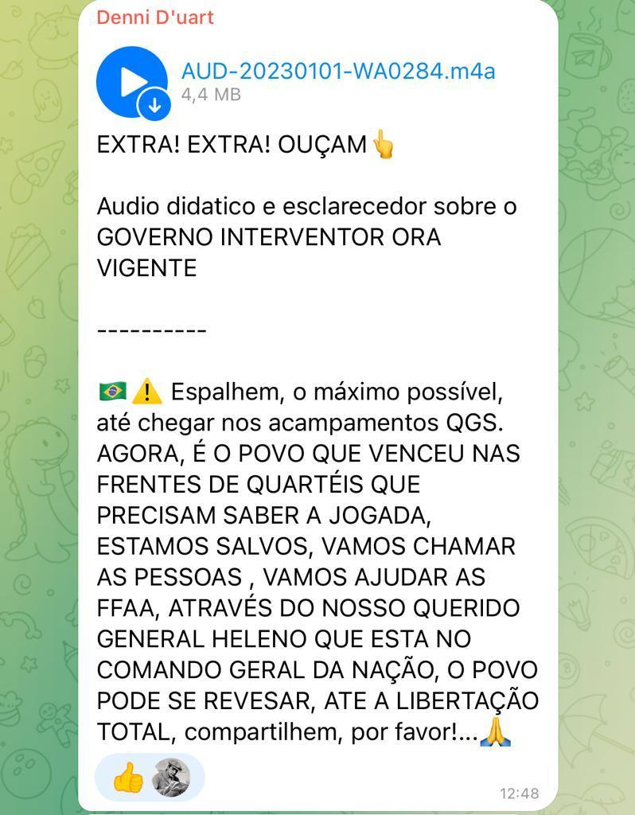

Figure 1: User 2 sustains that General Heleno has assumed the provisory Brazilian government.[32] Source: Telegram, 2 January, 2023.

Well, what a barbarity. General Heleno is the overseer, and along with the armed forces, they will run Brazil within the boundaries. Let's stay strong in front of the barracks.   
– User 3, January 2, 2023.[33]

Continuing the thread of this same conversation, one user went as far as to clarify the nature of the Federal Official Gazette publication, followed by a comment questioning the validity of legal actions under the Lula government, even though the official acts in question were signed during the final days of the Bolsonaro administration.

Guys, Heleno was dismissed; he no longer holds the position of Minister of the Institutional Security Cabinet (GSI). This publication still has his name because it was signed before his dismissal and was published today. Let's stop deluding ourselves. The new GSI minister was appointed yesterday by 'nine'[34] [allusion to Lula], and it's MARCO EDSON GONÇALVES DIAS, one of the decrees signed by the 'LULA-THIEF' yesterday. I'll leave here the list of appointees.   
– User 4, January 2, 2023.[35]

The PT issues decrees without publishing them in the Federal Official Gazette, which has no validity. They desperately want power, even the inauguration was fake.   
– User 3, January 2, 2023.[36]

Starting on January 3, the narratives confirming the installed military intervention are replaced by questioning the possibility of it materializing through the mobilization of radical Bolsonarists. The increasing presence of these narratives is observed within the group by the users themselves who express that the movement is gaining strength in the media ecosystem of the radical right.

I notice this in the 14 Telegram groups I participate in as a conservative patriot and contributor to the dissemination of videos, audios, and written comments. Starting in the early hours of January 2, 2023, there is a significant increase in the average number of opinions. Most of them post banners saying 'GENERAL STRIKE ON THE 9TH' IN BRAZIL, and others invite to urgently form a large gathering of Brazilians in Brasília. They clarify that they do not desire a left-wing government, which they see as a THREAT to Freedom and democracy.   
– User 2, January 3, 2023.[37]

Between January 4 and 6, messages of convocation for the activities circulated intensively, including detailed information about caravans with links to city-specific groups organizing caravans to Brasília. In many messages, the use of the word 'selva' signifies the coup mobilization taking shape, and the term 'patriota' (‘patriot’) identifies the supporters of the cause, following an already established naming convention in Bolsonarist groups.

Patriots of God... For those who cannot go to Brasília, fill the QGs (military headquarters). But Brasília has to be huge. Many, many are already heading there. Believe, Bolsonaro had already posted the map on his Instagram a month ago, indicating Brasília as the center of the protest. Jungle, jungle. SOS Armed Forces. We don't want Lula in power. A general cleanup of institutions. Brasília must be surrounded, with coordinated and orderly crowds. No one enters or leaves (Congress and Supreme Court). Go, Brazil! Our flag will never be red.  
– User 5, January 4, 2023.[38]

Calling all patriots! Folks, let's share this group and clarify its true purpose. It's a call to patriots who want a new September 7th, just as Professor Olavo de Carvalho talks about in his videos. We will come out in the largest mass of people Brazil has ever seen. The left, which thinks it's the majority, will fall to the ground humiliated because God is the one who governs Brazil and our lives. Communism has no place... Order and progress now.   
– User 6, January 4, 2023.[39]

For those who need a bus to Brasília, just contact us on WhatsApp at [hidden number]. Ramiro Caminhoneiro is providing 3,000 buses. Everyone, join Ramiro dos Camioneiros' [sic] live on Instagram now. There are 3,000 buses to take people to Brasília for free. Share URGENTLY!!! It's a critical call, or it will be the slavery and misery of all.   
– User 2, January 5, 2023[40]

Good evening, everyone. We are recruiting individuals who have availability to travel to Brasília by bus, departing on Sunday and returning on Thursday. Everything is paid for, and you will be camping in the Planalto area. Please help us spread the word and find more people. We currently have 5 buses, and if we have more participants, we can secure additional buses. Interested individuals can contact Carla at [hidden number].  
– User 7, January 6, 2023.[41]

It is worth noting that the organizer mentioned by User 7, Ramiro Caminhoneiro, is one of the protest leaders arrested on January 20, 2023, by the Federal Police in a specific operation to apprehend financiers, participants, and instigators of the coup events.[42]

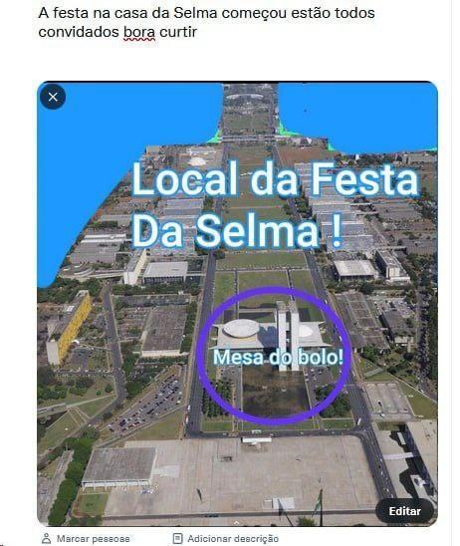

Figure 2: Post explaining where the locations for the attempted coup events would be held. The post reads: ‘The party at Selma's house has begun, everyone is invited, let's enjoy it’. In the image, you can see the text ‘Location of Selma's party’ and ‘cake table’, circled in purple. Source: Telegram, 6 January, 2023.

Another important aspect is the informative messages about the event in Brasília, which circulated primarily between January 6 and 7, explaining to group participants where they should position themselves on the Esplanade of Ministries – the central plaza with government buildings where the riots took place. In the image above, the term 'Mesa do Bolo' (‘cake table’, referring to the table where cake is served at birthday parties) refers to the building of the National Congress, indicated as the 'Location of Selma's Party' (Figure 2).

The term 'Festa da Selma' (‘Selma 's party’) was the code word used to call rioters for the events in Brasilia in late December, especially in messages circulating on open API platforms like Instagram, Facebook, TikTok, and Twitter, and made visible by the use of the hashtag *#festadaselma*.[43] The use of codes and encrypted messages was aimed at not drawing the attention of security agencies, the general public, or even the algorithms themselves,[44] as indicated in the following post, initially shared on Instagram and later disseminated in the Telegram group (Figure 3).

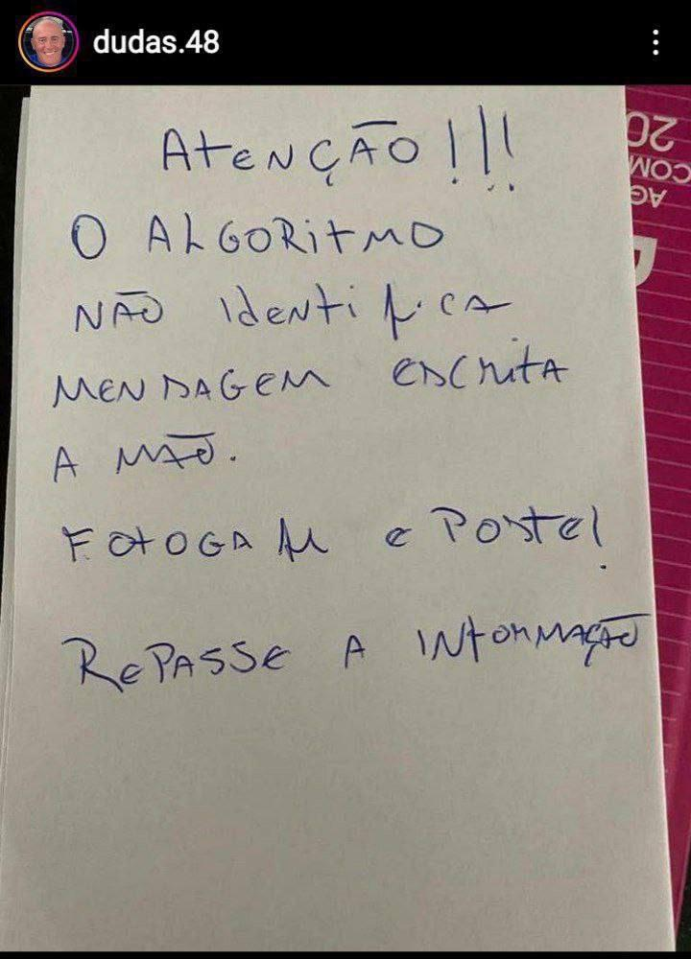

Figure 3: User providing instructions on how to circulate mobilization messages for the coup events. In the posted photo, it says in Portuguese: ‘Attention!!! The algorithm doesn't recognize handwritten messages. Take photos and post them! Share the information’.. Source: Telegram, 6 January, 2023.

Finally, the posts that circulated in the group between January 7 and 8 continue to coordinate the previously mentioned aspects, emphasizing information about the concentration of protesters and their arrival in Brasília, as well as images of the events themselves. January 8 was the peak in the circulation of videos and images in the group, highlighting the festive and celebratory tone which was followed by disillusionment in the face of the failed attempted coup movement. We also recognized messages that attest to the presence of 'infiltrators' who were allegedly distorting the supposed democratic nature of the event by promoting vandalism of public property.

The events concluded on January 8 with the declaration of a federal intervention in the public security department of the Federal District (Brasilia’s administrative region), that led to the removal of its governor, Ibaneis Rocha, and the police detention of 300 individuals in the act. On the same day, all Bolsonarist encampments near the army’s general headquarters and other military units in and around Brasilia were dismantled.[45]

As of the completion of writing this text in October 2023, the work of the Parliamentary Commission of Inquiry (CPI) on the attempted coup events in the National Congress is now in its final stages. Ongoing investigations continue by the Federal Public Ministry (state prosecutors) and the Federal Police. So far, thousands of individuals who participated in the attack have been issued prison warrants, with 2,151 of them arrested on the spot during acts of vandalism.[46] The Supreme Federal Court (STF) has been dedicated to the trial of the financiers of the attacks, having sentenced six of them with 12 to 17 years prison terms..[47] The alleged omission of the Institutional Security Office (GSI) (the Brazilian government’s intelligence unit, an agency directly subordinate to the President’s Office) , is also under investigation, with new names being added to the ongoing investigations. Among those recently indicted is the name of the former president, Jair Messias Bolsonaro.

## Conclusion

The intensification of social media usage and the spread of false information created a scenario in which platforms and the far-right media ecology played a crucial role in the events leading to the terrorist attacks during the attempted coup of January 8, 2023. This goes beyond the mere use of platforms as it involves a complex interplay between technology, social actors, and information ecosystems that fundamentally shape modern society. Understanding platformization goes beyond the technical features of these platforms and implies recognizing their substantial impact on establishing alternative realities, constructing extremist rhetoric, and disseminating it at alarming rates.

The extensive use of platforms in mobilizing Bolsonarists for the attempted coup not only raises a debate over media regulation in Brazil, but also implies a discussion on how the circulation of content in the Bolsonarist mediasphere intensifies the platform's anti-democratic potential.

At the end of the proposed framework, we can raise several questions that touch on profound themes such as: the operation of networks and algorithms; the foundation of social mobilizations and public demonstrations; the process of disinformation; the power of communication and discursive strategies within digital communities; and the escalation of hatred and advocacy of unconstitutional ideas. These tensions lead us to problematize the participation of civil society in discussions with platforms and governments.

We also note that these platforms not only transmit information and disinformation but also fuel the atmosphere of revolt, enthusiasm, and hope, thus reinforcing polarization beyond the election period. We can see how these emotions catalyzed the events of January 8 with the Bolsonarist mediasphere playing a fundamental role in organizing and mobilizing the terrorist acts, allowing communication and coordination among supporters of the Bolsonaro government.

Reflecting on the role of Telegram in mobilizing for the event on January 8, 2023 in Brazil contributes to an understanding of how platforms shape the course of global politics and democracy today, even though we cannot yet fully grasp the dynamics of the Bolsonarist mediasphere due to its integration into platform logic and surveillance capitalism. This brings to light the obscurity of the platformization ecosystem in which we are immersed because, as users, we are not allowed to comprehend all of its logics and operational dynamics. Who operates behind the mechanisms of the networks, and what are their intentions beyond monetization? Are we experiencing increased access to freedom, or is our security diminishing? These are open questions that raise future developments.

## References

Alcântara, Manoela, 'Cem dias após os atos de 8/1, Brasil tem 294 presos, prejuízo milionário e um golpe a apurar'Portal Metrópoles, 17 April 2023, https://www.metropoles.com/brasil/cem-dias-apos-os-atos-de-8-1-brasil-tem-294-presos-prejuizo-milionario-e-um-golpe-a-apurar.

Agência Câmara de Notícias, 'Criada a CPI mista para investigar o ataque às sedes dos três Poderes em 8 de janeiro'. Câmara dos Deputados', *Agência Câmara de Notícias*, 26 April 2023, https://www.camara.leg.br/noticias/956177-criada-a-cpi-mista-para-investigar-o-ataque-as-sedes-dos-tres-poderes-em-8-de-janeiro/.

Agência O Globo, 'Atos terroristas: os 11 pontos para entender tudo desde o 8 de janeiro', *Exame,* 11 January 2023, https://exame.com/brasil/atos-terroristas-os-11-pontos-para-entender-tudo-desde-o-8-de-janeiro/.

Afonso, Nathália e Soares, Gabriela, 'Vândalos falavam de 'Festa da Selma' para convocar ataques em Brasília', *UOL*, 8 January 2023, https://lupa.uol.com.br/jornalismo/2023/01/08/vandalos-festa-selma.

Calheiros, Orlando, 'Terrorismo em Brasília é resultado de ação orquestrada há anos', *The Intercept Brasil*, 10 January 2023, https://theintercept.com/2023/01/10/terrorismo-em-brasilia-e-resultado-de-acao-orquestrada-em-grupos-pro-ditadura/.

Castells, Manuel. *Redes de indignação e esperança: movimentos sociais na era da internet,* Rio de Janeiro: Zahar, 2013.

Cruz, Edgar Gómez e Harindranathand, Ramaswami. 'WhatsApp As ‘technology of life’: Reframing Research Agendas', *First Monday* 25.12 (2020): 1-13. https://doi.org/10.5210/fm.v25i12.10405.

Fonseca, Bruno e Scofield, Laura. 'Bolsonaristas usam código 'Festa da Selma' para coordenar invasão em Brasília', *Agência Pública*, 8 January 2023, https://apublica.org/sentinela/2023/01/bolsonaristas-usam-codigo-festa-da-selma-para-coordenar-invasao-em-brasilia/.

Franco, Thiago J. T. 'A indústria cultural (digital) e as personalidades autoritárias: a extrema-direita no Brasil contemporâneo', In. Zimmermann, Clovis Roberto and Danilo Uzêda da Cruz (eds), *Políticas Sociais No Governo Bolsonaro: Entre Descasos, Retrocessos e Desmontes,* Buenos Aires: CLACSO (2022):439-464. https://doi.org/10.2307/j.ctv2v88c2n.https://doi.org/10.2307/j.ctv2v88c2n.24.

Medeiros, Davi, 'Quem é Ramiro dos Caminhoneiros, preso pela Polícia Federal em operação contra suspeitos de ataques', *Estadão*, 20 January 2023, https://www.estadao.com.br/politica/quem-e-ramiro-caminhoneiros-preso-policia-federal-operacao-revolucao-manes/.

Moraes, Acácio, '94% têm conta em alguma rede social; WhatsApp lidera com 92%', Folha de São Paulo, 8 July 2022, https://www1.folha.uol.com.br/tec/2022/07/94-tem-conta-em-alguma-rede-social-whatsapp-ldera-com-92.html.

Pasquale, Frank. *The Black Box Society:* the secret algorhythms that control money and information. Cambridge, Massachusetts; London, England: Harvard University Press, 2015.

Recuero, Raquel, Zago, Gabriela e Soares, Felipe. 'Midia social e filtros-bolha nas conversações políticas no Twitter', Anais do XXVI Encontro Anual da Compós, 2017, https://lume.ufrgs.br/bitstream/handle/10183/166193/001047200.pdf?sequence=1&isAllowed=y.

Rocha, João C. C. *Guerra cultural e retórica do ódio: crônicas de um Brasil pós-político*, Goiânia: Caminhos, 2021.

_____. *Bolsonarismo: Da guerra cultural ao terrorismo doméstico: Retórica do ódio e dissonância cognitiva coletiva*. Belo Horizonte: Autêntica, 2023.

Sacchitiello, Bárbara, 'Sites e redes sociais lideram na busca por informação', *Meio e Mensagem*, 10 August 2022, https://www.meioemensagem.com.br/midia/sites-e-redes-sociais-lideram-na-busca-por-informacao.

Suresh, V. P., Nogara, G., Cardoso, F., Cresci, S., Giordano, S., e Luceri, L. 'Tracking Fringe and Coordinated Activity on Twitter Leading Up To the US Capitol Attack', *Proceedings of the 18th International Conference on Web and Social Media*, 2023, http://arxiv.org/abs/2302.04450.

Telegram, ‘Política de Privacidade do Telegram’, https://telegram.org/privacy/br.

Torres, Livia, 'Pesquisa aponta que WhatsApp é a principal fonte de informação de 79% dos entrevistados', Rádio Senado, 12 December 2019, https://www12.senado.leg.br/radio/1/noticia/2019/12/12/pesquisa-aponta-que-whatsapp-e-a-principal-fonte-de-informacao-de-79-dos-entrevistados.

Tortella, Thiago, 'A Invasão do Capitólio completa um ano: relembre o ataque à democracia dos EUA', *CNN*,6 January 2022, https://www.cnnbrasil.com.br/internacional/invasao-ao-capitolio-completa-um-ano-relembre-o-ataque-a-democracia-dos-eua/.

Uol, 'Deu polêmica: vamos fuzilar a petralhada, diz Bolsonaro', Youtube 4 September 2018, https://youtu.be/TAtz7E-XuCw.

Van Dijck, José; Poell, Thomas; De Wall, Martijn, *The Platform Society: public values in a connective world,* Oxford: Oxford University Press, 2018.

Vivas, Fernanda, '8 de janeiro: STF condena mais três réus por atos golpistas', Portal G1, 02 October 2023, https://oglobo.globo.com/politica/noticia/2023/10/02/stf-condena-mais-tres-pessoas-por-atos-golpistas-do-8-de-janeiro.ghtml

Whatsapp, ‘Aviso de privacidade - Brasil’, https://www.whatsapp.com/legal/brazil-privacy-notice.

Zuboff, Shoshana, *The Age of Surveillance Capitalism*, New York: Public Affairs, 2019.

1. Associate Professor at the Communication Sciences Department at Federal University of Santa Maria (UFSM), Brazil. E-mail: aline.dalmolin@ufsm.br.
2. Master student at the Communication Post Graduation Program at Federal University of Santa Maria (UFSM), Brazil. E-mail: mathias.maria@acad.ufsm.br.
3. 'Petralhada' is a derogatory term used to refer to the followers of the Partido dos Trabalhadores (PT), the party of President Lula. Uol, 'Deu polêmica: vamos fuzilar a petralhada, diz Bolsonaro', Youtube 4 September 2018, https://youtu.be/TAtz7E-XuCw.
4. This sentence represents Bolsonaro's rejection of the red color, which is present in the flag of the Partido dos Trabalhadores (Workers' Party) and is associated with socialist's symbolic. According to right-wing extremists, left-wing parties are purportedly seeking to replace national symbols with socialist ones, including the colors of the Brazilian national flag.
5. Gustavo Petró, ‘Relembre a reunião de Bolsonaro com embaixadores que o tornou inelegível’, *Portal G1*, 30 June 2023, https://g1.globo.com/politica/noticia/2023/06/30/relembre-a-reuniao-de-bolsonaro-com-embaixadores-que-o-tornou-inelegivel.ghtml
6. Thiago Tortella, 'A Invasão do Capitólio completa um ano: relembre o ataque à democracia dos EUA', *CNN*, 6 January 2022, https://www.cnnbrasil.com.br/internacional/invasao-ao-capitolio-completa-um-ano-relembre-o-ataque-a-democracia-dos-eua/.
7. Suresh, V. P., Nogara, G., Cardoso, F., Cresci, S., Giordano, S., and Luceri, L., 'Tracking Fringe and Coordinated Activity on Twitter Leading Up To the US Capitol Attack', *Proceedings of the 18th International Conference on Web and Social Media*, 2023, http://arxiv.org/abs/2302.04450
8. José Van Dijck, Thomas Poell e Martijn De Wall, *The Platform Society: Public Values in a Connective World*. Oxford: Oxford University Press, 2018.
9. Van Dijck, Poell and De Wall, *The Platform Society*, p. 4.
10. Cookies are files created by websites with the aim of making content more relevant based on the user's preferences and information.
11. Shoshana Zuboff, *The Age of Surveillance Capitalism,* New York: Public Affairs, 2019.
12. Frank Pasquale, *The Black Box Society:* the secret algorithms that control money and information. Cambridge, Massachusetts; London, England: Harvard University Press, 2015.
13. Zuboff, *The Age of Surveillance Capitalism.*
14. Pasquale, *The Black Box Society*, p. 4.
15. Manuel Castells, *Redes de indignação e esperança: movimentos sociais na era da internet,* Rio de Janeiro: Zahar, 2013.
16. A study conducted by Teads, a global media platform, in partnership with the Toluna Corporate Institute, demonstrated that 76% of Brazilians mentioned social media as their primary source when searching for information, with YouTube being cited by 72%. Bárbara Sacchitiello, 'Sites e redes sociais lideram na busca por informação', *Meio e Mensagem*, 10 August 2022, https://www.meioemensagem.com.br/midia/sites-e-redes-sociais-lideram-na-busca-por-informacao
17. João C.C. Rocha, *Guerra cultural e retórica do ódio:* crônicas de um Brasil pós-político. Goiânia: Caminhos, 2021 and Thiago J. T. Franco, 'A indústria cultural (digital) e as personalidades autoritárias: a extrema-direita no Brasil contemporâneo', In. Zimmermann, Clovis Roberto, and Danilo Uzêda da Cruz (eds), *Políticas Sociais No Governo Bolsonaro: Entre Descasos, Retrocessos e Desmontes*, Buenos Aires: CLACSO (2022):439-464. https://doi.org/10.2307/j.ctv2v88c2n.https://doi.org/10.2307/j.ctv2v88c2n.24
18. Rocha, *Guerra cultural e retórica do ódio.* 
19. Rocha, *Bolsonarismo: Da guerra cultural ao terrorismo doméstico: Retórica do ódio e dissonância cognitiva coletiva.* Belo Horizonte: Autêntica, 2023.
20. Orlando Calheiros, 'Terrorismo em Brasília é resultado de ação orquestrada há anos', *The Intercept Brasil*, 10 January 2023, https://theintercept.com/2023/01/10/terrorismo-em-brasilia-e-resultado-de-acao-orquestrada-em-grupos-pro-ditadura/.
21. Acácio Moraes, '94% têm conta em alguma rede social; WhatsApp lidera com 92%', *Folha de São Paulo*, 8 July 2022, https://www1.folha.uol.com.br/tec/2022/07/94-tem-conta-em-alguma-rede-social-whatsapp-ldera-com-92.html.
22. In a survey conducted by *DataSenado* in 2019 about the influence of social media in Brazilian society, it was emphasized that disinformation, in a scenario of political polarization, has a greater influence on individuals with biased opinions who are part of information bubbles. Livia Torres, 'Pesquisa aponta que WhatsApp é a principal fonte de informação de 79% dos entrevistados', *Rádio Senado*, 12 December 2019, https://www12.senado.leg.br/radio/1/noticia/2019/12/12/pesquisa-aponta-que-whatsapp-e-a-principal-fonte-de-informacao-de-79-dos-entrevistados.
23. Edgar Gómez Cruz e Ramaswami Harindranathand. 'WhatsApp As 'technology of life': Reframing Research Agendas', First Monday 25.12 (2020): 1-13. https://doi.org/10.5210/fm.v25i12.10405
24. Edgar Gómez Cruz e Ramaswami Harindranathand. 'WhatsApp As 'technology of life'.
25. Telegram defines itself as a communication service, while WhatsApp, created as an alternative to SMS, identifies itself as an instant messaging application.
26. Sucessos dos Anos 1980, Telegram, 14 May, 2023, https://t.me/andurinha.80.
27. The change of group names and profile pictures is a constant dynamic in Bolsonarist groups on Telegram.
28. On original: 'PROIBIDO enviar Pornografia e PIX'. Pix is a Brazilian digital payment system, owned by Banco Central do Brasil.
29. 'Selva' is a military greeting used in Brazil. Bolsonarists have appropriated this phrase to express their affiliation to militarism and interventionists ideas.
30. ‘Garantia de Lei e Ordem' is a constitutional principle that allows the President of the Republic to activate the Armed Forces to act temporarily with police powers in cases of extreme disturbance of public order and exhaustion of public security forces.
31. Originally, in Portuguese: 'Eu lutei todo esse tempo no quartel, pois acreditei que iam fazer algo. Mas agora não acredito no Bolsonaro, nem se ele me chamar novamente para as ruas'. User 1, 1 January, 2023.
32. English translation of the figure 1 text: 'EXTRA! EXTRA! LISTEN UP! Informative and enlightening audio about the INTERVENING GOVERNMENT, NOW IN EFFECT. Spread it as widely as possible, until it reaches the QGS camps. NOW, IT IS THE PEOPLE WHO HAVE TRIUMPHED ON THE BARRACKS' FRONTS THAT NEED TO KNOW THE MOVE, WE ARE SAFE, LET'S CALL PEOPLE, LET'S ASSIST THE ARMED FORCES, THROUGH OUR BELOVED GENERAL HELENO WHO IS IN COMMAND OF THE NATION, THE PEOPLE CAN TAKE TURNS UNTIL COMPLETE LIBERATION, please share!'
33. Originally, in Portuguese: 'Bah mas q barbaridade. Gente general heleno é interventor ele junto com as forças armadas irão administrar o Brasil dentro das 4 linhas. Vamos nos manter firmes na frente dos quartéis.' User 3, 2 January, 2023.
34. Bolsonarist depreciative way of referring to Lula, alluding to the fact that he has just nine fingers.
35. Originally, in Portuguese: 'Gente o Heleno foi exonerado ele não exerce mais o cargo de ministro do GSI. Está publicação ainda está com o nome dele pois foi assinada antes da exoneração e publicada hj. Vamos parar de se iludir. O novo ministro do GSI foi nomeado ontem pelo nine e é o MARCO EDSON GONÇALVES DIAS um dos decretos assinados ontem pelo LULADRÃO. Vou deixar a lista de nomeados'. User 4, 2 January, 2023.
36. Originally, in Portuguese: 'O PT faz decretos sem publicar no dou, isso não tem validade, eles querem por q querem o poder, até a posse foi fek.[Sic.]' 'Fek' is the misspelled form writed by the user, which refers to the English word 'fake'. User 3, 2 January, 2023.
37. Originally, in Portuguese: 'Percebo que nos 14 grupos que participo no Telegram, como patriota conservador e colaborador para a divulgação dos vídeos, audios e comentários escritos. Apartir do inicio da madrugada do dia 02Jan,2023 cresce significativamente o a média de opiniões ,na maioria publicam banner ' GREVE GERAL DIA 09' NO BRASIL E OUTROS CONVIDANDO PARA FORMAR URGENTEMENTE UMA GRANDE CONCENTRAÇÃO DE BRASILEIROS em Brasília. Esclarecendo que não desejam um governo de esquerda,representa UMA AMEAÇA a Liberdade e à democracia. [sic]' User 2, 3 January, 2023.
38. Originally, in Portuguese: 'Patriotas de Deus...Quem não puder ir pra Brasília, lotem os Qgs. Mas Brasília tem que ser gigante. Muitos, muitos já estão indo pra lá. Creiam, o Bolsonaro já havia publicado o mapa em seu Instagram 1 mês atrás, apontando Brasília como o centro da manifestação. Selva, selva SOS FFAA não queremos lula no poder. Limpeza geral nas instituições. Brasília tem que ser cercada, multidões coordenadas e ordeiras Ninguém entra e nem sai( congresso e STF) Avante Brasil Nossa bandeira jamais será vermelha.' User 5, 4 January, 2023.
39. Originally, in Portuguese: 'Convocação de todos os patriotas Pessoal vamos partilhar esse grupo e especificar para o que ele serve na verdade. Convocação de patriotas que querem um novo 7 setembro como o professor Olavo de carvalho fala nos videos. Vamos sair na maior massa de pessoas que o Brasil nunca viu, a esquerda essa que se acha a maioria cairá por Terra humilhados porque Deus é quem Governa o Brasil e nossas Vidas. Comunismo não tem vez..Ordem e progresso já'.[sic] User 6, 4 January h, 2023.
40. Originally, in Portuguese: 'Quem precisar de ônibus para Brasília, só chamar no WhatsApp (número ocultado) Ramiro Caminhoneiro está disponibilizando 3.000 Onibus Pessoal, entrem na live agora do Ramiro dos Camioneiros [sic], Instagram. São 3.000 ônibus para levar o povo para Brasília, de graça. Compartilha URGENTE!!! É um chamado crucial ou será a escravidão e miséria de todos'. User 2, 5 January, 2023.
41. Originally, in Portuguese: 'Boa noite pessoal Estamos recrutando pessoas que tenham Disponibilidade para ir a Brasília de ônibus que sairá no domingo e volta na quinta feira. Tudo pago La ficará acampado . No planalto Por favor me ajudem A divulgar e conseguir pessoas .. são 5 ônibus e se tiver mais pessoas conseguiremos mais ônibus Interessados procurar Carla - [número ocultado].'User 7, 6 January, 2023.
42. Davi Medeiros, 'Quem é Ramiro dos Caminhoneiros, preso pela Polícia Federal em operação contra suspeitos de ataques', Estadão, 20 January 2023, https://www.estadao.com.br/politica/quem-e-ramiro-caminhoneiros-preso-policia-federal-operacao-revolucao-manes/
43. Nathália Afonso e Gabriela Soares, 'Vândalos falavam de 'Festa da Selma' para convocar ataques em Brasília', UOL, 8 January 2023, https://lupa.uol.com.br/jornalismo/2023/01/08/vandalos-festa-selma.
44. Bruno Fonseca e Laura Scofield, 'Bolsonaristas usam código 'Festa da Selma' para coordenar invasão em Brasília', Agência Pública, 8 de January de 2023, https://apublica.org/sentinela/2023/01/bolsonaristas-usam-codigo-festa-da-selma-para-coordenar-invasao-em-brasilia/
45. Agência O Globo, 'Atos terroristas: os 11 pontos para entender tudo desde o 8 de janeiro', *Exame*, 11 January 2023, https://exame.com/brasil/atos-terroristas-os-11-pontos-para-entender-tudo-desde-o-8-de-janeiro/.
46. Manoela Alcântara, 'Cem dias após os atos de 8/1, Brasil tem 294 presos, prejuízo milionário e um golpe a apurar', *Portal Metrópoles*, 17 April 2023, https://www.metropoles.com/brasil/cem-dias-apos-os-atos-de-8-1-brasil-tem-294-presos-prejuizo-milionario-e-um-golpe-a-apurar
47. Fernanda Vivas, '8 de janeiro: STF condena mais três réus por atos golpistas', *Portal G1*, 02 October 2023, https://oglobo.globo.com/politica/noticia/2023/10/02/stf-condena-mais-tres-pessoas-por-atos-golpistas-do-8-de-janeiro.ghtml