# The Stories of the Victims: The Planalto Riots from the Perspective of Terrorized Art

### Oscar Svanelid[1]

‘The old world is dying. The new world is emerging slowly. And in this chiaroscuro, monsters are born.’ – Antonio Gramsci[2]

The political ideology of Bolsonarismo revealed its true monstrous face at the attempted coup of January 8th in 2023, known as the Planalto Riots. This movement which earlier boasted about representing the ‘upstanding citizen’,[3] now exposed itself as an unruly gang of neo-fascists defecating and urinating on the floor in a self-deprecating attack on the most prominent democratic institutions in Brazil. Their violent attack on the world-famous modernist buildings which Oscar Niemeyer drew in the 1950s showed them to be as ignorant of the values of democracy and national cultural heritage as many other neofascist movements across the globe. What they really wanted was to spread terror that, to their twisted minds, could restore a nightmarish world of authoritarian and theocratic order.[4]

The Planalto Riots occurred on a Sunday when the government buildings were mostly empty, so the rioters mainly targeted the architectural environment, artworks, and design objects housed inside. The media quickly reported on the staggering costs of repairing the damaged objects. However, I am wary of accepting the economic narrative at face value. Instead, I propose viewing the Planalto Riots from the perspective of the damaged objects themselves. Or, at the very least, presenting them as actors ‘on the historical stage [who] parallels and participates in the stories we tell ourselves’.[5] I suggest this approach as I feel that after this national trauma, everyone was speaking except for the victims themselves. While it may seem naive to empathize with a broken table, a kidnapped sculpture, or a wounded painting, it feels unfair not to include their perspective in the history of the Planalto Riots.

## The Planalto Riot as Anti-Modernist Iconoclasm

The Planalto Riots were hardly the first time aesthetic objects of great symbolic and economic value were vandalized and destroyed. Just think about the revolt against imperialist sculptures and other iconic objects that happened during the Paris Commune in 1871. Today there have been similar, although often less mass-oriented, events from politically opposed movements such as Black Lives Matter activists destroying sculptures of slave traders and white supremacists burning the Quran. This shows that contemporary political ideologies continue to live out the desire to destroy the symbolic order of the enemy, known as iconoclasm.[6] When speaking about the Planalto Riots, we should also not forget that one of the many nicknames of the former president of Brazil, Jair Bolsonaro, is ‘the enemy of modernity’. Therefore, it hardly came as a surprise when his followers attacked the P*raça dos Três Poderes* (The Three Powers Square), which the urban planner Lúcio Costa designed together with Niemeyer in the late 1950s as the core of the modern aesthetic and political order that Brasilia was meant to represent.

Costa's famous *Plano Piloto* (Pilot Plan) for Brasilia in 1957 was chosen by the jury as the purest representation of a new, post-historical beginning for Brazil.[7] While this *tabula rasa* could never actually function as a founding myth for the country, it certainly encapsulated what in the 1950s was understood as the modernized flight towards an (impossible) modern utopia. This idea did not simply arrive in a stroke of genius, as Costa liked to argue, but was deeply rooted in a colonial hallucination of occupying an empty land that belonged to Indigenous peoples.[8] Moreover, the so-called 'egalitarian order' that Costa envisaged for Brasilia exacerbated the very socioeconomic and racial divisions it aimed to surpass.[9]

The worst tragedy of Brasilia, however, occurred after the military coup in 1964, when this modernist city, which originally hinted at a classless society, was transformed into a symbol of authoritarianism. Yet, it is important to note that Brasilia should not be viewed solely as a modernity icon, but rather as a contested site of an ongoing iconoclastic struggle. This history was repeated in the recent neofascist spectacle in 2023. The Planalto Riots, due to a lack of military assistance, were more farcical than historical fascism with tanks and armies at its disposal. However, the objects targeted in the attack must have experienced this farce as a terrifying event.

## Kubitschek’s Table

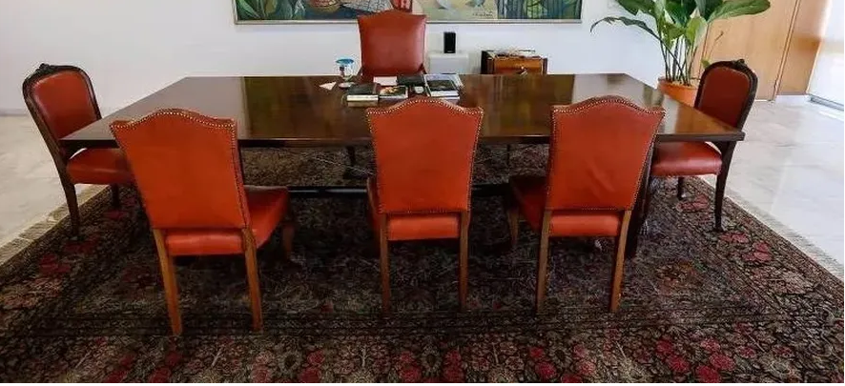

Figure 1: The work table designed by Oscar Niemeyer and used by the Brazilian president Juscelino Kubitschek in the 1960s.

The object that I sympathize with the most is a wooden table that was used as a barricade by *Bolsonaristas* during the riots at the Presidential Palace.[10] This table was designed by Brazilian architect Oscar Niemeyer and was made from Jacaranda wood, which was very popular in Brazilian furniture design at the time. The table could also be adjusted to change its size, making it an iconic example of modern design. During its early years, the table was used by Juscelino Kubitschek (JK) in his office as a material support for his vision of a modernized Brazil. However, over time, the table's role changed. In 1964, it witnessed the military coup that overthrew the democratic political system, which its founding fathers had put their faith in.[11] After this event, the table was used by generals who wrote the documents that enabled some of the worst human rights abuses in modern Brazilian history on its polished wooden surface.[12] Niemeyer’s table at least cannot complain that its life has been boring.

Fortunately, in the 1970s, the table was granted the elevated status of a historical object. This enabled its early retirement to the dark chambers of the presidential collection, where it could expect a long, quiet life without much happening. Although it lost its practical use, it was compensated with exponential growth in economic and symbolic value. Unlike human beings, design objects age beautifully and acquire an aura. The table entered the sublime space of the presidential collection with the expectation of delicate care and expertise, which less fortunate objects can only dream of receiving.

After decades of retirement, Niemeyer’s presidential table was unexpectedly brought back into use. One can only imagine how it must have felt to be reduced once again to a mere object. To make matters worse, this happened during the government of interim president Michel Temer (2016-2018), when the table was placed in the office of the Minister of the President's General Secretariat, Moreira Franco.[13] Franco tweeted that the table, which had become a symbol of the prosperous modern era for him, would inspire him to ‘put Brazil back on track’.[14]

While it is true that designed objects can play a role in shaping our human world, some problems are too complex for a wooden table to solve. Instead of addressing the chaos in Brazilian politics, Temer’s government is widely criticized for exacerbating the country's financial and social problems with its neoliberal economic policies. Today, the table is 60 years old and can once again look forward to retirement. Due to the damages caused during the Planalto Riots, this state appears to be perpetual. This leaves much time to reflect on its dramatic life story, which must be rather unique, at least for a table.

## Lady Justice Taken Hostage

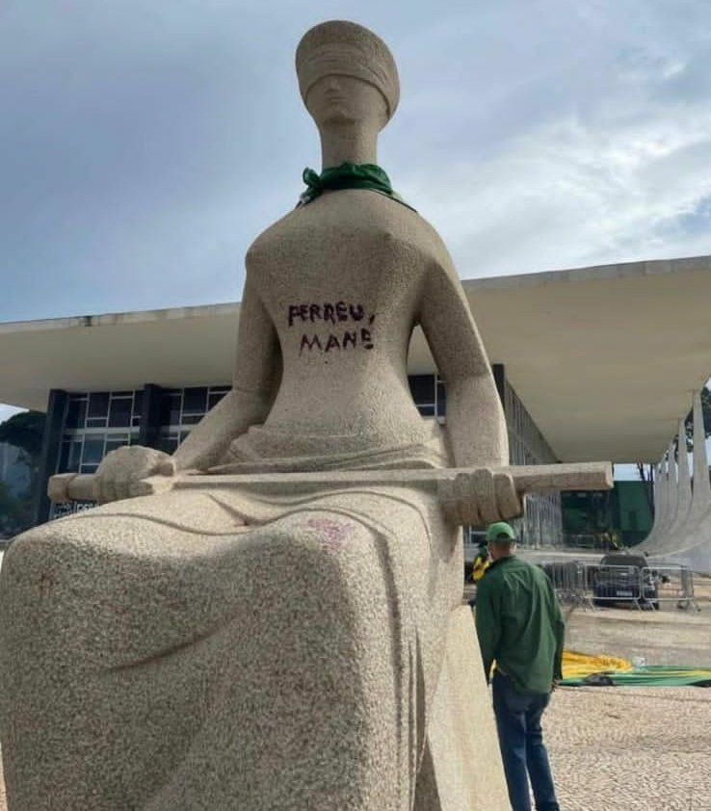

Figure 2: Alfredo Ceschiatti, *A Justiça*, 1961, granite, 3,3 x 1,48 m.

During the Planalto riots, valuable furniture wasn't the only thing that was targeted. Several famous paintings and sculptures were also destroyed. One of these was Alfredo Ceschiatti's three-meter-high granite sculpture, *A Justiça* (The Justice), from 1961, commissioned for a site outside the Supreme Court building. The sculpture was inspired by the allegoric image of Lady Justice, who is depicted as sitting down with a blindfold and a sword solemnly placed on her lap. However, what sets Ceschiatti's sculpture apart from other representations of this figure is that Justice lacks her notorious scale.

Legal theorist Rafael Lazzarotto Simioni suggests that *A Justiça* has not lost her scale by accident but has willingly given it away. This is to indicate that the scale has become the property of every citizen who, as subjects of the law, are responsible for balancing their deeds and desires.[15] People can no longer view Lady Justice as the allegorical embodiment of divine law; they are now expected to look inward and develop a sense of right and wrong themselves. This may explain why *A Justiça* is not standing up, waving her sword, as in many other sculptural representations. Instead, she appears as an embodiment of modernity, where self-discipline and control are viewed as more effective means of governing the population than cutting the throats of sinners. In this way, Ceschiatti's sculpture can also be viewed as an allegory for Brasilia, which aimed to design an urban environment where people would be forced to adopt the disciplinary order needed to acquire the peaceful habits of domesticated social life.

Yet, Ceschiatti's *A Justiça* is of monumental size, suggesting that it is not intended to be viewed as equal to humans. Instead, the figure appears to have originated from the radiance of the spiritual world of ideas. This implies that Lady Justice never fully trusted the Brazilian people with her scale. It is more reasonable to assume that she gave her scale as a symbolic gift to the ministers of the Supreme Federal Court building, under the condition that they use it wisely. In this context, the modern aspect of Ceschiatti's sculpture should thus be found in the trust that developed between Lady Justice and the judiciary institution in the early 1960s.

While Lady Justice suffered no severe physical damage during the Planalto Riots, the Bolsonaristas exerted psychological violence against her. They painted the phrase ‘Perdeu, Mané’ (‘You lost, man’) in blood-red color on her naked body and, even worse, hung a Brazilian flag around her neck. The phrase was meant as an act of revenge against Federal Judge Luís Roberto Barroso, a member of the Supreme Court, who had used the same expression when addressing a Bolsonaro supporter refusing the results of the democratic presidential election in 2022. We can also see that the rioters directed this phrase at Lady Justice, who was threatened with serving a military regime once again, which mocked her moral standards of faithfulness to the Brazilian constitution.

It may thus be suggested that the Bolsonaristas pointed out a flaw in Ceschiatti's *Lady Justice* sculpture. By giving away her scales to the Supreme Federal Court, she lost her ability to make independent judgments. This has put her in a position of dependence where she is unable to refuse even the most outrageous commands. Philosopher Giorgio Agamben reminds us that Lady Justice sometimes loses her mind, which is an essential aspect of her being as a historical figure.[16] We can only imagine the traumatic memories from the basements of the military regime, where she appeared as a ghostly presence, brought back by the rioters when they held her hostage. At the same time, the Bolsonaristas highlighted that Lady Justice has not always been as innocent as she likes to pretend.

This opens the riddle of why Lady Justice is portrayed as blindfolded. The most commonly accepted explanation is that the blindfold is meant to ensure impartiality in her verdicts, as she cannot base her decisions on appearance or be swayed by sparkling gifts.[17] Some may also argue that the blindfold rather serves as a veil of ignorance that humans have imposed on Lady Justice to protect ourselves from her piercing gaze.[18] However, historian Adriano Prosperi suggests that the leftist poet Edgar Lee Masters offers the most compelling explanation for Lady Justice's blindfold. Masters wrote that the blindfold is actually a bandage covering Lady Justice's eyes, which she had clawed out in a moment of madness. It thus appears that Ceschiatti is attempting to deceive us by using the image of a youthful body, but if we were to uncover her eyes, we might see the turmoil of a spirit in decline.[19] Therefore, it is important to condemn and penalize any form of psychological abuse against Lady Justice. In these times, it is crucial to ensure that Lady Justice is treated with the utmost care.

## The Unknown Horizon of Di Cavalcanti’s Women

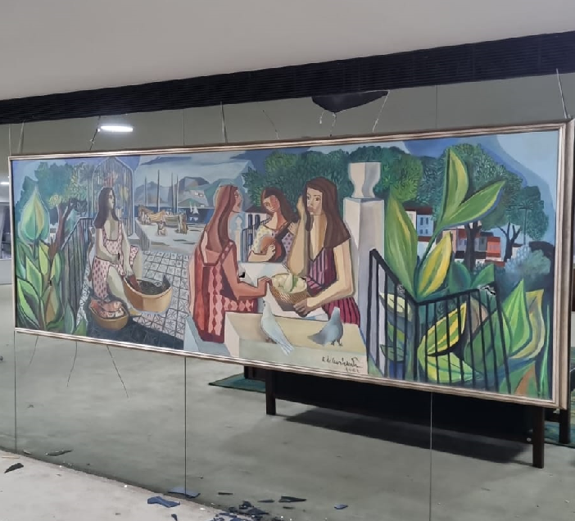

Figure 3: Emiliano Di Cavalcanti, *Untitled*, 1962, Oil on canvas, 1,20 x 3,43 m.

The act of vandalism that received the most attention in the Planalto Riots targeted a famous painting by Brazilian painter Emiliano Di Cavalcanti which circulated in the media with the derogatory title *As mulatas* (The Mulattas) from 1962.[20] Di Cavalcanti’s painting was wounded with several holes, which were likely caused by sharp cobblestones thrown by rioters. These cuts draw attention to the misogynistic aspect of neofascist movements, to which Bolsonaro repeatedly alluded. Furthermore, they can be seen as indicative of the alarming rates of femicide in Brazil, where black women are in the majority. Femicide and other forms of male violence against women have been a persistent issue in Brazilian society. However, the situation worsened under Bolsonaro's government. On one hand, the government made it easier for the population to access firearms. On the other hand, it opposed the so-called gender ideology, further contributing to the problem.[21]

Although Di Cavalcanti’s painting has been hanging in the Presidential Palace for several decades, it wasn't originally commissioned for that location. It was first displayed in the dining room of a cruiser named after Princess Leopoldina of Brazil.[22] The painting depicts a picturesque tropical setting with a group of women of color engaged in their daily activities. One is cleaning fish while the others are playing guitar and sitting quietly around a table. In the background, a harbor can be seen where a fisherman is unloading the day's catch. In recent years, there has been valid criticism of Di Cavalcanti's portrayal of black women in his paintings as sexualized objects of male desire, particularly those referred to as *mulatas*.[23] What stands out in this painting is also the women's absent gazes, which adds a sense of unease to the scene. It feels as if these women are waiting for something terrible to happen.

In the painting, the woman in the foreground is gazing at a distant horizon, and we are left wondering what she is looking at. We imagine the sound of guitar music being played by a woman next to her, but it doesn't seem to lift her spirits. The two women appear to be in each other's company, but not communicating through speech or eye contact. They seem to share an unspoken bond that extends beyond words. Perhaps it has something to do with their shared focus on a faraway space, which we can only assume is a musical space. This allows them to elude the gaze that tries to capture them.

The women in Di Cavalcanti's painting could thus seem to be avoiding the guests who are dining on the luxurious cruiser where the painting was first installed. Although the upper-class viewers were staring at them, the painter had the decency to hide their inner selves. When the painting was later moved to the Presidential Palace, it gained a political dimension. Now, the painting can be seen as a way to encourage those in positions of governmental power to empathize with these women from the past. However, the women remain as mysterious as ever, and it seems they will never fully reveal their secrets. This type of canonical painting has a long lifespan, and it will continue to be admired for generations to come. So, even though the painting won't provide any answers, the women in the painting are still waiting for someone to join them on their journey to the unknown horizon where they are gazing.

## Final remarks

The recent Planalto Riots have prompted us to reconsider the significance and agency of the architecture, design objects, and artworks located at Praça dos Três Poderes. As an art historian, I strongly suggest that we integrate the artworks into the narratives we create about this tragic event that has left yet another scar on Brazilian history. Furthermore, we should not only repair the damaged objects, but also collaborate to reimagine the role of art in the spaces of government and judiciary power. Although the objects were damaged during the riots, they should not be considered powerless. In fact, the rioters managed to activate the symbolic meaning and material force of resistance inherent in these objects. Through their existence, these objects have become active participants in a protest against neofascism and today serve as symbols of the preservation of democratic culture.

The 8th of January 2023 can be seen as a traumatic day in the history of Brazilian democracy. It is one of many such traumas that the country has faced. Bolsonarismo, according to Rodrigo Nunes, views politics as a battle to the death where anything goes.[24] This attitude may stem from Brazil's historical formation, where the state apparatus often masks an archaic structure of command inherited from the colonial division of labor. Local landowners have long confused their private interests with those of the public.[25] During the Planalto Riots, the ghost of authoritarian rule returned, embodied in the figure of Bolsonaro, and transformed into a mass movement. While the rioters may have reenacted the 1964 military coup in a farcical manner, it is important to pay attention to the historical forces at play. In my view, the damaged artworks and designed objects reveal the material and symbolic dimensions of neofascist violence. For instance, this violence represents an abuse of justice and an aggressive resentment toward the representation of Black women in sites of governmental power.

The white curvy walls of Niemeyer's governmental buildings may seem like an architectural relic of modernism's failed attempt to suppress Brazil's history. In recent years, many Brazilian artists have engaged in a critical dialogue with the country's modernist cultural heritage, connecting it with the history of slavery and colonialism. For instance, Arjan Martin's Complexo atlântico (Atlantic Complex - Rope), 2020, showcased at the Ciccillo Matarazzo pavilion during the 34th São Paulo Biennial, features a rusty anchor and a thick rope that stretches across the building's floor, stopping the messianic flight embodied by Niemeyer's iconic modernist structure.[26]

What is arguably needed at Planalto are artworks that resonate with the historical traumas and make the governmental buildings come alive. We cannot expect art in governmental spaces to smooth over the authoritarian and bloody legacy that continues to haunt Brazilian society as a ghost from its fascist and colonial past. On the contrary, artworks at these sites should remind us that governmental power cannot be separated from this part of history.

## Bibliography

Agamben, Giorgio, State of Exception, Chicago: University of Chicago Press, 2005.

Calirman, Claudia. Brazilian art under dictatorship: Antonio Manuel, Artur Barrio, and Cildo Meireles, Durham: Duke University Press, 2012.

Chamon, Andréa Marques. As “mulatas" de Di Cavalcanti – um estudo em Psicologia Social, Master thesis, Faculdade de Filosofia e Ciências Humanas da Universidade Federal de Minas Gerais, Belo Horizonte, 2017.

Gamboni, Dario. The Destruction of Art: Iconoclasm & Vandalism Since the French Revolution, London: Reaktion, 1997.

Giani MonteiroI, Mario Francisco; Ferreira RomioII, Jackeline Aparecida and Drezett, Jefferson. ‘Is There Race/Color Differential on Femicide in Brazil? The Inequality of Mortality Rates for Violent Causes Among White and Black Women´, Journal of Human Growth and Development 31 [Online], no.2 (May/August 2021): 359–366.

Holston, James. The Modernist City: An Anthropological Critique of Brasília, Chicago: University of Chicago Press, 1989.

Lannes, Paulo. ’Moreira Franco usa mesa histórica de JK e revolta curadores’, *Metrópoles*, 9 March 2017, https://www.metropoles.com/entretenimento/politica-cultural/moreira-franco-usa-mesa-historica-de-jk-e-revolta-curadores.

Lazzarotto Simioni, Rafael. ’Arte e direito: A Justiça, de Alfredo Ceschiatti, no STF’, *Suprema: revista de estudos constitucionais* 1 (July/December 2021): 221–255.

Nunes, Rodrigo. ‘Of what is Bolsonaro the name?’, *Radical Philosophy* 209 (Winter 2020): 3–14.

Masters, Edgar Lee. *Spoon River Anthology,* New York: Collier Books, 1967.

Mitchell, W. J. T. *Iconology: Image, Text, Ideology*, Chicago: Univ. of Chicago Press, 1986

Prosperi, Adriano. *Justice Blindfolded: The Historical Course of an Image*, trans. John Tedeschi & Anne C. Tedeschi, Leiden: Brill, 2018.

’Saiu uma reforma de Temer: a dos móveis do Palácio do Planalto’, *Gazeta do povo*, 6 November, 2017. https://www.gazetadopovo.com.br/politica/republica/saiu-uma-reforma-de-temer-a-dos-moveis-do-palacio-do-planalto-5fug8enmdy0io9678kryewsdk/.

Simões, Eduardo, ’Da sala de jantar de navio ao Salão Nobre, a viagem de 'As Mulatas' até a depredação’, *Neofeed*, 14 January 2023, https://neofeed.com.br/blog/home/de-sala-de-jantar-de-navio-ao-salao-nobre-a-viagem-de-as-mulatas-ate-a-depredacao/.

Svanelid, Oscar, ‘The São Paulo Biennial Ventures Deep Into the Brazilian Darkness’, Kunstkritikk, 22 October 2021, https://kunstkritikk.com/the-sao-paulo-biennial-ventures-deep-into-the-brazilian-darkness/.

Thotti, ’We Too Were Modern, Part II: The Tropical Ghost Is a Cannibal’, *e-flux Journal* 134 (March 2023), https://www.e-flux.com/journal/134/525520/we-too-were-modern-part-ii-the-tropical-ghost-is-a-cannibal/.

––––––. ‘We Too Were Modern, Part I: Of Brazilian Autophagic Flowers and Navigators’, *e-flux Journal* 133 (February 2023), https://www.e-flux.com/journal/133/516348/we-too-were-modern-part-i-of-brazilian-autophagic-flowers-and-navigators/.

Uribe, Gustavo, ‘Mesa de JK no Planalto deve passar por restauração e ser aposentada’, *CNN Brasil*, 5 January 2023, https://www.cnnbrasil.com.br/politica/mesa-de-jk-no-planalto-deve-passar-por-restauracao-e-ser-aposentada/.

1. Senior Lecturer and Postdoctoral Researcher in Art History at the Institution of Culture and Education at Södertörn University. Email: oscar.svanelid@sh.se
2. A quote from Antonio Gramsci reprinted in yellow and green on posters in artist Alfredo Jaar’s work Chiraoscuro (2021) at the 34th Bienal de São Paulo.
3. Rodrigo Nunes, ‘Of What Is Bolsonaro the Name?’, *Radical Philosophy 209* (Winter 2020), p 8.
4. For a vivid reflection on the notion of terror in Bolsonarismo, see Thotti, ‘We Too Were Modern, Part I: Of Brazilian Autophagic Flowers and Navigators’, *e-flux Journal* 133 (February 2023), https://www.e-flux.com/journal/133/516348/we-too-were-modern-part-i-of-brazilian-autophagic-flowers-and-navigators/. 
5. W. J. T. Mitchell, *Iconology: Image, Text, Ideology*, Chicago: University of Chicago Press, 1986.
6. Dario Gamboni, *The Destruction of Art: Iconoclasm & Vandalism Since the French Revolution*, London: Reaktion, 1997, pp.17–20.
7. In 1957, Lúcio Costa submitted his Plano Piloto as his proposal for the construction of Brazil’s new capital Brasilia. His proposal consisted of a series of simpler sketches beginning with a black cross against a white background.
8. See James Holston, *The Modernist City: An Anthropological Critique of Brasília*, Chicago: University of Chicago Press, 1989, p. 60–74.
9. Holston, *The Modernist City*, p. 211–217.
10. Gustavo Uribe, ‘Mesa de JK no Planalto deve passar por restauração e ser aposentada’, *CNN Brasil*, 5 January 2023, https://www.cnnbrasil.com.br/politica/mesa-de-jk-no-planalto-deve-passar-por-restauracao-e-ser-aposentada/.
11. Uribe, ‘Mesa de JK no Planalto deve passar por restauração e ser aposentada’.
12. In 1968, the Brazilian dictator Artur da Costa e Silva issued a decree called AI5, which resulted in the suspension of habeas corpus. This led to a significant increase in the use of torture and the execution of political opposition members. Additionally, it led to the censorship of the media and the arts, which were closely monitored for any messages that could be interpreted as subverting political and moral values. For an analysis of artistic responses to AI5, see Claudia Calirman, *Brazilian art under dictatorship: Antonio Manuel, Artur Barrio, and Cildo Meireles*, Durham: Duke University Press, 2012.
13. Michel Temer served as vice president for Dilma Rousseff during her second term as president (2014-2016) and subsequently replaced her in May 2016 as the President of Brazil after a highly controversial impeachment process in which he was actively involved.
14. See, ’Saiu uma reforma de Temer: a dos móveis do Palácio do Planalto’, *Gazeta do povo*, 6 November, 2017. https://www.gazetadopovo.com.br/politica/republica/saiu-uma-reforma-de-temer-a-dos-moveis-do-palacio-do-planalto-5fug8enmdy0io9678kryewsdk/.
15. Rafael Lazzarotto Simioni, ’Arte e direito: A Justiça, de Alfredo Ceschiatti, no STF’, *Suprema: revista de estudos constitucionais* 1 (July/December 2021), p. 248–250.
16. Giorgio Agamben, *State of Exception*, trans. Kevin Attell. Chicago: University of Chicago Press, 2005.
17. Adriano Prosperi, *Justice Blindfolded: The Historical Course of an Image*, trans. John Tedeschi & Anne C. Tedeschi, Leiden: Brill, 2018, pp. 8-10.
18. See Adriano Prosperi, *Justice Blindfolded*, p.60 and Rafael Lazzarotto Simioni, ‘’Arte e direito’, p.246.
19. Cf. Edgar Lee Masters, *Spoon River Anthology*, New York: Collier Books, 1967, cit in Adriano Prosperi, *Justice Blindfolded*, p.IX.
20. It seems that Di Cavalcanti did not title the work, and the title *As mulatas* was projected onto the painting by gallerists and collectors.
21. Mario Francisco Giani MonteiroI, Jackeline Aparecida Ferreira RomioII and Jefferson Drezett, ‘Is There Race/Color Differential on Femicide in Brazil? The Inequality of Mortality Rates for Violent Causes Among White and Black Women´, *Journal of Human Growth and Development* 31.2 (May/August 2021), p. 363.
22. Eduardo Simões, ’Da sala de jantar de navio ao Salão Nobre, a viagem de 'As Mulatas' até a depredação’, *Neofeed*, 14 January 2023, https://neofeed.com.br/blog/home/de-sala-de-jantar-de-navio-ao-salao-nobre-a-viagem-de-as-mulatas-ate-a-depredacao/.
23. For an engaged reading, see Andréa Marques Chamon, *As ‘mulatas’ de Di Cavalcanti – um estudo em Psicologia Social*, Master thesis, Faculdade de Filosofia e Ciências Humanas da Universidade Federal de Minas Gerais, Belo Horizonte, 2017.
24. Rodrigo Nunes, ‘Of What Is Bolsonaro the Name?’, p.9.
25. Rodrigo Nunes, ‘Of What Is Bolsonaro the Name?’, p. 10.
26. This work is discussed in more detail in my review of the 34th São Paulo Biennial. Oscar Svanelid, ‘The São Paulo Biennial Ventures Deep Into the Brazilian Darkness’, *Kunstkritikk*, 22 October 2021, https://kunstkritikk.com/the-sao-paulo-biennial-ventures-deep-into-the-brazilian-darkness/.