# STORY 3. Resistance storytelling: Anti-Surveillance campaign in Recife, Brazil

### Kainen Bell

In this essay I will share recent examples of how Brazilian communities and activists have resisted digital surveillance, specifically Facial Recognition, and how these technologies embody data colonialism. Currently, I am a doctoral student in Information Sciences at the University of Illinois at Urbana Champaign, researching how Afro-Brazilian communities resist digital surveillance technologies, and how to use my identities as an African American and Researcher, to support their grassroots movements. My interest in this topic sparked from a personal experience traveling to Recife, Brazil (where I was living at the time) and being required to use facial recognition to confirm my identity before boarding the flight. It worried me due to seeing recent stories of Black individuals being misidentified, and I was concerned it could happen to me as well.

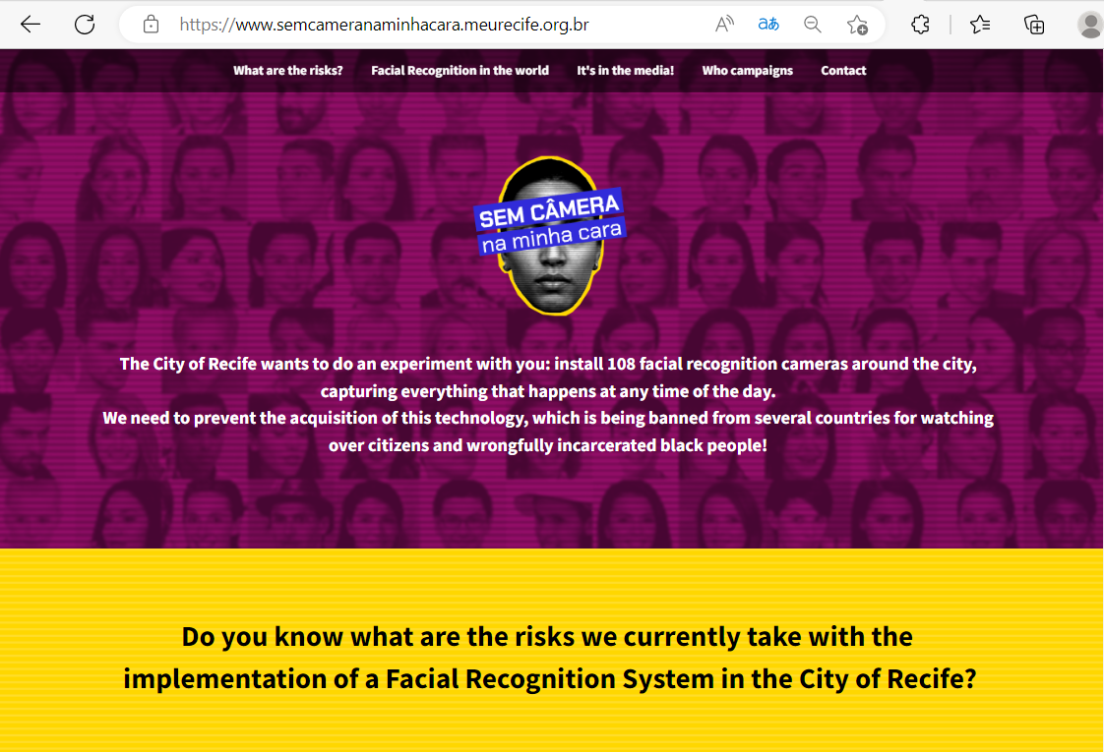

Image 1: ‘No Camera in my Face!’ Campaign website, translated to English via google translate.

Surprisingly, one year later while scrolling on Instagram, I learned about a local Brazilian anti-surveillance campaign titled ‘No Camera in my Face!’.[1] The campaign was founded in 2021 by grassroots organizers and human rights groups, to prevent the initialization of over 100 facial recognition cameras throughout Recife. Their campaign included a website describing the facial recognition initiative and its potential to replicate racism, transphobia, target activists, and violate the personal privacy rights of citizens. In May 2021, Recife’s Mayor, João Henrique Campos, proposed an initiative to install 108 digital clocks that would display the time, business advertisements, share free public Wi-Fi, but also include monitoring cameras with facial recognition capabilities.[2] Justifications for the cameras were to assist with traffic management and preserving the security of public property.[3] An open call was created to invite national and international technology companies to bid for the contract to install and maintain the system for 20 years. The contracted company would also be permitted to use the advertising services of the digital clocks and have access to all data collected. This project is the first of a series of public-private partnership infrastructure initiatives that the mayor intends to implement before his term ends. This initiative exemplifies data colonialism because of the unbalanced power of city municipalities to implement surveillance tools that have capabilities to monitor and track its citizens against their will, and because of the technology company’s profit driven interests and ability to extract data from the population without their knowledge.

In response, twenty-five grassroots and human rights organizations signed an open letter to the mayor requesting the cameras be removed from the project.[4] Their concerns included poor data management protocols, a lack of transparency of the private company’s access to or use of the data collected, and the possibility for racial and gender discrimination. The organizations soon after created the ‘No Camera in my Face!’ campaign. Campaign leaders raised awareness through public interviews critiquing the mayor’s initiative. For example, Raquel Saraiva, President of the Research Institute on Law and Technology of Recife (IP.rec) warned of the low accuracies of the facial recognition systems created in the Global North but applied to Brazil. She says: *‘*The import would be from the Global North, which has a completely different social composition from ours. With the representativeness different from that of the databases, the algorithm becomes even more poorly trained*’*.[5]Her words also painted a picture of why this project represents data colonialism.

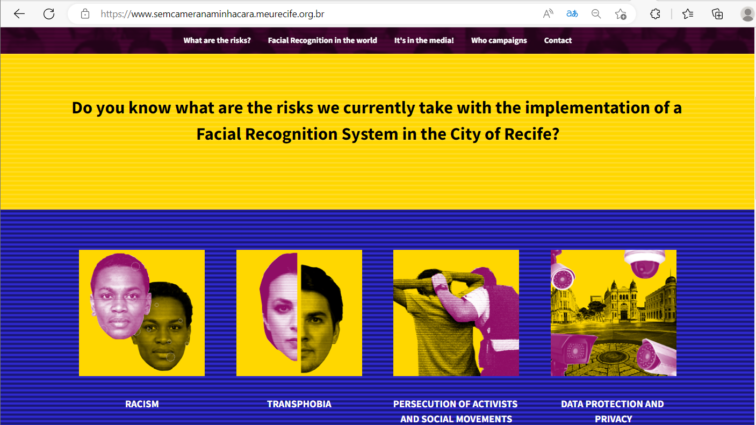

Image 2: ‘No Camera in my Face!’ Campaign website, translated to English via google translate.

A common narrative used to convince communities to buy into using facial recognition cameras is that they will reduce crimes, improve public safety, and because technology is more accurate and unbiased compared to humans. However, studies have proven that even the leading facial recognition systems created by global technology companies like Microsoft, Amazon, and IBM, have demonstrated high inaccuracies when used on racial minorities, especially women with darker skin tones.[6] Misidentifications often occur when the database of images used to test and create the systems are not diverse or inclusive of people with different gender identities or races. In addition, technologies often replicate discrimination and inequalities that already exist.[7] For example, when used by police, who historically have oppressed marginalized groups like black, low-income, and transgender populations, it creates huge risks. This is especially true in Brazil which has the third highest incarceration rate in the world (67% imprisoned are black or brown people), the most African Descendants outside the African continent, and research proving that police overuse these technologies on Black-Brazilians.[8] Black Brazilians are also 2.3 times more likely to be killed by police than white Brazilians[9] and it was reported that in 2019, 151 people were arrested in Rio de Janeiro and Bahia using Facial Recognition, and 90.5% were Afro-Brazilians.[10]

Misidentifications from police have already occurred in Brazil, including the 2019 Carnaval event in Rio de Janeiro, where a woman was falsely identified as a convicted murderer.[11] She was without documentation and unable to prove her identity, but fortunately the charges were dropped after being correctly identified at the police station. Recently, in Rio De Janeiro, it was also reported that a black educator man named Danilo Felix was misidentified and arrested on two separate occasions due to photographic recognition systems.[12] The first incident occurred in 2020 when he was mistakenly charged with theft due to a Facebook image used by a police database that identified him as a crime suspect. He was acquitted after the assault victim proved his innocence, however his image remained in the police database, and this year (April 2023) was falsely arrested for another crime.

Transgender communities are also at risk from these technologies. Coding Rights, a Feminist Digital Human Rights organization in Brazil, conducted a study on the impacts that facial recognition technologies have on transgender communities. They found that 90.5% of transgender individuals believed that facial recognition could operate from a transphobic perspective.[13] These findings resonate with the experiences of Sasha Costanza-Chock in her book, Justice Design, when describing her experiences as a transgender woman entering the full body scanners in airports and being exposed to vulnerable situations by the binary (male vs female) algorithms.[14] Transgender communities are already vulnerable to targeting and for 14 consecutive years Brazil has had the highest violence and murder rate of transgender populations in Latin America.[15] Similar to colonial power, surveillance technologies operate to make white cis-gender individuals the standard and invisible, while racial minorities and non-gender conforming individuals are hyper-visible and constantly surveilled.

Due to the demands of the campaign organizers, there were two public hearings with the city council to share concerns and in March 2022 the Public Ministry of Pernambuco opened a civil inquiry to investigate the possibility of racial discrimination.[16] However, despite the concerns raised, in June of 2022 the project was contracted to Eletromidia (Brazil’s largest home media and advertising company) for $102 million Brazilian Reais ($19.3 Million USD).[17] The mayor said the company would only build and maintain the project, instead of having the power to initiate the cameras or collect the data. In addition, he said the cameras would not be activated until there was a regulation policy made.

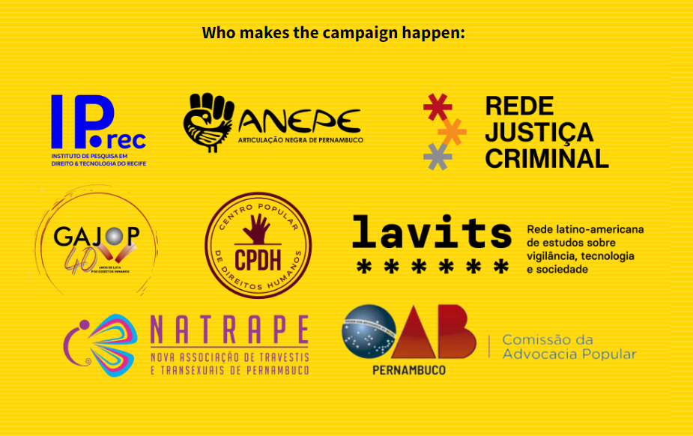

Image 3: “No Camera in my Face!” Campaign website, translated to English via google translate.

This was difficult news for the campaign, but it has not stopped them. An organizer mentioned that their efforts slowed afterwards due to shifting attention on the 2022 Presidential elections in October. However, they are currently focused on increasing public awareness through community workshops in Recife. Digital rights campaigns have typically been led by middle class folks and academics, instead of the vulnerable communities that are directly impacted.[18] By grounding their work in the community, understanding their needs, and showing how these facial recognition projects can impact their lives, it can strengthen the resistance movement and create more impactful solutions moving forward.

Their resistance campaign relates to a national movement in Brazil to completely ban the use of Facial Recognition Technology for security in public spaces, ‘Get my Face out of Your Sight!’ (Tire Meu Rosto Da Sua Mira). It was launched in May 2022 by thirty civil society and digital rights organizations from an open letter calling for the banning of Facial Recognition Technologies.[19] Their campaign includes a website and provides toolkits for community groups to create anti-surveillance campaigns in their areas, as well as maps of anti-surveillance legislation in Brazil. Horrara Silva, a consultant for the campaign, recently mentioned to me their efforts to stop a facial recognition initiative proposed by the city of São Paulo named Smart Sampa. The project intends to install 20,000 facial recognition cameras around schools, health institutions, parks, and other heavily populated areas.[20] In partnership with the Public Defender’s Office, several human rights organizations have entered a lawsuit to sue the city and stop the bidding process.

As an ally to anti-surveillance projects in Brazil, I encourage everyone to read and sign their open letter to ban the use of these technologies.[21] I also encourage you to read the work of Coding Rights,[22] LAVITS,[23] and the organizations within the ‘No Camera in my Face!’ campaign. These resistance movements are instrumental to stopping data colonialism and preventing the installation of surveillance technologies that discriminate and criminalize minoritized populations such as Black, low-income, and transgender communities. We must continue to resist, protest, and never give up the fight!

1. Sem Câmera na Minha Cara. https://www.semcameranaminhacara.meurecife.org.br
2. Augusto Tenório, ‘Organizações pedem que PCR abandone projeto de relógios com reconhecimento facial’, Universo Online, 23 Novembro 2021. https://jc.ne10.uol.com.br/blogs/jamildo/2021/11/14354363-organizacoes-pedem-que-pcr-abandone-projeto-de-relogios-com-reconhecimento-facial.html
3. Secretaria de Desenvolvimento Econômico, Ciência, Tecnologia e Inovação Institucional, ‘Prefeitura recebe proposta de R$ 100 milhões para a concessão dos novos relógios eletrônicos digitais’, Prefeitura Do Recife, 22 Junho 2022. https://www2.recife.pe.gov.br/noticias/22/06/2022/prefeitura-recebe-proposta-de-r-100-milhoes-para-concessao-dos-novos-relogios
4. Maria Carolina Santos, ‘Os riscos das 108 câmeras de reconhecimento facial que a prefeitura quer espalhar pelo Recife’, Marco Zero, 22 Novembro 2021. https://marcozero.org/os-riscos-das-108-cameras-de-reconhecimento-facial-que-a-prefeitura-quer-espalhar-pelo-recife/
5. Maria Lígia Barros, ‘Câmeras com reconhecimento facial no Recife podem agravar racismo e ameaçar direitos’, Brasil de Fato, 21 Março 2022. https://www.brasildefatope.com.br/2022/03/21/cameras-com-reconhecimento-facial-no-recife-podem-agravar-racismo-e-ameacar-direitos
6. Buolamwini and Gebru, ‘Gender Shades: Intersectional Accuracy Disparities in Commercial Gender Classification’.
7. Simone, Dark Matters: On the Surveillance of Blackness.
8. Barros, ‘Câmeras com reconhecimento facial no Recife podem agravar racismo e ameaçar direitos’.
9. David Nemer, Technology of the Oppressed : Inequity and the Digital Mundane in Favelas of Brazil, The MIT Press, 2022.
10. Pablo Nunes, ‘Exclusivo: levantamento revela que 90,5% dos presos por monitoramento facial no Brasil são negros’, Intercept Brasil, 21 Novembro 2019. https://www.intercept.com.br/2019/11/21/presos-monitoramento-facial-brasil-negros/
11. Edmund Ruge, ‘Brazil’s Biggest Metro Could Get Facial Recognition Cameras That Reinforce Racist Policing’, Vice, 2 March 2021. https://www.vice.com/en/article/5dp8wq/brazils-biggest-metro-could-get-facial-recognition-cameras-that-reinforce-racist-policing%E2%80%AF%E2%80%AF%E2%80%AF
12. NINJA, ‘Pela segunda vez, jovem negro inocente vira réu após reconhecimento por foto’, Mídia NINJA, 12 Abril 2023. https://midianinja.org/news/pela-segunda-vez-jovem-negro-inocente-vira-reu-por-causa-de-reconhecimento-por-foto/
13. Mariah Rafaela Silva and Joanna Varon, ‘Threats in the Usage of Facial Recognition Technologies for Authenticating Transgender Identities’, Privacy International, 30 March 2021. http://privacyinternational.org/news-analysis/4474/threats-usage-facial-recognition-technologies-authenticating-transgender
14. Sasha Costanza-Chock, Design Justice: Community-Led Practices to Build the Worlds We Need, MIT Press, 2020.
15. Ester Pinheiro, ‘Brazil continues to be the country with the largest number of trans people killed’, Brasil de Fato, 23 Janeiro 2022. https://www.brasildefato.com.br/2022/01/23/brazil-continues-to-be-the-country-with-the-largest-number-of-trans-people-killed
16. Barros, ‘Câmeras com reconhecimento facial no Recife podem agravar racismo e ameaçar direitos’.
17. Secretaria de Desenvolvimento Econômico, Ciência, Tecnologia e Inovação Institucional, ‘Prefeitura recebe proposta de R$ 100 milhões para a concessão dos novos relógios eletrônicos digitais’.
18. Nemer, Technology of the Oppressed : Inequity and the Digital Mundane in Favelas of Brazil.
19. Civil society (56 organisations and 419 individuals), ‘Open Letter to Ban the Use of Digital Facial Recognition Technologies in Public Security’, Tire Meu Rosto Da Sua Mira, 8 March 2022. https://tiremeurostodasuamira.org.br/en/open-letter/
20. Carlos Petrocilo, ‘Defensoria Pública vai à Justiça contra programa de reconhecimento facial em SP’, Folha de S. Paulo, 24 Maio 2023. https://www1.folha.uol.com.br/cotidiano/2023/05/defensoria-publica-vai-a-justica-contra-programa-de-reconhecimento-facial-em-sp.shtml
21. Tire Meu Rosto Da Sua Mira. https://tiremeurostodasuamira.org.br/en/home-eng/
22. Coding Rights. Hacking the Patriarchy. https://codingrights.org/en/
23. Lavits - Rede Latino-Americana de Estudos Sobre Vigilância, Tecnologia e Sociedade. https://lavits.org/en/lavits/