# LOG:: 06 SWIPE me SVA

Sometimes, one gesture comprises an entire drama, the accent of one word ruins an entire existence, and the indifference of one glance kills the happiest passion.

—Honore de Balzac

The *swipe-down* mechanism, a pervasive interface design element, is fundamentally altering human behavior and cognition. This seemingly simple algorithm is reshaping our neural pathways and diminishing our humanity by promoting compulsive behavior and instant gratification.

*Swipe culture* is the phenomenon of rapid-fire dating app matching, made prevalent through platforms like Tinder, Bumble, and Hinge. While this culture has made dating seeming more accessible and efficient, allowing users to quickly find potential matches based on their preferences, it has also introduced social behavioral concerns. The mechanism, used, by 2024, across social media platforms well beyond dating apps (news sites, video platforms), is designed to keep users continuously engaged by minimizing, quite literally, the need to lift a finger from the screen. Companies deliberately implement this design to maximize user engagement and screen time, resulting in unprecedented levels of media consumption. The psychological impact is significant: users become conditioned to expect immediate satisfaction and develop shortened attention spans. This behavioral modification extends beyond digital interfaces into real-life interactions, particularly in dating, where people make snap judgments based on brief impressions. This contributes to society's growing anxiety epidemic by keeping people in a constant state of high stimulation.[1]

Interface design exploits and amplifies human compulsive tendencies. While businesses benefit from increased engagement, users become trapped in addictive patterns of behavior that reduce their capacity for deeper, more meaningful interactions and thoughtful engagement with content. This cultivates a society of reactive, impatient individuals whose mental faculties are being diminished by constant exposure to this mechanism of instant gratification.

Swipe culture contributes to problematic behaviors like *ghosting*. When people abruptly cut off all contact with someone they've been dating or talking to, it's known by several terms that paint different shades of the same behavior. *Ghosting* is a sudden vanishing act: one day there, the next gone without explanation. *Simmering* keeps things at a low boil, occasionally responding just enough to keep the other person hanging on. *Icing* puts the relationship into deep freeze, deliberately ignoring someone while leaving the possibility of future contact dangling.

These behaviors share a common thread: avoiding direct communication about ending a relationship by simply disappearing, leaving the other person wondering what happened. While technology makes it easier than ever to stay connected, it also makes it surprisingly simple to vanish from someone's life with the tap of a *block* button, or by simply never opening their messages again. This common kind of relationship exit strategy leaves the person on the receiving end without closure or understanding of what went wrong. Instead of having potentially uncomfortable conversations about why things aren't working out, people choose to fade away into digital silence.

In swipe culture, people are likely to invest less time and energy in building relationships with negative impacts on commitment.

And the emergence of short-form video content and short-form video applications (SVA) has fundamentally contributed and transformed the social media landscape. The way young people interact with online content is affected by short-term video. The continuous video feed scrolling has become deeply embedded in daily social behavior.

TikTok, YouTube Shorts, and Instagram Reels have dramatically shifted the video content ecosystem. This represents a significant departure for YouTube, which traditionally dominated the long-form video market. While long-form videos previously offered clear monetization opportunities through multiple ad placements and brand collaborations, the shift to short-form content has somehow created a paradoxical situation: despite increasing viewer time spent on platforms, content creators face greater challenges in generating revenue due to reduced advertising opportunities. Audience viewing preferences and behavior patterns have changed radically.[2]

## connect, create, and capture

Essentially we are experiencing video today in more or less three different ways, each with its own personality and rhythm. First, there's the addictive world of TikTok and Instagram Reels; it’s like flipping through a magical deck of cards on your phone, each one packed with music, filters, and quick cuts. Videos are bite-sized snacks, gone in seconds, but somehow you keep finding more and more. It's a world where anyone can remix anything, and new trends spread like wildfire.

Then there’s the cozy campfire of live streaming, where you can settle in for the long haul. Creators and viewers share real moments together, complete with technical hiccups and unscripted surprises. It's less about perfect edits and more about building genuine connections. Live streaming can be thought of as the digital equivalent of hanging out with friends, where inside jokes flourish and communities grow stronger with each stream.

And then there is the silent sentinel of surveillance video—the watchful eye that never blinks. Unlike its more social cousins, this form of video isn't about entertainment or connection. It's the patient observer, storing endless hours of footage, quietly analyzing patterns and waiting for something noteworthy to happen (as described before).

What is fascinating, somehow, is how each of these video forms has carved out its very own niche. Each is like a different language in the visual world: TikTok speaks in rapid-fire bursts of creativity, live streams flow like long conversations, and surveillance footage whispers in the language of record-keeping. The way we engage with each one is completely different, from the quick dopamine hits of short-form content to the slow burn of a favorite streamer's broadcast.

These distinct cultures show us just how versatile video has become; it’s not just about watching anymore, but about how we connect, create, and capture our world in vastly multiple ways.

## Gestures in Time

There is a text by Giorgio Agamben, “Notes on Gesture*”*; it is the last chapter of *History & Infancy*, a concise piece. It’s also fascinating. He tells about an exciting symptom recorded by physicians at the end of the 19th century: the loss of gestures among urban (bourgeois) people, people forgetting manners of walking or experiencing disorders (uncontrollable jerking, etc.) while making simple everyday gestures. He says that with the start of the 20th century, this issue was no longer noted. Not only, says Agamben, because this state became *normal,* but also because of the rise of a *machinery of gestures.* Following Deleuze, Agamben calls cinema a production of gestures—blocks of space and movement, which are basically gestures. So, one loss of gestures was replaced by another kind of gesture production.

The state Agamben describes before the turn of century is a state of alienation, a response of the body when one suddenly falls into another form of life. The stranger forgets how to walk, how to move his hands, how to point and how to look.

*I’m living in this newly gentrified area, you know, which is an old immigrant neighborhood now invaded by mostly white young artists, students and yuppies. And I observe their manners and gestures, which are incredibly interesting; some sort of very much individualistic set of expressions, but highly stylized manners which are never original, or natural at all; an expressive explosion, as opposed to an expressive implosion, forgetting that is experienced by the other side, the immigrants.[3]*

We observe that every repeated action we perform shapes who we are and influences our future behavior, from the second time onward. This means there's no such thing as an insignificant repeated gesture. During the Enlightenment, this understanding of repetition took on new significance: people realized that the world's continuity depends on these patterns of repetition. This isn't an argument against unique events, but rather a criticism of how we overly romanticize the concept of uniqueness. Both nature and culture function as systems built on repetition. Even in religious terms, this concept holds true—divine power primarily works through nature's established patterns, with miracles being rare exceptions. Kierkegaard captured this modern understanding when he proposed that repetition is fundamental to existence itself; without God willing repetition, there would be no world. The world exists through and consists of these patterns of repetition. Nietzsche extended this thinking through his self-experimentation, suggesting that style, which he saw as the cultural expression of repetition, is the essence of a person. Someone who truly understands style sees happiness not as random occurrences but as a cultivated habit of being happy.

The key insight is that repetition isn't just mechanical reproduction; it’s the fundamental pattern that shapes both our world and ourselves.

*Was uns prägt und entprägt, was uns formt und entformt, sind eben nicht nur die durch die ‘Mittel’ vermittelten Gegenstände, sondern die Mittel selbst, die Geräte selbst: die nicht nur Objekte möglicher Verwendung sind, sondern durch ihre festliegende Struktur und Funktion ihre Verwendung bereits festlegen und damit auch den Stil unserer Beschäftigung und unseres Lebens, kurz: uns.[4]*

## Windows of Interaction

I like to imagine gestures as a language that speaks through movement—not just any movements, but those that carry meaning and intention. Such movements can be more than just physical actions. For example, Vilem Flusser viewed them as windows into how we express ourselves and interact with our world.[5]

Consider how writing has evolved: from the flowing motion of handwriting to the tapping of keys, and now to *this smooth swipe* of a finger across a screen. Each change in technology transforms not just how we move, but how we think and express ourselves. These technological shifts reshape our gestural vocabulary. In the world of smartphones and dating apps, the simple swipe has become a powerful gesture that would have intrigued Flusser. This single movement now carries the weight of complex social decisions—acceptance or rejection, interest or disinterest—all compressed into a quick slide of the finger. It's both liberating in its simplicity and constraining in its binary nature.

It is amazing how quickly these new gestures become second nature. Swiping has developed its own cultural language: a swipe right means one thing on Tinder, while a swipe up means something else on Instagram. These movements, though simple, reflect profound changes in how we interact with information, each other, and our world. The swipe gesture represents an extreme simplification of human judgment and interaction. What should be complex social, emotional, or intellectual decisions are reduced to binary, split-second movements. This reduction mirrors what Theodor Adorno might call the *standardization of consciousness*, where nuanced human experience is flattened into predetermined patterns. The swipe interface isn't neutral—it’s designed to maximize engagement and data collection. The gesture becomes a behavioral conditioning mechanism where users are trained to make rapid and emotional, rather than contemplative, decisions. The physical pleasure of the smooth swipe motion is paired with variable reward schedules. The endless feed structure creates what Jonathan Crary calls *24/7 capitalism*, where even our gestures are captured in cycles of continuous consumption.

## Embodied Alienation

As we repeatedly swipe through endless content, our bodies become like machines—our fingers dancing to the rhythm of algorithms, our touch transformed from an intimate human gesture into data points for tech companies to collect.

Time itself seems to bend. We're caught in what feels like an endless present, where thoughtful reflection gives way to split-second decisions. It's as if we're racing through a digital landscape at breakneck speed, barely processing one piece of content before moving to the next.

Though we're supposedly more connected than ever, there's an ironic loneliness to it all. Each of us sits alone, swiping through our personalized content streams, our relationships increasingly measured in likes and matches rather than genuine human moments. While we feel we're making choices, we're actually moving through carefully designed pathways, each swipe feeding data to invisible systems that learn our patterns and preferences.

Perhaps most profound is how this simple gesture is rewiring our thinking. Complex decisions become binary choices: left or right, like or dislike. We're training ourselves to react rather than reflect, our attention scattered across an endless stream of fleeting moments. It's a shift that goes beyond just changing how we use technology; it’s changing how we think, feel, and connect with the world around us.

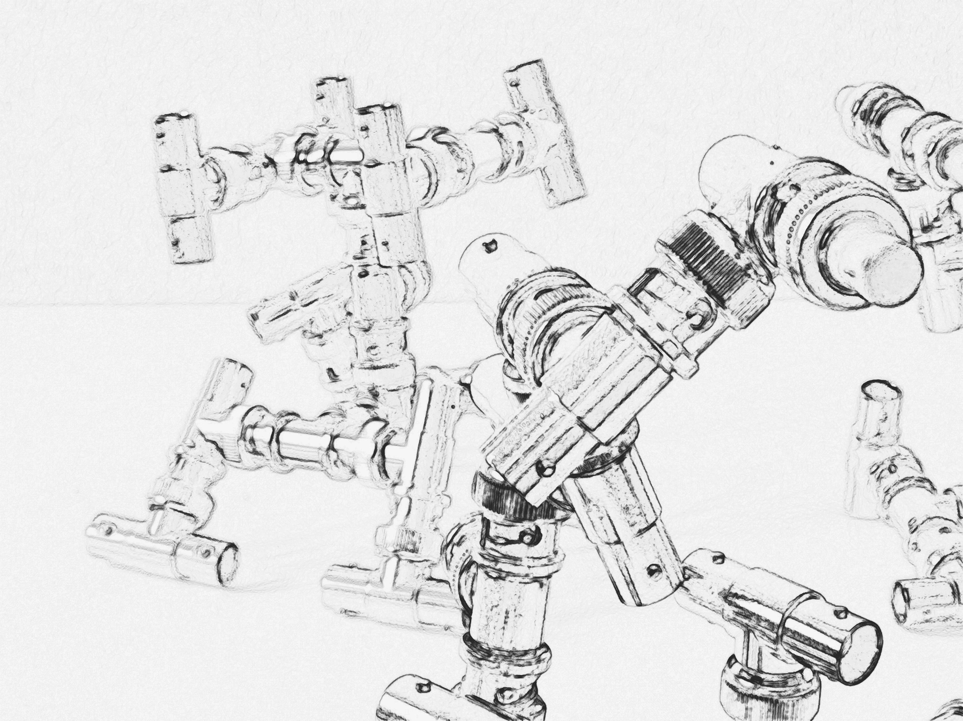

Fig. 7. META-SCHAUEN OBSCUR

The fundamental event of the modern age is the conquest of the world as picture. The word

*picture* *(Bild)* now means the structured image (*Gebild*) that is the creature of man's producing

which represents and sets before. In such producing, man contends for the position in which he

can be that particular being who gives the measure and draws up the guidelines for everything that is.[6]

In *Du Mode d’Existence des Objets Techniques(On the mode of existence 1958)*, Simondon showed us a new approach to the understanding of *technical objects*, and rethought the relation

between humans and machines, cultures and technologies. Today we are witnessing the proliferation of types of object – digital objects in particular – while the very notions of object and

objectivity are being transformed by digitizing processes.

This has inevitable implications for experiences and concepts of subjectivity, …[7]

1. Ansh Jain, The Swipe Culture, https://medium.com/@jainansh01/the-swipe-culture-15156d56e25, accessed 12 March 2025.
2. Prajit T. Rajendran, et al, Shorts on the Rise: Assessing the Effects of YouTube Shorts on Long-Form Video Content, ArXiv abs/2402.18208 (2024): n. pag., https://arxiv.org/html/2402.18208v1.
3. Email conversation with Aras Ozgun.
4. Günther Anders, Die Antiquiertheit des Menschen, Über die Seele im Zeitalter

   der zweiten industriellen Revolution, Band I. Verlag C.H. Beck, München 1996.
5. Vilém Flusser, Gestures. Translated by Nancy Ann Roth, Minneapolis: University

   of Minnesota Press, 2014.
6. Martin Heidegger, The Age of the World Picture. Freiburg, 1938. Translated by William Lovitt.
7. Audio Proceedings of Simondon and Digital Culture. 21-22 November, 2013, Lüneburg, Germany, http://www.digitalmilieu.net/simondon/, accessed 26 January 2025.