# LOG:: 09 Temporal Audiovisual Workouts

Was vernünftig ist, das ist wirklich, and was wirklich ist, das ist vernünftig.

—G.W.F. Hegel

What is more educational is most aesthetic, and what is most aesthetic is most educational

—Nam June Paik

What can you do with video without recording and immediately sharing the social self-referential instant?

What can you do with video if you don't record fictional material for whatever mini-feature or story of another self of you?

Are these the right and adequate questions? Shouldn’t we rather ask how to stay fit with video? Fit not in the sense of physical exercises, but in the sense of exercises that maintain fitness for technological-driven cinematographic or non-cinematographic audiovisual things, visuals, worlds, or environments.

I like to call this etude, or finger exercises: a post-cinema video practice, or temporal audiovisual workouts. Etudes are exercises to train and make us sensible in our daily lives with video. They are meant to strengthen, maintain, and enjoy. We have to stay fit! Fit with Video for Video!

Etudes for video are little conceptual exercises to train observation, flow, and rhythm, settling a diverse practice, a form. The parallel here is not between running on a machine in a sports salon and running with the camera in extreme position and depth of field shots, or between parameters of the body lifting tools and the parameters of the lens, the parameters of recording, playback, editing and montage, parameters of projection, display, and the sweat of bodies in mirrors.

## What makes you sweat when you are video graphing?

Etudes in a post-cinema-video practice are about something other than learning how to make better videos through lessons and technical tutorials, advice from influencers, creators, industry insiders, and personal creativity consultants from social media video-driven technological platforms.

Let's think of video as the form and material of a simple camera, a signal, and a processing unit. The exercises should consider diverse aspects of this form.

The etudes are an artistic practice as a form of orientation.

But which elements belong to the form, the frame, and the light when we do not want to fall into the trap of cinematic capital labor and dictatorship?

Body and Hand - video sports or protocols of life, feeling time, longing for contemplation, images of change and natural movement, perception and lateral thinking, water logic, dancing with video, a framework for a hypothesis to experience video not in the old way, to be a barbarian with primitive tools and ways overcoming the obsolete in the static. Language forces us to look at the world in traditional ways, which have become outdated.

Perceptual truth is system truth.[1]

In a way, we should stop teaching film/video, or at least stop treating film/video like film/video cinema/video. We should end the Hollywood-like industrial production model and the European countries' cultural subvention model and move on.

Where? TikTok has opened up a different way: multiple speeches, ways to talk, writing in movement, ephemeral, disappearing as the words are uttered, or as the song is sung. But we need a different kind of literacy to utter this speech and free ourselves from any mode of exploitation.

A film festival in 2022 in the Turkish coastal city of Antalya invites 250 students to its film school. It sounds wonderful. Cinema has become everyone's again. But why should we feed a machine that has already run out? Aren't the monstrously hungry streaming platforms and the kids on the block the new feeders and fodder in the barn?

Should we re-learn a way of video to prepare for the new world of non-human actors? What is the method needed? What kind of fiction will they embed? Let's remember: how did we learn to write? We repeated a symbol over and over. Isn't that like TikTok for paper? The teachers should have told us to send our pages to publishers. They didn't invite us to festivals of cultural officials and social workers.

Film studies is dead. Media studies is dead. Cultural studies is dead.

Technologies of video's moving image, politics, and aesthetics are alive.

The big school of social media is taught by TikTok. Every new situation changes the use we can make. The mythos of the great film director is dying, a new type is appearing, and the disappearance of the cinematic championship needs to be accepted and then forgotten to have this new historical moment of great pleasure, a phantasm to create new science and build new knowledge.

Everyone is a creator.

## Observation

Observation is the basic concept of every video etude or practice. Etudes or audiovisual video practices—workouts for video—can take many forms, many variations, and can be done everywhere, in restaurants, cafes, bars, at train stations, airports, hotels, maybe in classrooms or studios, but also in private spaces—anytime.

Etudes are fragments of time and view – not necessary manipulated through editing, not necessarily operated during recording, and not reframed. These are pure shots, following a basic instruction. Their nature is planned, but their execution is mostly spontaneously, and not really set up or framed. But they have one general condition in common: the way they are practiced.

Etudes follow the spirit of early cinema practice, where movies were attractions of one single shot. But after more than 100 years of cinema history, with the development of television, digital platforms, and mobile media devices, there are no more attractions except going back to the purest form of cinema: time and space. In other words, leaving the sphere of action to action images - as Deleuze would describe it – through a conscious limitation. And therefore giving back to the camera its actual meaning: its character as an object of recording.

Etudes are *fern-sehen*. The German word *fernsehen* or far seeing, which is used for television, comes back to its original meaning.

Etudes are not live. They are live recorded. Also, they are not live streamed. Only in this way can they become *present* whenever they are watched. This happened, this was recorded, it happens, it is actually there, the camera was there, the camera is there, I was there, I am there—and I am here.

Concentration - Conditioning - Celebration[2]

We need to concentrate. We need to repeat. We need to have fun.

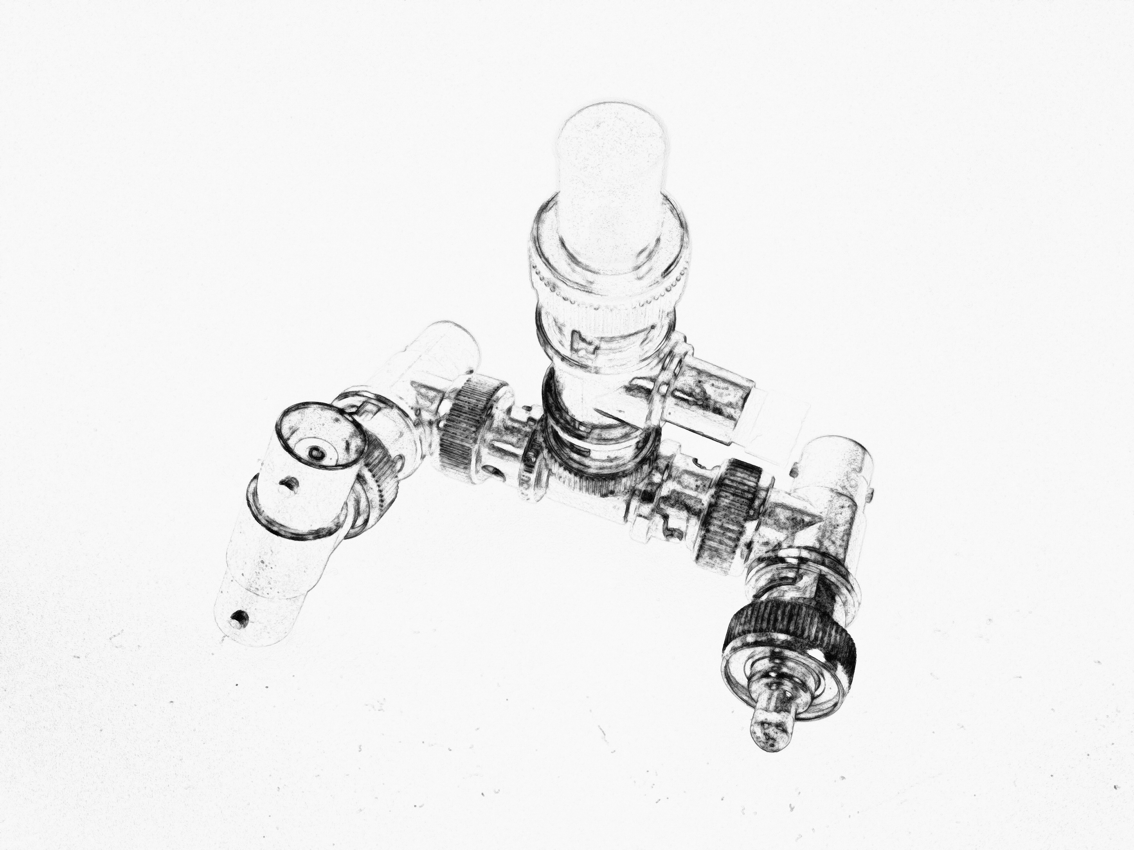

Fig. 10. ALL THINGS MOVE

‘All things move, all things run, all things are rapidly changing.’

- From the Manifesto of Futurist Painters, April 1910

1. Edward De Bono, Water Logic, London: Penguin 1993.
2. Daniel Irizarry’s three C’s in: *Mantı ve Çay. A documentary by Boran Aksoy, Melih Aydinat, Daniel Irizzary and Andreas Treske.* Bilkent University, Ankara 2019. https://vimeo.com/346824086, 9 January 2025.