## LOG:: 10 Clair-Obscur

For everything that is shown, something is hidden.

James Bridle[1]

We have become screen people. Like shopping malls with no outside windows, our travels, as once with trains from one place to another, don't need the window anymore to explore the landscape rushing along. The fantastic world of screens has created Alice's wonderland for us.

We had been warned. The shower curtain of Hitchcock's *Psycho* presented us with the silhouette, obscuring the perpetrator. The medium had presented a veil. But the veil was not covered, and there was no protection. It was just an instrument of suspense, lengthening emotional involvement and tension.

But the inside of the screens, the beautiful screen worlds, present a new now, a now of being together inside. What a marvelous soap bubble.

So, first, windows are replaced by screens. We don't need to look outside, and we don't need light to enter. Second, small screens are in our hands, computing anytime from anywhere and observing us as cameras and multi-functional sensors. Screens and cameras and computers merged into tiny super devices in our hands, building an algorithmically calculated space between our surrounding walls, where the paint watches us.

A constant feedback circuit.

There had always been a trend for invisible technology that blends into the background, a trend to camouflage technology. Hardware is merging and getting smaller, transforming into a future skin, close. This development is no longer about human mobility. Movement has given away to agents, chatbots, or our digital doubles. We are too slow with our bodies and minds, which lack the super microsecond reaction time of high-speed trading worlds.

Amid the limits to the space around us still left in an overcrowded planet we call home, the physical is becoming another interface and distribution environment, an *Umwelt* for us living together with digital objects. The camera itself is becoming the operating system. The real world and the web are a single time and space. Spatial computing turns the world into a new canvas. The camera finally gets its active role. The camera creates the experience of consumption and transaction, a trustworthy platform for extended reality, the next playground for developers, and an obsession for all of us consumers. The camera or the designed physical object that functions as a camera directly will compute and run applications in a *virtual* representation of the world. Pokemon Go has already given us a little taste of the augmented world to come. Apple Vision or Meta’s phantasies are the next step in immersive technology and spatial computing stretching out.

Imagine that we can compute and interact with, on many levels, what we see or sense. The world around us is then programmable, in an always-available and always-on relation with anything digital. We don't need to ask for availability; we always have access to contextualized information. With these new operative lenses, imagination becomes the only limit. This might be the near future of our smartphones. It is all about the camera. It’s all about sensing and operation.

**Clair-obscur**

There is light and shadow. In painting and cinematography, we talk about chiaroscuro to describe the use of contrasts of light to give three-dimensional objects and figures some form of volume. In libertine literature of the 18th century, writers questioning and challenging moral principles would rely on veils and *linguistic shadows* to make their texts more intriguing and more erotic. The notion of *Clair-obscure* draws on an analogy between a painter creating harmony between the light and the dark on his canvas and a libertine writer aiming to reach a balance between polarities in pleasures: liaisons unfold between vice and virtue, control and abandonment, society and the self; seductions rely on a compromise between revelation and concealment, clarity and obscurity, bridging the gap between the aesthetic and erotic spheres. *Clairs-obscures* are conceptualized as crucial factors for a superior form of enjoyment. Darkness is the core and source of artistic and erotic pleasures.[2] Libertine authors re-evaluated the charms of shadows and departed from the tradition of praising the beauty of light. Obscurity has more than a simple aesthetic function; it is also endowed with erotic powers.

**Eye Window Brain**

What do the new layers of our world obscure that gives us pleasure? Is pleasure no longer focused on the in-between, the suggestion, the half darkness, or the could be? We see our boring world between four walls, but what reflects our senses is an experience in which we are part of pleasure.

From its moment of initiation, cinema has always had a relationship with money. Capital is the driving force behind the development of audiovisual technologies. What we see or sense is directly influenced by and through technology, controlled by finance. It does nothing but obscure what it does.

Ann Friedberg, in *The Virtual Window: from Alberti to Microsoft*,[3] looks at the paintings of the Renaissance painter Leon Alberti and notes that the aim of an *open window* is a metaphor for perception and the organization of a particular form of subjective vision. The visual regime operates on several levels. It shows a variable rectangular frame, uses the window as a metaphor for the frame of the painting, points to the 'subject' seen through the frame, and produces the human figure as a standard of measure and a determined *centric point*, thereby creating the immobility of the viewer.[4] Consequently, cinema, in the sequence of development of the window as a visual metaphor, is the quintessence of the system of vision imposed by Western aesthetics. Descartes uses, in his description of the *camera obscura,* the word *finestre*—window—to describe the hole in the eye—the *shutter* or lens—that lets light through and focuses light into the retina. The window reference underlines the essential etymological root for the window as a mediating lens to vision.[5] The metaphor suggests the world is already filtered through a frame, making visual perception inherently unreliable. The rise of camera technology, mirroring the eye, amplifies these anxieties. In essence, early film theories echo Descartes's framework. The *mirror that becomes clear glass*—human vision as a mediating window—evokes the same suspicion Descartes felt when questioning optical illusions. While positioning the human eye as the standard for film, these theorists potentially overlook non-human or future forms of vision.

The urge for cinema to exist independently of human perception mirrors the shift in capitalism where money holds value independent of gold. Both these developments are not just consequences of crisis, but also contribute to it. What defines industrial art is not mechanical reproduction but the internalized relation with money.[6] Money folds within the cinematic image in an intimate and intrinsic correspondence of forms. Further new structures of power and control just now give way to the erosion of Vertov's camera eye and introduce of new interactions between *film* and life. The regime of vision that implemented the golden mean and produced a whole, unified subject gives way to a new system that Deleuze explicitly points toward: the brain as the screen. The screen has overruled the conventions of the subject and of human posture. It constitutes rather a pool of data and information, a seemingly transparent surface to layer other commercial worlds, replacing the eyes of nature.

The camera-money exchange has become the only relation that moves through the window.[7]

In his essay *Postscript on the Societies of Control*, Gilles Deleuze identifies a substantial shift in power dynamics. Modern societies dismantle the defined spaces of family, school, and work, *breaking down interiors* that used to structure people's lives. Individuals are no longer distinct entities within the crowd but *individuals* constantly monitored by control systems. This fragmented state reflects the workings of financial systems, with money itself exemplifying the difference.

The concept of the brain screen, where the mind becomes a receiving surface for images, perfectly aligns with this era of control. Cinema initially presented itself as an objective window to the world, but ultimately undermined that very idea. The cinematic image precipitates its undoing, and the closure of the gold window points to an ambivalence within film as an industrial art: its flexibility and adaptability to the functioning of systems of control. Furthermore, understanding the function of visual economies in our present world must consider the financial logic that structures the relationship between cinema and money, between video technologies and capital.

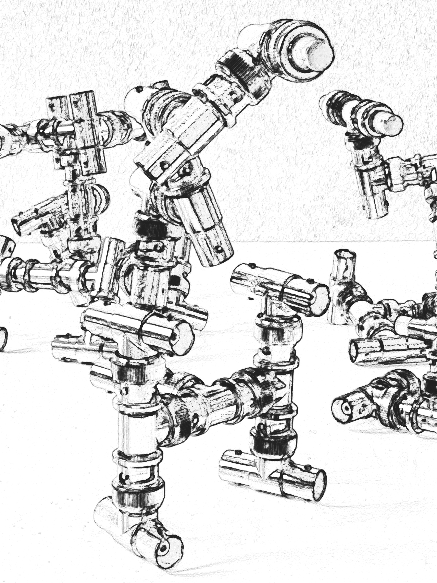

Fig. 11 DOMAIN

Transformers is a media franchise produced by American toy company Hasbro and Japanese toy

company Takara Tomy. Initially a line of transforming mecha toys rebranded from Takara's Diaclone and Microman toylines, the franchise began in 1984 with the Transformers toy line, and centers on factions of self-configuring modular extraterrestrial robotic lifeforms in an endless civil war for dominance or eventual peace. In its history, the Transformers robot superhero franchise has

expanded to encompass comic books, animation, video games and films. Marvel’s cinematic universe - Construct a fully furnished world and then gradually reveal the space/ mythology of that world. Gradually revealing a world’s hyperdiegesis and borrowing the spatial configuration of video games creates an environment that encourages exploration. This environment propels hard-core fans to seek out more information, draw connections, and gain a better understanding of the fictional world. At the same time, casual fans can imagine a vast expanse while focusing on the characters and main events of the show.[8]

Where diegesis is the narrative world seen by audiences, Matt Hill’s hyperdiegesis is *the creation*

*of a vast and detailed narrative space, only a fraction of which is ever directly seen or encountered*

*within the text, but which nonetheless appears to operate according to principles of internal logic*

*and extension* (2002: 137). This vast world is built throughout the series by accumulating and

reiterating details. Mentions of people (The Federation in Star Trek), places (Maps included in Lord of the Rings books), and events (“Vatican cameos!” in Sherlock Holmes) suggest a complete world with a long history. Though gaps in this history may be explored by the primary text in future

episodes, fan productions are used to fill them in the meantime. The hyperdiegesis provides a

coherent world and the rules of operations by which it works, rules that fans must abide by when

they choose to explore the world themselves. While a show’s hyperdiegesis needs to remain

consistent to maintain the trust of its audience, Hill believes that producers must *play with their*

*own established rules and norms… in order to preserve audience interest* (2004:511).[9]

1. James Bridle, New Dark Age: Technology and the End of the Future, Verso 2018.
2. M. GANOFSKY, Libertine Clairs-Obscurs: The Enticement of the Shadows, J 18th Cent Stud, 37: 499-515 2014. https://doi.org/10.1111/1754-0208.12203.
3. Ann Friedberg, The Virtual Window. From Alberti to Microsoft, The MIT Press 2009.
4. Friedberg 2009: 27.
5. Friedberg 2009: 51.
6. Alasdair King, The Financial Image. Finance, Philosophy and Contemporary Film, Springer 2024
7. Morgan M. Adamson, The Closure of the ‘Gold Window’: From ‘Camera-Eye’ to ‘Brain-Screen’, Film-Philosophy 17.1 (2013) https://www.euppublishing.com/doi/pdf/10.3366/film.2013.0014
8. Aaron Smith, Transmedia Storytelling in Television 2.0, Thesis, 2009, https://sites.middlebury.edu/mediacp/about/, accessed 12 March 2025.
9. Matt Hills, Fan Cultures, London: Routledge, 2002.