# LOG:: 12 Sharpness

In this language of images, one must lose completely the notion of image. The images must exclude the idea of image.

—Robert Bresson, 1997

As video becomes ever more realistic and sharper, it somehow loses something essential—a certain mystery or illusion present in older media forms. Unlike the analog television image written line by line, creating a progressive scanning effect, digital video appears as a complete, instantaneous image. This fullness, this crystal clarity, can feel almost unsettling or *unheimlich* (uncanny).

This explains the deliberate addition of softness or *cuteness* to ultra-sharp digital images. It's as if we are trying to create emotional distance from the overwhelming clarity of digital video. Think of how bokeh (that beautiful blur in out-of-focus areas of photographs) has become not just a technical effect but an aesthetic choice that adds emotional depth. We are encountering a paradox of clarity and distance.

The streaming era has changed our relationship with moving images in fundamental ways. While traditional cinema was always experienced *there*, in specific architectural spaces within cities, streamed content exists in an immediate *here and now*. This immediacy creates a kind of closeness that needs to be mediated, softened, or disguised in some way for comfortable sharing.

The technical evolution reflects this tension. From the 525 or 625 vertical scan lines of early television to today's 4K resolution (3,840 horizontal pixels), we have pursued ever-greater clarity. When Hollywood transitioned from analog to digital, they needed to jump straight to 4K imagery because 2K appeared too grainy on large screens. Yet paradoxically, as our ability to capture and display crystal-clear images has improved, we continue to develop numerous techniques and filters to reintroduce blur, softness, and imperfection. There must be something profound about human perception and emotion: sometimes clarity needs to be veiled to be truly seen, and precision needs to be softened to be fully felt. The *unschärfe* (blur) isn't just a technical imperfection—it's a bridge to emotional connection.

When George Lucas shot Star Wars Episode II in 2002 with the first digital cinema cameras, he and his crew encountered digital clarity as one of their essential problems. All of a sudden, smudges and brushstrokes in the makeup were visible. Lucas needed to use filters to soften the image and make it less sharp. Sets, costumes and makeup needed to be more precise and refined. Everything needed to be more finely detailed.[1]

In 1986, long before digital video became commonplace, an interesting paradox of image quality emerged during the filming of John Lennon's "Imagine" music video, as Babette Mangolte notes.[2] Using a prototype Sony high-definition video camera, the crew obsessed over the image sharpness on their monitors. However, when transferred to 35mm film, these *perfectly sharp* electronic images revealed unexpected patterns of sharpness and softness—quite different from what traditional film emulsion would produce. The image seemed to exist in two stark states: either sharp or soft, without the subtle gradations typically found in film.

This early experience with high-definition video foreshadowed issues that would later emerge in digital cinema. Take 1995's *Toy Story*, for example. As the first fully digital feature animation, it exhibited an almost unnatural total sharpness across the entire frame, lacking the natural depth-of-field effects we're accustomed to in traditional film. While later digital animations learned to mimic traditional film techniques like chiaroscuro and selective focus, there remained something artificial about digital softness. The hard-edged nature of pixels always lurked beneath the surface.

Interestingly, many filmmakers today actively avoid the pristine sharpness of digital video, preferring to manipulate shutter speeds to create what they call the *film look*, essentially recreating the motion blur characteristic of traditional film.

While extreme sharpness might seem to prevent the mind from wandering freely (a quality valued in certain types of cinema), the real challenge may lie in the digital image's brightness and its collapse of the distinction between *real time* and *screen time*. Rather than freeing the mind to wander, this hyper-clarity creates a kind of restlessness - perhaps explaining why we often seek to soften these too-perfect images.

•

## ZOOM

And then there are the blurred backgrounds in our daily video conferencing, hiding the wall, the pictures, the shelf, the cafe, hotel lobby, the transitional space to isolate the head, the face, the shoulder, the close up…

Clair obscure.

Fig. 13. UTOPIA

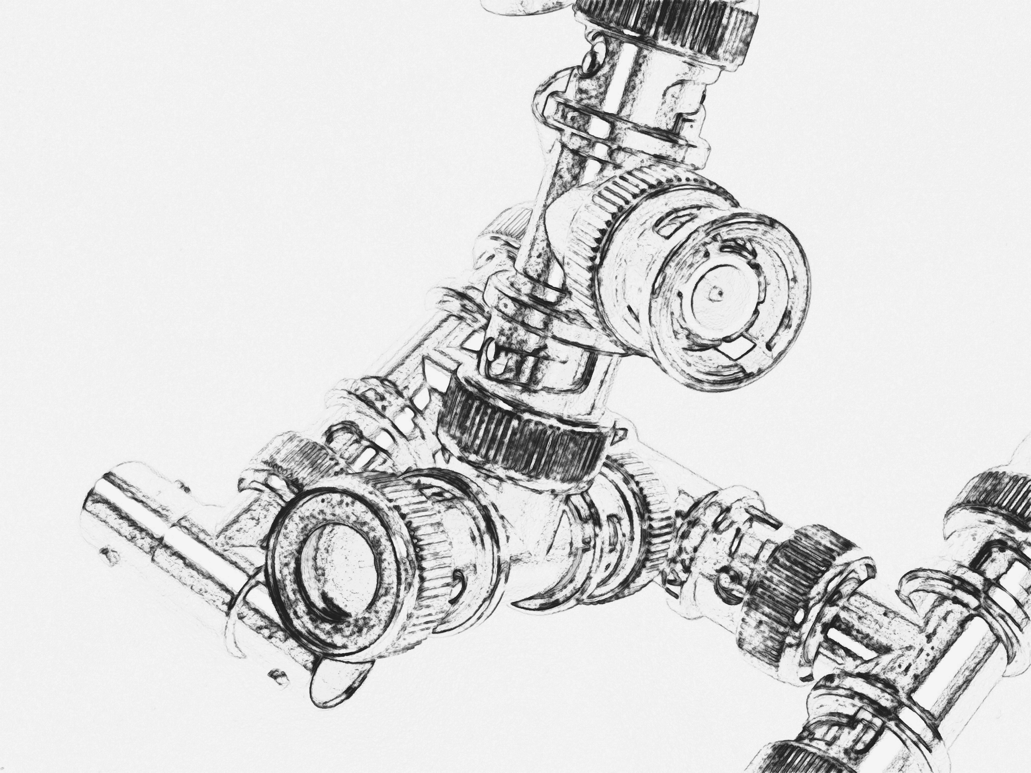

It is not as if the world has not long, long been one in which vast numbers live in dystopian depredation. The horizon is more visible now to many who had thought themselves insulated, if they thought about it at all. And dystopia for some is utopia for others. To repeat something I have said elsewhere, we live in a utopia: it just isn’t ours.

- China Miéville[3]

1. American Cinematographer: George Lucas Interview Interview by Ron Magid. https://theasc.com/magazine/sep02/exploring/, accessed 1 December 2024.
2. Babette Mangolte, A Matter of Time. e-flux notes. 2024 https://www.e-flux.com/notes/641724/a-matter-of-time, accessed 10 January 2025.
3. China Miéville, A Strategy for Ruination. An interview with China Miéville. 8 January 2018. https://bostonreview.net/literature-culture-china-mieville-strategy-ruination, accessed 12 January 2025.