## LOG:: 14 Generative TeleVisuality

The starting-point of any study of television must be with what is actually there on the screen. This is what content analysis is concerned to establish. It is based upon the non-selective monitoring, usually by a team of researchers, of the total television output for a specified period. It is not concerned with questions of quality, of response or of interpretation, but confines itself to the large scale, objective survey of manifest content. However, the reading of television must progress from the manifest content to the latent content, and very few analyst have begun to tread this path.[1]

YouTube dominates watch time across platforms. YouTube is one of the biggest platforms in music. YouTube is rapidly eating podcasting, and is now a major cable competitor, and much more. *If YouTube can make the big screen and the small screen feel like the same screen, it’ll become even more unstoppable.[2]*

A year-end update reveals that more people than ever are watching the video sharing platform on television—an inevitable switch in consumption habits.[3] Traditional television is evolving into something much more dynamic and interactive. I like to call or define this transformation as *Generative Televisualty*.

The concept of *televisuality,* following John Caldwell, reflects on television as *a system of business conditions, styles, ideologies, cultural values, modes of production, programming and audience practices that make up television as a medium within a specific historical and geographical context*.[4] Caldwell revolutionized television studies by emphasizing its visual nature and the economic value of program styles, highlighting the interconnectedness of aesthetics, economics, and technology in television.

Imagine watching a show that adapts its storyline based on your reactions, or content that's partially created by artificial intelligence responding to viewer preferences. This isn't science fiction; it's happening now. Television is no longer just a one-way broadcast; it's becoming a conversation between creators, algorithms, and audiences. That is said in a positive sense.

At the heart of this transformation is the merger of traditional television with digital technology. Algorithms analyze viewing patterns and help shape content, while interactive features allow viewers to influence what they watch in real-time. Social media integration means audiences can engage with content as it unfolds, creating a feedback loop that shapes future programming.

Netflix and Hulu analyze our viewing habits to suggest shows and movies we might enjoy. Viewers get control over what and when to watch, enabling binge viewing, marathon sessions of entire series. However, this freedom can lead to a paradox—the more you watch, the harder it becomes to find fresh content, and recommendations start to feel repetitive. Meanwhile, platforms like YouTube and Twitch add a social dimension that traditional television never had, with viewers able to chat with each other and interact during live streams.

The impact of generative televisuality extends beyond just how we watch TV. Production teams now use real-time rendering and virtual production techniques, while AI and machine learning help create and modify content. The line between producer and consumer is once again blurring, as viewers become active participants in the evolution of the content they consume. Viewers need to become creators.

This shift raises questions about the future of storytelling and narrative. Will our TV shows become completely personalized? How will AI influence creativity? What happens to shared cultural experiences when everyone's viewing journey is unique? As technology continues to advance, television is becoming less of a fixed medium and more of a dynamic, evolving form of expression that responds and adapts to its audience in real-time.

Generative AI plays a crucial role in reshaping content creation and audience engagement. While it offers significant opportunities for innovation and efficiency, it also presents not yet known challenges; in particular, authenticity and bias are already obvious. As these technologies continue to evolve, their impact on both the production processes and viewer experiences will deepen more.

From game design we have already learned that players easily can destroy the game experience. It is something naturally to test out the borders, and it is only consequently that any interactive experience has to be a controlled and invisible guided experience. You can do only what you are allowed to do, and you can only get what is in stock. But the stock can be rendered endlessly.

Together with Aras Ozgün we wrote about how streaming platforms are reshaping not just what we watch, but how we experience entertainment itself.[5] Streaming has ended the act of gathering around TV at a specific time, the common physical sharing of an experience with family or friends. *Microcasting* has let to a world where algorithms serve up personalized content just for you. While this customization might seem convenient, it comes with a trade-off: we're losing those shared cultural moments that traditional TV once provided. For the first moon landing, people gathered around television sets and lived every minute live with the transmission. Today, space travel is shared via social media, and millions of singled-out people are watching alone on a personal device. It’s me with the device with the event.

The algorithms that power streaming platforms are like invisible curators, quietly shaping our viewing habits. They don't just suggest what to watch next; they're actively molding how we interact with the library content. It's a bit like having a very attentive but somewhat controlling friend who's always ready with recommendations, but might be limiting your exposure to new experiences. The awkward nerd from the video store took his revenge.

This shift toward personalized viewing has deeper implications for our society. When everyone is watching different content at different times, those conversations about last night's big show become increasingly rare. While we're gaining convenience and personalization, we might be losing something valuable: the collective experience of shared cultural moments. I still remember discussing every new episode of Star Trek seen on the weekend on a Monday morning with my friends while waiting for our school bus. Now, these discussions have shifted to notes and messages on WhatsApp, somewhere in the feed.

Yet streaming platforms aren't just passive content delivery systems. They're constantly evolving, experimenting with new ways to keep us engaged. As our viewing habits become increasingly personalized and algorithm-driven, how do we maintain the social connections and shared cultural experiences that traditionally brought us together through media?

Rather then praising technology unreservedly, paint doomsday scenarios, or get lost in economic analysis, we need to dig deeper. We have to acknowledge how technology is changing our world while maintaining a thoughtful critical perspective, to gain some distance. We have to stay away from a *technology is good* versus *technology is bad* debate. Instead, we need to continue to look at streaming platforms as complex systems that shape our culture in both visible and invisible ways. We need to understand how algorithms do more than just recommend content; they actually influence how we experience and make sense of media. For this we need to examine the whole system, and the infrastructure that keeps it running.

Streaming as media practice does not have to be as we now experience it in 2025. Alternative forms emphasizing participatory culture and collaboration in content creation and distribution could be facilitated. Algorithms could be used for fostering critical dialogues.

Creativity and *responsiveness* are the keys for community. Streaming platforms have the potential for cultural expression, particularly in times of crisis. They can generate reciprocal changes and therefore produce *real* interactivity.

We need to address interdisciplinary collaboration, economic sustainability, alternative revenues, social protocols, digital platforms, and support innovative formats for artistic expression and social commentary to challenge traditional and new technological boundaries.

**The Force again**

Yes, we have understood that television shapes our world. TV is more than just a box that delivers entertainment. It is a powerful force that actively shapes how we understand reality and experience the world around us.

I like to recall Paolo Carpignano, who pointed out that television has the unique ability to create what he calls *present-ness*.[6] Think about how TV can make millions of people feel like they're experiencing the same moment together, whether it's a historic event, a sports match, or a season finale, or the moon landing mentioned earlier. A Taylor Swift concert live? Carpignano argued that this shared experience is something special to television, creating a unique kind of intimacy that bridges the gap between our private lives and the public world.

Something quite profound about television's influence is not just about what we watch, but how we watch it. The way television presents information—its visual language, its rhythms, its way of telling stories—has fundamentally changed how we perceive and remember events. It's almost as if television has created its own language of experience that we've all learned to speak. An event did not exist if it was not or is not broadcasted.

Carpignano's framework of thinking about televisuality proves remarkably useful in analyzing how streaming services and digital platforms are transforming our viewing experiences. Even as we have moved away from traditional TV, many of the conventions and patterns he identified continue to influence how digital content is created and consumed. It is as if television's DNA has been passed down to these new forms of media, shaping how we expect to experience content in the digital age.

•

**The Cybernetic Desert - Intermission by Aras Ozgun[7]**

Streaming media technologies transfigured 'publics', founded by print and broadcast media in modern times. In its new form, the 'audience' became an amalgamation of individuals, whose aesthetic and ideological preferences, along with their everyday routines and viewing habits, could now be quantified and assessed by the platforms, which gradually gained control over the production of the content as well as its streaming delivery. The incorporation of generative AI technologies into contemporary media culture takes place on this ground.

We often hear the complaints (not 'analyses' but indeed complaints) these days that generative AI technologies will strip humanity of its creative/intellectual essence. Well, stripping humanity of its creative/intellectual capacities began when Thomas Edison set up the Black Maria studio and consequently founded the Motion Picture Patents Company. Adorno and Horkheimer have already shown that mitigating critical reason is the operational logic of modern culture industries. What generative AI technologies actually do today is to remove media professionals from their 'middleman' position in this process. Algorithms, instead of producers, determine what people (not a general audience, but sums of individuals) precisely want, and generative AI produces that content from script to screen, instead of production crews.

It is quite interesting that despite the fact that the 'hyper-realism' of generative AI and Large Language Models (LLM) already provides us with perfect simulations, we seem to have forgotten Jean Baudrillard and his criticism organized around the notions of 'hyper-reality' and 'simulacrum'[8]. Baudrillard's criticism was directed towards a highly saturated, increasingly visual media environment, in which representations had started to substitute for the ‘real’, and without any reference to real. The problem, according to Baudrillard, was the loss of touch with reality at a collective level—the subsumption of the world outside by televisuality, so to speak. Today’s social media platforms already become phatic communication domains that channel massive misinformation flows[9]. Streaming media platforms too, mainly serve a phatic function by accompanying molar audiences everywhere at all times on their mobile devices, feeding them nothing but what they feel they like. At this technological junction, the main promise of generative AI under platform capitalism is a cybernetic desert, a media environment devoid of information that representations of secondary order perpetually reproduce. Information, for Bateson, was a difference that makes a difference[10]. Whereas what generative AI produces is a simulation that resembles the same just enough to be able to substitute it, or reconfigure the parts of the same just enough to create an illusion of the new.

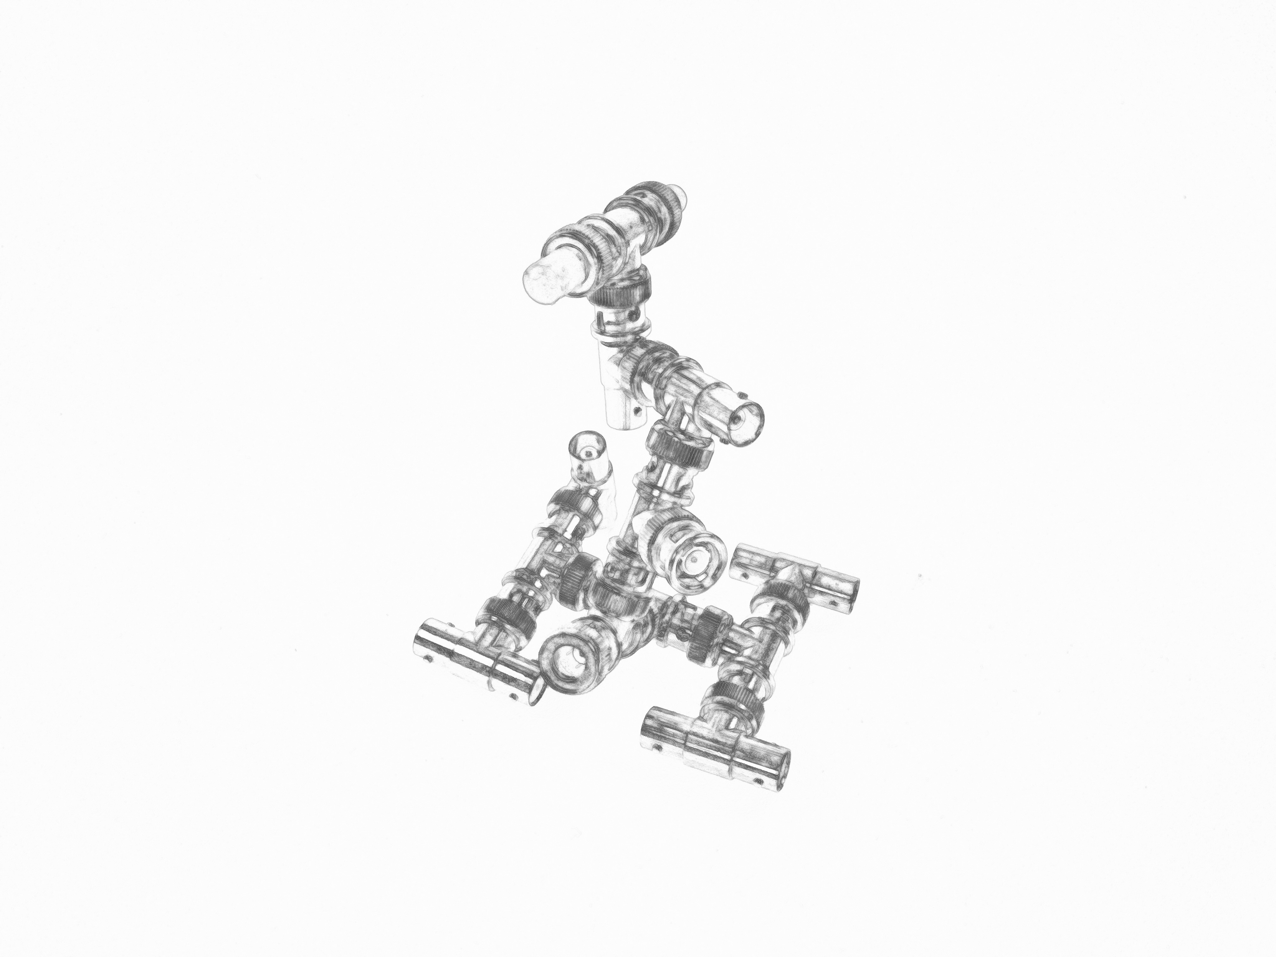

Fig. 14 UNKNOWN

1. John Fiske and John Hartley, Reading Television, Routledge, London and New York 1988: 21.
2. David Pierce. YouTube is a hit on TVs — and is starting to act like it. The Verge. https://www.theverge.com/2024/12/11/24318434/youtube-living-room-tv-growth-2024 Dec 20, 2024
3. Chris Stokel-Walker. YouTube is taking over TV. https://www.fastcompany.com/91246335/youtube-is-taking-over-tv Dec 20, 2024
4. Redefining Televisuality: Programmes, Practices, Methods. International conference. ECREA Television Section Conference 2023. Filmuniversität Babelsberg Konrad Wolf, Potsdam, 25-27 October 2023. https://www.consultacinema.org/2023/02/27/redefining-televisuality-programmes-practices-methods/
5. Aras Özgün and Andreas Tresk3, On Streaming-Media Platforms, Their Audiences, and Public Life. Rethinking Marxism, 33(2), 2021: 304–323. https://doi.org/10.1080/08935696.2021.1893090 and Aras Özgün ve Andreas Treske. “Süreğen Medya Platformları: İzleyici Etkinliğinin Dönüşümü Ve Toplumsal Etkileri”. Ankara Üniversitesi İlef Dergisi, c. 8, sy. 1, 2021, ss. 109-32, doi:10.24955/ilef.933277.
6. Paolo Carpignano, Televisuality, July 31, 1997. Via Wayback Machine - https://web.archive.org/web/19970731123140/http://www.newschool.edu/mediastudies/tv/televisuality.html
7. Aras Ozgun and I worked for some time on streaming media and their audiences, which resulted in several published articles. When writing, I thought it was needed to ask him to connect these notes to our discussion.
8. J. Baudrillard, *Simulacra and Simulation* (S. Glaser, Trans.). University of Michigan Press 1994.
9. Nikhilesh Dholakia, Aras Ozgun & Deniz Atik (2023): The miasma of

   misinformation: a social analysis of media, markets, and manipulation, Consumption Markets &

   Culture, DOI: 10.1080/10253866.2022.2149508
10. Gregory Bateson, Steps to an Ecology of Mind; Collected Essays in Anthropology, Psychiatry, Evolution, and Epistemology, San Francisco, CA: Chandler 1972.