# LOG:: 15 Speak, The speech!

It is as if one saw a screen with scattered colour-patches, and said: the way they are here, they are unintelligible; they only make sense when one completes them into a shape.—Whereas I want to say: Here is the whole. (If you complete it, you falsify it.)

—Ludwig Wittgenstein[1]

Speak the speech

I was told to ‘speak the speech.’

So...I am speaking. And in doing so it is a speech.

Therefore I am speaking the speech. The speech about speaking the speech.

To speak about speaking, About speeches, About speaking speeches...one could end up preaching to

peaches how to preach to a spoken peach. Yes! Preaching.

…

Yet here I AM.

Speaking The Speech.

And now you know, now you know that you, you, you, are you, And I, I, I am I. And now you know

how to speak the speech.

How do you speak the speech? You speak! You speak The Speech

–I am the Angora Rabbit and I approve this message-[2]

•

## Video is a cybernetic medium

Tom Sherman writes on Facebook in September 2015:

*Video is a cybernetic medium based in feedback and control born in the latter half of the 20th century--film had emerged much earlier, at the end of the 19th century. There are different and better ways to use video than to continue translating live drama and literature into the screenplay. Video art was born largely in the context of the visual arts in the 1960s and 70s. Video was an expansion of sculpture under the influence of CCTV, closed-circuit television. Video expanded the spatial, sculptural domain as a superb surveillance technology. And video extended performance art through its documentation and expansion of performance* *in media. Video was employed in an evidential role, as an audio/visual form of documentation. Documentary and document are two different things, documentary being more akin to propaganda, the declarative insistence of what the evidence means. (Experimental film, the last great celebration of celluloid, was an extension of abstract painting.)[3]*

Early video art challenged the dominance of television, the king of centralized media, by dissecting and critiquing it. Unlike traditional cinema's focus on narrative storytelling, video emerged as a decentralized tool for anyone to create, offering the potential for anyone to be an author. These early video artists weren't interested in simply carrying on the storytelling tradition of cinema. Their focus was on using video as an electronic tool to understand the here and now, the immediate events unfolding around them. They explored how this electronic intervention impacted the world and its effects on society, politics, economics, and even aesthetics. In simpler terms, video, with its ability to document, receive feedback, and continuously adapt representation, became a powerful tool for social change, pushing boundaries in all these areas.

In his seminars on video at Middle East Technical University in the mid-90s, the Turkish sociologist and media philosopher Ulus Baker emphasized that video differs from cinema. It's not just about technology. We appreciate cinema, but video offers new possibilities, he underlined. We can create an archive of open-ended works with video works, like unfinished music, that can connect to other videos. We don't need a rigid structure to create an ending, as in a film, and the challenge, says Baker, is how to achieve this. Our explanations and conclusions might be lacking, but that's part of the exploration. Godard, for instance, aimed for a *new image type*, a combination of all visual elements. This *I see* approach in video goes beyond cinema. In Godard's work, cinema is re-evaluated within a new visual style. He appreciates cinema but also seeks to expand it. Baker connects to Tarde's philosophy: new things come from encounters. The theater has grappled with similar issues. Grotowski's *poor theater* stripped away everything but the actor's body, in reaction to cinema's spectacle. In theater, you're not a passive observer but part of the experience. Cinema, however, presents a pre-existing world. The *I see* in cinema puts interpretation in the viewer's hands. As a pure *I see,* video offers the potential to explore these possibilities more freely. Ultimately, we must invent new ways of *seeing* with video. Video for Baker brings thinking back to the act of speech rather than writing.

We are citing ready items of thoughts through the replay of video and sharing. But isn't it like any experience, in that it has been there, and any thought has been formed, deja vu? The technique of instant replay added to our human abilities. The storage of audiovisual sense or sensation equal experience aims to hold the moment in flow and stop forgetting instant access.

Endless resolution and endless looks, views, memory machine, assisting brain or in creating intelligence through the ability of memory device.

Baker builds his ideas partially on the philosophy of Kant, bringing back questioning the focus on simple observation (*I see*). This reevaluation challenged the way artists viewed the world. Imagine a path, says Baker, starting with Descartes (known for *I think. Therefore I am*) and leading to modern philosophers like Blanchot and Foucault. Descartes's statement marked the beginning of contemporary philosophy, emphasizing the importance of reason and thought over mere perception. However, Kant argued that thought isn't just abstract concepts. It's about applying ideas within a specific time and space. He uses the French Revolution as an example: its ideals would only have mattered with the legal framework established afterward. Following Kant, modern thought emphasizes the practical application of ideas. Today, any idea or concept needs a real-world context to be considered valuable. Simply having an idea without a way to put it into practice holds little weight.

Images are seen as records of things within time and space, following Kant's ideas. Baker argues that if our existence is proven by action (*I walk, therefore I exist*), can the same be said for seeing? (*I see, therefore I think*). Video as a medium can prove thought because it's always trapped within the limitations of time and space.

Before Kant, we assumed thinking perfectly mirrored reality. We believed ideas were pre-existing things we had to remember or invent. Kant changed this. He argued there's a difference between the world itself (the *thing in itself*) and how we experience it (the *appearance*). Our minds actively shape our experience through concepts like space and time. So, when we say *I see* or *I think*, it's not a guarantee we're directly grasping the thing itself. We can only ever experience it through the lens of our minds. This shift from passive reflection to active construction became a key idea in modern philosophy. Just as an image in a movie can spark an idea, our experiences can trigger thoughts. This is similar to how editing techniques in film (like those used by Eisenstein) can guide the viewer's experience. Baker suggests that video art should indirectly imitate this process to create a *thinking instrument* for viewers, avoiding the manipulative techniques of modern advertising.

What are the conditions of being determined?

I can guess that: ‘her yiğidin bir yoğurt yeyişi vardır deriz de her yoğurdun bir yiğide farklı bir yeniş biçimi vardır demeyiz…’[4]

Suppose we see cinema and video always as an activity of reactions. While cinema often focuses on responses, Baker proposes two essential purposes for cinema: depicting daily life and creating fantastical worlds. The second has become more popular, but the first offers a more critical perspective for him. Subjectivity is not simply a given. Subjectivity requires actively constructing viewpoints and attitudes, which can be challenging and constantly in flux. Authentic subjectivity isn't fixed or inherited but a continuous process of creation and potential failure.

In his attempt to understand video, Baker draws on Kant’s schemas, which aren’t pictures but rather the underlying rules that govern how something is perceived. A schema is a concept that bridges the gap between our abstract ideas and the world we perceive through our senses. Kant believed we have pure concepts, like causality or substance, that aren't learned from experience. Schemata are not mental images. They are more like processes or guidelines for making sense of our sensations according to our concepts.

The focus on *seeing* in video creates a unique space for thinking linked to the act of observation. Baker is questioning why video, with its focus on the act of seeing, isn't considered a more valuable tool for creative expression in a society dominated by spectacle (like dream cinema) and low-quality television (*poor TV*).

In a break from traditional filmmaking, Godard embraced revolution and documentary styles (*Cinéma-Vérité*). He used video to create films, but in a way that defied expectations. Unlike classic cinema's *I show you* approach, Godard's films embodied an *I see* perspective. Cinematic conventions do not limit this new way of seeing the world. Evaluating everything through traditional cinema doesn't work with video. While initially seen as avant-garde, video presents new challenges: its place as a mass medium and its artistic potential.

Cinema has yet to achieve its full potential. Deleuze and Godard believed films could make audiences think critically, but cinema is still mostly seen as entertainment. He emphasizes the importance of truly *seeing* a movie, not just watching it passively. Great directors have shown a *high-seeing* ability beyond what can be described. This contrasts with *low talking*, everyday speech that just relays what can be seen. True art uses language (*high talking*) to express things that can't be seen. Blanchot, unlike others, believed in the possibility of *high seeing* in film. Watching a movie isn't enough; you must grasp its deeper meaning. A film becomes truly powerful when it transcends language and can't be fully explained with words.

## The GAP

In his doctoral thesis, Ulus Baker explored a gap in social science:

*For seven years, I wrestled with how to integrate film analysis into the study of social issues. While documentaries are often viewed as mere illustration, I believe they offer a powerful way to capture the essence of human experience. I see myself as a social scientist who utilizes film, not as a documentarian or video artist. Unlike traditional researchers, I believe video archives can be more than just data. A camera's perspective can reveal hidden aspects of a situation, like poverty, in a way text cannot. Documentary filmmakers have a unique ethical responsibility. They understand the impact of their choices, unlike many social scientists who rely solely on surveys. Our research often lacks a deep understanding of the lived experience. We can analyze, discuss, and propose solutions, but we may never truly see the issue. My inspiration came from studying still lifes (Naturmorts). Initially, these paintings depicted wealthy households. Poverty was only hinted at through symbols of death and decay. However, by the 19th century, artists like Cezanne used still lifes to portray the destruction of working-class communities.*

*I believe poverty can be portrayed in positive ways, not just through symbols of lack. A crack in a wall, a pregnant woman, a hand churning butter—all these elements can tell a story. My thesis argued that film has the potential to create a powerful archive of poverty unlike traditional social science methods. This archive wouldn't rely on pre-existing footage. I wouldn't just record poverty or sift through existing visuals. Instead, I would explore the full spectrum of possibilities for representing poverty on film. Ultimately, I reject the rigid separation of art and science. Every artwork embodies thought and reflection. Likewise, research without emotional connection seems pointless to me.[5]*

Ulus Baker's main interest was a call to a politics of affect, to inspire people and challenge dominant power structures and ideologies. He draws on Spinoza's notion of *affections* to understand social life: a dynamic, non-linguistic form of a relation between entities with the definition of images as *affective thought processes*. Sociology is too focused on summarizing opinions, which are unreliable and better suited for journalism or traditional archives. He proposes a *sociology of affects* that studies emotions and experiences. He believes film and video are powerful tools for analyzing society, capturing the *invisible* aspects that text-based approaches miss. He sees traditional methods in sociology, which rely on analyzing written works, as limited and prone to bias. Baker suggests a new approach that incorporates visual and audio elements alongside text, inspired by the montage technique of filmmaking. This could revolutionize how sociology is taught and practiced. He highlights the rise of the *image age* with the growth of video and electronic media. These *thought-images* he sees as a new way of conveying knowledge and understanding, potentially replacing traditional text-based information. In simpler terms, Baker argues that sociology should move beyond just studying opinions and focus on emotions and experiences.

Images hold a hidden power. Godard notes that it is not possible to see *the same smile in the faces of Soviet worker girls and the German youth* (Nazi propaganda). This *power of the image* could be used to explore emotions and social connections through documentaries. The challenge is in combining documentary filmmaking with social science. Social science offers theories and methods, while documentaries have powerful images but lack a solid theoretical framework. The goal is to create a *sociology of affects* that uses documentary images to explore societal emotions. Film, from its beginnings, has analyzed social realities. Baker argues that cinema isn't just for analysis by other disciplines; it can analyze things itself. The danger isn't the power of images but their misuse. Television, for example, turns images into repetitive clichés. The key is to liberate images from becoming mere TV clichés.

Our archive is multimedia, going beyond mere opinions. It captures sights, sounds, and emotions. Similar to Michel Foucault's *énoncé* (statements), these elements are uncommon, and their scarcity defines their existence. Clichés and opinions are ubiquitous, forming a constant background noise. But as Castoriadis observed, people often dismiss them as meaningless or tune them out—a phenomenon he called the *rise of non-importance*. Only by critically analyzing television and even using its methods can we cultivate a *neo-Vertovian* sensibility. Images can be creative forces that produce new ways of seeing the world.

Emotions like desire, joy, and sadness are linked to our will to exist.[6] They show how strong we are in this pursuit. Negri builds on this, saying emotions are a force for personal and collective action. They're personal. They connect us to the unmeasurable aspects of life and the collective because they connect us to each other.

We're all connected (as minds, bodies, and feeling beings) and actively shape the world around us, a world of struggle, power, and desire. Just by having desires, we're part of this world-building process.

Affects are emotions and feelings, but not simply reactions to events. They are seen as forces that can shape our understanding of the world. Baker’s *sociology of affects* focuses on these forces rather than on fixed opinions. This focus on affects has several implications for political thought. First, it expands the range of actors and forms of resistance. People don't need fully formed opinions to challenge the status quo. Second, it emphasizes the role of the body and emotions in political life. Thinking isn't a purely rational process but is shaped by our feelings.

•

## Tom Sherman - September 4, 2015 · Facebook

*All this is not to deride cinema and those who love film. It is simply to say that video art is not a historical footnote to film, and it is certainly not merely an anomalous component of cinema, that historical reenactment and recycled history of theatre in motion pictures. Nor is video art’s role to revitalize or enrich cinema, which has become a bit of a black hole as it has aged and now functions as an anachronistic monolith in homage to the power of literature. Video art has a whole other universe to connect with as digital moving images and sounds swirl and tunnel through myriad networks as surveillance data and music and fashion and personal message streams are coursing through phones and tablets and lighting up an image exchange via screens and goggles and projections on the walls and halls and canyons of the complex global architecture of our electronic message culture at large. … Vertov did put up one hell of a fight. He recognized the qualities and potential of celluloid and he executed a new cinema. I must emphasize that Vertov made the break, a radical strain of celluloid didn't make it for him. (Video doesn't have a will.) Individuals will find ways of using digital highly network-compatible video that will differ from those choosing to replicate the appearance and mundane functionality of celluloid embodied narratives, the dominant narratives of the 20th century.*[7]

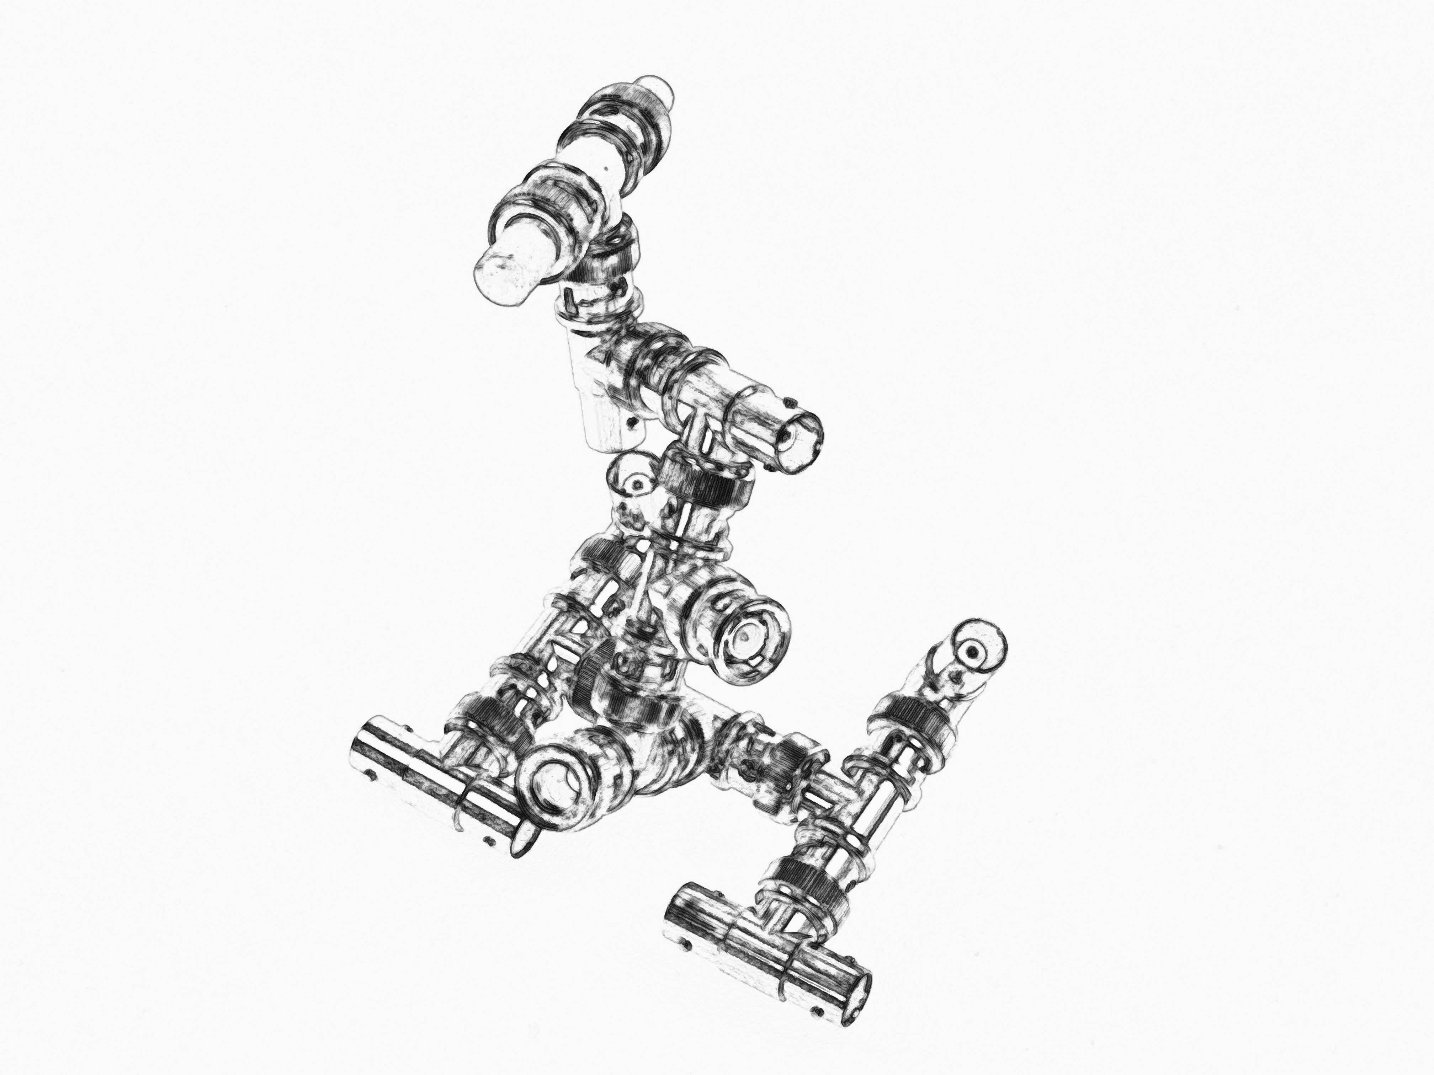

Fig. 15. UNKNOWN CLOSER

1. Ludwig Wittgenstein, Remarks on the Philosophy of Psychology. Oxford, 1980, vol. i, Remark 257.
2. Daniel Irizarry, Mouthgasm, Angora Rabbit. Bilkent 2016
3. Note copied from Facebook by the author in September 2015.
4. Google Translate: *We say that every brave man has his own way of eating yoghurt, but we do not say that every yoghurt has a different way of being eaten by a brave man… ;-)*
5. Baker on video. Original Turkish. körotonomedya. Without year. https://www.korotonomedya.net/kor/index.php﹖id=21,147,0,0,1,0.html.
6. Spinoza. Ethics, Book III, Proposition 57
7. Facebook note