Introduction

The book in your hands is a message in a bottle that washed ashore ten years after it was sent. Armin Medosch began documenting self-managed local networking initiatives with his book Freie Netze published in the German language in 2004. He developed The Rise of the Network Commons in draft chapters presented on his cooperative website, The Next Layer, from 2013 until 2015, before his death in February 2017.

Nearly two years later, Volker Grassmuck, who with Elektra Aichele was working on freeing unused TV spectrum for WLAN, came across the manuscript. He reached out to Ina Zwerger, Adam Burns and a few other friends with the idea to collectively complete Armin’s book project. We considered the main body of text finished, only in need of proofreading. He had planned an addendum with case studies of wireless networks in several countries, of which he only published Ignacio Nieto’s report about two cases from Chile and his own open letter to Fidel and Raul Castro after a visit to Cuba. Our idea to invite people from networks around the world to contribute additional case studies turned out to be too ambitious. The book project went through ups and downs until it was defibrillated back to life at the PicoPeering Meeting 2024 in Berlin.

Adam Burns and Volker Grassmuck took on the editing role and were supported by many of the people who this book is about, including Elektra Aichele, Panayotis Antoniadis, Gregers Baur-Petersen, Andreas Bräu, Sebastian Büttrich, Teresa Dillon, André Gaul. Aaron Kaplan, Geert Lovink, Monic Meisel, Mauricio Román Miranda, Jürgen Neumann, Ignacio Nieto Larrain, Julian Priest, Enrique Rivera, Tim Schütz, Felix Stalder, Thomas Thaler, Ulf Treger, Sven (C-ven) Wagner and Simon Worthington. His partner Ina Zwerger, as heir to the copyright of Armin’s original work, kindly agreed to and supported this publication project from the start.

At the Institute of Network Cultures, who agreed to publish this work, the editors are thankful to Geert Lovink, Sepp Eckenhaussen, Ruben Stoffelen, Tommaso Campagna, and Katja Stiphout.

The phrase Network Commons was conceived right after Armin’s previous book had been published in long conversations with his London neighbor and colleague Adam Burns together with Consume cofounder Julian priest. It continued to evolve in Armin’s thinking. He wanted to have an English-language companion and update to his 2004 book. In his own words:

The Rise of the Network Commons is the working title of a new book which I am currently writing. It returns to the topos of the wireless commons on which I worked during the early 2000s. In this new version, combining original research from my German book Freie Netze (2004) and new research conducted in the context of the EU funded project Confine (2012-2015), the exciting world of wireless community network projects such as Guifi.net and Freifunk, Berlin, gets interspersed with philosophical reflections on the relationship between technology, art, politics, and history.

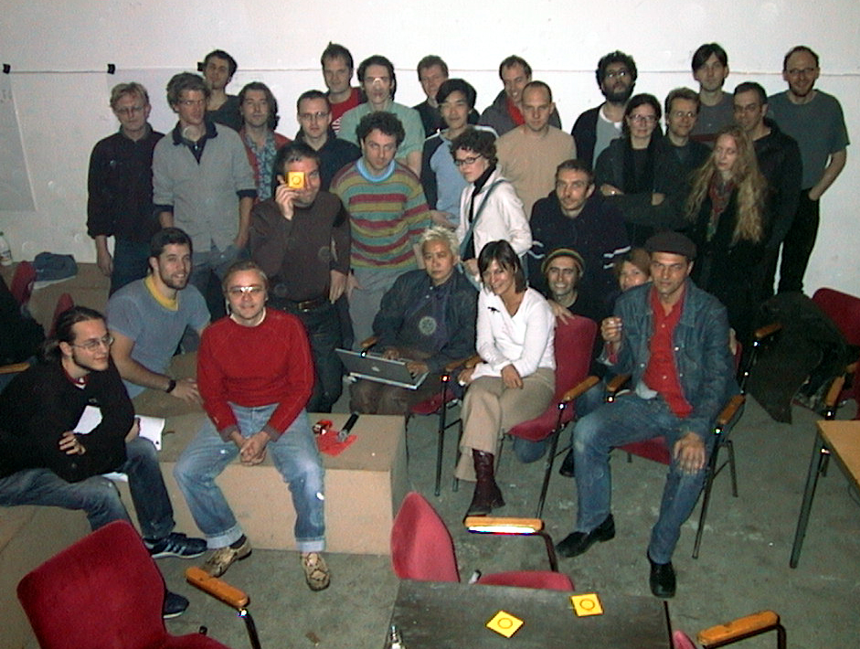
Fig. 0. BerLon Meeting, Berlin, 2002. Armin Medosch is in first row at the right in jeans and red shirt.

The model of wireless community networks at the heart of this book, Consume.net, was conceived in London during the last days of the 20th century. Armin emphasizes that the two founding protagonists driving Consume were no techies but artists, web designers, internet pioneers and most importantly, endowed social networkers. The Consume model attracted a wide range of people with different backgrounds and skills, including: hacker-programmers, artist-engineers, operating systems developers, networking wizards, social entrepreneurs, technology activists, as well as artists and curators like Armin, whom you will meet on the following pages.

In the following years, Consume participants teamed up with other international groups to experiment with and share cutting-edge mesh networking technology. As each network node joins the mesh network, it senses its own network environment and interconnects to grow the local network in an organic way. Participants can share local resources with each other and communicate directly without leaving their own community infrastructure, only using the wider commercial internet when communicating with the outside world. A sense of network freedom spread fast. First we take the neighborhood, then we take the world. Armin sees the spirit as catching on:

Our mesh network dispositif does not (yet) add up to all society, but it is something that is widely shared among techies building wireless community networks. It is a discursive behavior, but also a set of beliefs and a set of material assemblages. […] Decentralization was at the core of the idea, politically as well as technologically.

Geographically, the self-provisioning Consume spirit caught on throughout the UK and Europe. The internationalization of the Network Commons manifested itself in the BerLon meeting in Berlin in 2002. Figure 0 shows the British, German, Danish, Austrian members of that historic unconference where the German Freifunk was founded. ‘The exciting world of wireless community nework projects’ spreads from the urban to the rural, from the global north to global south. It spreads as an educational, emancipatory movement: by learning and exchanging knowledge and skills with our neighbors.

Building and maintaining telecommunication networks is seen as a technical task but affects fundamental human rights and social issues. Thus, everybody should have at least some idea about how it works, as one otherwise cannot meaningfully participate in Network Society.

This is the twofold thesis that Armin develops in this book: Involving ordinary people in building a network commons has a profound emancipatory effects on them. At the same time, doing so contributes to the democratization of technology: it is not developed behind closed walls into a product to be consumed. By having community networkers participate in shaping future technologies, those technologies become less elitist and less controlled by narrow commercial or security interest:

The original peer-to-peer spirit of the Net gets enhanced and made fit for the future in a network commons that is there to protect our democratic freedoms and rights.

Today at the beginning of Trump’s second reign over the USA, the need for resilient socio-technical systems for defending democratic rights and freedoms is more evident than ever. As a history of community infrastructure, The Rise of the Network Commons is therefore a highly topical narrative for strengthening the resilience of our last mile digital infrastructures and re-enforcing regional digital self-sovereignty through direct community participation and knowledge sharing.

And indeed, we find that the spirit in Armin’s text resonates in many areas today – the spirit of peer-to-peer, of decentral and federated networks – both technologically and politically. We see it in the rise of the Fediverse, whose applications such as Mastodon and Peertube offer alternatives to globally centralized social media giants, and in projects for federated European cloud and media infrastructures.

It is our hope that this posthumous publication will inform and inspire successive generations of activists to continue to build a more decentralized, networked, human-centric, and commons-oriented world.

Adam Burns & Volker Grassmuck, Berlin, March 2025

Armin Medosch (1962 – 2017) was an Austrian media artist, journalist, curator, theorist, critic, and a pioneer of internet culture in Europe. As art activist, he co-initiated the transformation of the ship MS Stubnitz, a former GDR deep-sea fishing vessel, into a floating art space. He is well recognized as a journalist and as the co-editor of Telepolis. As an academic he earned a Master of Arts in Interactive Digital Media at the University of Sussex and a PhD at Goldsmiths, University of London and continued to his last days to publish, teach and research. See also the obituaries collected by Monoskop.

Adam Burns (1966) is a technologist & Australian internet pioneer. He was the technical manager for Australia’s first national ISP assisting activists to communicate across south east Asia and Pacific Islands. He founded the first open community wireless network in Europe. He designed the software behind the Pocket FM broadcast system deployed in crisis areas & IDP camps in the Middle East and Africa. Published, interviewed, filmed and quoted in numerous publications and documentaries (including Steal This Film 2), he advocates for open source, as well as equitable digital access and participation.

Volker Grassmuck (1961) is a media sociologist, free-lance author, and activist, has studied and conducted research on Free Software, copyright law and practice, Public Service Media, and the knowledge commons at Free University Berlin, Tokyo University, Humboldt University Berlin, University of São Paulo and Leuphana University of Lüneburg. Most recently he was Senior Researcher in the H2020 project European Media Platforms (EuMePlat) at the Leibniz Institute for Media Research | Hans Bredow Institute Hamburg (2021 to 2024). He was project lead of the conference series Wizards-of-OS.org and of the copyright information portal iRights.info, co-founded mikro-berlin.org, privatkopie.net and CompartilhamentoLegal.org, is member of Digitale Gesellschaft e.V., c-base.org and C3S.cc. He blogs at vgrass.de.

Armin Medosch, Freie Netze. Geschichte, Politik und Kultur offener WLAN-Netze, Heise Verlag, Hannover 2004, https://ftp.heise.de/tp/buch_11.pdf.
Archived at https://webarchiv.servus.at/thenextlayer.org/.
PicoPeering 2024 held above c-base in Berlin on 17 and 18 May 2024. See sig0namectl at Picopeering 2024 Unconference, 18 May 2024, https://sig0namectl.networkcommons.org/posts/20240518-picopeering-2024-presentation/.
Confine Project (2012-2015), archived October 2015, https://web.archive.org/web/20151003180403/https://www.confine-project.eu/. See also its successor Horizon 2020 project, netCommons (2016-2018, https://netcommons.eu/), a key output of which was the book Melanie Dulong de Rosnay, Félix Tréguer, Panayotis Antoniadis, Ileana Apostol, Virginie Aubrée, et al. (Dir.). Telecommunications Reclaimed: A Hands-On Guide to Networking Communities. ISOC, 2019, https://shs.hal.science/halshs-02414439/file/telecommunications-reclaimed-webversion-page-1.pdf.
Armin Medosch, The Rise of the Network Commons, Chapter 1 (draft), The Next Layer blog, 8 August 2014, https://webarchiv.servus.at/thenextlayer.org/node/1231.html.
Others include: Julian Priest (back row 2nd left), Juergen Neumann (back row 3rd left), Thomas Krag (back row 3rd right), Saul Albert (3rd row left, sitting) Adam Burns (3rd row 2nd from left), Gio D’Angelo (3rd row 3rd left), Alexei Blinov (3rd row 5th left), Simon Worthington (front row 2nd from left), Shu Lea Cheang (3rd row center, with laptop).
This and the following quotes are from the present book.
Monoskop, Armin Medosch (1962-2017), 28 February 2017, https://monoskop.org/images/c/c3/Armin_Medosch_1962-2017.pdf.
Started in 1992, the original project went bankrupt in 1994, yet the ship lives on as art space: https://www.stubnitz.com/.
The original one, co-founded in 1996 by Armin Medosch und Florian Rötzer as first online-only magazine of the Heise Group, which after Rötzer’s retirement at the end of 2020, is now headed by Harald Neuber, who at the end of 2024 decided to take all pre-2021 articles offline, i.e. large parts of the early digital cultural heritage (Ludger van der Heyden, “Qualitätsoffensive.” Der Heise Scheiß. Zensur des Archivs, KI-Journalismus und Mainstream: Kritiker beklagen Geschichtsfälschung bei Onlinemagazin Telepolis, Junge Welt, 13 December 2024, https://www.jungewelt.de/artikel/489833.qualit%C3%A4tsoffensive-der-heise-schei%C3%9F.html).
E.g. New Tendencies: Art at the Threshold of the Information Revolution (1961–1978), MIT University Press, 2016.
At Ravensbourne College in London, at Goldsmiths, and at Singidunum University in Belgrade.
Monoskop, Armin Medosch (1962-2017), 28 February 2017, https://monoskop.org/images/c/c3/Armin_Medosch_1962-2017.pdf.
The League of Noble Peers, Steal This Film 2, 2007, https://archive.org/details/StealThisFilmII.

