# 7. Free Networks Between Countryside and City, Between North and South

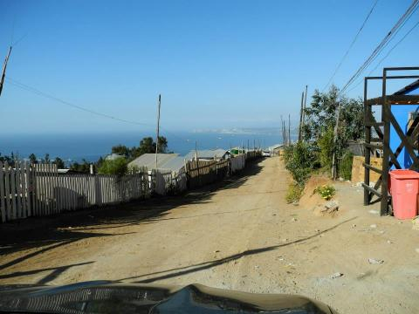Fig. 25. Mariposa Hill, Valparaiso, Chile. The blue building on the right is the Torres de Mesana Community Center.

The previous chapter has delved into some of the bigger implications of free networks in relation to the overall historic development. It has described the overall development as an incomplete paradigm shift, characterized by an ongoing structural crisis of the information society. This chapter starts with the question, what makes a network sustainable? On the surface of things it looks like the conditions for growth are better in rural areas, where there are no good alternatives provided by the telecommunications industry. Examples in Spain, Germany, as well as Greece show that there can be successful models that bring together community initiatives with municipalities. This appears to have worked less well in the USA where after a good start in the early 2000s hardly any wireless community networks exist. It seems that the relationship between rich and poor in the US is almost like the relationship between the overdeveloped world and the poor nations of the South. This chapter finishes with a more sustained look into selected projects from the global South.

As the introduction to this chapter has stated, it often looks like the main difference, regarding the demand for wireless community networks, is whether broadband is available at reasonable cost or not. In East Berlin and East Germany, Freifunk found a lot of support initially because of the presence of the OPAL network, a fibre optical backbone which prevented the implementation of ADSL. The availability of broadband often comes down to the difference between the city and the countryside. Therefore, Guifi.net in Spain had its origin in rural Catalonia.

In the countryside in Catalonia, the problem was and is that it is hard to get broadband internet at an affordable price. As the very first chapter has pointed out, Guifi.net originated in Gurb, a small village near the larger town Vic. Twelve years ago, there was no broadband in Gurb, not even for a very high price. Now it is attainable through telecommunications carriers, but the price is very high. The reason, according to Guifi.net founder Ramon Roca, is the collusion between business and politics. The incumbent telecommunications provider has no incentives to change its business practices. Since the liberalization of telecommunications laws in Spain, no significant competitor to the incumbent has arisen. Guifi started in the countryside out of a real need. According to my interview with Ramon Roca, initially they could use a public library as access point:

One of the things that helped us a lot in the beginning, maybe we did not have the internet at home, but looking at places where there were some public institutions like libraries was a way of sharing the internet. In our case it was a public library, it was paid through our taxes. So we were already paying for that internet access; and they were happy for sharing it. It was free in this case in terms of gratis, so it was paid already by taxpayers’ money.

Ramon suggests, there are a number of ways in which community networks and public institutions can cooperate. So this is like an open model of cooperation between community network and the communes, the local small political entities. This is not a one-size-fits-all scheme of *municipal wireless*. There have been several schemes around the world, where cities made full-mouthed announcements about bringing free WLAN to public places, but then soon had to row back for various reasons. What Guifi.net promotes is something else, a suggestion of cooperation between communities and public entities. For the politicians, who want to get re-elected, it is good to support Guifi, because they can say they brought their citizens cheap broadband, and for Guifi support by the municipality makes life much easier. Similar models have also been founded in Germany, where Freifunk communities have entered successful cooperations with local communities or firms; and in Greece, where in the Sarantaporo area wireless community networks[1] are getting built.

The enthusiasm around Sarantaporo is a reminder of how exciting all this has been, as it was in other regions 10 years previously. There seems to be a better chance that community WLAN prospers, when it taps into other needs of a region or community. The fruit and vegetable farmers in Sarantaporo hope to have a more direct access to markets, giving them fairer prices.

In cities such as Barcelona it is different. There, you have various providers offering different types of broadband, from ADSL to cable to fibre optic at relatively affordable prices. The widely shared assumption is that in such a setting there need to be other motivations to participate in a wireless community network; for the municipality the motivation – it seems – to support such a network is small as the politicians can say that the market provides for all needs. But this is not really true.

I would advise caution with regard to such assumptions. In the still ongoing economic crisis, the price for broadband is not negligible, especially if you are on low income. In cities there is also a digital divide but it is part of a larger divide, of social stratifications in class-based societies where the class structure is often veiled behind a language that implies there is just one large middle class. This class structure often coincides with shifting urban geographies. I think community networks would be wise to adopt strategies which make it a strong point that collective and not-for-profit network provision is also cheaper and fairer; even in the city it gives an economic advantage. The second point is that also in cities it can be beneficial to have cooperation between community networks and political entities.

In Berlin, a benevolent development has been the financial support of the regional government for the Berlin Backbone, built by Freifunk. This gives Freifunk resources to work with, such as money for hardware, access to public buildings but also added legitimacy in the public eye. Getting access to tall public buildings such as the mayor’s hall in the Berlin district of Neukölln and using it as a hub for the wireless backbone, has had a very positive impact on the perception of Freifunk by the public and in the media, according to Jürgen Neumann. Freifunk had used some tall buildings and also churches in Berlin for many years for its wireless backbone. Only after getting access to mayor’s halls in Kreuzberg and Neukölln, Freifunk suddenly became celebrated as Robin Hoods of network society, especially since they used those buildings not only as supernodes for their backbone but also to distribute open public wireless access. Citizens in some of the more edgy inner city areas of Berlin, can now access the Net on their smartphones and tablets while waiting to conclude some public errands.

It appears that both Guifi and Freifunk have successfully built models for growth of community networks across large metropolitan areas – because this is what is the case, their networks cover not just cities such as Berlin and Barcelona, but whole regions such as Catalonia and Eastern and Northern Germany. The crucial point is to tap into real needs, which are always slightly specific and local, and find a layer where it is possible to bring those needs and resources together. Yet, *resources* in this context means the mobilization of people to come together and cooperate.

This appears to have worked less well in the USA. In the most powerful nation of the world, the USA, the regulatory climate and the general business environment is so strongly pro-business that community networks have a hard time to get going at all. The USA really pose a conundrum. In 2003, 04, 05, there were community networks such as NYC Wireless, Seattle Wireless, and Personal Telco, Portland, Oregon. Those initiatives were quite vocal and participated in regional and international debates. Nowadays you have to search for them like a needle in a haystack. As this article[2] shows, there are still some wireless community networks in the USA. This is really great, but Pittsburgh’s mesh network with its 11 nodes looks a bit meagre compared with Guifi’s almost 28,000 at this point in time (9 April 2015), or Freifunk’s nearly 13,000.

The story of one such project, Wireless Philadelphia, is being told in this report by New America.[3] The city of Philadelphia created a *quango* (a quasi-autonomous non-governmental organization), Wireless Philadelphia, with the aim of creating a city-wide wireless network. However, this quango made the mistake of handing over the commission to build the network to a private company, rather than consider alternatives (such as an initiative by community activists). This created a dependency and weakened Wireless Philadelphia’s ability to carry out its declared goals of closing the digital divide. Now, a newly configured Wireless Philadelphia tries to find other ways of furthering network access. The regulatory climate is difficult, to put it mildly. Companies use the courts to prevent cities from supporting non-commercial networks for poorer citizens, as this is considered *unfair competition*.

## 7.1 Free Networks in the Global South

It is a question that stares you into the face when you study wireless community networks. Hardly any seem to exist in the USA today, despite the work of organizations such as the Open Technology Institute which does its best to promote and study wireless community networks. OTI, formerly part of the New America Foundation (which has been renamed New America[4]), is behind projects such as the Digital Stewards scheme in Detroit, where people are sent into poor areas to raise digital literacy. After the riots in Ferguson and Baltimore in recent months, the world has been reminded that in the USA race and class divisions go through society which are reminiscent of the divisions between the rich overdeveloped world and the poor global South. A scheme such as Digital Stewards reminds of approaches in so called *development projects* with ICT in what used to be the Third World many years ago.

The basic scheme behind such projects was that the good knight from the North came with his horse and shining armor to bring the internet to the suffering people of the South. For *horse and shining armor* think, of course, jeep, laptop, and solar panels. From very early on it was considered a good idea to use wireless networks in poor, rural areas. In my book Freie Netze (2004) I had a chapter about a number of such projects (pp. 152-157). Lee Felsenstein is not just a pioneer of computer science but also a pioneer of community networks, having built the Community Memory project in the Berkeley area between 1972 and 74, probably the first computerized community network in the world. In the 2000s, Felsenstein was involved with the JHAI foundation which undertook ICT projects in Laos and Cambodia. They developed a special purpose computer with low energy consumption and resistant to the extreme climactic conditions to link villages and assist them in important issues such as crop selection and bringing their harvest to markets. Meanwhile, I would assume, many more projects of this kind exist.

While I would not doubt for one millisecond the good intentions of everyone involved, the problem with those schemes is their one-sidedness and the specific ideas regarding *development* and *aid* they are often connected with. Thomas Krag and Sebastian Büttrich of Wire.less.dk have been involved with Geekcorps and went to Ghana to build wireless networks. They went there well prepared, bringing technology such as the solar energy supported *Autonokit*, a set of hardware and software components that should allow building a wireless community network based on free and open source software in Africa in the countryside. What they had to find out is that our notions of free and open source do not necessarily function in Africa in the same way. In areas where poverty is endemic and education and knowledge are bottlenecks which are an impediment to development, some of the people they had to work with, such as local business people and ISPs were not fond of the idea of sharing knowledge. They were afraid that if they trained people so that they could build wireless community networks, they would walk away and found their own companies.

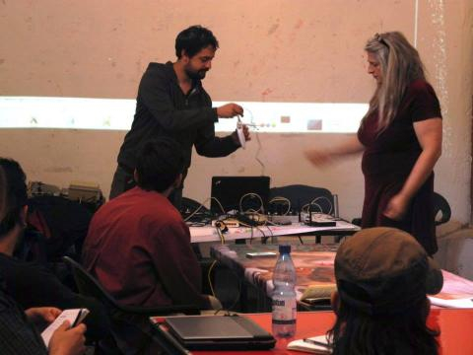Fig. 26. Elektra, right hand side, at workshop at Espacio G.

Even where the social separations are by far not as pronounced as in sub-Saharan Africa, obstacles arise from the nature of the social environment. In 2010, Ignacio Nieto reports, an extremely interesting project was launched in Santiago, Chile. After a meeting of free network activists from Latin America in Uruguay, this group, together with long-term Freifunk activist Elektra, came to Santiago to realize a project that would use a wireless community network to connect to a pirate television station. Through the wireless network, an internet portal was created, through which everyone would be able to post video which then would be re-broadcast on the television station. The project very nearly succeeded, but after Elektra, who had provided a lot of the technical expertise, left, technological development stopped. It also seems that there were issues around the appropriation of funds.

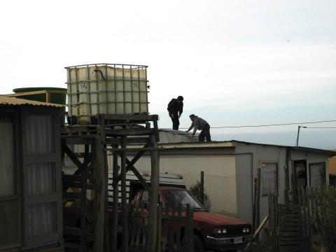Fig. 27. Antenna installation on Mariposa Hill.

In 2014, Elektra was again invited to Chile, this time by Espacio G, an alternative gallery hacker space in Valparaiso. There, poorer areas in the outskirts had been devastated by fire. While people live on the hills, all public services are in the valley. So the idea was to connect the two hillsides through a mesh network. Again, a prototype was built with Elektra’s help. In a recent interview she called those types of projects *helicopter drop* projects. As a well-meaning person she participated, but was already aware that this was possibly not very sustainable. And again, soon after Elektra’s departure the project fell apart for a number of reasons. One reason, according to Ignacio’s report[5] was that the people in the poor neighborhoods of Valparaiso were not motivated enough. They probably did not feel they had a real stake in the project.

It does not necessarily have to be that way. Carlos Rey-Moreno works at the University of Western Cape in South Africa. His project, which also received support through the Open Call of the Confine EU project, created a wireless mesh network and Voice-Over-IP (VOIP) project in a tribal area in the Eastern Cape province, where the Mankosi people live.[6] Here, the aim has been from the beginning to involve the community as much as possible to create a sustainable model for a village telco. As Carlos Rey-Moreno told me in an interview, it is important to consider the specific circumstances that came together.

Mankosi is composed of twelve villages, around which 6,000 people live in 500 households. The average income per household, consisting of around 10 people, is about 53 euros. In this community, there is coverage from mobile telephone operators but they tailor their services for wealthier urban users. South Africa is the second most unequal country in the world when it comes to income distribution. With regard to mobile communications, matters are made worse by middlemen who go to town and bring the airtime, so that there is a markup for airtime, local people are charged even more than everyone else. We are talking of about 30% of household income going into phone communication, with all the hazards that implies for other areas, such as health, education.

The project used *mesh potatoes* from the Village Telco project as hardware. Twelve houses were chosen as nodes, with solar panels and antennas. The local people were involved in all aspects of the project, such as choosing the houses and installing everything. It was not always a smooth process, reports Carlos. The locals are used to relying on the tribal elders for all decisions. The result is that not always everything is very transparent. For example, some of the owners of the houses where nodes were installed did not tell everyone else that this new infrastructure was a shared property. After seven months absence, Carlos returned and started a process of public meetings.

Now we have regular meetings with about ten people meeting monthly, people from every village, so that it has become much easier to reach decisions. This is now beginning to take root, that working together is a better way. They start to apply that to other areas as well. Some sort of transformative effect appears to be taking place, apart from the network as such.

Initially, the plan had been to use the network mainly for voice calls between the 12 villages. But then the villagers raised the demand to also make break-out calls into the telephone net. As a result, a cooperative was formed, which has attained the status of a local network carrier. As a small provider, they could negotiate better conditions with a commercial VOIP company. Carlos stresses that now the project has become self-sustainable. Income is raised by using the solar panels for charging mobile phones for a small fee. Break-out calls can be made at a quarter of the normal costs. The maintenance and the operation of the network is now in the hands of the people of Mankosi. It is true that Western Cape University provided initial capital and that Carlos’ role had been important to overcome initial hurdles regarding technological and social issues. He thinks that it had been important that of the 20 months of the project’s duration, he had spent around 10 months in Mankosi. At the same time he thinks it had been important that he took care not to impose himself on their decision making processes and allow them to find their own feet. But now he thinks this has created a model that could be replicated with much less work in other, similar areas.

1. Sarantaporo.gr, https://www.sarantaporo.gr/. See also the documentary by Personal Cinema, Building Communities of Commons in Greece (1:03:15), July 2016, https://www.youtube.com/watch?v=T5Uj-twO-zc.
2. Jason Tashea, ‘12 communities experimenting with mesh networks’, Technical.ly, 06 April 2015, https://technical.ly/diversity-equity-inclusion/12-communities-experimenting-mesh-networks/.
3. Joshua Breitbart, ‘The Philadelphia Story. Learning from a Municipal Wireless Pioneer’, New America Foundation, ca. 2007, https://web.archive.org/web/20130317002126/http://www.newamerica.net/files/nafmigration/NAF_PhilWireless_report.pdf.
4. New America, https://www.newamerica.org/.
5. See below under Case Studies: Free Mesh Networks. Two Cases from Chile.
6. Village Telco: Mankosi – South Africa, https://villagetelco.org/deployments/mankosi-south-africa/.