**ChunkLagChecker  
v 1.2.1 by DigitalSketch**

Plugin searches through loaded chunks and returns the chunks with the top most entities. By default, the plugin will list the chunk with the most living entities in it. The plugin will return the world area (overworld, nether or end), the amount of entities, and the coordinates of the center of the found chunk:

In world: chunk has ## entities. Center: X=###, Z=###

**Base command**

Displays the chunk with the most living entities  
/clc

C:\Users\BigJ\Documents\Untitled-1.jpg

**Available Arguments**

Arguments can be combined with other arguments unless noted.

**Help**

Displays the list of commands available and a description. (Ignores other arguments)

/clc h or /clc help

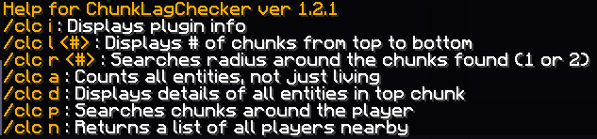

**Information**

Displays the information about the plugin (Ignores other arguments)

/clc i or /clc info

C:\Users\BigJ\AppData\Roaming\.minecraft\screenshots\untitled.jpg

**List Top Chunks**

Displays a list of chunks for the user, for example /clc l 5 will display the top five chunks. If no number is passed, the argument will default to 5. Passing /clc with a number (/clc <#>) will default to the list argument passing the number entered.

/clc l <#> or /clc list <#> or /clc <#>

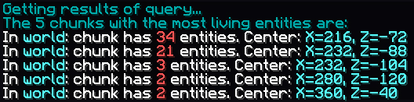

**Radius Search**

Searches a radius around loaded chunks for entities. radius or r must be followed by either 1 (9 chunks) or 2 (25 chunks) (2 is the max)

/clc r <#> or /clc radius <#>

C:\Users\BigJ\Documents\Untitled-1.jpg

**All Entities**

When thrown, this will count ALL entities in the chunk, not just the living entities.

/clc a or /clc all

C:\Users\BigJ\Documents\Untitled-1.jpg

**Details**

Displays details of the top chunk (or radius of chunks) with counts for each entity. This argument will force the “all” argument to run as well. (‘l’/‘list’ cannot be passed with this argument)

/clc d or /clc detail

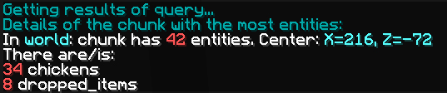

**Entities around Player**

Displays the entity count around the player executing the command with a chunk radius of 2 (9 chunks) (no other arguments can be thrown with this argument)

/clc p or /clc player



**Players found nearby**

Lists all the players around the user executing the command within the server’s viewable distance. (no other arguments can be thrown with this argument)

/clc n or /clc nearby



**Combining Arguments**

You can combine arguments such as list, radius and all to return different data. Arguments must have a space between each. The arguments can be in any order, but arguments with a second value such as list or radius must have a number as the argument immediately after it. The following list of arguments returns a list of 5 chunks with a radius of 1 and all entities.

/clc list 5 radius 1 all (or /clc l 5 r 1 a)

The same results will be returned with a different order of the arguments:

/clc radius 1 all list 5 (or /clc r 1 a l 5)

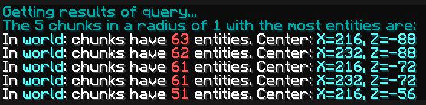

**Change Log**

* 1.1.0
  + Added list # argument option to allow for list of multiple chunks to be displayed
* 1.1.1
  + Updated permissions (plugin.yml) to only allow groups to have access
* 1.1.2
  + Shortened the sendMessage() to fit to one line in MC chat
* 1.2.0
  + Added the radius # argument to search the radius around the top listed chunk
  + Added the player argument to search entities around the player
  + Added the all argument to return a list of all entities, not just living
  + Added the detail argument to return a list (and count) of entities in the top returned chunk
* 1.2.1
  + Added the nearby argument to return the list of players in the server’s viewable distance around the player executing the command
  + Updated the l or list argument so that if no number is entered, it will default to 5. Also, typing /clc # will show the list with the number entered.