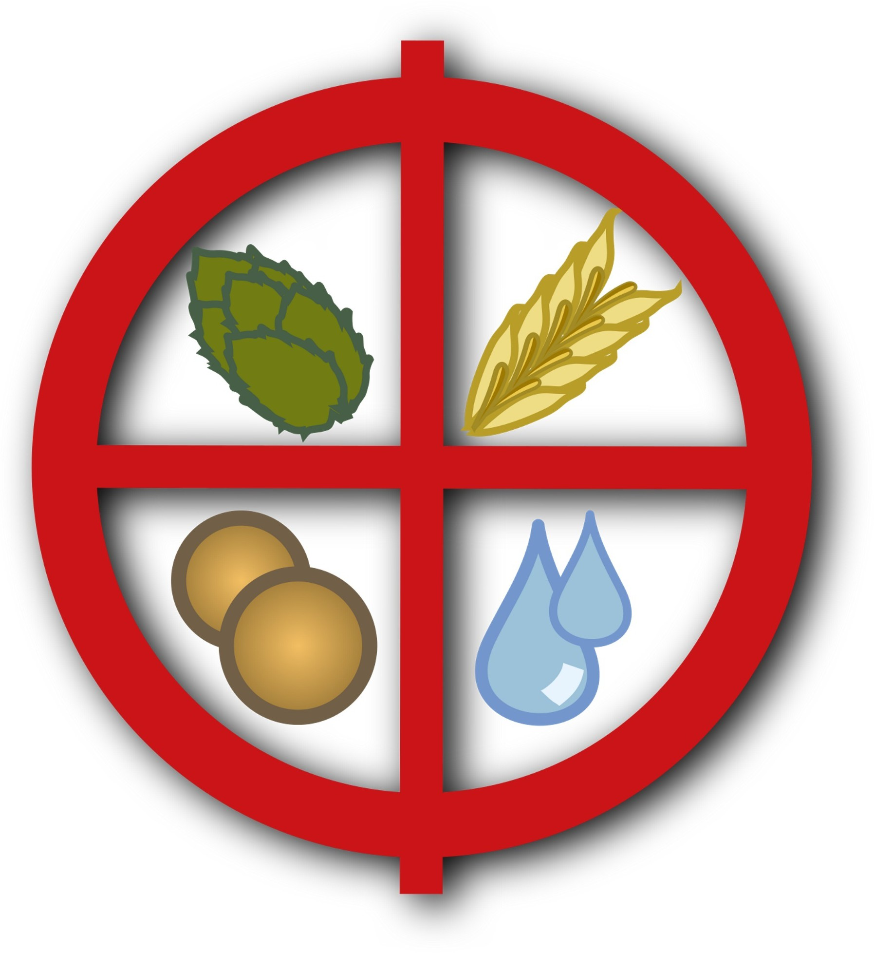

|  |  |  |
| --- | --- | --- |
|  | **Table of Contents** |  |
| Introduction |  | 0 |
| Chapter 1 |  | 1 |
| Chapter 2 |  | 2 |
| Chapter 3 |  | 3 |
| Appendices |  | 4 |
| Glossary |  |  |

# Brewtarget

Version 2.3

# Contributors

Many souls have contributes to providing you with this manual, here we make an effort to thank them for their work. You too could contribute to the community by either: improving the software, improving this manual, or translating this manual in your language.

|  |  |
| --- | --- |
| **Locale translation** | **Base manual** |
| Same as base manual | Maxime Lavigne (malavv) [duguigne@gmail.com](mailto:duguigne@gmail.com) Philip G. Lee [rocketman768@gmail.com](mailto:rocketman768@gmail.com) |

# Foreword

*By Philip G. Lee*

Dear Reader,

This manual is intended to quickly acquaint you with using Brewtarget. It is by no means comprehensive, but is instead focused on providing concrete examples. If something is unclear, please let us know at [our source code repository](https://github.com/Brewtarget/manual).

# Preface

As of the writing of this document, Brewtarget already had a long history of helping homebrewers achieve the brew they wished.

## Chapter 1: A Walkthrough

This book makes the assumption that the best way of getting you started is with what we all love, making a beer. You will be guided here through making your first beer using Brewtarget with an easy to follow, step-by-step guide.

## Chapter 2: General Concepts

General Concepts are functionalities that Brewtarget offers you. They range from recipe management, to cost reporting to exporting and importing recipes. This section will provide you with an overview on what is offered in the application and how to use it. It's a great way to gradually learn new features.

## Chapter 3: Tools

The tools section is presents specific tools within Brewtarget meant to ease your life. They describe what tools are available, their purpose and how to use them.

# Chapter 1: A Walkthrough

It is probably easier to demonstrate the features of the program rather than trying to explain every single concept. So, here we will create a simple American Amber Ale, touching on as many features as possible.

## Setting Options

First, let’s set a few options. Brewtarget’s options are in Tools → Options .

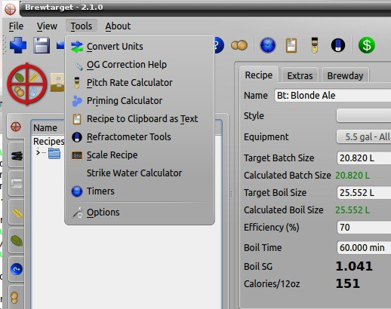

Figure 1. Select Options

Here you should set your preferences for the unit system you wish to use, and which formulae you want to use in creating your recipes. For the purposes of this walkthrough, go to the units tab and set weight and volume to US traditional, temperature to Fahrenheit, gravity to specific gravity, and color to SRM.

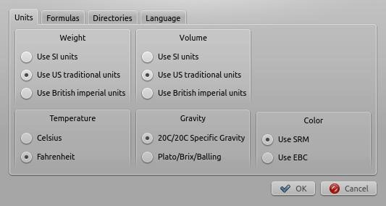

Figure 2. Units

If you choose Plato for gravity, then all the displayed FG numbers are *not* corrected. So, the displayed FG reflects the actual FG: not what you will see if you use your refractometer.

Important

On the Formulas tab, set Color to "Morey’s" and "IBU" to Tinseth. The screen should look like:

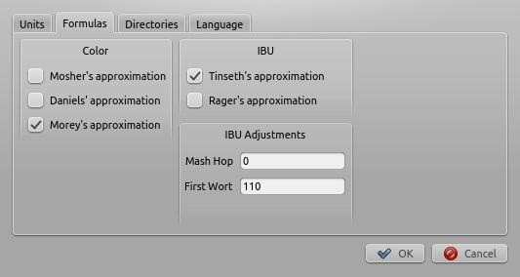

Figure 3. Formulas

## Defining Your Equipment

always set up an equipment profile before creating a recipe.

Important

Having an equipment profile for your recipe is very important in Brewtarget. It contains a lot of information about your *particular* setup, and helps Brewtarget make better estimates.

There are three ways to create a new equipment profile. You can click View->Equipments to open the equipment editor:

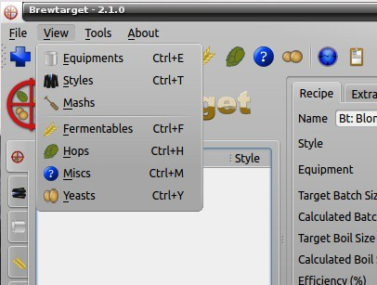

Figure 4. Equipment

You can click the Equipment icon in the tool bar

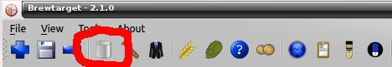

Figure 5. Equipment Toolbar

…or you can open the equipment tree. Right click and select "new".

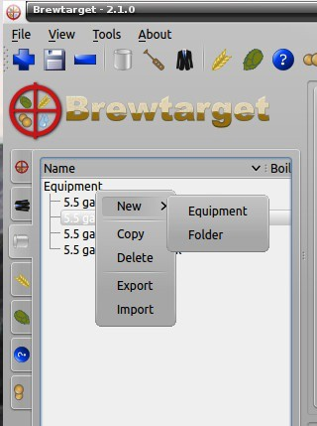

Figure 6. Equipment Tree

If you use the first two methods, you need to click the blue "+" at the bottom of the window to create a new profile. After you click the plus, or if you started from the equipment tree, you will need to provide a name for the profile. Once you have done that, press "OK".

Fill out as many of these fields as you can.

Table 1. Equipment Fields

|  |  |
| --- | --- |
| **Field** | **Description** |
| Set as Default | Set as the default profile to be used when creating recipes |
| **Required Fields** | |
| Name | Any name you choose to title your equipment setup |
| Pre-boil volume | Amount of wort in the kettle immediately prior to boil |
| Calculate pre-boil volume | Automatically calculate the pre-boil volume based on boil time, losses, and water additions, instead of entering it by hand |
| Batch size | How much wort you want in the primary fermenter |
| **Boiling & Water** | |
| Boil time | How long you usually boil |
| Evaporation rate | Water loss during the boil, per hour. Typically, around 3L or 0.75 US gallons. |
| Kettle top-up water | Amount of water you usually add directly to the kettle before boiling. For **extract** recipes, this should be equal to the boil volume |
| Final top-up water | Amount of water to add to the wort immediately before going into the primary |
| Grain absorption | How many liters of water are permanently lost to each kilogram of grain during mashing. The default value is 1.0875 liters per kilogram. This can fluctuate due to the fine-ness of your grind, humidity, brand, and other factors. Pressing the "Default Absorption" button will reset the value to this default |
| Boiling Point of Water | The temperature at which water boils. The default value is 100C (212F), but the actual value will vary with altitude. |
| Hop Utilization | Correction for hop utilization. Typically 100 percent in homebrew systems, somewhat more than 100 percent for larger systems. |

|  |  |
| --- | --- |
| **Mash Tun** | |
| Volume | The maximum volume your mash tun can hold |
| Mass | Mass of your mash tun |
| Specific Heat | Specific heat of the material of your mash tun in cal/(g*C). Typical values are * Aluminum - 0.215 * Copper - 0.092 * Iron/Steel -  0.108 * Plastic - 0.359 |
| **Losses** | |
| Kettle to fermenter | How much wort you leave in the kettle when you transfer the wort to primary |
| Lauter deadspace | How much wort you lose in the lauter tun |

When done, press the diskette button at the bottom of the dialog to save the new profile. You should have something like this.

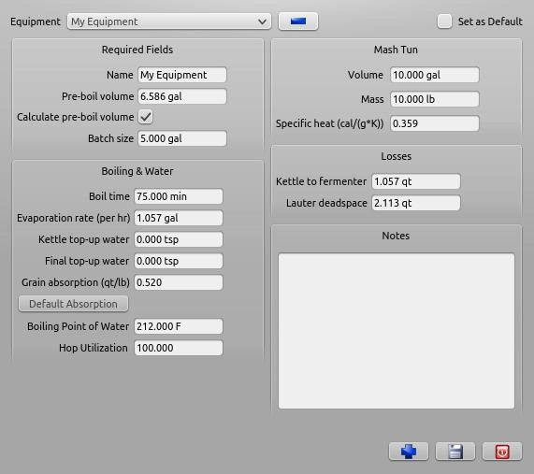

Figure 7. Equipment Profile

## Making a New Recipe

Click on either File->"New Recipe", click the blue plus in the toolbar at the top of the main window or right-click in the recipe tab of the tree and select "New Recipe". Name your recipe in the box that pops up, and click "OK".

## Adjusting Recipe Parameters

If you created your equipment profile as shown above, and you made it the default profile, you won’t need to do anything else.

Otherwise, choose the equipment profile you set up in Defining Your Equipment from the Equipment drop-down list. You can also drag it from the tree on the left and drop it on the recipe. After selecting or dropping the equipment, you will be asked if you want to set the batch and boil size of the recipe to that of the equipment. Click "Yes".

## Selecting the Style

Brewtarget comes pre-loaded with all of the BJCP styles. You can check your recipe against the guidelines for the particular style you are brewing. To do this, select "American Amber Ale" from the Style drop down list

You will notice that the bubbles in the right pane changed.

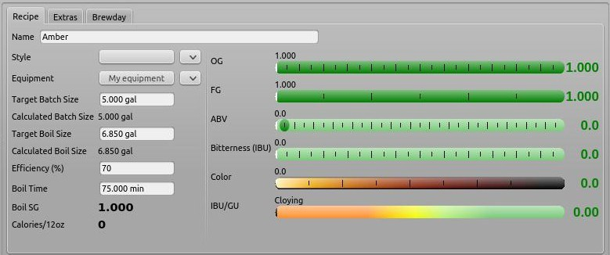

Figure 8. Before Style

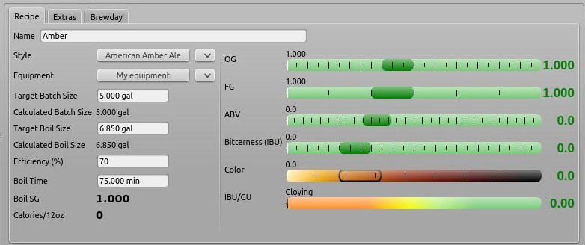

Figure 9. After Style

The dark green bubbles show the expected range for the style you selected. The color bubble shows the expected colors for the style. Since we haven’t added any grains, hops or yeast to our beer yet, they don’t show anything else.

## Adding Ingredients

Open the "Fermentable" tree in the left pane (denoted with a barley icon),

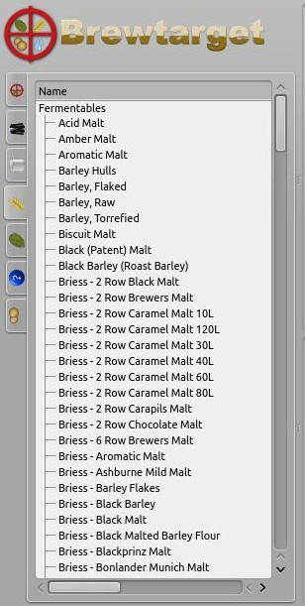

Figure 10. Fermentable Tree

and drag the following items into the Fermentables pane.

Briess 2 Row Brewers Malt

 Briess Caramel Malt 80L

This is not an endorsement of Briess; they are simply near the top.

In the main window, you will see those two malts in your recipe. Click on the Crystal 80’s "Mashed" checkbox to tell it that we want to have this in the mash (malt can also be steeped). You should have this:

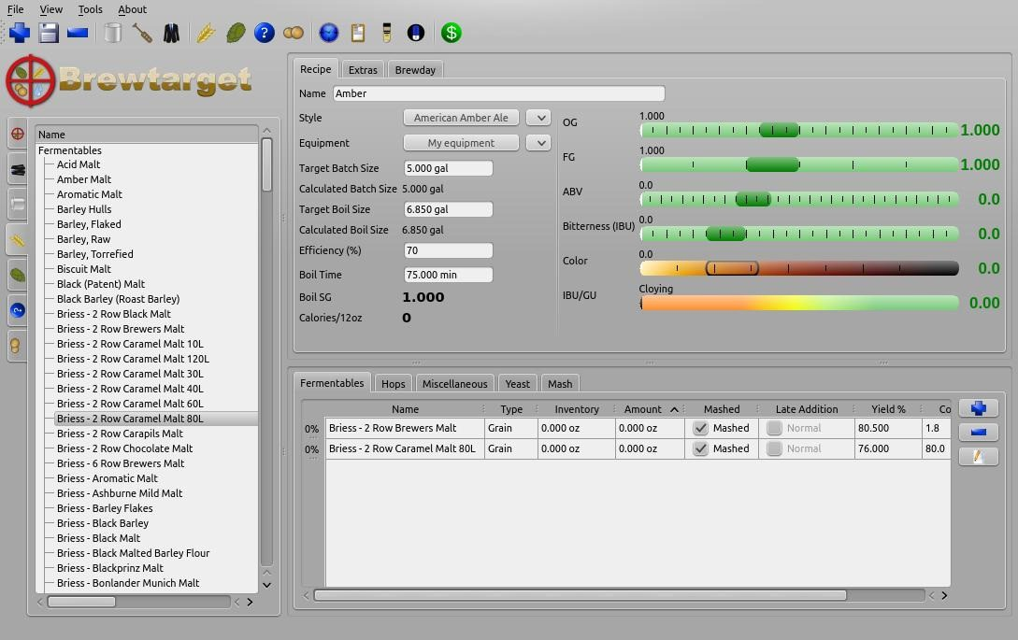

Figure 11. Recipe After Fermentables

Double-click the 2-row’s "amount" cell and enter "4.536 kg". You will see that it gets converted automatically into "10.000 lb" if you’re using US units. For the Caramel 80, tell it "32 oz". You can change US/English/SI preferences in Tools->Options. Please see [Supported Units] in this document to see the correct abbreviation for each unit.

Now you should notice something different about the bubbles in the main window. The OG bubble now has a white line with "12.2" above it, within the dark green bubble. This means the OG is within the range defined by the American Amber style.

The FG, though, is way off to the right of the bubble and nowhere near the dark green bubble. This means the FG is too high for the style. The ABV is pegged at zero, far to the right of the "to style" range. We will fix this once we add a yeast and a mash schedule to the recipe.

The color bubble now has a white line within the "to style" range.

Finally, the IBU/GU meter shows the beer as 0 and cloying. This bubble provides a general guide on how balanced your beer is.

Now, go to the Hops tab and add 1 oz Cascade at 1 hr, 1 oz Cascade at 15 min, and 1 oz Cascade at 5 min. The IBUs should be about 33.4, and in the green.

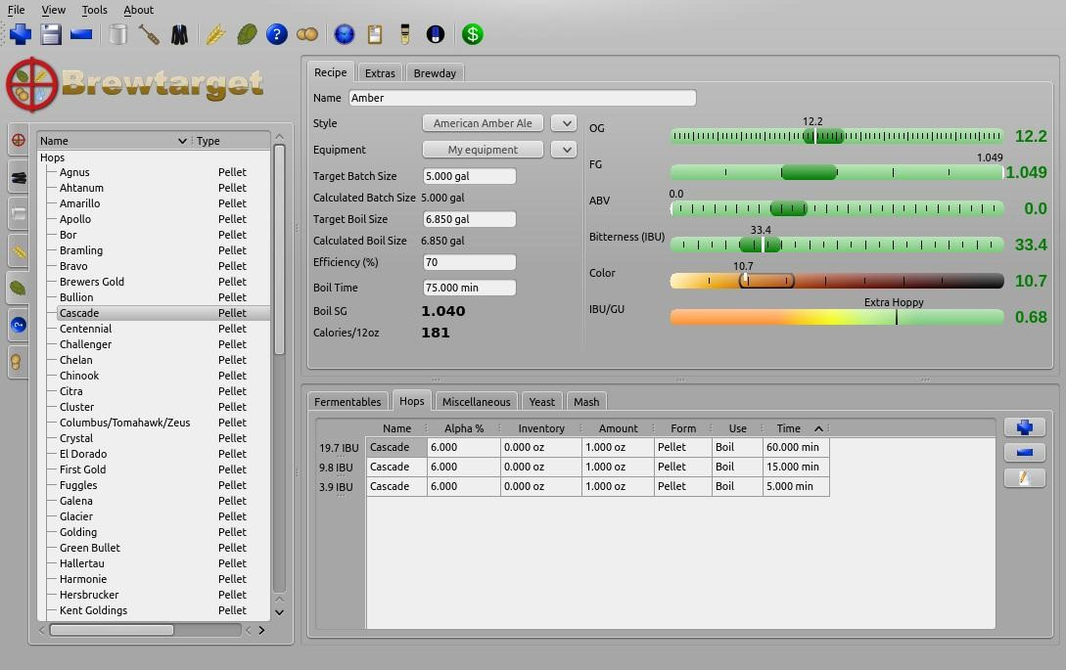

Figure 12. Adding the hops

Add WLP001 yeast to the recipe. Now everything should be in the green.

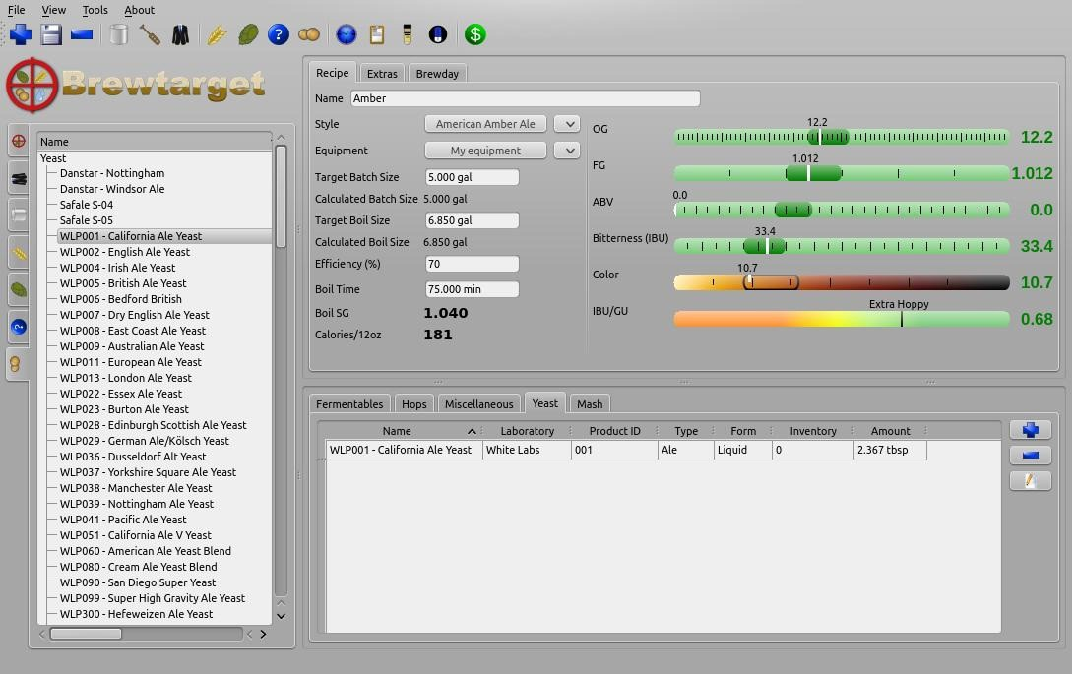

Figure 13. Adding the yeast

## Making a Mash

Let’s do a 2-step mash with a protein rest at 121 F and a conversion rest at 152 F.

Until now, Brewtarget has been **lying** to you. Underneath the target batch size on the main window, it says your calculated batch size and the calculated boil size are not 0. These are estimates based on your equipment profile. Brewtarget is lying because it’s convenient just to be able to start adding the ingredients and get an approximate answer. After setting the mash addition volumes, you will get a real answer.

Important

Switch to the Mash tab in the main window. Click on "Edit Mash" and give it a name. You can enter the initial grain temp, sparge temp and initial tun temp here. Entering these as accurately as possible will give you the best chance to nail your temperatures. To set tun mass and specific heat, you should click "From Equipment".

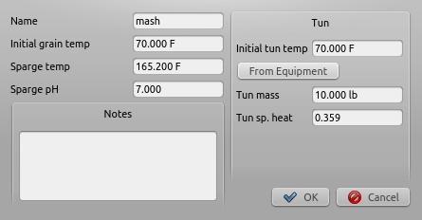

Figure 14. Set up the mash

You can save this mash profile by pressing "Save Mash" at the bottom of the mash tab. It will be saved under the name you gave it in the "Edit mash" dialog. You can recall a mash profile by selecting it in the appropriate drop down box. From here, there are two ways to create the mash.

## Method 1: Mash Wizard

Go to the mash tab and click the blue plus. Name it "Protein" and click "OK".

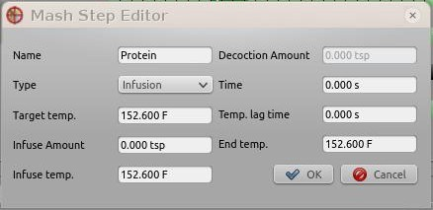

Figure 15. Protein step

Double click its "Target Temp" cell and change to "121 F", and change the "Time" to "20 min". This means we want to hit a target temperature of 121 F for 20 minutes.

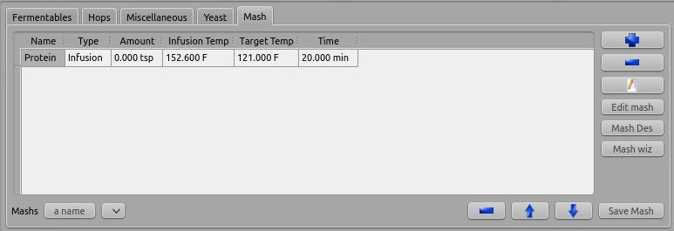

Figure 16. Protein step

Do the same for a "Conversion" step at "152 F" for "1 hr".

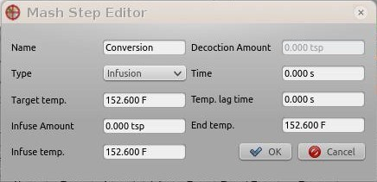

Figure 17. Conversion step

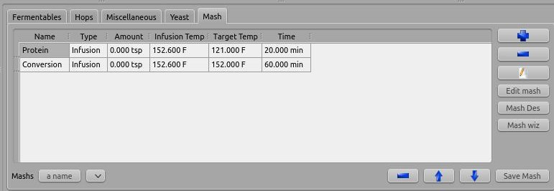

Figure 18. Conversion step

The mash wiz is for quickly and easily getting the correct mash temperatures and volumes for a single batch sparge mash. Click on the "Mash wiz" button, and give it a mash thickness of 1.25 qt/lb (or 2.6 L/kg).

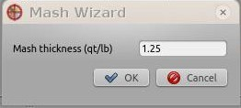

Figure 19. Mash wizard

When you select "OK", the mash wizard does 3 things for you: calculated infusion volumes, infusion temps, and gave you a sparge step that will make you hit your pre-boil volume.

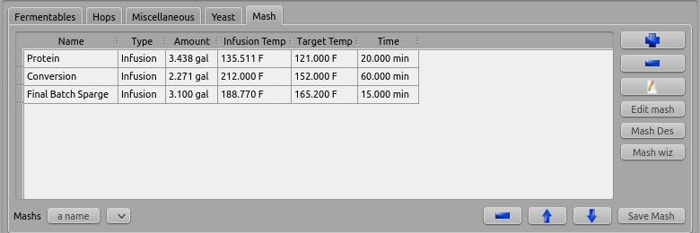

Figure 20. Mash wizard results

Now Brewtarget is not lying anymore about the calculated boil volume and batch size. You can see any of the infusion temperatures under the "Infusion Temp" column.

You don’t have to actually sparge with all of the sparge water, but can put a portion directly into the kettle depending on how you like to sparge. You can also split the sparge water into multiple sparge batches. Fly sparging should understand the "final batch sparge" to indicate the volume of sparge water they should collect.

Important

Since your equipment and recipe might change, you should always do the mash wizard after recalling a saved mash profile.

Important

## Method 2: Mash Designer

The mash designer is for more advanced use. It can be used to create any mash schedule you desire with however many sparges, and at whatever infusion temp or volume you desire. To start it, just click the "Mash Des" button. A dialog will ask you for the temperature of the tun before the first infusion, so enter 70 F and continue.

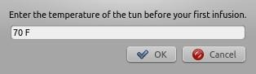

Figure 21. Mash designer start

We are now looking at the parameters for the first infusion. Enter "Protein" for the name, leave the type at "Infusion", enter "121 F" for "Target temp.", and "20 min" for the time. Now, you can either move the infusion/decoction amount slider OR the infusion temp slider.

Moving one will cause the other to move so that the combination of amount and infusion temp causes you to hit 121 F. The upper and lower limits of these sliders are based on the maximum available space left in the tun (as given by the current equipment), and the boiling

temperature of water. Start the amount slider at the far left. You will see that the tun fullness meter on the right shows an infusion ratio of 0.11 qt/lb which is far too low. How do I know it’s too low? The total collected wort meter shows a negative value, meaning that the grain will absorb all of the infusion’s water and could absorb more. So, slowly move the amount slider until the infusion ratio reaches about 1.25 qt/lb.

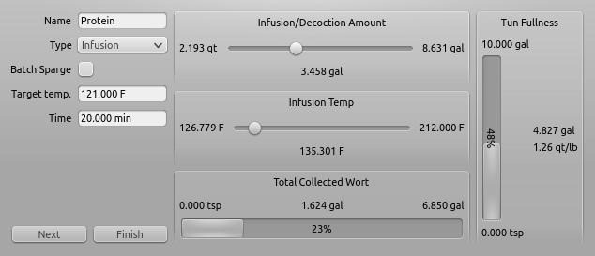

Figure 22. Mash designer protein rest

You should see that the tun is about half full, and we have reached 1.9 gal of the 6.25 gal that we plan to collect pre-boil. Click "Next".

Name this step "Conversion" and set the target temp to 152 F and the time to 1 hr. Slowly move the temp slider all the way to 212 F.

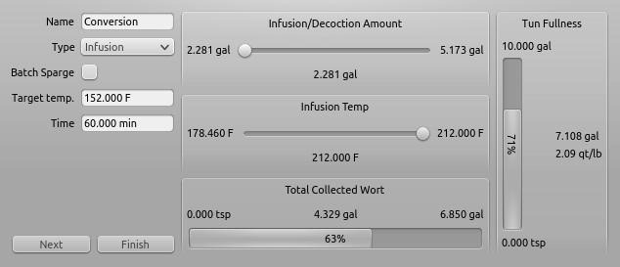

Figure 23. Mash designer conversion step

Click "Next". Name this step "Batch Sparge". Click the "Batch Sparge" checkbox, set the target temp to 165 F, and the time to 15 min. You will notice that the tun fullness has gone down, simulating that you have drained the tun of liquid; this is the purpose of the checkbox. Move the amount slider slowly to the right until the total collected wort reaches about 6.25 gal.

If you exceed the target collected wort volume, the progress bar will still show 100 percent, so be careful and pay attention to the text which shows the actual collected wort.

Important

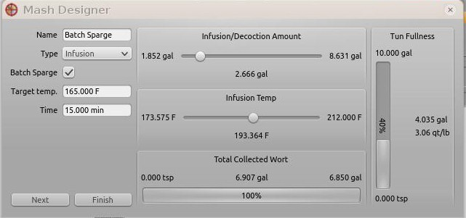

Figure 24. Mash designer

Finally, click "Finish" to return to the main window.

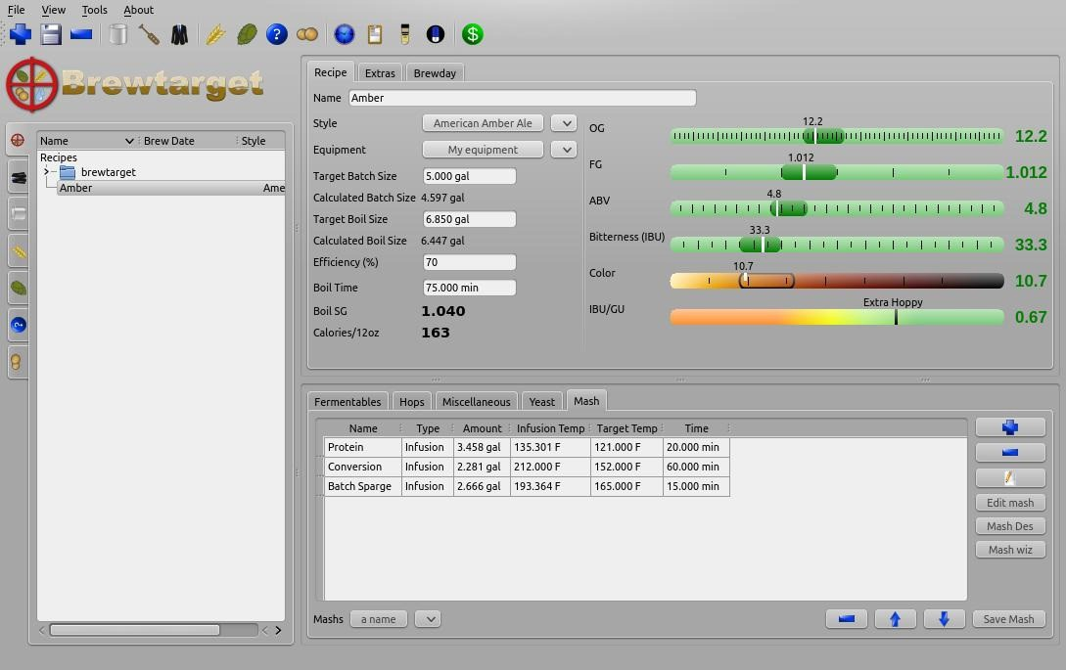

Figure 25. Mash designer finished

**Congratulations!** You have just created your first recipe with Brewtarget!

## Brewday Mode

Now that your recipe is all planned, wouldn’t it be good to have some instructions on your brewday? Click the "Brewday" tab at the top of the main window. Click "Generate Instructions". It has made all instructions for you and listed them on the left in order. You can remove, shift up/down, insert, change steps as you see fit to help you be organized on your brew day.

There are 3 timers to help you with time-critical steps if you click the clock button in the toolbar of the main window. They are in HH:MM:SS format, and the text box above each one is what you use to set it. Just enter "1:00:00" and press "set" to set the timer for 1 hour, for example. The "Sound" button allows you to select a sound that will be played when the timer reaches zero. Brewtarget has provided many default sounds to choose from, or you can select any other sound file on your computer.

## Printing the Recipe

Print and print preview are available under the "File" menu. There are two printouts available. One is "Recipe" and the other is "Brewday". The recipe printout is all the info related to the recipe you have made. The brewday printout is formatted in organized specifically for following when you brew.

## Saving Your Work

When you close Brewtarget, you will be given an option to either save or discard your work.

# Chapter 2: General Concepts

Brewtarget maintains a database of recipes, ingredients, etc. If brewtarget should crash unexpectedly, you will be prompted to either restore the changes made last session or rollback the database to discard the changes in the last session.

## Inventory

Brewtarget can keep track of how much of each brewing ingredient you have available. The mechanism is straight-forward. Open up the item you want to record your inventory, say "Briess 2 Row Brewers Malt". Towards the bottom of the left hand side, enter the amount you have in inventory. On any recipe you have used this malt, you can now see what you have in inventory.

Every time you use the "Brew It!" functionality, the amount in inventory is reduced by the amount the recipe uses. Be somewhat careful; brewtarget does not warn you if a recipe calls for 2 kg of crystal 80, but only 1 kg is available in the inventory.

## Trees

A tree is a hierarchical view of ingredients, recipes, and other items.

The application window is split into three major panes: the trees, the recipe and the ingredients. The tree pane is a set of tabs that displays your recipes, equipment profiles, fermentables, hops, miscellaneous items and hops. You can sort any of the trees on the displayed fields.

Double clicking on any item in the tree will open up the appropriate editor for that item. Double clicking a recipe will open the recipe in the main window.

There are 6 tabs:

Recipes - this tree shows all your recipes. You can drag and drop the recipe onto the main window and that recipe will be loaded. Each recipe will also show any associated brewnotes.

Equipment - this shows all your defined kit. You can drag and drop a piece of equipment onto your recipe which will have the same effect as changing the equipment via the dropdown box.

Fermentables, Hops, Misc and Yeast - these show all of your ingredients. Dragging an item onto the main window will add that item to the recipe.

You can drop recipes, styles and equipment profiles onto the recipe pane; you can drop fermentables, hops, miscellaneous and yeast onto the ingredients pane.

You can right-click almost anywhere on a tree and get a menu of options. The menu allows you to create a new item or a folder. The item you can create depends on the tree you clicked in. If you right-clicked in the miscellaneous tree, for example, you can create a miscellaneous item. Otherwise, the menus are identical for each tree.

You can select multiple items, right-click and then perform an action on the entire selected list. The only exception is the "Export" function. Limitations in the BeerXML format do not allow recipes and ingredients to be exported at the same time.

## Folders

Items in trees can be organized into folders.

The folder separator is "/". You can create many subfolders, like "/IPA/BYO/2012/Sept", as long as you use forward slashes (/) to separate them.

Empty folders, or folders that contain only more empty folders, will be removed after restart. If you want a folder to be preserved, make sure to put at least one item in the folder.

Deleting a folder deletes its contents too. You will only be prompted to delete the folder, not each item in the folder.

 Be careful when dropping a folder. There is a space between items that is not a valid drop target. Nothing will happen if you drop it there, which will can be frustrating.

## Brew Notes

If you right-click a recipe, you can select an action called "Brew It". If you select this action, a new entry will be created below the recipe and a new tab will be opened in the main window. This new tab allows you to record important information about your beer during brewing (sg, volumes, temperatures, etc.). This allows you to track performance over time and adjust equipment and efficiencies to better predict what you brew.

The values are preloaded based on the recipe as written. As you move through your brewday, you can record the actual numbers. The calculated values in the middle of the screen will change based on those inputs. For example, if you expected an SG of 1.036 but only got 1.032 the projected OG, ABV and ABV will all change to reflect the lower SG.

There are four main sections on the brewnote tab.

Table 1. Brewnote Fields

|  |  |
| --- | --- |
| **Field** | **Description** |
| **Preboil** | |
| SG | Specific gravity of the collected wort |
| Volume | The volume of wort that made it into your boil kettle |
| Final temp | The temperature of your mash after dough in |
| **Postboil** | |
| OG | Specific gravity of the wort after the boil |
| Postboil Volume | The volume of wort in your boil kettle |
| Volume into Fermenter | The volume of wort in your primary fermenter |
| Pitch temp | The temperature of your wort when you pitched the yeast |
| **Postferment** | |
| FG | Specific gravity of the wort after fermentation |
| Volume | The volume of beer bottled or kegged |
| Date | The date the beer finished fermenting |
| **Notes** | |
| Notes | Any notes specific to the brew day |

## Adding Ingredients to a Recipe Method 1: Editors

If you are looking for a fermentable with a specific SRM or a yeast from a specific lab, this approach allows you to sort on any column you want.

1. Choose the appropriate tab in the main window (Fermentable, Hops,…).
2. Click the "add" button in the tab.
3. Select any column of the row of the ingredient you wish to add.
4. Click "Add to Recipe".

## Method 2: Drag and Drop

This is a simpler method, as long as you don’t mind the default sorting

1. Open the appropriate tree in the left pane.
2. Click on the item you wish to add.
3. Drag it to the ingredients pane on the main window, and drop it
4. The tabs will change if required. E.g., if you drop a hop onto the "Fermentables" tab, the focus will change to the "Hops" tab.

## Importing Recipes

You can import other BeerXML recipes (such as from Beersmith) by using File->Import Recipes. However, be aware that Beersmith and other software do not strictly adhere to BeerXML or XML standards in general, so you may have some trouble importing recipes from time to time. Brewtarget tries to maintain strict compatability with the standards.

## Exporting Recipes

This option will export selected recipes to BeerXML.

## Database Backup and Restore

For many reasons, you may want to back up all your recipes, ingredients, and everything else. To do this, go to File->"Backup Database" and select an empty directory. Restoring the database is just as simple.

when you restore a database, everything in your current database will be replaced.

Important

Restoring a database will cause brewtarget to automatically restart.

Important

## Sharing Recipes

Brewtarget offers two different methods for posting your recipes in simple readable formats.

## Method 1: Recipe to Clipboard

This tool makes a text version of the recipe so that you may post it online or pretty much anywhere else. To export a text version, Tools->"Recipe to Clipboard as Text", then click paste where you want the recipe text to be pasted.

## Method 2: Recipe to HTML

Another way you can share you recipes is to export them to HTML, which is viewable in any web browser. Use File->"Recipe"->"Save to HTML". You can export either the recipe or the brewday instructions.

## Supported Units

Brewtarget supports SI, Imperial, and US customary units. To switch between these modes, go to Tools->Options->Units, and check/uncheck the appropriate box. It also supports auto- conversion. For example, if you are in US mode, and you enter "0.50 gal" into a text field, it will appear as "2.000 qt". You may also enter units from the other unit system if you like. If you enter an unsupported unit, Brewtarget applies a default unit (which is usually SI). For example, if you enter "20 asdf" into a volume field while in US mode, you will see "5.283 gal" because Brewtarget assumed you meant "20 L" and then converted to US units. Always use a valid unit suffix to avoid unit confusion.

## Controlling Default Unit and Scale

You can control what units are used in the display and how they scale. In any field where it makes sense (volumes, weights, temperatures and gravities), you can right-click the associated label and be presented with the unit and scale menu. Selecting one of those options will cause that field to be displayed in the selected unit. So you can, for example, display Boil SG and OG in Plato, but FG in specific gravity.

You can also select the scale for any volume or weight field. You can use this to, for example, cause your target batch size to be displayed in quarts instead of gallons. You can do the same thing in any of the ingredient tabs by right clicking on the column header. This will allow you to display your hops in grams, but keep your fermentables displayed in pounds.

Volumes will present you with the options "default", "SI", "US Customary" and "British Imperial"; weights will present you with the options "default", "SI" and "US Customary"; temperatures will present the options "default", "Celsius" and "Fahrenheit"; gravities will show "default", "Plato" and "Specific Gravity".

## Caveats

With US and Imperial units, people have a tendency to sometimes put a trailing "s" or a period at the end (hrs, hrs., etc.). Brewtarget only supports singular no-period units to be consistent with the metric system. The units supported, and the exact unit abbreviation you should use are given in Supported Units.

## Supported Units

Table 2. US Customary and Imperial Units

|  |  |
| --- | --- |
| **Unit** | **Abbreviation** |
| **Mass/Weight** | |
| Pounds | lb |
| Ounces | oz |
| **Volume** | |
| Barrels | bbl |
| Gallons | gal |
| Quarts | qt |
| Cups | cp |
| Tablespoons | tbsp |
| Teaspoons | tsp |
| **Temperature** | |
| Fahrenheit | F |

Table 3. SI Units

|  |  |
| --- | --- |
| **Unit** | **Abbreviation** |
| **Mass/Weight** | |
| Kilograms | kg |
| Grams | g |
| Milligrams | mg |
| **Volume** | |
| Liters | L |
| Milliliters | mL |
| **Temperature** | |
| Celsius | C |
| Kelvin | K |

Table 4. Shared Units

|  |  |
| --- | --- |
| **Unit** | **Abbreviation** |
| **Time** | |
| Days | day |
| Hours | hr |
| Minutes | min |
| Seconds | s |

# Chapter 3: Tools

Brewtarget offers a lot of tools to aid the brewer in writing recipes and on the brew day itself.

## OG Correction

This tool helps you to correct the OG when you overshoot or undershoot your anticipated efficiency.

To correct this in the boil, choose Tools->"OG Correction Help". Please note that this tool makes the assumption that you are not going to add any water post boil. Enter the current SG, temperature of sample, and calibration temp of the hydrometer OR the degrees Plato of the wort pre-boil. Then enter the pre-boil volume. Click "Calculate" and 3 fields will populate on the output half of the window. The first shows you the post-boil OG if you take no action. The next shows you how much water to add (or boil off if negative) in order to achieve the planned OG. The last shows how much wort you will end up with if you take this action.

## Pitch Rate Calculator

This tool calculates the correct amount of yeast to add.

This tool is located in Tools->"Pitch Rate Calculator". Enter the wort volume, OG and starter OG and select the pitch rate. The pitch rate should be 0.75-1.00 for most ales and 1.50-2.00 for lagers. The output is the number of yeast cells required (in billions), the number of wyeast activator packs or White Labs vials needed without a starter, the amount of dry yeast required (without starter), and the size of the starter needed to reach the cell count at the given starter OG (usually never over 1.030).

## Priming Calculator

This tool calculates the correct amount of priming agent for the desired carbonation level in the finished beer.

Tools->"Priming Calculator". Put in the required input values, select a priming agent, and press calculate.

## Refractometer

This tool performs several conversions related to refractometers.

Tools->"Refractometer Tools". Here, you can find OG and current SG by using refractometer readings. You must always enter the current Plato and either the original Plato or the OG. If you just want to find out what specific gravity 11.2 Plato corresponds to, enter 11.2 in both the original Plato and current Plato fields.

**Glossary**

# Homebrew

Beer or other alcoholic drink brewed at home.

1. Chapter 1