Installing Docker Desktop for Windows
- If you are Linux user, you shouldn’t need instructions and Mac users can download dmg file and install that and just launch the Docker Desktop app.

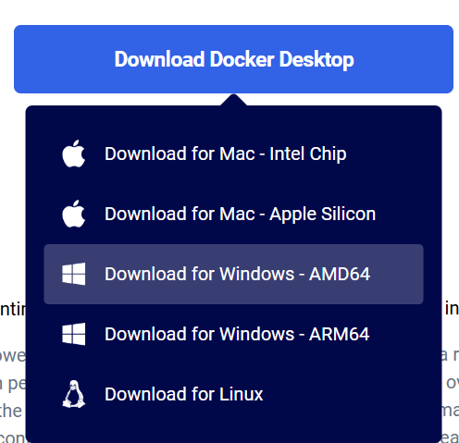
Step 1: Download Docker Desktop
- Go to the Docker Desktop download page (https://www.docker.com/products/docker-desktop/) find the download part and click on the "Download for Windows". (most likely the AMD64 unless you have ARM cpu)

Step 2: Run the Installer
- Prerequirement: You should have Admin rights to conduct the installation
- Prerequirement: BIOS-level hardware virtualization (VT-x, AMD-V, or similar) should be enabled
- Once the download is complete, double-click the downloaded Docker Desktop Installer.exe file to run the installer.
- Follow the on-screen instructions to complete the installation. This includes accepting the license agreement and choosing the installation options.

Step 3: Enable Required Windows Features
- During the installation, Docker Desktop might prompt you to enable the necessary Windows features, such as WSL (Windows Subsystem for Linux) and Hyper-V. Simply follow the prompts and allow Docker Desktop to make these changes.
  - You also need Admin rights for this
- If prompted, restart your computer to apply the changes.

Step 4: Start the installed Docker Desktop app
- Docker Desktop will complete its setup and may prompt you to enable the WSL feature if it is not already enabled. Follow the prompts to complete the setup.
- Lower left corner of Docker Desktop application should state “Engine running”

Step 5: Run a Test Container
- In Docker Desktop, go to the Docker Hub tab and search for the hello-world image.
- Click on the image and select Run to start a container. If everything is set up correctly, you will see a message “Hello from Docker! + additional info) indicating that Docker is working.
After you have completed these steps you should be ready to run the provided ASR docker by following the separate instructions.

