**Installing Docker Desktop for Windows**

* If you are Linux user, you shouldn’t need instructions and Mac users can download dmg file and install that and just launch the Docker Desktop app.

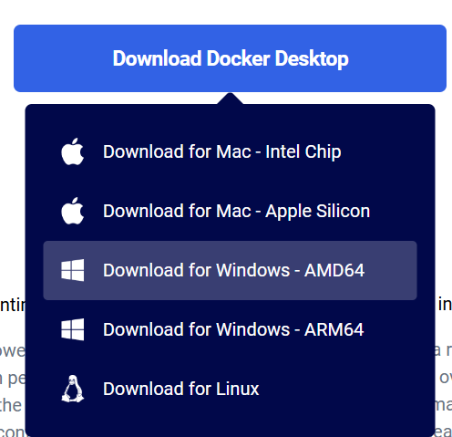**Step 1: Download Docker Desktop**

1. Go to the Docker Desktop download page (<https://www.docker.com/products/docker-desktop/>) find the download part and click on the "Download for Windows". (most likely the AMD64 unless you have ARM cpu)

**Step 2: Run the Installer**

1. **Prerequirement:** You should have Admin rights to conduct the installation
2. **Prerequirement**: BIOS-level hardware virtualization (VT-x, AMD-V, or similar) should be enabled
3. Once the download is complete, double-click the downloaded Docker Desktop Installer.exe file to run the installer.
4. Follow the on-screen instructions to complete the installation. This includes accepting the license agreement and choosing the installation options.

**Step 3: Enable Required Windows Features**

1. During the installation, Docker Desktop might prompt you to enable the necessary Windows features, such as WSL (Windows Subsystem for Linux) and Hyper-V. Simply follow the prompts and allow Docker Desktop to make these changes.
   * You also need Admin rights for this
2. If prompted, restart your computer to apply the changes.

**Step 4: Start the installed Docker Desktop app**

1. Docker Desktop will complete its setup and may prompt you to enable the WSL feature if it is not already enabled. Follow the prompts to complete the setup.
2. Lower left corner of Docker Desktop application should state “Engine running”
   * Note, lower right-hand corner might state about updated version. If so, conduct the update

**Step 5: Run a Test Container**

1. In Docker Desktop, go to the Docker Hub tab and search for the hello-world image.
2. Click on the image and select **Run** to start a container. If everything is set up correctly, you will see a message “Hello from Docker! + additional info) indicating that Docker is working.

After you have completed these steps, you should be ready to run the provided containers.