Kmeans_Clustering_R

## Analyse de la base de données ‘Live’

La base de données ‘Live’ contient des informations collectées auprès de vendeurs sur Facebook en Thaïlande.

Elle comprend différents types de statuts (photo, vidéo, etc.) ainsi que diverses métriques telles que les ‘likes’, ‘shares’, et ‘comments’.

Les détails précis des variables peuvent varier en fonction du fichier de données spécifique utilisé.

La base de données contient les inforamtions suivantes:

- status_id : L’ID unique de chaque publication.

- status_type : Le type de publication (par exemple, photo, statut, lien, vidéo).

* status_published : La date et l’heure de la publication.

- num_reactions : Le nombre total de réactions à la publication (par exemple, likes, love, wow, haha, sad, angry).

* num_comments : Le nombre total de commentaires sur la publication.

- num_shares : Le nombre total de partages de la publication.

- num_likes : Le nombre total de “J’aime” pour la publication.

- num_loves : Le nombre total de “Love” réactions pour la publication.

- num_wows : Le nombre total de “Wow” réactions pour la publication.

- num_hahas : Le nombre total de “Haha” réactions pour la publication.

- num_sads : Le nombre total de “Sad” réactions pour la publication.

- num_angrys : Le nombre total de “Angry” réactions pour la publication.

L’objectif de cette analyse est **de découvrir des modèles et des tendances dans les données qui peuvent nous aider à comprendre comment les utilisateurs de Facebook en Thaïlande** interagissent avec les publications des vendeurs en ligne.

Ces informations peuvent être utilisées pour optimiser la stratégie de contenu des vendeurs, améliorer l’engagement des utilisateurs et, finalement, augmenter les ventes.

# Etape 1: Importation des données et description des données

chemin<-"/Users/natachanjongwayepnga/Documents/GitHub/LeCoinStat/Kmeans_Logiciel_R/data"# Remplacez par le chemin dans lequel se trouve votre base de données  
base_publication<-read.csv(paste0(chemin,"/Live.csv"))  
  
#Visualiser les premières lignes de la base de données   
  
head(base_publication)

status_id status_type status_published num_reactions  
1 246675545449582_1649696485147474 video 4/22/2018 6:00 529  
2 246675545449582_1649426988507757 photo 4/21/2018 22:45 150  
3 246675545449582_1648730588577397 video 4/21/2018 6:17 227  
4 246675545449582_1648576705259452 photo 4/21/2018 2:29 111  
5 246675545449582_1645700502213739 photo 4/18/2018 3:22 213  
6 246675545449582_1645650162218773 photo 4/18/2018 2:14 217  
 num_comments num_shares num_likes num_loves num_wows num_hahas num_sads  
1 512 262 432 92 3 1 1  
2 0 0 150 0 0 0 0  
3 236 57 204 21 1 1 0  
4 0 0 111 0 0 0 0  
5 0 0 204 9 0 0 0  
6 6 0 211 5 1 0 0  
 num_angrys Column1 Column2 Column3 Column4  
1 0 NA NA NA NA  
2 0 NA NA NA NA  
3 0 NA NA NA NA  
4 0 NA NA NA NA  
5 0 NA NA NA NA  
6 0 NA NA NA NA

#Types des variables dans la base de données  
str(base_publication)

'data.frame': 7050 obs. of 16 variables:  
 $ status_id : chr "246675545449582_1649696485147474" "246675545449582_1649426988507757" "246675545449582_1648730588577397" "246675545449582_1648576705259452" ...  
 $ status_type : chr "video" "photo" "video" "photo" ...  
 $ status_published: chr "4/22/2018 6:00" "4/21/2018 22:45" "4/21/2018 6:17" "4/21/2018 2:29" ...  
 $ num_reactions : int 529 150 227 111 213 217 503 295 203 170 ...  
 $ num_comments : int 512 0 236 0 0 6 614 453 1 9 ...  
 $ num_shares : int 262 0 57 0 0 0 72 53 0 1 ...  
 $ num_likes : int 432 150 204 111 204 211 418 260 198 167 ...  
 $ num_loves : int 92 0 21 0 9 5 70 32 5 3 ...  
 $ num_wows : int 3 0 1 0 0 1 10 1 0 0 ...  
 $ num_hahas : int 1 0 1 0 0 0 2 1 0 0 ...  
 $ num_sads : int 1 0 0 0 0 0 0 0 0 0 ...  
 $ num_angrys : int 0 0 0 0 0 0 3 1 0 0 ...  
 $ Column1 : logi NA NA NA NA NA NA ...  
 $ Column2 : logi NA NA NA NA NA NA ...  
 $ Column3 : logi NA NA NA NA NA NA ...  
 $ Column4 : logi NA NA NA NA NA NA ...

#install.packages("dplyr")  
# Assurez-vous que le package dplyr est chargé  
library(dplyr)

Attaching package: 'dplyr'

The following objects are masked from 'package:stats':  
  
 filter, lag

The following objects are masked from 'package:base':  
  
 intersect, setdiff, setequal, union

# Suppression des colonnes inutiles  
base_publication<-base_publication %>% select(-c("Column1", "Column2", "Column3","Column4", "status_published"))  
  
str(base_publication)

'data.frame': 7050 obs. of 11 variables:  
 $ status_id : chr "246675545449582_1649696485147474" "246675545449582_1649426988507757" "246675545449582_1648730588577397" "246675545449582_1648576705259452" ...  
 $ status_type : chr "video" "photo" "video" "photo" ...  
 $ num_reactions: int 529 150 227 111 213 217 503 295 203 170 ...  
 $ num_comments : int 512 0 236 0 0 6 614 453 1 9 ...  
 $ num_shares : int 262 0 57 0 0 0 72 53 0 1 ...  
 $ num_likes : int 432 150 204 111 204 211 418 260 198 167 ...  
 $ num_loves : int 92 0 21 0 9 5 70 32 5 3 ...  
 $ num_wows : int 3 0 1 0 0 1 10 1 0 0 ...  
 $ num_hahas : int 1 0 1 0 0 0 2 1 0 0 ...  
 $ num_sads : int 1 0 0 0 0 0 0 0 0 0 ...  
 $ num_angrys : int 0 0 0 0 0 0 3 1 0 0 ...

#Résumé rapide de la base de données  
summary(base_publication)

status_id status_type num_reactions num_comments   
 Length:7050 Length:7050 Min. : 0.0 Min. : 0.0   
 Class :character Class :character 1st Qu.: 17.0 1st Qu.: 0.0   
 Mode :character Mode :character Median : 59.5 Median : 4.0   
 Mean : 230.1 Mean : 224.4   
 3rd Qu.: 219.0 3rd Qu.: 23.0   
 Max. :4710.0 Max. :20990.0   
 num_shares num_likes num_loves num_wows   
 Min. : 0.00 Min. : 0.0 Min. : 0.00 Min. : 0.000   
 1st Qu.: 0.00 1st Qu.: 17.0 1st Qu.: 0.00 1st Qu.: 0.000   
 Median : 0.00 Median : 58.0 Median : 0.00 Median : 0.000   
 Mean : 40.02 Mean : 215.0 Mean : 12.73 Mean : 1.289   
 3rd Qu.: 4.00 3rd Qu.: 184.8 3rd Qu.: 3.00 3rd Qu.: 0.000   
 Max. :3424.00 Max. :4710.0 Max. :657.00 Max. :278.000   
 num_hahas num_sads num_angrys   
 Min. : 0.0000 Min. : 0.0000 Min. : 0.0000   
 1st Qu.: 0.0000 1st Qu.: 0.0000 1st Qu.: 0.0000   
 Median : 0.0000 Median : 0.0000 Median : 0.0000   
 Mean : 0.6965 Mean : 0.2437 Mean : 0.1132   
 3rd Qu.: 0.0000 3rd Qu.: 0.0000 3rd Qu.: 0.0000   
 Max. :157.0000 Max. :51.0000 Max. :31.0000

## Analyse des données manquantes

# Fonction pour calculer la proportion de valeurs manquantes par variable  
proportion_valeurs_manquantes <- function(data) {  
 # Calcul du nombre de valeurs manquantes par colonne  
 nb_valeurs_manquantes <- sapply(data, function(x) sum(is.na(x)))  
  
 # Calcul de la proportion de valeurs manquantes  
 proportion_manquantes <- nb_valeurs_manquantes / nrow(data)  
  
 # Création d'un dataframe pour le résultat  
 resultat <- data.frame(Nombre = nb_valeurs_manquantes, Proportion = proportion_manquantes)  
  
 return(resultat)  
}  
  
# Utilisation de la fonction avec votre base de données  
resultat <- proportion_valeurs_manquantes(base_publication)  
resultat

Nombre Proportion  
status_id 0 0  
status_type 0 0  
num_reactions 0 0  
num_comments 0 0  
num_shares 0 0  
num_likes 0 0  
num_loves 0 0  
num_wows 0 0  
num_hahas 0 0  
num_sads 0 0  
num_angrys 0 0

# Charger le package VIM  
if (!require(VIM)) install.packages("VIM")

Loading required package: VIM

Loading required package: colorspace

Loading required package: grid

VIM is ready to use.

Suggestions and bug-reports can be submitted at: https://github.com/statistikat/VIM/issues

Attaching package: 'VIM'

The following object is masked from 'package:datasets':  
  
 sleep

library(VIM)  
  
# Utilisation de la fonction aggr() pour visualiser les valeurs manquantes  
# base_publication : le dataframe contenant vos données  
# col : définit les couleurs utilisées dans le graphique (navyblue pour les valeurs existantes, yellow pour les manquantes)  
# numbers : si TRUE, affiche le pourcentage de valeurs manquantes pour chaque variable  
# sortVars : si TRUE, trie les variables par le taux de valeurs manquantes  
# labels : les étiquettes à utiliser pour chaque variable, ici on utilise les noms des colonnes de base_publication  
# cex.axis : taille du texte des étiquettes d'axe (réduite ici à 0.7 pour une meilleure lisibilité)  
# gap : espace entre les barres dans l'histogramme  
# ylab : étiquettes pour l'axe des y, ici définies comme un histogramme des données manquantes et leur motif  
  
aggr(base_publication, col=c('navyblue','yellow'), numbers=TRUE, sortVars=TRUE,   
 labels=names(base_publication), cex.axis=.7, gap=3, ylab=c("Histogram of missing data","Pattern"))

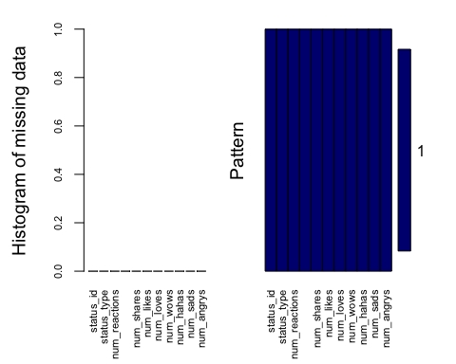

Variables sorted by number of missings:   
 Variable Count  
 status_id 0  
 status_type 0  
 num_reactions 0  
 num_comments 0  
 num_shares 0  
 num_likes 0  
 num_loves 0  
 num_wows 0  
 num_hahas 0  
 num_sads 0  
 num_angrys 0

## Analyse du type de statut

# Chargement du package ggplot2 pour la visualisation  
library(ggplot2)  
  
# Création d'une table des fréquences pour la variable status_type  
  
type_statut_table <- table(base_publication$status_type)  
  
# Conversion de la table en dataframe pour la visualisation  
type_statut_df <- as.data.frame(type_statut_table)  
  
# Renommage des colonnes  
names(type_statut_df) <- c("status_type", "Count")  
  
# Ajout d'une colonne pour les proportions  
type_statut_df$Proportion <- type_statut_df$Count / sum(type_statut_df$Count)  
  
# Création du diagramme en barres  
ggplot(type_statut_df, aes(x = status_type, y = Count, fill = status_type)) +  
 geom_bar(stat = "identity") +  
 geom_text(aes(label = paste(round(Proportion * 100), "%")), vjust = -0.5) +  
 labs(title = "Répartition par Type de Statut", x = "Type de Statut", y = "Nombre") +  
 theme_minimal() +  
 scale_fill_brewer(palette = "Pastel1")

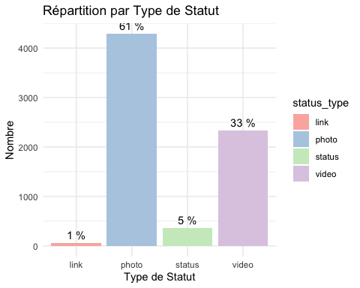

#Afficher le nombre  
type_statut_table

link photo status video   
 63 4288 365 2334

## Analyse des variables quantitatives

# Installer les packages nécessaires si ce n'est pas déjà fait  
if (!require(ggplot2)) install.packages("ggplot2")  
  
# Charger les packages  
library(ggplot2)  
# Identifier les colonnes quantitatives  
liste_variable_quanti <-colnames(base_publication)[-c(1,2)]  
  
# Créer un histogramme pour chaque variable quantitative  
for (var in liste_variable_quanti) {  
 # Vérifier si la variable est continue  
 if (is.numeric(base_publication[[var]])) {  
 print(ggplot(base_publication, aes(x = .data[[var]])) +  
 geom_histogram(bins = 30, fill = "blue", color = "black") +  
 theme_minimal() +  
 labs(title = paste("Histogramme de", var), x = var, y = "Fréquence"))  
 } else {  
 message(paste("La variable", var, "n'est pas quantitative et sera ignorée."))  
 }  
}

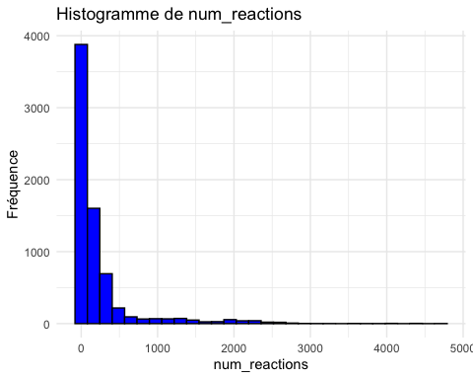

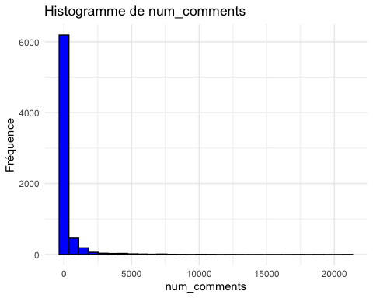

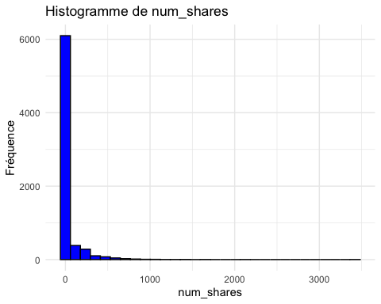

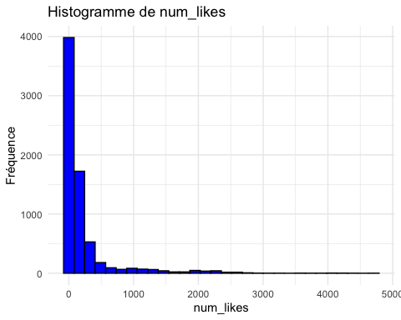

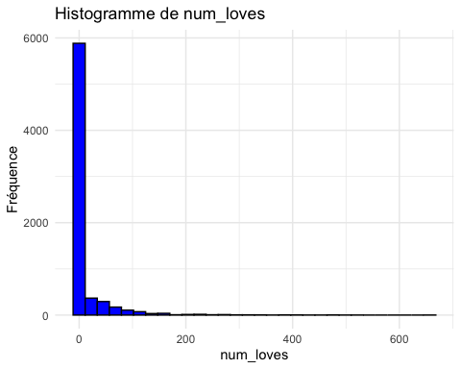

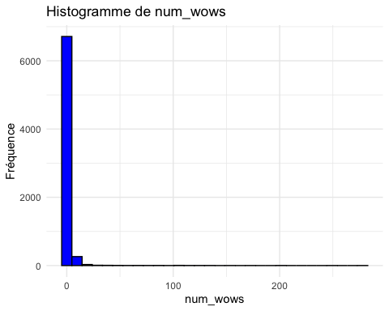

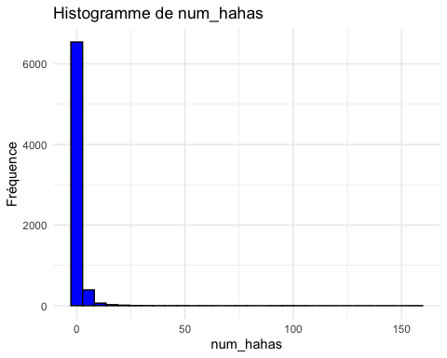

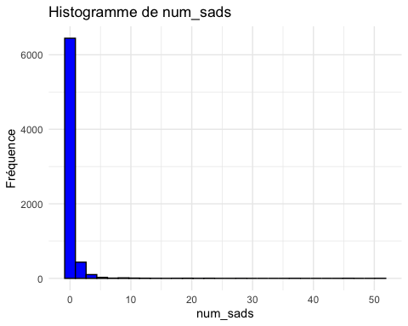

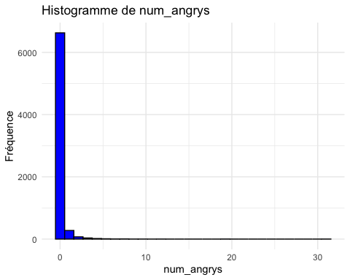

# Créer un boxplot pour chaque variable quantitative  
for (var in liste_variable_quanti) {  
 # Vérifier si la variable est continue  
 if (is.numeric(base_publication[[var]])) {  
 print(ggplot(base_publication, aes(x = factor(1), y = .data[[var]])) +  
 geom_boxplot(fill = "skyblue", color = "darkblue") +  
 theme_minimal() +  
 labs(title = paste("Boxplot de", var), x = "", y = var))  
 } else {  
 message(paste("La variable", var, "n'est pas quantitative et sera ignorée pour les boxplots."))  
 }  
}

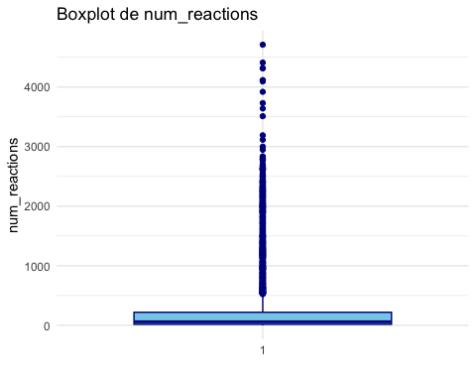

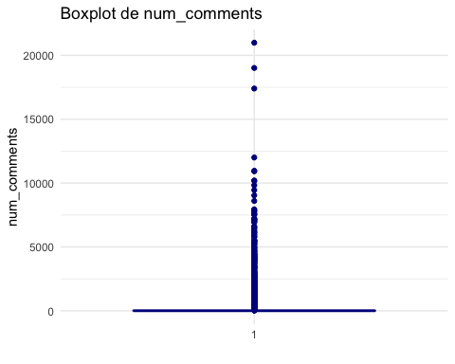

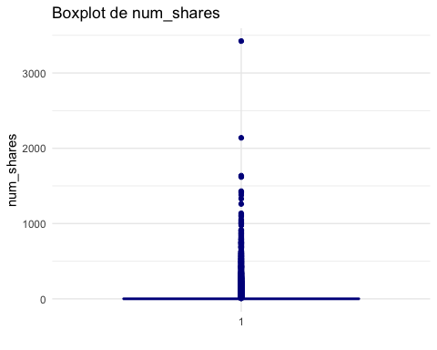

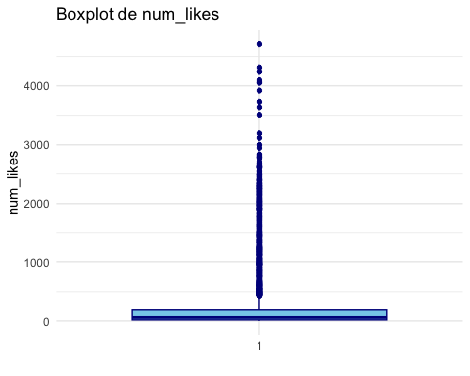

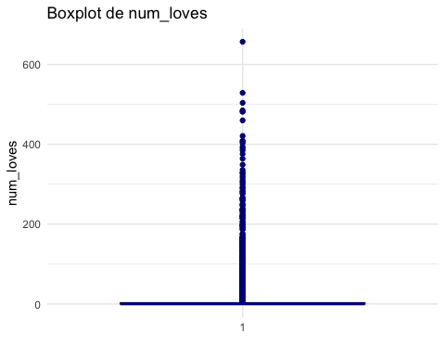

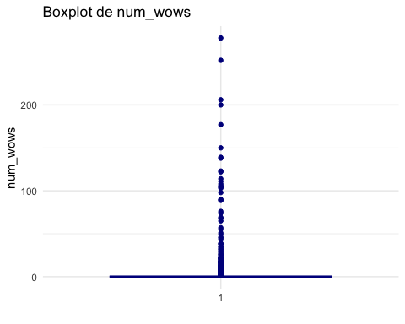

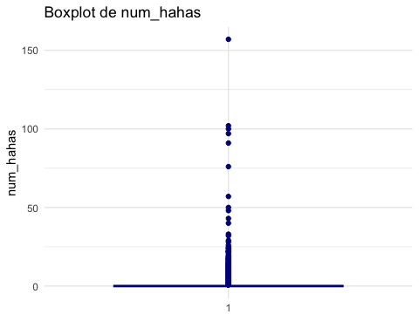

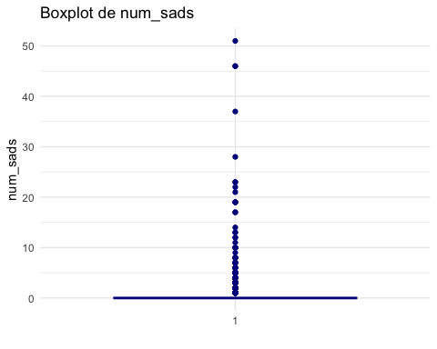

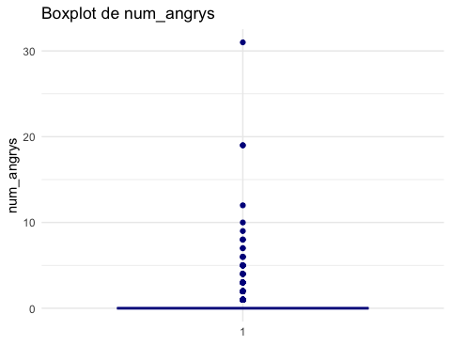

library(psych)

Attaching package: 'psych'

The following objects are masked from 'package:ggplot2':  
  
 %+%, alpha

describe(base_publication[,liste_variable_quanti])

vars n mean sd median trimmed mad min max range  
num_reactions 1 7050 230.12 462.63 59.5 112.55 77.84 0 4710 4710  
num_comments 2 7050 224.36 889.64 4.0 35.21 5.93 0 20990 20990  
num_shares 3 7050 40.02 131.60 0.0 7.06 0.00 0 3424 3424  
num_likes 4 7050 215.04 449.47 58.0 100.85 74.13 0 4710 4710  
num_loves 5 7050 12.73 39.97 0.0 2.95 0.00 0 657 657  
num_wows 6 7050 1.29 8.72 0.0 0.24 0.00 0 278 278  
num_hahas 7 7050 0.70 3.96 0.0 0.08 0.00 0 157 157  
num_sads 8 7050 0.24 1.60 0.0 0.00 0.00 0 51 51  
num_angrys 9 7050 0.11 0.73 0.0 0.00 0.00 0 31 31  
 skew kurtosis se  
num_reactions 3.74 16.72 5.51  
num_comments 9.03 126.74 10.60  
num_shares 7.10 96.77 1.57  
num_likes 3.92 18.41 5.35  
num_loves 6.00 50.52 0.48  
num_wows 18.24 415.18 0.10  
num_hahas 20.30 586.60 0.05  
num_sads 17.57 426.65 0.02  
num_angrys 19.50 624.13 0.01

## Etape 2: Analyse des relations entre les variables

# Chargement des packages nécessaires  
if (!require(GGally)) install.packages("GGally")

Loading required package: GGally

Registered S3 method overwritten by 'GGally':  
 method from   
 +.gg ggplot2

library(GGally)  
# Sélection des variables quantitatives  
base_anal <- base_publication[,-1]#Enlever l'identifiant de la base  
  
# Création du pairplot  
plot(base_anal)

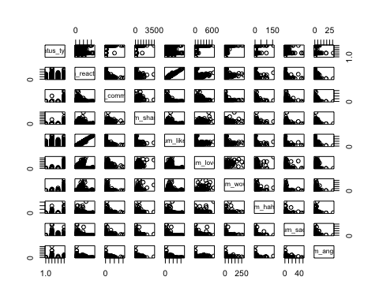

## Heatmap de corrélation entre les variables quantitatives

if (!require(ggplot2)) install.packages("ggplot2")  
if (!require(reshape2)) install.packages("reshape2") # Pour transformer la matrice de corrélation

Loading required package: reshape2

library(ggplot2)  
library(reshape2)  
base_quati <- base_publication[,-c(1,2)] # Enlever les colonnes non quantitatives  
matrice_correlation <- cor(base_quati, use = "complete.obs")  
  
# Fondre la matrice de corrélation pour une utilisation avec ggplot2  
melted_cormat <- melt(matrice_correlation)  
  
  
ggplot(data = melted_cormat, aes(Var2, Var1, fill = value)) +  
 geom_tile(color = "white") +  
 scale_fill_gradient2(low = "blue", high = "red", mid = "white",   
 midpoint = 0, limit = c(-1,1), space = "Lab",   
 name="Corrélation de Pearson") +  
 theme_minimal() +   
 theme(axis.text.x = element_text(angle = 45, vjust = 1,   
 size = 12, hjust = 1),  
 axis.text.y = element_text(size = 12)) +  
 coord_fixed()

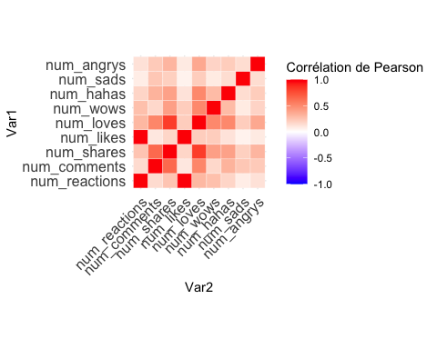

## Relation variable qualitative et une variable quantitative

if (!require(ggplot2)) install.packages("ggplot2")  
  
# Charger les packages  
library(ggplot2)  
  
# Pour chaque variable quantitative, créer un boxplot par rapport à status_type  
for (col in liste_variable_quanti) {  
 # Créer le boxplot  
 p <- ggplot(base_publication, aes(x = status_type, y = .data[[col]], fill = status_type)) +  
 geom_boxplot(alpha = 0.7) + # Supprimer la bordure noire  
 scale_fill_brewer(palette = "Set1") + # Utiliser une palette de couleurs vive  
 labs(title = paste("Boxplot de", col, "par status_type"), x = "Status Type", y = col) +  
 theme_minimal() +  
 theme(axis.text.x = element_text(angle = 45, hjust = 1), # Incliner le texte de l'axe X  
 plot.title = element_text(hjust = 0.5)) # Centrer le titre  
  
 # Afficher le boxplot  
 print(p)  
}

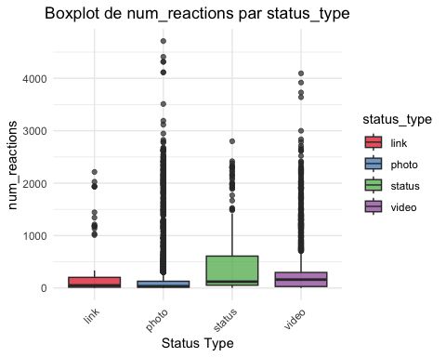

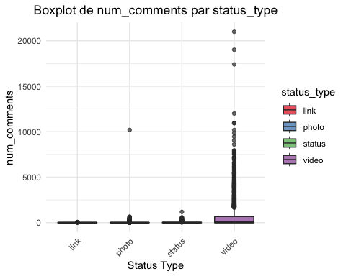

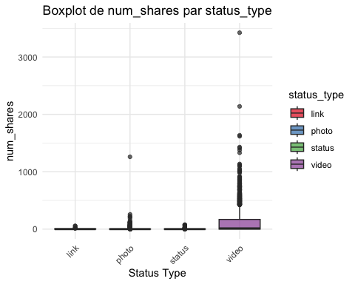

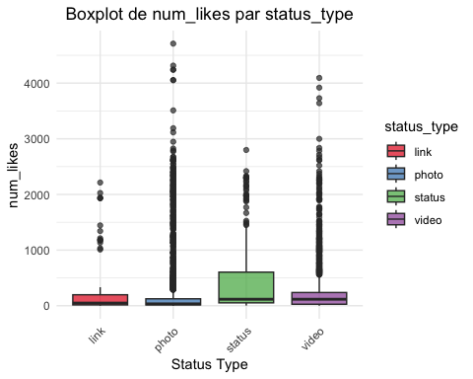

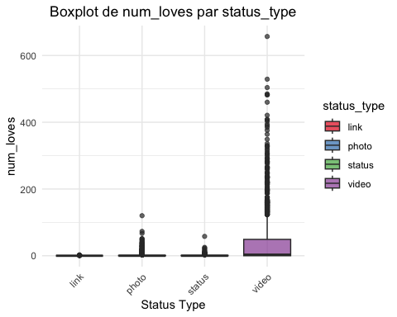

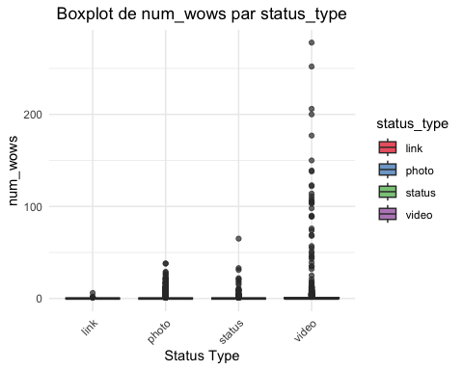

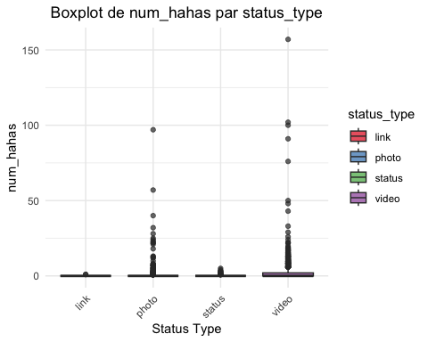

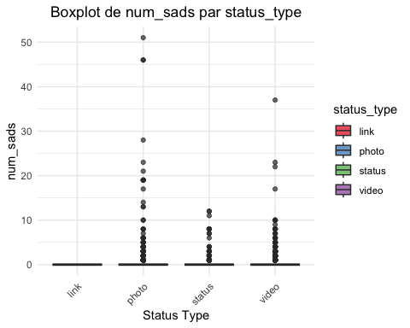

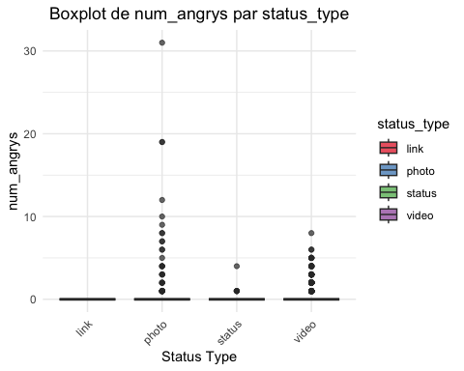

# Effectuer le test de Wilcoxon pour chaque variable quantitative par rapport à une variable qualitative  
  
resultats_tests <- list()  
  
for (col in liste_variable_quanti) {  
 # Exécution du test de Kruskal-Wallis  
 test <- kruskal.test(as.formula(paste(col, '~ status_type')), data = base_publication)  
   
 # Stocker la statistique de test et la p-valeur  
 resultats_tests[[col]] <- c(statistic = test$statistic, p.value = test$p.value)  
}  
  
# Conversion de la liste des résultats en dataframe  
resultats_dataframe <- as.data.frame(t(sapply(resultats_tests, c)))  
  
# Nommer les colonnes et les lignes du dataframe  
colnames(resultats_dataframe) <- c("statistic", "p.value")  
rownames(resultats_dataframe) <- liste_variable_quanti  
  
resultats_dataframe

statistic p.value  
num_reactions 430.0462 6.860611e-93  
num_comments 748.0684 7.916056e-162  
num_shares 1539.8307 0.000000e+00  
num_likes 357.6951 3.216644e-77  
num_loves 883.4864 3.379917e-191  
num_wows 196.5584 2.337563e-42  
num_hahas 1336.2606 1.994865e-289  
num_sads 511.4759 1.554607e-110  
num_angrys 643.2248 4.288563e-139

# Etape 3: Réaliser l’ACP

if (!require(FactoMineR)) install.packages("FactoMineR")

Loading required package: FactoMineR

if (!require(factoextra)) install.packages("factoextra")

Loading required package: factoextra

Welcome! Want to learn more? See two factoextra-related books at https://goo.gl/ve3WBa

library(FactoMineR)  
library(factoextra)  
  
# Sélection des variables quantitatives  
base_quanti <- base_publication[,-c(1,2)] # Exclure les colonnes non quantitatives  
  
# Variable qualitative comme supplémentaire  
status_type <- base_publication$status_type

# Normalisation (centrage et réduction) des variables quantitatives  
base_quanti_norm <- scale(base_quanti)  
acp <- PCA(base_quanti_norm, graph = FALSE)  
fviz_eig(acp)

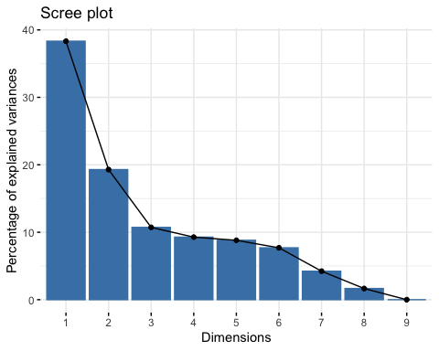

# Cercle de corrélation  
fviz_pca_var(acp, col.var = "contrib", repel = TRUE) # Colorer par contribution

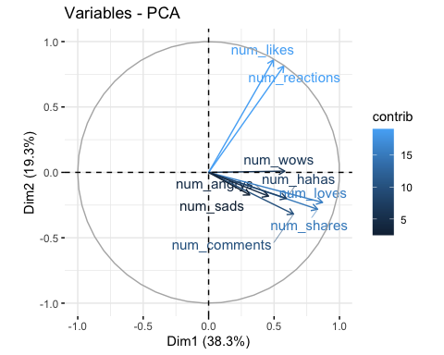

fviz_pca_var(acp, col.var = "cos2", repel = TRUE) # Colorer par contribution

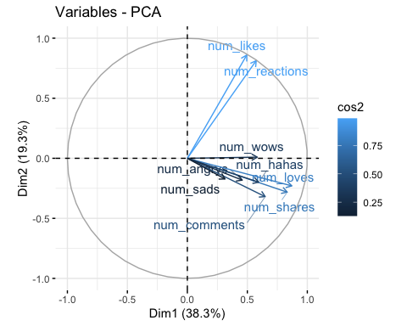

# Mise en place des kmeans

## Etape 4: Détermination du nombre de cluster

if (!require(factoextra)) install.packages("factoextra")  
if (!require(cluster)) install.packages("cluster")

Loading required package: cluster

library(factoextra)  
library(cluster)

Méthode du coude

### Elbow Method

Recall that, the basic idea behind cluster partitioning methods, such as k-means clustering, is to define clusters such that the total intra-cluster variation (known as total within-cluster variation or total within-cluster sum of square) is minimized:

minimize(k∑k=1W(Ck))(8)(8)��������(∑�=1��(��))

where Ck�� is the kth��ℎ cluster and W(Ck)�(��) is the within-cluster variation. The total within-cluster sum of square (wss) measures the compactness of the clustering and we want it to be as small as possible. Thus, we can use the following algorithm to define the optimal clusters:

1. Compute clustering algorithm (e.g., k-means clustering) for different values of *k*. For instance, by varying *k* from 1 to 10 clusters
2. For each *k*, calculate the total within-cluster sum of square (wss)
3. Plot the curve of wss according to the number of clusters *k*.
4. The location of a bend (knee) in the plot is generally considered as an indicator of the appropriate number of clusters.

We can implement this in R with the following code. The results suggest that 4 is the optimal number of clusters as it appears to be the bend in the knee (or elbow).

<https://uc-r.github.io/kmeans_clustering#optimal>

# détermination du nombre de cluster optimal avec la règle de coude  
fviz_nbclust(base_quanti_norm, kmeans, method = "wss") +   
 geom_vline(xintercept = 4, linetype = 2) # Ajuster le xintercept selon le résultat

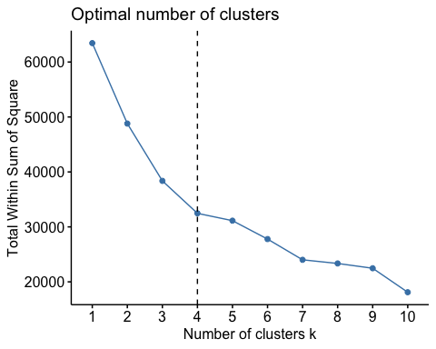

In short, the average silhouette approach measures the quality of a clustering. That is, it determines how well each object lies within its cluster. A high average silhouette width indicates a good clustering. The average silhouette method computes the average silhouette of observations for different values of *k*. The optimal number of clusters *k* is the one that maximizes the average silhouette over a range of possible values for *k*.[2](https://uc-r.github.io/kmeans_clustering#fn:kauf)

We can use the silhouette function in the cluster package to compuate the average silhouette width. The following code computes this approach for 1-15 clusters. The results show that 2 clusters maximize the average silhouette values with 4 clusters coming in as second optimal number of clusters.

<https://uc-r.github.io/kmeans_clustering>

if (!require(purrr)) install.packages("purrr")

Loading required package: purrr

library(purrr)  
  
# function to compute average silhouette for k clusters  
avg_sil <- function(k) {  
 km.res <- kmeans(base_quanti_norm, centers = k, nstart = 25)  
 ss <- silhouette(km.res$cluster, dist(base_quanti_norm))  
 mean(ss[, 3])  
}  
  
# Compute and plot wss for k = 2 to k = 15  
k.values <- 2:15  
  
# extract avg silhouette for 2-15 clusters  
avg_sil_values <- map_dbl(k.values, avg_sil)

Warning: did not converge in 10 iterations  
  
Warning: did not converge in 10 iterations  
  
Warning: did not converge in 10 iterations  
  
Warning: did not converge in 10 iterations  
  
Warning: did not converge in 10 iterations

plot(k.values, avg_sil_values,  
 type = "b", pch = 19, frame = FALSE,   
 xlab = "Number of clusters K",  
 ylab = "Average Silhouettes")

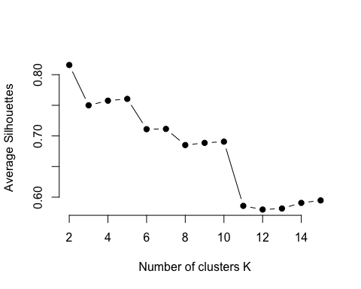

fviz_nbclust(base_quanti_norm, kmeans, method = "silhouette")

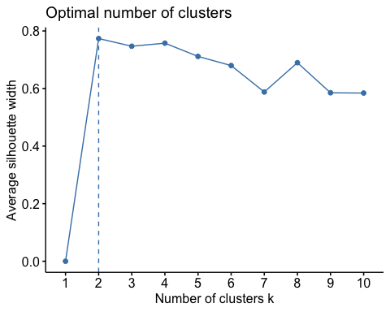

The gap statistic has been published by [R. Tibshirani, G. Walther, and T. Hastie (Standford University, 2001)](http://web.stanford.edu/~hastie/Papers/gap.pdf). The approach can be applied to any clustering method (i.e. K-means clustering, hierarchical clustering). The gap statistic compares the total intracluster variation for different values of *k* with their expected values under null reference distribution of the data (i.e. a distribution with no obvious clustering). The reference dataset is generated using Monte Carlo simulations of the sampling process. That is, for each variable (xi��) in the data set we compute its range [min(xi),max(xj)][���(��),���(��)] and generate values for the n points uniformly from the interval min to max.

For the observed data and the the reference data, the total intracluster variation is computed using different values of *k*. The *gap statistic* for a given *k* is defined as follow:

Gapn(k)=E∗nlog(Wk)−log(Wk)(9)(9)����(�)=��∗���(��)−���(��)

Where E∗n��∗ denotes the expectation under a sample size *n* from the reference distribution. E∗n��∗ is defined via bootstrapping (B) by generating B copies of the reference datasets and, by computing the average log(W∗k)���(��∗). The gap statistic measures the deviation of the observed Wk�� value from its expected value under the null hypothesis. The estimate of the optimal clusters (^k�^) will be the value that maximizes Gapn(k)����(�). This means that the clustering structure is far away from the uniform distribution of points.

In short, the algorithm involves the following steps:

1. Cluster the observed data, varying the number of clusters from k=1,…,kmax�=1,…,����, and compute the corresponding Wk��.
2. Generate B reference data sets and cluster each of them with varying number of clusters k=1,…,kmax�=1,…,����. Compute the estimated gap statistics presented in eq. 9.
3. Let ¯w=(1/B)∑blog(W∗kb)�¯=(1/�)∑����(���∗), compute the standard deviation sd(k)=√(1/b)∑b(log(W∗kb)−¯w)2��(�)=(1/�)∑�(���(���∗)−�¯)2 and define sk=sdk×√1+1/B��=���×1+1/�.
4. Choose the number of clusters as the smallest k such that Gap(k)≥Gap(k+1)−sk+1���(�)≥���(�+1)−��+1.

To compute the gap statistic method we can use the clusGap function which provides the gap statistic and standard error for an output.

# compute gap statistic  
set.seed(123)  
gap_stat <- clusGap(base_quanti_norm, FUN = kmeans, nstart = 25,  
 K.max = 10, B = 50)

Warning: Quick-TRANSfer stage steps exceeded maximum (= 352500)  
  
Warning: Quick-TRANSfer stage steps exceeded maximum (= 352500)

Warning: did not converge in 10 iterations  
  
Warning: did not converge in 10 iterations

Warning: Quick-TRANSfer stage steps exceeded maximum (= 352500)

Warning: did not converge in 10 iterations  
  
Warning: did not converge in 10 iterations

Warning: Quick-TRANSfer stage steps exceeded maximum (= 352500)  
  
Warning: Quick-TRANSfer stage steps exceeded maximum (= 352500)

Warning: did not converge in 10 iterations

Warning: Quick-TRANSfer stage steps exceeded maximum (= 352500)  
  
Warning: Quick-TRANSfer stage steps exceeded maximum (= 352500)  
  
Warning: Quick-TRANSfer stage steps exceeded maximum (= 352500)

Warning: did not converge in 10 iterations  
  
Warning: did not converge in 10 iterations

Warning: Quick-TRANSfer stage steps exceeded maximum (= 352500)

Warning: did not converge in 10 iterations  
  
Warning: did not converge in 10 iterations  
  
Warning: did not converge in 10 iterations

Warning: Quick-TRANSfer stage steps exceeded maximum (= 352500)

Warning: did not converge in 10 iterations  
  
Warning: did not converge in 10 iterations  
  
Warning: did not converge in 10 iterations  
  
Warning: did not converge in 10 iterations

Warning: Quick-TRANSfer stage steps exceeded maximum (= 352500)

Warning: did not converge in 10 iterations  
  
Warning: did not converge in 10 iterations

Warning: Quick-TRANSfer stage steps exceeded maximum (= 352500)

Warning: did not converge in 10 iterations  
  
Warning: did not converge in 10 iterations  
  
Warning: did not converge in 10 iterations  
  
Warning: did not converge in 10 iterations

Warning: Quick-TRANSfer stage steps exceeded maximum (= 352500)  
  
Warning: Quick-TRANSfer stage steps exceeded maximum (= 352500)

Warning: did not converge in 10 iterations  
  
Warning: did not converge in 10 iterations  
  
Warning: did not converge in 10 iterations  
  
Warning: did not converge in 10 iterations

Warning: Quick-TRANSfer stage steps exceeded maximum (= 352500)

Warning: did not converge in 10 iterations  
  
Warning: did not converge in 10 iterations  
  
Warning: did not converge in 10 iterations  
  
Warning: did not converge in 10 iterations

Warning: Quick-TRANSfer stage steps exceeded maximum (= 352500)

Warning: did not converge in 10 iterations  
  
Warning: did not converge in 10 iterations  
  
Warning: did not converge in 10 iterations  
  
Warning: did not converge in 10 iterations  
  
Warning: did not converge in 10 iterations

Warning: Quick-TRANSfer stage steps exceeded maximum (= 352500)  
  
Warning: Quick-TRANSfer stage steps exceeded maximum (= 352500)

Warning: did not converge in 10 iterations  
  
Warning: did not converge in 10 iterations  
  
Warning: did not converge in 10 iterations  
  
Warning: did not converge in 10 iterations  
  
Warning: did not converge in 10 iterations  
  
Warning: did not converge in 10 iterations  
  
Warning: did not converge in 10 iterations

Warning: Quick-TRANSfer stage steps exceeded maximum (= 352500)

Warning: did not converge in 10 iterations

Warning: Quick-TRANSfer stage steps exceeded maximum (= 352500)  
  
Warning: Quick-TRANSfer stage steps exceeded maximum (= 352500)

Warning: did not converge in 10 iterations  
  
Warning: did not converge in 10 iterations

Warning: Quick-TRANSfer stage steps exceeded maximum (= 352500)  
  
Warning: Quick-TRANSfer stage steps exceeded maximum (= 352500)  
  
Warning: Quick-TRANSfer stage steps exceeded maximum (= 352500)

Warning: did not converge in 10 iterations  
  
Warning: did not converge in 10 iterations  
  
Warning: did not converge in 10 iterations  
  
Warning: did not converge in 10 iterations  
  
Warning: did not converge in 10 iterations

fviz_gap_stat(gap_stat)

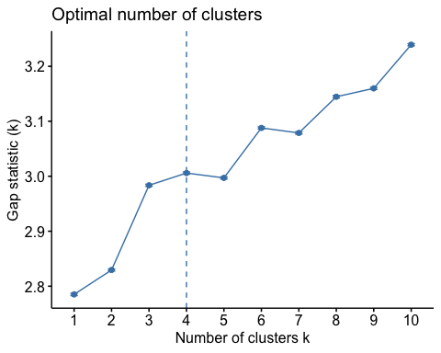

# Print the result  
print(gap_stat, method = "firstmax")

Clustering Gap statistic ["clusGap"] from call:  
clusGap(x = base_quanti_norm, FUNcluster = kmeans, K.max = 10, B = 50, nstart = 25)  
B=50 simulated reference sets, k = 1..10; spaceH0="scaledPCA"  
 --> Number of clusters (method 'firstmax'): 4  
 logW E.logW gap SE.sim  
 [1,] 8.283575 11.06868 2.785108 0.002153090  
 [2,] 8.130847 10.96030 2.829452 0.001846325  
 [3,] 7.918122 10.90171 2.983584 0.001798601  
 [4,] 7.844422 10.85025 3.005826 0.001995501  
 [5,] 7.817575 10.81461 2.997033 0.001874129  
 [6,] 7.691330 10.77928 3.087948 0.002059557  
 [7,] 7.676262 10.75504 3.078774 0.002105350  
 [8,] 7.587567 10.73221 3.144639 0.002146998  
 [9,] 7.557042 10.71693 3.159886 0.002061950  
[10,] 7.463133 10.70244 3.239308 0.002013925

set.seed(123) # Pour la reproductibilité  
kmeans_result <- kmeans(base_quanti_norm, centers = 4, nstart = 25)

fviz_cluster(kmeans_result, data = base_quanti_norm)

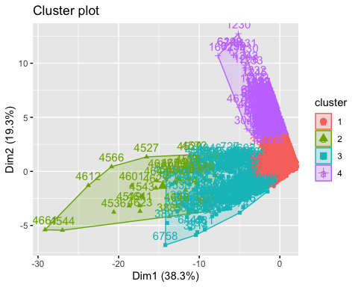

set.seed(123) # Pour la reproductibilité  
k2 <- kmeans(base_quanti_norm, centers = 2, nstart = 25)  
k3 <- kmeans(base_quanti_norm, centers = 3, nstart = 25)  
k5 <- kmeans(base_quanti_norm, centers = 5, nstart = 25)  
  
# plots to compare  
p1 <- fviz_cluster(k2, geom = "point", data = base_quanti_norm) + ggtitle("k = 2")  
p2 <- fviz_cluster(k3, geom = "point", data = base_quanti_norm) + ggtitle("k = 3")  
p3 <- fviz_cluster(k5, geom = "point", data = base_quanti_norm) + ggtitle("k = 5")  
p4 <- fviz_cluster(kmeans_result, geom = "point", data = base_quanti_norm) + ggtitle("k = 4")  
  
library(gridExtra)

Attaching package: 'gridExtra'

The following object is masked from 'package:dplyr':  
  
 combine

grid.arrange(p1, p2, p3,p4, nrow = 2)

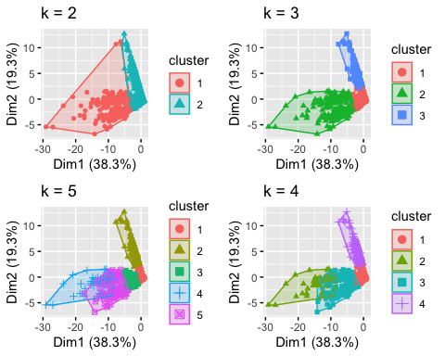

#Etape 5: Interprétation des résultats

base_publication$cluster <- factor(kmeans_result$cluster)

# Pour chaque variable quantitative, créer un boxplot par rapport à cluster  
for (col in liste_variable_quanti) {  
 p <- ggplot(base_publication, aes(x = cluster, y = .data[[col]], fill = cluster)) +  
 geom_boxplot() +  
 scale_fill_brewer(palette = "Set1") + # Utiliser une palette de couleurs  
 labs(title = paste("Boxplot de", col, "par cluster"), x = "Cluster", y = col) +  
 theme_minimal() +  
 theme(axis.text.x = element_text(angle = 45, hjust = 1), # Incliner le texte de l'axe X  
 plot.title = element_text(hjust = 0.5)) # Centrer le titre  
  
 # Afficher le boxplot  
 print(p)  
}

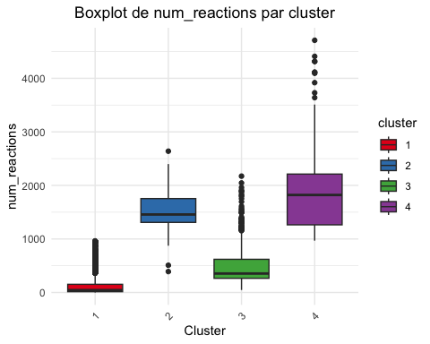

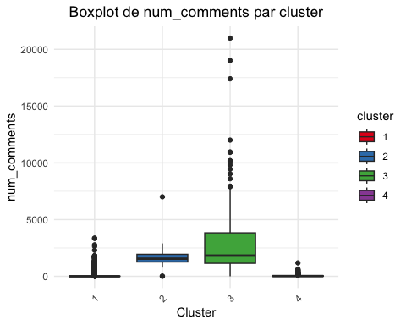

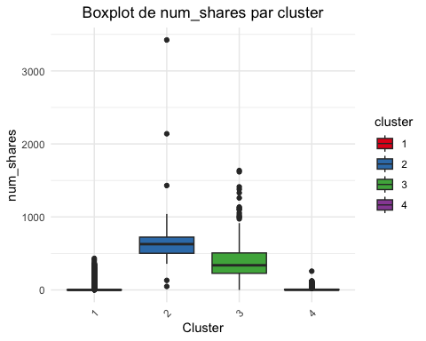

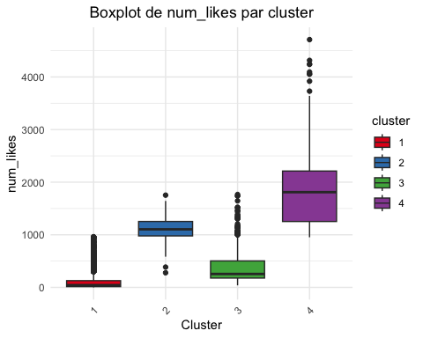

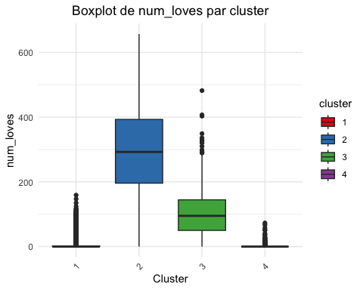

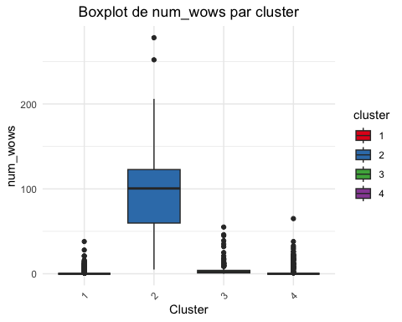

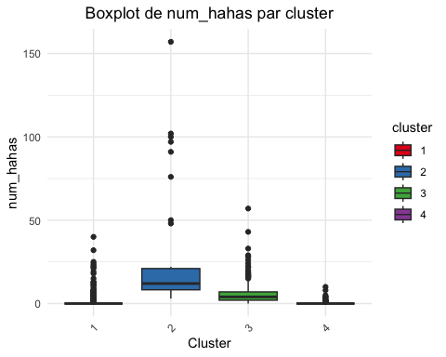

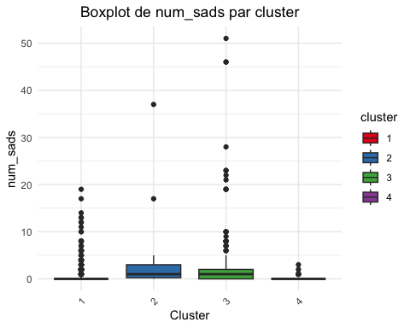

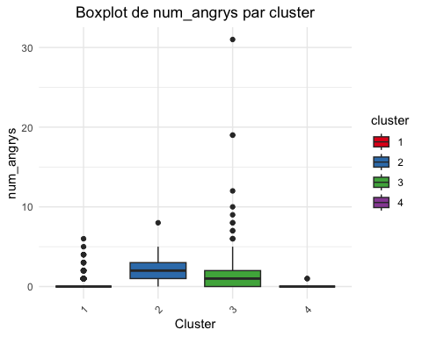

ggplot(base_publication, aes(x = factor(cluster), fill = status_type)) +  
 geom_bar(position = "dodge") +  
 scale_fill_brewer(palette = "Set1") + # Utiliser une palette de couleurs  
 labs(title = "Répartition des types de statuts par cluster",  
 x = "Cluster",  
 y = "Nombre de statuts") +  
 theme_minimal() +  
 theme(axis.text.x = element_text(angle = 45, hjust = 1)) # Incliner le texte de l'axe X

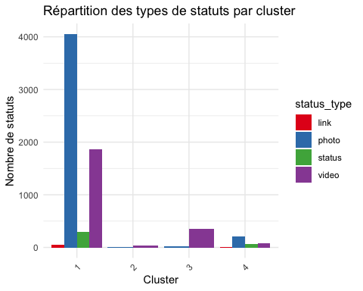

library(dplyr)  
#install.packages("tidyverse")  
library(tidyverse)

── Attaching core tidyverse packages ──────────────────────── tidyverse 2.0.0 ──  
✔ forcats 1.0.0 ✔ stringr 1.5.1  
✔ lubridate 1.9.3 ✔ tibble 3.2.1  
✔ readr 2.1.4 ✔ tidyr 1.3.0  
── Conflicts ────────────────────────────────────────── tidyverse_conflicts() ──  
✖ psych::%+%() masks ggplot2::%+%()  
✖ psych::alpha() masks ggplot2::alpha()  
✖ gridExtra::combine() masks dplyr::combine()  
✖ dplyr::filter() masks stats::filter()  
✖ dplyr::lag() masks stats::lag()  
ℹ Use the conflicted package (<http://conflicted.r-lib.org/>) to force all conflicts to become errors

# Calculer les proportions  
base_groupe <- base_publication %>%  
 group_by(cluster, status_type) %>%  
 summarise(count = n()) %>%  
 ungroup() %>%  
 mutate(freq = count / sum(count))

`summarise()` has grouped output by 'cluster'. You can override using the  
`.groups` argument.

ggplot(base_groupe, aes(x = factor(cluster), y = freq, fill = status_type)) +  
 geom_bar(stat = "identity", position = "fill") +  
 geom_text(aes(label = scales::percent(freq, accuracy = 1)),   
 position = position_fill(vjust = 0.5),   
 size = 3,   
 color = "black") +  
 scale_fill_brewer(palette = "Set1") + # Utiliser une palette de couleurs  
 labs(title = "Répartition proportionnelle des types de statuts par cluster",  
 x = "Cluster",  
 y = "Proportion (%)") +  
 theme_minimal() +  
 theme(axis.text.x = element_text(angle = 45, hjust = 1)) # Incliner le texte de l'axe X

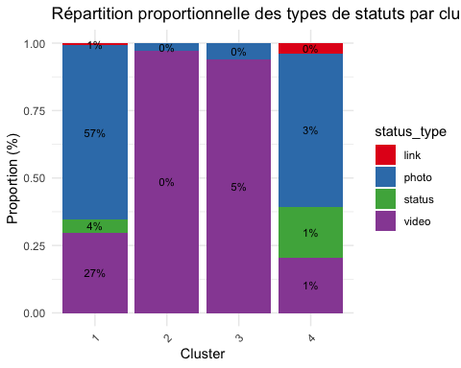

## Interprétation avec 3 clusters

base_publication$cluster3 <- factor(k3$cluster)

# Pour chaque variable quantitative, créer un boxplot par rapport à cluster  
for (col in liste_variable_quanti) {  
 p <- ggplot(base_publication, aes(x = cluster3, y = .data[[col]], fill = cluster3)) +  
 geom_boxplot() +  
 scale_fill_brewer(palette = "Set1") + # Utiliser une palette de couleurs  
 labs(title = paste("Boxplot de", col, "par cluster3"), x = "Cluster", y = col) +  
 theme_minimal() +  
 theme(axis.text.x = element_text(angle = 45, hjust = 1), # Incliner le texte de l'axe X  
 plot.title = element_text(hjust = 0.5)) # Centrer le titre  
  
 # Afficher le boxplot  
 print(p)  
}

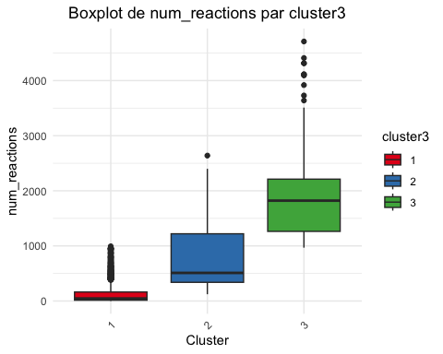

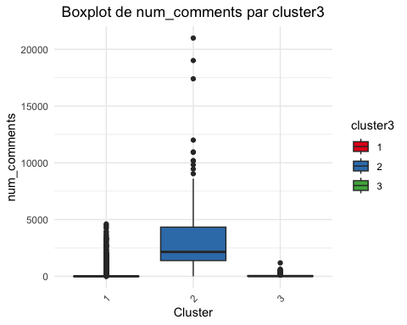

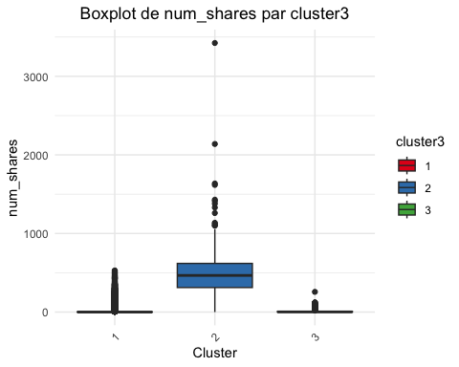

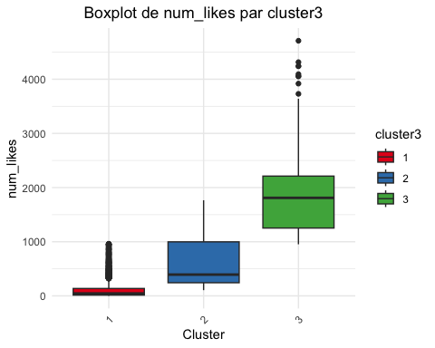

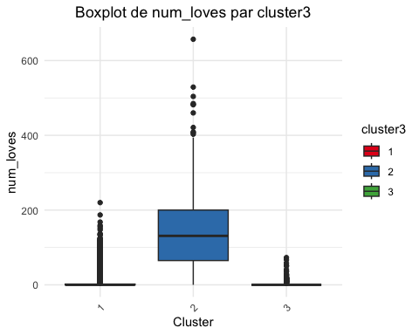

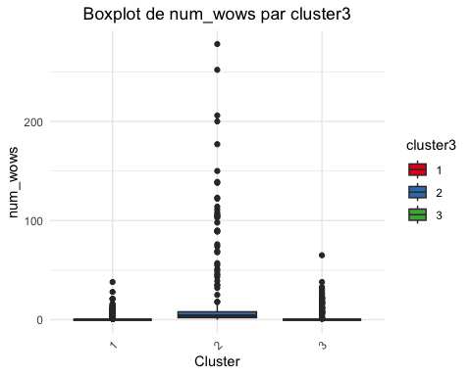

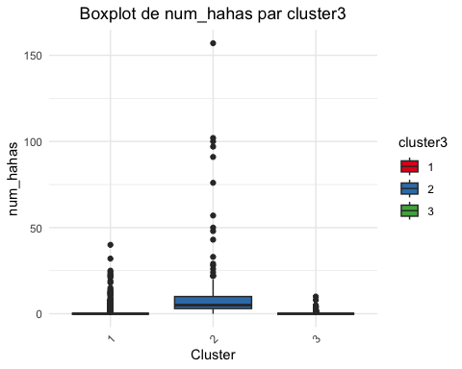

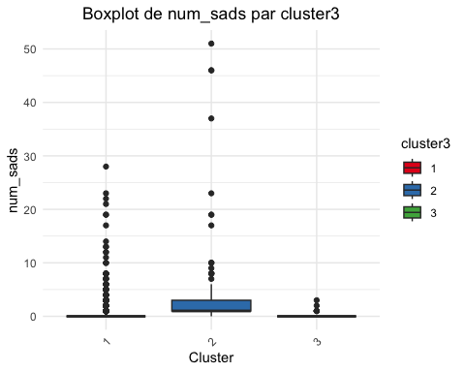

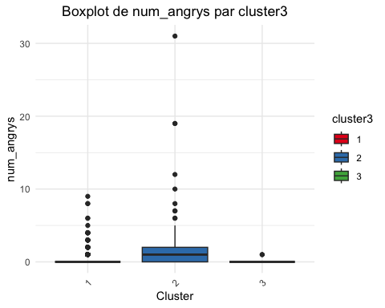

library(dplyr)  
#install.packages("tidyverse")  
library(tidyverse)  
# Calculer les proportions  
base_groupe <- base_publication %>%  
 group_by(cluster3, status_type) %>%  
 summarise(count = n()) %>%  
 ungroup() %>%  
 mutate(freq = count / sum(count))

`summarise()` has grouped output by 'cluster3'. You can override using the  
`.groups` argument.

ggplot(base_groupe, aes(x = cluster3, y = freq, fill = status_type)) +  
 geom_bar(stat = "identity", position = "fill") +  
 geom_text(aes(label = scales::percent(freq, accuracy = 1)),   
 position = position_fill(vjust = 0.5),   
 size = 3,   
 color = "black") +  
 scale_fill_brewer(palette = "Set1") + # Utiliser une palette de couleurs  
 labs(title = "Répartition proportionnelle des types de statuts par cluster",  
 x = "Cluster",  
 y = "Proportion (%)") +  
 theme_minimal() +  
 theme(axis.text.x = element_text(angle = 45, hjust = 1)) # Incliner le texte de l'axe X

