REST API

Trial list
/api/api_trials_list.php
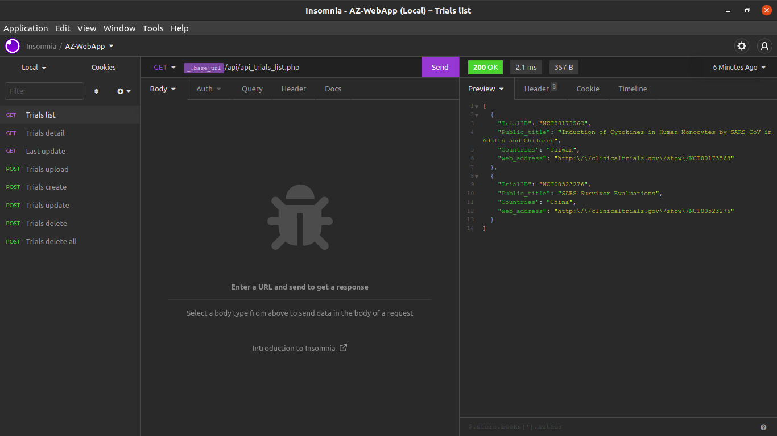
Trial detail
/api/api_trials_detail.php
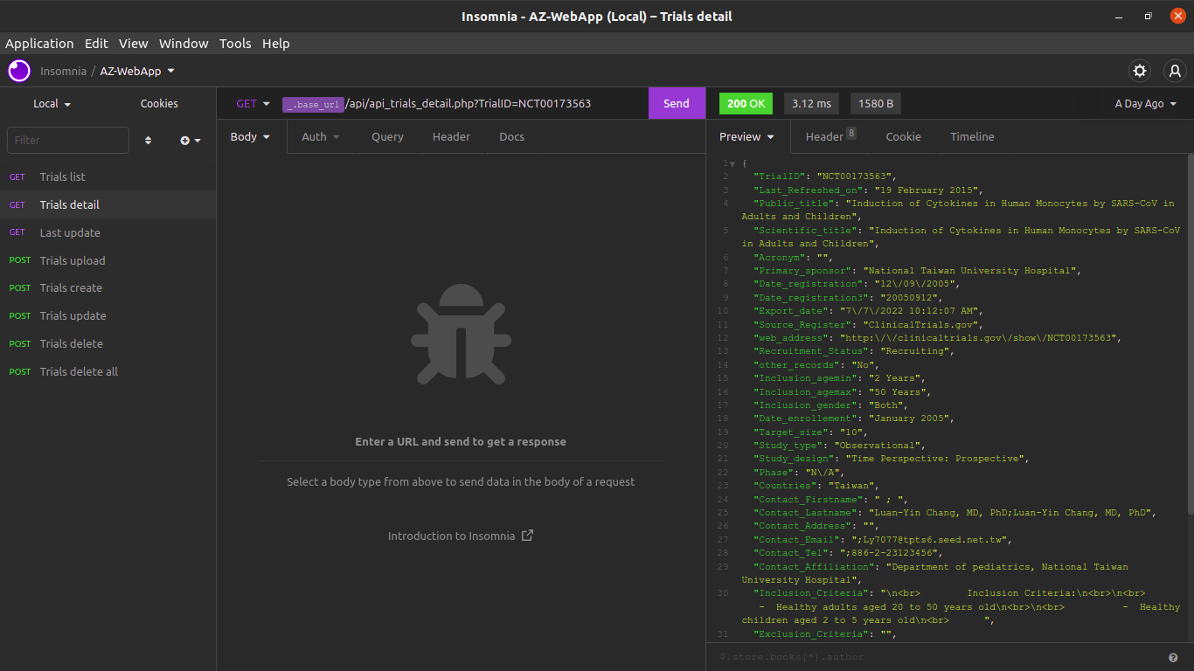

Last update
/api/api_last_update.php
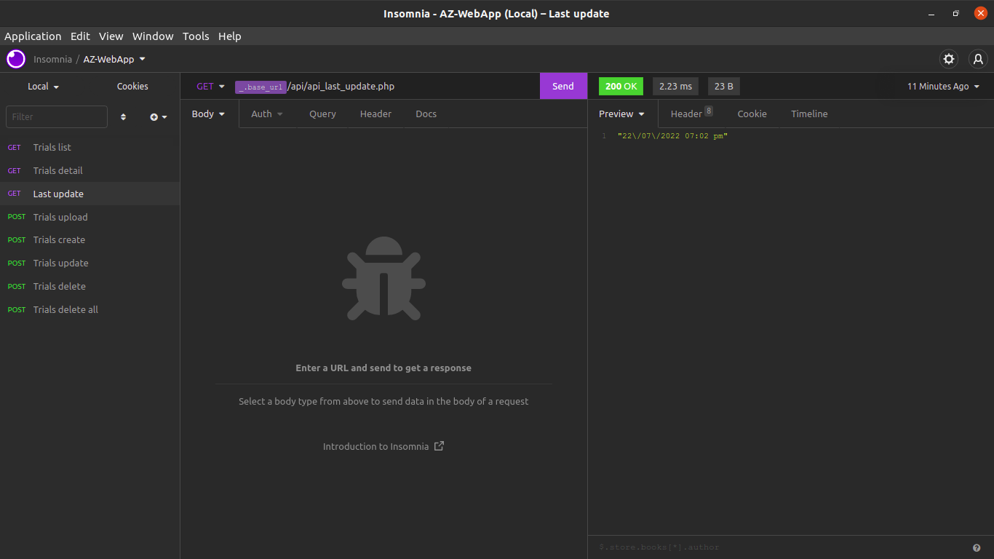

Trials upload
/api/api_trials_upload.php
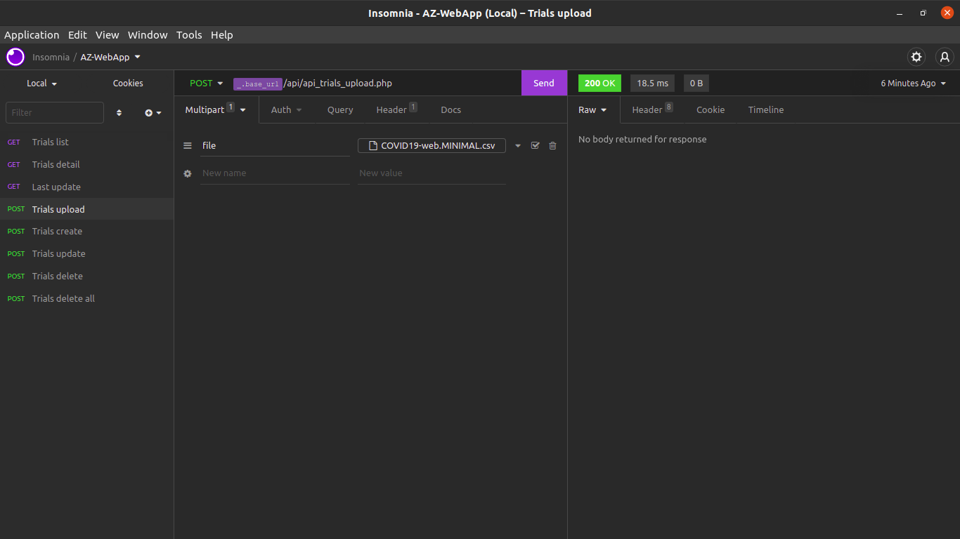

Trial create
/api/api_trials_create.php
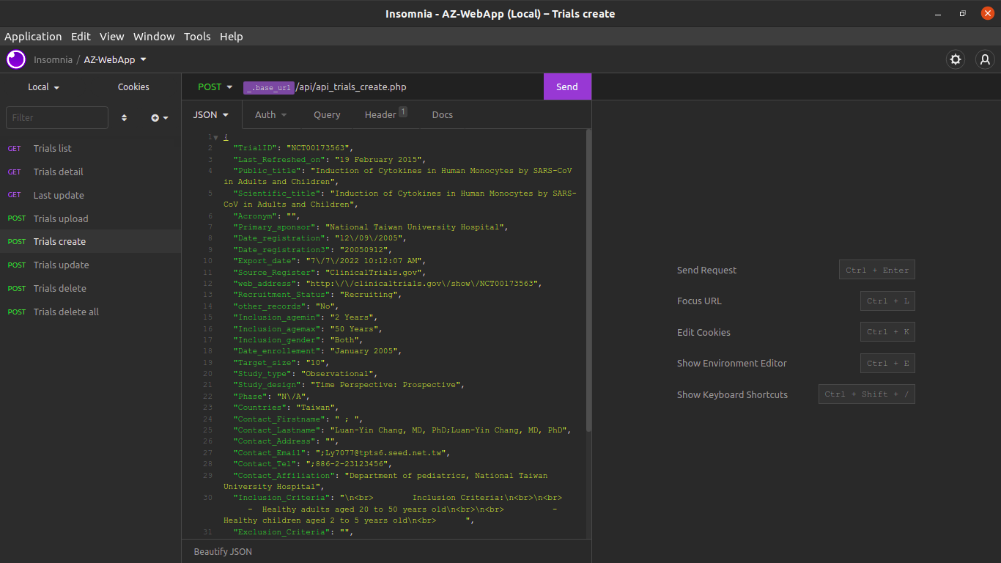

Trial update
/api/api_trials_update.php
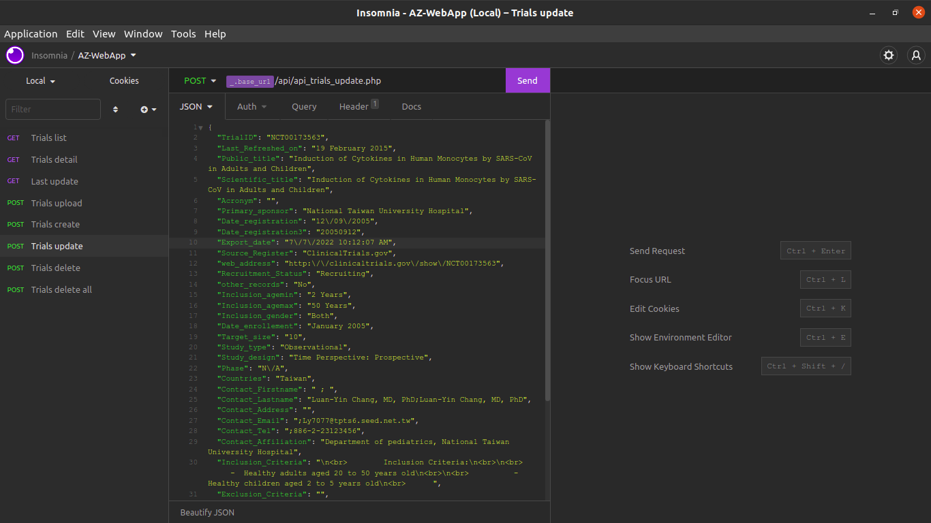

Trial delete
/api/api_trials_delete.php?TrialID=<TrialID>
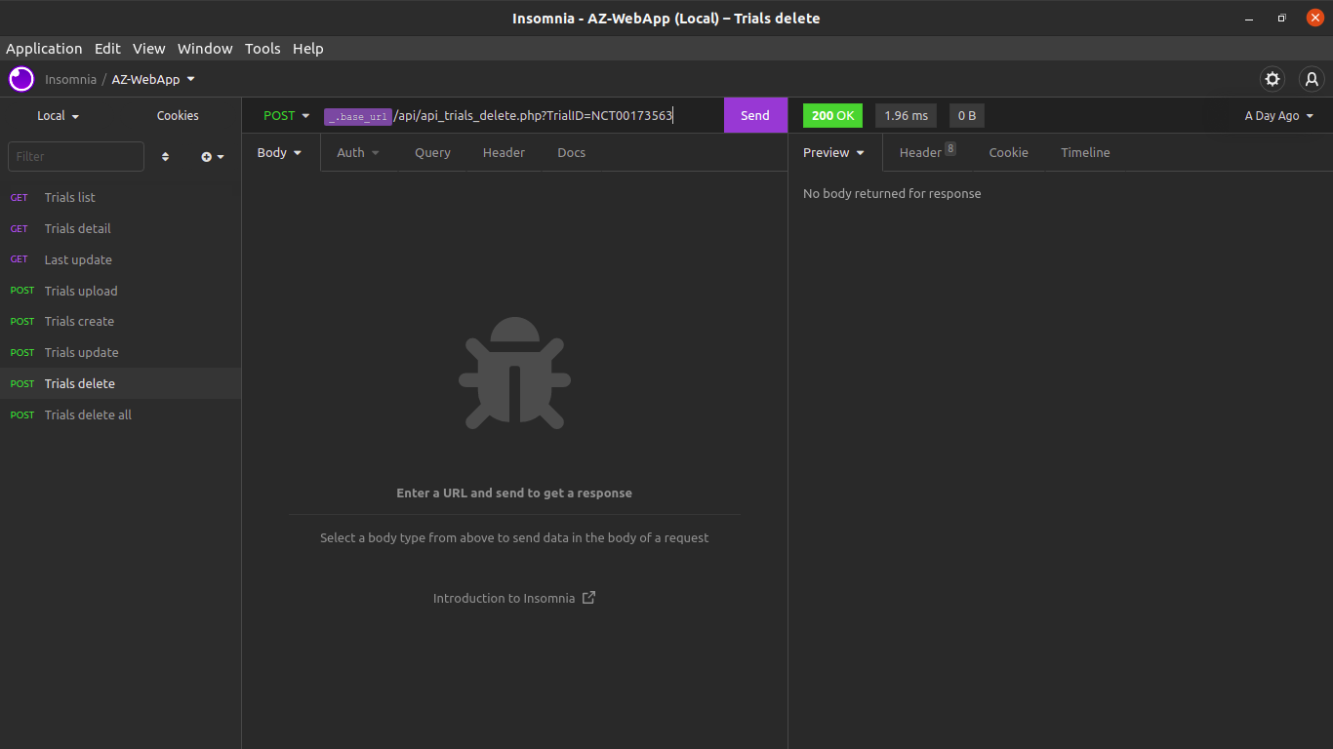

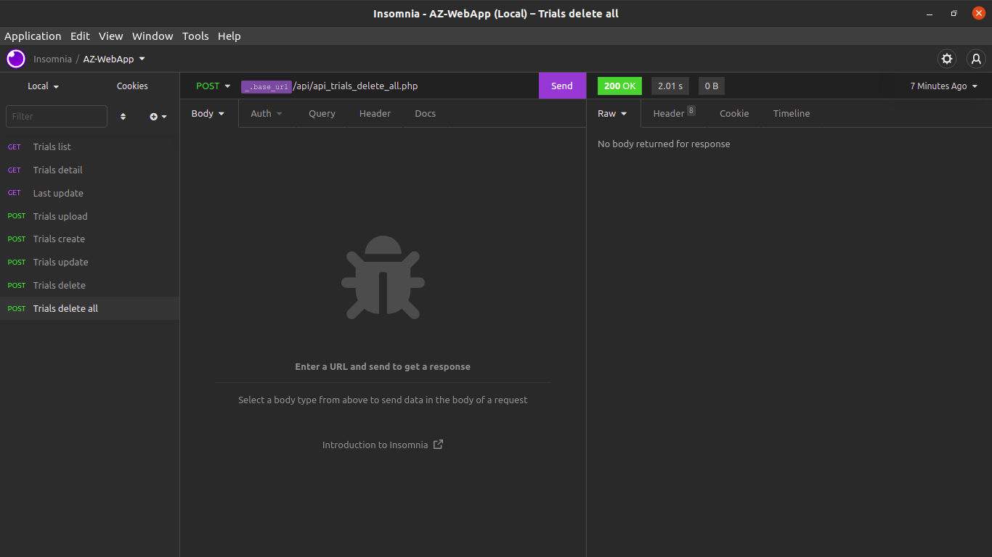
Trials delete all
/api/api_trials_delete_all.php

