Dynamic Pricing for Dedicated Inference

Executive Summary
We propose dynamic GPU-hour pricing for On Demand Dedicated Inference. Today, a customer pays the same rate whether 10% or 95% of our GPU fleet is allocated. This means idle GPUs generate zero revenue and scarce capacity is underpriced.
The dynamic model sets GPU-hour prices using a formula: Price = Baseline price x Scarcity Multiplier. The price moves within a protected range. E.g. A floor at $4.30/hr (H200) guarantees 60% gross margin, which we will apply to each GPU offered on DI. A ceiling that prevents overpricing. The customer sees the final (dynamic) price at the current slot, on the external pricing page as well as in the console while launching the droplet. It adjusts based on how full our fleet is.
We have two model options. Option 1 (Market Rate + Scarcity) uses a competitor-derived baseline ($5.66/hr, weighted avg of dedicated deployment rates). It produces a wider dynamic range ($4.30 to $6.45) but requires a competitor rate pipeline. Option 2 (Scarcity Only) uses an internally derived baseline ($5.16/hr, Floor x 1.20). It produces a tighter range ($4.30 to $5.88) but has zero external dependencies. Both share the same floor, same multiplier formula, and same 60% margin guarantee.
For Phase 1 launch, we recommend Option 2 (scarcity only). No competitor data dependency. Ships in 3.5 weeks. The details below use Option 2 numbers. Option 1 layers in at Phase 2 when we build the competitor rate pipeline.
At Phase 1 launch:
Utilization | Price/GPU-hr | Scale Factor | vs Baseline | Margin | 8-GPU Box/hr | Box/month
0-60% (idle) | $4.30 | 0.83 | -16.7% | 60.0% | $34.40 | $25,112
70% | $4.61 | 0.90 | -10.5% | 62.8% | $36.91 | $26,947
80% | $5.00 | 0.97 | -3.0% | 65.6% | $40.02 | $29,215
90% | $5.44 | 1.06 | +5.5% | 68.4% | $43.50 | $31,753
95% | $5.68 | 1.10 | +10.1% | 69.7% | $45.42 | $33,159
99% | $5.88 | 1.14 | +14.0% | 70.8% | $47.02 | $34,323

The scale factor crosses 1.0 at ~82% utilization. Below that, customers see a discount from baseline. Above that, we capture premium. Margin never drops below 60%. Phase 1 launches with manual scale factor inputs in 3.5 weeks. Phase 2 automates the pipeline. Phase 3 adds model type, time-of-day, and commitment tier variables.

Why Dynamic Pricing
Static pricing has two problems. First, when fleet utilization is low, we have idle GPUs generating zero revenue. A lower price could fill those GPUs and generate contribution margin above the floor. Second, when utilization is high, we are selling scarce capacity at the same rate as when capacity is abundant. We leave revenue on the table in both directions.
Dynamic pricing solves both by creating a price range between a protected floor and a ceiling, with the actual price set by real-time fleet scarcity.

Pricing Model: The Formula
DI Price = Baseline x Scarcity Multiplier
Bounded by: Floor (minimum) and Ceiling (maximum)
There are four components. Here is what each one does and why.

1. Baseline (the price the multiplier acts on)
What it is: A fixed reference price used by the billing system. The customer never sees this number. They see the final price after the scale factor is applied.
Formula: Baseline = Floor x 1.20
Why 1.20x: The baseline sits 20% above the floor, creating room for the scale factor to move in both directions. At low utilization, price drops below baseline toward the floor. At high utilization, price rises above baseline toward ceiling. The 1.20 multiplier sets the crossover point at ~82% utilization, which means premium pricing only kicks in when the fleet is genuinely busy.

2. Scarcity Multiplier (the adjustment lever)
What it is: A number between 0.65 and 1.15 that adjusts the baseline up or down based on fleet utilization.
Scarcity: Scarcity = 1 - (Remaining GPUs / Total GPUs). If 80 of 100 GPUs are allocated, scarcity = 0.80.
Multiplier formula:
Multiplier = Min + (Max - Min) x Scarcity²
Multiplier = 0.65 + 0.50 x Scarcity²
Min = 0.65 (max discount when fleet is empty, 35% below baseline)
Max = 1.15 (max premium when fleet is full, 15% above baseline)
Scarcity² = the squared utilization ratio (the curve that keeps price flat until the last 20-30% fills up)
Why squared: The squared curve is intentional. Price stays relatively stable when we have plenty of capacity (0-60% utilization). The adjustment only accelerates in the last 20-30% of capacity. This prevents price volatility during normal operations and only kicks in premium pricing when inventory is genuinely scarce.
Scarcity | Multiplier | Effect on Baseline | Rationale
0 (all idle) | 0.65 | 35% below baseline | Fill empty GPUs
0.5 (half full) | 0.78 | 22% below baseline | Attract workloads
0.8 (busy) | 0.97 | 3% below baseline | Normal operations
1.0 (full) | 1.15 | 15% above baseline | Scarce capacity

3. Floor (margin protection)
What it is: The absolute minimum price. No customer ever pays less than this, regardless of how empty the fleet is.
Formula: Floor = Unit Cost / (1 - Target Margin)
We target a 60% unit margin at the floor. Unit cost is derived from the 8-chip configuration (worst case COGS) to guarantee margin protection for all chip configs. For H200: unit cost = $1.72, floor = $1.72 / 0.40 = $4.30/hr.

4. Ceiling (price cap)
What it is: The maximum price, even when demand is extreme. How it is set depends on which model option we use.

Two Model Options
The formula is the same in both options. The difference is what the scarcity multiplier is applied to, and where the ceiling comes from.
 | Option 1: Market Rate + Scarcity | Option 2: Scarcity Only
Formula | Baseline x Multiplier | Baseline x Multiplier
Baseline | $5.66  (weighted average of competitor dedicated deployment prices) | $5.16  (internal: Floor x 1.20, from unit economics)
Baseline source | External: Fireworks, Together, Baseten, CoreWeave, RunPod | Internal: unit cost, target margin, buffer
Floor | $4.30 (same in both)  (60% margin) | $4.30 (same in both)  (60% margin)
Ceiling | $6.67 (70th percentile of competitor prices + 15%) | $6.70  (Baseline x 1.30, manual cap)
Ceiling source | External: requires competitor rate pipeline | Internal: no external dependency
Price at 80% util | $5.49 (SF 1.06) | $5.00 (SF 0.97)
Price at 90% util | $5.97 (SF 1.16) | $5.44 (SF 1.06)
Price at 99% util | $6.45 (SF 1.25) | $5.88 (SF 1.14)
Dynamic range | $4.30 to $6.45 (wider) | $4.30 to $5.88 (tighter)
Crossover (SF=1.0) | ~72% utilization | ~82% utilization
External dependency | Yes: weekly/daily competitor rate updates | None: runs entirely on internal data
When to use | Phase 2+: after competitor rate pipeline is built | Phase 1: ships in 3.5 weeks, no dependencies

Why Option 1 has a wider range: The market rate baseline ($5.66) is higher than the internal baseline ($5.16) because competitor pricing is above our cost-derived baseline. The same multiplier applied to a bigger number produces bigger swings.
Why Option 2 is recommended for Phase 1: Zero external dependencies. The entire model (floor, baseline, ceiling, multiplier) runs on internal unit economics. No competitor rate scraping, no stale data risk, no pipeline to build. Ships in 3.5 weeks. Option 1 layers in at Phase 2 when we automate competitor rate collection.
Both options share the same floor ($4.30), the same multiplier formula (0.65 + 0.50 x Scarcity²), and the same 60% margin protection. The only difference is what the multiplier is applied to and where the ceiling comes from.

Price Chain

H200 (Phase 1: Scarcity Only / Option 2)
Layer | How It Is Derived | Value | Margin | Role
Unit Cost | Raw GPU-hr Price x (1 - 8-chip Margin) | $1.72/hr | 0% | Internal
Floor | Unit Cost / (1 - 60%) | $4.30/hr | 60.0% | Min price
Baseline | Floor x 1.20 | $5.16/hr | 66.7% | Billing anchor
Ceiling | Baseline x 1.30 (manual cap) | $6.70/hr | 74.3% | Max price

Note: "Raw GPU-hr Price" ($3.44 for H200) is the published selling price at ~50% margin. It is not the unit cost. Unit cost ($1.72) is derived from it.

(Unit cost details)
GPU | Raw Price | Unit Cost | Floor (60%) | Baseline | Ceiling
H100 | $2.99 | $1.59 | $3.98 | $4.78 | $6.21
H200 | $3.44 | $1.72 | $4.30 | $5.16 | $6.70
MI300x | $1.99 | $1.32 | $3.30 | $3.96 | $5.15

Customer Examples (H200, Option 2)
Util % | Scar. | Mult. | Final $ | Baseline | Delta | SF | Margin | 8-GPU/hr
0-60% | 0-0.6 | 0.65-0.83 | $4.30 | $5.16 | -16.7% | 0.83 | 60.0% | $34.40
70% | 0.70 | 0.895 | $4.61 | $5.16 | -10.5% | 0.90 | 62.8% | $36.91
80% | 0.80 | 0.970 | $5.00 | $5.16 | -3.0% | 0.97 | 65.6% | $40.02
90% | 0.90 | 1.055 | $5.44 | $5.16 | +5.5% | 1.06 | 68.4% | $43.50
95% | 0.95 | 1.101 | $5.68 | $5.16 | +10.1% | 1.10 | 69.7% | $45.42
99% | 0.99 | 1.140 | $5.88 | $5.16 | +14.0% | 1.14 | 70.8% | $47.02

Floor-bound until ~65% utilization. Below 65%, raw price falls below $4.30 and the floor catches it. Every GPU-hour sold in this zone still delivers 60% margin. The floor is doing its job: filling idle GPUs while protecting economics.
Customer invoice example: A customer running 8x H200 GPUs when the fleet is at 90% utilization. The customer sees $5.44/hr per GPU on the pricing page. Their monthly invoice: $5.44 x 8 GPUs x 730 hours = $31,753. Internally, billing computed this as baseline ($5.16) x scale factor (1.06) x 8 x 730. The 8-chip deployment delivers 68.4% unit margin at this price point.

Competitive Positioning
All prices below are dedicated inference/deployment pricing, not raw GPU rental.
Provider | H200 $/hr | Billing | Type | Our Position
Together AI | $4.99 | Per minute | Dedicated Endpoint | Comparable
CoreWeave | $4.25 | Per hour | GPU Cloud (BYO) | We bundle stack
RunPod | $4.18 | Per second | Mixed | Comparable
Fireworks AI | $6.00 | Per second | Dedicated Deploy | We are cheaper
Baseten | $10.50 | Per minute | Premium Managed | 50%+ cheaper
Ours (dynamic) | $4.30-$5.88 | Per hour | Dedicated Inference | SF 0.83-1.14

How It Connects to Billing
The customer sees the final price on the pricing page. That number moves based on fleet scarcity. Internally, the billing system stores a fixed Baseline and multiplies it by a Scale Factor attached to GPU start/stop events.
Scale Factor = Final Dynamic Price / Baseline Price
E.g scale factor = 6/3 = 2
Invoice = Baseline x Scale Factor x GPUs x Hours

Plan of Action

Phase 1: Manual Inputs (Weeks 1-4)
The pricing team manually sets the scale factor weekly based on fleet utilization data. Validate model output against actual billing. Build confidence with finance before automation. No engineering build required beyond the scale factor field on GPU events.

Phase 2: Build the System (Weeks 5-12)
Automate competitor rate collection. Real-time fleet telemetry feeds scarcity input. Pricing engine computes and applies scale factor to GPU events daily. Upgrade from Option 2 (scarcity only) to Option 1 (market rate + scarcity) for more dynamic range.

Phase 3: Add More Variables (Quarter 2+)
Model type premium (larger models command higher prices), time-of-day demand patterns, commitment length (spot vs reserved pricing tiers), customer tier and volume discounts, regional demand signals.

Key Decisions
1. Pricing granularity: 24-hour blocks recommended for launch. Fastest path to ship in 3.5 weeks.
2. Model choice at launch: Option 2 (Scarcity Only). No competitor data dependency. Scale factor range 0.83 to 1.14 based on GPU availability across all regions. Manually updated in 24 hour timeframe.
3. Floor margin: 60% unit margin.
4. Baseline derivation: Floor x 1.20. Sets the crossover at ~82% utilization.

FAQ
- Is this a one way door decision?
- What should customers do when the price goes down?

Mockup

Appendix A: Decision Tree
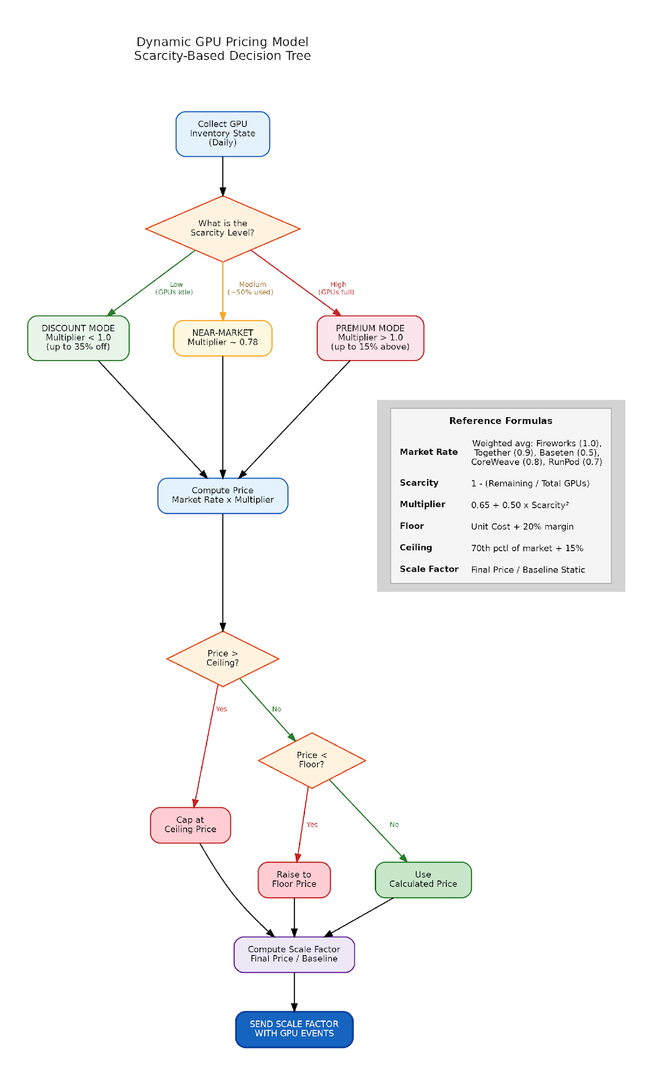

Appendix B: Example Scenarios
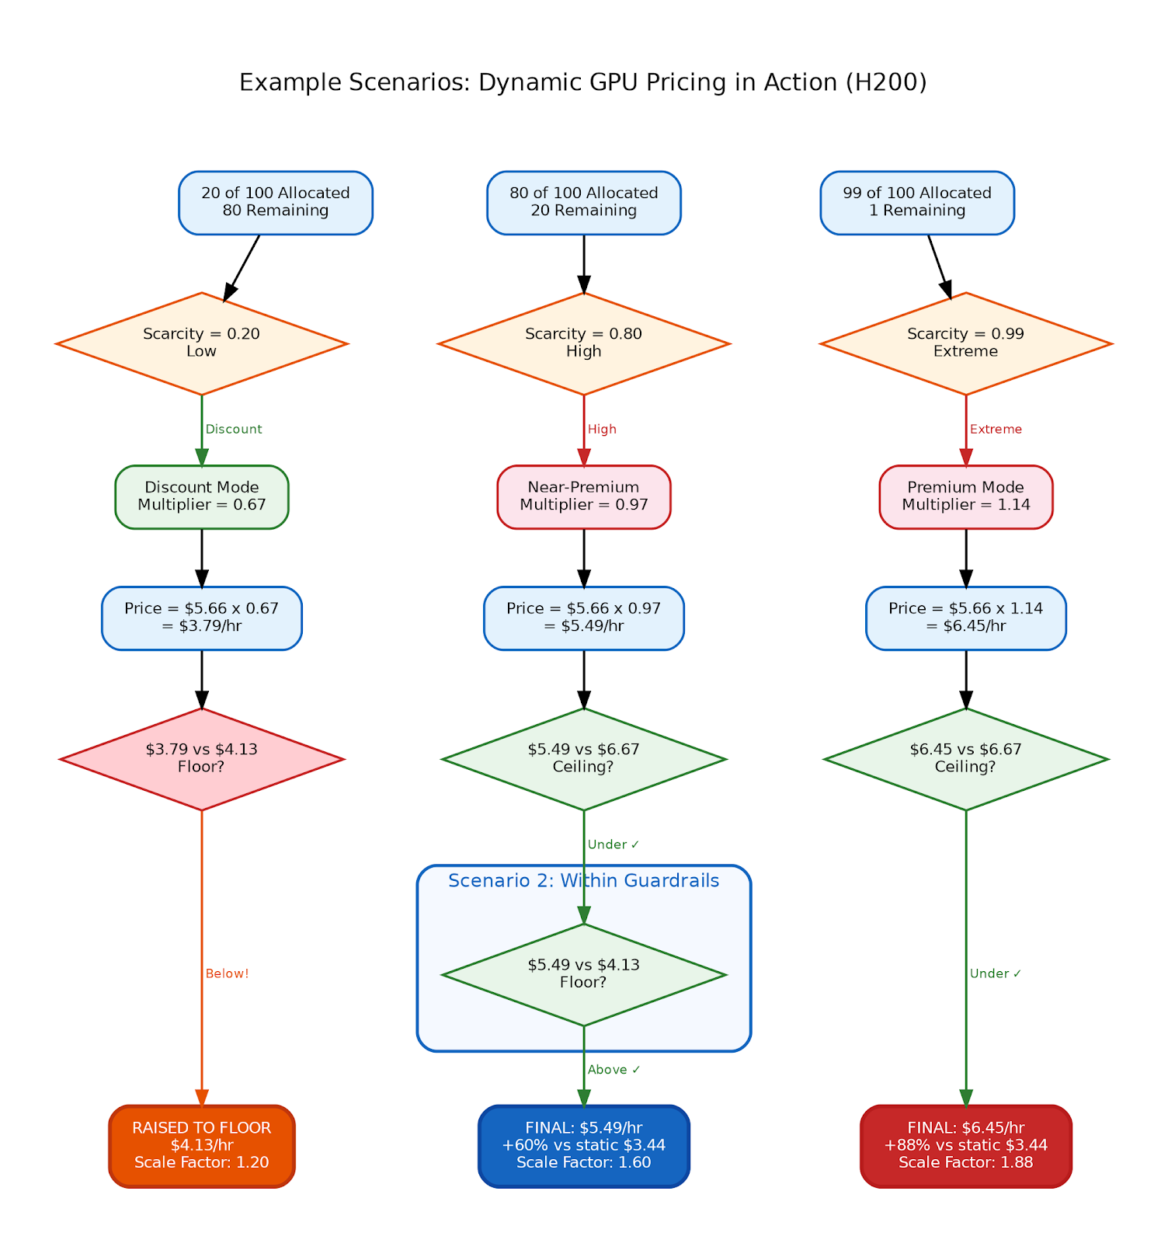

Appendix C: Scale Factor Integration Flow
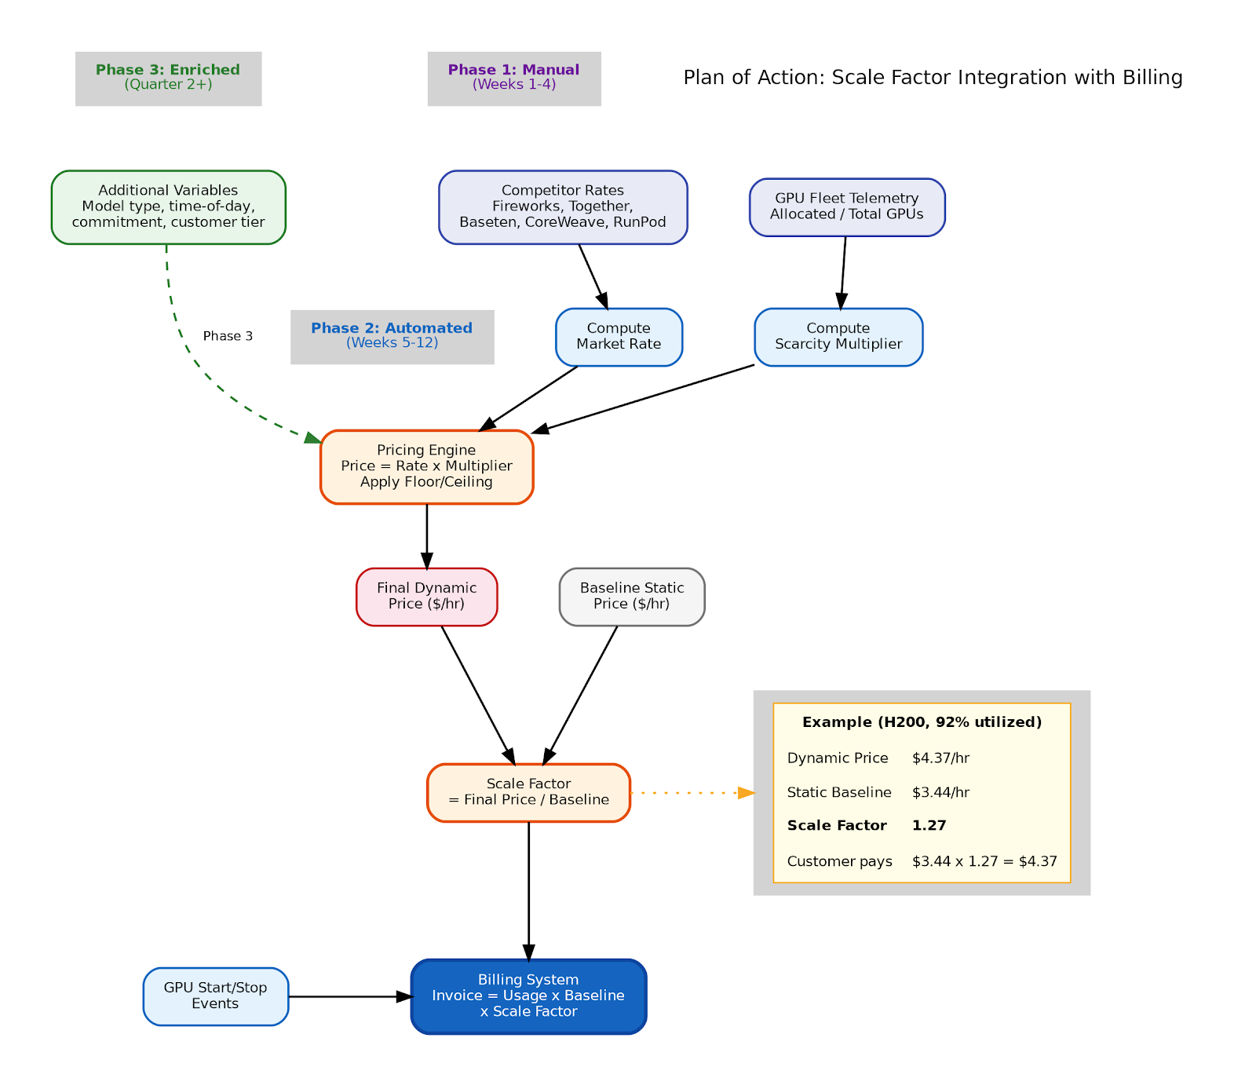

Appendix D: Pricing Model Eval

