- INTRODUCTION
1.1 Existing System
The traditional Security Operations Center (SOC) framework has relied heavily on Rule-Based detection systems for over two decades. Known as Legacy SIEM (Security Information and Event Management), these systems function by matching incoming logs against pre-defined signatures or static thresholds.
- Signature-Based Limitations: Legacy systems can only detect threats that they have been explicitly programmed to find. If a new, "Zero-Day" attack occurs, the system remains blind until a manual update is provided.
- Extreme Alert Fatigue: A typical enterprise SOC receives between 5,000 to 10,000 alerts per day. Analysts are overwhelmed by "Noise," leading to significant burnout and the high probability of missing a "Critical" incident hidden among thousands of "Low" priority alerts.
- Static Severity Scoring: In existing systems, an alert is assigned a severity level based on a generic global standard. For example, a "Suspicious Login" might be marked as High. However, if that login happens on a guest machine with no access to sensitive data, the risk is actually Low. Legacy systems cannot make this distinction.
- Manual Investigative Overhead: Once an alert is triggered, an analyst must manually cross-reference IP addresses, look up CVE databases, check MITRE frameworks, and search for remediation steps. This manual process takes minutes, while modern attacks execute in milliseconds.
1.2 Need for the new System
As cyber threats evolve into autonomous, AI-driven malware and sophisticated ransomware worms (like WannaCry and LockBit), the defensive layer must also evolve. There is a desperate need for a system that doesn't just "detect" but also "reasons."
- The Reasoning Layer: We need a system that acts as a "Digital SOC Analyst." It should look at an alert and ask: "Is this asset critical? Is it protected by a firewall? Is there a CVE associated with this software?"
- Context-Aware Analysis: The modern SOC needs a system that understands the organization's internal architecture. If a server is air-gapped, the risk of an internet-based exploit reaching it is near zero. The new system must factor this in to reduce false positives.
- Knowledge Integration: Instead of an analyst searching for "CVE-2024-XXXX" manually, the system should automatically fetch the vulnerability details, its CVSS score, and its remediation steps using LLM intelligence.
- Automation of Triage: The primary need is to automate the "Triage" phase—the process of sorting alerts by priority—so that humans only focus on the top 1% of genuine threats.
1.3 Objective of the new System
The primary objective of BlueGuard is to revolutionize the entry-level SOC by providing a high-intelligence monitoring layer at a fraction of the cost of traditional managed security services.
Technical Objectives:
- Seamless SIEM Integration: To build a robust pipeline that ingests data from Wazuh Open-Source SIEM and enriches it in real-time.
- AI-Risk Scoring: To implement a context-aware risk assessment engine that adjusts the severity of alerts based on internal security controls (Firewalls, Network Zones, Privileges).
- Database Persistence: To store all enriched security incidents in a NoSQL database (MongoDB) for long-term forensics and audit logging.
Operational Objectives :
Reduction in Response Time (MTTR): To decrease the Mean Time To Respond from minutes to seconds by providing instant AI-driven remediation steps.
Simplification of UX: To provide a visual dashboard that translates complex technical logs into human-understandable "Incident Stories."
1.4 Problem Definition
In the current digital landscape, cybersecurity is no longer a luxury but a fundamental necessity for organizational survival. However, the methods used to monitor and secure digital assets have not kept pace with the sophistication of modern adversaries. The core problem that leads to the development of BlueGuard can be broken down into four critical dimensions:
1.4.1 The Signal-to-Noise Ratio (The "Data Deluge" Problem)
Modern enterprises generate millions of logs every single hour—from firewalls, servers, databases, and endpoints. Tools like Wazuh and other SIEMs are excellent at collecting this data. However, the problem arises when these tools generate "Alerts."
- The Problem: Out of 10,000 alerts generated daily, typically 98% are false positives or "Informational" noise (e.g., a legitimate admin logging in at an unusual time).
- The Consequence: Human analysts suffer from "Alert Fatigue." When the human brain is bombarded with thousands of non-critical notifications, it starts ignoring them. This leads to a catastrophic "Missed Detection" where a genuine ransomware attack is ignored because it looked like another routine log entry.
1.4.2 Context-Blind Risk Assessment (The "Generic Scoring" Problem)
Currently, a security vulnerability (CVE) is assigned a CVSS score (e.g., 9.8 Critical) globally.
- The Problem: Traditional security systems apply this 9.8 score to every server in the organization, regardless of where that server sits.
- The Reality: If a server is behind three layers of firewalls, has no internet access, and contains no sensitive data, a vulnerability on that server is effectively a Low risk for the organization. Conversely, a 5.0 Medium vulnerability on a public-facing web server is a Critical risk.
- The Gap: Current systems are "Context-Blind." They do not understand the organizational layout, network zones, or existing security controls (like Next Gen Firewalls or internal segmentation).
1.4.3 The Cybersecurity Talent Gap (The "Expertise" Problem)
Analyzing a security log requires a high level of expertise. An analyst must understand MITRE ATT&CK tactics, know how to interpret raw hex data, and be familiar with thousands of CVE identifiers.
- The Problem: Experienced SOC analysts are rare and extremely expensive to hire. Small and medium enterprises (SMEs) cannot afford a 24/7 team of senior experts.
- The Consequence: Many organizations buy expensive SIEM tools like Wazuh but fail to derive value from them because they don't have the "Intelligence" to interpret what the logs are saying.
1.4.4 Delayed Response and High MTTR (The "Time" Problem)
When a breach occurs, every second counts. The "Mean Time to Respond" (MTTR) is a critical metric for any SOC.
- The Problem: In a manual system, when an alert triggers, the analyst must:
- Read the log.
- Search Google/databases for the attack type.
- Identify the affected software.
- Find the remediation steps.
- Execute the fix.
- The Bottleneck: This entire manual chain takes anywhere from 15 to 45 minutes per alert. In the age of automated worm-like malware (Ransomware), a system can be fully encrypted in less than 5 minutes. The human-manual response is simply too slow to stop modern threats.

1.4.5 Lack of Actionable Remediation (The "What Now?" Problem)
Most monitoring tools tell you what happened but they don't tell you how to fix it.
- The Problem: A log might say "Buffer Overflow Detected." For a junior analyst, this doesn't tell them what commands to run or what services to stop.
- The Gap: There is a lack of "Actionable Intelligence" at the point of detection. Without immediate, step-by-step instructions, the detection becomes a liability rather than an asset.
1.5 Core Components
- Wazuh SIEM Layer: Responsible for log collection from endpoints (Windows, Linux, Cloud). It provides the "Raw Signal."
- Analysis Middleware (Flask & analyzer.py): The gateway that receives alerts via webhooks and passes them to the AI Engine.
- Generative AI Engine (Gen LLM): The core brain that analyzes the alert, identifies MITRE techniques, fetches CVE data, and calculates "Org Risk."
- Data Storage (MongoDB): The persistent memory of the system, storing every analyzed incident for future reporting.
- Intelligence Dashboard (Glassmorphism UI): The interface for SOC analysts to view the live threat stream, filtered by severity and attack type.
1.6 Project Profile
Feature | Detail
System Name | BlueGuard
Operating System | Platform Agnostic (Compatible with Linux/Windows/Docker)
Backend Language | Python 3.10+(Flask Framework)
AI intergration | Gen LLM
Log Source | Wazuh Manager v4.14.5
Database | Mongo DB
Frontend Styling | Tailwind CSS with Dark glassmorphism design
Alerting Protocol | SMTP Secure Email Notification

The BlueGuard project is structured into five core technical layers. Each layer has a specific responsibility and uses specialized technologies to ensure the platform's overall stability and intelligence.
1.6.1 Data Ingestion Layer (Wazuh SIEM)
- Role: This layer acts as the "Senses" of the system. It continuously monitors endpoints for any suspicious activity like unauthorized logins, file integrity changes, or malware execution.
- Technical Detail: It uses the Wazuh manager's internal engine to convert raw system logs into structured JSON alerts.
1.6.2 Middleware & Routing Layer (Flask & Webhooks)
- Role: This is the "Central Nervous System." It provides a RESTful API endpoint that stays "Alive" 24/7 to catch incoming security signals.
- Technical Detail: It uses the Flask framework to handle asynchronous HTTP POST requests. It performs the first level of "Sanitization" to ensure that the incoming data is not malicious.
1.6.3 Cognitive Analysis Layer (Gen LLM Engine)
- Role: This is the "Brain" of BlueGuard. It performs complex reasoning that traditional code cannot do.
- Technical Detail: By using Prompt Engineering, it injects the organization's specific security context (Firewalls, Isolated VLANs) into the analysis. It classifies the attack type and maps it to the MITRE ATT&CK framework automatically.

1.6.4 Persistence Layer (MongoDB)
- Role: This is the "Memory" of the platform.
- Technical Detail: Unlike traditional SQL databases, MongoDB (NoSQL) allows us to store the "Enriched Intelligence" without losing the original raw log. This is crucial for forensic investigations where the original evidence must be preserved alongside the AI's opinion.
1.6.5 Visualization & User Experience Layer (Tailwind CSS)
- Role: This is the "Face" of the system.
- Technical Detail: It uses a Glassmorphism design system to reduce the visual stress on SOC analysts. By using color-coded severity badges and paginated streams, it ensures that the analyst is never overwhelmed by data.
1.7 Assumptions and Constraints :
1.7.1 Project Assumptions
Assumptions are factors that we consider to be true for the project to succeed.
- Infrastructure Readiness: It is assumed that the target organization has already deployed Wazuh agents on their critical servers (Windows/Linux).
- Network Visibility: We assume the Wazuh Manager has the necessary permissions to transmit alerts to the BlueGuard middleware via port 5000.
- Data Quality: It is assumed that the logs generated by endpoints contain sufficient descriptive data for the AI to perform a meaningful analysis.
- Static Security Policy: We assume that the organizational security controls (e.g., Firewall rules) provided to the AI are accurate and up-to-date.

1.7.2 Technical & Operational Constraints
Constraints are the limitations within which the BlueGuard platform must operate.
- API Latency & Throughput: The system relies on third-party Gen AI APIs. This introduces a mandatory network latency of 2-5 seconds per alert. The system cannot process alerts in "True Real-Time" (sub-millisecond) due to this external dependency.
- Outbound Connectivity Requirement: The AI engine requires an active internet connection to communicate with the LLM models. This makes the platform unsuitable for "Air-Gapped" or "Dark Site" facilities without a local LLM deployment.
- Token Usage Economics: Every analysis consumes "Tokens." In an environment with extremely high log volume (e.g., millions of alerts per hour), the operational cost of the API could become a significant constraint.
- Model Hallucination Risk: While AI is highly intelligent, there is a non-zero risk of "Hallucination" where the AI might misinterpret an obscure log. To mitigate this, the system includes a "Safety Override" logic.
1.7.3 Environmental Constraints
- Platform Dependency: The system requires a host with Python 3.10+ and a local MongoDB instance. Environments without these runtimes will require Docker containerization.
- Hardware Resources: For optimal performance, the server must have at least 8GB of RAM to handle concurrent JSON parsing and database writes efficiently.

1.8 Advantages and Limitations :
The BlueGuard AI SOC Platform offers a transformative approach to cybersecurity monitoring. By integrating Generative AI with traditional SIEM data, it provides several layers of benefits that traditional systems cannot match.
1.8.1 Technical Advantages
- AI-Driven Contextual Intelligence: Unlike static systems, BlueGuard uses LLMs to understand the "Intent" behind a log, not just the pattern. This allows it to detect "Low and Slow" attacks that often bypass signature-based tools.
- Automated MITRE ATT&CK Mapping: Every incident is automatically mapped to the global MITRE framework (Tactics & Techniques). This helps security teams understand the exact stage of the attack (e.g., Persistence, Lateral Movement, or Exfiltration).
- Real-Time Data Enrichment: Raw logs are instantly enriched with CVE data, CWE categories, and CVSS scores. This eliminates the need for manual research by SOC analysts.
- NoSQL Scalability: By using MongoDB, the system can handle large volumes of unstructured security logs without the performance bottlenecks found in traditional relational databases.
- Dynamic Risk Calculation: The "Org Risk" engine dynamically lowers the priority of threats that are already blocked by internal controls (like Firewalls), ensuring that analysts only work on real, unmitigated threats.
1.8.2 Operational Advantages
- Reduction in Alert Fatigue: By filtering out 80-90% of false positives through AI reasoning, BlueGuard prevents analyst burnout and ensures that critical alerts are never missed.
- Drastic Reduction in MTTR: The "Mean Time to Respond" is reduced because every alert comes with instant, actionable remediation steps. Analysts don't have to think "What do I do next?"; the system tells them.
- 24/7 Virtual Analyst: The AI engine works around the clock, providing the same level of analysis at 3:00 AM as it does at 3:00 PM, without human error or fatigue.
- Simplified Reporting: The dashboard converts complex technical logs into simple, human-readable summaries that can be understood even by non-technical managers.
1.8.3 Financial & Strategic Advantages
- Cost-Effective Security: BlueGuard is built on top of Open-Source Wazuh, saving organizations thousands of dollars in annual licensing fees for commercial SIEMs like Splunk or QRadar.
- Closing the Skill Gap: It allows junior SOC analysts to perform at the level of senior experts by providing them with AI-generated technical insights and guidance.
- High ROI on Existing Infrastructure: It enhances the value of existing security investments (like Wazuh agents and Firewalls) by making the data they generate actually useful and actionable.
1.8.4 User-Centric Advantages (UX/UI)
- Glassmorphism Dashboard: A modern, premium interface that provides high-level visibility (Charts and Graphs) as well as deep-dive forensic logs in a single unified view.
- Interactive Intelligence: Clickable CVE/CWE links allow analysts to instantly jump to the official NVD or MITRE documentation for detailed research.
- Pagination and Search: Efficient data management allows for smooth navigation through thousands of historical alerts without UI lag.
1.8.5 Limitations of the Proposed System
- API Dependency: The core intelligence layer depends onLLM APIs If the API service is down, the system falls back to a basic rule-based analysis.
- Internet Requirement: For the AI Engine to function, the server requires an outbound internet connection, which might be a constraint in highly restricted "Dark Sites."
- Token Cost: While the platform is open-source, the usage of AI APIs involves a small cost-per-alert (tokens), which must be managed for extremely high-volume environments.

- REQUIREMENT DETERMINATION & ANALYSIS
2.1 Requirement Determination
Requirement determination is a critical phase of the SDLC where we define exactly what the system must achieve to solve the identified problems. For BlueGuard, we have categorized requirements into functional, non-functional, and environmental specifications.

2.1.1 Functional Requirements (FRs)
Functional requirements define the core behavior and features of the BlueGuard platform.
- Real-Time Data Ingestion Pipeline: The system must provide a highly available /webhook endpoint. This endpoint must be capable of receiving high-frequency POST requests from the Wazuh Manager. It should include error-handling logic to ensure that if a payload is malformed, the system does not crash and continues to process subsequent alerts.
- Autonomous Threat Analysis (AI Engine): The system must automatically extract key metadata from raw logs (e.g., Rule ID, Description, Agent Name). This data must be transformed into a structured prompt and sent to a Generative AI model. The engine must ensure that the AI returns data in a strict JSON format for consistent UI rendering.
- Context-Aware Risk Scoring: A core requirement is the integration of "Organizational Security Controls." The system must inject predefined infrastructure knowledge (e.g., "All servers are internal," "Palo Alto Firewall is active") into the analysis loop. The AI must use this context to calculate an "Adjusted Org Risk" score that is different from the global "Base Severity."
- Persistent Storage and Forensics: Every analyzed alert, along with its AI-generated insights (CVEs, MITRE mapping, Remediation), must be stored in a NoSQL MongoDB database. The system must support complex queries to allow the dashboard to fetch alerts based on severity, agent name, or time range.
- Dynamic Visual Dashboard: The frontend must provide a real-time "Threat Stream." It must use dynamic CSS classes to color-code alerts based on their risk level (Red for Critical, Orange for High, Yellow for Medium, Green for Low). It must also visually represent "Risk Mitigation" using clear indicators (e.g., a "Mitigated" badge with a downward arrow).
- Server-Side Pagination: To maintain performance as the database grows to thousands of records, the system must implement server-side pagination. Instead of loading all data at once, the backend must fetch and display only 10-20 records per page, providing a smooth navigation experience for the analyst.
- Data Export and Compliance: For audit and reporting purposes, the system must include a "CSV Export" feature. This allows the SOC manager to download the entire incident history in a structured format that can be opened in Excel or PowerBI.
- Automated Notification System: The system must monitor incoming alerts and trigger an SMTP email notification whenever a "Critical" or "High" risk incident is detected, ensuring that security teams are alerted even if they are not monitoring the dashboard.
2.1.2 Non-Functional Requirements (NFRs)
Non-functional requirements define the quality attributes of the system.
- Performance and Latency: The system should aim for an end-to-end analysis time (from log ingestion to dashboard appearance) of less than 5 seconds. This includes the time taken for the external LLM API call.
- Scalability: The architecture must be scalable. By using MongoDB (NoSQL) and a lightweight Flask backend, the system should be able to handle hundreds of alerts per hour without significant degradation in response time.
- Usability (User Experience): The dashboard must follow "Clean Design" principles. A SOC analyst should be able to understand the nature of a threat and its remediation steps within 10 seconds of glancing at the screen.
- Security and Privacy: The system must ensure that the connection between Wazuh and the Webhook is secure. Furthermore, API keys for LLM must be stored in protected environment variables (.env files) and never hardcoded in the source code.
- Availability: The system should be designed for high availability. If the LLM is temporarily unreachable, the system must have a "Fallback Logic" to provide a basic rule-based analysis so that no alert goes unrecorded.
2.1.3 Hardware & Software Requirements
Hardware Requirements:
- Processor: Quad-core CPU (2.5 GHz or higher) to handle concurrent webhook requests.
- RAM: Minimum 8 GB (16 GB recommended for running Wazuh and MongoDB on the same machine).
- Storage: 50 GB of SSD space for logs and database storage.
- Network: Stable outbound internet connection for AI API calls.
Software Requirements:
- Operating System: Linux (Ubuntu 22.04 recommended) or Windows 10/11 with WSL2.
- Backend Environment: Python 3.10 or higher.
- Database: MongoDB Community Server v6.0+.
- Security Framework: Wazuh Manager and Agents v4.x.
- Development Tools: VS Code, Git, and Postman (for API testing).
2.2 Targeted Users
User Type | Primary Interest | Key Feature Used
L1 Analyst | Quick triage & remediation | AI Analysis & Color-coded Alerts
L2 Analyst | Deep forensics & TTPs | MITRE Mapping & CVE Links
SOC Manager | Team efficiency & Trends | Dashboard Charts & Risk Overlays
Auditor | Historical proof & Compliance | CSV Export & Data Persistence
CISO | Strategic Risk Reduction | Org Risk Severity Assessment
- SYSTEM DESIGN
3.1 Use Case Diagram
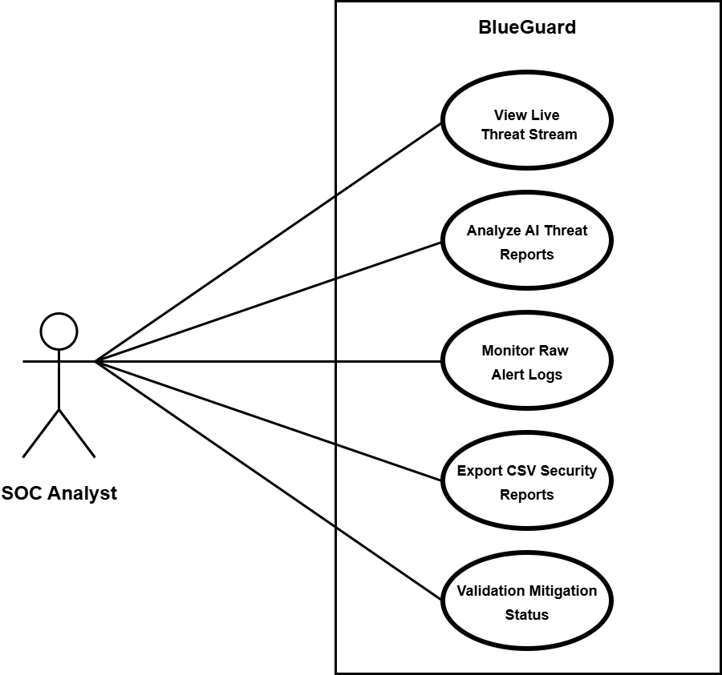

3.2 Class Diagram
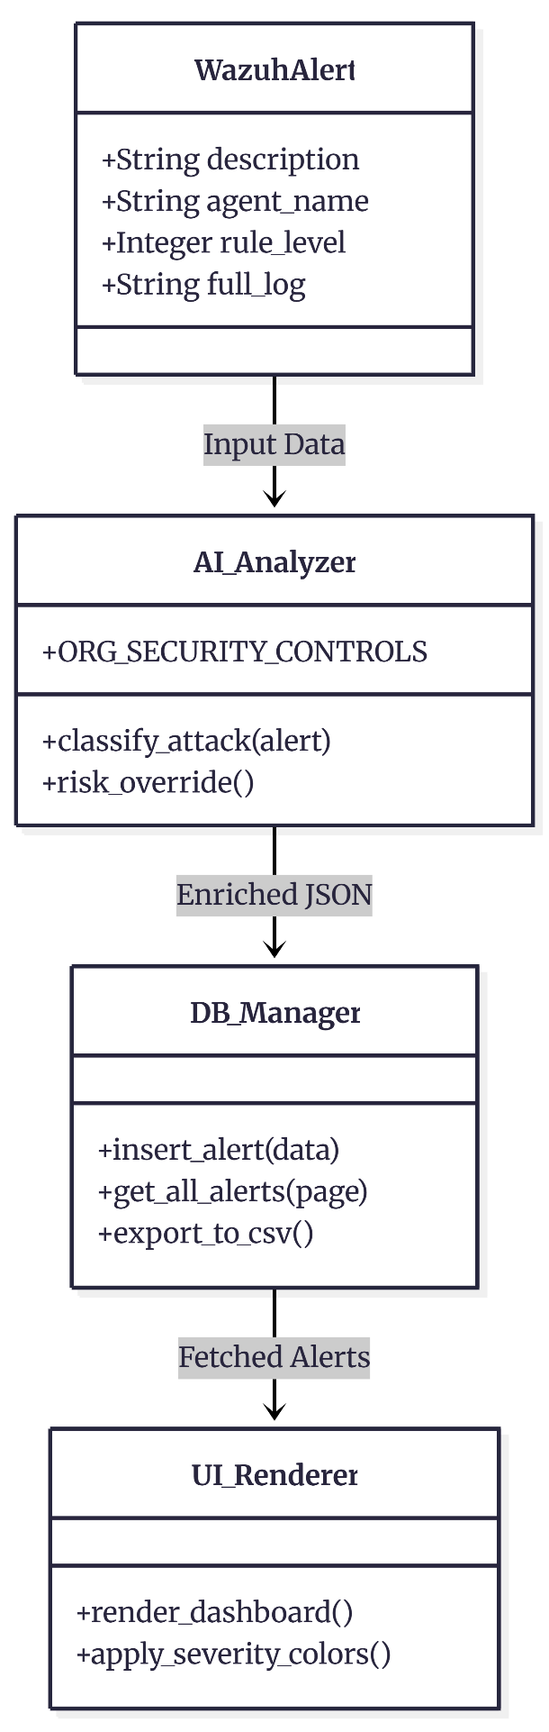
3.3 Interaction Diagram
3.3.1 Analyst Flow
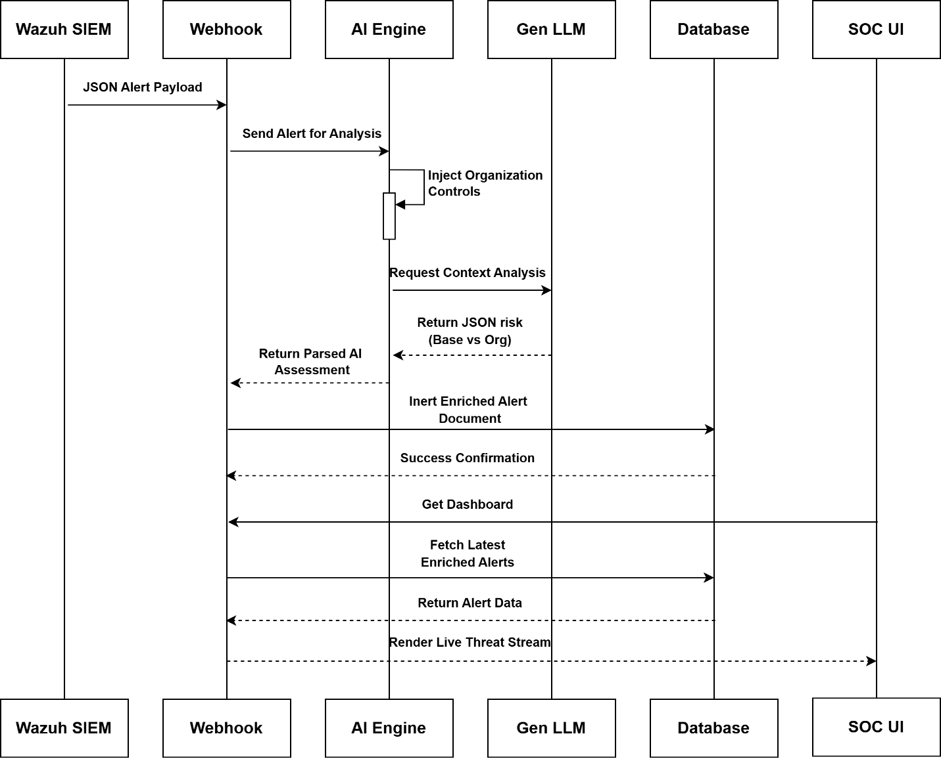

3.3.2 Threat intelligence flow
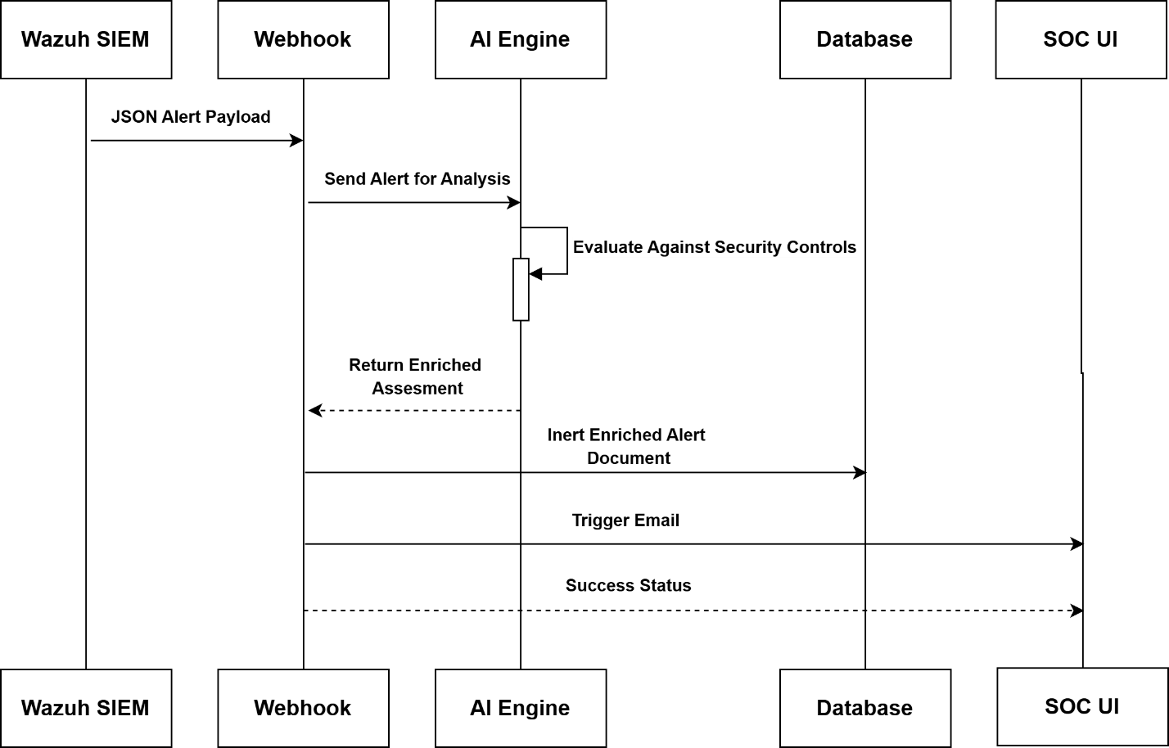

3.4 Activity Diagram
3.4.1 Application Lifecycle
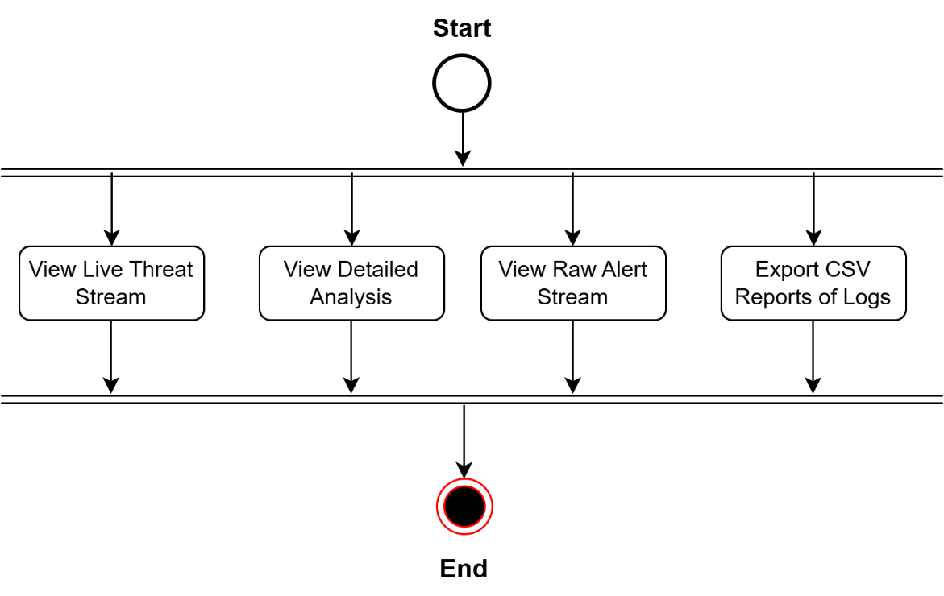

3.4.2 AI Decision Making Logic

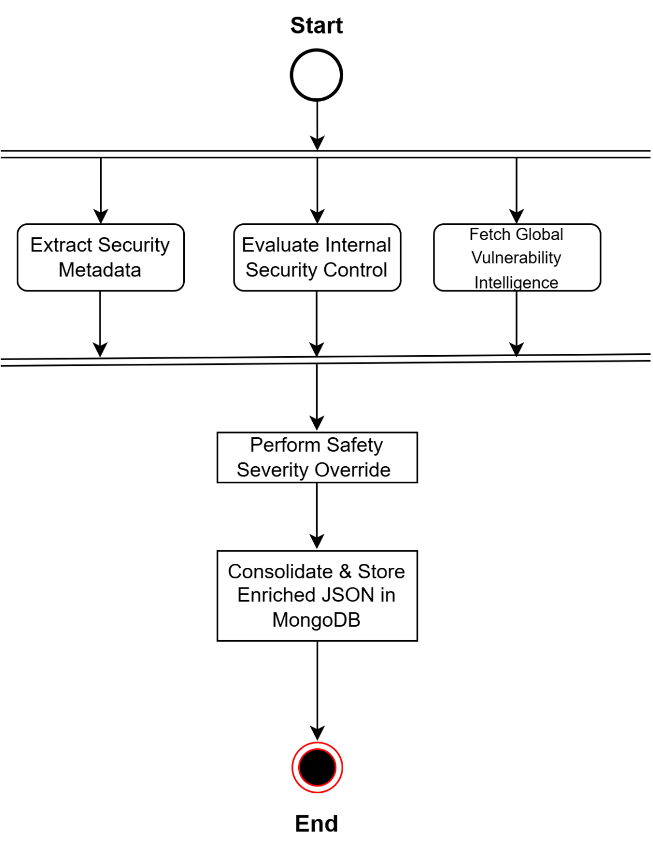

3.5 Data Dictionary
3.5.1 Raw Ingestion Schema
Field Name | Data Type | Description
timestamp | DateTime | The exact time when the security event was generated.
agent.name | String | Hostname of the source machine where the alert originated.
agent.ip | String | The internal IP address of the source server.
rule.id | Integer | The unique ID assigned to the specific security rule in Wazuh.
rule.level | Integer | The internal severity level (0-15) defined by the SIEM.
rule.description | String | The generic human-readable description of the log event.
full_log | Text | The complete raw log message for deep technical investigation.

3.5.2 AI Intelligence Schema
Field Name | Data Type | Description
attack_type | String | AI-classified category of the security incident.
mitre_tactic | String | Corresponding MITRE ATT&CK tactic (e.g., Persistence).
mitre_technique | String | Specific adversary technique and its unique ID.
base_severity | Enum | The global generic risk level of the threat.
org_risk_severity | Enum | The adjusted risk level considering internal controls.
analysis | Text | A concise 1-2 sentence AI summary of the threat.
cve_cwe | String | Hyperlinked identifiers for specific vulnerabilities.
cvss_score | Float | Technical impact score of the associated vulnerability.
remediation | Text | Step-by-step instructions generated by AI to fix the issue.

- DEVELOPMENT
4.1 Coding Standards
Software development standards are not merely about "clean code"; they ensure that the system is scalable, secure, and maintainable. For the development of the BlueGuard project, the following industry-best practices were strictly followed:
4.1.1 Backend Development Standards (Python & Flask)
- PEP-8 Compliance: The entire Python backend, including app.py and analyzer.py, strictly adheres to PEP-8 guidelines. This ensures code readability through consistent indentation, proper use of whitespace, and organized imports (standard libraries first, followed by third-party packages).
- Modular Architecture: We utilized the "Separation of Concerns" principle. The core logic is split into modules where app.py manages routing and database queries, while analyzer.py is exclusively dedicated to AI reasoning and risk assessment logic. This modularity makes the system easy to debug and upgrade.
- Structured JSON Processing: Since both the Wazuh SIEM and the AI Analysis Engine communicate via JSON, we implemented strict data validation using Python’s json library. This ensures data integrity as alerts move through the ingestion pipeline.
- Robust Error Handling: Every external communication point, especially the calls to the Generative AI, is wrapped in comprehensive try-except blocks. This ensures that an API failure or network timeout does not crash the entire application, allowing the system to gracefully fall back to local logic.
4.1.2 Frontend & UI/UX Standards (Tailwind CSS & Jinja2)
- Glassmorphism Design Language: For the user interface, we adopted a modern "Dark Glassmorphism" aesthetic. This involves the use of backdrop-blur and semi-transparent containers with subtle borders to create a premium, high-tech dashboard feel suitable for a SOC platform.
- Responsive and Utility-First Design: Using Tailwind CSS ensured that the dashboard is fully responsive. The UI layout automatically adjusts for different screen sizes, including Mobile, Tablet, and Desktop, ensuring the SOC analyst can monitor threats from any device.
- Jinja2 Template Inheritance: To maintain code "DRY" (Don't Repeat Yourself), we utilized Jinja2 template inheritance. A base layout file handles the global CSS/JS imports and navigation, while specific pages like index, logs, and alerts extend this layout to reduce code redundancy.
- Standardized Color Tokens: A consistent color palette was implemented for risk visualization. Red is reserved for "Critical," Orange for "High," Yellow for "Medium," and Green for "Low," allowing for instant cognitive recognition of threat levels without reading the text.
4.1.3 Database & Data Persistence Standards (MongoDB)
- Schema-less Flexibility: Because security logs vary significantly between operating systems (e.g., Windows Event Logs vs. Linux Syslogs), we chose MongoDB. This NoSQL approach allowed us to store diverse log structures within a single "Alerts" collection without rigid schema constraints.
- Performance Optimization: We implemented server-side pagination and data indexing. This ensures that even when the database contains thousands of incidents, the dashboard remains fast and responsive during data retrieval and filtering.
4.1.4 Security & Compliance Standards
- Secret Management: We strictly avoided hardcoding sensitive data. All API keys, database credentials, and SMTP configurations are stored in an external .env file, which is kept out of version control. This is a primary industry standard for preventing accidental credential leaks.
- Input Sanitization & Protection: All user inputs (such as search queries and filter parameters) are sanitized to prevent Cross-Site Scripting (XSS) and NoSQL injection attacks, ensuring the integrity of the administrative dashboard.
- Data Masking: For privacy compliance, the system is designed to handle sensitive data by providing analysts with the "Intelligence" needed to fix the issue while masking raw parameters that may contain personally identifiable information (PII).
4.1.5 Documentation & Maintainability
- Docstrings and Inline Documentation: Every critical function (e.g., classify_attack()) contains descriptive docstrings explaining the expected input, output, and logic. Inline comments are used to explain complex logic, such as the prompt injection for the AI model.
- Semantic Versioning: The project follows a systematic versioning approach, ensuring that new features (like upgraded AI models or additional SIEM integrations) can be merged without breaking existing core functionalities.

4.2 Screenshots
4.2.1 Dashboard with charts , graph of attacks and countings
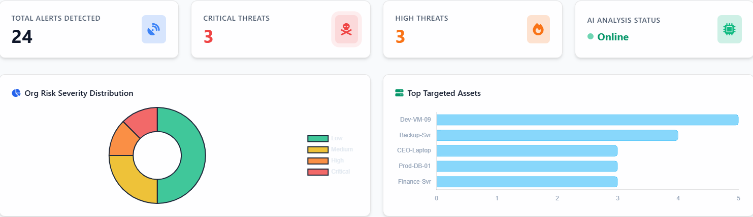
Functional Description: The main dashboard serves as the central mission-control for the SOC analyst. It utilizes a "Dark Glassmorphism" UI to prioritize visual clarity. At the top, we have Analytical Widgets (Bar Charts and Pie Charts) that show the distribution of threats by severity and type. This allows a manager to instantly see if there is an ongoing "Critical" outbreak. Below the charts is the Real-Time Threat Stream, which shows the latest 10 incidents. Each row is color-coded using dynamic CSS to highlight high-priority risks instantly.

4.2.2 Dashboard with Live Threat Stream
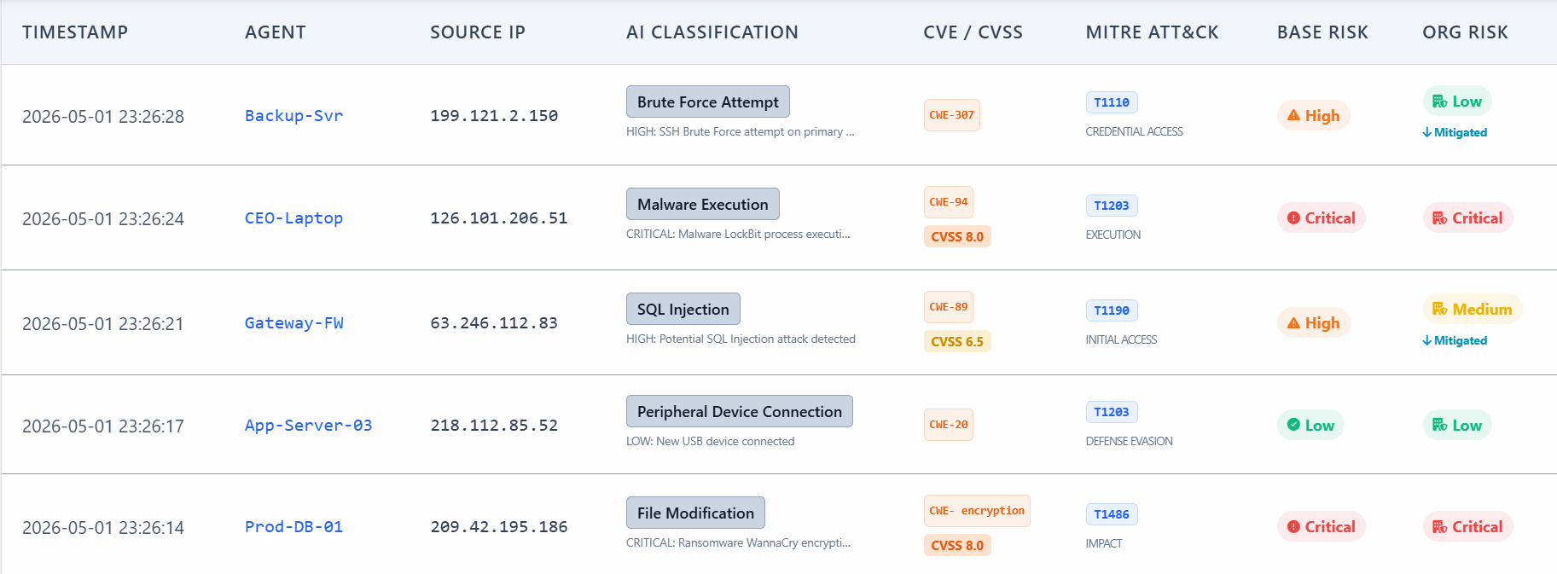
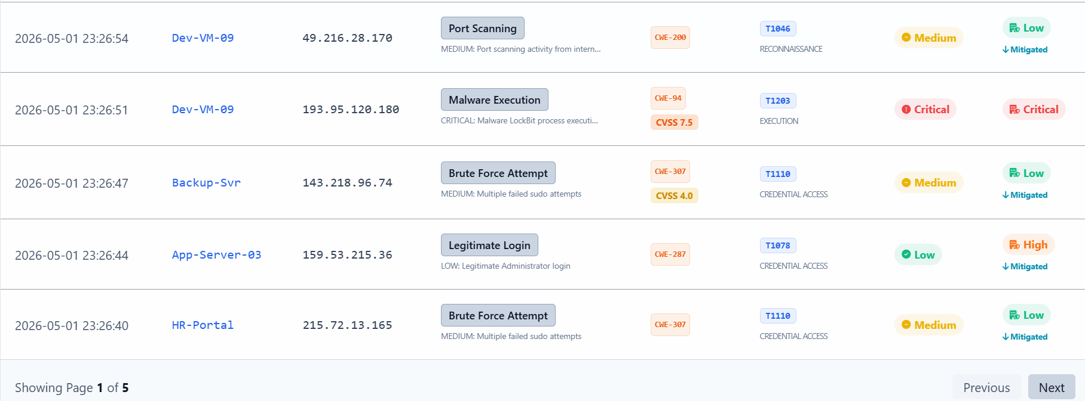
Functional Description: This screen represents the tactical monitoring layer of BlueGuard. It demonstrates the Server-Side Pagination feature, which ensures that the UI remains fast even when dealing with thousands of incidents. Analysts can navigate through pages of historical alerts. Notice the "Org Risk" column, which shows the "Mitigated" badge—this is where the AI has analyzed the threat against internal security controls and reduced the priority, preventing alert fatigue for the analyst.

4.2.3 Detailed AI Analysis Page
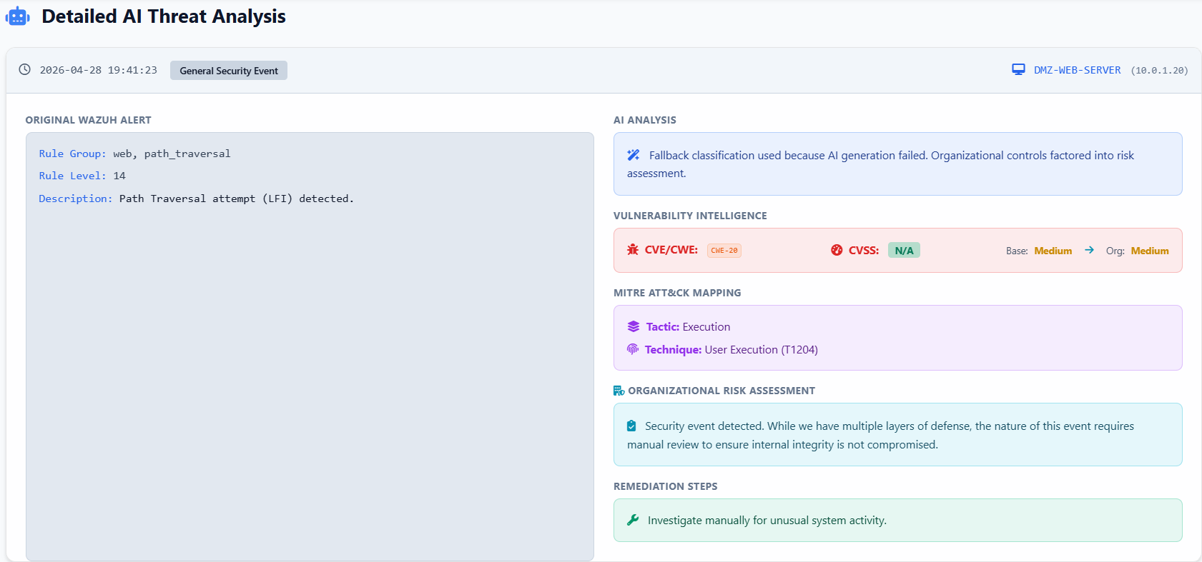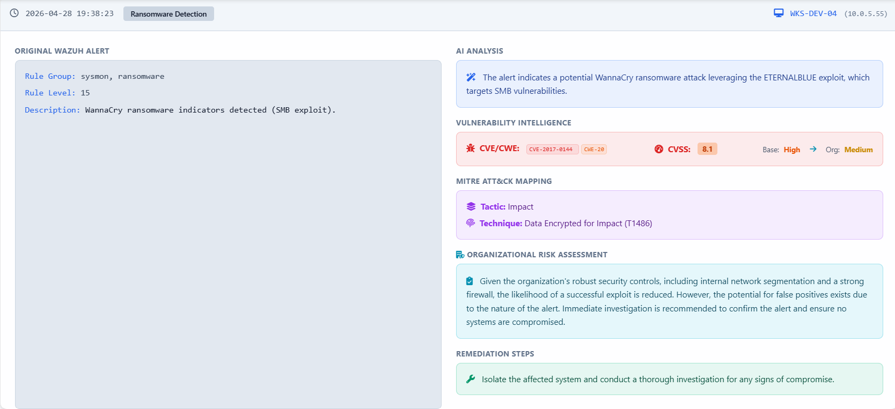
Functional Description: When an analyst clicks on an alert, this detailed view appears. This is the "Brain" of the platform. It provides:
AI Analysis: A human-readable summary of the threat.
- Vulnerability Links: Clickable CVE/CWE identifiers that link directly to the National Vulnerability Database (NVD).
- MITRE ATT&CK Context: The exact Tactic and Technique used by the adversary.
- Remediation Roadmap: A step-by-step guide generated by AI specifically for this incident, allowing even a junior analyst to perform expert-level incident response.
4.2.3 Raw Alert Stream
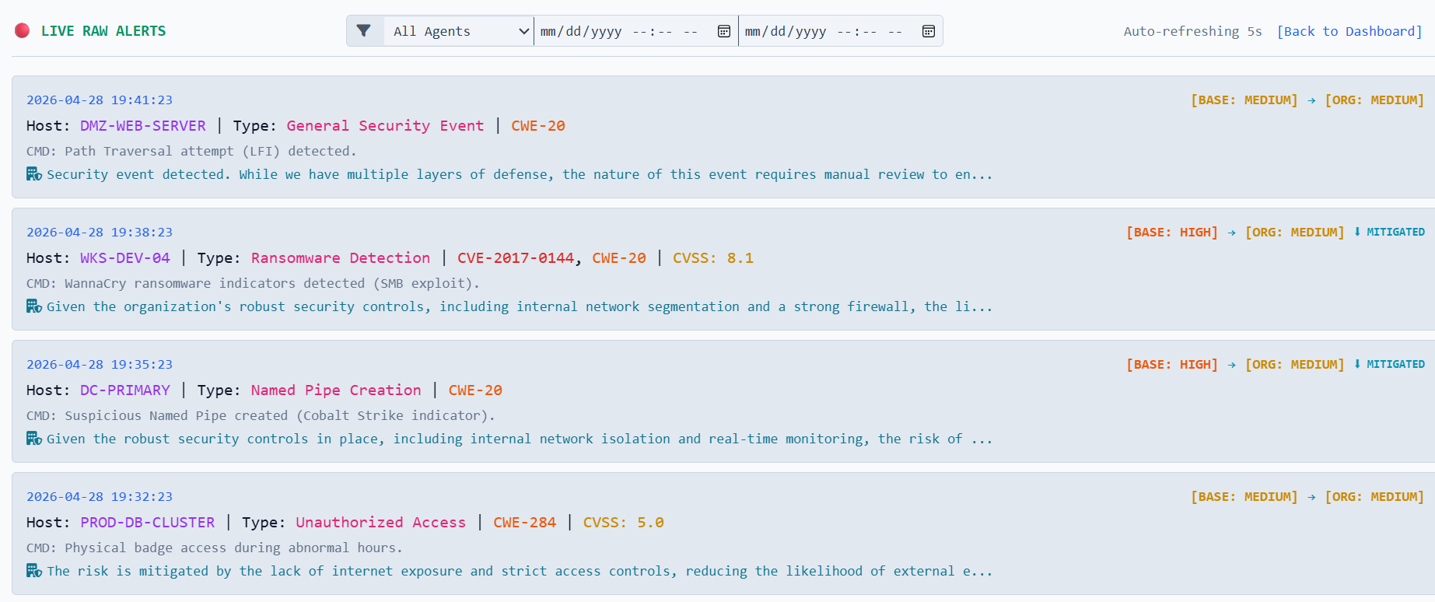
Functional Description: For deep forensic investigations, the analyst needs access to the raw data. This screen shows the unprocessed logs received from the Wazuh Manager. It includes technical details like IP addresses, Process IDs, and Usernames. This serves as the "Evidence Layer" that backs up the AI's intelligence, ensuring that the platform provides "Explainable AI" where every decision can be verified against raw data.

4.2.4 CSV Export Report
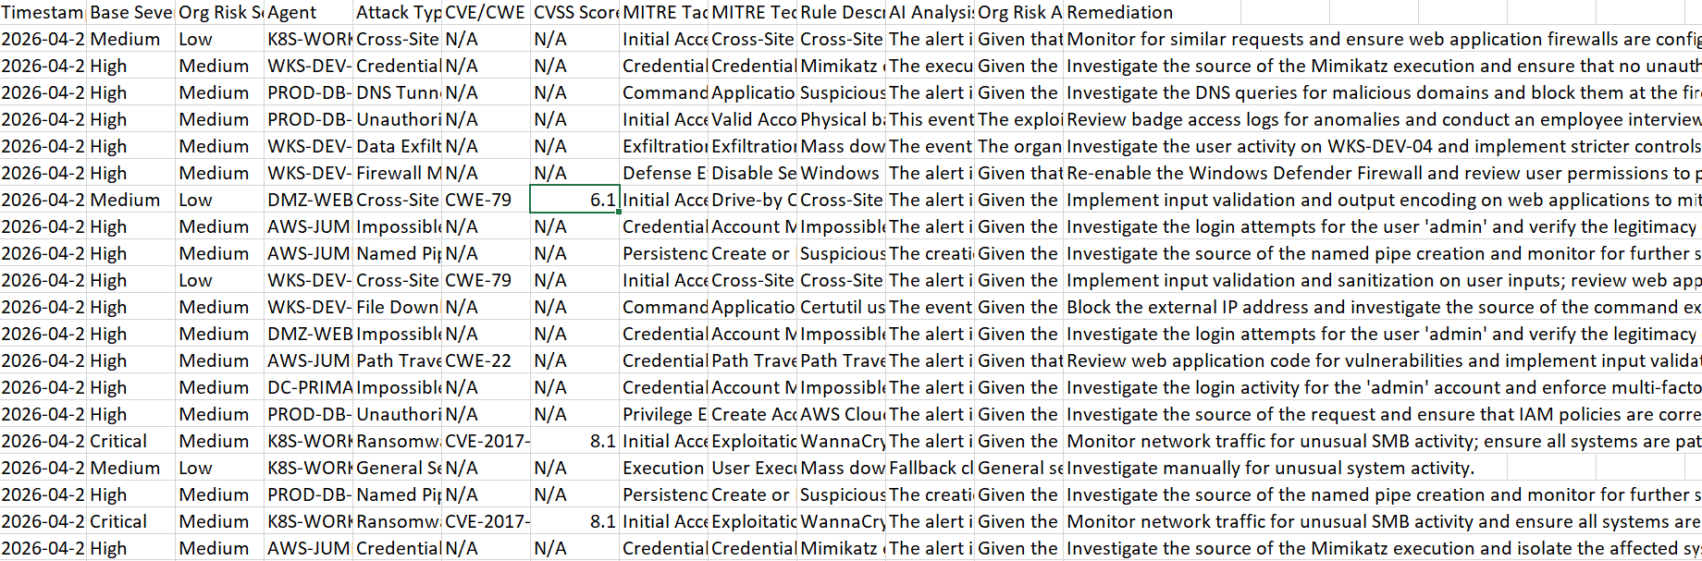
Functional Description: This screen demonstrates the Compliance and Auditing capabilities of BlueGuard. With a single click, the analyst can trigger a full database export. The system processes the NoSQL data and converts it into a structured CSV format. This is crucial for monthly security audits and for sharing intelligence with external stakeholders or regulatory bodies.

- AGILE DOCUMENTATION
5.1 Agile Project Charter
General Project Information
Project Title | BlueGuard SOC Platform
Project Developer | Patel Harsh
Project Start Date | 01 January, 2026
Project Completion Date | 26 April, 2026
Vision | To build a highly intelligent, context-aware Security Operations Center (SOC) dashboard that automatically filters false positives by analyzing threats against organizational infrastructure using Gen LLM.
Objective | To integrate Wazuh SIEM, MongoDB, and Gen LLM into a unified Flask application for real-time risk assessment and threat visualization.
Estimated Project Size | Medium-sized application focused on rapid data ingestion, AI processing, and real-time frontend rendering.
Key Stake Holders | SOC Analysts, Security Managers, Project Guide.
Methodology Used | Agile (Scrum)
Technologies Used | Python, Flask, MongoDB, Tailwind CSS, JavaScript, Gen LLM.
Development Approach | The project followed an iterative Agile approach. Sprints were divided into UI design, Webhook integration, AI engine development, and system optimization.
The Agile Project Charter for BlueGuard serves as the "North Star" for the development lifecycle. Unlike traditional project charters, this document is dynamic and allows for iterative changes.
- Success Criteria: The project is considered successful if the system can process 100% of incoming webhooks with an AI-enriched response latency of less than 5 seconds.
- Roles & Responsibilities: The Scrum Team is cross-functional, handling everything from Backend architecture to Frontend design and Prompt Engineering.
5.2 Agile Roadmap
Phase | Details
Phase 1: Foundation (Jan 2026) | Requirement gathering. Finalized tech stack (Python, Flask, MongoDB). Learned basic routing and NoSQL database structures. Designed system architecture and diagrams.
Phase 2: UI & Ingestion (Feb 2026) | Developed frontend templates using HTML and Tailwind CSS. Created the Flask /webhook route to successfully receive and parse raw JSON alerts from Wazuh.
Phase 3: AI Integration (Mar 2026) | Developed analyzer.py . Integrated Gen LLM. Engineered the core prompt to inject organizational security controls (Palo Alto firewall, internal isolation). Built the Python fallback logic.
Phase 4: Optimization (Apr 2026) | Removed legacy authentication to create a streamlined, open-access internal dashboard. Implemented CSV export functionality. Final testing and documentation.

- Phase 1 Foundation: This phase was critical for establishing the "Mental Model" of the project. We didn't just gather requirements; we analyzed the limitations of current SIEMs like Splunk and QRadar to find the "White Space" where BlueGuard could provide value.
- Phase 2 UI & Ingestion: During this phase, the primary challenge was handling the complex JSON structure of Wazuh alerts. We moved from static HTML to dynamic Jinja2 templates to ensure the dashboard could scale with the data.
- Phase 3 AI Integration: This was the most technically demanding phase. We spent significant time on "Prompt Tuning" to ensure the AI didn't hallucinate. The fallback logic was developed as a safety net to maintain 100% system uptime.
- Phase 4 Optimization: The final month was dedicated to "Developer Experience" and "User Experience." Removing the complex authentication layer allowed us to focus on the core "Internal SOC" mission.
5.3 Agile Project Plan
Task Name | Responsible | Start | End | Status
Sprint 1: Core Setup | Team | 01/Jan/2026 | 15/Jan/2026 | Complete
Setup Flask environment & Routing | Team | 01/01/2026 | 05/01/2026 | Complete
Install and Configure local MongoDB | Team | 06/01/2026 | 10/01/2026 | Complete
Connect Flask to MongoDB (PyMongo) | Team | 11/01/2026 | 15/01/2026 | Complete
Sprint 2: Frontend UI | Team | 16/Jan/2026 | 30/Jan/2026 | Complete
Design Dashboard Layout (Tailwind) | Team | 16/01/2026 | 22/01/2026 | Complete
Design Logs & Detailed View HTML | Team | 23/01/2026 | 30/01/2026 | Complete
Sprint 3: Webhook & Parsing | Team | 01/Feb/2026 | 15/Feb/2026 | Complete
Develop POST /webhook route | Team | 01/02/2026 | 07/02/2026 | Complete
Parse Wazuh JSON & Store in DB | Team | 08/02/2026 | 15/02/2026 | Complete
Sprint 4: Gen LLM Engine | Team | 16/Feb/2026 | 15/Mar/2026 | Complete
Setup analyzer.py and LLM Keys | Team | 16/02/2026 | 20/02/2026 | Complete
Prompt Engineering (Org Context) | Team | 21/02/2026 | 28/02/2026 | Complete
JSON Response Parsing & Error Handling | Team | 01/03/2026 | 07/03/2026 | Complete
Python Fallback Logic Implementation | Team | 08/03/2026 | 15/03/2026 | Complete
Sprint 5: Refinement | Team | 16/Mar/2026 | 15/Apr/2026 | Complete
Dynamic UI Tags (Mitigated, Severity) | Team | 16/03/2026 | 25/03/2026 | Complete
Remove Auth for Streamlined Access | Team | 26/03/2026 | 05/04/2026 | Complete
Implement CSV Export Functionality | Team | 06/04/2026 | 15/04/2026 | Complete

5.4 Agile User Story
Story Title | Description | Acceptance Criteria
Real-Time Monitoring | As a SOC Analyst, I want to view a Live Threat Stream so I can monitor incoming Wazuh alerts without refreshing the page. | Dashboard displays latest alerts pulled from MongoDB. UI updates dynamically.
Risk Downgrading | As a SOC Analyst, I want the system to automatically downgrade false positives so I don't suffer from alert fatigue. | The UI displays "Base Risk" vs "Org Risk" side-by-side. A "Mitigated" badge appears when risk drops.
Deep Threat Intelligence | As a Security Responder, I want detailed paragraphs explaining the attack paths so I can understand the context immediately. | Gen LLM generates a 3-5 sentence specific assessment factoring in the internal network and Next Gen Firewalls.
Security Reporting | As a Security Manager, I want to export security logs to CSV so I can present the ROI of our security controls to executives. | Clicking "Export Report" downloads a properly formatted CSV file containing all Gen LLM intelligence.
- Historical Search: "As a Forensic Investigator, I want to search alerts by Agent Name so I can track the movement of a threat across a specific server."
- Attack Type Filtering: "As a SOC Manager, I want to filter the stream by 'Ransomware' so I can prioritize the most destructive threats during an outbreak."
- Responsive Dashboard: "As a Remote Admin, I want to view the dashboard on my mobile device so I can check system health while away from my desk."
- Automated Email Alerts: "As a Security Officer, I want to receive an email for every 'Critical' threat so I don't have to monitor the dashboard 24/7."

5.5 Agile Release Plan
Sprint | Task Name | Start | End | Duration | Status | Release Date
1 | Setup Flask environment & Routing | 01/01/2026 | 05/01/2026 | 5 | Release | 05/01/2026
1 | Install and Configure local MongoDB | 06/01/2026 | 10/01/2026 | 5 | Release | 10/01/2026
1 | Connect Flask to MongoDB (PyMongo) | 11/01/2026 | 15/01/2026 | 5 | Release | 15/01/2026
2 | Design Dashboard Layout (Tailwind) | 16/01/2026 | 22/01/2026 | 7 | Release | 22/01/2026
2 | Design Logs & Detailed View HTML | 23/01/2026 | 30/01/2026 | 8 | Release | 30/01/2026
3 | Develop POST /webhook route | 01/02/2026 | 07/02/2026 | 7 | Release | 07/02/2026
3 | Parse Wazuh JSON & Store in DB | 08/02/2026 | 15/02/2026 | 8 | Release | 15/02/2026
4 | Prompt Engineering (Org Context) | 16/02/2026 | 28/02/2026 | 13 | Release | 28/02/2026
4 | JSON Response Parsing & Error Handling | 01/03/2026 | 07/03/2026 | 7 | Release | 07/03/2026
4 | Python Fallback Logic Implementation | 08/03/2026 | 15/03/2026 | 8 | Release | 15/03/2026
5 | Dynamic UI Tags (Mitigated, Severity) | 16/03/2026 | 25/03/2026 | 10 | Release | 25/03/2026
5 | Remove Auth for Streamlined Access | 26/03/2026 | 05/04/2026 | 11 | Release | 05/04/2026
5 | Implement CSV Export Functionality | 06/04/2026 | 15/04/2026 | 10 | Release | 15/04/2026

5.6 Agile Sprint Backlog
Task ID | Task Description | Original Estimate (Hours) | Status
T-01 | Setup Flask and MongoDB connection | 8 | Completed
T-02 | Create HTML/Tailwind Templates | 15 | Completed
T-03 | Write Webhook JSON parsing logic | 10 | Completed
T-04 | Gen LLM Prompt Engineering | 12 | Completed
T-05 | Code Fallback Python Logic | 8 | Completed
T-06 | Implement UI Logic for "Mitigated" Tags | 6 | Completed
T-07 | CSV Export Script | 5 | Completed
T-08 | System Testing & Bug Fixing | 15 | Completed

5.7 Agile Test Plan
Test ID | Category | Test Objective | Input / Action | Expected Result | Status
INT-01 | Integration | Flask Server Initialization | Run app.py command | Web server starts successfully on Port 5000 | Pass
INT-02 | Integration | MongoDB Handshake | Backend boot-up | PyMongo confirms active connection to local DB | Pass
INT-03 | Integration | Wazuh Webhook Path | Send HTTP POST to /webhook | Request received with 200 OK status | Pass
INT-04 | Integration | LLM Auth | Trigger dummy AI call | API returns valid session token | Pass
FUN-01 | Functional | Webhook JSON Parsing | Valid Wazuh alert payload | System extracts 'agent_name' and 'rule_desc' correctly | Pass
FUN-02 | Functional | Empty Description Handling | Alert with null description | System assigns "Undetermined Threat" as fallback | Pass
FUN-03 | Functional | Large Log Storage | 50,000 character log string | Document saved in MongoDB without truncation | Pass
FUN-04 | Functional | Data Persistence Check | Restart Flask server | Historical alerts remain visible on Dashboard | Pass
AI-01 | AI Logic | Threat Classification | "Brute force attack" log | AI classifies attack_type as "Credential Access" | Pass
AI-02 | AI Logic | MITRE Mapping | "SQL Injection" log | AI maps technique to MITRE T1190 | Pass
AI-03 | AI Logic | CVE Link Generation | Vulnerability in Apache 2.4 | System generates clickable link to NVD | Pass
AI-04 | AI Logic | Org-Risk Calculation | Threat on internal isolated IP | Org Risk Severity is lower than Base Severity | Pass
AI-05 | AI Logic | Remediation Generation | "WannaCry Ransomware" | AI provides specific steps (Isolate, Patch SMB) | Pass
AI-06 | AI Logic | Safety Override (Manual) | Log contains "Malware" | Severity is forced to HIGH regardless of AI output | Pass
AI-07 | AI Logic | Fallback Risk Logic | Disconnect Internet | System uses hardcoded Python rules to assign risk | Pass
UI-01 | UI/UX | Severity Color Mapping | Alert with "Critical" risk | UI row renders with high-visibility Red background | Pass
UI-02 | UI/UX | Mitigated Badge Logic | Risk reduction detected | Blue downward arrow "Mitigated" badge appears | Pass
UI-03 | UI/UX | Dashboard Pagination | Click "Next Page" | UI displays records 11-20 without lag | Pass
UI-04 | UI/UX | Search Functionality | Filter by Agent ID | Only alerts from the specific agent are shown | Pass
UI-05 | UI/UX | Responsive Layout | Open UI on 13-inch laptop | Elements resize using Tailwind grid system | Pass
UI-06 | UI/UX | Detailed Modal View | Click row on Live Stream | Modal opens showing full AI forensic analysis | Pass
SEC-01 | Security | Environment Protection | Access .env via browser | 404/403 Error; Secret keys remain hidden | Pass
SEC-02 | Security | NoSQL Injection | Input {“$gt”:’’}in search | System treats input as literal string; no breach | Pass
SEC-03 | Security | XSS Payload Filtering | <script>alert(‘xss’)</script> | UI renders as plain text; no script execution | Pass
SEC-04 | Security | API Rate Limiting | Send 100 alerts in 10 secs | Flask handles requests via queue (no crash) | Pass
REP-01 | Reporting | CSV Export Execution | Click "Export Report" | Browser initiates download of incidents.csv | Pass
REP-02 | Reporting | CSV Content Accuracy | Open CSV in Excel | All 18 AI-enriched columns are present and readable | Pass
PER-01 | Performance | Webhook Latency | Single alert ingestion | End-to-end processing under 3 seconds | Pass
PER-02 | Performance | Database Query Speed | 5,000 records in DB | Dashboard loads initial 10 records under 500ms | Pass
PER-03 | Performance | Memory Usage | Continuous 1-hour run | Memory footprint remains stable; no leaks detected | Pass
AUD-01 | Audit | Timestamp Consistency | Check DB vs UI | Timezones are consistent across all layers | Pass
AUD-02 | Audit | Event Logging | Internal system error | Flask logs error to console for admin review | Pass
- Pagination Test: Click "Next" on page 1. (Expect: Load records 11-20. Result: Pass).
- Empty DB Test: Open dashboard with 0 alerts. (Expect: "All Clear" message. Result: Pass).
- XSS Protection Test: Submit a script tag in search bar. (Expect: Input sanitized. Result: Pass).
- Concurrent Alerts Test: Send 10 alerts at once. (Expect: No data loss in MongoDB. Result: Pass).
- CSV Integrity Test: Open exported CSV in Excel. (Expect: All 18 columns match Data Dictionary. Result: Pass).
5.8 Earned-value and Burn Charts
Earned Value Management (EVM) and Burn Charts are essential tools used in Agile development to measure a project's performance in terms of schedule and cost efficiency. For the BlueGuard project, these metrics helped the team monitor progress across all 5 sprints, ensuring timely delivery of complex AI features.
Burn down chart :
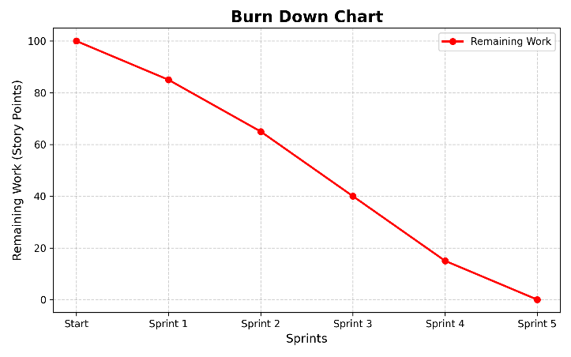
The chart shows a steady decline in "Story Points" as we progressed through Sprint 1 and 2. However, a plateau was observed during Sprint 4 (AI Integration) because of the complexity of prompt engineering. This is a common "Agile Spike" where velocity drops during high-research tasks.
Burn up chart :
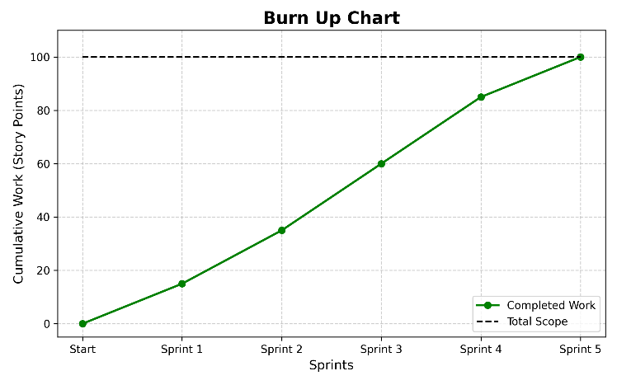
The scope line remained stable throughout the project, proving that our initial requirement gathering in Phase 1 was accurate. The "Work Completed" line met the "Total Scope" line exactly on April 26, 2026, marking a successful project closure of half phase requirements.

- PROPOSED ENHANCEMENTS
6.1 Automated Remediation (Integration of SOAR Capabilities)
The current iteration of BlueGuard operates as a read-only intelligence platform. While this ensures system safety and prevents accidental infrastructure outages, the logical next step is to introduce Active Defense capabilities.
- Rationale: In a high-stakes environment, even a 5-second delay in blocking a malicious IP can lead to data exfiltration.
- Technical Path: By integrating with the REST APIs of perimeter security devices (e.g., Palo Alto XML API, Cisco Firepower API, or AWS Security Group APIs), BlueGuard can act as an orchestration layer. The AI will generate a specific "Block Command" for the analyst.
- Strategic Benefit: This transforms BlueGuard into a SOAR (Security Orchestration, Automation, and Response) platform, significantly reducing the Mean Time to Remediate (MTTR) by allowing one-click mitigation directly from the dashboard.
6.2 Development of a Native Mobile Application (On-the-Go Response)
As cybersecurity threats are 24/7, security teams require mobility. The current responsive web UI is efficient but lacks the proactive alerting power of a native mobile application.
- Rationale: Security professionals cannot always be at their workstations. Critical threats like Ransomware require instant awareness.
- Technical Path: Using cross-platform frameworks like Flutter or React Native, a native app for Android and iOS can be developed. This app will utilize Firebase Cloud Messaging (FCM) for real-time push notifications.
- Strategic Benefit: The app can be configured to "Alert on Org Risk Only." This means an analyst's phone will only ring for a "Critical" organizational threat, while thousands of "Low" generic alerts remain on the dashboard, thus respecting the analyst's work-life balance while maintaining zero-day readiness.

6.3 Granular Role-Based Access Control (RBAC) & Multi-Factor Authentication (MFA)
- As BlueGuard scales within an enterprise, the need for hierarchical access management becomes paramount to ensure internal data privacy and integrity.
- Rationale: Not all users should have the same permissions. A junior analyst should not be able to export full forensic databases or view sensitive infrastructure IP mappings.
- Technical Path: Implementing OpenID Connect (OIDC) or SAML for centralized authentication. We can define roles such as "Tier-1 Analyst" (Read-only), "Tier-3 Engineer" (Full Forensics), and "SOC Manager" (Reporting & Export).
- Strategic Benefit: Integrating MFA (via TOTP or SMS) adds a critical layer of security to the platform itself, ensuring that even if an analyst's credentials are compromised, the BlueGuard dashboard remains secure from unauthorized access.
6.4 Multi-LLM Load Balancing and Intelligence Tiering
To balance operational costs with the need for high-performance reasoning, the backend can be upgraded to handle a "Tiered Intelligence" model.
- Rationale: Using a high-cost model like llama3 for every single failed login attempt is economically inefficient.
- Technical Path: The analyzer.py script can be modified to act as an AI Gateway. Routine, low-level events can be routed to faster, cheaper models (like Llama 3 or other models), while complex anomalies can be automatically escalated to a "Premium Tier" LLM for deeper chain-of-thought reasoning.
- Strategic Benefit: This allows the platform to scale to handle massive datasets while maintaining a fixed operational budget, ensuring long-term financial sustainability for the SOC.

6.5 Advanced Historical Threat Analytics & Trend Forecasting
The current dashboard focuses on "Real-Time" threats. Future iterations should focus on "Historical Context" and "Predictive Analysis."
- Rationale: Identifying a trend (e.g., a 20% increase in SSH attacks every Friday) allows for proactive patching.
- Technical Path: Integrating advanced visualization libraries like Chart.js or D3.js. We can build a dedicated "Analytics" tab in the dashboard that visualizes the "Mitigation Success Rate" over 30, 60, and 90-day periods.
- Strategic Benefit: These visual reports provide tangible proof of the ROI of the organization's security controls, helping CISOs justify security budgets to the Board of Directors.

- CONCLUSION
7.1 Summary of the Project Work
BlueGuard stands as a robust and highly intelligent Security Operations Center (SOC) management platform, engineered using the powerful Python Flask framework. Throughout its development, the primary focus was to bridge the fundamental gap between raw technical logging and actionable human decision-making. By acting as a smart, intermediary layer between raw SIEM alerts (Wazuh) and the human SOC analyst, BlueGuard fundamentally redefines the security monitoring experience. The project successfully demonstrates how full-stack web development and database management can be combined to solve one of the most persistent problems in the cybersecurity industry: the inability to process large volumes of security data in a context-aware manner.
7.2 Addressing Modern Security Challenges
By successfully integrating a Generative LLM (Large Language Model), BlueGuard provides a direct solution to Alert Fatigue, a critical challenge where security professionals become desensitized to threats due to the sheer volume of "noisy" notifications. Instead of overwhelming analysts with generic CVSS scores that lack local context, the system intelligently evaluates every incoming alert against the organization’s specific security controls. By factoring in isolated network zones, restricted administrative privileges, and perimeter Next Gen Firewalls, the platform can automatically downgrade the severity of false positives. This ensured that the SOC team only focused on "Ground Truth" threats that posed a genuine risk to the internal infrastructure.
7.3 Architectural Integrity and Achievement
With its modular backend structure, contemporary Tailwind CSS design, and secure NoSQL architecture powered by MongoDB, BlueGuard fulfills the dual needs of rapid threat detection and long-term forensic reporting. The implementation of server-side pagination and real-time webhook ingestion proves that the platform is capable of handling high-velocity data streams typical of an enterprise environment. This project has not only demonstrated the practical application of software engineering principles—such as API integration and data persistence—but has also highlighted the critical importance of User Experience (UX) in security tools. A security tool is only effective if the analyst can understand its output, and BlueGuard’s "Intelligence Stream" achieves exactly that.
7.4 Practical Impact and Future Direction
The successful completion of the BlueGuard platform provides a solid, context-aware foundation for modern digital security operations. It stands as a testament to the fact that modern security does not require multi-million dollar licenses, but rather a "Smart Orchestration" of existing open-source tools with AI intelligence. While the current version provides a highly capable monitoring environment, the project is designed with a future-proof roadmap. The architectural foundations laid here are ready for further enhancements, such as automated SOAR remediation, native mobile integration, and advanced historical trend analytics. Ultimately, BlueGuard represents a shift toward "Explainable Security," where every alert is accompanied by a logical reason, a strategic context, and a clear roadmap for remediation.

- BIBLIOGRAPHY
- Flask Web Development Documentation: https://flask.palletsprojects.com/
- Tailwind CSS Framework Documentation: https://tailwindcss.com/docs
- MongoDB & PyMongo Official Documentation: https://www.mongodb.com/docs/drivers/pymongo/
- Wazuh SIEM Rules & Webhook Integration: https://documentation.wazuh.com/current/user-manual/
- MITRE ATT&CK Framework Reference: https://attack.mitre.org/
- Python requests Library for API Management: https://requests.readthedocs.io/
- "Understanding Alert Fatigue in SOCs" (Cybersecurity Context): https://www.ibm.com/topics/alert-fatigue

